Table S1. Data sources of variables applied in driving analysis.
Data category | Variables | Spatial Resolution | Source
Climate | Precipitation (MAP) | 1km | National Tibetan Plateau Data Center
Climate | Temperature (MAT) | 1km | National Tibetan Plateau Data Center
Climate | Land surface temperature(LST) | 1km | Landsat 5 Level-2 ST product (ST_B6); MODIS Terra daytime LST
Climate | Potential evapotranspiration(PET) | 1km | MODIS global evapotranspiration product (MOD16A2)
Topography | Elevation(DEM) | 30m | National Geomatics Center of China
Topography | Slope | 30m | Derived from DEM
Soil | Soil organic carbon (SOC) | 250m | ISRIC SoilGrids 250m v2.0
Soil | Bulk density (BD) | 250m | ISRIC SoilGrids 250m v2.0
Soil | Soil nitrogen content (N) | 250m | ISRIC SoilGrids 250m v2.0
Ecological factors | Built-up land density in 1990 (BU) | 300m | Global Human Modification (GHM) dataset
Ecological factors | Cropland density in 1990 (Crop) | 1km | Derived from land-use data
Ecological factors | Forest density in 1990 (FD) | 1km | China Land Cover Dataset (CLCD)
Ecological factors | Net primary productivity in 1990 (NPP) | 500m | CASA
Human activity | Distance to protected areas (D_BHQ) | 1km | Resource and Environmental Science Data Platform
 | Population density (POP) | 1km | WorldPop Global Project
 | Human activity index in 1990 (HA) | 300m | Global Human Modification (GHM) dataset
Table S2. Features applied in classification of vegetation.
Feature category | Feature parameters | Number of features
Spectral features | Mean and standard deviation of blue, green, red, near-infrared, shortwave infrared 1 and shortwave infrared 2 bands | 2*6
Vegetation indices | Mean, standard deviation, median, range and coefficient of variation of NDVI, EVI, SAVI and NDWI | 5*4
Textural features | Contrast, dissimilarity, entropy, inverse difference moment, variance and correlation at 1-, 3- and 5-pixel scales | 6*3
Phenological features | Growing-season NDVI mean, dormant-season NDVI mean, NDVI maximum, NDVI minimum, seasonal amplitude, growing-season length and peak month | 7
Time-series statistical features | standard deviations of interannual differences of NDVI, EVI, SAVI and NDWI, mean NDVI change rate during the growing season; LandTrendr-derived rate of change, magnitude of change, and pre-change value | 2*4+3
Table S3. Accuracy assessment of Random Forest classification in the upper, middle, and lower reaches of the Yellow River Basin.
Region | Reference class | Predicted naturally regenerated vegetation | Predicted human-assisted vegetation | Predicted stable vegetation | Producer’s accuracy
Upper reaches | Naturally regenerated vegetation | 100 | 14 | 26 | 0.71
Upper reaches | Human-assisted vegetation | 38 | 50 | 29 | 0.43
Upper reaches | Stable vegetation | 19 | 4 | 117 | 0.84
Middle reaches | Naturally regenerated vegetation | 142 | 24 | 14 | 0.79
Middle reaches | Human-assisted vegetation | 61 | 85 | 17 | 0.52
Middle reaches | Stable vegetation | 22 | 0 | 149 | 0.87
Lower reaches | Naturally regenerated vegetation | 16 | 2 | 1 | 0.84
Lower reaches | Human-assisted vegetation | 4 | 10 | 2 | 0.63
Lower reaches | Stable vegetation | 1 | 1 | 12 | 0.86
Rows indicate reference classes, and columns indicate predicted classes.
Figure S1. Pearson correlation matrix of candidate driving factors used for multicollinearity screening. Variables with absolute correlation coefficients greater than 0.9 were considered highly correlated, and one variable from each highly correlated pair was removed before XGBoost–SHAP modeling.
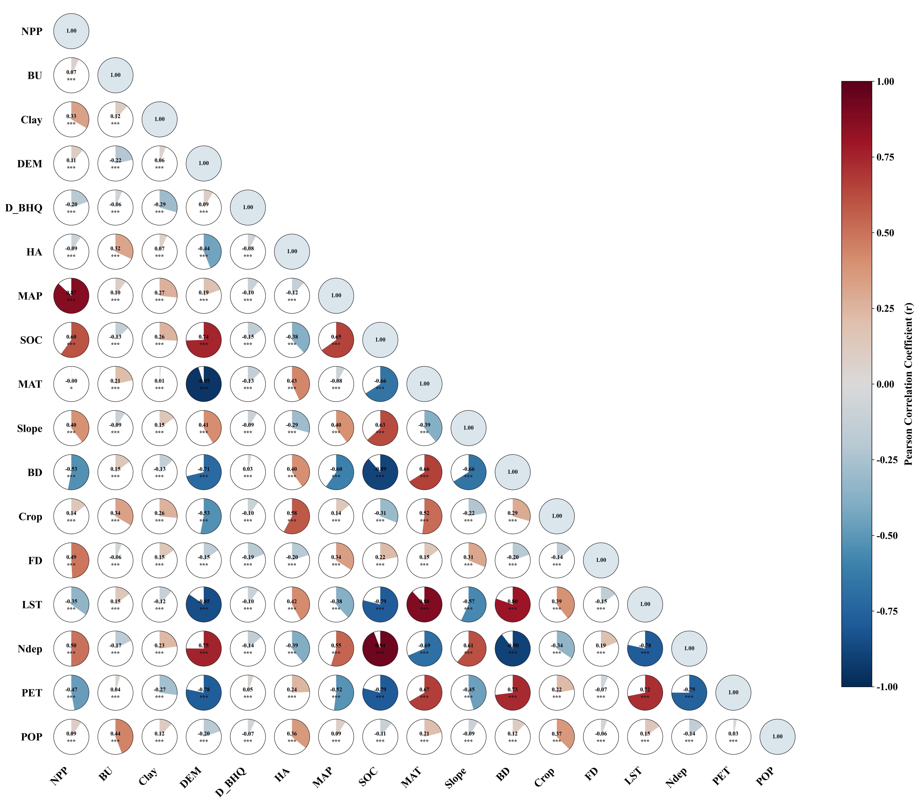
Figure S2. Global Moran’s I scatterplots of natural regeneration indicators. Panels show spatial autocorrelation patterns for (a) natural regeneration proportion, (b) forest regeneration proportion, (c) regeneration rate, and (d) regeneration variability.
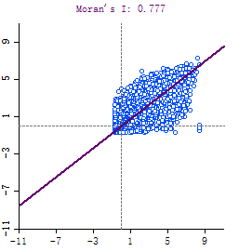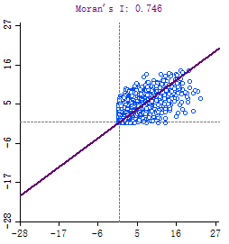
(a)
(b)
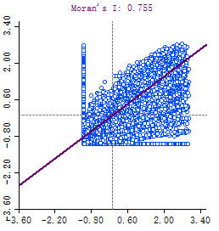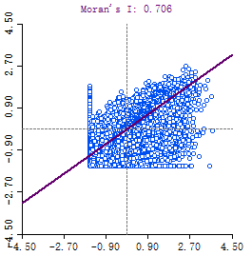
(c)
(d)

Figure S3. Performance of XGBoost models for natural regeneration indicators. Panels show observed versus predicted values for (a) natural regeneration proportion, (b) forest regeneration proportion, (c) regeneration rate, and (d) regeneration variability.
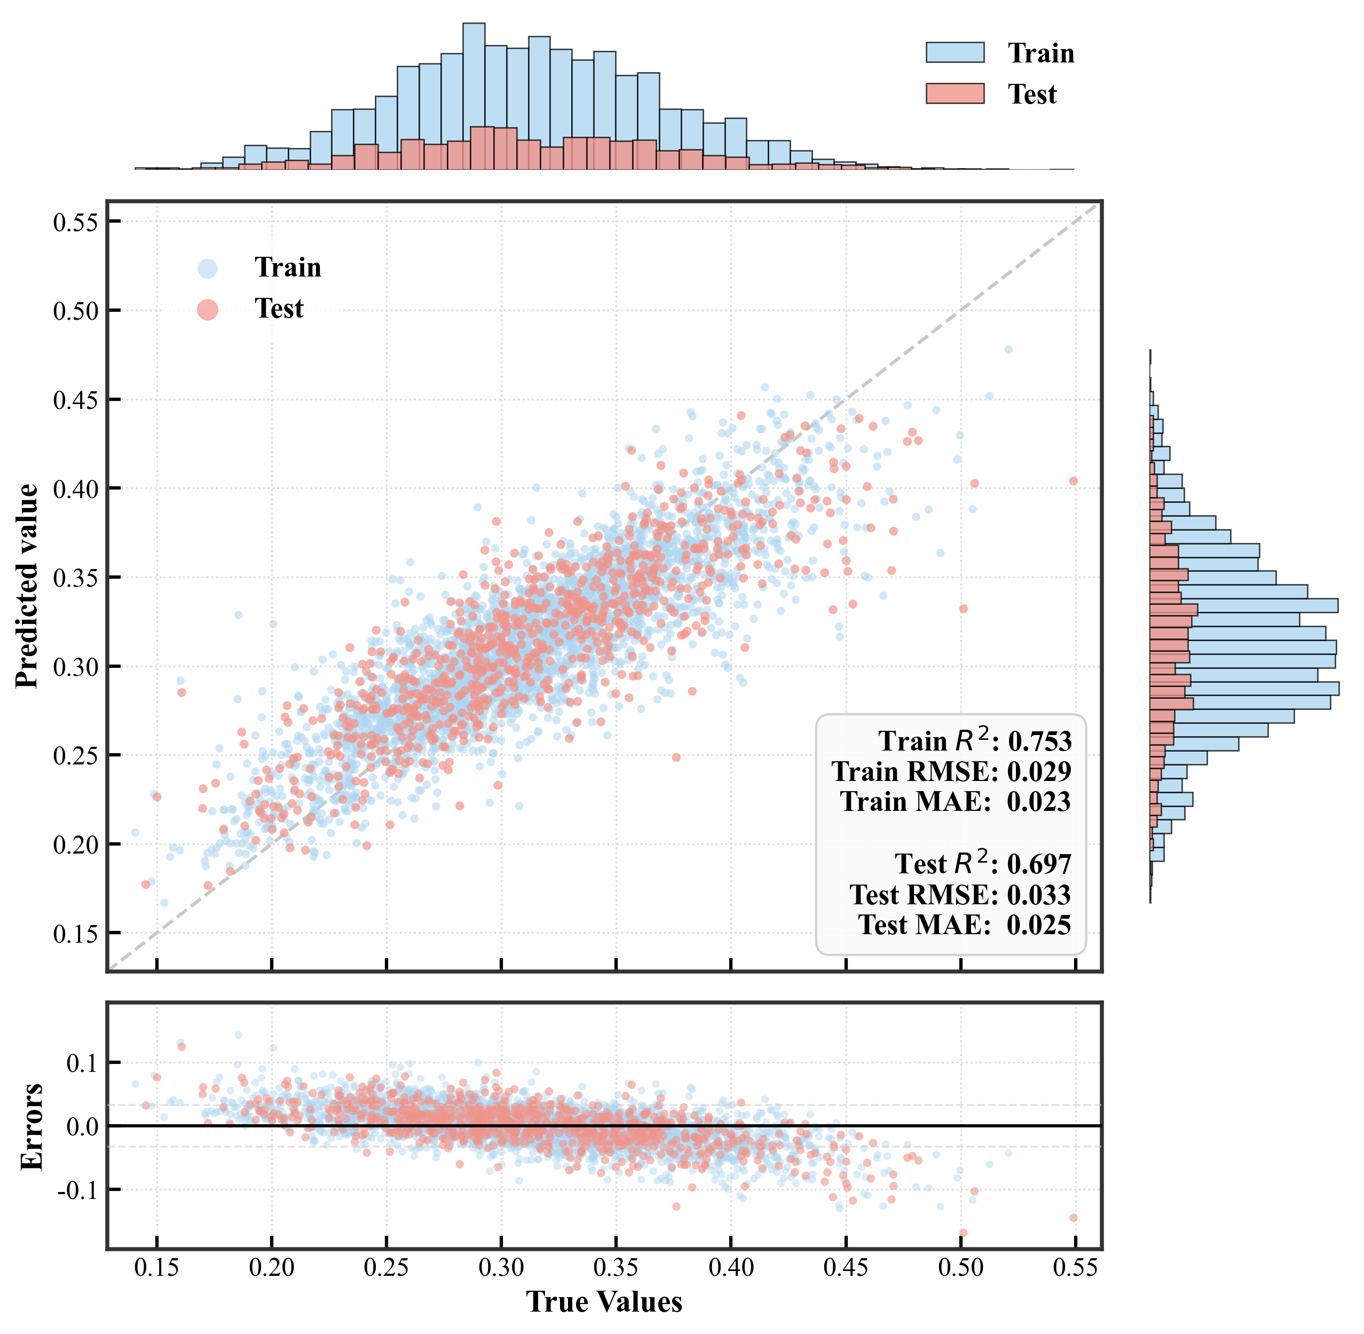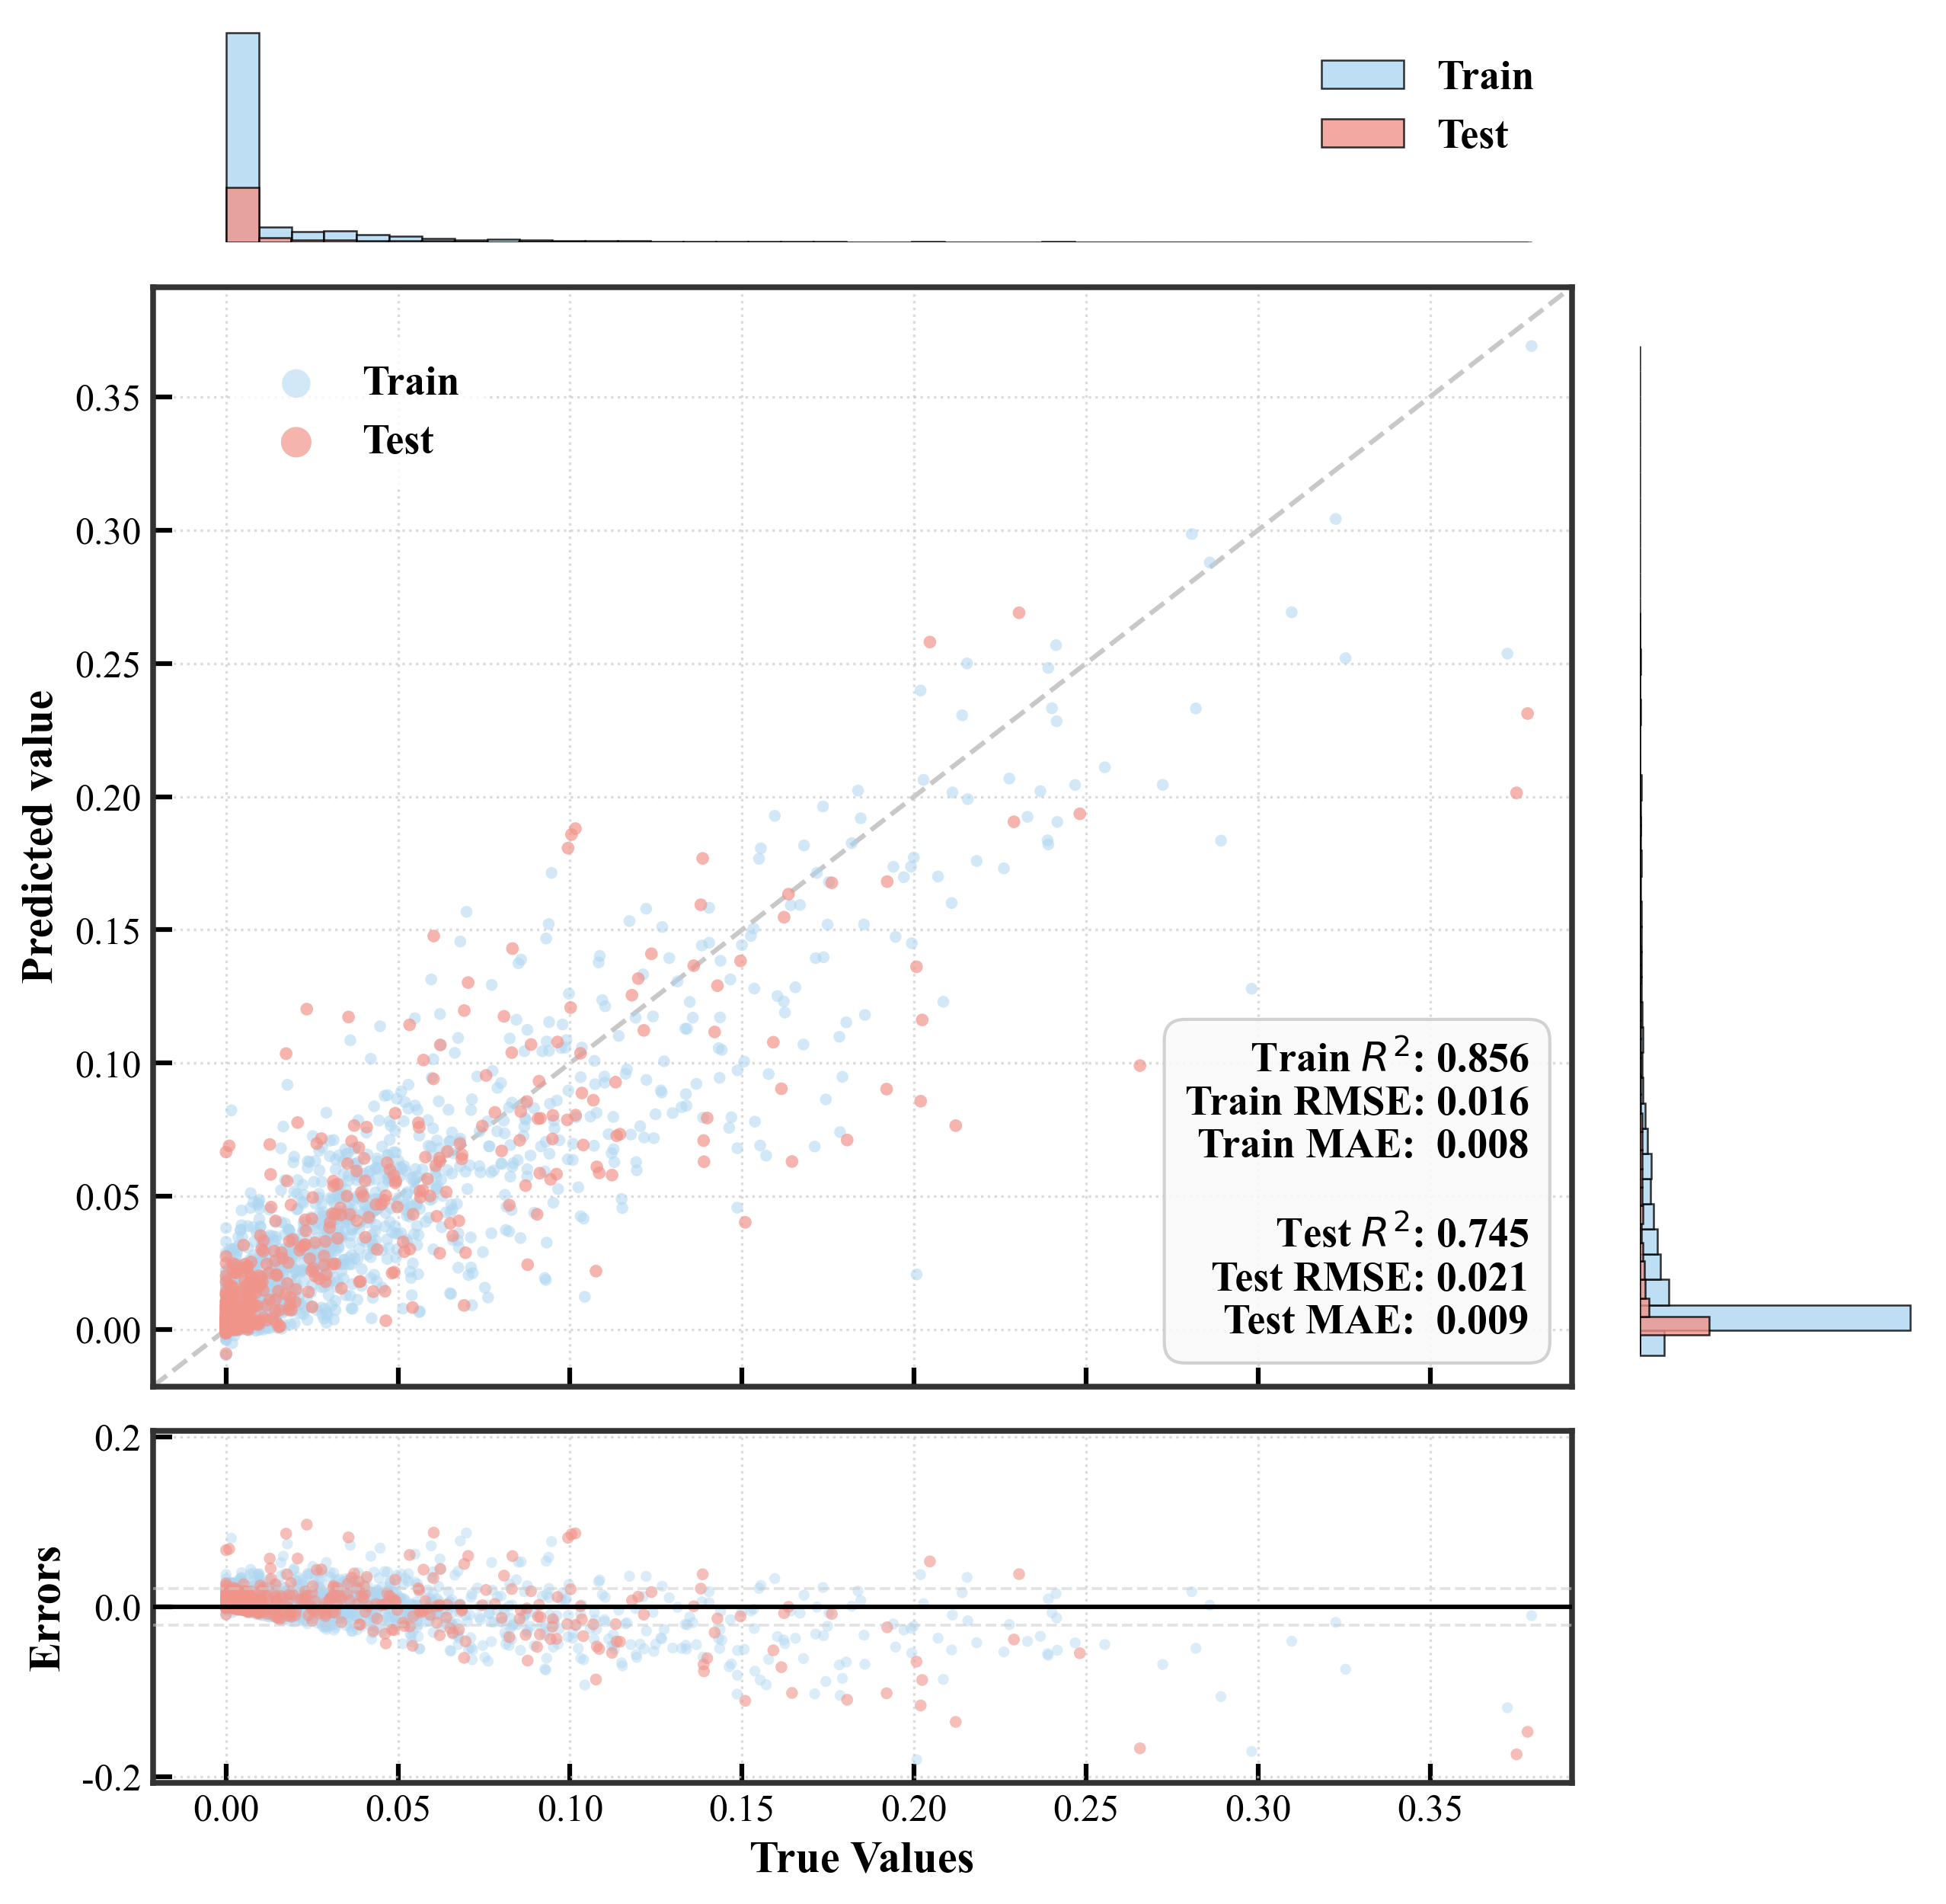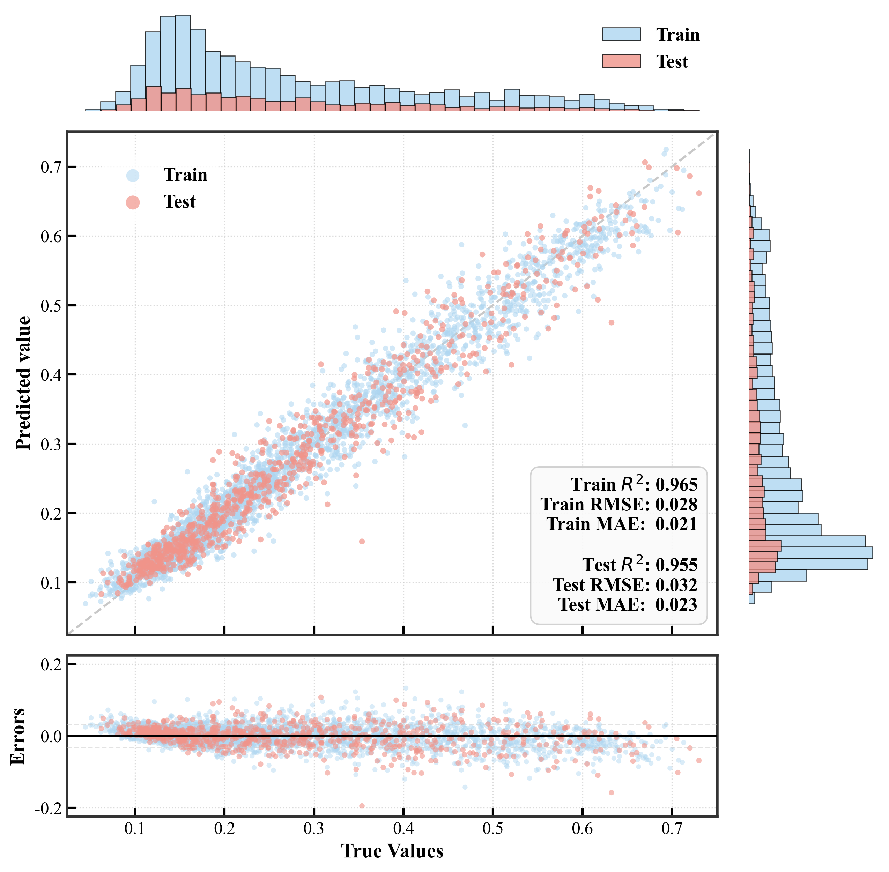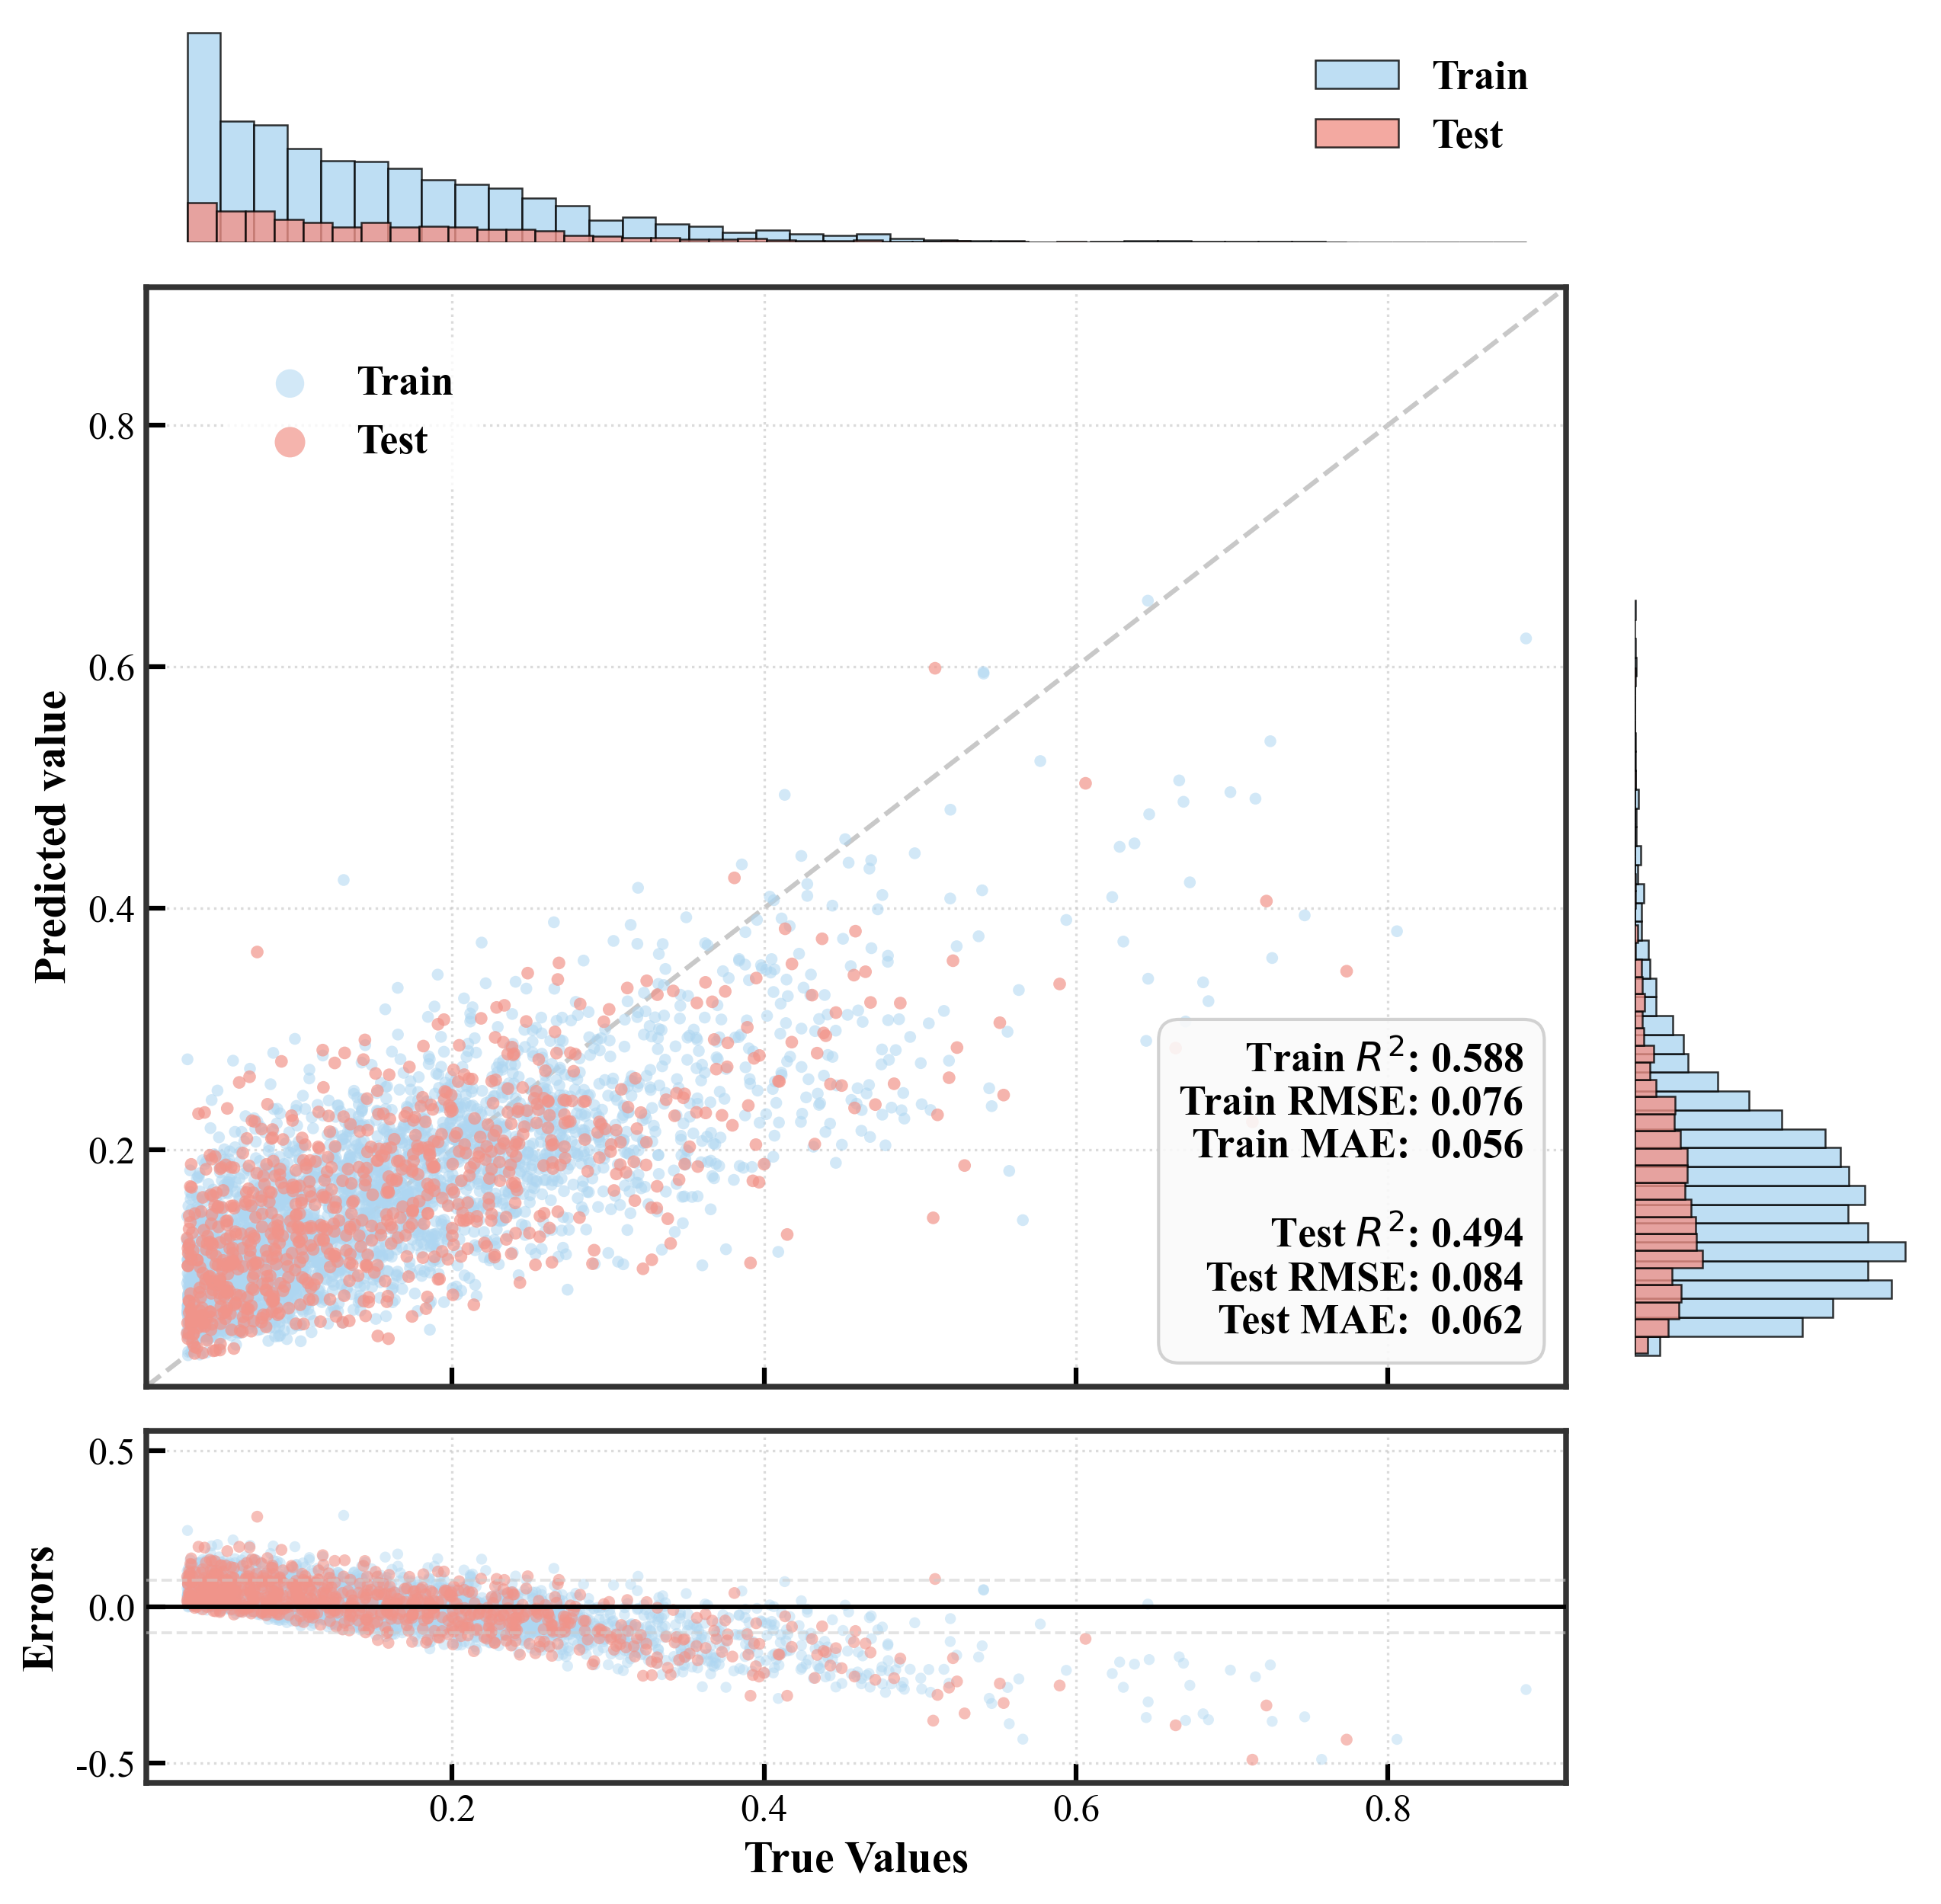
(a)
(b)
(c)
(d)

