Characterization of the chemical components of the extracted Carduus pycnocephalus L, and assessment of its potential novel antioxidant, antibacterial, and anticancer activities

Luay Y. El Hayyany¹, El‐Sayed F. El‐Halawany¹, Hoda M. Soliman¹, and Yasser A. El-Amier¹*
¹Botany Department, Faculty of Science, Mansoura University, Mansoura - 35516, Egypt
* Corresponding author e-mail: yasran@mans.edu.eg; Tel. +201017229120;
ORCID ID: https://orcid.org/0000-0001-8920-8278

Supplementary data
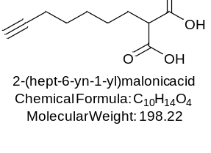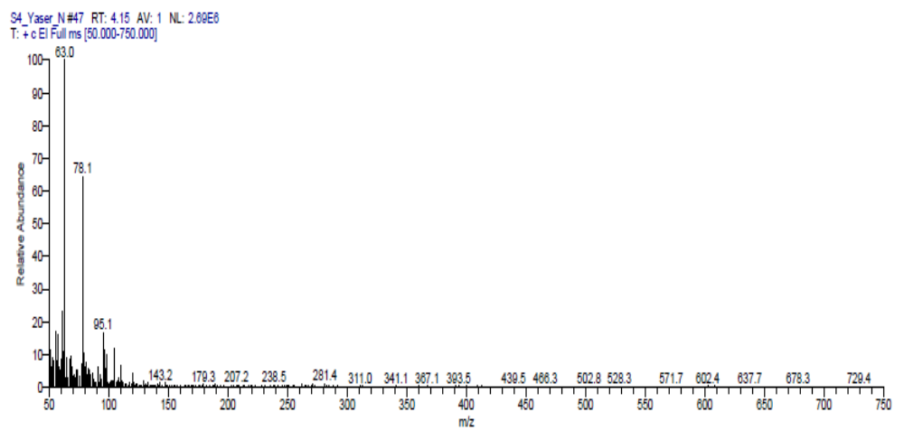
Fig. S1. The chemical structure of the chemical constitute identified after 4.15 min of retention time for the essential oil isolated from the extracted Carduus pycnocephalus L.

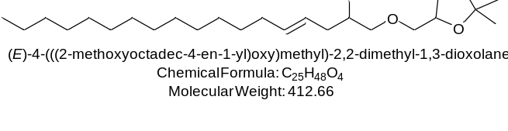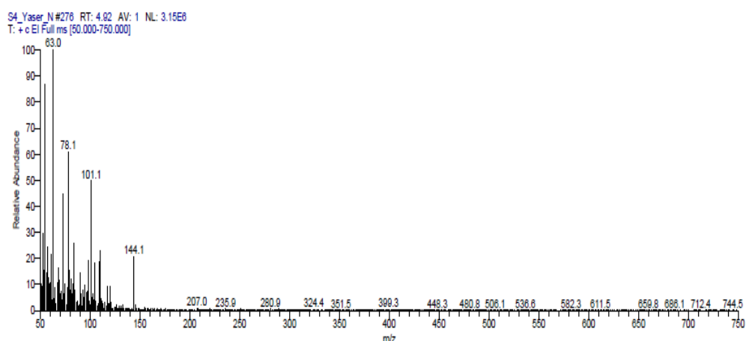
Fig. S2. The chemical structure of the chemical constitute identified after 4.92 min of retention time for the essential oil isolated from the extracted Carduus pycnocephalus L.

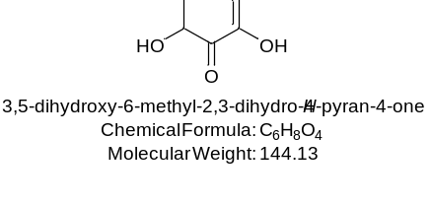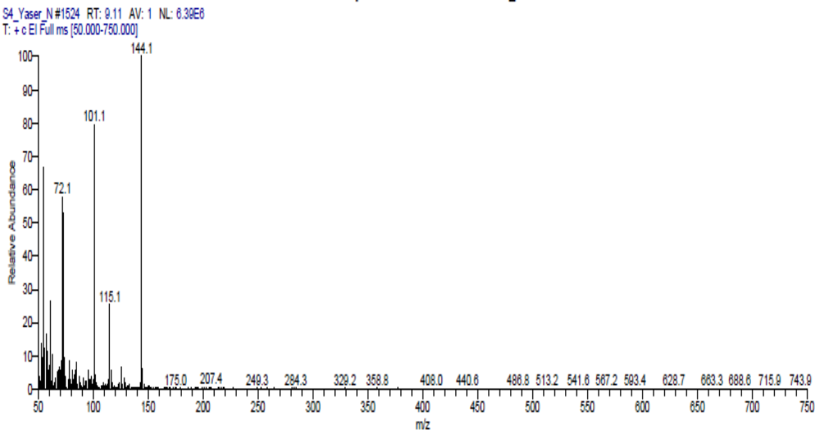
Fig. S3. The chemical structure of the chemical constitute identified after 9.11 min of retention time for the essential oil isolated from the extracted Carduus pycnocephalus L.

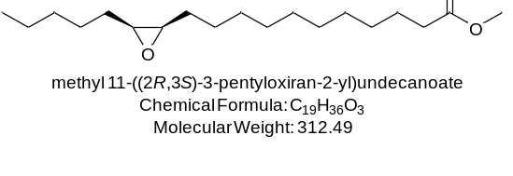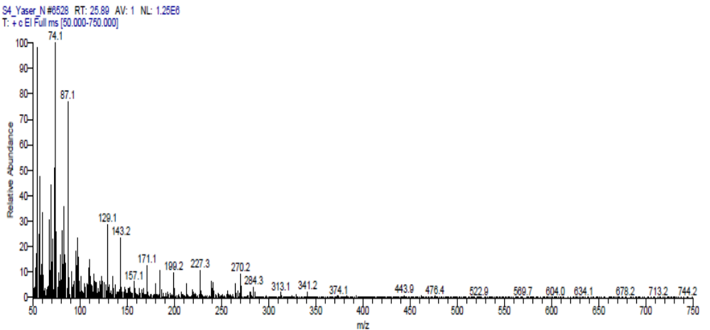
Fig. S4. The chemical structure of the chemical constitute identified after 25.89 min of retention time for the essential oil isolated from the extracted Carduus pycnocephalus L.

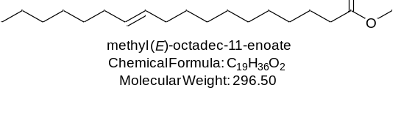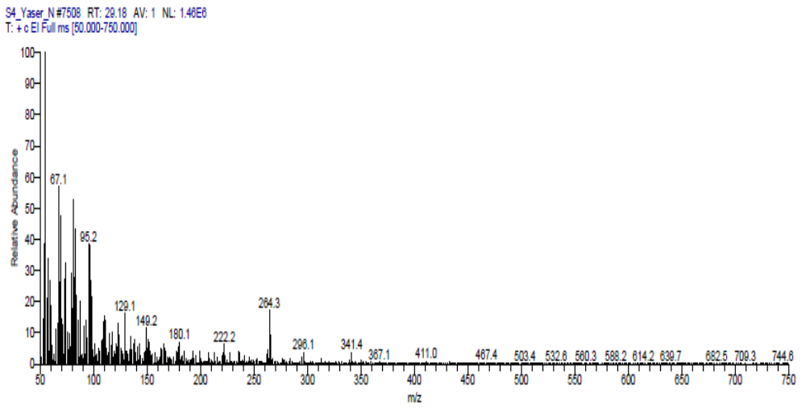
Fig. S5. The chemical structure of the chemical constitute identified after 29.18 min of retention time for the essential oil isolated from the extracted Carduus pycnocephalus L.

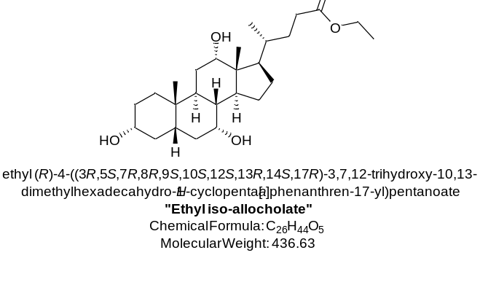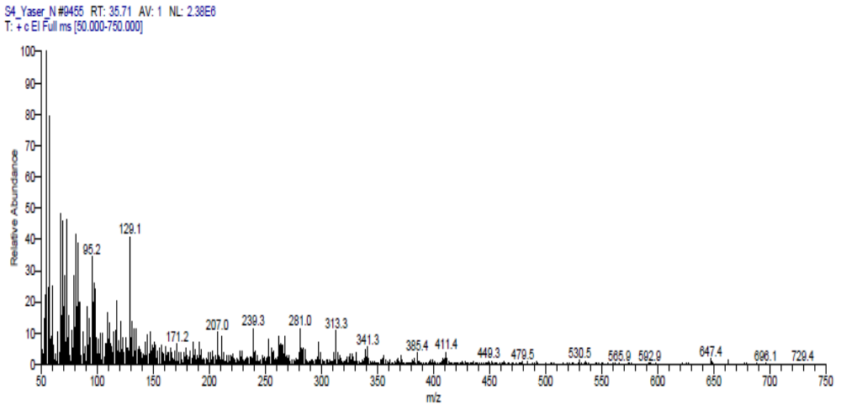
Fig. S6. The chemical structure of the chemical constitute identified after 35.71 min of retention time for the essential oil isolated from the extracted Carduus pycnocephalus L.

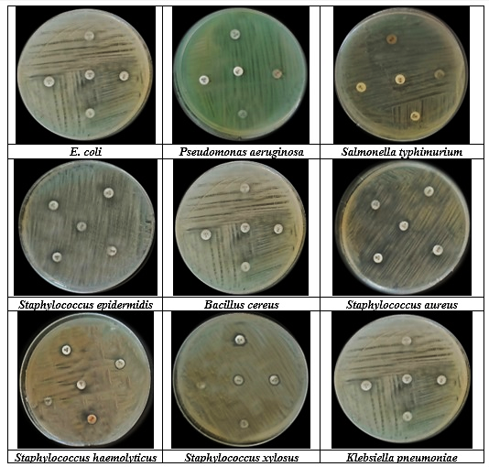
Fig. S7. The inhibition zones raised from the effects of the control sample, and the different antibiotic standards (Cephradin, Tetracycline, Azithromycin, and Ampicillin) on the plates seeded with diverse bacterial species by disc diffusion technique.

