Supplementary Information

Type II porous ionic liquid based on metal-organic cage that enables _{L}-tryptophan identification

Zhuxiu Zhang¹, Baolin Yang¹, Bingjie Zhang¹, Mifen Cui¹, Jihai Tang*^{1,2}, Xu Qiao*^{1,2}

¹State Key Laboratory of Materials-Oriented Chemical Engineering,
College of Chemical Engineering, Nanjing Tech University, No. 30 Puzhunan Road,
Nanjing 211816, China.
²Jiangsu National Synergetic Innovation Centre for Advanced Materials (SICAM),
No. 5 Xinmofan Road, Nanjing 210009, China.

E-mail: jhtang@njtech.edu.cn, qct@njtech.edu.cn

Table of contents:

Supplementary Fig. 1 TGA curves of HD/THTP_Cl and THTP_Cl. 1
Supplementary Fig. 2 Stress versus shear rate plots of HD/THTP_Cl measured at room temperature under rotation mode. 1
Supplementary Fig. 3 Viscosity versus shear rate plots of HD/THTP_Cl measured at room temperature under rotation mode. 2
Supplementary Fig. 4 The number of occupying methane molecules in the HD as a function of time during the production run at 25℃ and 65 bar. 2
Supplementary Fig. 5 _{L}-Phe extraction isotherms of HD/THTP_Cl and THTP_Cl. 3
Supplementary Fig. 6 _{L}-Tyr extraction isotherms of HD/THTP_Cl and THTP_Cl. 3
Supplementary Fig. 7 The simulation box of _{L}-Phe simulation system. Snapshot of empty HD without _{L}-Phe molecule in its cavity. 4
Supplementary Fig. 8 The simulation box of _{L}-Tyr simulation system. Snapshot of empty HD without _{L}-Tyr molecule in its cavity. 4
Supplementary Fig. 9 RMSD for _{L}-Trp simulation system. 5
Supplementary Fig. 10 RMSD for _{L}-Phe simulation system. 5
Supplementary Fig. 11 RMSD for _{L}-Tyr simulation system. 6
Supplementary Fig. 12 Color-filled RDG isosurfaces depicting noncovalent interaction regions of the encapsulated-_{L}-Trp and HD cage. 6
Supplementary Fig. 13 Color-filled RDG isosurfaces depicting noncovalent interaction regions of the absorption of _{L}-Trp by the periphery of HD cages. 7
Supplementary Fig. 14 The van der Walls interactions between the encapsulated-_{L}-Trp and HD cage by the RDG method. 7
Supplementary Fig. 15 The van der Walls interactions between the encapsulated-_{L}-Trp and HD cage by the RDG method. 8
Supplementary Fig. 16 The C-H…π interaction between CH₂ group and the benzene ring of ligand. 8
Supplementary Fig. 17 The N-H…O hydrogen bond between between the nitrogen atom in the indole ring and oxygen atom in the polyoxovanadate. 9
Supplementary Fig. 18 The weak N-H…O hydrogen bond between between the nitrogen atom in the indole ring and oxygen atom in the polyoxovanadate. 9
Supplementary Fig. 19 The weak N-H…O hydrogen bond between between the nitrogen atom in the indole ring and oxygen atom in the polyoxovanadate. 9
Supplementary Fig. 20 The weak N-H…O hydrogen bond between between the nitrogen atom in the indole ring and oxygen atom in the polyoxovanadate. 10
Supplementary Fig. 21 Calibration curve for the determination of _{L}-Trp. 10
Supplementary Fig. 22 Calibration curve for the determination of _{L}-Phe. 11
Supplementary Fig. 23 Calibration curve for the determination of _{L}-Tyr. 11
Supplementary Fig. 24 ¹H NMR of the white precipitate (D₂O, 400 MHz, 298 K). 12
Supplementary Table 1 RMSD values obtained from the MD simulations. 13

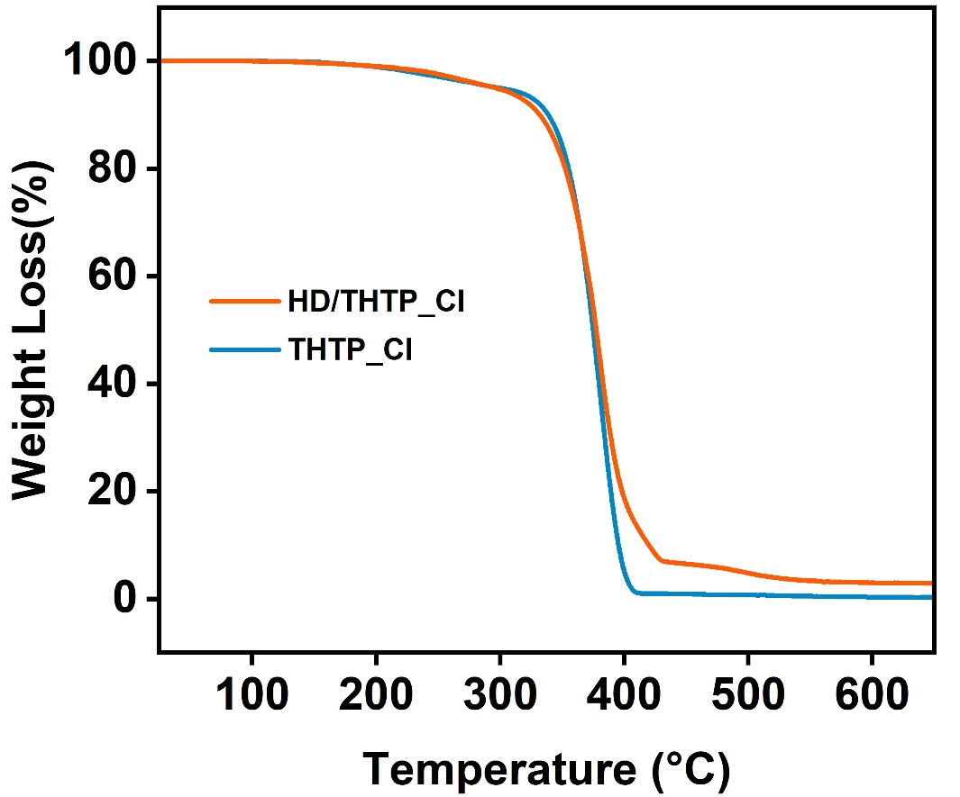

Supplementary Fig. 1 TGA curves of HD/THTP_Cl and THTP_Cl.

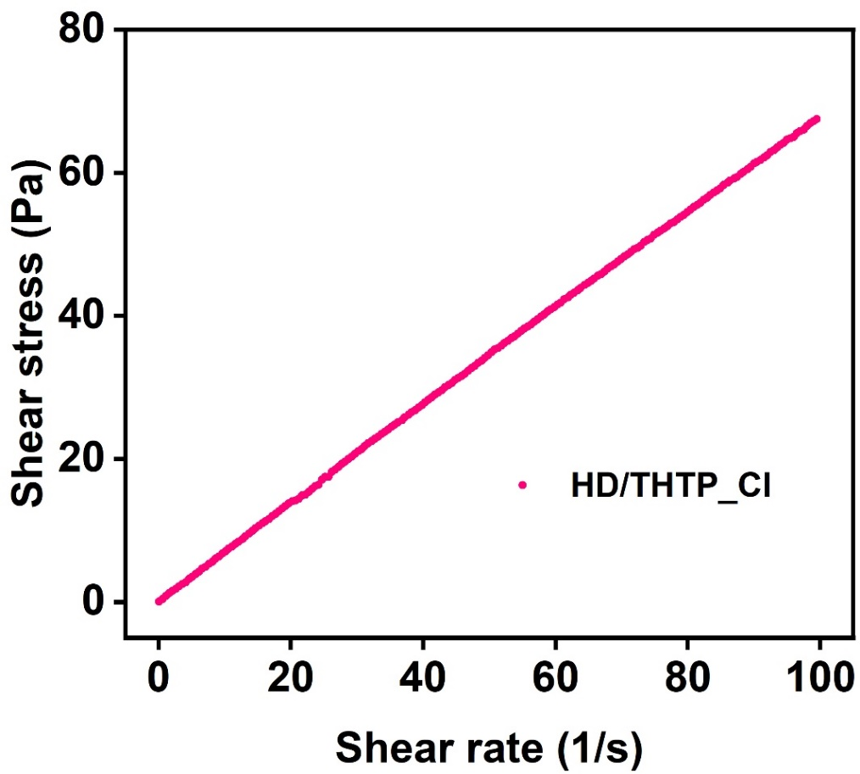

Supplementary Fig. 2 Stress versus shear rate plots of HD/THTP_Cl measured at room temperature under rotation mode.

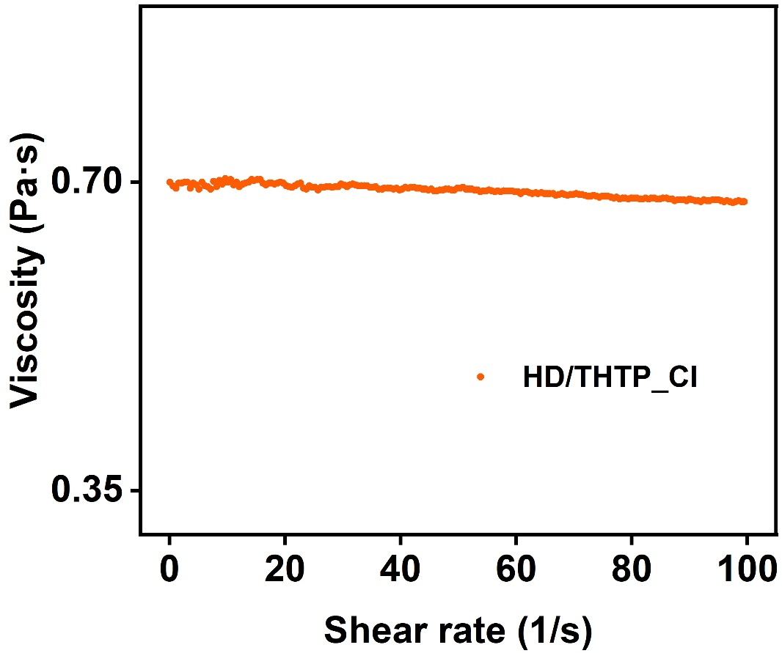

Supplementary Fig. 3 Viscosity versus shear rate plots of HD/THTP_Cl measured at room temperature under rotation mode.

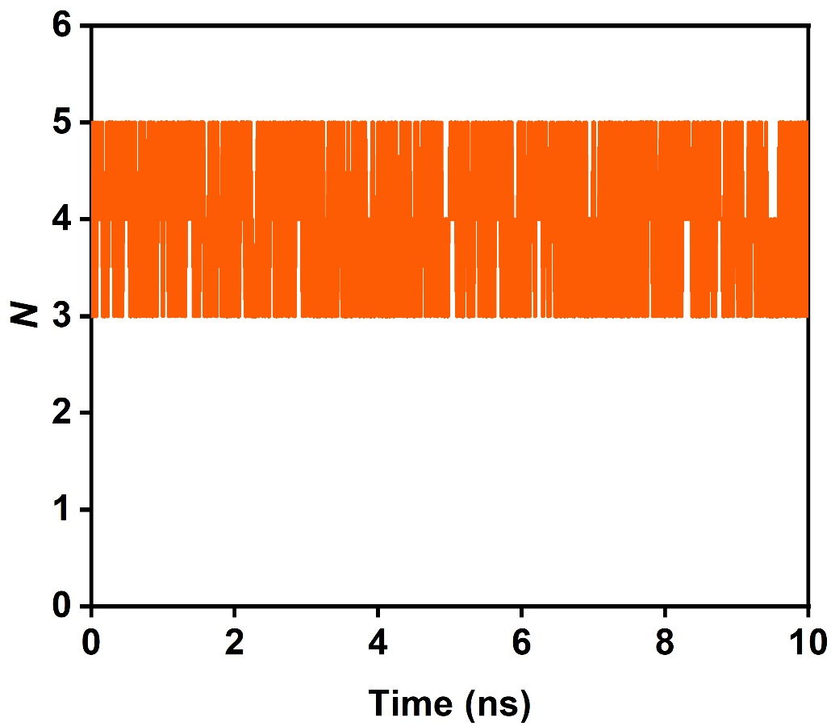

Supplementary Fig. 4 The number of occupying methane molecules in the HD as a function of time during the production run at 25℃ and 65 bar.

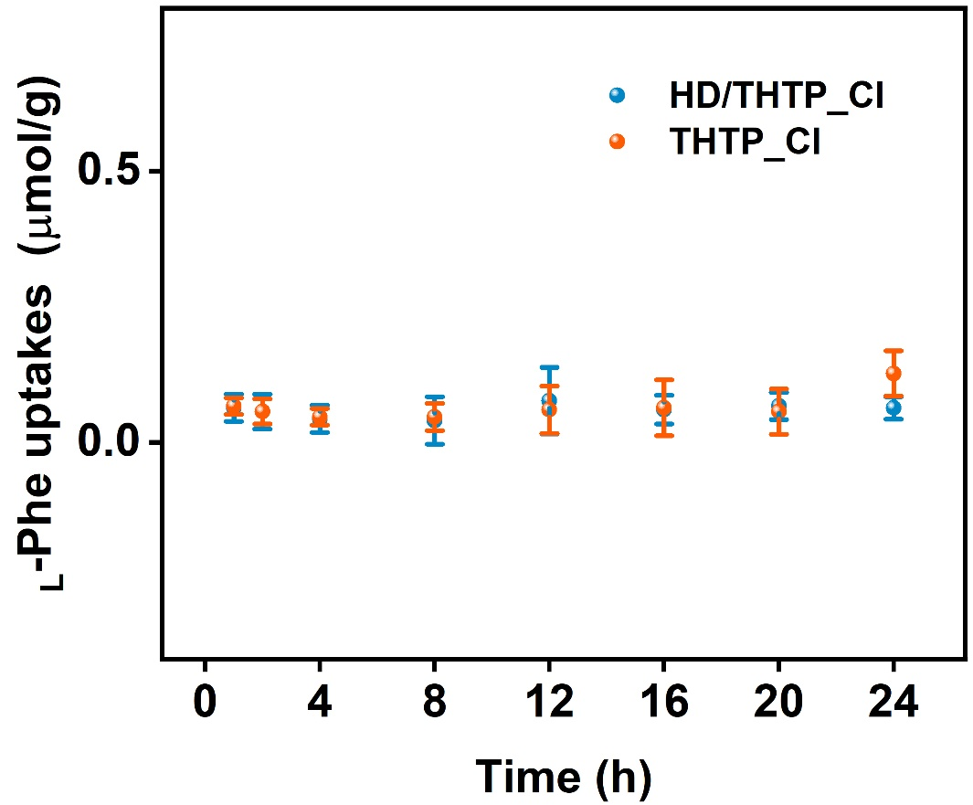

Supplementary Fig. 5 _{L}-Phe extraction isotherms of HD/THTP_Cl and THTP_Cl.

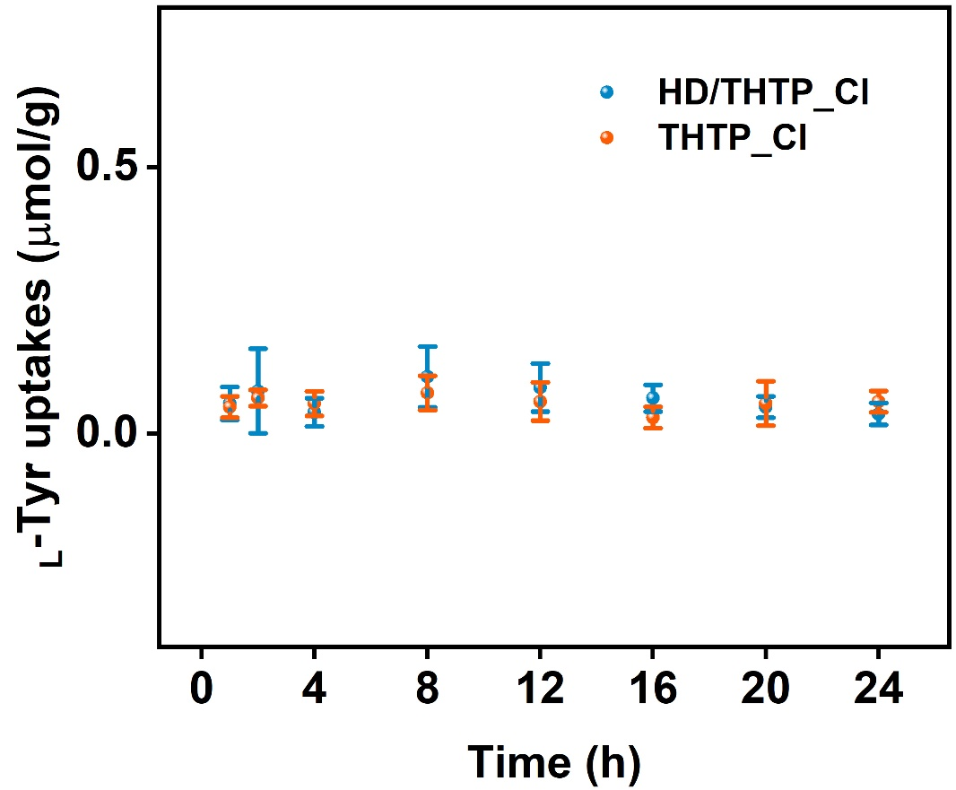

Supplementary Fig. 6 _{L}-Tyr extraction isotherms of HD/THTP_Cl and THTP_Cl.

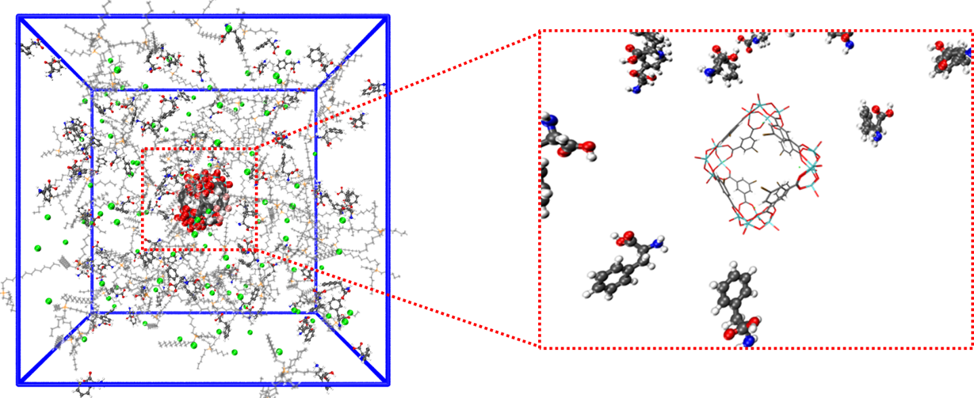

Supplementary Fig. 7 The simulation box of _{L}-Phe simulation system. Snapshot of empty HD without _{L}-Phe molecule in its cavity.
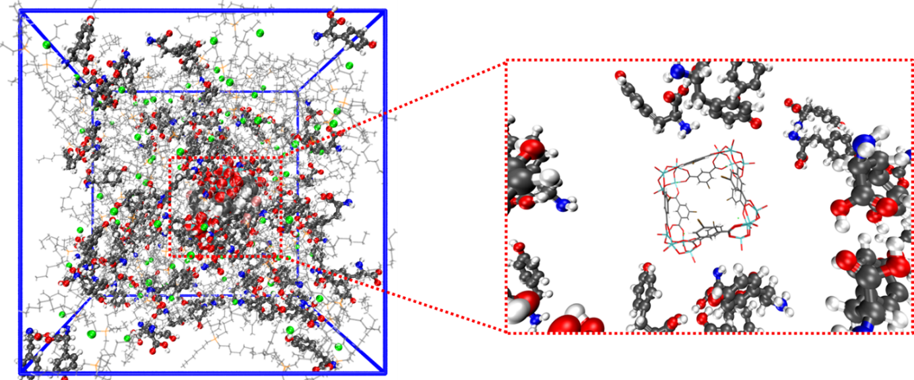

Supplementary Fig. 8 The simulation box of _{L}-Tyr simulation system. Snapshot of empty HD without _{L}-Tyr molecule in its cavity.

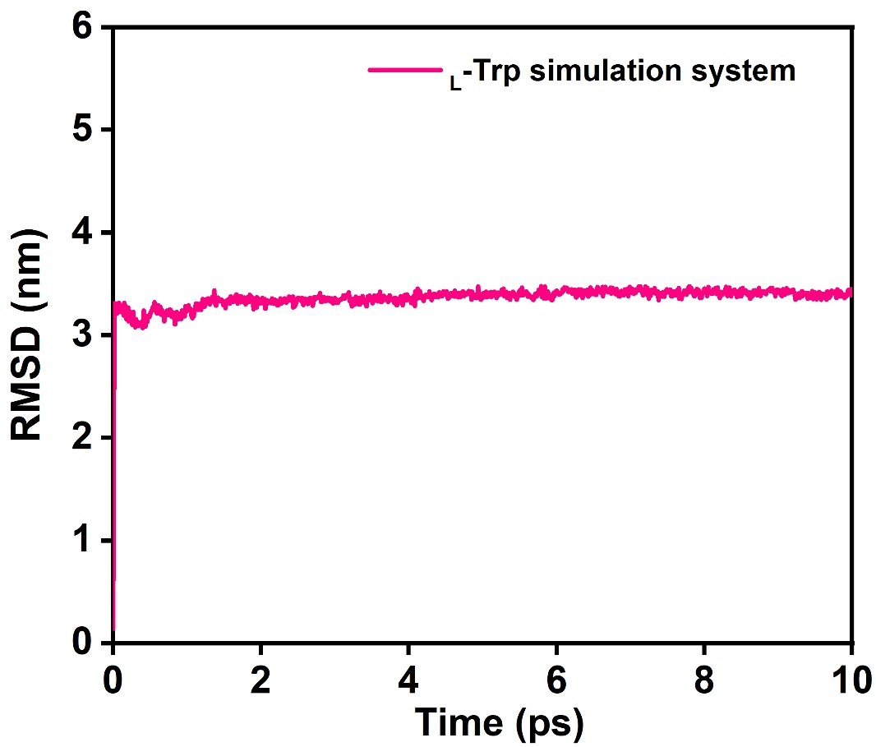

Supplementary Fig. 9 RMSD for _{L}-Trp simulation system.
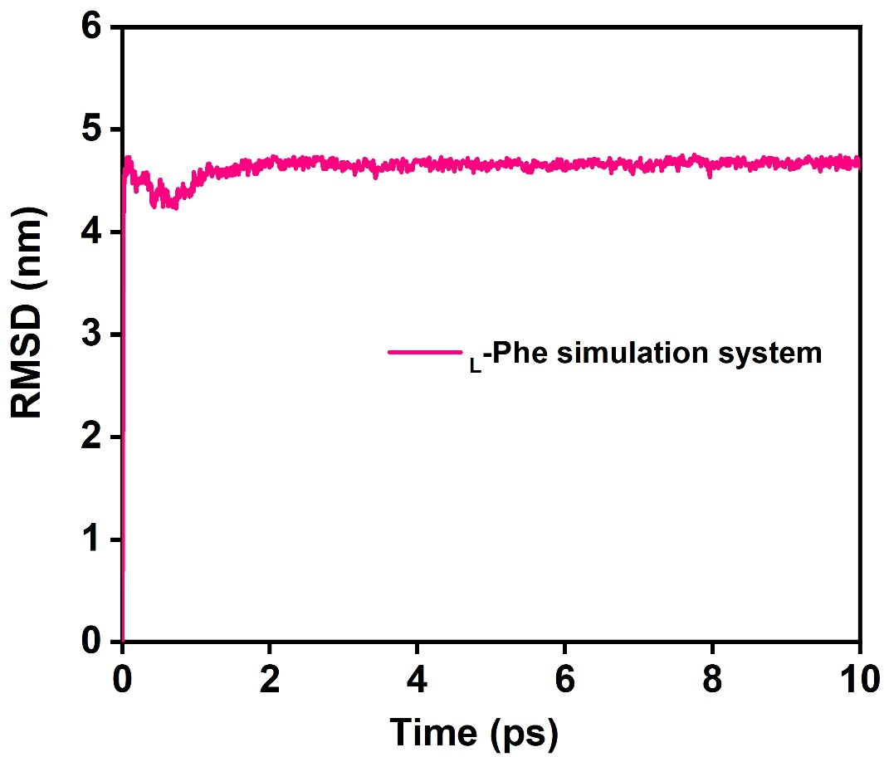

Supplementary Fig. 10 RMSD for _{L}-Phe simulation system.

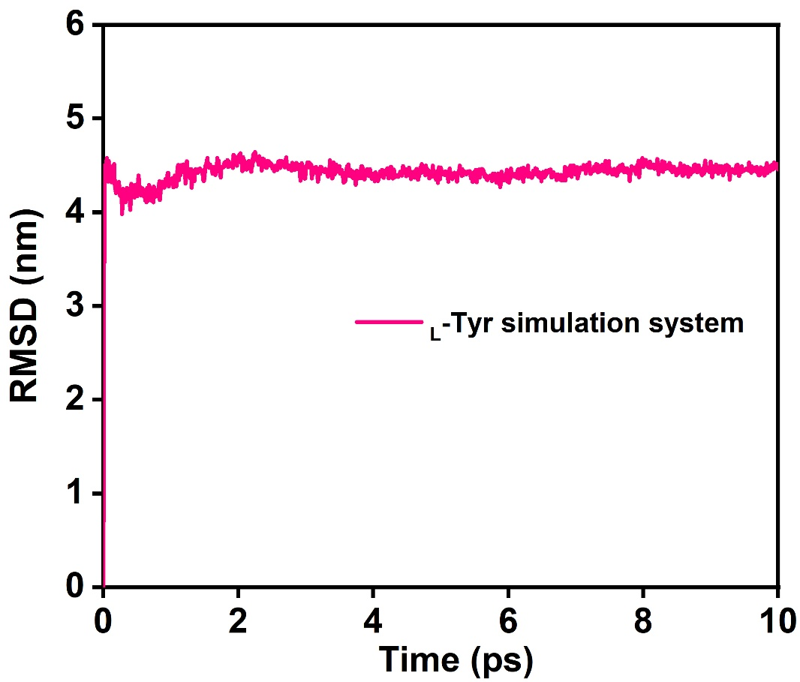

Supplementary Fig. 11 RMSD for _{L}-Tyr simulation system.

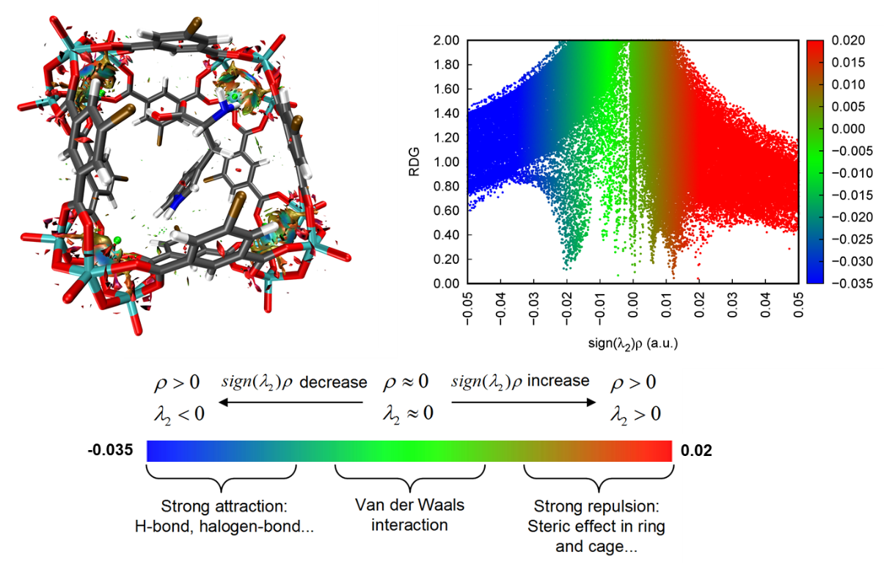

Supplementary Fig. 12 Color-filled RDG isosurfaces depicting noncovalent interaction regions of the encapsulated-_{L}-Trp and HD cage. The blue, green, and red clouds represent hydrogen bonding, van der Waals interactions, and steric hindrance, respectively.
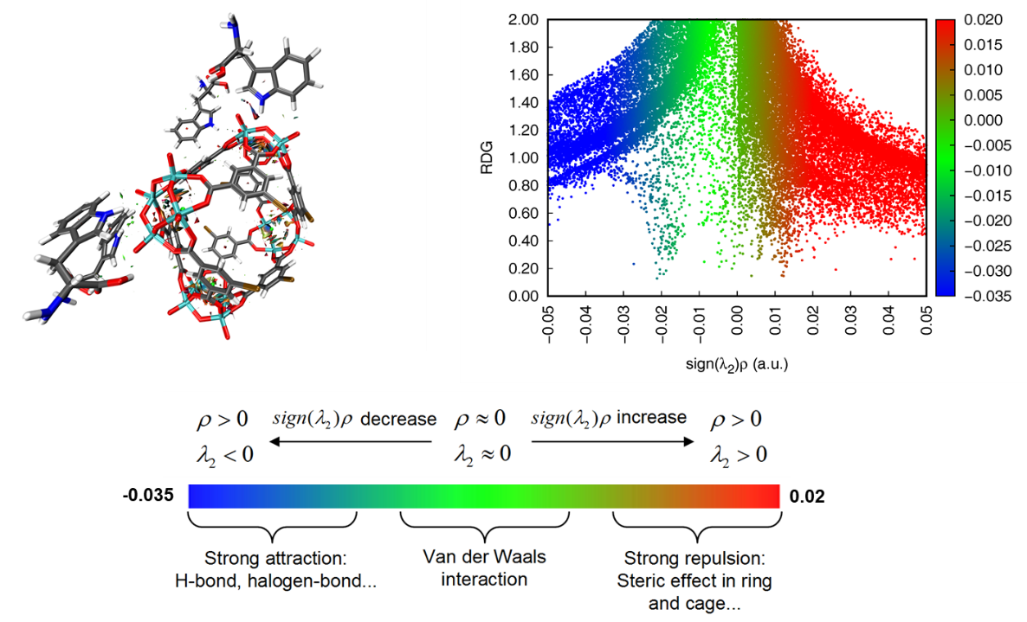

Supplementary Fig. 13 Color-filled RDG isosurfaces depicting noncovalent interaction regions of the absorption of _{L}-Trp by the periphery of HD cages. The blue, green, and red clouds represent hydrogen bonding, van der Waals interactions, and steric hindrance, respectively.
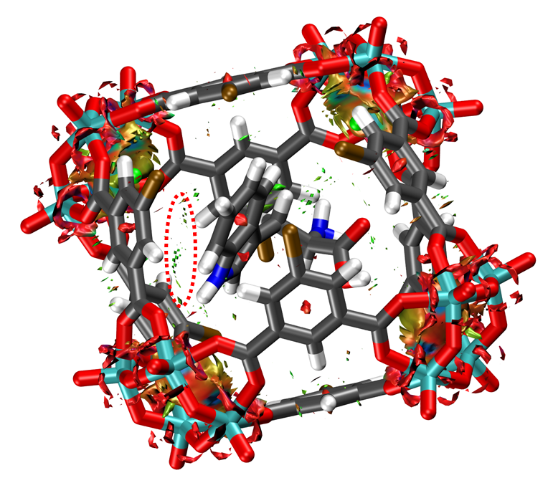

Supplementary Fig. 14 The van der Walls interactions between the encapsulated-_{L}-Trp and HD cage by the RDG method.
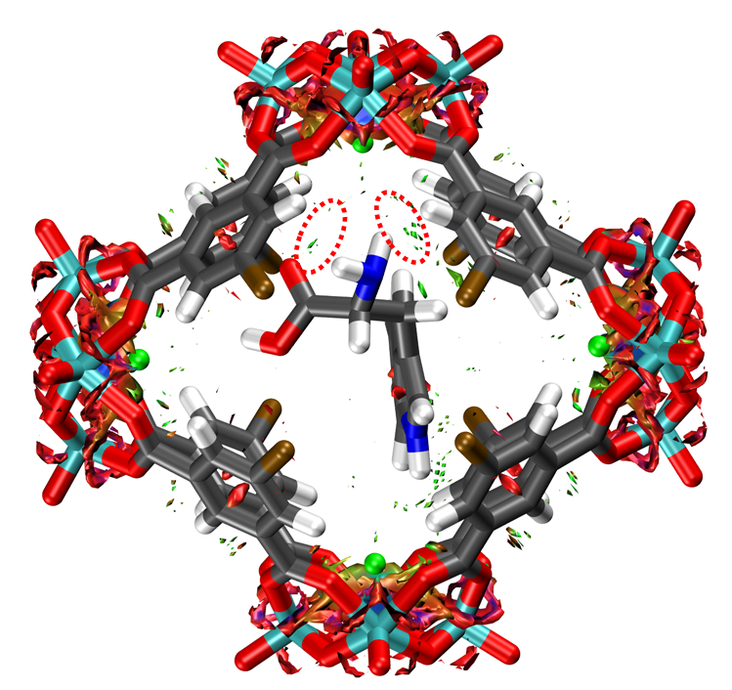

Supplementary Fig. 15 The van der Walls interactions between the encapsulated-_{L}-Trp and HD cage by the RDG method.
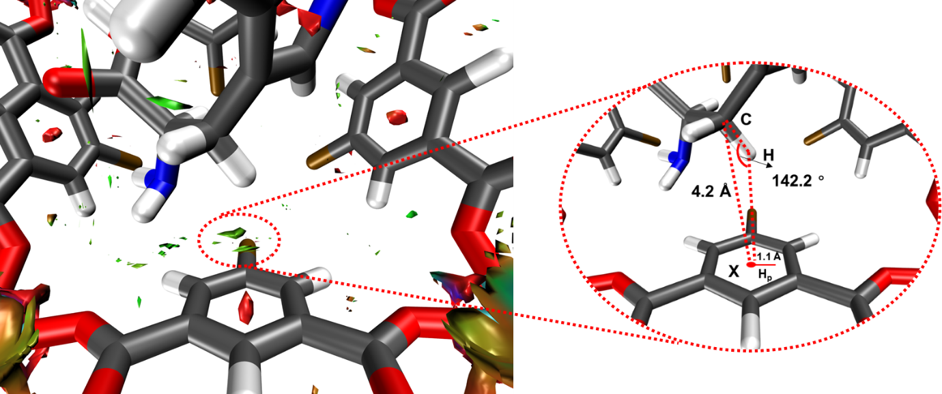

Supplementary Fig. 16 The C-H…π interaction between CH₂ group and the benzene ring of ligand. Geometric parameters are measured according to the Brandl-Weiss system for defining C-H…π interaction: (1) the distance between the donor carbon and the ring centroid of the aromatic system (d_{C–X} ≤ 4.5 Å), (2) the angle formed by the donor carbon, hydrogen and ring centroid (∠C–H–X ≥ 120°), (3) the distance of the vertical projection of the donor H-atom onto the acceptor π system from the geometric center of the aromatic system (d_{Hp–X} = 1–1.2 Å).

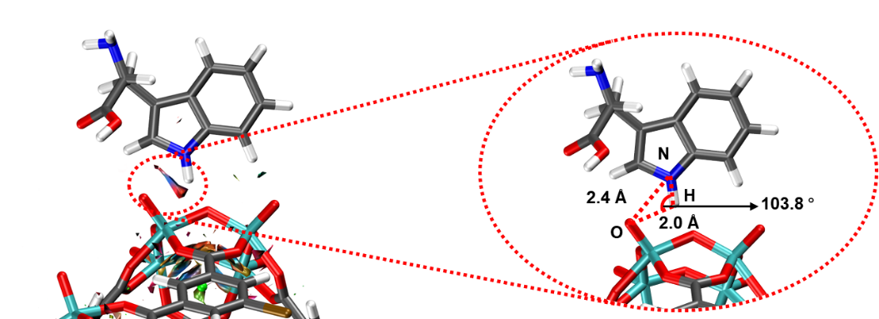

Supplementary Fig. 17 The N-H…O hydrogen bond between between the nitrogen atom in the indole ring and oxygen atom in the polyoxovanadate.
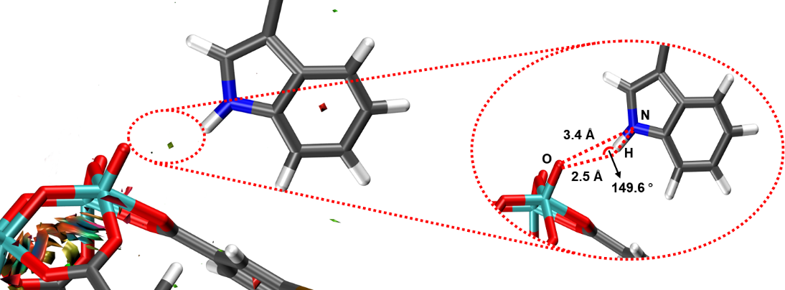

Supplementary Fig. 18 The weak N-H…O hydrogen bond between between the nitrogen atom in the indole ring and oxygen atom in the polyoxovanadate.
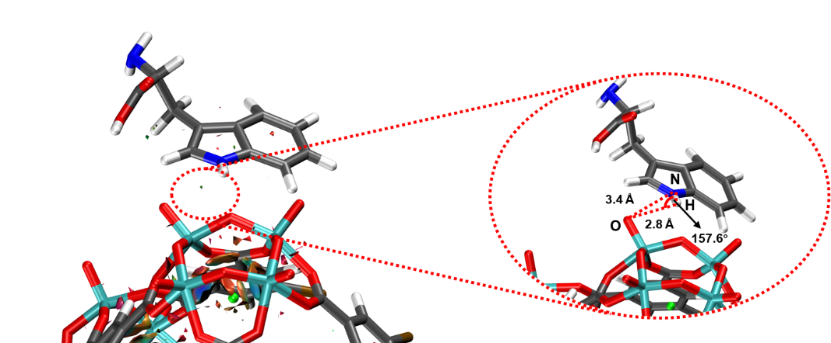

Supplementary Fig. 19 The weak N-H…O hydrogen bond between between the nitrogen atom in the indole ring and oxygen atom in the polyoxovanadate.
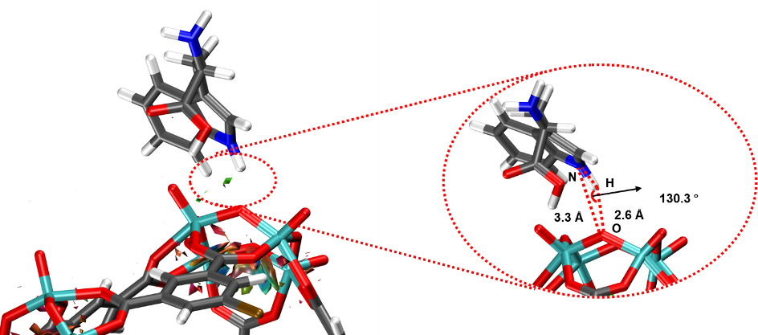

Supplementary Fig. 20 The weak N-H…O hydrogen bond between between the nitrogen atom in the indole ring and oxygen atom in the polyoxovanadate.
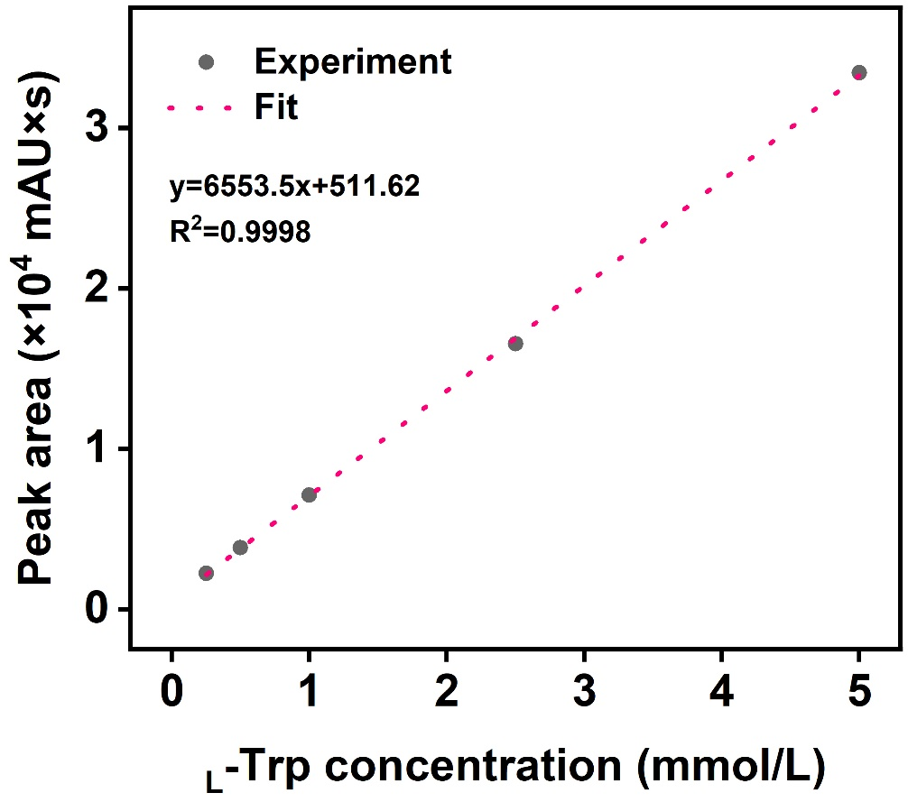

Supplementary Fig. 21 Calibration curve for the determination of _{L}-Trp.
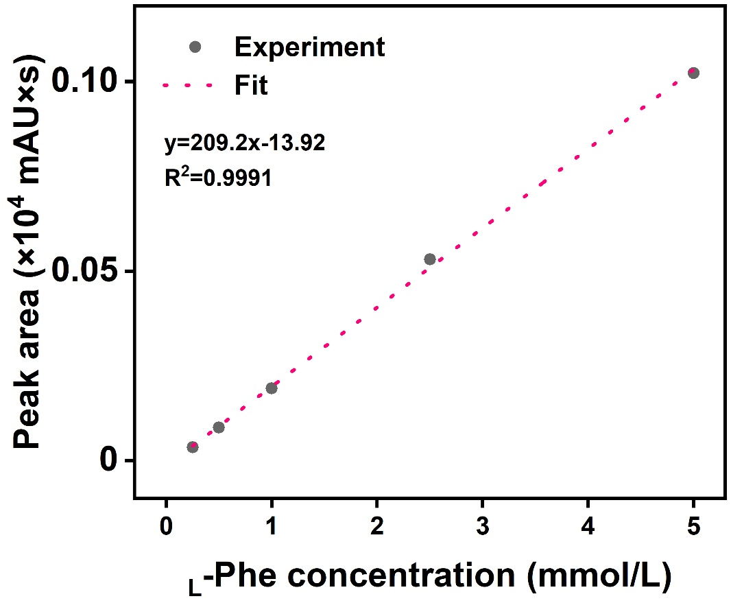

Supplementary Fig. 22 Calibration curve for the determination of _{L}-Phe.
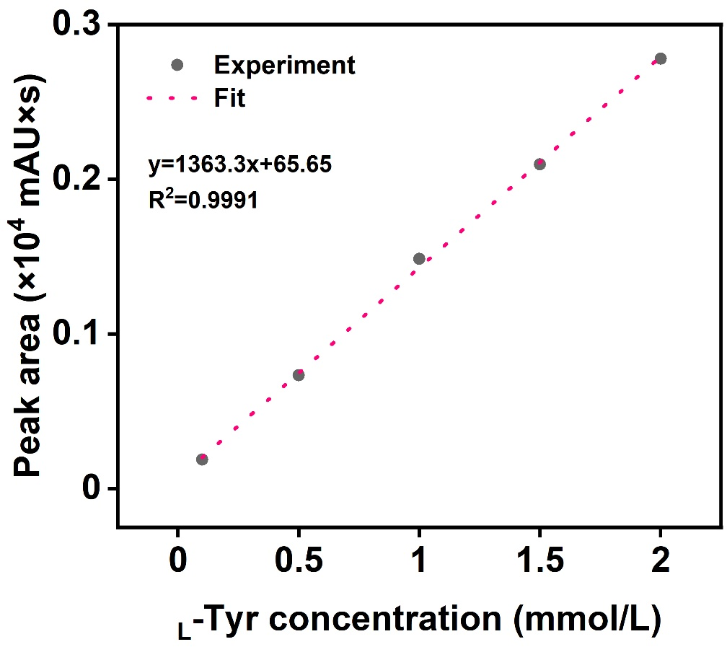

Supplementary Fig. 23 Calibration curve for the determination of _{L}-Tyr.

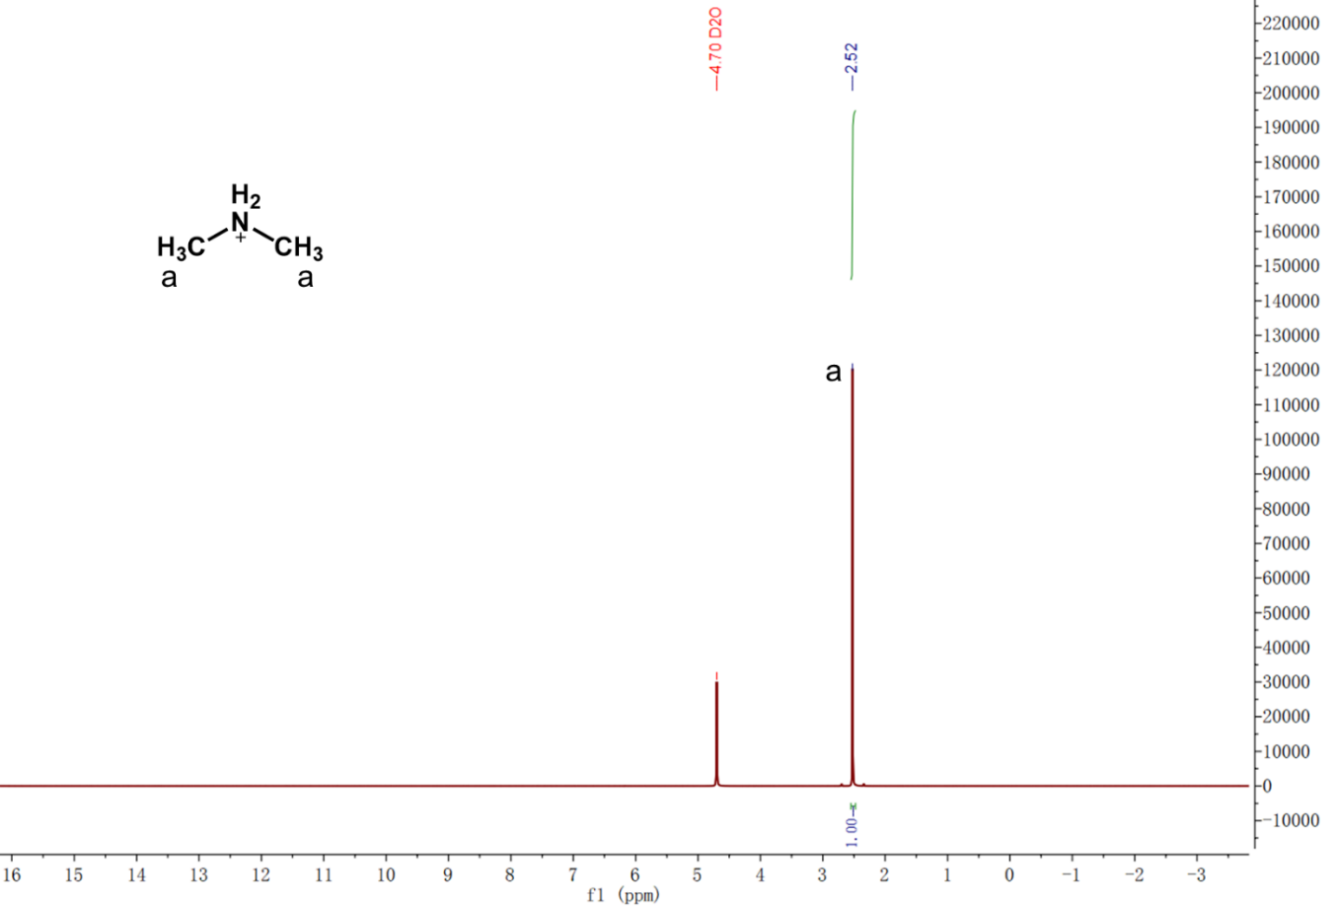

Supplementary Fig. 24 ¹H NMR of the white precipitate (D₂O, 400 MHz, 298 K).

Supplementary Table 1 RMSD values obtained from the MD simulations.
System | RMSD (nm)
_{L}-Trp simulation system | 3.38 ± 0.043
_{L}-Phe simulation system | 4.66 ± 0.035
_{L}-Tyr simulation system | 4.43 ± 0.050

