Online Resource 1. Supplementary material
Article title: Zero-waste City Policy and the Short-Lived Efficiency Window in Urban Green Innovation: Evidence from China’s Staggered Pilot
This Online Resource provides methodological details, sample diagnostics, robustness checks, alternative mechanism tests, heterogeneity analysis, and supplementary figures for the main manuscript.
Appendix A. Methodological details
A.1. Green patent data source
Green patent data are sourced from the China National Intellectual Property Administration (CNIPA) and identified using the WIPO IPC Green Inventory. This inventory covers alternative energy, transportation, waste management, energy conservation, and emission reduction. It is widely used in studies of green technology and green innovation. We use the number of green patent applications, rather than granted patents, as the output indicator for Stage E₁. This helps avoid the timing bias caused by the delay between patent application and patent grant.
A.2. Frontier construction
We adopt a year-specific frontier in the SBM-DEA estimation rather than a pooled frontier. A pooled frontier assumes that all years share the same technology possibility set. This assumption is too strong for the 2012 to 2023 period, during which the innovation frontier of Chinese cities changed substantially. A yearly frontier allows each year to have its own best practice reference set. This avoids systematically penalizing earlier years for technological progress that occurred later. This approach is also consistent with the mainstream literature on urban green innovation efficiency.
A.3. Equal-weight aggregation
We construct the composite index as GIE = (E₁ + E₂)/2, using equal weights. This choice is based on two considerations. First, the two stages capture different parts of the green innovation process. E₁ measures the efficiency of knowledge production, while E₂ measures the efficiency of economic conversion. Both are central to the urban green innovation system. Second, equal weighting avoids the subjectivity introduced by alternative weighting schemes. As a robustness check, we also construct a multiplicative composite index; results in Table S8 remain qualitatively unchanged.
A.4. Log transformation
The baseline regressions use ln(GIE) as the dependent variable. Since GIE is a bounded efficiency score, its values are often compressed near the frontier. Taking logs helps reduce right skew and makes the residuals closer to normal. The log specification also makes the DID coefficient easier to interpret. The coefficient can be read as an approximate percentage change, since (exp(β) − 1 ≈ β for small β), thereby enhancing economic interpretability. Robustness checks using the level specification show that the main conclusions do not depend on the functional form.
A.5. Channel-identification note
The main causal analysis uses the CSDID DRIPW framework. However, no well-established mediation decomposition method currently exists for multi-period DID settings. For this reason, the mediation analyses in Sections 5.1 and 5.2 use the Baron and Kenny three-step procedure under TWFE, based on the clean sample that excludes the 2022 expansion cohort. At the same time, we also report CSDID overall ATT estimates for each mechanism variable as a complementary check. This dual reporting strategy helps ensure that the mediation findings do not rely only on the TWFE specification.

Table S1. Composition of the city-year balanced panel.
Item | Value
Sample period | 2012-2023
Prefecture-level cities | 210
First-wave treated cities (2020 cohort) | 11
Later-treated cities (2022 cohort) | 70
Total treated cities | 81
Never-treated cities by 2023 | 129
Note: The balanced panel contains 2,520 city-year observations. The 2022 expansion cohort is explicitly retained in the CSDID framework as later-treated rather than being misclassified as control observations.
Table S2. CSDID diagnostics: sample composition, covariate balance, and propensity score overlap.
Panel A. Sample Composition by Cohort
Cohort | Sample
Never-treated (G=0) | 129 cities, 1,548 city-year obs
First batch (G=2020) | 11 cities, 132 city-year obs
Expansion (G=2022) | 70 cities, 840 city-year obs
Total | 210 cities, 2,520 city-year obs
Note: Event-time availability—G = 2020 cohort: k = −8 to +3 available (panel 2012–2023), estimation window [−4, +3]; G = 2022 cohort: k = −10 to +1 available, k = +2 and +3 not estimable (would require 2024–2025 data).

Panel B. Covariate Balance at Baseline (2019): First-Batch Treated vs. Control
Variable | Treated mean | Treated SD | Control mean | Control SD | Std. diff.
C_PD_2019 | 6.335 | 1.073 | 5.546 | 1.012 | 0.757
C_AGDP_2019 | 11.232 | 0.361 | 10.643 | 0.419 | 1.505
C_FDI_2019 | 0.015 | 0.010 | 0.012 | 0.014 | 0.286
C_FI_2019 | 3.284 | 1.589 | 2.750 | 1.914 | 0.304
C_HEDU_2019 | 0.023 | 0.014 | 0.014 | 0.013 | 0.665
C_EDU_2019 | 13.549 | 1.242 | 13.098 | 0.770 | 0.436
C_INT_2019 | 3.565 | 0.674 | 2.975 | 0.697 | 0.860
Baseline ln(GIE) | −0.413 | 0.161 | −0.326 | 0.137 | −0.589
Note: Standardized difference = (mean_T − mean_C) / √((SD_T² + SD_C²)/2). Values of |d| < 0.25 are generally considered adequate balance. Several covariates exhibit standardised differences well above this threshold (AGDP: 1.505, INT: 0.860, PD: 0.757), indicating substantial baseline imbalance. This motivates our adoption of the DRIPW doubly robust estimator, which remains consistent provided either the propensity-score or the outcome model is correctly specified. Moreover, Section 4.4 cross-validates this small-sample inference through leave-one-out city sensitivity (Table S5), 1,000 random permutation tests (empirical p = 0.023), and alternative control-group definitions (Table S6).

Panel C. Propensity Score Overlap (Logit of Treatment on Baseline Covariates, Year = 2019)
Group | Mean | SD | Min | Max | Common support
Treated | 0.2406 | 0.2098 | 0.0512 | 0.7790 | [0.0512, 0.6241]
Control | 0.0648 | 0.1031 | 0.0020 | 0.6241 | [0.0512, 0.6241]
Note: The propensity score distributions show adequate overlap between treated and control groups on the interval [0.0512, 0.6241], with no severe lack of common support.

Table S3. Descriptive statistics and pre-treatment balance between treated and control cities.
Variable | Treated mean | Treated SD | Control mean | Control SD | Difference  (T minus C)
E₁ | 0.577 | 0.131 | 0.650 | 0.120 | -0.073* (p=0.056)
E₂ | 0.761 | 0.084 | 0.807 | 0.073 | -0.046* (p=0.052)
GIE | 0.669 | 0.107 | 0.729 | 0.097 | -0.060* (p=0.054)
ln(GIE) | -0.413 | 0.161 | -0.326 | 0.137 | -0.088** (p=0.045)
POP | 722.480 | 943.359 | 404.620 | 336.400 | 317.860** (p=0.015)
PD | 1223.585 | 2444.282 | 412.689 | 510.416 | 810.896*** (p=0.002)
AGDP | 80640.790 | 34926.411 | 46150.936 | 23208.380 | 34489.855*** (p=0.000)
FDI | 0.015 | 0.010 | 0.012 | 0.014 | 0.003 (p=0.410)
FI | 3.284 | 1.589 | 2.750 | 1.914 | 0.535 (p=0.370)
HEDU | 0.023 | 0.014 | 0.014 | 0.013 | 0.009** (p=0.029)
EDU | 1.64e+06 | 2.32e+06 | 7.15e+05 | 1.16e+06 | 9.27e+05** (p=0.022)
INT | 3.565 | 0.674 | 2.975 | 0.697 | 0.590*** (p=0.008)
ISWCU | 82.856 | 18.067 | 69.766 | 23.895 | 13.090* (p=0.079)
IS | 0.240 | 0.379 | 0.212 | 0.362 | 0.028 (p=0.819)
Note: Descriptive statistics are computed as city means over 2012–2019. The “Difference” column reports the treated minus control mean. Two-sided t-test p-values are in parentheses. ***, **, and * denote significance at the 1%, 5%, and 10% levels.

Table S4. TWFE baseline DID estimates of ZWCP on GIE.
Variable | (1) | (2) | (3)
Treated × Post (Post2020) | 0.064 | 0.061 | 0.040
 | (1.34) | (1.33) | (0.92)
PD |  | −0.016 | −0.041
 |  | (−0.35) | (−1.02)
AGDP |  | −0.030 | −0.038
 |  | (−1.00) | (−1.33)
FDI |  | 0.010 | 0.005
 |  | (1.05) | (0.57)
FI |  | 0.004 | 0.004
 |  | (0.92) | (0.86)
HEDU |  | −0.393 | −0.372
 |  | (−0.50) | (−0.49)
EDU |  | −0.030 | −0.036
 |  | (−1.19) | (−1.46)
INT |  | −0.025** | −0.023**
 |  | (−2.07) | (−2.08)
2019 POP × COVID2020 |  |  | 0.028***
 |  |  | (2.73)
2019 POP × COVID2021 |  |  | 0.034**
 |  |  | (2.32)
2019 AGDP × COVID2020 |  |  | 0.062***
 |  |  | (2.75)
2019 AGDP × COVID2021 |  |  | 0.065**
 |  |  | (2.53)
City fixed effects | Yes | Yes | Yes
Year fixed effects | Yes | Yes | Yes
Time-varying controls | No | Yes | Yes
COVID interactions (2019 baseline × 2020/2021) | No | No | Yes
Observations | 1,680 | 1,680 | 1,680
R² | 0.741 | 0.751 | 0.760
Note: Cluster robust t statistics at the city level are in parentheses. All specifications include city and year fixed effects. ***, **, and * denote significance at the 1%, 5%, and 10% levels.

Table S5. Leave-one-out sensitivity: ATT(2020) estimates after sequentially dropping each pilot city.
City dropped | ATT(2020) | SE | p-value | 95% CI | % change$\%ΔGIE$
Sanya | 0.0349** | 0.0173 | 0.044 | [0.0010, 0.0689] | 3.56%
Baotou | 0.0396** | 0.0165 | 0.017 | [0.0072, 0.0719] | 4.04%
Weihai | 0.0294* | 0.0175 | 0.092 | [−0.0049, 0.0637] | 2.99%
Xuzhou | 0.0319* | 0.0182 | 0.081 | [−0.0039, 0.0676] | 3.24%
Shenzhen | 0.0208* | 0.0123 | 0.090 | [−0.0033, 0.0448] | 2.10%
Panjin | 0.0383** | 0.0160 | 0.016 | [0.0070, 0.0696] | 3.91%
Shaoxing | 0.0307* | 0.0179 | 0.087 | [−0.0044, 0.0657] | 3.11%
Xining | 0.0401** | 0.0166 | 0.016 | [0.0075, 0.0727] | 4.09%
Xuchang | 0.0332* | 0.0173 | 0.055 | [−0.0007, 0.0671] | 3.38%
Chongqing | 0.0342* | 0.0196 | 0.081 | [−0.0042, 0.0726] | 3.48%
Tongling | 0.0315* | 0.0171 | 0.065 | [−0.0020, 0.0649] | 3.20%
Note: Each row re-estimates the 2020 calendar-time ATT after dropping one first-batch pilot city. The last column converts ATT to approximate percentage change via exp(ATT) − 1.$\%ΔGIE100×\left(exp\left(ATT\right)−1\right)$

Table S6. Control group robustness: not-yet-treated (main) versus never-treated.
Indicator | Main (not-yet-treated) | Alternative (never-treated)
Overall ATT | 0.0014 (p=0.944) | 0.0003 (p=0.989)
Cohort ATT: G = 2020 | −0.0068 (p=0.695) | −0.0115 (p=0.522)
Cohort ATT: G = 2022 | 0.0040 (p=0.874) | 0.0040 (p=0.874)
Calendar ATT: 2020 | 0.0330** (p=0.043) | 0.0333** (p=0.026)
Calendar ATT: 2021 | 0.0062 (p=0.761) | −0.0128 (p=0.628)
Calendar ATT: 2022 | −0.0038 (p=0.875) | −0.0038 (p=0.875)
Calendar ATT: 2023 | 0.0016 (p=0.942) | 0.0016 (p=0.942)
Note: p-values in parentheses. The main specification uses not-yet-treated cities as controls; the alternative restricts the comparison to cities that never entered the pilot program.

Table S7. Robustness to alternative GIE constructions.
GIE construction | Overall ATT | Calendar ATT(2020) | p-value | Pretrend p
Main specification$ln\left(\text{GI}{\text{E}}_{\text{i,t}}\right)$ | 0.0014 (0.0196) | 0.0330** (0.0163) | 0.043 | 0.361
Multiplicative composite$\text{ln}\left({\text{GIE'}}_{\text{i,t}}\right)$ | 0.0017 (0.0416) | 0.0678** (0.0331) | 0.041 | 0.359
One-period-lagged green patents in E₂ | 0.0020 (0.913) | 0.0233 | 0.267 | 0.511
Super-efficiency SBM | 0.0028 (0.840) | 0.0200* | 0.056 | 0.229
Note: SE in parentheses; all estimates from CSDID (DRIPW) with not-yet-treated as controls and city-clustered SE. ***, **, and * denote significance at the 1%, 5%, and 10% levels.$\%ΔGIE100×\left(exp\left(ATT\right)−1\right)$ Point estimates are uniformly positive and of similar magnitude across constructions, but statistical significance varies: the multiplicative index retains significance at the 5% level, Super-SBM is marginally significant, and the lagged-patent specification does not reach conventional significance — indicating that the core finding is directionally robust, although the precise magnitude is sensitive to the GIE construction.

Table S8. Robustness: dropping year 2020 from the sample.
Indicator | ATT | SE | p-value | 95% CI
Overall ATT (excl. 2020) | −0.0006 | 0.0208 | 0.976 | [−0.0415, 0.0402]
Calendar ATT 2021 | 0.0062 | 0.0205 | 0.761 | [−0.0339, 0.0463]
Calendar ATT 2022 | −0.0038 | 0.0240 | 0.875 | [−0.0507, 0.0432]
Calendar ATT 2023 | 0.0016 | 0.0218 | 0.942 | [−0.0412, 0.0443]
Note: CSDID (DRIPW) estimates with city-clustered SE. Year 2020 is excluded from the sample to test whether the main result is driven by pandemic-year anomalies. $\%ΔGIE100×\left(exp\left(ATT\right)−1\right).$

Table S9. Robustness: excluding mega-cities and COVID-hit outliers.
Indicator | ATT | SE | p-value | 95% CI
Overall ATT (excl. mega) | −0.0148 | 0.0158 | 0.348 | [−0.0457, 0.0161]
Calendar ATT 2020 | 0.0413* | 0.0244 | 0.090 | [−0.0065, 0.0891]
Calendar ATT 2021 | 0.0094 | 0.0226 | 0.678 | [−0.0350, 0.0538]
Calendar ATT 2022 | −0.0197 | 0.0205 | 0.338 | [−0.0599, 0.0205]
Calendar ATT 2023 | −0.0219 | 0.0176 | 0.212 | [−0.0564, 0.0125]
Note: Dropped Chongqing (municipality) and control cities with 2019 population above the 90th percentile (threshold: 6.81 million).

Table S10. Robustness: extended COVID baseline interactions.
Indicator | ATT | p-value | Cf. Main spec (Comparison with the main specification)
Overall ATT | 0.0014 | 0.944 | 0.0014 (p=0.944)
Calendar ATT 2020 | 0.0330** | 0.043 | 0.0330
Note: All 2019 baseline covariates (PD, FDI, FI, HEDU, EDU, INT) interacted with 2020 and 2021 dummies, in addition to POP and AGDP interactions.
Table S11. Robustness: spatial spillover tests (three-pronged).
Panel / Indicator | Coef. | SE | p-value | Note
Panel A: covariate control (full N=2520)
Overall ATT | −0.0025 | 0.0199 | 0.898 | Main: 0.0014
Calendar ATT 2020 | 0.0262 | — | 0.372 | Main: 0.0330
Panel B: spillover test (control only N=1548)
Spillover DID (neighbor × Post) | −0.0305 | 0.0190 | 0.112 | Insig. ⇒ SUTVA supported
Panel C: exclude same-province controls (N_ctrl=77)
Overall ATT | 0.0005 | 0.0176 | 0.976 | Main: 0.0014
Calendar ATT 2020 | 0.0261 | — | 0.140 | Main: 0.0330
Note: Panel A adds a spatial-lag covariate (300 km inverse-distance-weighted mean GIE of treated neighbors); Panel B tests whether neighbor effects contaminate control-group cities; Panel C excludes same-province controls to mitigate within-province spillovers.$\%ΔGIE100×\left(exp\left(ATT\right)−1\right).$

Table S12. Robustness: announcement-effect placebo (2019 versus 2018 baseline).
Year | ATT on ln(GIE) | SE | p-value | 95% CI
2019 | −0.0094 | 0.0080 | 0.242 | [−0.0252, 0.0064]
Note: Derived from the CSDID event study with k = −1 (2019) re-normalized to the 2018 baseline: ATT(2019 | base 2018) = −ATT(k = −2 | base 2019).

Table S13. Robustness: concurrent pilot policies (three-pronged).
Panel / Indicator | Coef. | SE | p-value | Note
Panel A: CSDID + concurrent_pilot (full sample)
Overall ATT | 0.0004 | 0.0198 | 0.985 | Main: 0.0014
Calendar ATT 2020 | 0.0340** | — | 0.034 | Main: 0.0330
Panel B: TWFE + concurrent_post (N=1680)
ZWCP DID (net of concurrent) | 0.0292 | 0.0428 | 0.497 | TWFE Spec3 base: 0.0396
Concurrent × Post (direct) | 0.0354** | 0.0158 | 0.026 | Concurrent policies not confounding
Panel C: sequential exclusion (treated overlap only)
Excl. low-carbon overlap (N_treat=7) — Overall | 0.0044 | 0.0211 | 0.836 | Main: 0.0014
Excl. low-carbon overlap — ATT(2020) | 0.0251 | — | 0.169 | Main: 0.0330
Note: Nine of 11 first-batch ZWCP pilots overlap with at least one concurrent policy (low-carbon: 4; carbon trading: 2; smart city: 7).

Table S14. CSDID calendar-time ATT estimates with industrial solid waste removed from E₂.
Year | ATT | SE | p-value | 95% CI | Sig.
2020 | 0.0273 | 0.0153 | 0.073 | [−0.0027, 0.0573] | *
2021 | −0.0049 | — | — | —
2022 | −0.0077 | — | — | —
2023 | 0.0117 | — | — | —
Overall | 0.0031 | — | 0.796 | —
Note: CSDID (DRIPW) estimates with SE clustered by city. Relative to the main specification (ATT = 0.0330, p = 0.043), the 2020 ATT retains a similar magnitude but significance falls to the 10% level. The implied 17% reduction reflects measurement overlap between E₂ and ISWCU and is conceptually distinct from the 17% mediation share attributed to industrial restructuring in main-text Table 5. ***, **, and * denote significance at the 1%, 5%, and 10% levels.

Table S15. ISWCU overall ATT and TWFE mediation analysis under the waste-excluded E₂ specification.
Panel A: ISWCU Overall ATT (CSDID, DRIPW)
Variable | ATT | SE | p-value | 95% CI | Sig.
ISWCU (level, %) | 6.3549 | 1.8860 | 0.001 | [2.6583, 10.0514] | ***
Note: Consistent with the main-specification ISWCU ATT of 5.93 pp, confirming that the ISWCU effect is not sensitive to the E₂ construction.

Panel B: TWFE Mediation Analysis (ISWCU → GIE)
Path | Coefficient | SE | p-value | Remark
a: ZWCP→ISWCU | 19.90 | — | <0.001 | ***
b: ISWCU→GIE|ZWCP | 0.0001 | — | 0.628 | Insig.
a × b (indirect effect) | 0.0022 | — | 0.649 | Insig.
Proportion mediated | 10.6% | — | — | —
Note: Clean sample (excluding the 2022 expansion cohort), city-clustered bootstrap SE. The a-path is highly significant, indicating that ZWCP did raise ISWCU; however, the insignificant b-path indicates that ISWCU changes do not statistically explain variation in the waste-excluded GIE, ruling out ISWCU as a causal mediator under this specification.

Table S16. Alternative mechanism tests: government attention (EGOV) and environmental enforcement intensity (EEI).
Path / Indicator | EGOV | EEI
Panel A: TWFE Mediation Analysis (Clean Sample)
(a) DID → Mediator | 0.0001  (0.0003) | 0.0632  (0.1471)
(b) Mediator → ln(GIE) | −0.5678  (2.0814) | 0.0328  (0.0213)
Indirect effect (a × b) | −0.0001  [−0.0015, 0.0013] | 0.0021  [−0.0115, 0.0157]
Direct effect (c') | 0.0396  (0.0428) | 0.0375  (0.0435)
Total effect (c) | 0.0396  (0.0429) | 0.0396  (0.0429)
Proportion mediated | −0.2% | 5.2%
N | 1,680 | 1,680
Panel B: CSDID (DRIPW) Overall ATT
ATT | −0.0001  (0.0003) | −0.0129  (0.0678)
p-value | 0.647 | 0.850
95% CI | [−0.0008, 0.0005] | [−0.1457, 0.1200]
Note: Panel A reports three-step mediation analysis (Baron and Kenny framework) using TWFE Spec 3 on the clean sample (excluding the 2022 expansion cohort). SE in parentheses, clustered at the city level; bootstrap 95% CI in brackets, based on 1,000 city-clustered replications consistent with Section 5.3. Panel B reports CSDID (DRIPW) overall ATT with not-yet-treated as controls. EGOV = zero-waste keyword frequency in government work reports / total word count; EEI = environmental penalty cases / resident population (10,000 persons). Neither mediator shows a statistically significant indirect effect.

Table S17. Heterogeneity analysis by region and information infrastructure (TWFE Spec 3).
Variable / Indicator |  | (1) | (2) | (3) | (4)
Panel A: Regional heterogeneity
Subgroup | Full |  | East | Central | West
DID (ZWCP × Post) | 0.0396 |  | 0.0641 | −0.0345*** | 0.1015
 | (0.92) |  | (1.48) | (−4.24) | (0.95)
N | 1,680 |  | 552 | 696 | 432
R² | 0.760 |  | 0.739 | 0.840 | 0.825
Between-group difference test | chi²(2) joint test, p = 0.011 (rejects the null hypothesis of homogeneous regional effects)
Panel B: Innovation base heterogeneity — informatization level
Subgroup | Full |  | High INT | Low INT | —
DID (ZWCP × Post) | 0.0396 |  | −0.0365** | 0.0449 | —
 | (0.92) |  | (−2.27) | (1.02)
N | 1,680 |  | 840 | 840 | —
R² | 0.760 |  | 0.839 | 0.742 | —
Between-group difference (High − Low) | −0.1879*** (p < 0.001) (high-INT group first-year effect significantly lower than low-INT group)
Note: Dependent variable is ln(GIE). All specifications use TWFE Spec 3, with two-way fixed effects, time-varying controls, and COVID interaction terms. Standard errors are clustered at the city level. Panel A splits cities into East, Central, and West. Panel B splits cities at the 2019 median of INT. Difference tests use a joint chi square test and interaction t tests. ***, **, and * denote significance at the 1%, 5%, and 10% levels.

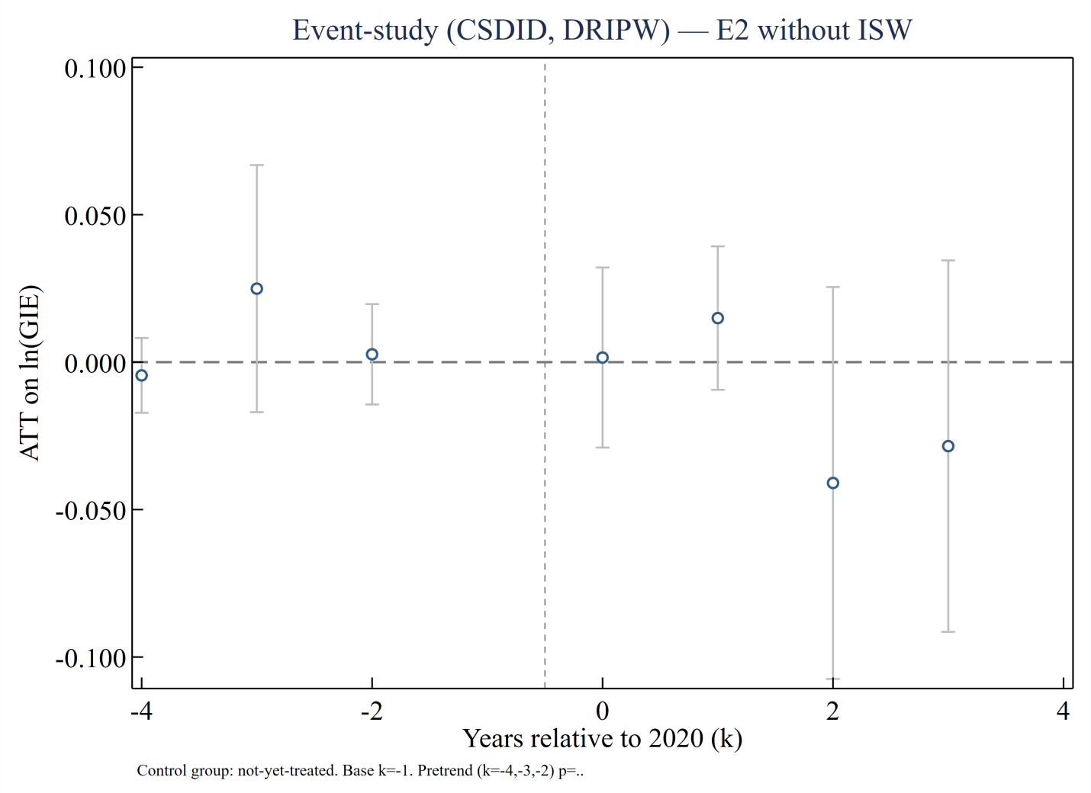
Fig. S1. Event-study estimates of ZWCP on GIE with industrial solid waste removed from E₂.

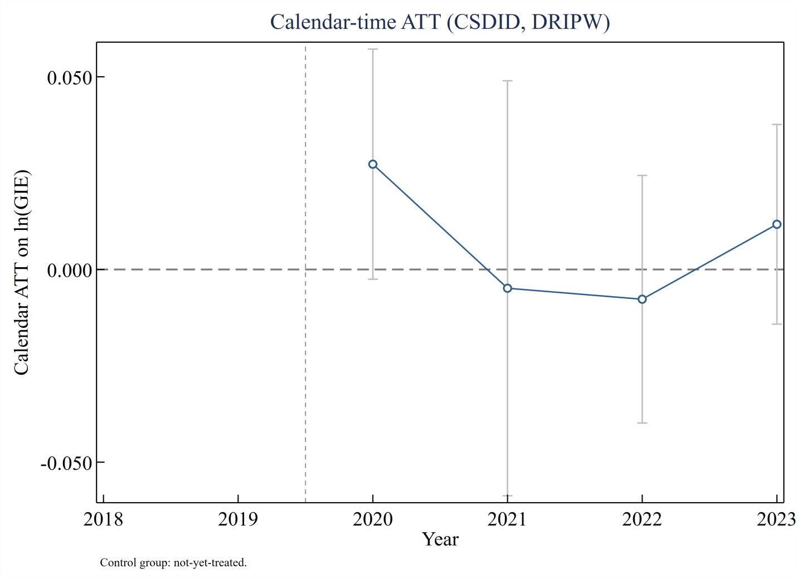
Fig. S2. Calendar-time ATT dynamics for GIE with industrial solid waste removed from E₂.

