Supplementary Table 6. Prevalence of indoor smoking among individuals aged ≥10 years, by province in Indonesia (SKI 2023)
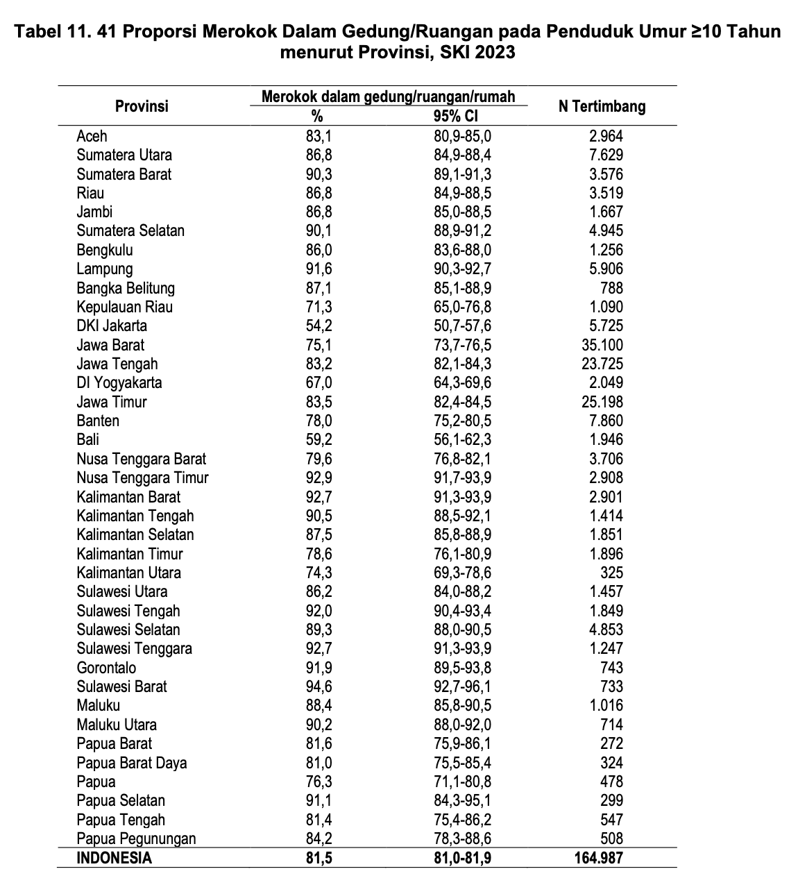
Supplementary Table 7. Prevalence of indoor smoking among individuals aged ≥10 years, stratified by sociodemographic characteristics (SKI 2023)
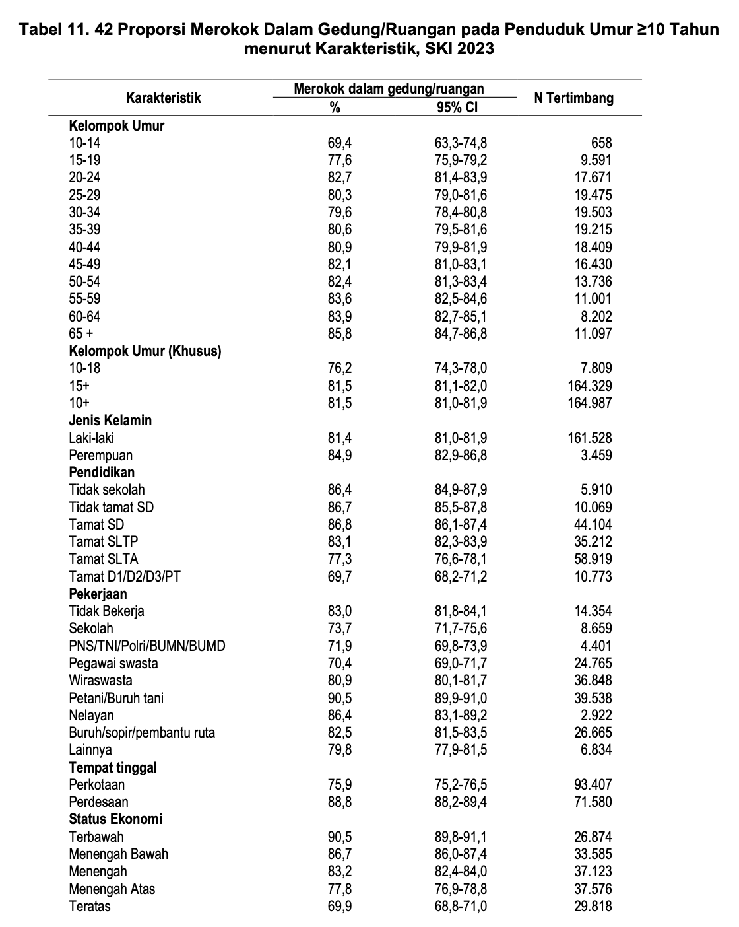

Supplementary Table 8. Prevalence of indoor smoking among individuals aged ≥10 years, by province in Indonesia (RISKESDAS 2018)
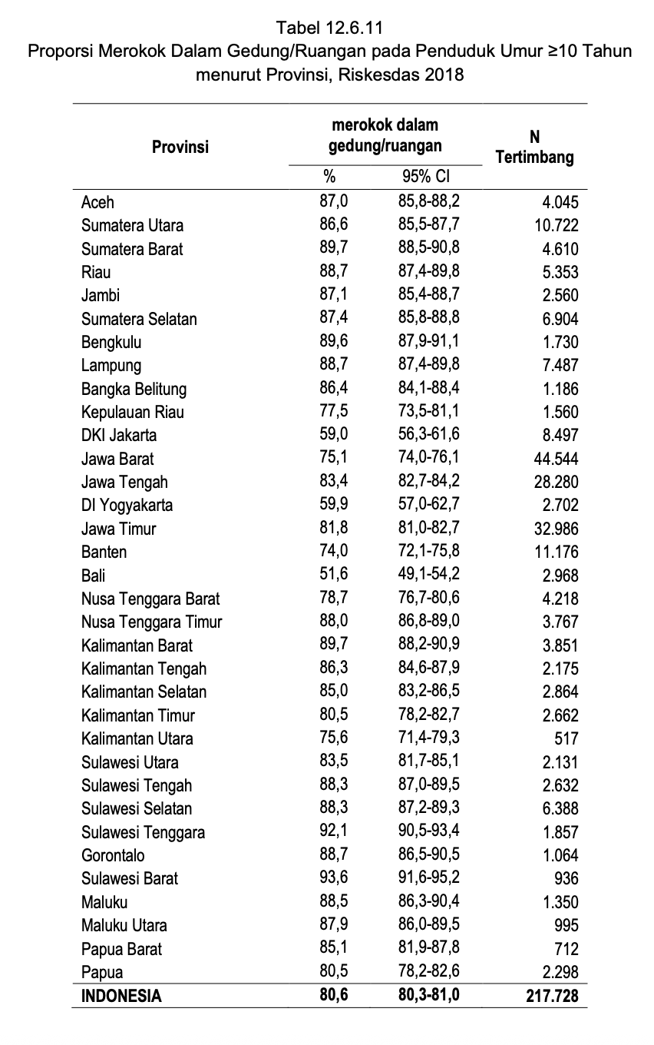
Supplementary Table 9. Prevalence of indoor smoking among individuals aged ≥10 years, stratified by sociodemographic characteristics (RISKESDAS 2018)
