Supplementary Table 2. Prevalence of preterm birth according to gestational age at delivery among children aged 0–59 months across provinces in Indonesia (RISKESDAS 2018)
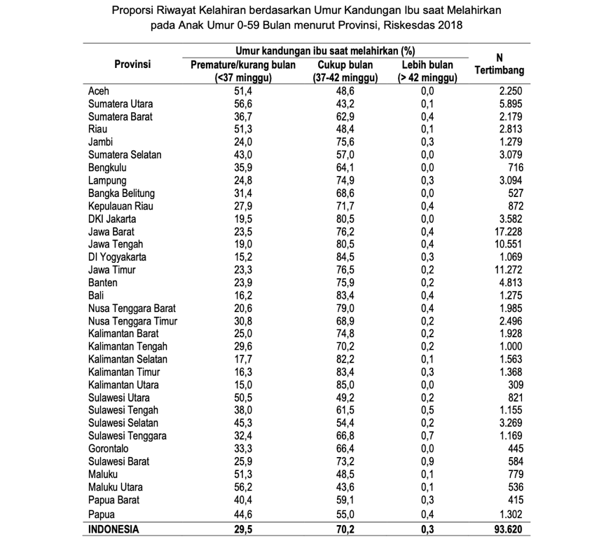
Supplementary Table 3. Prevalence of preterm birth according to gestational age at delivery among children aged 0–59 months, stratified by sociodemographic characteristic (RISKESDAS 2018)
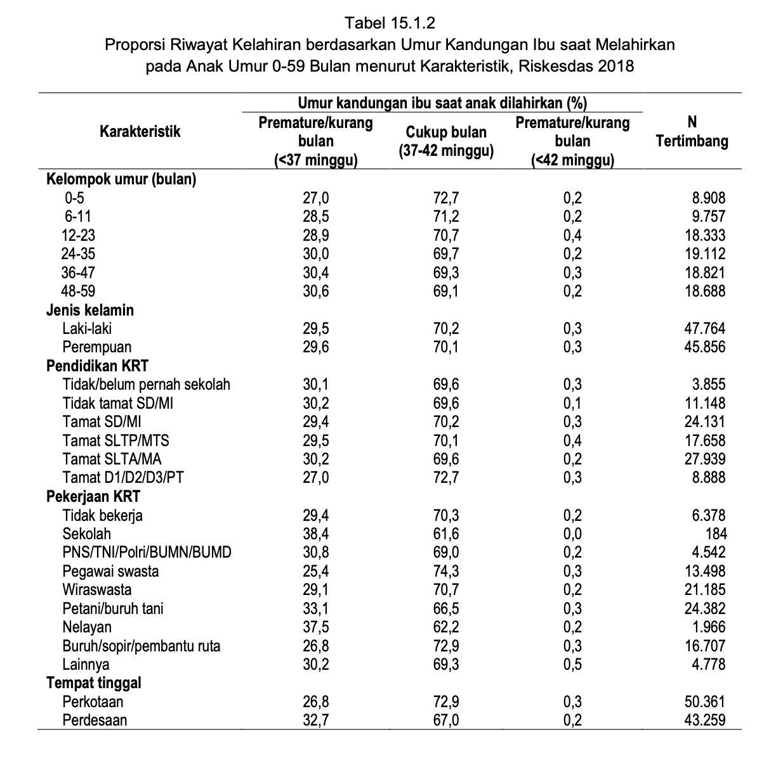
Supplementary Table 4. Prevalence of preterm birth according to gestational age at delivery among children aged 0–59 months across provinces in Indonesia (SKI 2023)
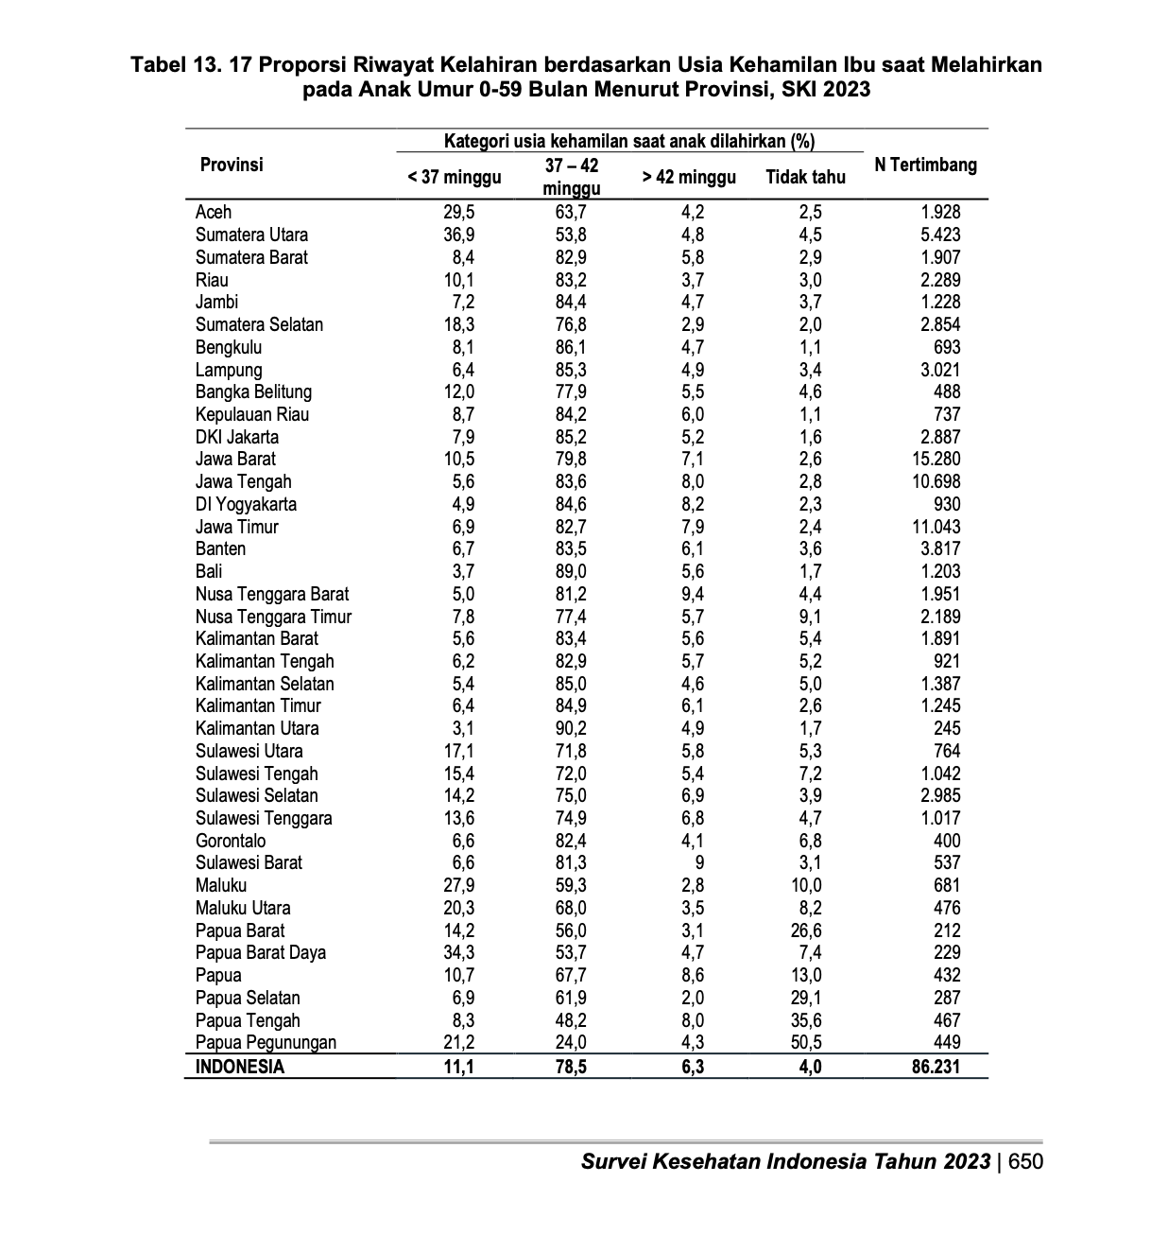
Supplementary Table 5. Prevalence of preterm birth according to gestational age at delivery among children aged 0–59 months, stratified by sociodemographic characteristic (SKI 2023)
