Table S1: Limit of detection, wavelength, and recovery rate of the inductively coupled plasma spectrometer for different elements
Metal | Al | As | Cd | Co | Cr | Cu | Fe | Hg | Ni | Pb | Zn
LOD(mg/kg) | 0.001 | 0.014 | 0.003 | 0.001 | 0.015 | 0.20 | 0.099 | 0.00037 | 0.001 | 0.01 | 0.01
LOQ (mg/kg) | 0.003 | 0.034 | 0.11 | 0.004 | 0.047 | 0.7L1 | 0.0171 | 0.0012 | 0..0037 | 0.034 | 0.034
Wavelength (nm) | 396.15 | 189.04 | 214.43 | 228.6 | 267.71 | 327.39 | 259.94 | 184.95 | 231.6 | 220.35 | 213.85
Recovery(%) | 100.47 | 82.27 | 97.15 | 95.96 | 97.85 | 95.26 | 95.57 | 80.56 | 94.72 | 93 | 86.12

Table S2: Health risk assessment indices and variables based on the EPA model
Variables | Definition | Unit | Value | Refrences
C | Concentration | mg/kg | Table 1
IR | Milk Intake Rate | kg/day | Adult=0.06, Child= 0.03 | (Statistics 2016)
EF | Exposure Frequency | Days/Year | 365 | (USEPA 2011)
ED | Exposure Duration | Year | Adult=70, Child= 6 | (USEPA 2011)
BW | Body Weight | kg | Adult=70, Child= 20 | (USEPA 2011)
AT | Average Time | Days | Adult=25550, Child= 2190 | (USEPA 2011)
EDI | Estimated Daily Intake | mg/kg/day | Table 2
RfD | Oral Reference Dose | mg/kg/day | As=0.0003, Cd=0.001, Al=0.7, Co=0.0004, Cu=0.04, Fe=0.7, Hg=0.0004, Zn=0.3, Cr=0.003, Ni=0.02, Pb=0.0035, Ba= 0.07 | (USEPA 2011)
OSF | Oral Slope Factor | mg/kg/day-1 | As=1.5, Pb=0.0085, Cd=0.38, Hg=0.0003 | (USEPA 2011)
HQ | Hazard Quotient | THQ indicates a possible non-carcinogenic risk to toxic elements | Table 3 | (USEPA 2001, EPA 2005)
HI | Hazard Index | HI < 1 indicating no non-carcinogenic risk from exposure to toxic elements/ HI > 1 indicating possible non-carcinogenic risk | Table 3 | (USEPA 2001, EPA 2005)
CR | Cancer Risk | CR < 10⁻⁴ indicating carcinogenic risk from exposure to toxic elements/ CR > 10⁻⁴ indicating possible carcinogenic risk | Table 4 | (USEPA 2011)

Table S3: Heavy metal levels in low-fat and whole-fat pasteurized milk

seasons | Heavy metals levels (mg/L)
seasons | Al | As | Al | Co | Al | Cu | Al | Hg | Al | Pb | Al
low-fat milk, n= 108 (1% fat) | 0.099±0.11 | 0.058±0.044 | ND | 0.001* | 0.066±0.04 | 0.17±0.11 | 0.13±0.11 | 0.035±0.006 | 0.076±0.033 | 0.049±0.021 | 3.25±0.49
Whole fat milk  n= 108 (5% fat) | 0.10±0.11 | 0.051±0.017 | ND | 0.013±0.007 | 0.071±0.041 | 0.21±0.22 | 0.19±0.17 | 0.034±0.006 | 0.096±0.034 | 0.098±0.10 | 3.20±0.57
Total  (n=216) | 0.10±0.11 | 0.054±0.033 | ND | 0.012±0.008 | 0.069±0.041 | 0.19±0.17 | 0.16±0.14 | 0.035±0.006 | 0.087±0.034 | 0.067±0.065 | 3.23±0.53
^{b}p-value | 0.73 | 0.43 | - | 0.11 | 0.46 | 0.66 | 0.10 | 0.72 | 0.21 | 0.45 | 0.24
ND: not detected N: sample size, * Items that have been detected only once in the measurements; therefore, it is not possible to calculate the standard deviation., ±: standard deviation, b: Statistically significant difference between the concentration of heavy metals in low-fat and whole-fat milk was done using the Mann-Whitney test.

Table S4: Heavy metals levels in in different commercial brands pasteurized milk
Brands | Heavy metals levels (mg/L)
Brands | Al | As | Cd | Co | Cr | Cu | Fe | Hg | Ni | Pb | Zn
A | 0.094±0.090 | 0.055±0.013 | ND | ND | 0.060±0.037 | 0.22±0.12 | 0.12±0.12 | 0.031±0.004 | 0.059±0.031 | 0.041±0.004 | 3.35±0.61
B | 0.046±0.058 | 0.046±0.014 | ND | 0.014* | 0.059±0.034 | 0.23±0.18 | 0.16±0.11 | 0.034±0.004 | 0.12* | 0.042* | 3.12±0.37
C | 0.10±0.089 | 0.056±0.019 | ND |  | 0.084±0.035 | 0.18±0.19 | 0.19±0.18 | 0.039±0.012 | 0.076±0.027 | 0.13±0.10 | 3.40±0.7
D | 0.10±0.094 | 0.078±0.095 | ND | 0.014±0.001 | 0.067±0.038 | 0.16±0.055 | 0.13±0.067 | 0.034±0.004 | 0.15* | 0.036±0.016 | 3.03±0.42
E | 0.14±0.091 | 0.062±0.022 | ND | 0.006±0.008 | 0.068±0.045 | 0.19±0.065 | 0.26±0.27 | 0.036±0.002 | 0.095* | ND | 3.51±0.37
F | 0.099±0.091 | 0.047±0.018 | ND | 0.012* | 0.065±0.038 | 0.19±0.15 | 0.16±0.13 | 0.032±0.007 | 0.035±0.028 | ND | 3.17±0.40
G | 0.066±0.076 | 0.047±0.016 | ND | 0.02±0.011 | 0.079±0.048 | 0.10±0.035 | 0.15±0.092 | 0.036±0.008 | 0.11±0.002 | 0.045* | 3.093±0.43
H | 0.095±0.096 | 0.049±0.018 | ND | 0.017* | 0.069±0.047 | 0.19±0.22 | 0.13±0.097 | 0.033±0.006 | 0.12* | ND | 3.34±0.54
I | 0.17±0.22 | 0.051±0.011 | ND | ND | 0.071±0.048 | 0.23±0.35 | 0.14±0.084 | 0.037±0.001 | 0.09±0.023 | 0.055* | 3.039±0.71
ªp-value | 0.68 | 0.48 | - | 0.56 | 0.55 | 0.06 | 0.78 | 0.90 | 0.12 | 0.21 | 0.095
ND: not detected, * Items that have been detected only once in the measurements; therefore, it is not possible to calculate the standard deviation., ±: standard deviation, a: Statistically significant difference between the concentration of heavy metals in different commercial brands was determined using Kruskal-Wallis tests.

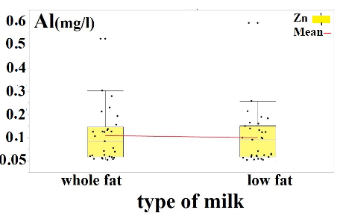 | 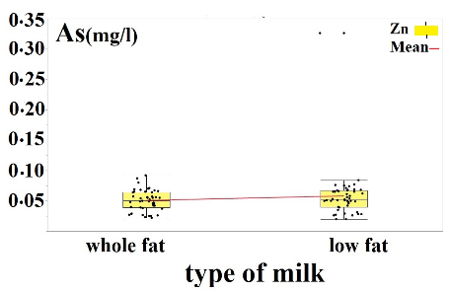 | 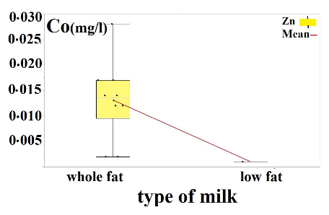
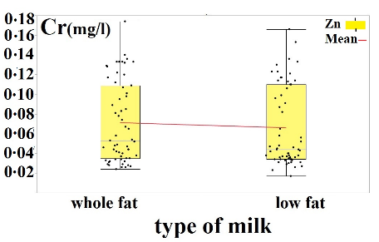 | 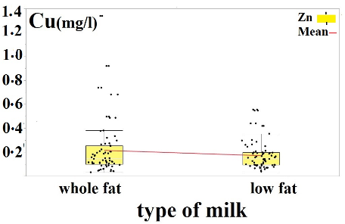 | 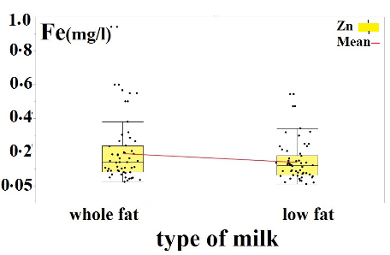
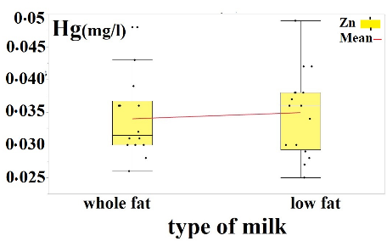 | 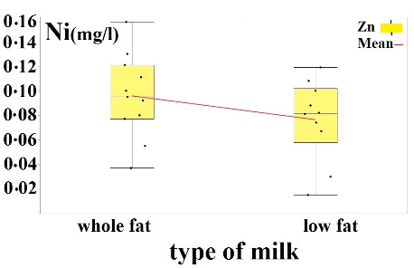 | 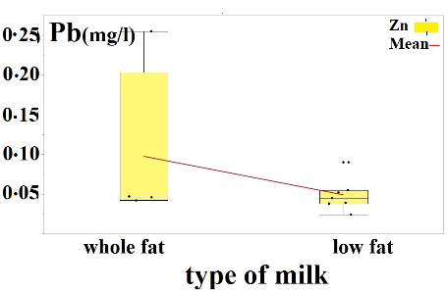
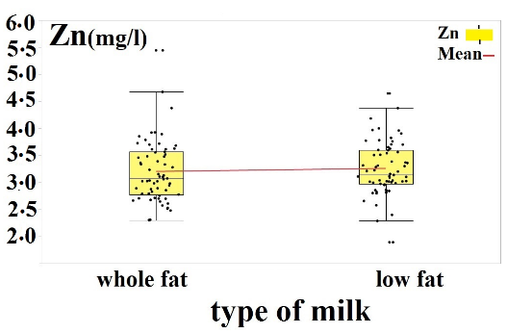

Fig S1: Heavy metals levels in low-fat and whole fat pasteurized milk

