Supporting Information

For
An aptamer-controlled Mn-Au oxidase-mimicking nanozyme for smartphone-assisted colorimetric detection of mercury ions
Chen Ma^{1*}, Yida Zhang², Shuai Mu³, Yuan Zhang¹, Shuoyun Wei¹, Quanfang Li¹, Shufang Ren¹.
¹Gansu Province Key Laboratory of Evidence Science Techniques Research and Application, Gansu University of Political Science and Law, Lanzhou, China
²College of Chemistry and Chemical Engineering, Lanzhou University, Lanzhou, PR China
³The First Hospital of Lanzhou University, Lanzhou, PR China
*Corresponding Author. E-mail address: machenfighting@126.com.

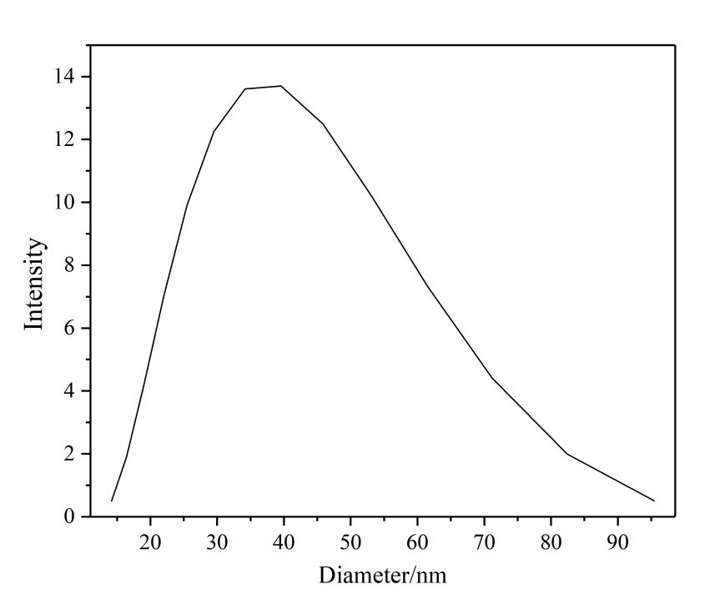
Figure S1. Particle size distribution of MnAuNPs.
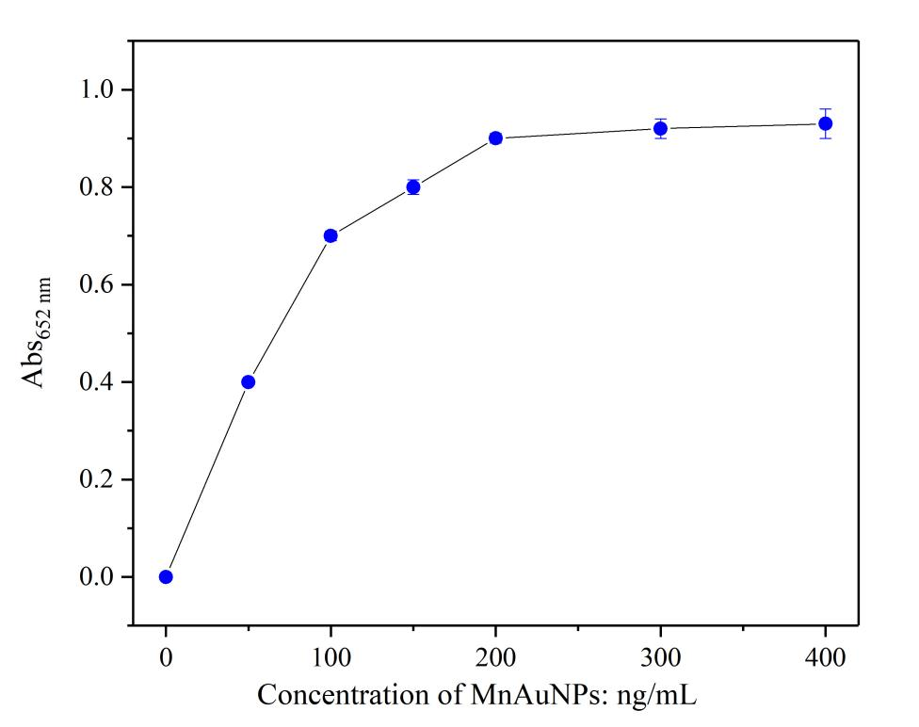
Figure S2. Dependence of oxidase-like activity on MnAuNP concentration.

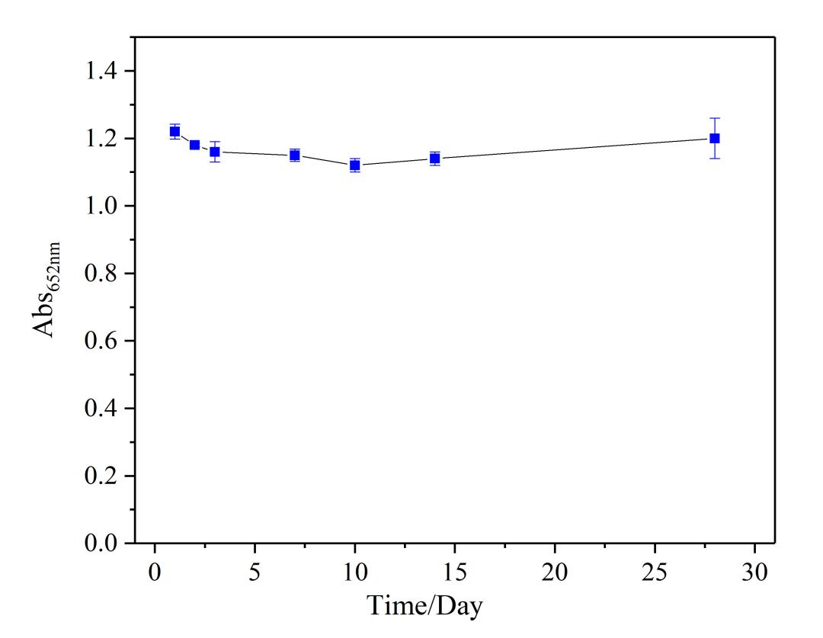
Figure S3. Study on long-term storage stability of MnAuNPs.
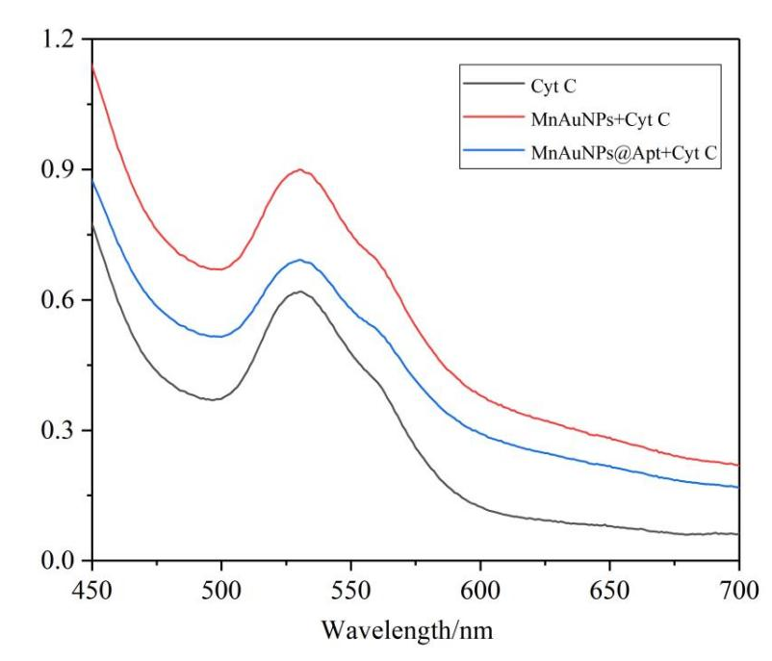
Figure S4. UV-vis absorption spectra of cytochrome c after incubation with MnAuNPs and MnAuNPs@Apt, showing a reduced absorption peak of oxidized cytochrome c at 530 nm in the presence of MnAuNPs@Apt.

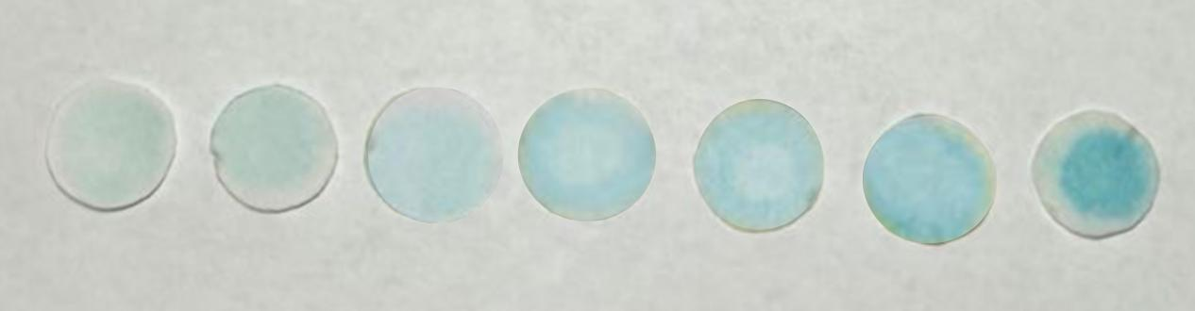

Figure S5. Color changes upon exposure to increasing concentrations of Hg²⁺. From left to right, the concentrations of Hg²⁺ are 0, 5,10, 20, 30, 40 and 50 μM respectively.

Table S1. The K_{m} and V_{max} values of MnAuNPs and other reported oxidase-like catalysts for the substrate of TMB.
Materials | K_{m} (mM) | V_{max} (10⁻⁶ M S⁻¹) | References
NSC/Co6Ni₃S₈ | 0.68 | 0.078 | [1]
MnO₂ sub-microspheres | 0.10 | 0.2 | [2]
OVs-Mn₂O₃-400 | 0.15 | 0.11 | [3]
Mn-PBANaOH@MIP | 0.13 | 0.17 | [4]
HS-Mn/Co-MOF | 0.15 | 0.2 | [5]
MnAuNPs | 0.21 | 38.8 | This work

Reference
- Liu TT, Li YH, Gu JJ, Zhang L, Qian FY, Li BR, Wang XD (2023) Achieving smartphone-based colorimetric assay for Hg²⁺ with a bimetallic site strategy based on Hg²⁺-triggered oxidase-like catalytic activity of NSC/Co6Ni₃S₈ nanocomposite. Anal Chim Acta 1278:341734. https://doi.org/10.1016/j.aca.2023.341734
- Isho RD, Sher Mohammad NM, Omer KM (2023) Synthesis of MnO₂ sub-microspheres with effective oxidase-mimicking nanozymes for the colorimetric assay of ascorbic acid in orange fruits and juice. New J Chem 47:7800. https://doi.org/10.1039/d3nj00136a
- Song Y, Huang C, Li Y (2023) Nanozyme rich in oxygen vacancies derived from Mn-based metal-organic gel for the determination of alkaline phosphatase. Inorg Chem 62:12697-12707. https://doi.org/10.1021/acs.inorgchem.3c01020
- Liu B, Zhu H, Liu J, Wang M, Pan J, Feng R, Hu P, Niu X (2023) Alkali-etched imprinted Mn-based Prussian blue analogues with superior oxidase-mimetic activity and precise recognition for tetracycline colorimetric sensing. ACS Appl Mater Interfaces 15:24251-24260. https://doi.org/10.1021/acsami.3c02207
- Liang T, Huang YL, Yang LWX, Chai YF, Hao ZX, Chen HP, Ma GC (2025) Hollow Mn/Co-MOF as a powerful oxidase-like nanozyme for detection of total antioxidant capacity and black tea fermentation degree. Small 21:2411275. https://doi.org/10.1002/smll.202411275

