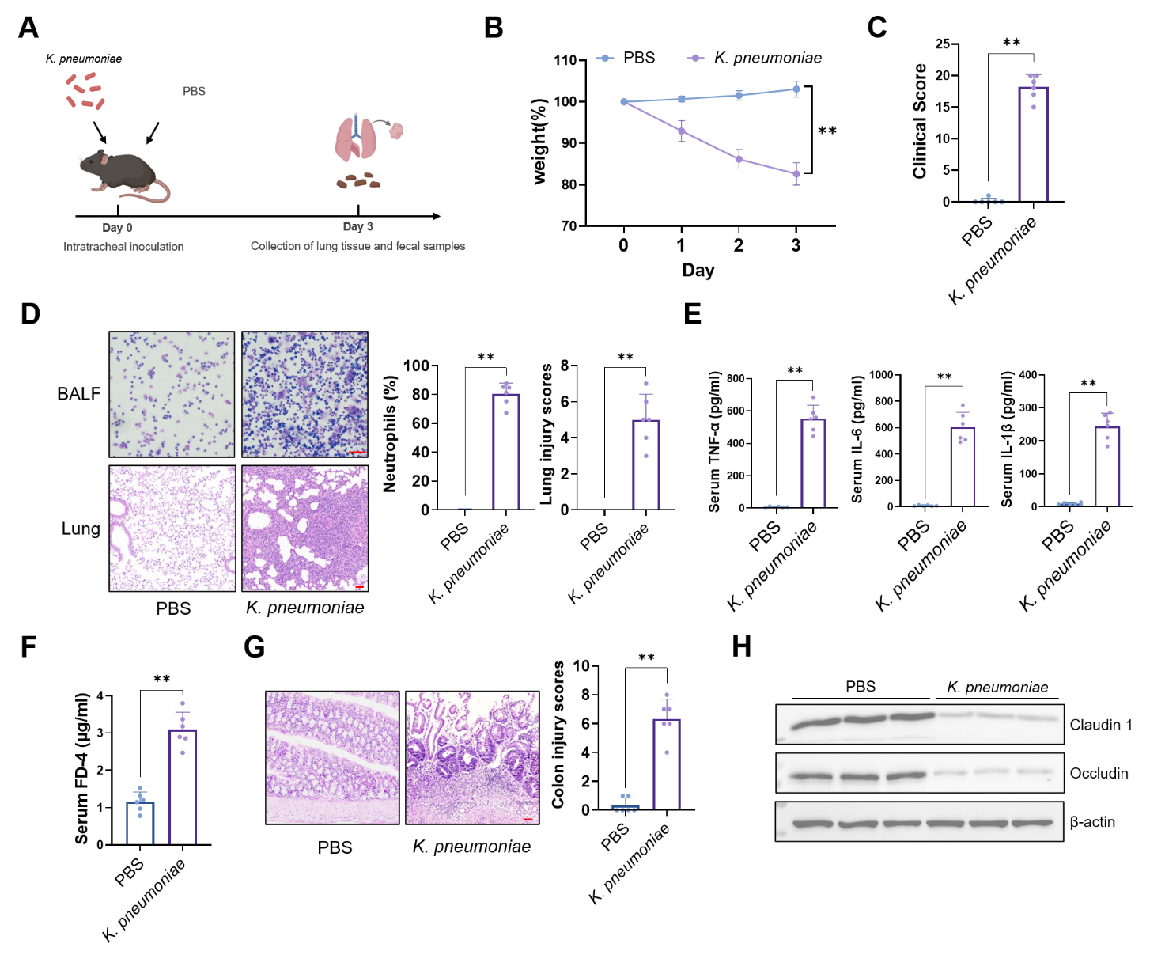
Figure S1. Establishment of the K. pneumoniae pneumonia model and evaluation of intestinal barrier function.
A. Schematic workflow of the experimental design for K. pneumoniae lung infection and sample collection.
B, C. Daily body weight changes (B) and clinical disease scores (C) of mice following intratracheal instillation of PBS or K. pneumoniae.
D. Representative images of Giemsa-stained BALF cells (upper, scale bar = 20 μm) and H&E-stained lung sections (lower, scale bar = 50 μm), with corresponding histological lung injury scores (right).
E. Serum levels of pro-inflammatory cytokines IL-1β, IL-6, and TNF-α measured by ELISA.
F. Intestinal permeability assessed by the concentration of FITC-dextran in serum 3 days post-infection.
G. Representative H&E staining of colonic sections showing mucosal integrity (scale bar = 50 μm).
H. Western blot analysis of tight junction proteins Claudin-1 and Occludin in colonic tissues, with β-actin as a loading control. Data are presented as mean ± SEM. *p < 0.05, **p < 0.01 by Student’s t-test.

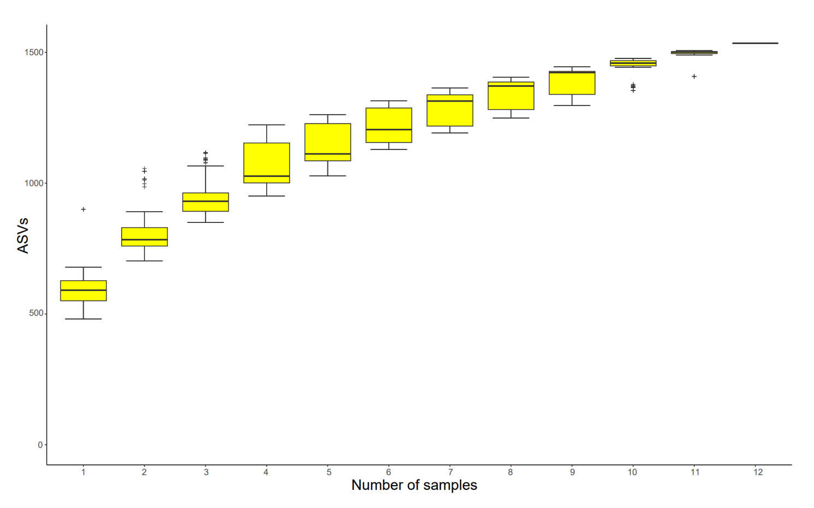
Figure S2. Species accumulation curve of fecal microbiota.
The species accumulation curve illustrates the rate of increase in observed Amplicon Sequence Variants (ASVs) as a function of the number of samples analyzed. The plateau indicates that the sampling depth was sufficient to capture the majority of the microbial diversity in the environment.

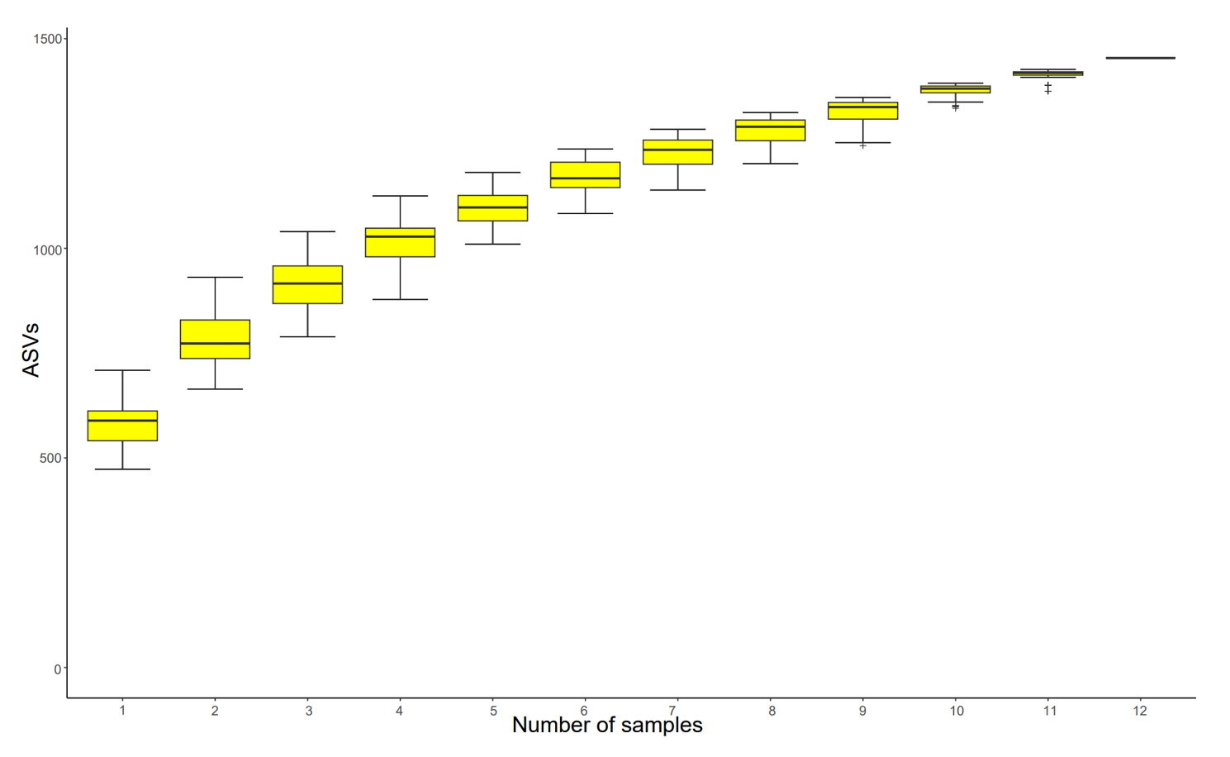
Figure S3. Species accumulation curve for the FVT intervention cohort.
The plateauing of the observed Amplicon Sequence Variants (ASVs) across the sampled cohort demonstrates that the sequencing depth was sufficient to accurately capture the gut microbial diversity.

