Supplementary information

Symmetry-Broken Eccentric Campanile Probe for Polarization-Insensitive Broadband Nanofocusing with Strong Resonant Field Enhancement

Hanjin Dong ¹, Wenbo Hu ¹, Weihao Tao ¹, Shuhao Zhao ¹, Jiaxiang Liang ¹, Xin Wen ¹, Peirui Ji ¹, and Shuming Yang ^{1, *}
¹ State Key Laboratory for Manufacturing Systems Engineering, Xi’an Jiaotong University, Xi’an, Shaanxi, 710049, China.

*Corresponding author: Shuming Yang (shuming.yang@mail.xjtu.edu.cn)

Abstract: This supplementary document provides the symmetry analysis and design principle of the eccentric campanile probe, the focused-ion-beam fabrication process, FDTD simulation optimization of geometric parameters, polarization-resolved verification of 633 nm nanofocusing, simulation and measurements confirming broadband operation from 550 to 760 nm, and SEM characterization of the test sample.

1. Probe Design Principle and Symmetry Analysis
Conventional plasmonic fiber probes usually rely on radially polarized excitation for efficient nanofocusing of surface plasmon polaritons (SPPs). Although effective, this approach requires complex polarization control and is highly sensitive to alignment between the incident beam and the probe axis. Under linearly polarized illumination, many symmetric probe geometries also suffer from destructive interference between counter-propagating or out-of-phase SPP modes, which can substantially reduce field localization at the apex. To address these limitations, an eccentric campanile probe (ECP) was designed and fabricated to support stable nanofocusing and enhanced near-field confinement under linearly polarized excitation at arbitrary orientation¹.
The ECP consists of a square pyramid integrated with a truncated-cone platform². The square pyramid is positioned on the smaller circular surface of the truncated cone, referred to here as the platform base. A key feature of the ECP is that the center of the square-pyramid base does not coincide with the center of the circular platform base. This eccentric configuration breaks the mirror symmetry of the structure and changes the propagation paths of the SPP modes along the metallic surfaces. In addition, the square-pyramidal section is defined by two independent structural parameters, namely the pyramid base length and the pyramid height, which facilitates systematic parametric analysis and reproducible fabrication.
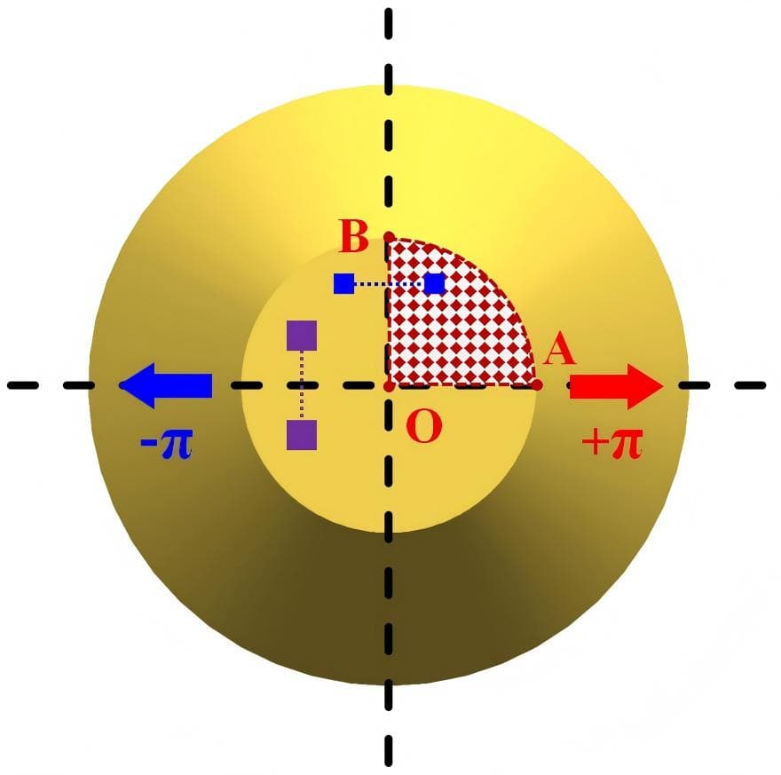
Fig. S1. Top-view schematic of the truncated-cone platform. Owing to the axial symmetry of the platform base and the phase-opposed symmetric distribution associated with linearly polarized excitation, the simulation region can be reduced to a quarter-circle sector.
The fundamental design concept is illustrated in Fig. 1c. The geometric task is to determine the position of the square-pyramid base center relative to the platform-base center so as to realize the symmetry-broken configuration. A top-view schematic of the truncated-cone platform is shown in Fig. S1. Because the platform base is rotationally symmetric and the field distribution under linearly polarized excitation is phase-opposed, symmetry reduces the circular design region first to a semicircle and then to a quarter-circle sector. The resulting right-angled fan-shaped region OAB in Fig. S1 therefore serves as the parametric design region in Fig. 1d.
Fig. 1e shows the top-view geometric model of the ECP. An xy coordinate system is established with the center of the platform base defined as the origin. The lateral displacement of the square-pyramid base center relative to the platform-base center is denoted by Δx in the x direction and Δy in the y direction.
The purpose of introducing the eccentric geometry is to eliminate the dependence of conventional plasmonic probes on radially polarized excitation. In conventional axisymmetric probes, radially polarized beams are typically required to maintain constructive interference of SPPs during propagation toward the apex. However, the generation and alignment of radially polarized beams increase the experimental complexity and reduce system robustness. Moreover, even small deviations between the optical axis of the incident beam and the probe axis can lead to substantial degradation of the focusing efficiency.
Several asymmetric plasmonic probes have previously been reported for operation under linearly polarized illumination³. Nevertheless, most existing structures still retain residual symmetry under specific polarization orientations. When the incident polarization is perpendicular to such a symmetry axis, the plasmonic propagation paths on opposite sides of the structure become equivalent, producing SPP modes with opposite phases. As a consequence, destructive interference occurs near the apex, suppressing field localization and preventing efficient nanofocusing.
In the ECP proposed here, the center of the square-pyramid base is displaced from the center of the platform base along two orthogonal directions by Δx and Δy, respectively. The conditions Δx ≠ 0, Δy ≠ 0, and |Δx| ≠ |Δy| are imposed to remove all mirror-symmetry planes from the structure. Under these conditions, no linear polarization orientation can produce equivalent plasmonic propagation paths on opposite sides of the probe. The out-of-phase SPP distribution that causes destructive interference is suppressed across the full polarization range, enabling stable nanofocusing under linearly polarized excitation at arbitrary orientations.
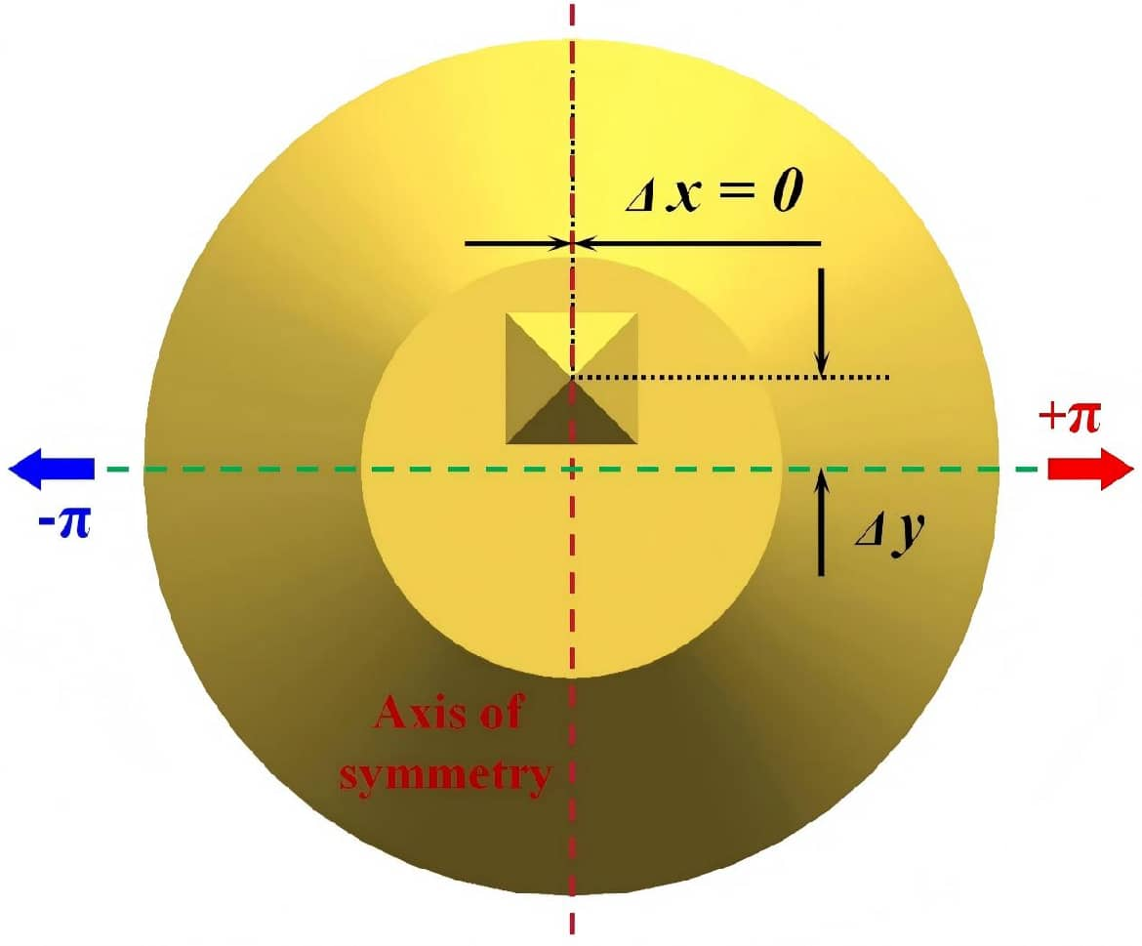
Fig. S2. Top-view schematic of the probe structure when Δx = 0.
As shown in Fig. S2, when Δx = 0, the structure retains mirror symmetry with respect to the y axis. If the incident linear polarization is oriented perpendicular to this symmetry axis, the structures on both sides of the axis become equivalent. The corresponding SPP modes therefore acquire opposite phases and interfere destructively near the apex, preventing effective field localization. This configuration is therefore not suitable for polarization-insensitive nanofocusing.
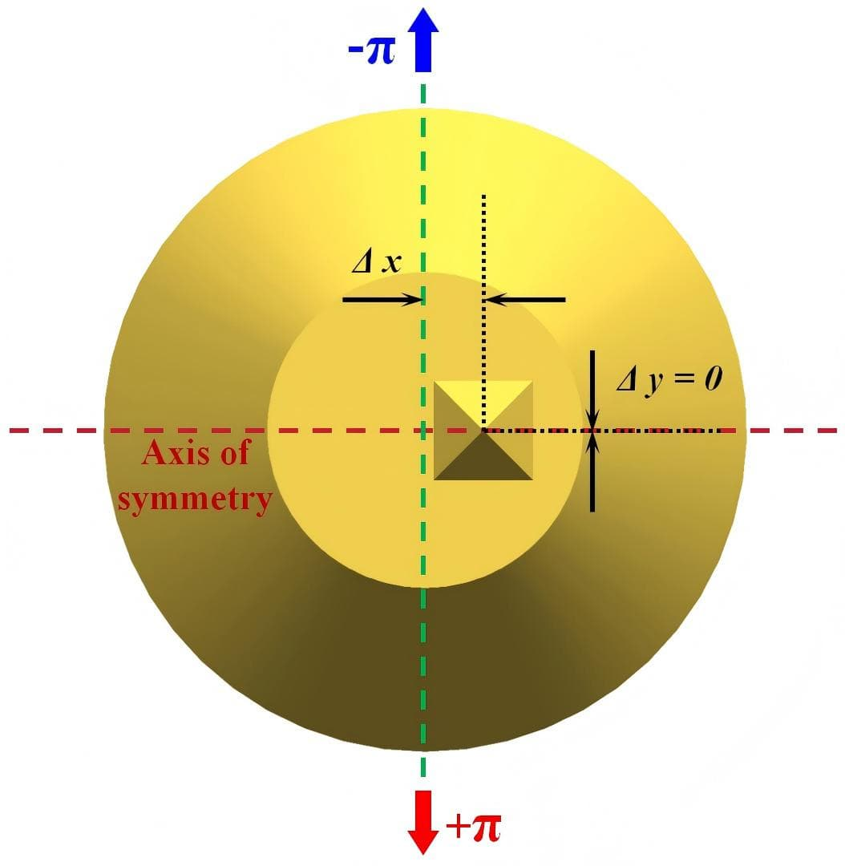
Fig. S3. Top-view schematic of the probe structure when Δy = 0.
Similarly, when Δy = 0, the structure retains mirror symmetry with respect to the x axis, as illustrated in Fig. S3. Under linearly polarized excitation perpendicular to this symmetry axis, the two sides of the structure again become equivalent, leading to destructive interference of the SPP modes near the apex. Efficient nanofocusing is therefore not obtained.
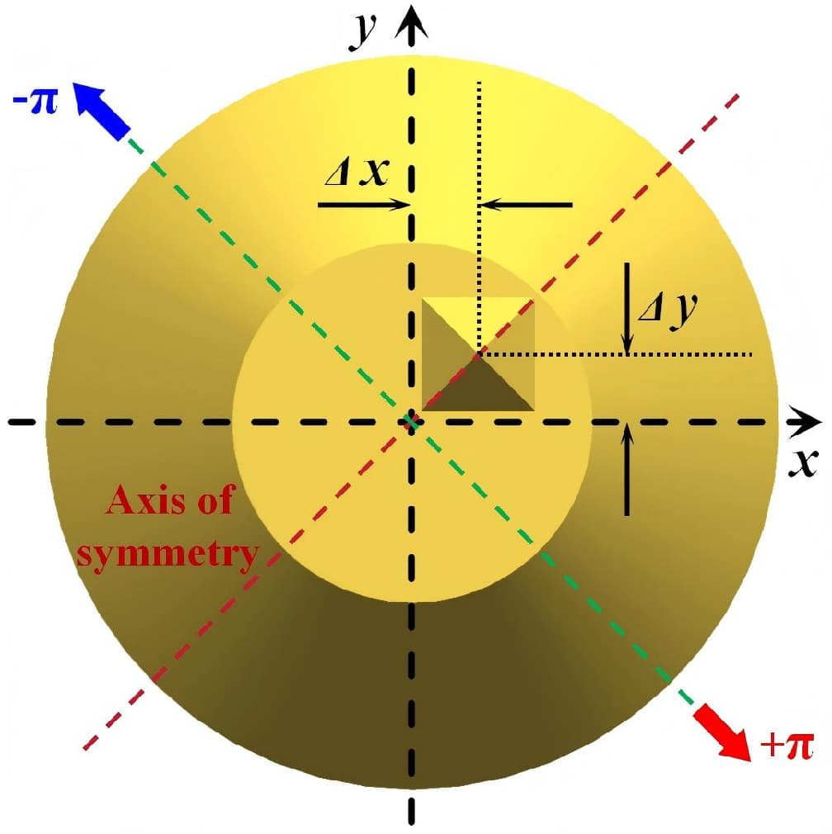
Fig. S4. Top-view schematic of the probe structure when |Δx| = |Δy|. The center of the square-pyramid base is located in the first quadrant.
Fig. S4 shows the case |Δx| = |Δy|. Although the structure is geometrically eccentric, a mirror-symmetry plane remains along the diagonal direction. The example shown corresponds to Δx > 0 and Δy > 0, where the square-pyramid base center is located in the first quadrant of the coordinate system. When the incident polarization is perpendicular to the symmetry axis, destructive interference between opposite-phase SPP modes again occurs near the apex and suppresses nanofocusing.
Therefore, all mirror-symmetry planes are removed from the probe geometry only when Δx ≠ 0, Δy ≠ 0, and |Δx| ≠ |Δy| are satisfied simultaneously. Under these conditions, destructive interference of SPP modes is suppressed for arbitrary linear-polarization orientations, enabling polarization-insensitive nanofocusing in the ECP.

2. Probe Fabrication Process
To fabricate the ECP with high geometric fidelity and reproducible dimensions, focused-ion-beam (FIB) milling was employed for micro- and nanomachining of the probe⁴. The experiments were carried out on a Thermo Scientific Helios 5 UX dual-beam system. In this instrument, the electron and ion columns are arranged at 0° and 52°, respectively. The ion source was a Ga source, with an acceleration voltage of 0.5–30 kV and a beam current of 1 pA–65 nA. The electron beam acceleration voltage was 1–30 kV, and the electron-beam resolution reached 0.6 nm at 15 kV.
Before FIB processing, the optical fiber was immersed in hydrofluoric acid for wet etching to form a conical taper with an apex angle of approximately 30°. A conductive metal layer was then deposited on the etched fiber surface by electron-beam evaporation to ensure sufficient conductivity for FIB milling.
Although the final ECP geometry combines a square pyramid with an eccentric platform base, it can be fabricated using a two-step FIB process. During processing, the taper axis of the conical fiber probe was first aligned perpendicular to the ion-beam axis, so that the probe axis lay in the ion-beam imaging plane⁵. Under this configuration, the ion-beam image shows a triangular outline, which corresponds to the front view of the etched conical fiber. A milling pattern was then defined in the ion-beam processing window⁶. One representative design is shown in Fig. S5. The pattern consists of a rectangle and an isosceles triangle. The rectangle fully encloses the triangle, and one side of the rectangle coincides with the base of the triangle. The length of that side is larger than the base length of the isosceles triangle. This design allows the platform base to be formed directly while the square-pyramid section is being milled. During processing, the overlap between the rectangle and the isosceles triangle was left unprocessed, whereas the remaining area was etched. The isosceles-triangle parameters directly define the square-pyramid geometry. The triangle base length corresponds to the square-pyramid base length L, and the triangle height corresponds to the pyramid height H.
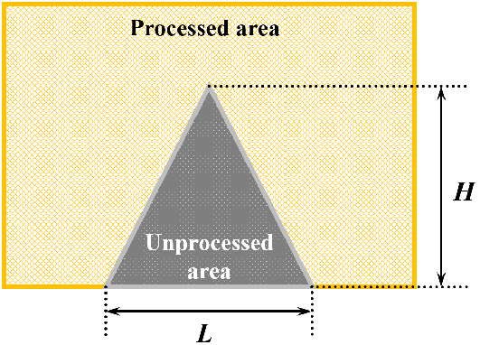
Fig. S5. One representative FIB pattern used for ECP fabrication.
In the first milling step, the pattern was positioned near the taper apex, with the symmetry axis of the isosceles triangle parallel to, but not coincident with, the taper axis. In this step, the lateral offset between the triangle symmetry axis and the probe axis was Δx. After milling, the portion of the rectangle not overlapping the triangle base was removed, and part of the platform base was formed simultaneously. At the same time, one half of the square-pyramid structure was created. The resulting morphology is similar to a triangular prism resting on the platform base, with an isosceles-triangular longitudinal section and upper and lower surfaces inherited from the original taper.
The probe was then rotated by 90° about its original axis for the second milling step. The same pattern was applied again. In the ion-beam imaging window, the side of the pattern where the rectangle overlaps the isosceles triangle was aligned with the partial platform base formed in the first step, while the symmetry axis of the triangle remained parallel to, but not coincident with, the probe axis. In this step, the offset between the triangle symmetry axis and the probe axis was Δy. After the two milling steps, the ECP geometry was fully formed. The fabrication scheme is summarized in Fig. S6. The final platform base is perpendicular to the original taper axis, which passes through the center of the platform base. The fabricated square pyramid has the same height and base length as defined by the triangle in the pattern. The platform base is formed at the conical cross section corresponding to the overlap of the rectangle and the isosceles triangle in the FIB pattern. The parameters Δx and Δy correspond to the offsets of the square-pyramid base center relative to the platform-base center along two orthogonal directions and to the lateral displacements of the triangle symmetry axis relative to the taper axis in the two milling steps. The entire fabrication process requires only two FIB milling steps, and the geometric dimensions are readily controlled⁷. Finally, an Au film was deposited on the probe surface to complete the ECP fabrication.
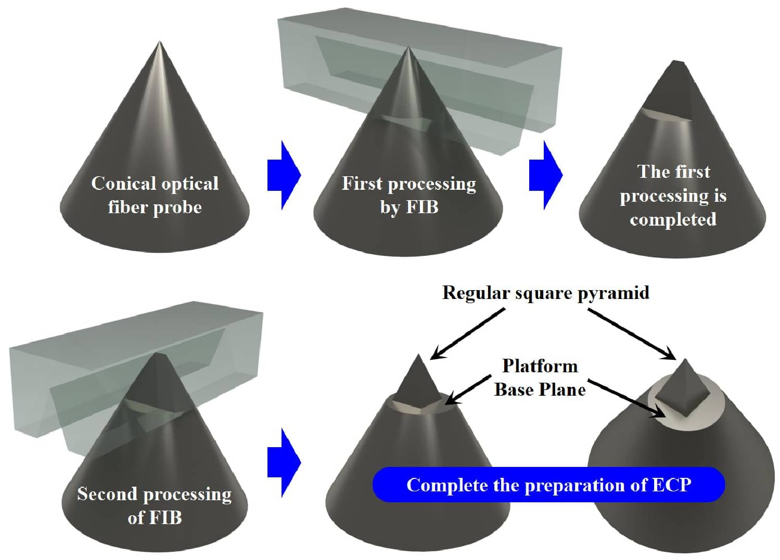
Fig. S6. Schematic of the ECP fabrication process.

Fig. S7 shows the actual fabrication process observed in the ion-beam imaging window. Before milling, the probe appears as a triangular profile corresponding to the front view of the conical fiber after hydrofluoric-acid etching and conductive-layer deposition. A pattern was then defined for the initial milling step. For practical reasons, the actual pattern was not a strict rectangle, but the unprocessed central region remained an isosceles triangle. This triangular region corresponds to the cross-sectional geometry of the square pyramid. Consistent with the schematic in Fig. S6, the first milling step produced part of the platform base and a transitional structure resembling a triangular prism. The probe was then rotated by 90° about its axis for the second milling step. The size of the isosceles triangle was kept unchanged, and its symmetry axis remained parallel to, but not coincident with, the probe axis, thereby realizing the two-dimensional offset between the square-pyramid base center and the platform-base center. After the second milling step, the complete ECP geometry was obtained.

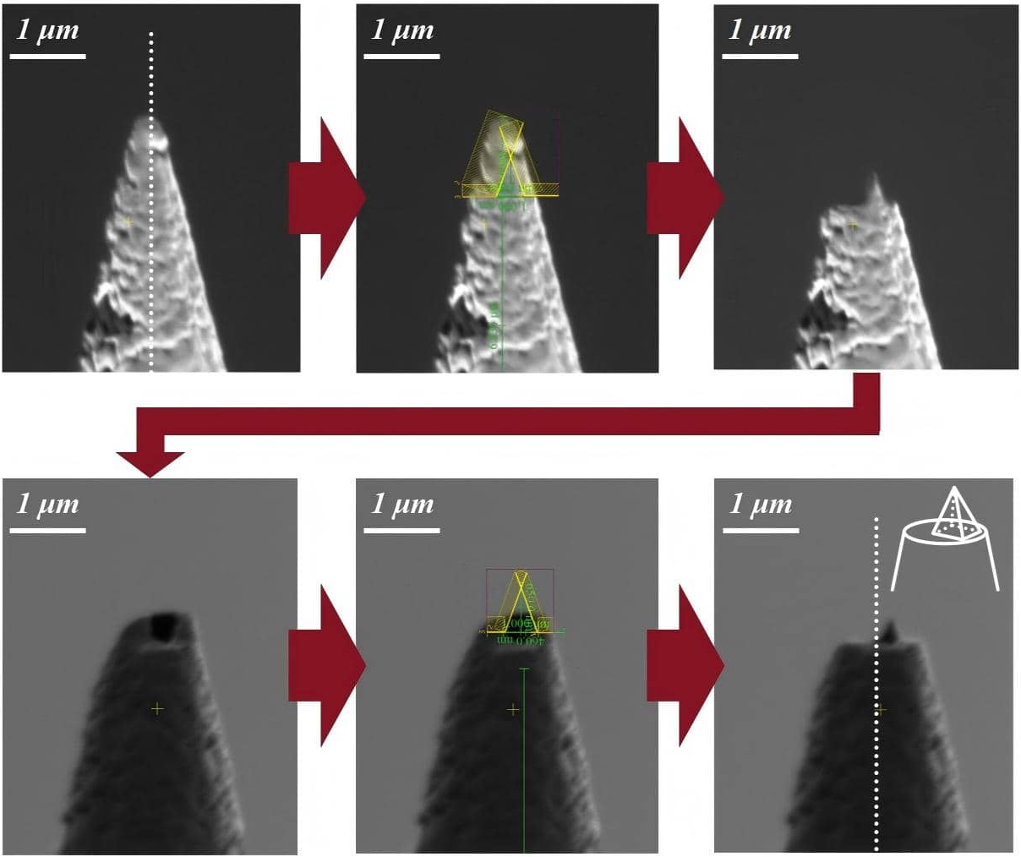
Fig. S7. Actual fabrication process of the ECP observed in the ion-beam imaging window. The white dashed line indicates the taper axis of the conical fiber probe.

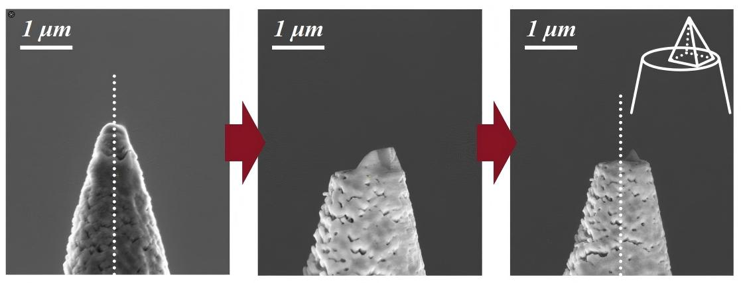
Fig. S8. Actual fabrication process of the ECP observed in the electron-beam imaging window. The white dashed line indicates the taper axis of the conical fiber probe.
Fig. S8 shows the actual fabrication process observed in the electron-beam imaging window, including the states of the conical fiber probe before milling, after the first milling step, and after the second milling step. Because the electron and ion columns of the FIB system are separated by 52°, the image in the electron-beam window is rotated by 52° about the probe axis relative to the corresponding image in the ion-beam window. The final square-pyramid axis is clearly displaced from the original probe axis. After the two-step FIB milling process, Au deposition completed the ECP fabrication. The SEM images of the final fabricated ECP are shown in Fig. 1g, h.

3. Geometric-Parameter Simulation Optimization of the ECP
We used finite-difference time-domain (FDTD) simulations to analyze SPP propagation and nanofocusing in the ECP and to optimize the geometric parameters⁸. The platform-base radius was fixed at R=500 nm. In the initial simulations, the square-pyramid base length was set to L=300 nm and the pyramid height to H=500 nm, corresponding to L/H=3/5.

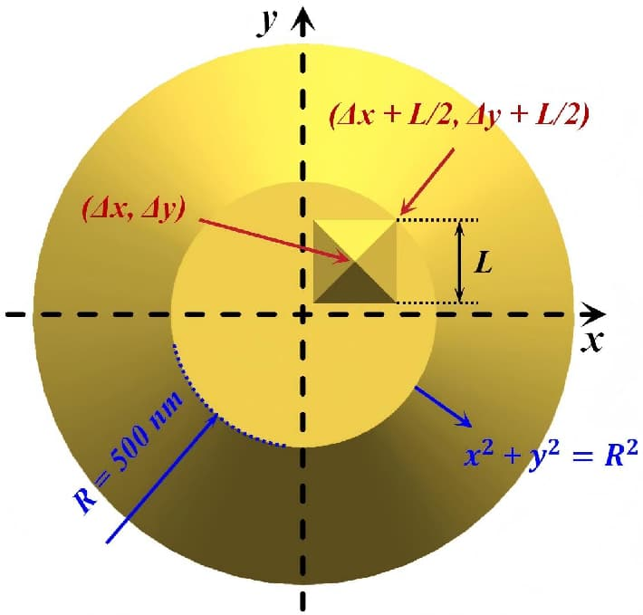
Fig. S9. Schematic diagram of the movement range of the vertices of the square pyramid base in the ECP. The upper-right vertex of the square pyramid base is located on the circumference of the platform base.

Fig. S9 illustrates the accessible region of the square-pyramid vertices. The center of the square-pyramid base is denoted by (Δx,Δy). When the square pyramid reaches its limiting position, its upper-right vertex lies on the circumference of the platform base. Because the base is square, the coordinates of this vertex are (Δx+L/2, Δy+L/2), which satisfies ${\text{(Δ}\text{x}\text{+}\frac{\text{L}}{\text{2}}\text{)}}^{\text{2}} \text{+} {\text{(Δ}\text{y}\text{+}\frac{\text{L}}{\text{2}}\text{)}}^{\text{2}}\text{ = }{\text{R}}^{\text{2}}$. Therefore, the offsets must satisfy the constraint condition:
${\text{(Δ}\text{x}\text{+}\frac{\text{L}}{\text{2}}\text{)}}^{\text{2}} \text{+} {\text{(Δ}\text{y}\text{+}\frac{\text{L}}{\text{2}}\text{)}}^{\text{2}} \text{≤} {\text{R}}^{\text{2}}$ (S1)
In the initial simulations, L=300 nm and R=500 nm, so Eq. (S1) becomes ${\text{(Δ}\text{x}\text{+}\text{150}\text{)}}^{\text{2}} \text{+} {\text{(Δ}\text{y}\text{+}\text{150}\text{)}}^{\text{2}} \text{≤} 250000$. Because only the first quadrant was considered, both Δx and Δy are non-negative. The admissible ranges of Δx and Δy along the 21 characteristic rays in Fig. 1d are listed in Tables S10 and S11.

Table S10. Range of Δx when Δx is the independent variable
Equation | y = 0 | y = x/10 | y = 2x/10 | y = 3x/10 | y = 4x/10 | y = 5x/10
Δx value range | Δx ≤ 327.0 | Δx ≤ 315.9 | Δx ≤ 303.5 | Δx ≤ 290.2 | Δx ≤ 276.7 | Δx ≤ 263.2
Equation | y = 6x/10 | y = 7x/10 | y = 8x/10 | y = 9x/10 | y = x
Δx value range | Δx ≤ 250.0 | Δx ≤ 237.3 | Δx ≤ 225.4 | Δx ≤ 214.1 | Δx ≤ 203.6

Table S11. Range of Δy when Δy is the independent variable
Equation | x = 9y/10 | x = 8y/10 | x = 7y/10 | x = 6y/10 | x = 5y/10 | x = 4y/10
Δy value range | Δy ≤ 214.1 | Δy ≤ 225.4 | Δy ≤ 237.3 | Δy ≤ 250.0 | Δy ≤ 263.2 | Δy ≤ 276.7
Equation | x = 3y/10 | x = 2y/10 | x = 1y/10 | x = 0
Δy value range | Δy ≤ 290.2 | Δy ≤ 303.5 | Δy ≤ 315.9 | Δy ≤ 327.0

The sweeps corresponding to the 11 Δx-dependent rays are shown in Fig. S12. For each ray, the minimum value of the independent variable Δx was 20 nm, and the sweep step was 20 nm.

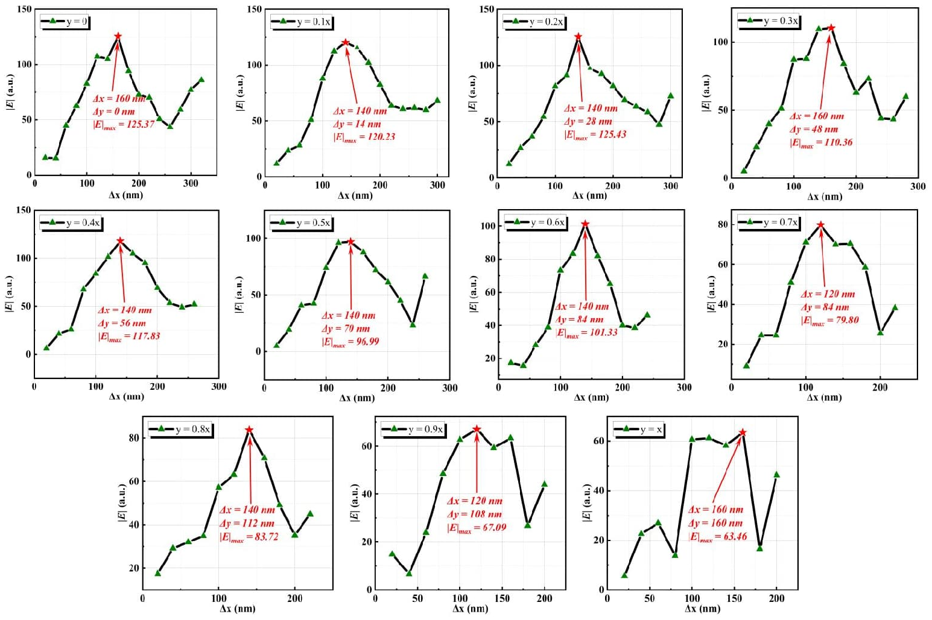
Fig. S12. Parametric sweep results for the 11 characteristic rays with Δx as the independent variable.

The sweeps corresponding to the 10 Δy-dependent rays are shown in Fig. S13. For each ray, the minimum value of the independent variable Δy was 20 nm, and the sweep step was 20 nm.
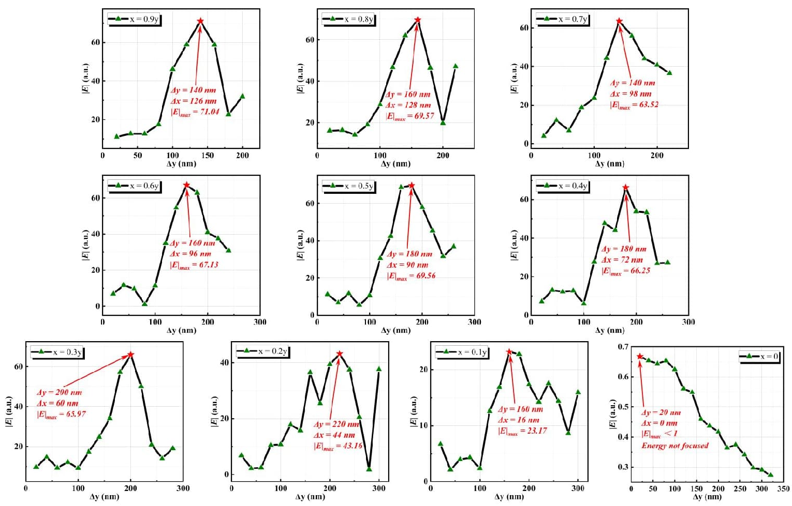
Fig. S13. Parametric sweep results for the 10 characteristic rays with Δy as the independent variable.

The maximum field-amplitude enhancement on each of the 21 characteristic rays was then collected and compared, as shown in Fig. S14. The largest response occurs when the square-pyramid base center lies on the ray y=0.2x. According to Table S10, the admissible range of Δx on this ray is Δx ≤ 303.5 nm. Accordingly, Δx was swept from 20 to 300 nm in 20 nm steps, yielding the optimum offsets Δx = 140 nm and Δy = 28 nm. All subsequent optimizations were performed using this offset position.

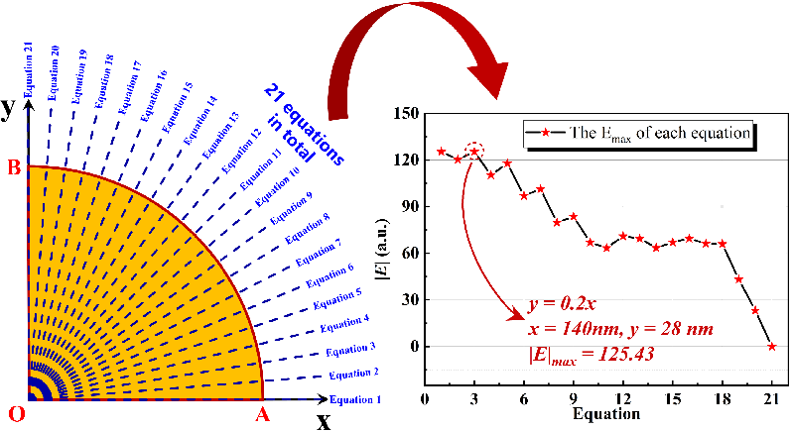
Fig. S14. Statistics of the maximum field-amplitude enhancement on the 21 characteristic rays. The left panel shows the numbering of the 21 rays, and the right panel shows the corresponding maximum enhancement values.

With the optimal offset fixed, we then optimized the key geometric parameters of the square pyramid⁹. First, Δx=140 nm and Δy=28 nm were fixed, and L/H=3/5 was retained. Substituting Δx=140 nm, Δy=28 nm, R=500 nm, and L=3H/5 into Eq. (S1) gives 0≤H≤883.6 nm. To account for fabrication feasibility, the sweep of H was performed from 100 to 850 nm in 50 nm steps. As shown in Fig. 2b, the electric-field amplitude reaches its maximum at H=650 nm. Next, the ratio L/H was optimized. With Δx=140 nm, Δy=28 nm, and H=650 nm fixed, Eq. (S1) yields 0≤L≤530.2 nm. Considering practical fabrication, L was swept from 130 to 520 nm, corresponding to L/H from 1/5 to 4/5, with a step size of 1/45. The maximum field amplitude occurs at L/H=23/45, as shown in Fig. 2c.
Finally, with the optimized geometry fixed, the Au-film thickness T was swept from 50 to 300 nm in 10 nm steps. A film that is too thin suppresses efficient SPP excitation, whereas an excessively thick film increases fabrication cost. The results are summarized in Fig. 2d.

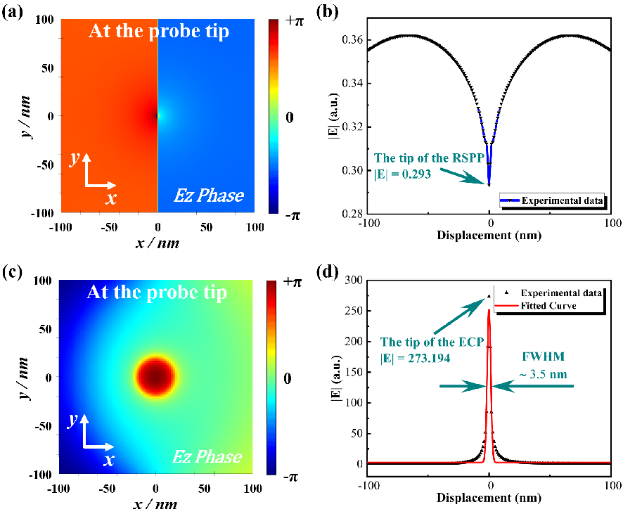
Fig. S15. Comparison of the phase distributions and field-amplitude profiles at the apex of the ECP and RSPP under the optimal parameters. (a) Phase distribution in the xy plane at the RSPP apex under the optimal parameters. (b) Field-amplitude profile along the x direction at the RSPP apex. (c) Phase distribution in the xy plane at the ECP apex under the optimal parameters. (d) Field-amplitude profile along the x direction at the ECP apex and the corresponding fit.

To clarify the focusing mechanism, we compared the phase distributions and field-amplitude profiles at the apex of the ECP and a regular square-pyramid probe (RSPP) under the optimal parameters. The results are shown in Fig. S15. For the RSPP, the fully axisymmetric geometry produces an inherent π phase difference between the SPPs excited on both sides of the central axis under linearly polarized excitation (Fig. 2f). As the SPPs propagate toward the apex, they undergo complete destructive interference. At the apex, the xy plane still maintains a π phase difference, and the field-amplitude profile is extremely weak, making it impossible to achieve effective focusing (Fig. S15a, b). In contrast, the eccentric geometry of the ECP removes mirror symmetry in the apex region (Fig. S15c). SPPs propagate along the square-pyramid waveguide without mutual cancellation and form a highly localized focal spot at the apex. The focal-spot FWHM is 3.5 nm (Fig. S15d), consistent with the combined action of the eccentric geometry and the Fabry–Pérot response supported by the platform base^{10–12}. These results support the design rationale of the ECP and are consistent with the proposed nanofocusing mechanism.

4. Experimental Verification of ECP Nanofocusing
Table S16. Parameters of the 630-HP single-mode fiber
Parameters | Unit | Value
Operating Wavelength | nm | 600–770
Numerical Aperture |  | 0.13
Core Diameter | μm | 3.5
Cladding Diameter | μm | 125 ± 1
Coating Diameter | μm | 245 ± 15
Operating Temperature | °C | -55 to +85

A 633 nm laser source was used for the nanofocusing measurements. To facilitate efficient coupling into the fiber, a 630-HP single-mode optical fiber from Coherent/Nufern was selected; its specifications are listed in Table S16.

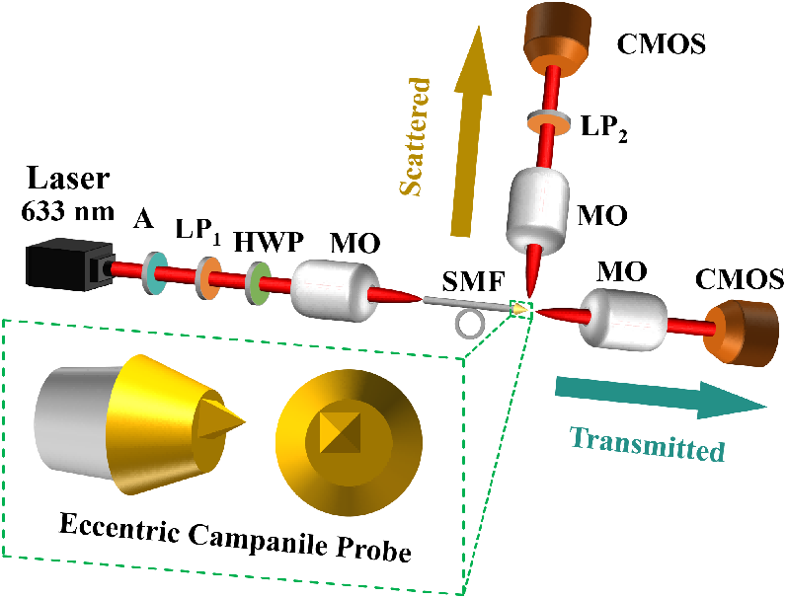
Fig. S17. Schematic of the polarization-resolved experimental setup for the probe focal field. A, attenuator; LP, linear polarizer; HWP, half-wave plate; MO, micro-objective; SMF, single-mode fiber.

To verify the nanofocusing performance and polarization-insensitive response of the ECP, polarization-resolved far-field characterization was performed using the setup shown in Fig. S17¹³. The 633 nm laser beam was sequentially passed through an attenuator (A), a linear polarizer (LP₁), and a half-wave plate (HWP) to generate linearly polarized light with a controlled polarization angle. A micro-objective (MO) was then used to focus and couple the beam into a single-mode fiber (SMF). The far-field scattering and transmission spots from the probe tip were recorded with a scientific-grade CMOS camera (Thorlabs CS126CU). For the far-field scattering measurements, a second linear polarizer (LP₂) was placed between the probe tip and the CMOS camera to analyze the scattered field components associated with the tip focal spot. During the measurements, the incident power was adjusted continuously from 0% to 100% by the attenuator, and the incident polarization angle was tuned by rotating the HWP.
To identify the dominant field component in the far-field scattering signal, the attenuator, LP₁, and HWP were kept fixed, and only LP₂ was rotated. The focal intensity at the probe tip was then measured in the scattering direction¹⁴. The attenuation setting remained unchanged throughout this measurement. Fig. 3a–c shows the far-field scattering results of the ECP. Fig. 3a corresponds to the case without LP₂, whereas Fig. 3b, c shows the results with LP₂ inserted. When the white arrow in the figure is horizontal, the transmission axis of LP₂ is parallel to the probe axis, and the detected signal is dominated by the field component along the probe axis. When the white arrow is vertical, the transmission axis of LP₂ is perpendicular to the probe axis, and the detected signal is dominated by the orthogonal field component.
To further evaluate the polarization-insensitive response of the ECP tip, the dependence of the tip signal on the incident polarization angle was measured experimentally, and the corresponding focusing behavior was analyzed by simulation. In this set of measurements, LP₂ in front of the CMOS camera was removed. The polarization direction of the linearly polarized input light was continuously adjusted by rotating the HWP, and the focused intensity at the probe tip was measured in both the transmission and scattering channels. Fig. 3j, k shows the simulated and measured polarization dependence of tip focusing, respectively. The experimental results agree well with the simulations and show that the ECP maintains stable tip focusing under linearly polarized illumination across the full polarization rotation range.

5. Simulation and Experimental Verification of Broadband Nanofocusing of the ECP
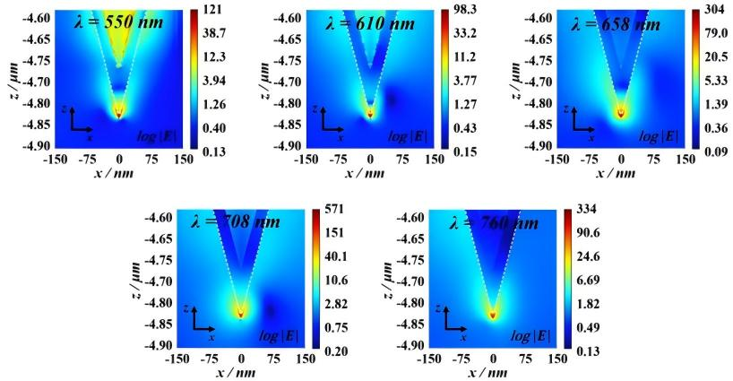
Fig. S18. Logarithmic electric-field distributions in the xz plane near the ECP tip at five representative wavelengths: 550, 610, 658, 708, and 760 nm.

To verify broadband nanofocusing, field distributions near the tip were simulated at five representative wavelengths using the optimized Au-film thickness of 110 nm. The results are shown in Fig. S18. At all tested wavelengths, the tip exhibits stable and pronounced field enhancement¹⁵, indicating that SPPs can propagate along the probe surface and remain localized at the apex¹⁶. At the short-wavelength limit of 550 nm, where intrinsic absorption in Au becomes more significant¹⁷, the platform base still recovers part of the backward-propagating SPP energy through Fabry–Pérot reflection. This compensates for propagation loss and preserves a strong apex electric-field amplitude. These results demonstrate broadband nanofocusing capability of the ECP over the visible range¹⁸.
For the broadband experimental measurements, a multimode fiber was used as the transmission medium to enable efficient broadband coupling. The detailed specifications of the fiber are listed in Table S19. Compared with the single-mode fiber used in the 633 nm measurements, this multimode fiber provides a broader operating-wavelength range and is better suited for broadband optical coupling.
Table S19. Parameters of the multimode optical fiber
Parameters | Unit | Value
Operating Wavelength | nm | 300–2400
Numerical Aperture |  | 0.22 ± 0.02
Core Diameter | μm | 105 ± 3
Cladding Diameter | μm | 125 ± 2
Coating Diameter | μm | 250 ± 10
Operating Temperature | ℃ | -40 to +85

6. SEM Characterization of the Structural Dimensions of the Tested Sample
To verify the imaging performance of the ECP in SNOM, an X-shaped nanoslit sample was fabricated by FIB milling. The SEM characterization of the sample is shown in Fig. S20. From manually annotated SEM images, the widths of nanoslits L₁ and L₂ were estimated to be approximately 28 nm and 34 nm, respectively, providing an independent consistency check for the AFM and SNOM measurements.

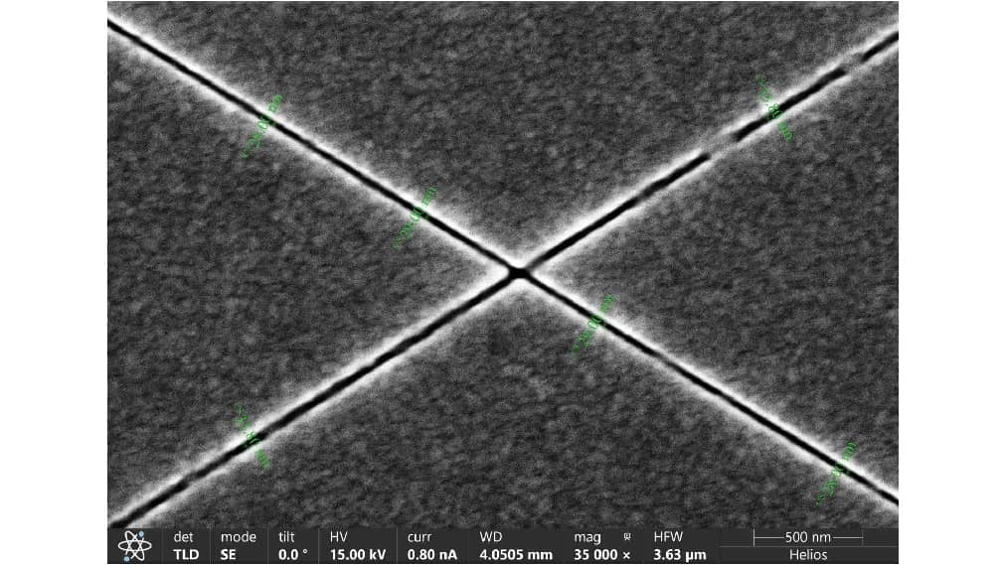
Fig. S20. SEM characterization of the structural dimensions of the X-shaped crossed nanoslit sample.
7. Reference
1. Gramotnev, D. K. & Bozhevolnyi, S. I. Nanofocusing of electromagnetic radiation. Nat. Photonics 8, 13–22 (2014).
2. Bao, W. et al. Mapping local charge recombination heterogeneity by multidimensional nanospectroscopic imaging. Science 338, 1317–1321 (2012).
3. Li, S. et al. Plasmonic interference modulation for broadband nanofocusing. Nanophotonics 10, 4113–4123 (2021).
4. Calafiore, G. et al. Campanile near-field probes fabricated by nanoimprint lithography on the facet of an optical fiber. Sci. Rep. 7, 1651 (2017).
5. Cui, T. et al. A low-loss molybdenum plasmonic waveguide: perfect single-crystal preparation and subwavelength grating optimization. Nanophotonics 12, 4185–4193 (2023).
6. Chen, Y. et al. Rapid focused ion beam milling based fabrication of plasmonic nanoparticles and assemblies via “sketch and peel” strategy. ACS Nano 10, 11228–11236 (2016).
7. Lee, J. S. et al. Multifunctional hydrogel nano-probes for atomic force microscopy | nature communications. Nat. Commun. 7, 11566 (2016).
8. Zhao, W. et al. Observation of hydrodynamic plasmons and energy waves in graphene. Nature 614, 688–693 (2023).
9. Long, L., Deng, Q., Huang, R. & Li, Z.-Y. Plasmonic enhanced fluorescence via 3D printing spiral conical tapered gold tip bound to optical fiber. APL Photonics 7, 46107 (2022).
10. Güell-Grau, P. et al. Elastic plasmonic-enhanced fabry–pérot cavities with ultrasensitive stretching tunability. Adv. Mater. 34, 2106731 (2022).
11. Böckmann, H. et al. Near-field manipulation in a scanning tunneling microscope junction with plasmonic fabry-pérot tips. Nano Lett. 19, 3597–3602 (2019).
12. Wang, F. et al. A flat-based plasmonic fiber probe for nanoimaging. Nano Res. 16, 7545–7549 (2023).
13. Liu, M. et al. Highly efficient plasmonic nanofocusing on a metallized fiber tip with internal illumination of the radial vector mode using an acousto-optic coupling approach. Nanophotonics 8, 921–929 (2019).
14. Tugchin, B. N. et al. Plasmonic tip based on excitation of radially polarized conical surface plasmon polariton for detecting longitudinal and transversal fields. ACS Photonics 2, 1468–1475 (2015).
15. Kim, S. et al. High external-efficiency nanofocusing for lens-free near-field optical nanoscopy. Nat. Photonics 13, 636–643 (2019).
16. Dong, H. et al. Broadband plasmon modulation and high-intensity nanofocusing for high-resolution nanoscale imaging using fabry–pérot probes. Microsyst. Nanoeng. 12, 71–82 (2026).
17. Taguchi, K., Umakoshi, T., Inoue, S. & Verma, P. Broadband plasmon nanofocusing: comprehensive study of broadband nanoscale light source. J. Phys. Chem. C 125, 6378–6386 (2021).
18. Umakoshi, T., Tanaka, M., Saito, Y. & Verma, P. White nanolight source for optical nanoimaging. Sci. Adv. 6, eaba4179 (2020).

