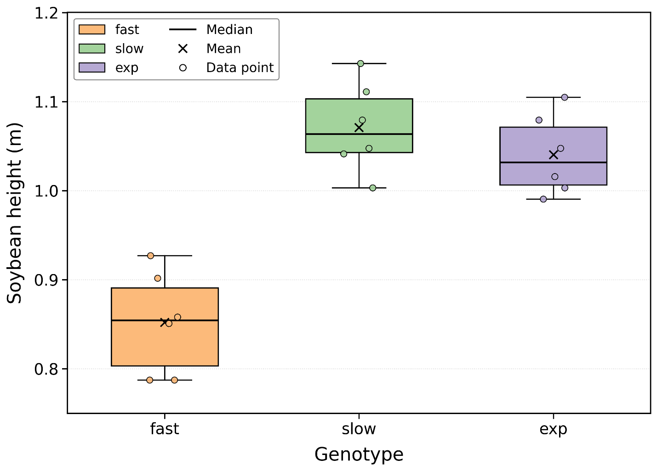
Figure S1. Distribution of ground-measured soybean plant height by genotype (fast, slow, exp) on 2025-08-29. Boxes show the interquartile range, horizontal line the median, "×" the mean, whiskers the 1.5×IQR range, and dots individual plot values (n = 6 plots per genotype, pooled across D7 Irrigated and D9 Rainfed).
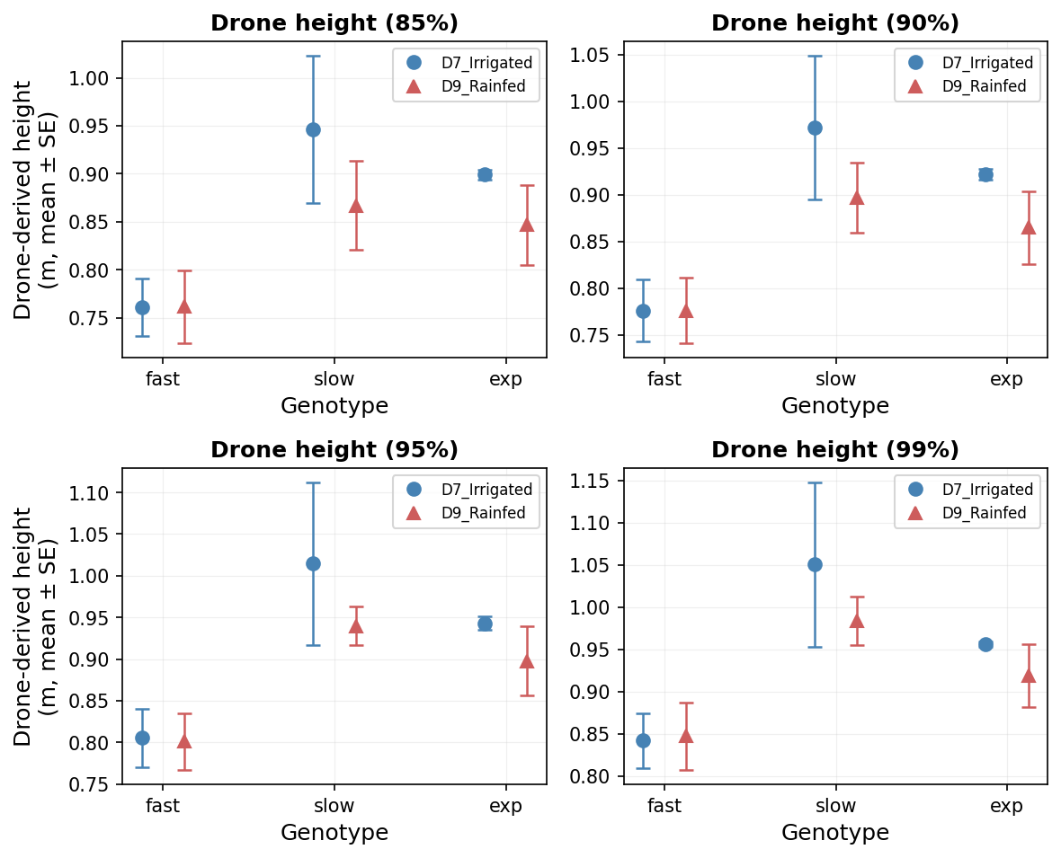
Figure S2. Mean ± SE of UAV-derived soybean canopy height at four percentiles of the canopy-height distribution (85%, 90%, 95%, 99%) by genotype (fast, slow, exp) and irrigation treatment (D7 Irrigated, D9 Rainfed). Values are means across three plots per treatment × genotype combination (n = 3).
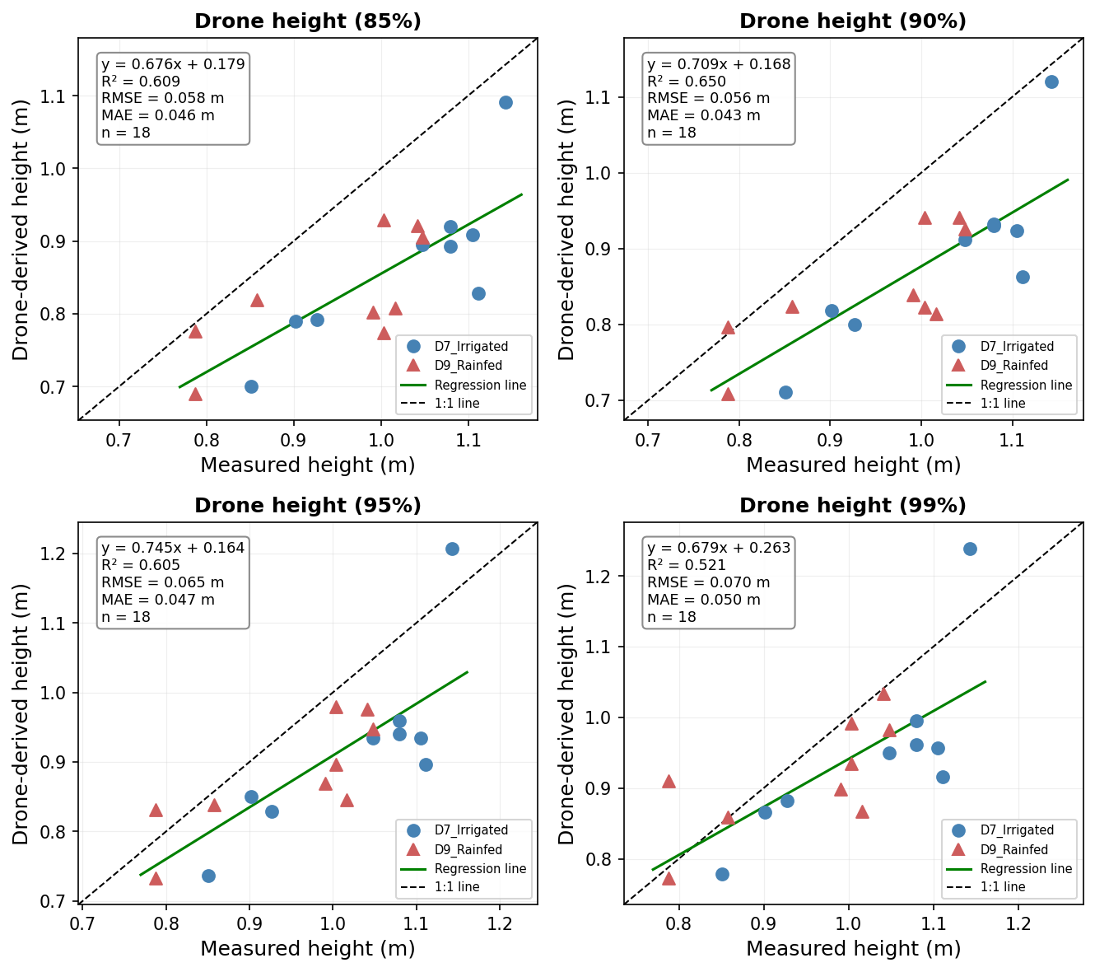
Figure S3. Linear regression of UAV-derived soybean canopy height against field-measured plant height at four canopy-height percentiles (85%, 90%, 95%, 99%), pooled across treatments (D7 Irrigated, red circles; D9 Rainfed, teal triangles). Dashed black line = 1:1 reference, solid green line = ordinary-least-squares fit; inset gives the equation, R², RMSE, MAE, and n.
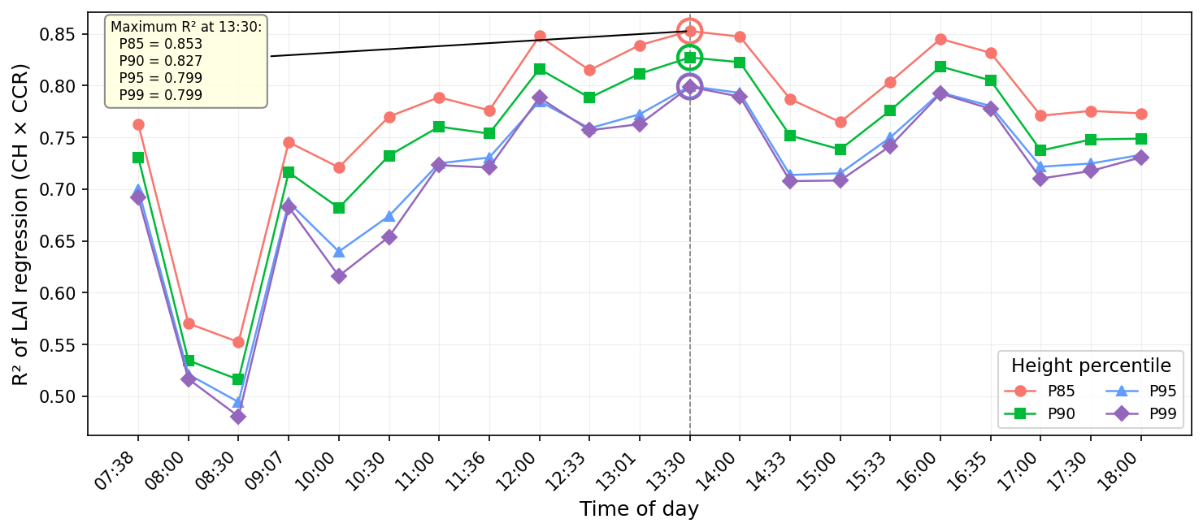
Figure S4. Diurnal variation in the coefficient of determination (R²) of the LAI regression using canopy height × canopy cover ratio (CH × CCR) as the predictor, evaluated at four UAV-derived canopy-height percentiles (P85, P90, P95, P99) across 21 times of day (07:38–18:00). All four percentiles peak at 13:30 (P85 = 0.853, P90 = 0.827, P95 = 0.799, P99 = 0.799; dashed line), indicating that midday imagery provides the strongest predictor of LAI.

