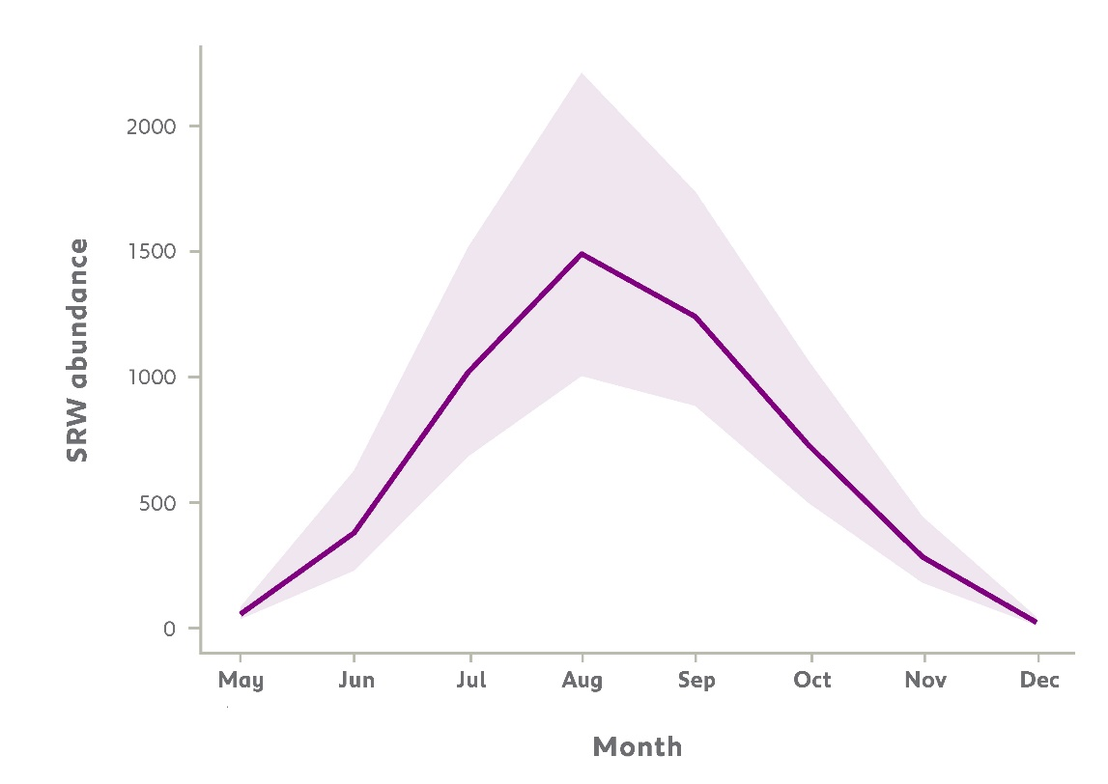
SUPPLEMENTARY
Figure S1. Monthly abundance of Southern right whale in 2024. The solid purple line shows the mean number of whales from May to December, while the shaded area indicates the associated 95% confidence interval.
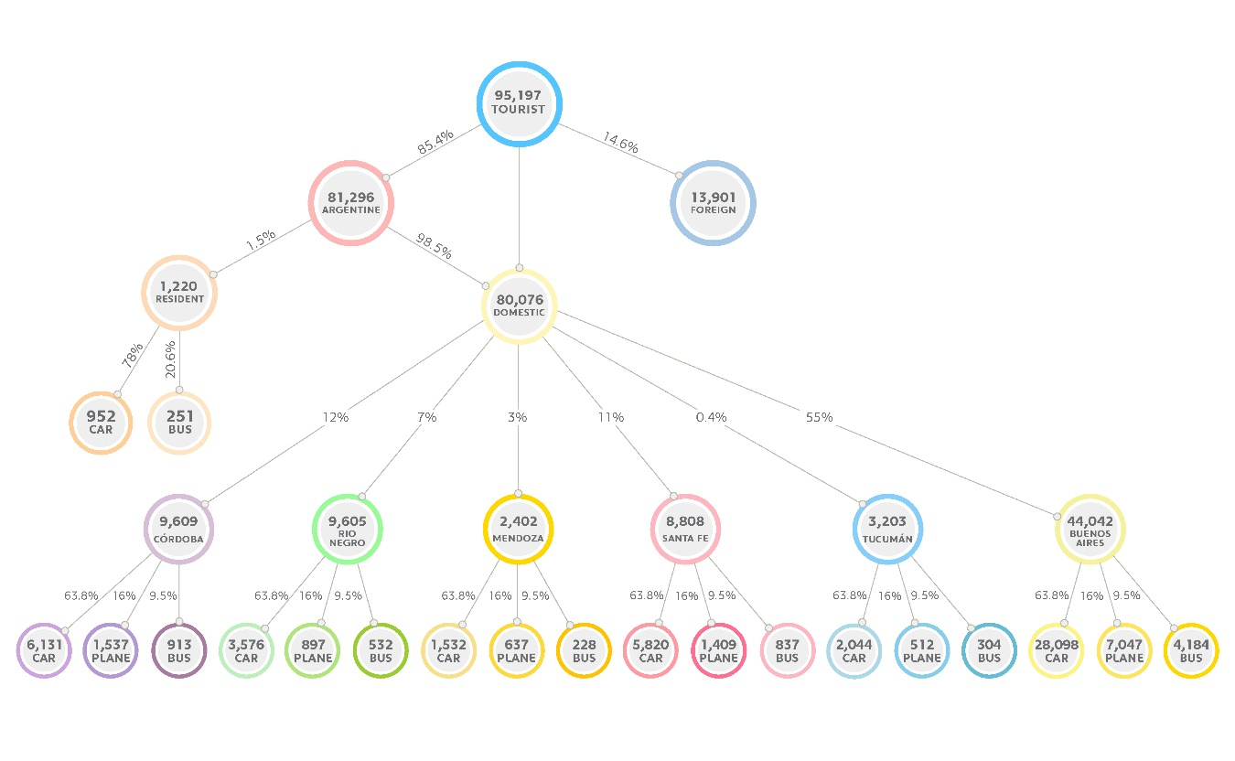
Figure S2. Hierarchical breakdown of whale-watching tourists in 2024, distinguishing between foreign and Argentine visitors. Argentine tourists are further divided into residents of Chubut Province and national visitors from other provinces. Lower-level nodes indicate the mode of transportation used (car, plane, or bus) and the corresponding number of tourists.

