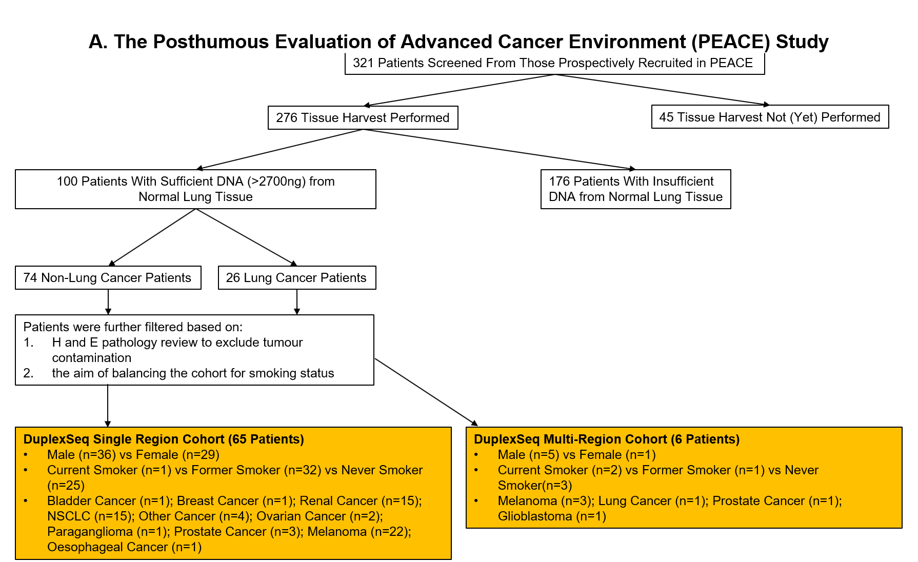

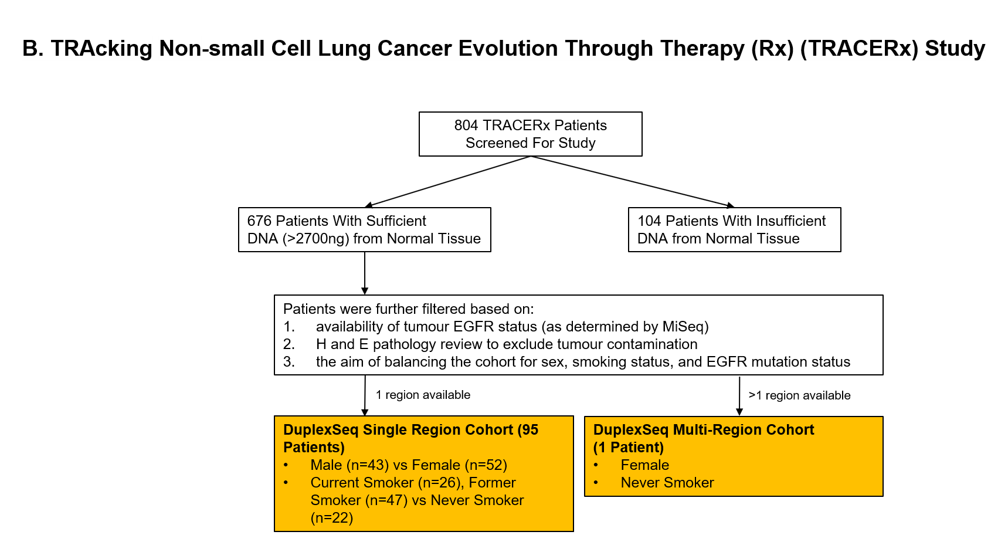

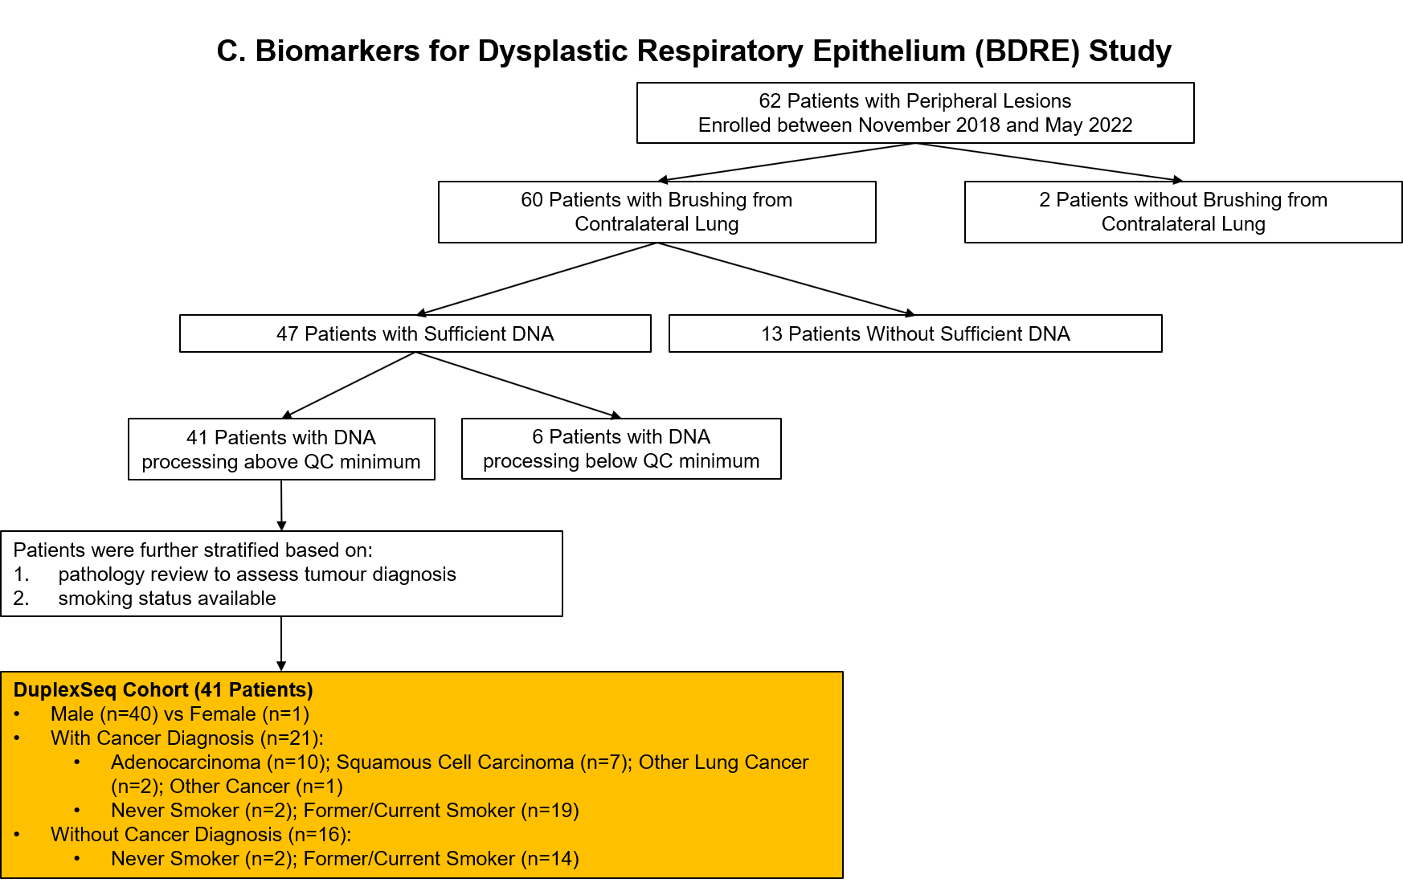
Extended Data Figure 1. Diagram of sample selection. For the PEACE (A), TRACERx (B), and BDRE (C) cohorts, we provide a breakdown of the selection of samples used for the study.

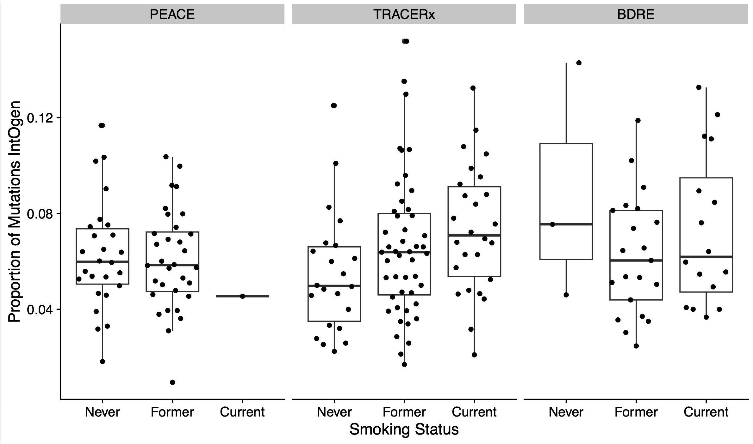
Extended Data Figure 2. Proportion of mutations detected in each cohort that have also been seen in IntOGen tumors, separated by smoking status groups.

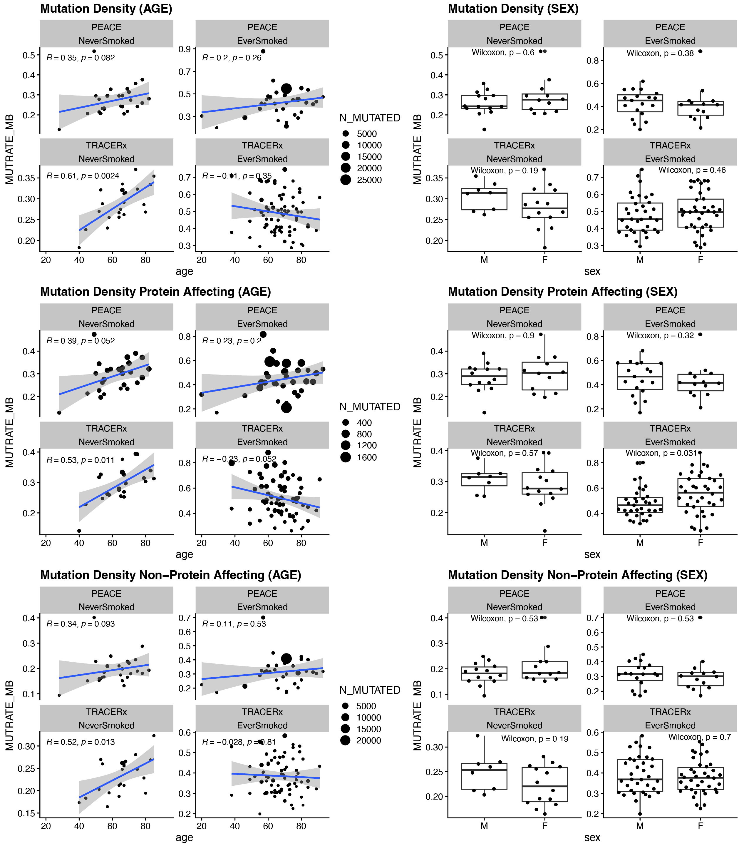
Extended Data Figure 3. Mutation density across ages and sexes. Left: Scatter plots displaying age of the patient and mutation density observed in each normal lung tissue sample of all mutations (top), protein affecting mutations (middle) and non-protein affecting mutations (bottom). Right: Box plots comparing mutation density between sex groups. Mutation density for all mutations (top), protein affecting mutations (middle) and non-protein affecting mutations (bottom) are displayed.

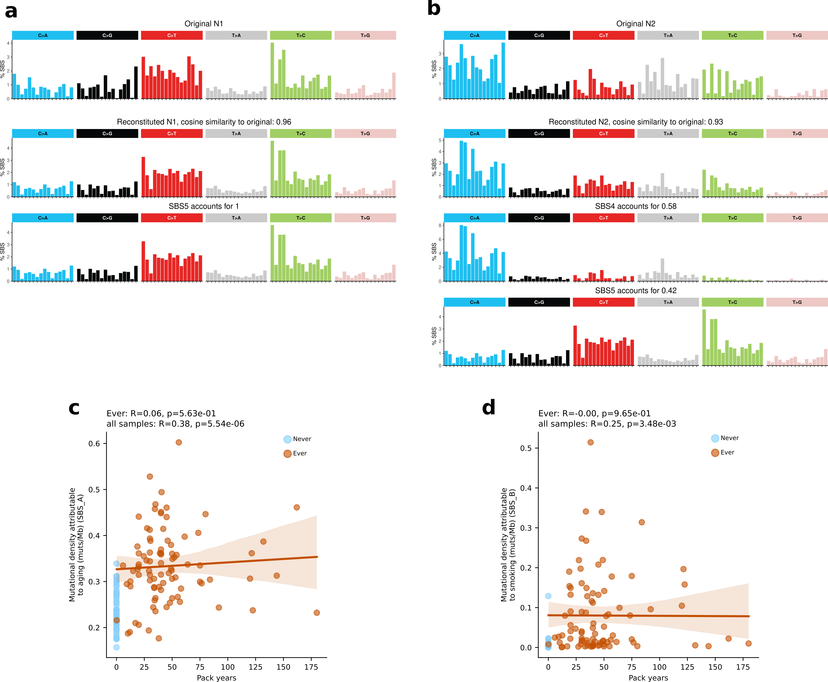
Extended Data Figure 4. Source of the observed mutational processes and correlation with pack years. a, b decomposition of the extracted signatures SBS_A and SBS_B into SBS signatures of the COSMIC reference catalog. c, correlation between the mutation density attributable to aging and the intensity of smoking (measured by pack years). d, correlation of mutation density attributable to smoking and the intensity of smoking. Pearson R and p-values are shown for each group.

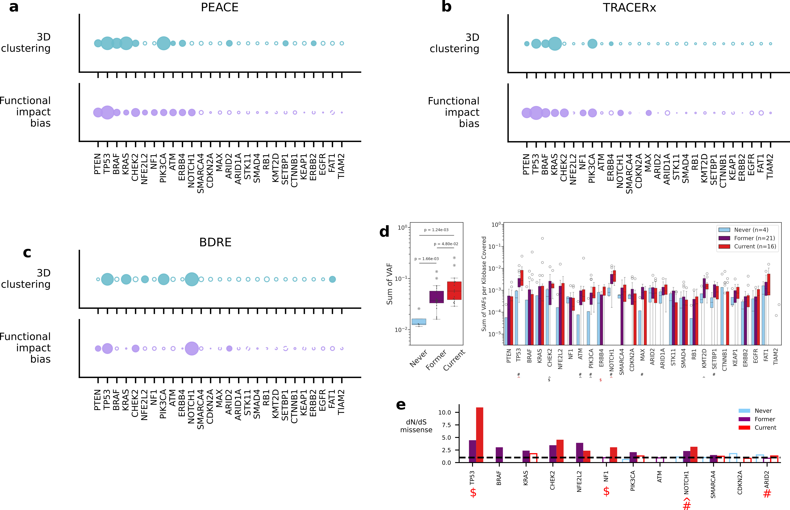

Extended Data Figure 5. Estimations of 3D clustering and functional impact for mutations, and measurements of smoking dependent selection in BDRE. a-c, Bubble plots of 3D clustering of missense mutations within a protein (Oncodrive3D) and of the functional impact bias of the mutations within a gene (OncodriveFML). Filled in shapes indicate statistically significant positive selection. d. Box and whisker plots of the sums of VAFs of protein-affecting mutations by smoking status across the sequencing panel (left) and by gene within the panel (right). e, Bar plots of VAF-weighted dN/dS calculations of missense mutations in genes under selection stratified by smoking status. For d-e, black and red symbols indicate that unadjusted and adjusted, respectively, p-values < 0.05 for comparisons in cohorts. The #, ^, and $ symbols indicate never-former, never-current, and former-current comparisons, respectively. Groups in e were compared using a Fisher’s exact test on the proportions of driver-vs-expected mutations in each group.

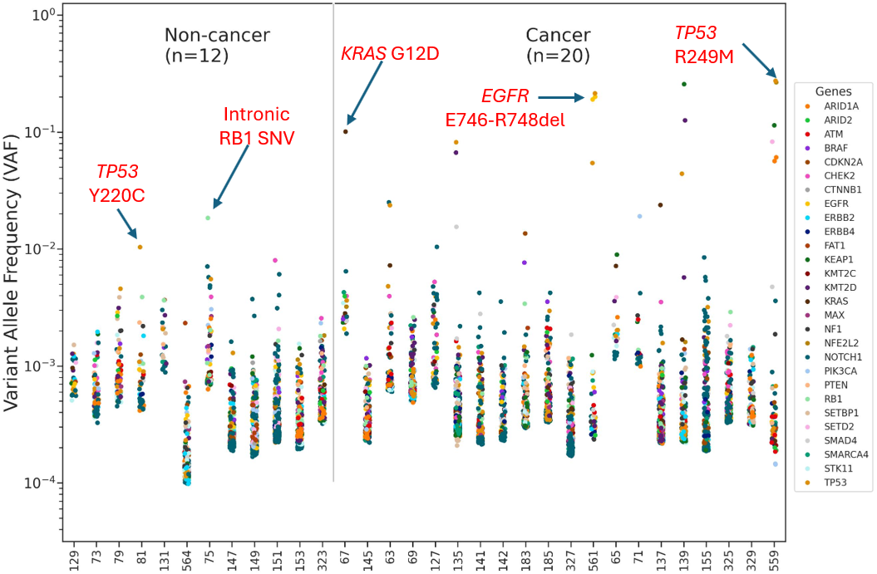
Extended Data Figure 6. Mutations in the involved side of bronchoscopy brushings. Log-scale strip plot stratified by cancer diagnosis of the VAFs of the mutations in the lesions observed in CT scans. The samples were taken from bronchoscopy brushings. Each datapoint represents a mutation and the color indicates the gene in which that mutation resides. Some high VAF mutations are denoted to highlight the oncogenic drivers in those with lung cancer.

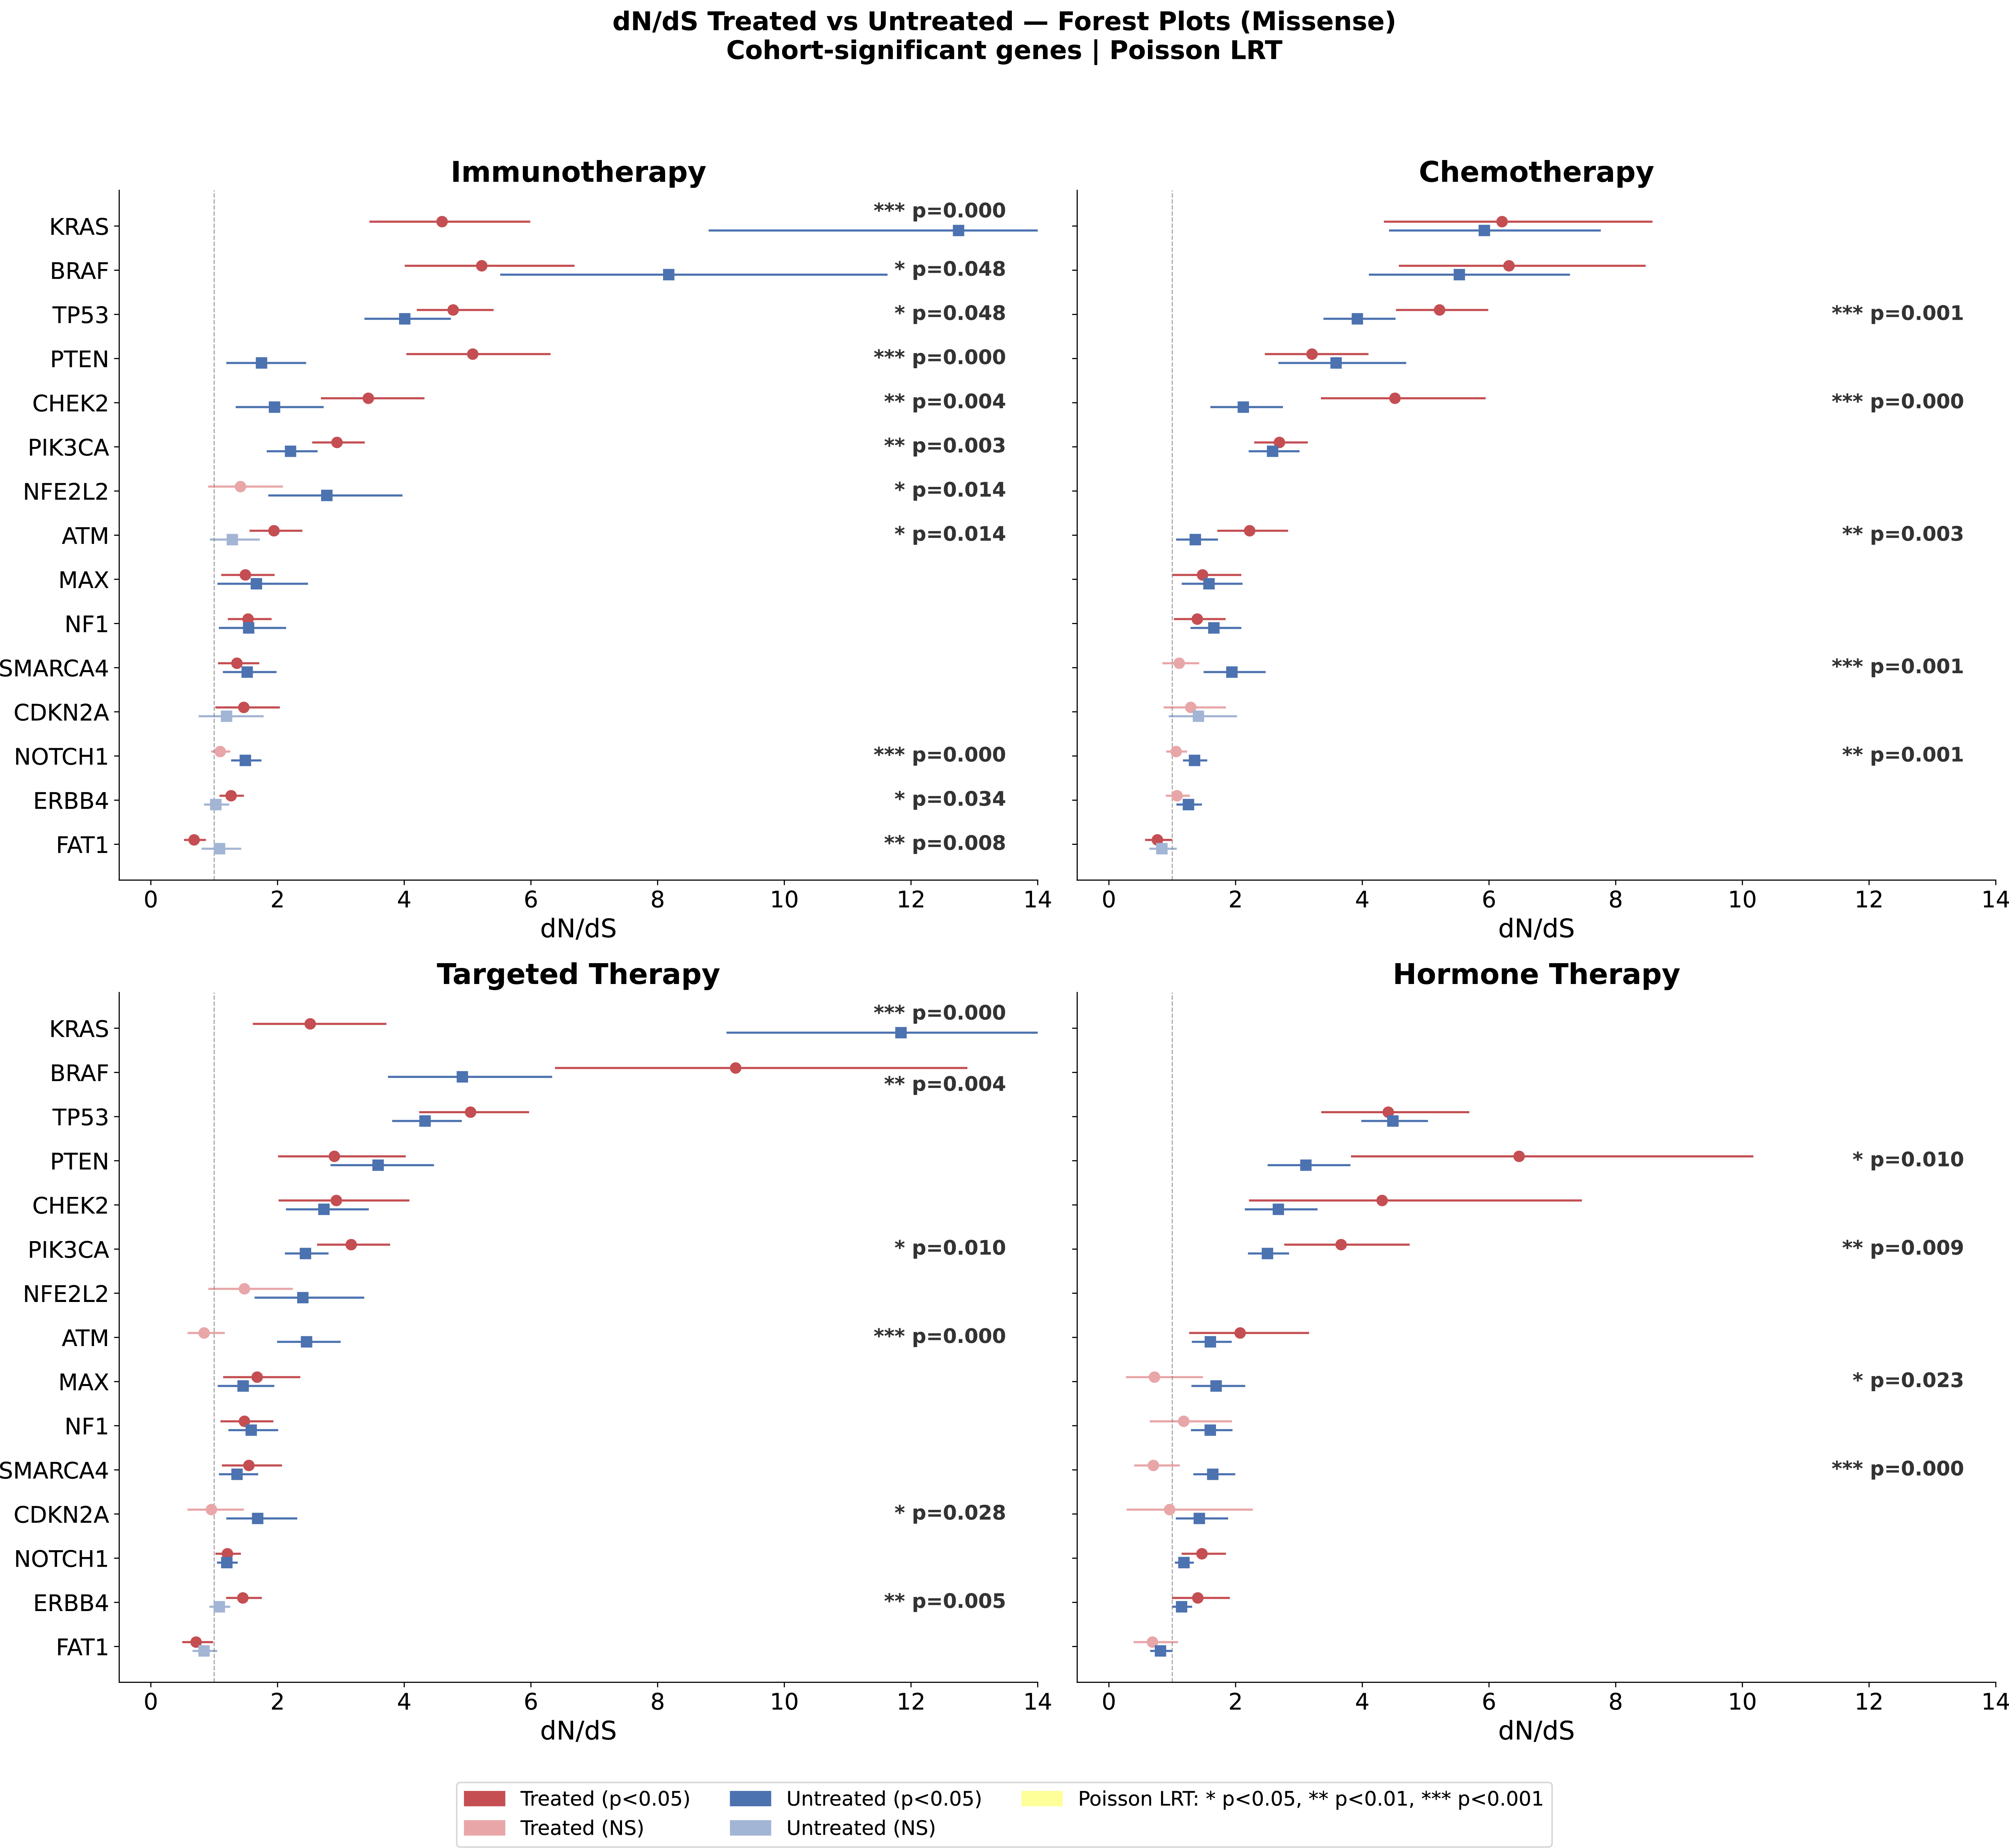
Extended Data Figure 7. Therapy can impact the mutation-driven clonal selection in the normal lung. Forest plots of the impact of immunotherapies, chemotherapies, targeted therapies, and hormone therapy on the selection for the panel’s genes calculated by dN/dS of missense mutations.

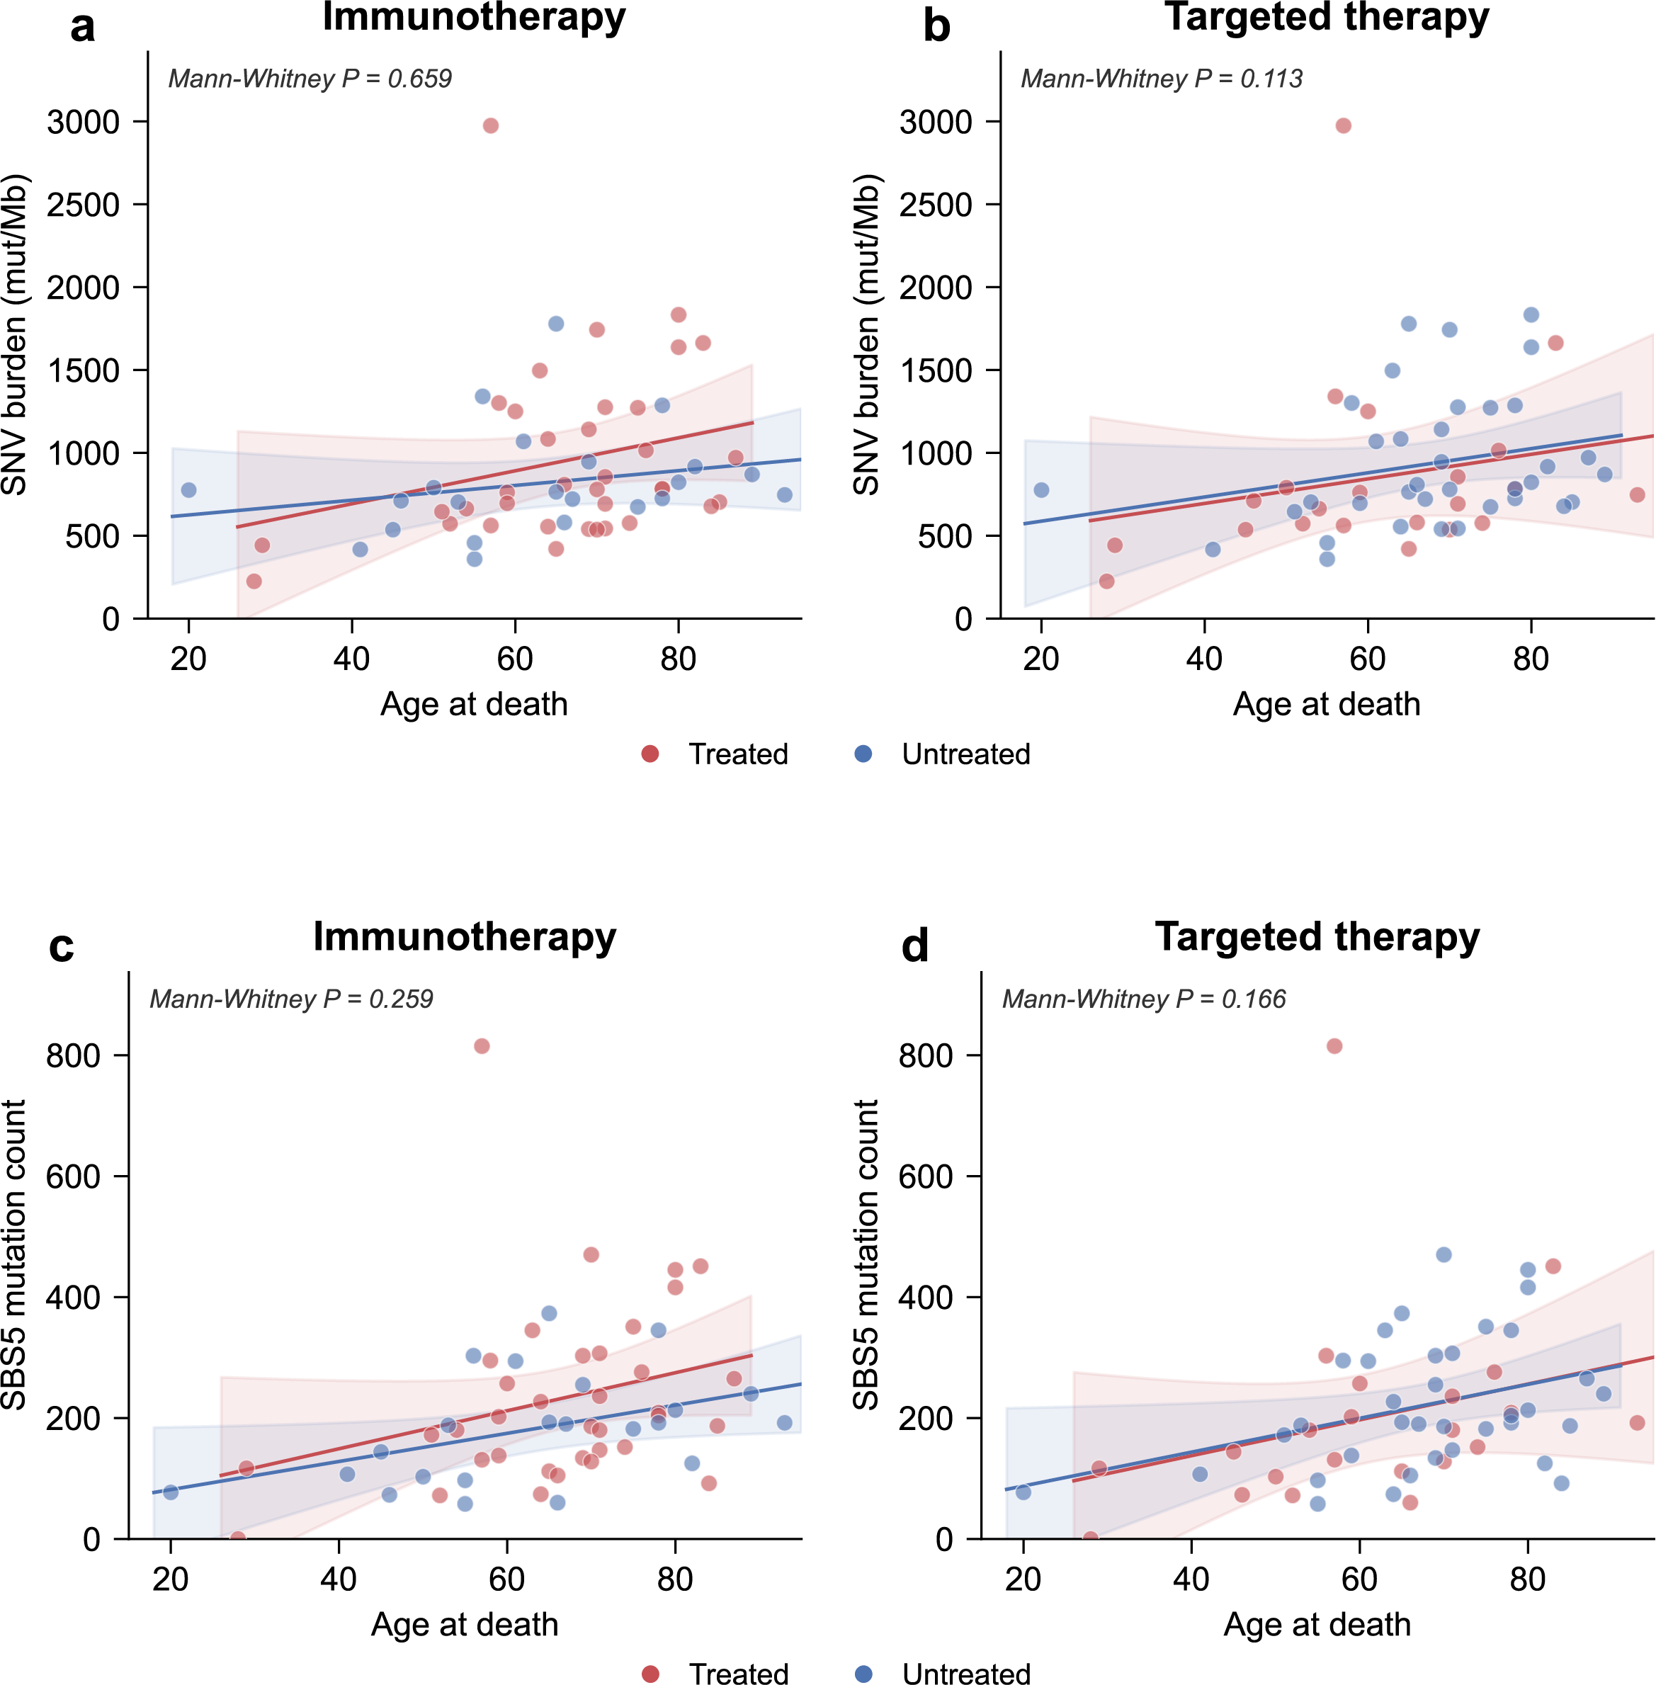
Extended Data Figure 8. Mutation burden and clock-like signature activity are not significantly altered by prior immunotherapy or targeted therapy. (a,b) SNV burden (mutations per megabase) plotted against age at death for patients who received immunotherapy (a) or targeted therapy (b), compared with untreated patients. (c,d) SBS5 mutation counts plotted against age at death for patients who received immunotherapy (c) or targeted therapy (d).

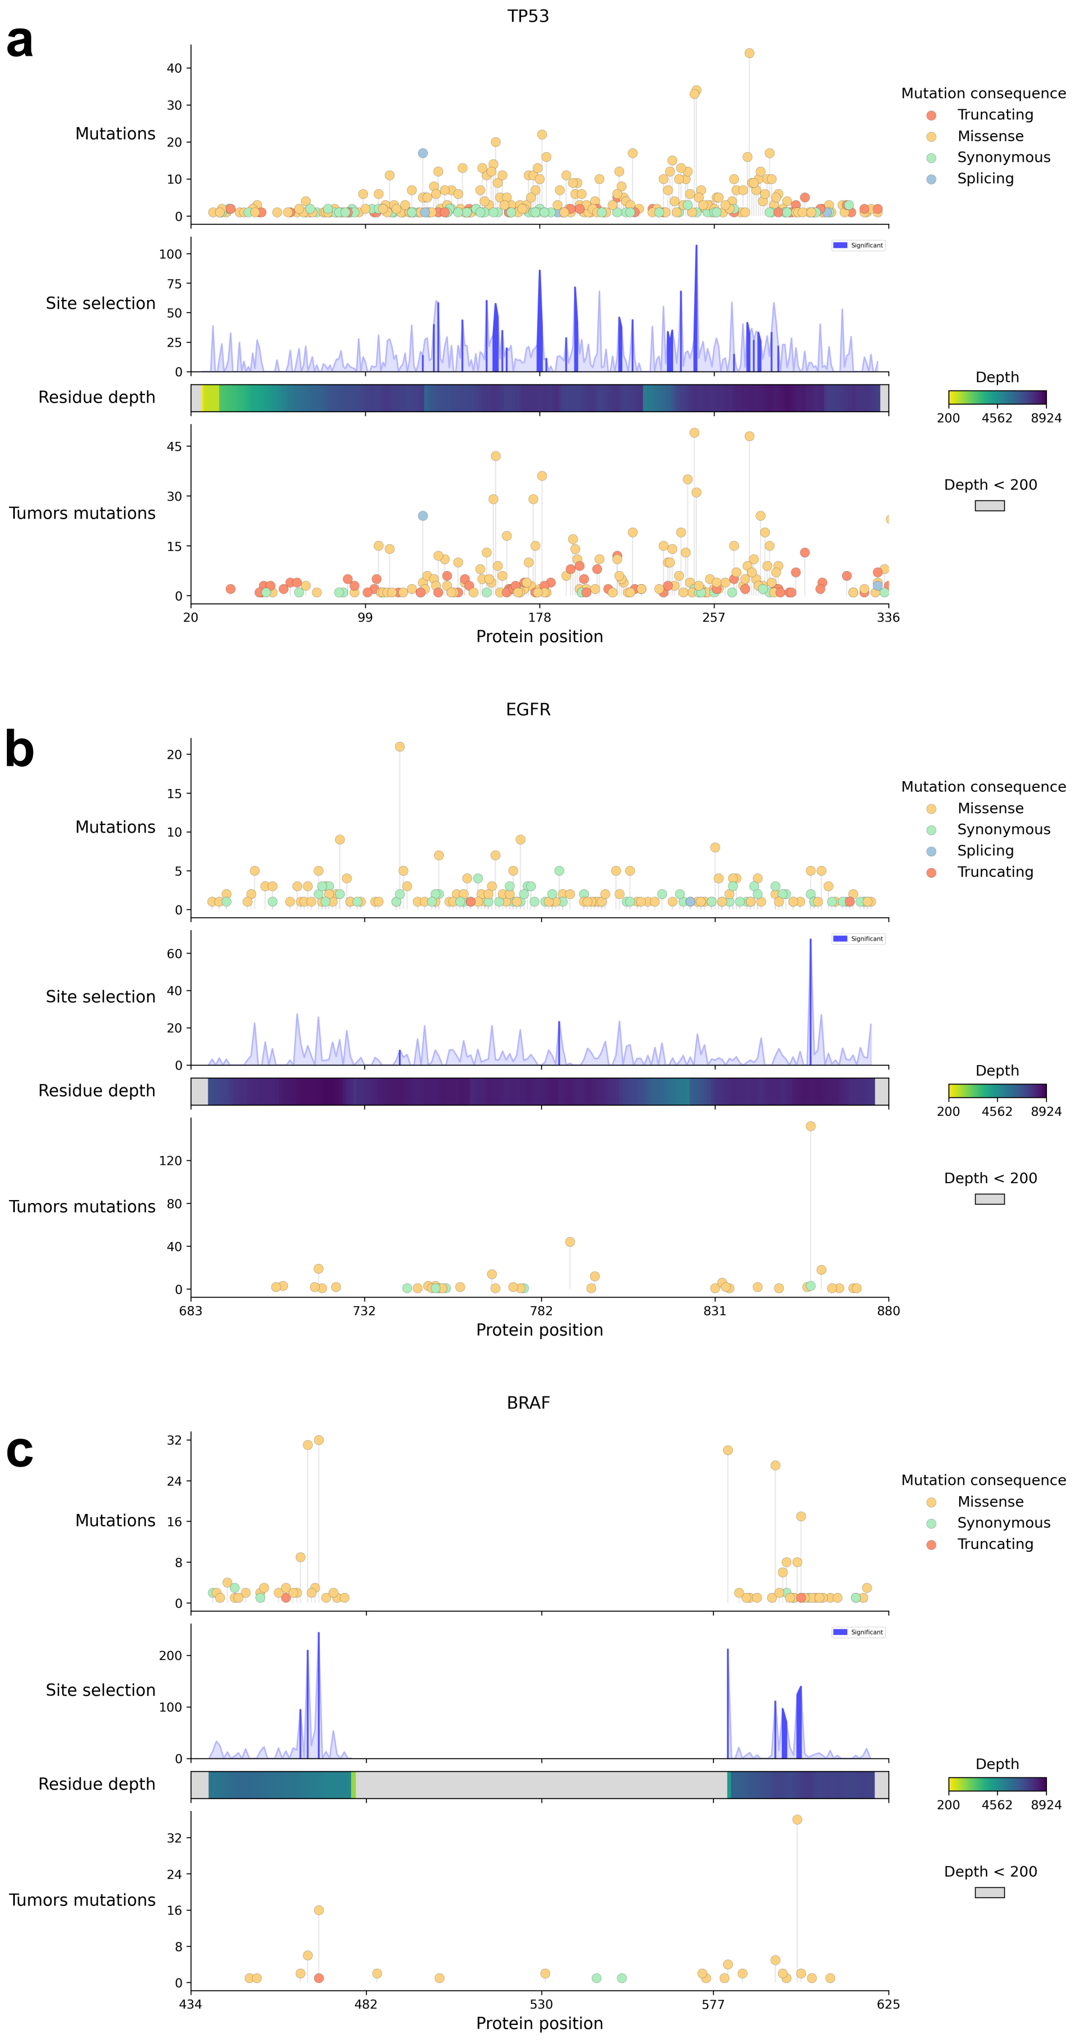
Extended Data Figure 9. Site selection plots for additional genes. For BRAF (a), EGFR (b), and TP53 (c), each plot contains a first track showing the mutations per position in the protein separated by consequence type. The second track indicates the selection for each individual site in the protein. The next track represents the average sequencing depth for each position of the gene, and the last track shows the number of mutations observed in lung tumors of IntOGen.
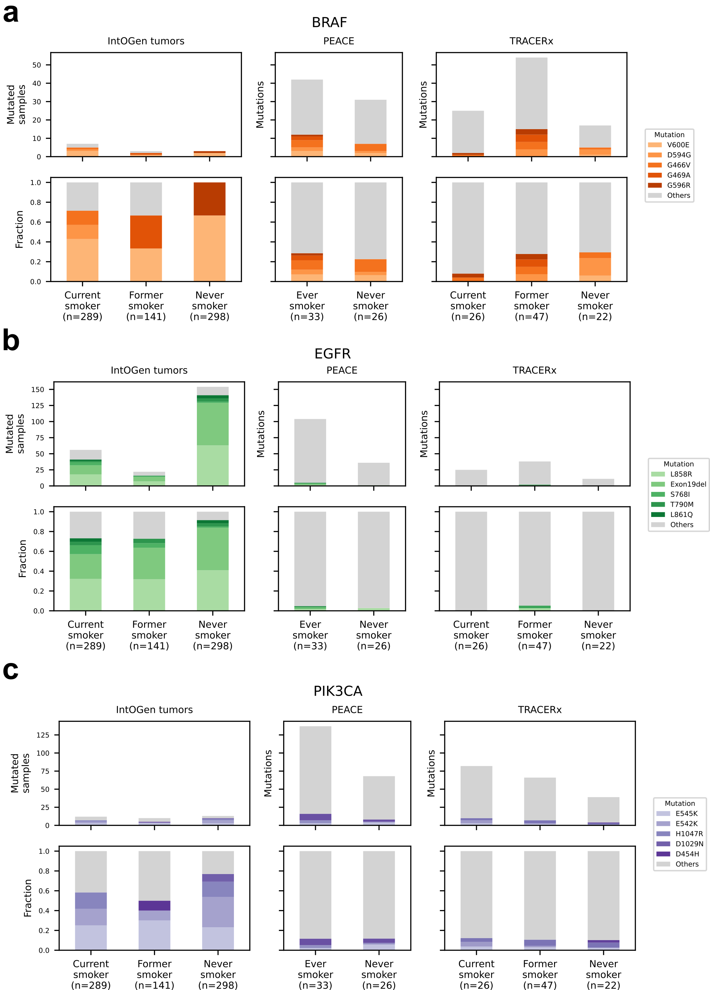
Extended Data Figure 10. Cancer and normal hotspots per smoking group for additional genes. For BRAF (a), EGFR (b), and PIK3CA (c), each plot shows the number (top track) and proportion of mutations (bottom track) classified as drivers according to BoostDM (+ EGFR exon 19 deletion). The same information is shown for the tumors in the IntOGen cohorts and the normal tissue samples of PEACE and TRACERx.

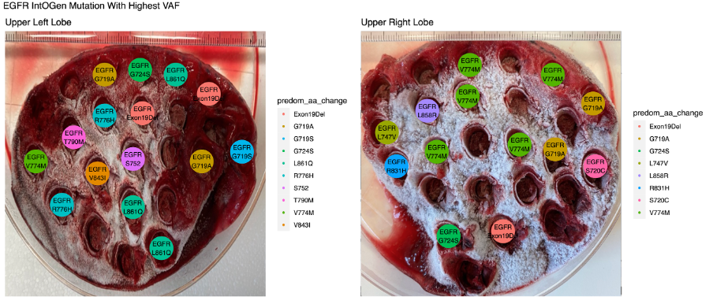
Extended Data Figure 11. IntOGen EGFR mutations in multi-region samples from CRUKP5309. The left and right lobe normal lung tissue slices are displayed. The colored dots represent regions where an IntOGen EGFR mutation is detected. The color indicates the amino acid change of the mutation.

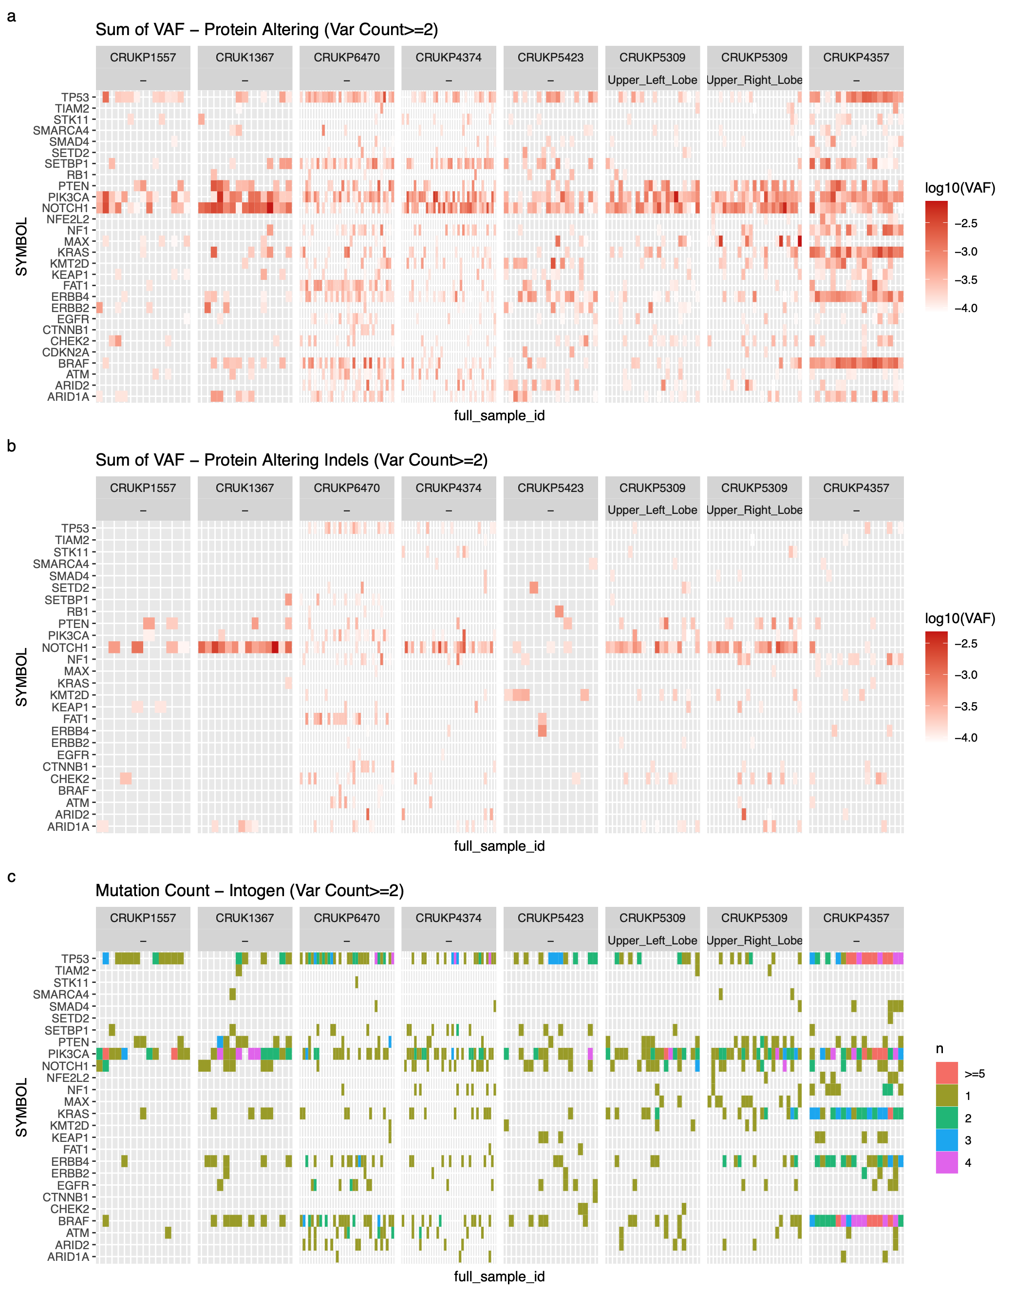
Extended Data Figure 12. Mutated genes in multi-region samples obtained from 7 patients. Top: For each gene, the sum of VAFs (var count >2) across all protein affecting mutations (a), protein affecting indels (b), and the count of IntOGen mutations (c, var count >2) in each sample is displayed.

Extended Data Table 1. Targeted panel for duplex sequencing. The table is comprised of the chromosome, start position, end position, and gene name of genomic loci that are captured by the probes for targeted sequencing. See attached Excel file.

Extended Data Table 2. Patient characteristics of provided samples. The table is comprised of sheets for all normal tissue samples across the cohort, PEACE, TRACERx, normal tissue, contralateral BDRE sample data, and involved site BDRE sample data. See attached Excel file.

Extended Data Table 3. Calculations of confounding factors. Top: The means of age and BMI and count of the sexes in the PEACE, TRACERx, and BDRE cohorts stratified by smoking status. 9 of the 59 participants in the PEACE cohort were missing BMI information. Bottom: Calculated p-values of differences in the confounding factors across smoking status. For age and BMI, T-test or Mann-Whitney U (also called Wilcoxon Ranked Sum) test is the statistical test depending on normality of data. For sex comparisons, we used the Fisher Exact test. Red indicates statistical significance.

GENE | Protein position | Amino acid change | Observed mutations | Expected mutations | OBS/EXP | pvalue
NF1 | 2276 | E/A | 3 | 0.033596 | 89.29 | 0.00000616303
EGFR | 858 | L/R | 5 | 0.073969 | 67.59 | 0.000000017351
NOTCH1 | 357 | F/S | 4 | 0.065663 | 60.91 | 0.00000073498
SMARCA4 | 926 | N/S | 8 | 0.15474 | 51.69 | 7.10576E-12
SETD2 | 1962 | P/L | 7 | 0.154289 | 45.36 | 3.60869E-10
ERBB2 | 310 | S/F | 7 | 0.178379 | 39.24 | 9.756013E-10
KEAP1 | 469 | N/S | 8 | 0.209648 | 38.15 | 7.683654E-11
SETBP1 | 1130 | P/T | 6 | 0.177026 | 33.89 | 0.000000036736
NOTCH1 | 718 | N/S | 7 | 0.216226 | 32.37 | 0.000000003629
ATM | 337 | R/C | 14 | 0.461732 | 30.32 | 1.110223E-16
ERBB4 | 697 | P/Q | 14 | 0.485767 | 28.82 | 3.330669E-16
KMT2D | 4572 | N/S | 5 | 0.201567 | 24.80 | 0.000002345027
NOTCH1 | 336 | I/T | 5 | 0.21354 | 23.41 | 0.000003098356
NFE2L2 | 28 | I/T | 5 | 0.251027 | 19.91 | 0.00000674288
KEAP1 | 426 | Y/C | 6 | 0.312797 | 19.18 | 0.000000995713
ERBB4 | 848 | N/K | 7 | 0.447426 | 15.64 | 0.000000482093
EGFR | 742 | V/I | 18 | 2.24321 | 8.024217 | 3.884071E-11
ERBB4 | 838 | R/* | 32 | 4.487009 | 7.131699 | 3.330669E-16
ERBB4 | 840 | V/I | 31 | 4.543618 | 6.822757 | 3.330669E-16
ERBB4 | 106 | R/C | 13 | 2.749904 | 4.727438 | 0.00000654532
Extended Data Table 4. Amino acid changes with significant signals of selection for genes with non-significant missense dN/dS at gene level. Summary table of all sites with significant site selection values across the entire PEACE and TRACERx cohorts. Genes with significant missense dN/dS at the gene level were excluded from this table, and only sites with a p-value smaller than 10⁻⁵ are shown. Shaded rows indicate known hotspots identified in the sequencing of cancer genomes.
Extended Data Table 5: Sum of variant allele frequency comparisons by gene against control gene TIAM2. For each gene in the PEACE and TRACERx cohort across smoking statuses, we compared the sum of VAF of each lung cancer-associated gene to TIAM2. If the p-value > 0.05, it is marked red, highlighting the genes that did not differ and were likely not under strong positive selection. BDRE is excluded from this analysis due to insufficient samples run with the TIAM2 control gene.

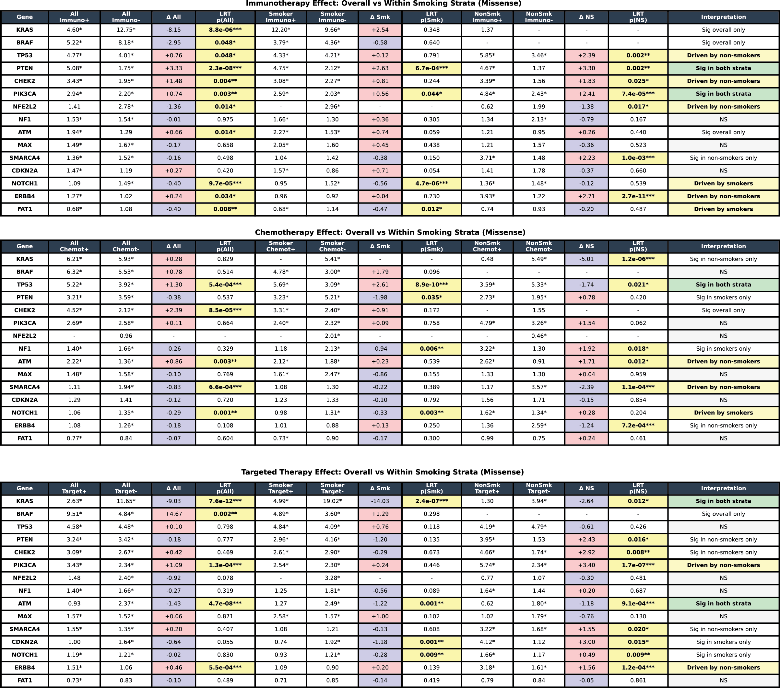
Extended Data Table 6. Treatment effect on missense dN/dS stratified by smoking status across therapy types. For each gene, dN/dS estimates (with asterisks denoting individual gene-level significance, * p<0.05) are shown for treated and untreated groups in the overall cohort and within smoking strata (smokers and never-smokers). The delta (Δ) columns report the difference in dN/dS between treated and untreated groups (treated minus untreated), with positive values indicating higher dN/dS in treated patients. Poisson likelihood ratio tests (LRT) compare dN/dS between treated and untreated groups within each stratum, with p-values highlighted in yellow where p<0.05. Δ NS (never-smokers) values are colored red where treatment is associated with higher dN/dS and blue where treatment is associated with lower dN/dS. The Interpretation column summarizes where significant treatment effects are observed: "Sig in both strata" (treatment effect in both smokers and never-smokers), "Driven by non-smokers" (significant in never-smokers only), "Driven by smokers" (significant in smokers only), "Sig overall only" (significant in the overall cohort but not within individual strata), or "NS" (not significant).

