Baicalin-Loaded MOF-818 Nanozyme for Ischemic Stroke Treatment via ROS Scavenging and Neuroinflammation Suppression

Fig. S1. Pore distribution of MOF-818.

Fig. S2. Encapsulation ratio of Bai@MOF-818 at different feeding ratios. The data are presented as the mean ± sd. *p < 0.05, **p < 0.01.

Fig. S3. Loading capacity of Bai@MOF-818 at different feeding ratios. The data are presented as the mean ± sd. *p < 0.05, **p < 0.01.

Fig. S4. Cellular uptake of Rhodamine B-labeled MOF-818 in PC-12 cells. The data are presented as the mean ± sd. *p < 0.05, **p < 0.01.

Fig. S5. Viability of PC-12 cells after incubation with different concentrations of Bai@MOF-818. The data are presented as the mean ± sd. *p < 0.05, **p < 0.01.

Fig. S6. Viability of PC-12 cells after incubation with different concentrations of Bai@MOF-818 under OGD/R condition. The data are presented as the mean ± sd. *p < 0.05, **p < 0.01.

Fig. S7. Quantification of DCFH-DA fluorescence (n= 3). The data are presented as the mean ± sd. *p < 0.05, **p < 0.01.

Fig. S8. Quantitative analysis of mitochondrial Δ𝜓m (n= 3). The data are presented as the mean ± sd. *p < 0.05, **p < 0.01.

Fig. S9. mRNA expression of IL-6, TNF-α, IL-10, and Arg-1 in each group (n= 3). The data are presented as the mean ± sd. *p < 0.05, **p < 0.01.

Fig. S10. Quantitative analysis of TUNEL-positive cells in each group (n= 3). The data are presented as the mean ± sd. *p < 0.05, **p < 0.01.

Fig. S11. Behavioral function assessments after MCAO/R. (A) Cylinder test. (B) Longa neurological deficit score. (C) Adhesive Tape Removal Test. The data are presented as the mean ± sd (n= 5). *p < 0.05, **p < 0.01.

Fig. S12. RT-qPCR analysis of inflammatory marker gene expression (Arg-1, TNF-α, IL-6, and IL-10). The data are presented as the mean ± sd (n= 3). *p < 0.05, **p < 0.01.

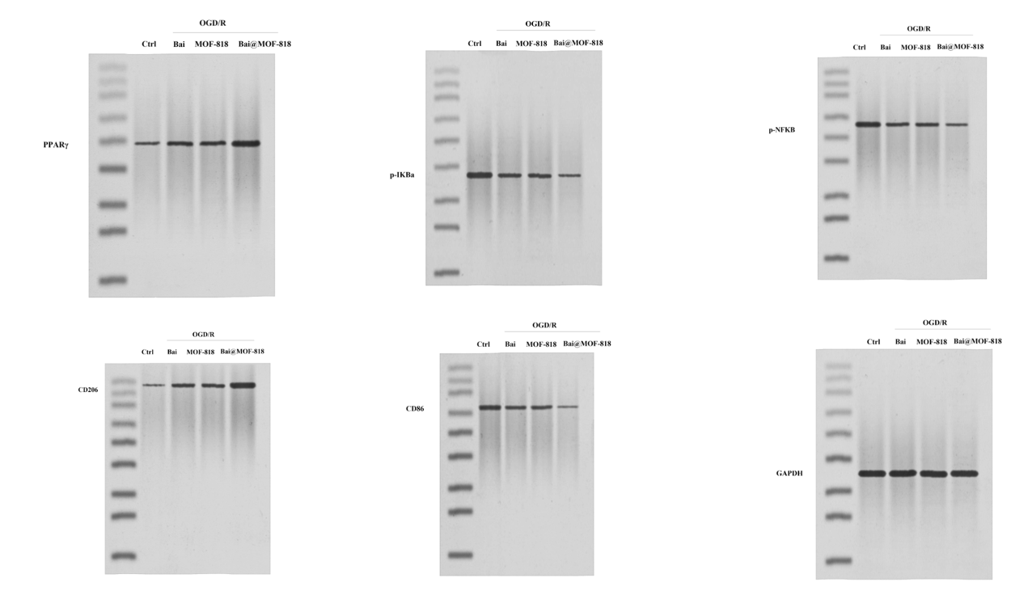
Fig. S13. Full, uncropped Western blots from independent replicate experiments corresponding to Figure 4 in the main manuscript.

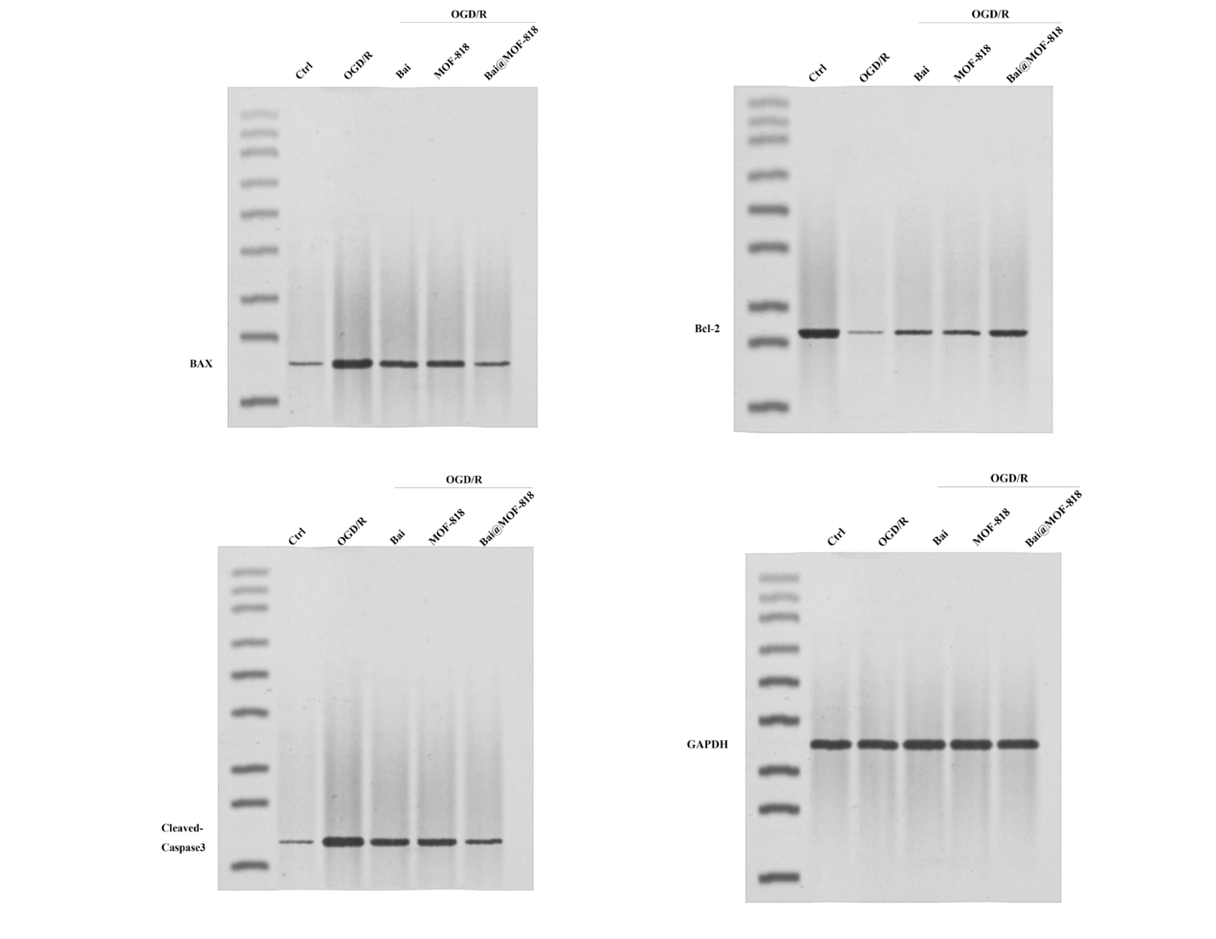
Fig. S14. Full, uncropped Western blots from independent replicate experiments corresponding to Figure 5 in the main manuscript.

