Supplementary Materials
Text S1. Scale, life history, and genetic considerations
There are both local and system-wide benefits of reef management. Reef fish populations can benefit from spillover effects of marine reserves in locations beyond the protected area. Given the long-range dispersal of broadcast-spawning corals, similar benefits are expected from local coral conservation actions^{16,22,35,36}. While our study focussed primarily on quantifying system-wide effects of different management actions, local effects are also important, especially for specific high value reefs that provide social, cultural, or economic services. Notably, the scale of local management activities that we tested was considerable, modelling the full protection of one third of the reef system from manageable disturbances or the out-planting of corals across one tenth of reef area (30% reef area at a third of reefs). While this large scale of intervention may preclude direct interpretation of absolute coral coverage and heat tolerance gains in the model, the insights into this strategy are sound. The importance of utilising heatwave exposure gradients in spatial prioritisations increases substantially for systems with stronger spatial heatwave gradients. Further, larger benefits can be expected if spatial prioritisation also considers the larval connectivity of management sites, for instance, heatwave hotspots that are also strong larval source reefs can act as evolutionary pumps for the wider metapopulation^{16,23,30}.
Coral species occupy a range of life history strategies, including weedy, competitive, and stress tolerant taxa⁵⁵. Our model is designed for corymbose Acropora corals which comprise a large portion of the coral community on Palauan outer reefs. How interactions between species traits, evolution, and spatial heatwave gradients could alter future trajectories and spatial conservation advice will be a critical topic for future research. The fact that our results remained the same when colony growth rates and initial heat tolerances were parameterised to that of massive Porites suggests that management advice from our study is robust to differing coral taxa, however, more comprehensive future investigations are required to understand the management importance of species diversity, interspecific coral competition, and reproductive mode. For instance, brooding coral species, like Stylophora pistillata, exhibit internal fertilisation, release competent larvae, and have much smaller dispersal distances than broadcast spawning species⁴². As such, evolutionary trajectories of brooding coral populations could be far more spatially heterogenous as compared to broadcast spawners, like Acropora and Porites.
Coral heat tolerance is a complex trait influenced by 100s to 1000s of genes and non-genetic factors including colony size, exposure to irradiance, current flow, and their symbiotic microbial associations^{39,53,56–58}. Our model tracks evolution of heat tolerance as a quantitative trait, not by simulating trait-associated alleles. Therefore, our model is unable to account for the inherent importance of effective population size on evolutionary potential, erosion of genetic diversity due to selection, or genetic drift. To elucidate the relative influence of different management interventions, our model assumed heat tolerance to be a purely genetically based trait, however, these other factors could play a role in thermal evolution and coral population persistence. For instance, different taxa of microalgal and prokaryotic symbionts are known to influence holobiont tolerance^{37,59}, and there is also scope for evolutionary adaptation of these symbiont species⁶. Recent work on Palauan Acropora digitifera found a rare putative Cladocopium species (C15h) that is associated with low heat tolerance in corals from hotspots but not thermal refugia, while other work has identified higher heat tolerance variability in corals from thermal refugia^{7,39}. These findings allude to the possibility of gene-by-environment interactions, which are not included in our modelling framework, such that genes positively associated to heat tolerance in one environment can have no association or negative associations in other environmental contexts³⁸.
Text S2. Baseline Eco-evolutionary Model (ReefMod-PALAU)
ReefMod-PALAU is an agent-based eco-evolutionary metapopulation model developed for corymbose Acropora corals across 95 spatially explicit reefs in Palau⁹. The model simulates individual coral colonies and algal patches and incorporates ecological interactions, coral demography, size-dependent coral spawning and sexual reproduction, followed by larval dispersal among reefs given biophysical larval connectivity matrices^{9,60}. Bleaching mortality at the end of the warm season is driven by marine heatwaves, and coral heat tolerance is represented as an individual-level heritable quantitative trait subject to selection through differential survival during heat stress events. In practice, this is implemented as sigmoidal bleaching mortality curve which is a function of cumulative heat stress (DHW) such that all corals share the same global slope but with individual-level intercepts as in Lachs et al. 2024⁹. Notably, the model has previously been validated against independent long-term monitoring datasets of coral cover, colony size structure, and heatwave responses from Acropora corals and assemblages in Palau⁹.
Text S3. Parameterisation of Recurring Non-thermal Disturbances
To represent manageable non-thermal disturbances on coral reefs—factors that cause elevated coral mortality such as poor water quality, outbreaks of coral predators like crown-of-thorns starfish, or destructive fishing practices—we introduced a stochastic mortality process applied to individual coral colonies. Rather than capturing a specific disturbance type, our approach was designed to represent generalised, recurring anthropogenic stressors that can be mitigated through local management. Each non-thermal disturbance event at an affected reef was modelled by imposing a 50% probability of mortality for every coral colony at that reef. For the primary analyses, disturbances occurred stochastically with a once-per-decade likelihood (generated through random draws that resulted in unique disturbance chronologies for each simulation replicate) and affected all reefs across Palau to represent region-wide exposure to manageable stressors.
To assess robustness of our findings to the non-thermal disturbance regime we conducted a series of sensitivity analyses. First, we ran management simulations across a range of different disturbance frequencies by varying the return interval likelihood from once every 6 years to once every 16 years in two-year increments. Then, we repeated this approach for a disturbance regime with a more frequent but less widespread disturbance regime. This regime was designed so that the total mortality probabilities emerging from the primary analyses (50% mortality at all reefs once per decade) were equivalent in the new disturbance regime (50% mortality at 30% of reefs once every 3 years). These different disturbance regimes span plausible recurrence intervals and extent for episodic disturbances in coral reef systems and allowed us to evaluate whether conclusions were sensitive to disturbance regime assumptions.
Text S4. Heat Stress Regimes
The heatwave exposure for each reef was derived from NOAA CoralTemp version 3.1, a gap-free daily sea surface temperature dataset⁶¹, and Global Climate Models (GCMs) for the future projection period, as in Lachs et al. 2024⁹. Cumulative heat stress was determined in terms of DHW, which is then directly linked to coral survival through past empirical quantification of heat tolerance variability of the corymbose coral Acropora aff. digitifera in Palau^{7,9,34,62}.
To determine the historic heat stress regime of each reef, we analysed the satellite-derived DHW record for Palau (1985-2020) for all moderate or greater heatwaves that have occurred (defined as those exceeding a Palau-wide average of 4 °C-weeks which corresponds to the NOAA Bleaching Alert Level 1). For each heatwave, we calculated relative DHW exposure among reefs (Reef’s DHW anomaly = reef-specific maximum DHW – Palau-wide average DHW). Each reef’s long-term heat stress regime was then summarised as the mean DHW anomaly across all qualifying events. This metric was used to rank reefs along a gradient from consistently heat-exposed “hotspots” (defined as the top tercile of reefs based on mean DHW anomaly) to consistently heat-avoiding “thermal refugia” (defined as the bottom tercile of reefs based on mean DHW anomaly).
To illustrate the spatial variability in mortality that a moderate-to-severe heatwave could generate across this heatwave exposure (DHW) gradient, we simulated an 8 °C-weeks event (NOAA Bleaching Alert Level 2), with spatial DHW variability aligned to historical patterns⁷. For each reef, we simulated 1,000 independent draws of survival for 1,000 colonies based on the present-day empirical distribution of heat tolerances⁹, corresponding to the initial trait distribution in the model. This exercise demonstrates that mortality contrasts between hotspots and refugia under equivalent regional forcing, showing the heat stress gradient is also a selection gradient.
DHW gradients can be substantial, even within a single 5 km grid cell of the focal satellite-derived SST dataset, for instance, Moore Reef in the Great Barrier Reef which varies by 4-5 °C-weeks despite being an order of magnitude smaller in spatial scale than Palau²⁹. To assess the influence of stronger DHW gradients, we took the native DHW gradient (DHW anomalies for each reef that vary by up to ~2 °C-weeks), and we add this to the anomaly map to each year in the timeseries under levels of x1 (native – no addition), x1.5 (addition of a 0.5x DHW anomaly map), x2, x3, x4, and x5. DHW ranges among these scenarios were 2.1, 3.1, 4.2, 6.3, 8.3, and 10.4 °C-weeks, respectively. These thus represent scenarios in which it is technologically possible to identify extreme hotspots and extreme thermal refugia. In reality, this would require more advanced dynamic and depth-integrated physical models rather than satellite observation of the sea surface.
Text S5. Climate Forcing and Global Climate Model (GCM) Selection
Here we use future projections of DHW heatwave stress from a subset of a sixteen-GCM ensemble used in our previous work^{9,10}. Equilibrium climate sensitivity (ECS) is a metric used in climate modelling to determine the amount of global warming caused by an immediate doubling of CO₂ in the atmosphere. The best estimate from the Intergovernmental Panel on Climate Change for ECS of the Earth system is between 2.5 and 4 °C. However, the full ensemble of GCMs includes ten ‘hot models’ that are overly sensitive to CO₂ ⁹. Therefore, our study focussed only on the six GCMs with ECS values within the IPCCs best estimate range.
These six GCMs were then evaluated for their ability to reproduce observed spatial variability in heatwave exposure across Palau, calculated as the mean cumulative heat stress anomaly (DHWa) across all events exceeding 4°C-weeks (e.g., Fig. 2a). Congruency in DHW anomaly gradients between the satellite record (DHWa_{CT}) and future projections statistically downscaled from GCMs (DHWa_{GCM}) were tested using linear regressions. All retained models exhibited strong agreement with observations (0.67 ≤ R² ≤ 0.81), except one GCM with lower congruency (R² = 0.50–0.57 depending on scenario), which was excluded from further analyses (Fig. S14). The final ensemble of five models therefore comprised GCMs that reliably reproduced observed spatial heat stress variability.
Text S6. Management Parameterisation
Management interventions were applied annually from 2025 until the end of the simulation in 2100 and consisted of either protection or restoration at all 31 selected sites (of the possible 95 sites, e.g., the top tercile of DHWa or in other words all hotspot reefs). Protection was implemented by exempting selected reefs from the stochastic non-thermal disturbance process described above. In effect, protected reefs did not experience disturbance-induced mortality, resulting in improved local survival and increased reproductive output relative to unmanaged reefs. Restoration involved out-planting corals at selected reef across 30% of the available substrate at that reef, and at a density of 4 individuals/m². We parameterised outplant traits to reflect a restoration approach of local broodstock collection followed by one year of rearing and out-planting to the natal reef, without any manipulation of heat tolerance (i.e., selective breeding or assisted evolution). To achieve this, we set outplant colony size to 3.2 cm diameter (± 0.25 SD) as determined from out-planting trials of Acropora digitifera in Palau⁴⁹, and outplant heat tolerance to that of the previous year’s reproductive colonies (potential broodstock).

Supplementary Figures
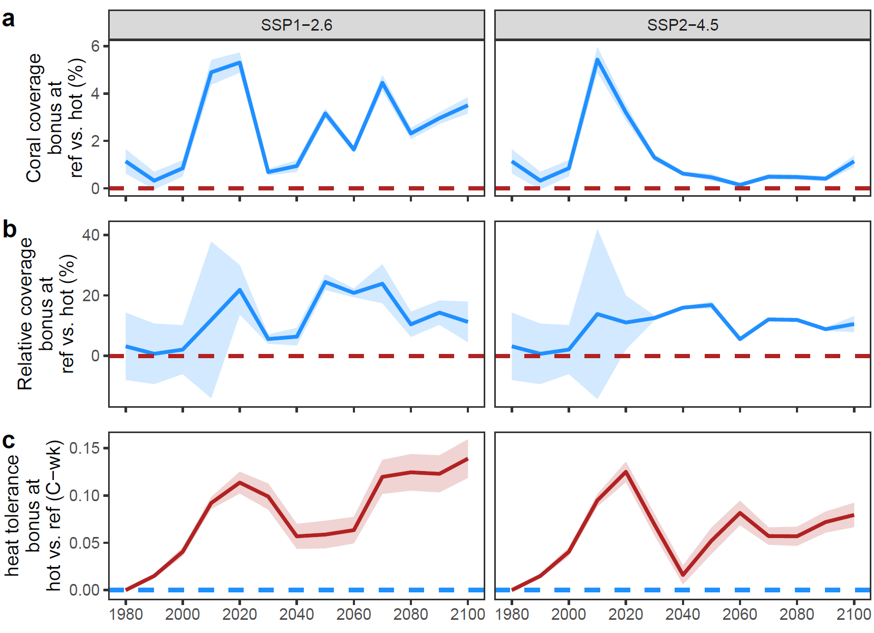
Figure S1. Differences between hotspot reefs (hot, red) and thermal refugium reefs (ref, blue) in the counterfactual scenario with once-per-decade recurring non-thermal disturbances. Results are shown as decadal mean differences (across 10 random simulations) between the two regions (colours) in terms of three metrics. (a) Absolute benthic coral coverage. (b) The percentage additional coral coverage relative to hotspot levels. For example, the additional ~0.5% areal coverage of corals at refugia compared to hotspots at the end of the 21st century in SSP2-4.5 (see a) is equivalent to an additional ~10% in relative terms (see b) because absolute coral coverage at hotspots is ~4.5% and at refugia is ~5% (0.5% absolute bonus = 10% relative bonus). (c) Heat tolerance. Dashed lines show the reference region with lower values; hotspots for coral coverage (a-b), and refugia for heat tolerance (c). Error bars show standard errors of delta values computed through propagation of standard errors on means.

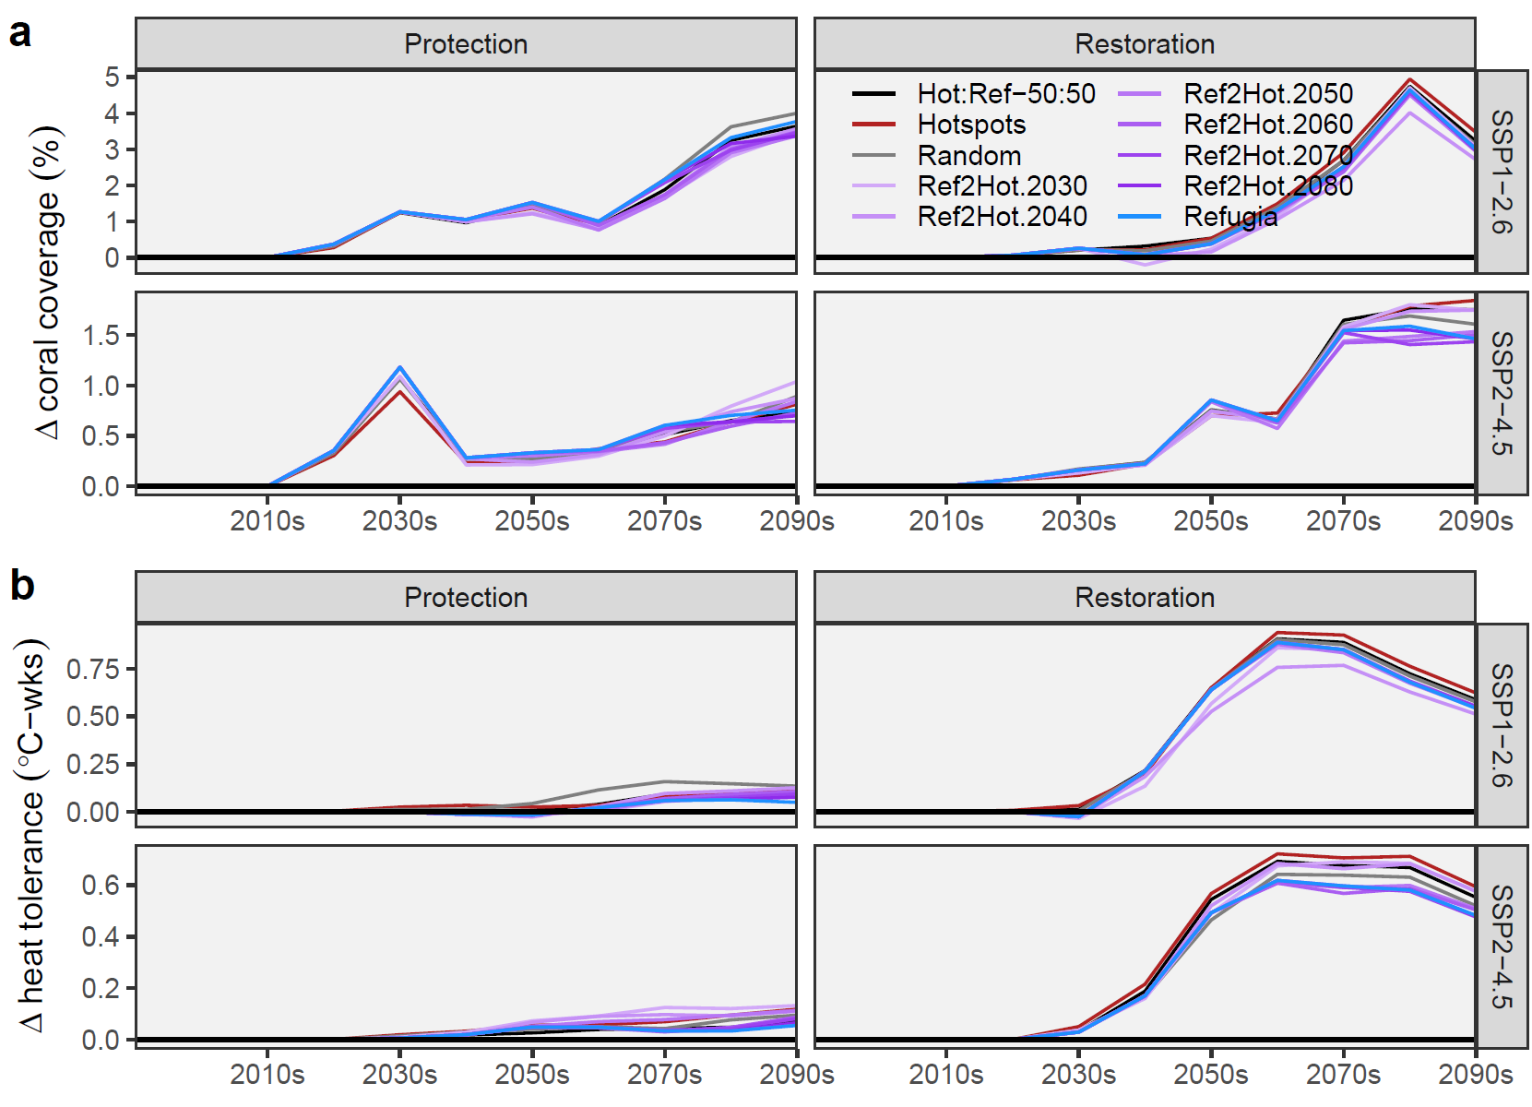
Figure S2. System-wide benefits of management strategies (i.e., protection or restoration) relative to the counterfactual scenario of no management (y=0, black line). Time series are shown for delta values of coral coverage (a) and heat tolerance (b) as a function of management type and emissions scenario. Temporally fixed strategies (hotspot-only, refugia-only, random reef portfolio) and temporally shifting strategies (Ref2Hot, moving from early focus on refugia to later focus on hotspots) are shown. Lines represent decadal means across Global Climate Models and 10 random simulation runs for once-per-decade disturbances.

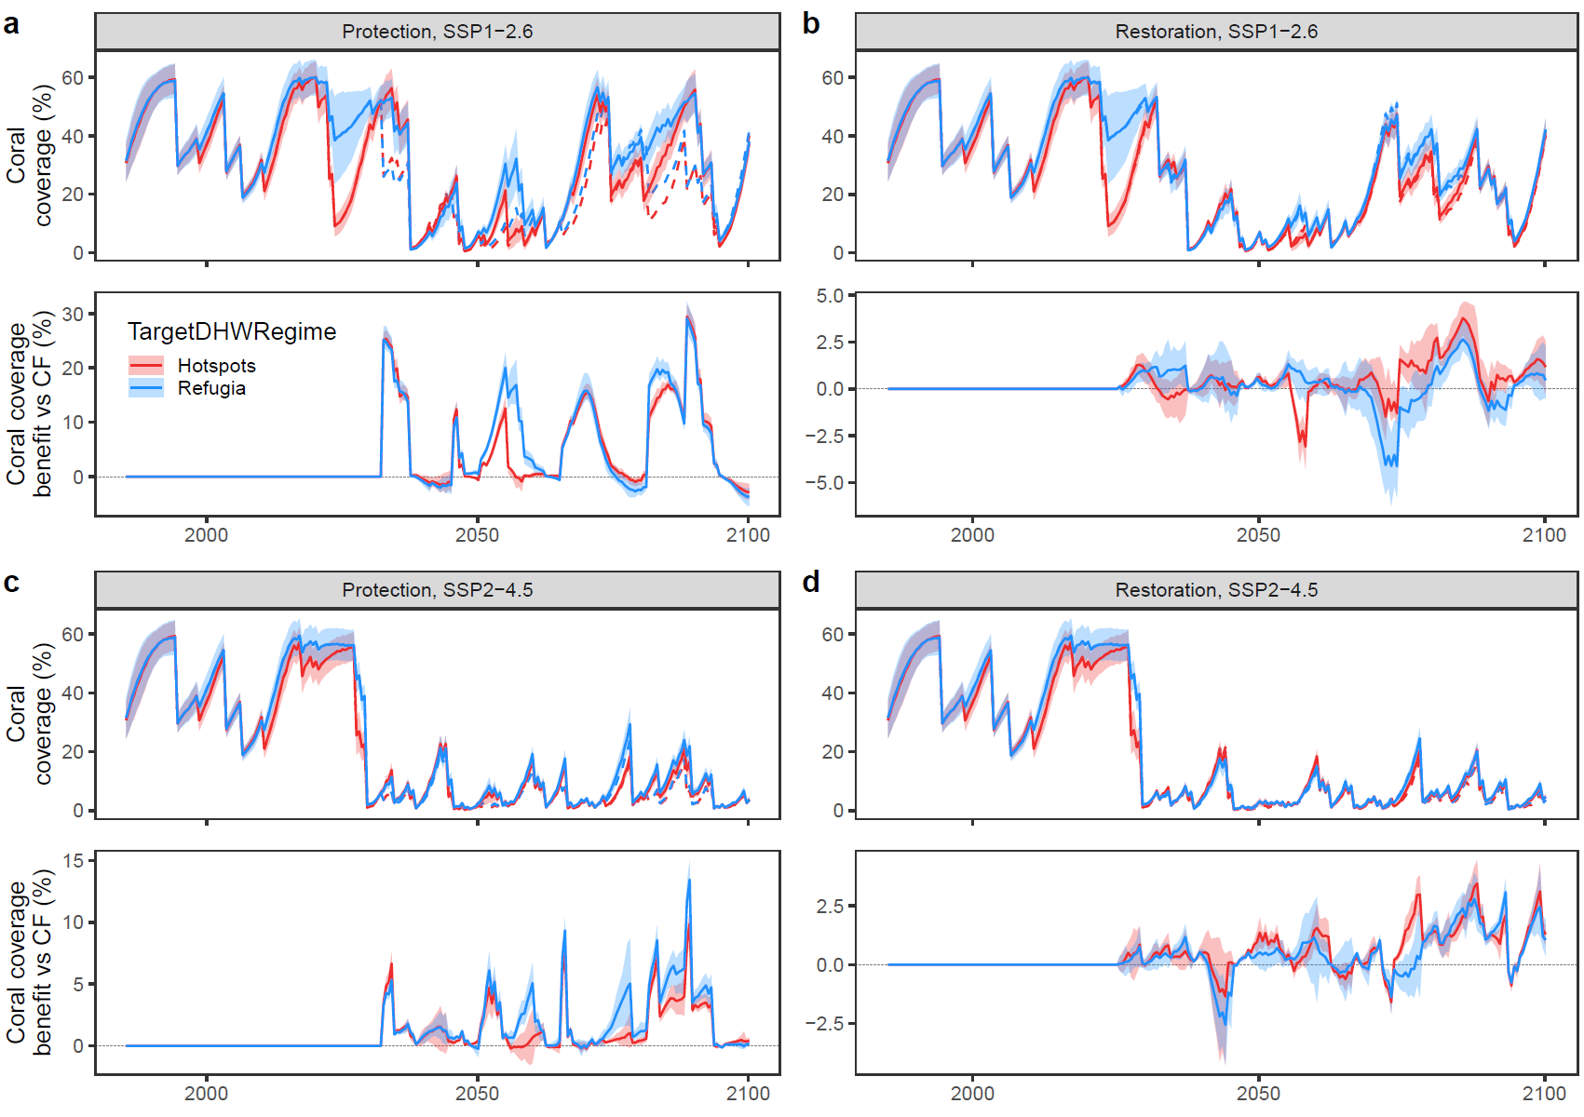
Figure S3. Local benefits in coral coverage at target locations. Results are shown for protection (a,c) and restoration (b,d) under SSP1-2.6 (a-b) and SSP2-4.5 (c-d) for a single simulation under heatwave forcing from the MIROC6 GCM. Upper panels show coral coverage at target locations, in other words, at hotspots for hotspot-focussed strategies (red) and at refugia for refuge-focussed strategies (blue), as the mean (solid line) and standard deviation (shading) from the management scenario and as the mean of the counterfactual without management (dashed line). Lower panels show the coral coverage benefit of management in terms of the mean (line) and the 25th to 75th percentiles (shading) for each of the target regions (colour). This benefit is relative to the counterfacual (CF) of no management (dashed black line, y=0).

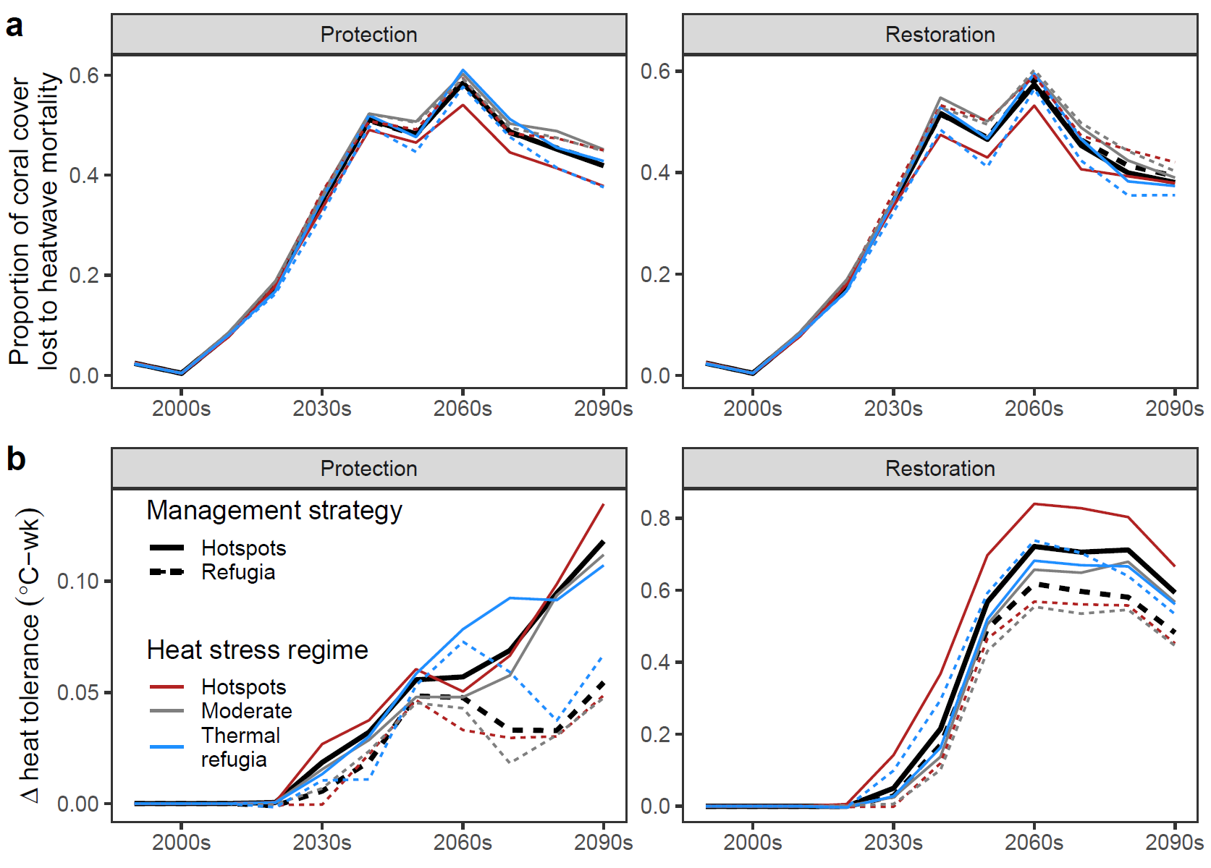
Figure S4. System-wide and regional coral losses due to heatwave-induced mortality with simulated protection or restoration at hotspots or thermal refugia (bold or dashed lines) under the higher-level warming scenario SSP2-4.5. (a) Mean proportion of a reef’s coral coverage lost due to heatwave-mediated bleaching mortality for all of Palau (black line) and for the subsets of reefs falling into different heat stress regimes (coloured lines): hotspots, moderately heat-exposed reefs and thermal refugia. (b) Corresponding decadal progression of heat tolerance benefits relative to a counterfactual scenario of no intervention shown as delta values, ∆X = X_{Strategy} – X_{Counterfactual}). System-wide proportional coral losses due to heat stress are lessened when restoration focusses on hotspots rather than thermal refugia, in part due to elevated heat tolerance. Lines represent decadal means across GCMs and 10 random simulation runs for once-per-decade disturbances.

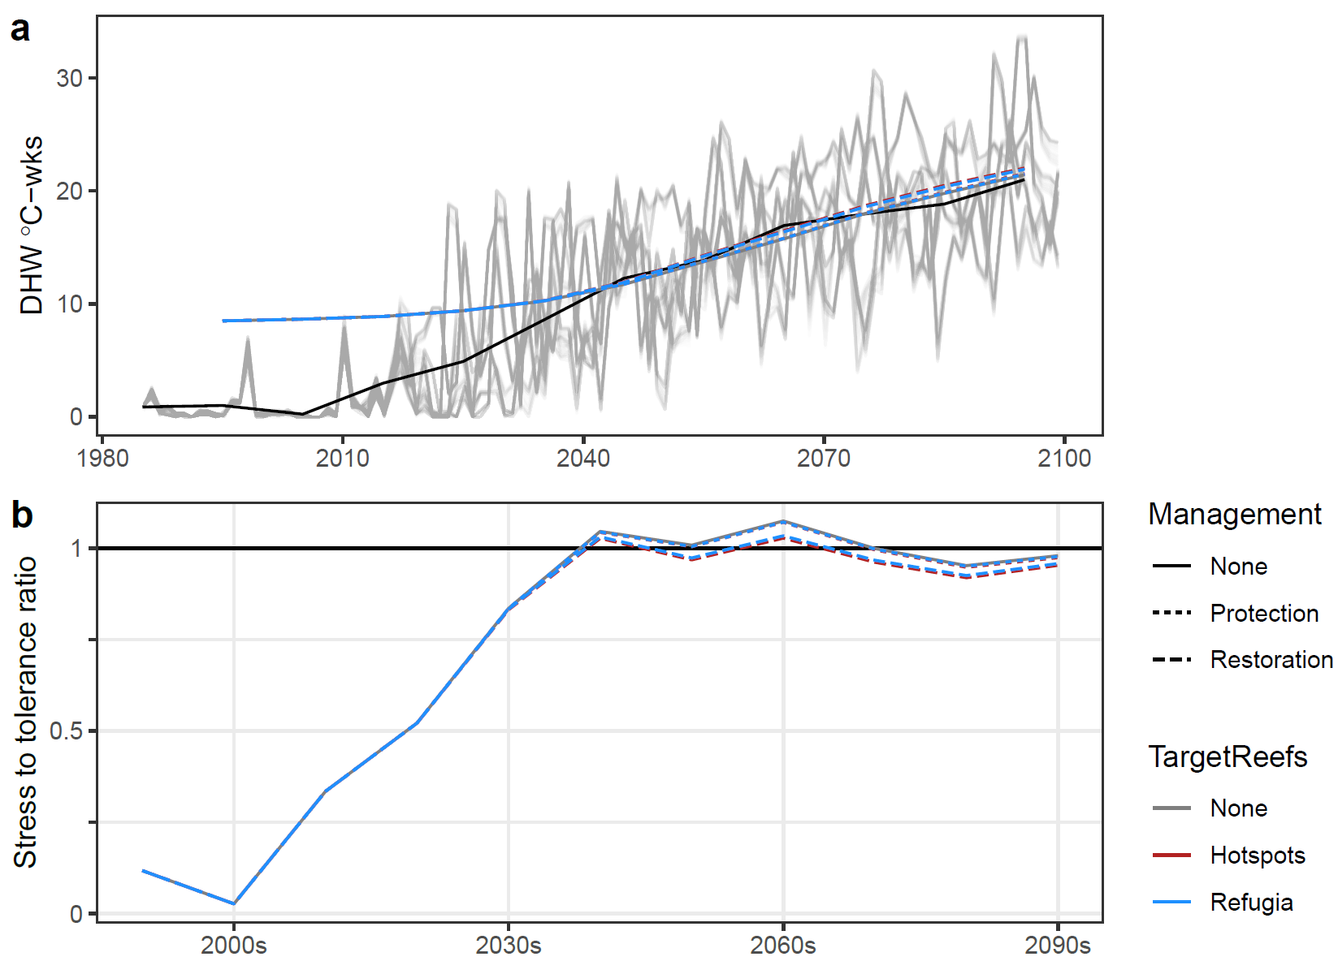
Figure S5. Heat stress and stress to tolerance ratio under SSP2-4.5. (a) Timeseries of annual maximum DHW heat stress is shown for each reef and GCM (grey lines) and the ensemble decadal mean (black line). The decadal mean system-wide heat tolerance of corals for protection and restoration scenarios focussing on hotspots and refugia (blue and red solid and dashed lines) are also shown in a. Note overlapping lines, so earlier years appear blue. (b) The heat stress to heat tolerance ratio is given as decadal means for each reef management scenario. Values less than one are for cases where heat stress is less than heat tolerance and values greater than one are when heat stress exceeds levels of tolerance.

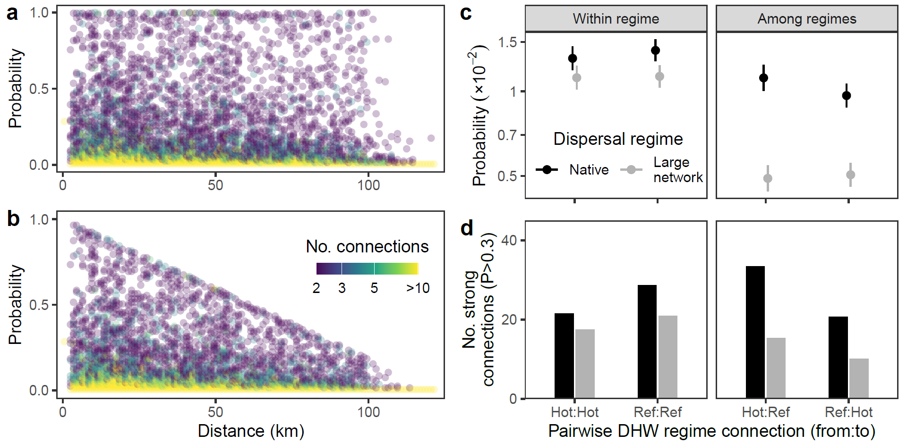
Figure S6. Comparison of the native dispersal regime with and low dispersal regime designed to mimic a larger reef network with reduced dispersal by distance. (a-b) Connectivity probabilities across all twelve connectivity matrices and sites are shown as a function of pairwise distance for the Palau dispersal regime (a) and the large-scale dispersal regime (b), coloured by data density. (c-d) Comparisons of connectivity within the same heat stress regime (i.e., hotspot to hotspot or thermal refugium to thermal refugium) and among different heat stress regimes (i.e., hotspot to refugium or refugium to hotspot) are shown for both dispersal regimes (grey and black). Variables shown are the mean connectivity probability and 95% confidence intervals (c) and the number of strong connections (P>0.3, the 90th percentile) per dispersal simulation (d).
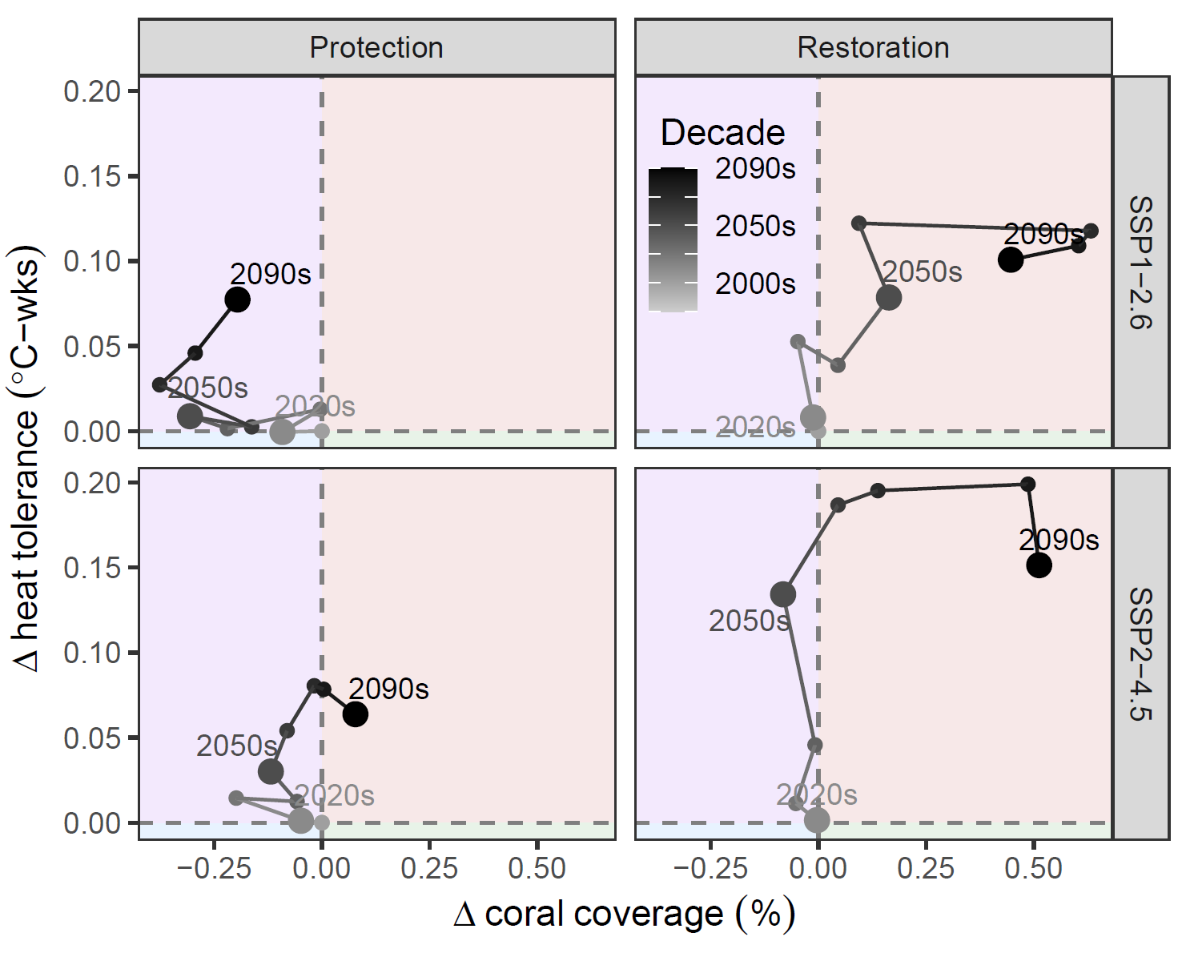
Figure S7. Comparison of hotspot and thermal refugia-focussed strategies to reef management under a large-dispersal network scenario. The low dispersal regime is that shown in Fig. S6, with reduced larval connections among heat stress regimes, as would be the case over reef systems that exist over larger spatial scales. Interpretation of axes and colours are the same as in Fig. 3.
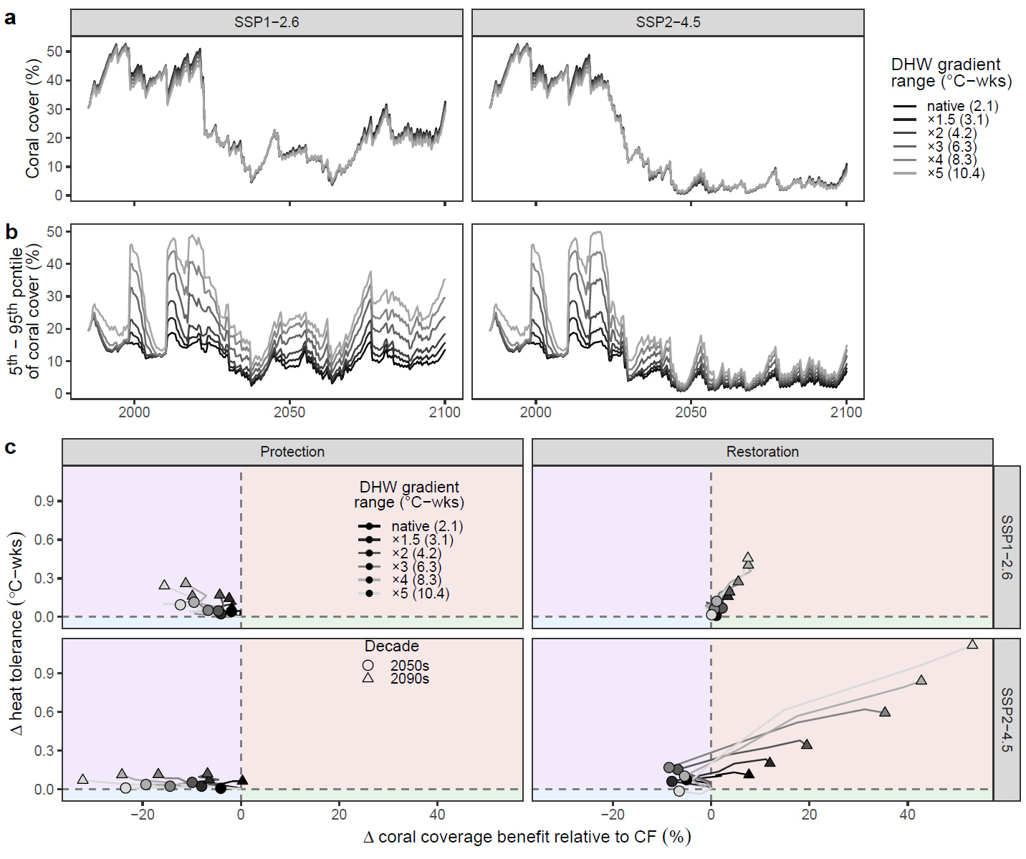Figure S8. Influence of DHW gradient strength on outcomes. (a) System-wide mean coral coverage under two SSPs, depending on the DHW gradient strength (grey shading), ranging from x1 (native) to a fivefold spatial DHW gradient (x5), with the range of spatial DHW anomalies given in brackets. (b) The among-reef variability in coral coverage, expressed as the absolute difference between the 5th and the 95th percentiles of coral coverage by year. As expected, coral coverage variability among reefs is greater when the spatial DHW gradient is greater (e.g., pale grey). (c) The difference between hotspots and thermal refugia (delta values) of each conservation scenario’s relative coral coverage benefits (relative to the counterfactual, i.e., coverage with management minus coverage without management).

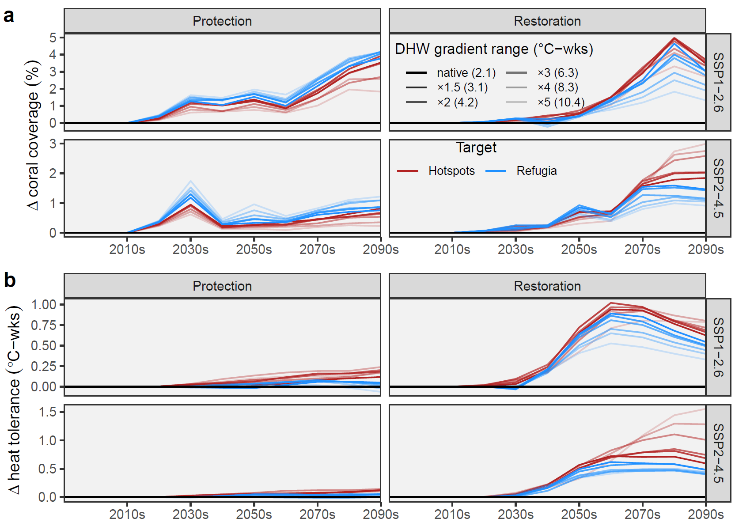Figure S9. Timeseries of coral coverage and heat tolerance depending on the strength of the DHW gradient. (a) coral coverage and (b) heat tolerance benefits in management scenarios (coloured lines) are shown relative to the counterfactual of no management (black line). Trajectories are coloured depending on the target region for management, either hotspots (red) or thermal refugia (blue), with paleness representing the strength of the DHW gradient, from x1 (the native gradient with DHW anomaly range among sites = 2.1 °C-weeks) to x5 (a five-fold stronger DHW anomaly gradient with range among sites of 10.4 °C-weeks).

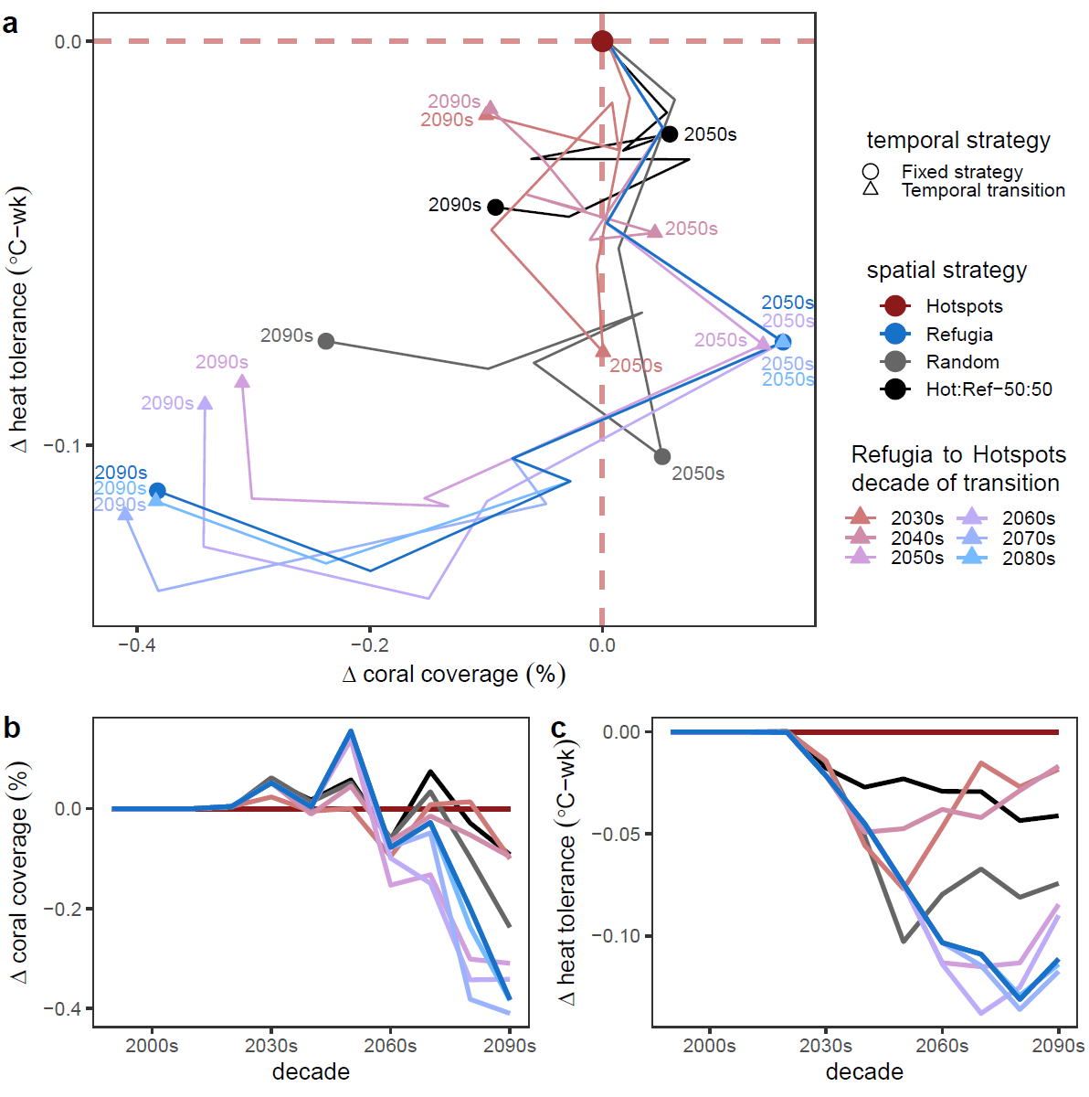
Figure S10. Time-series comparison of spatial and spatiotemporal strategies toward restoration under a high emissions future (SSP2-4.5). These include temporally fixed strategies to target hotspots (red, c.f. Fig. 3), thermal refugia (blue, c.f. Fig. 3), or random reefs (grey), and temporally shifting strategies (Ref2Hot, purple) with restoration efforts first focusing on thermal refugia before gradually transitioning to hotspots over a single decade period. Different versions of Ref2Hot scenarios are tested, each with a different decade of transition (purple hue). These spatiotemporal strategies test the ability to address the near-term losses resulting from targeting restoration at hotspots rather than thermal refugia in SSP2-4.5 (c.f. Fig. 3b). Each restoration strategy is compared to a purely hotspot reef-focussed approach in terms of coral coverage and heat tolerance (red), shown together (a) and independently (b-c). Lines represent decadal means across GCMs and 10 random simulation runs for once-per-decade disturbances. The 2020s, 2050s, and 2090s decades are highlighted with text (in a) to allow easier interpretation of timeseries combined coverage and tolerance trajectories.
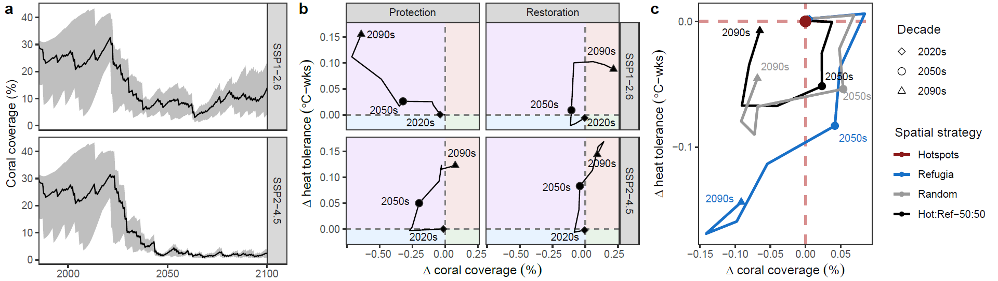
Figure S11. Model behaviour for a slow growing but high heat tolerance coral taxon like Porites lobata. The colony growth rate and heat tolerance were based on differences between corymbose Acropora and massive Porites based on Bozec et al. 2022⁵⁴, with linear growth rate of 0.6 cm/6 months and heat tolerance with LD50 of 12.9 °C-weeks. (a) Counterfactual projections of coral coverage under SSP1-2.6 and SSP2-4.5, showing a lower carrying capacity than corymbose Acropora given the slower coral growth rate (compare to Fig. 2c-d). (b) Differences in system-wide coral coverage and heat tolerance benefits between hotspot-focussed and refuge-focussed management approaches (delta values, ΔX = X_{Hotspots} – X_{Refugia}). (c) Comparison of spatial portfolio restoration strategies in SSP2-4.5 relative to the hotspot only strategy (ΔX = X_{Other Strategy} – X_{Hotspots}), to assess whether portfolios can address time-dependent trade-offs in near- and long-term coral coverage that exist between hotspot-only versus refuge-only approaches.

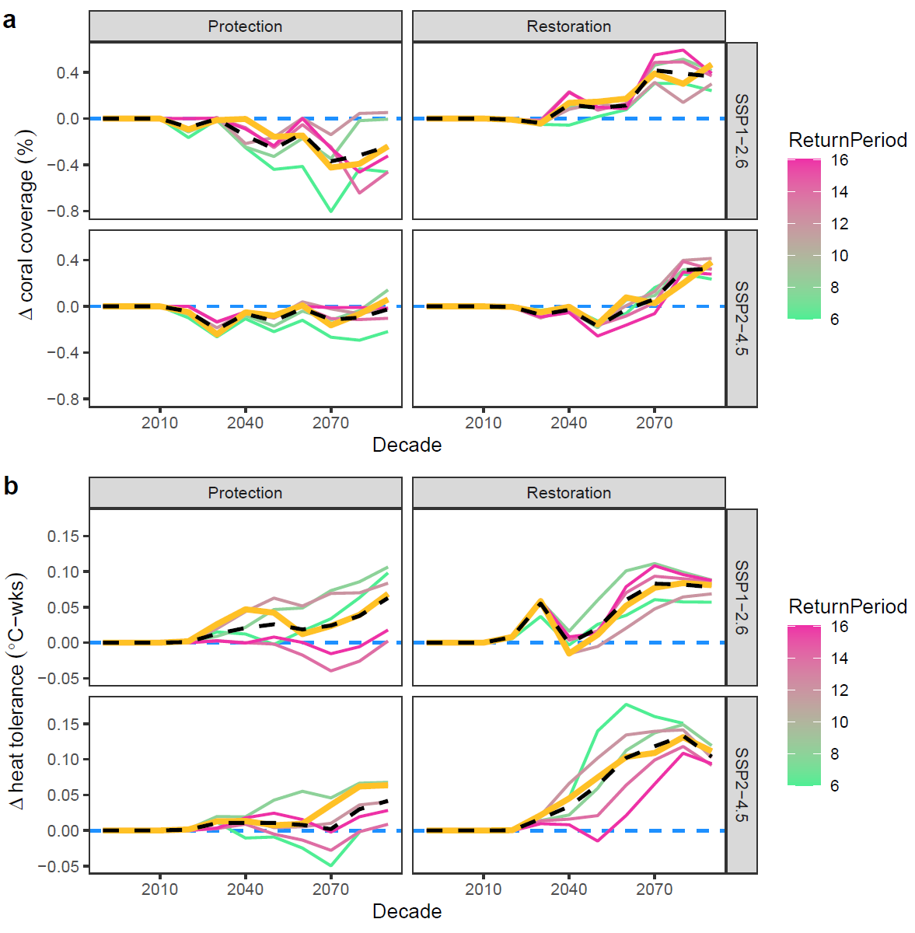
Figure S12. Sensitivity analysis of the difference between hotspot-focussed and thermal refugia-focussed management strategies as a function of the return period of manageable spatially ubiquitous non-thermal disturbances. All data are shown as decadal means across the GCM ensemble and 10 random simulations, displayed as differences in system-wide coral coverage (a) and heat tolerance (b) between hotspot-focussed strategies versus thermal refugia-focussed strategies (coloured solid lines). Delta values (∆X = X_{Hotspot} – X_{Refuge}) are shown relative to the thermal refuge strategy, which is highlighted as the null (y=0, dashed blue line). We highlight the trajectory for the once-per-decade disturbance regime (yellow line) and the average trajectory across all disturbance return time regimes (dashed black line).

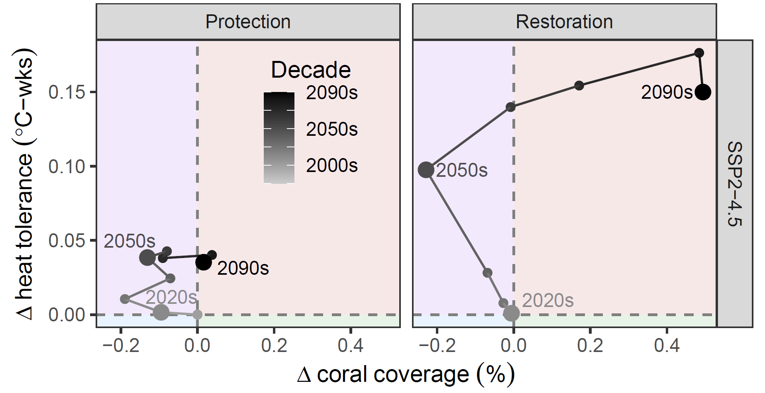
Figure S13. Comparison of hotspot and thermal refugia-focussed strategies to reef management under SSP2-4.5, with a spatially patchy rather than the spatially ubiquitous non-thermal disturbance regime. This disturbance regime is characterised by 3-year return time disturbances that affect 30% of reefs. Interpretation of axes and colours are the same as in Fig. 3.

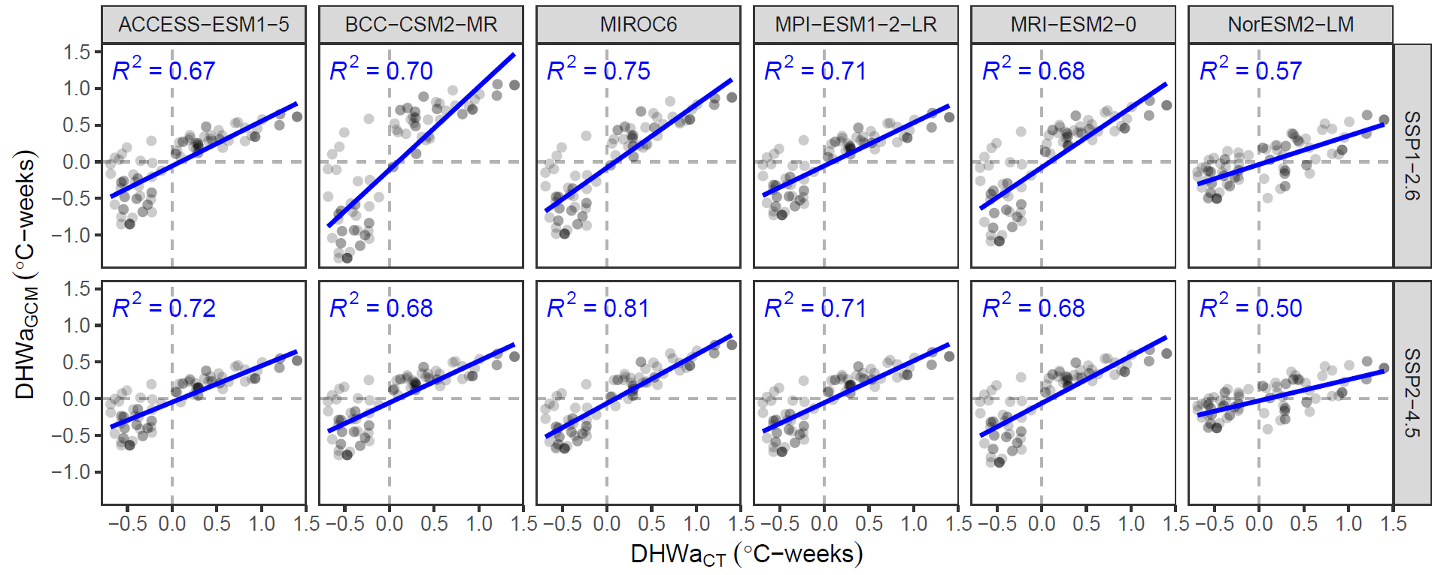
Figure S14. Correlation between the heat stress regimes, calculated as the mean cumulative heat stress anomaly (DHWa) across all events exceeding 4°C-weeks, between the historic satellite record (DHWa_{CT}) and future projections statistically downscaled from global circulation models (DHWa_{GCM}). The NorESM2-LM model was excluded from analyses due to lower coefficient of determination (R²).

