Supplementary Information
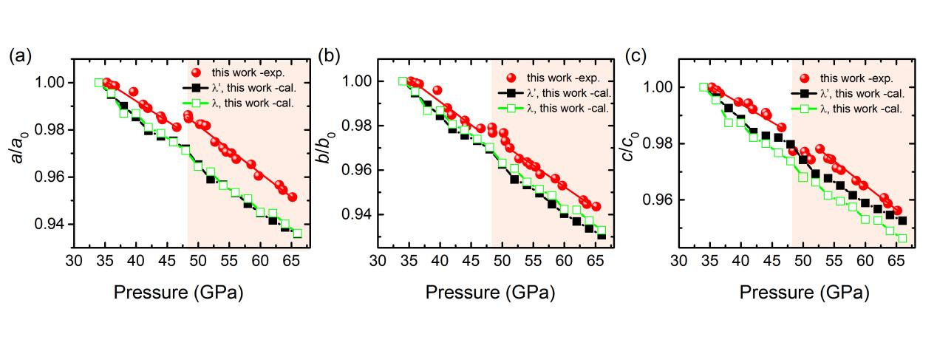
Fig. 1 The pressure dependence of a/a₀, b/b₀ and c/c₀ for the λ-N₂ and λ’-N₂.
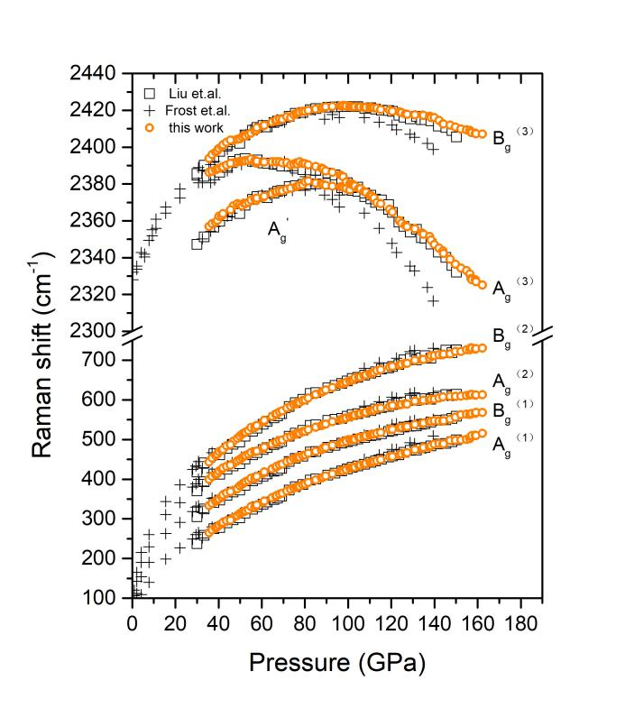
Fig. 2 The experimental Raman peaks of λ-N₂ (λ’-N₂) at various pressures at room temperature in comparison with the data in the literature [1, 2]. The orange circles are the present work. The hollow squares and vertical crosses are previous experiments data.
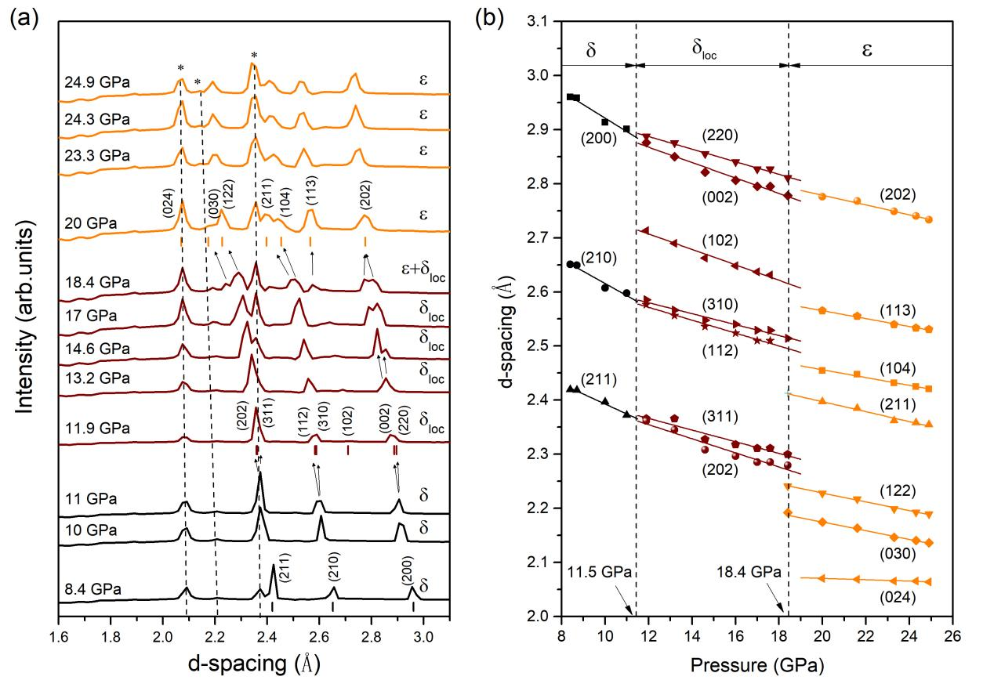
Fig.3 a Integrated X-ray diffraction patterns of ordinary nitrogen phases collected at room temperature from 8.4 to 24.9 GPa at Beijing Synchrotron Radiation Facility (BSRF, China) with an X-ray wavelength of 0.6199 Å. The black dashed lines indicate the three diffraction peaks from the Re gasket, also identified at 24.9 GPa by black asterisks, which could be followed with pressure. Vertical bars indicated the d spacing positions. Nitrogen from 8.4 GPa to 11 GPa was identified as the δ-N₂ phase. The onset of the δ_{loc}-N₂ phase occurs at 11.5 GPa. The phase transition from δ_{loc} to ε occurs at 18.4 GPa. b The d spacings of the δ, δ_{loc}, and ε phases as a function of pressure, the black dashed lines indicate the pressure boundary between these phases.
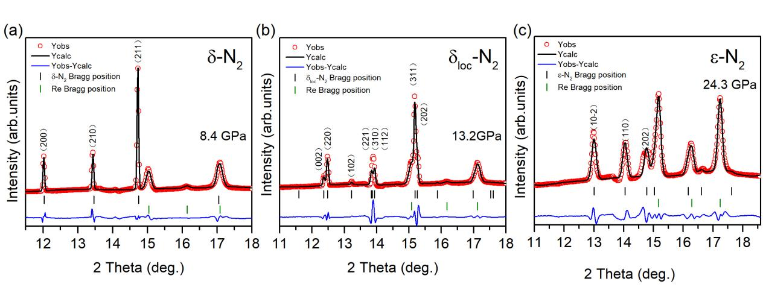
Fig. 4 Representative diffraction data and Rietveld-refined patterns of δ-N₂, δ_{loc}-N₂, and ε-N₂ a The refinement results of δ-N₂ at 8.4 GPa: a=b=c=5.9139 Å, R_{wp}=2.97%, R_{p}=1.89%. b The refinement results of δ_{loc}-N₂ at 13.2 GPa: a=b=8.1360 Å, c=5.7014 Å, R_{wp}=4.01%, R_{p}=1.84%. c The refinement results of ε-N₂ at 24.3 GPa: a=b=7.4349 Å, c=10.4038 Å, R_{wp}=5.70%, R_{p}=6.90%.
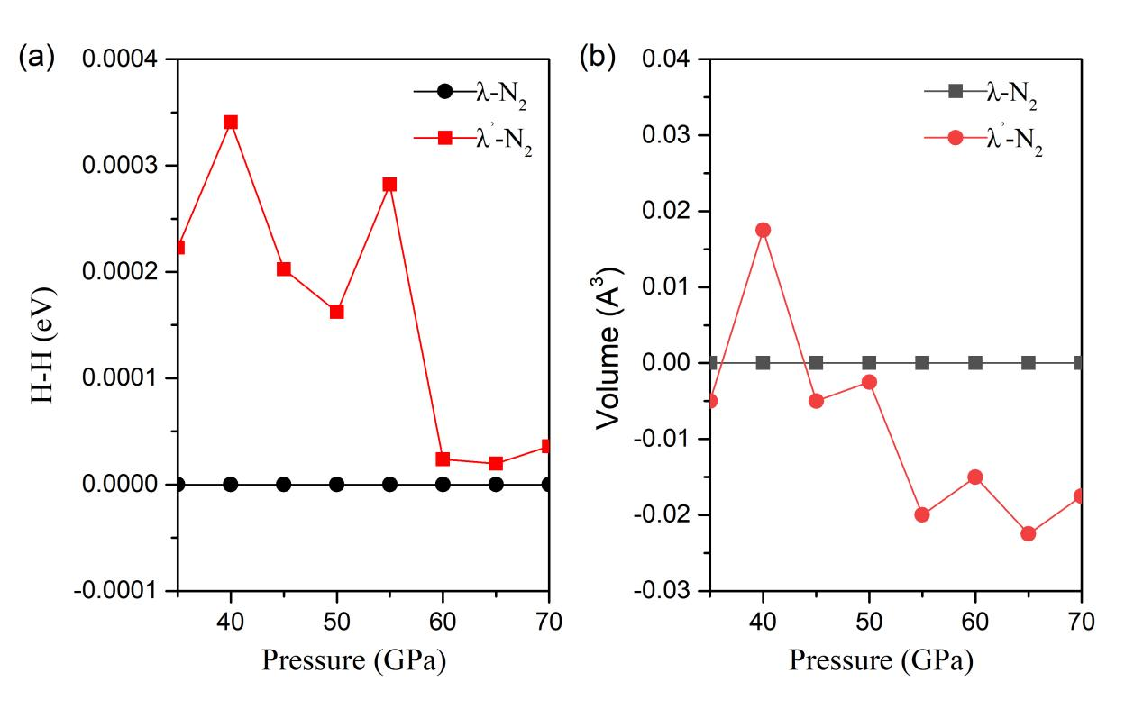
Fig. 5 a Enthalpy and b volume curves of the λ’-N₂ structure relative to the λ-N₂ structure as a function of pressure.
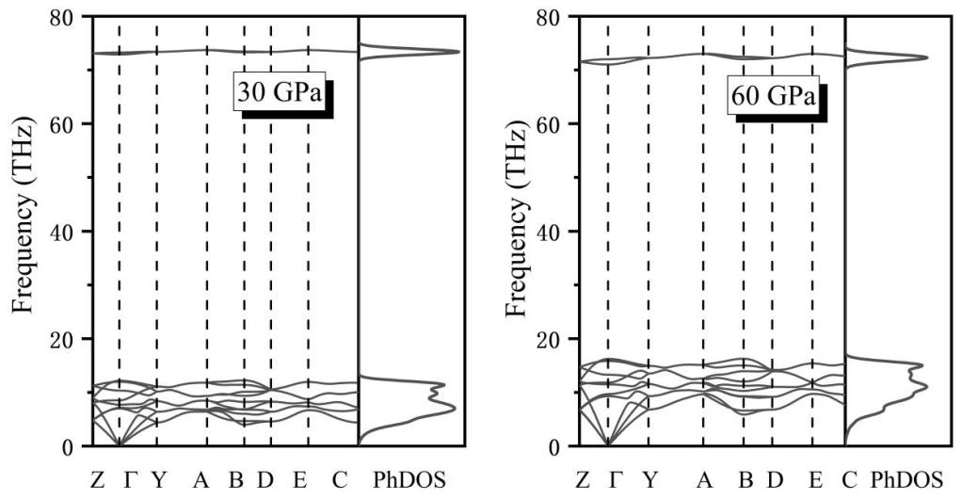
Fig. 6 Phonon dispersion and phonon DOS curves for the λ’-N₂ structure at 30 GPa (left) and 60 GPa (right), respectively.
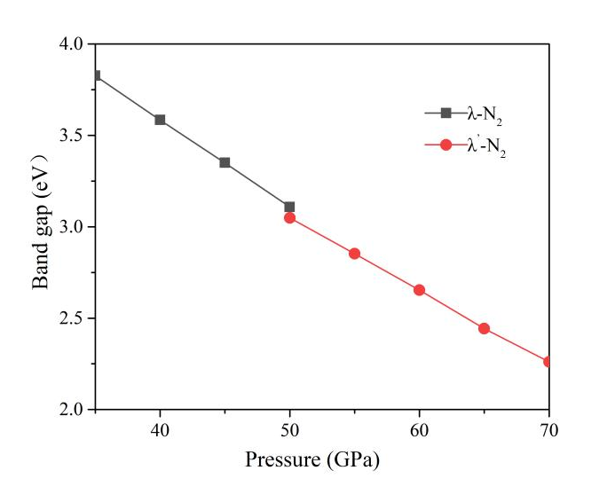
Fig. 7 The band gap of λ-N₂ and λ’-N₂ structures as a function of pressure.
Supplementary References
1. Frost, M., Howie, R. T., Dalladay-Simpson, P., Goncharov, A. F., & Gregoryanz, E. Novel high-pressure nitrogen phase formed by compression at low temperature. Phys. Rev. B 93 024113 (2016).
2. Liu, S. et al. Raman spectroscopy and phase stability of λ-N₂. Solid State Commun. 310, 113843 (2020).

