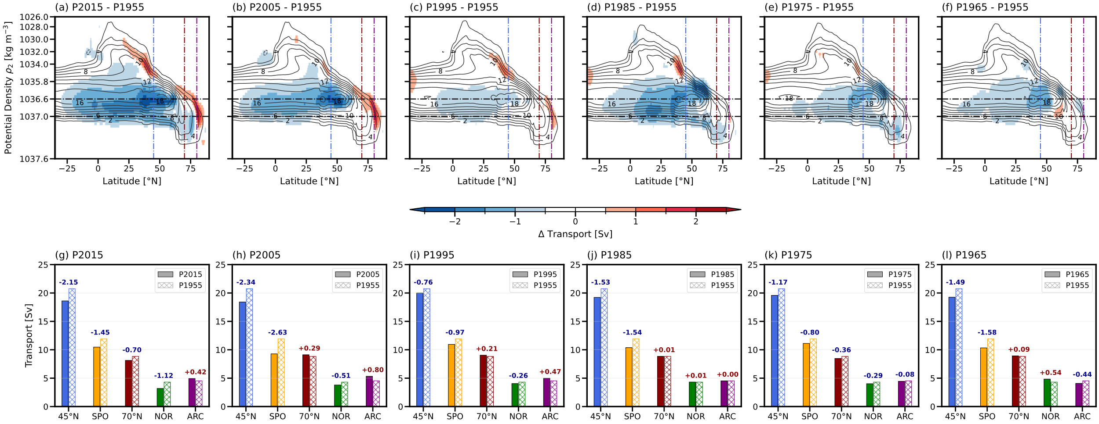
Figure S1. Decadal AMOC streamfunction anomalies and regional transport summaries for 1965–2022. (a–f) AMOC streamfunction anomalies in potential density (ρ₂) coordinates against latitude for the 2015–2022, 2005–2014, 1995–2004, 1985–1994, 1975–1984, and 1965–1974 periods relative to the 1955–1964 b baseline period. (g–l) Corresponding bar plots summarizing the absolute transport values for regional MOC components (MOC_{45N}, MOC_{SPO}, MOC_{70N}, MOC_{NOR}, and MOC_{ARC}) compared to the baseline period (hatched bars). Analysis periods are denoted by their initial boundary years (e.g., P1955 represents the 1955–1964 baseline, and P2015 represents 2015–2022). The vertical dash-dot lines in (a–h) indicate 45°N, 70°N, and 80°N latitudes, while the horizontal dash-dot lines in (a–h) indicate two ρ₂ isopycnal horizons (1036.6, and 1037 kg m⁻³) that roughly demarcate the boundaries between the AMOC’s upper and lower limbs, and between the lower limb and the Nordic Seas overflow waters, respectively.

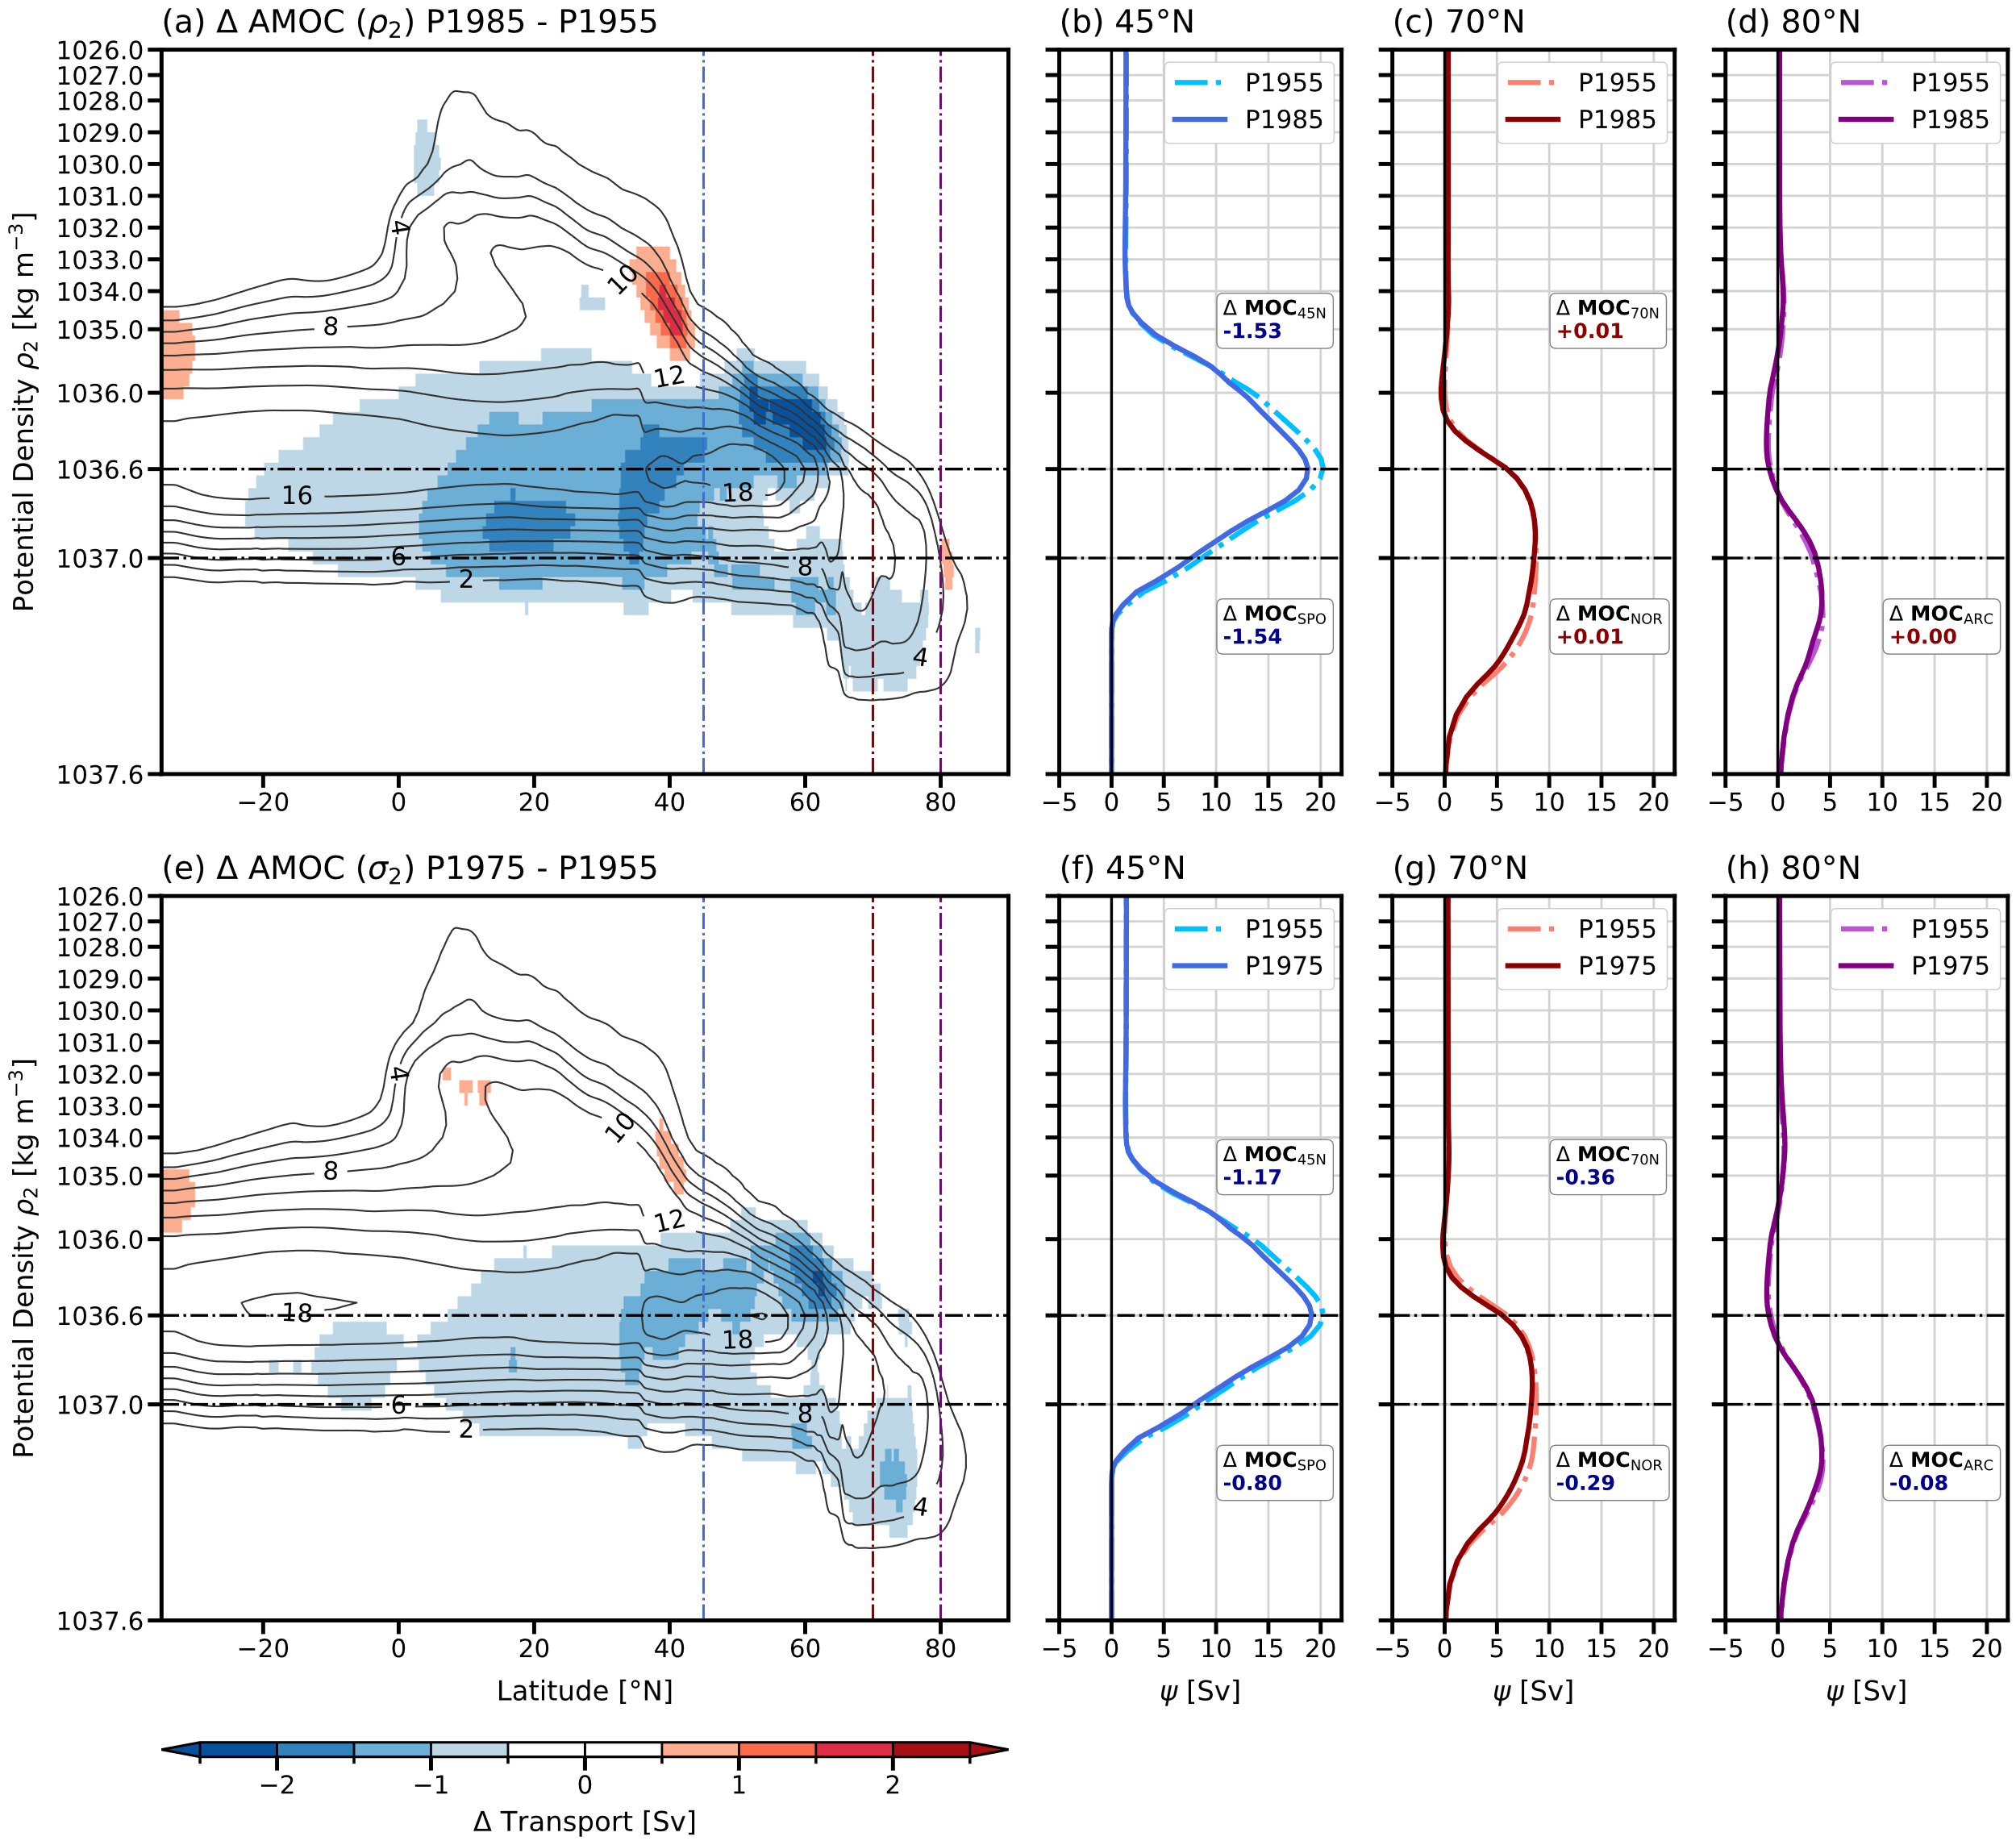
Figure S2. AMOC streamfunction and profiles for the 1975–1984 and 1985–1994 decadal periods. (a, e) Total AMOC streamfunction in potential density (ρ₂) coordinates against latitude. Contour lines represent the total transport, while color shading indicates the transport anomaly relative to the 1955–1964 baseline period. (b–d, f–h) Profiles of the AMOC in ρ₂ across 45°N, 70°N, and 80°N. Solid lines in (b–d, f–h) denote the specified decadal period, and dashed lines in (b–d, f–h) represent the baseline period. Inset boxes indicate the transport difference (ΔMOC) for specific regional components. Analysis periods are denoted by their initial boundary years (e.g., P1955 represents the 1955–1964 baseline, and P2015 represents 2015–2022). The vertical dash-dot lines in (a, e) indicate 45°N, 70°N, and 80°N latitudes, while the horizontal dash-dot lines in (a, e) indicate two ρ₂ isopycnal horizons (1036.6, and 1037 kg m⁻³) that roughly demarcate the boundaries between the AMOC’s upper and lower limbs, and between the lower limb and the Nordic Seas overflow waters, respectively.

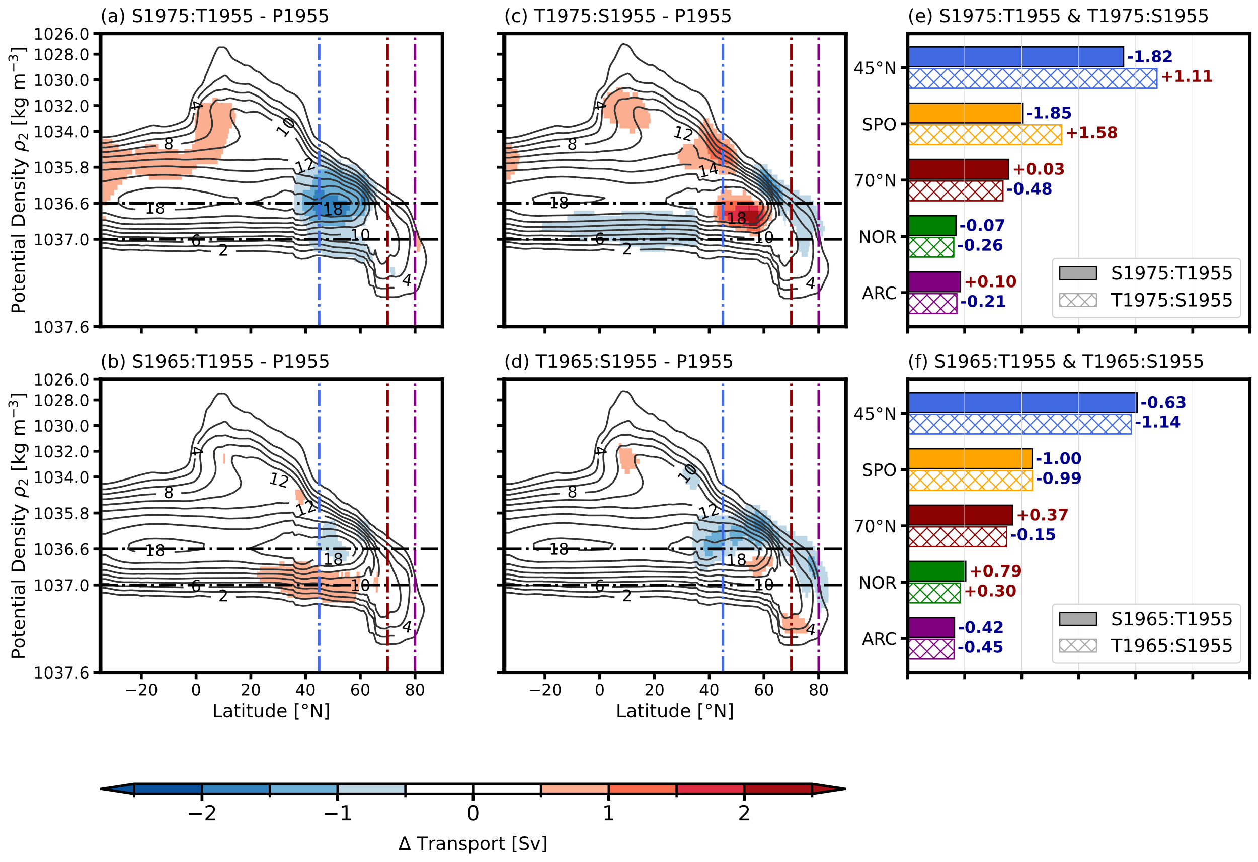
Figure S3. Attribution of AMOC changes to salinity and temperature forcing for the 1965–1974 and 1975–1984 periods. (Left Column) AMOC streamfunction anomalies for sensitivity runs constrained by decadal salinity but relaxed to baseline temperature. (Middle Column) Anomalies for runs constrained by decadal temperature but relaxed to baseline salinity. (Right Column) Bar plots quantifying the isolated salinity and temperature effects on regional MOC components. S1975:T1955, for example, denotes the experiment constrained by 1975–1984 salinity and 1955–1964 temperature, whereas T1975:S1955 denotes the experiment constrained by 1975–1984 temperature and 1955–1964 salinity. P1955 denotes the 1955–1964 baseline period. The vertical dash-dot lines in (a–d) indicate 45°N, 70°N, and 80°N latitudes, while the horizontal dash-dot lines in (a–d) indicate two ρ₂ isopycnal horizons (1036.6, and 1037 kg m⁻³) that roughly demarcate the boundaries between the AMOC’s upper and lower limbs, and between the lower limb and the Nordic Seas overflow waters, respectively. See Figure 6 for
S2015:T1955, S2005:T1955, S1995:T1955, S1985:T1955, T2015:S1955, T2005:S1955,
T1995:S1955, and T1985:S1955.

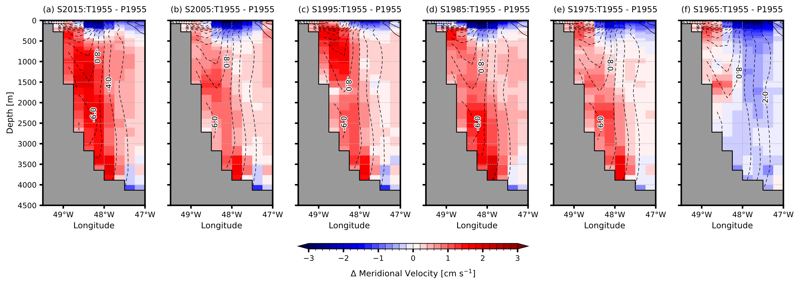
Figure S4. Deep Western Boundary Current (DWBC) anomalies constrained by decadal salinity. (a–f) Cross-sections across 45°N off the Grand Banks of Newfoundland (49.5°W to 47°W) showing anomalies in meridional velocity for the sensitivity runs, constrained by decadal salinity (a 2015–2022, b 2005–2014, c 1995–2004, d 1985–1994, e 1975–1984, and f 1965–1974) but relaxed to baseline temperature, relative to the 1955–1964 baseline period.
S2015:T1955, for example, denotes the experiment constrained by 2015–2022 salinity and 1955–1964 temperature. P1955 denotes the 1955–1964 baseline period. Contours represent the total southward velocity, and color shading represents the anomaly. Red shading indicates a positive anomaly (a weakening of the southward flow), while blue shading indicates a negative anomaly (an intensification of the southward flow).

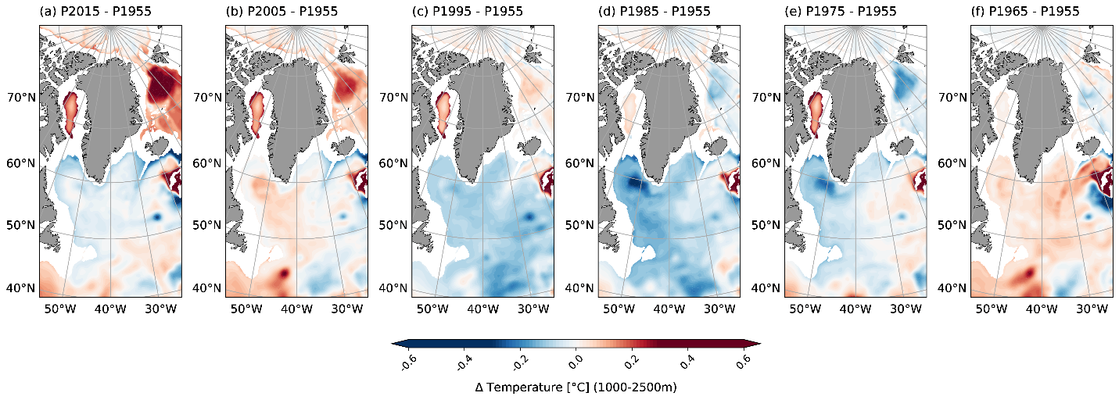
Figure S5. Temperature anomalies of the LSW layer (1000–2500 m) from the Arctic to the Subpolar North Atlantic. Time-averaged temperature anomaly of the LSW layer (1000–2500 m) for each of the six decadal periods (a 2015–2022, b 2005–2014, c 1995–2004, d 1985–1994, e 1975–1984, and f 1965–1974) relative to the 1955–1964 baseline period. Analysis periods are denoted by their initial boundary years (e.g., P1955 represents the 1955–1964 baseline, and P2015 represents 2015–2022).

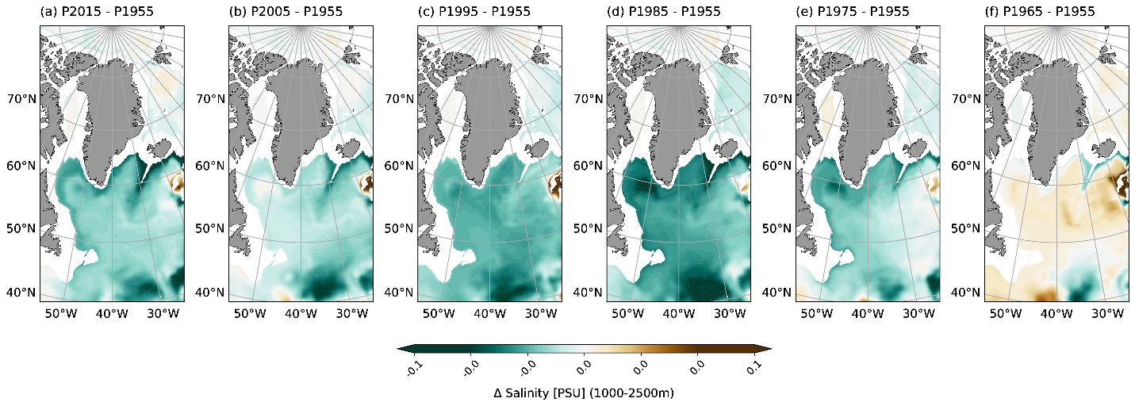
Figure S6. Salinity anomalies of the LSW layer (1000–2500 m) from the Arctic to the Subpolar North Atlantic. Time-averaged salinity anomaly of the LSW layer (1000–2500 m) for each of the six decadal periods (a 2015–2022, b 2005–2014, c 1995–2004, d 1985–1994, e 1975–1984, and f 1965–1974) relative to the 1955–1964 baseline period. Analysis periods are denoted by their initial boundary years (e.g., P1955 represents the 1955–1964 baseline, and P2015 represents 2015–2022).

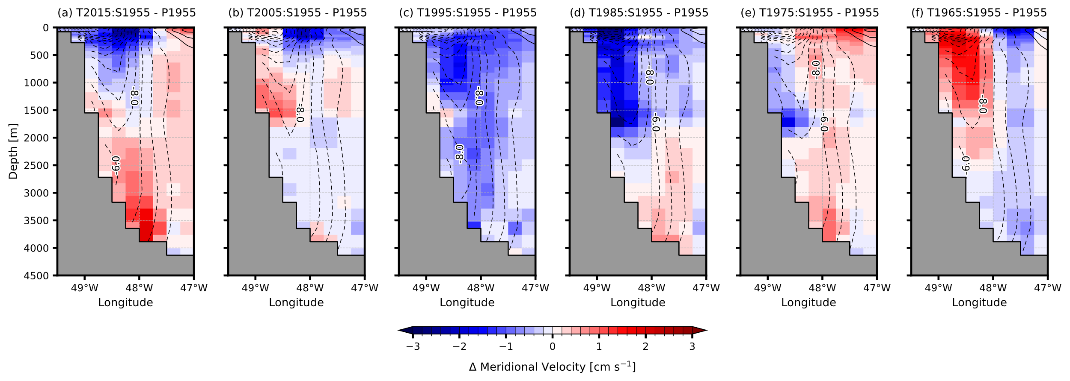
Figure S7. Deep Western Boundary Current (DWBC) anomalies constrained by decadal temperature. (a–f) Cross-sections across 45°N off the Grand Banks of Newfoundland (49.5°W to 47°W) showing anomalies in meridional velocity for the sensitivity runs, constrained by decadal temperature (a 2015–2022, b 2005–2014, c 1995–2004, d 1985–1994, e 1975–1984, and f 1965–1974) but relaxed to baseline salinity, relative to the 1955–1964 baseline period. T2015:S1955, for example, denotes the experiment constrained by 2015–2022 temperature and 1955–1964 salinity. P1955 denotes the 1955–1964 baseline period. Contours represent the total southward velocity, and color shading represents the anomaly. Red shading indicates a positive anomaly (a weakening of the southward flow), while blue shading indicates a negative anomaly (an intensification of the southward flow).

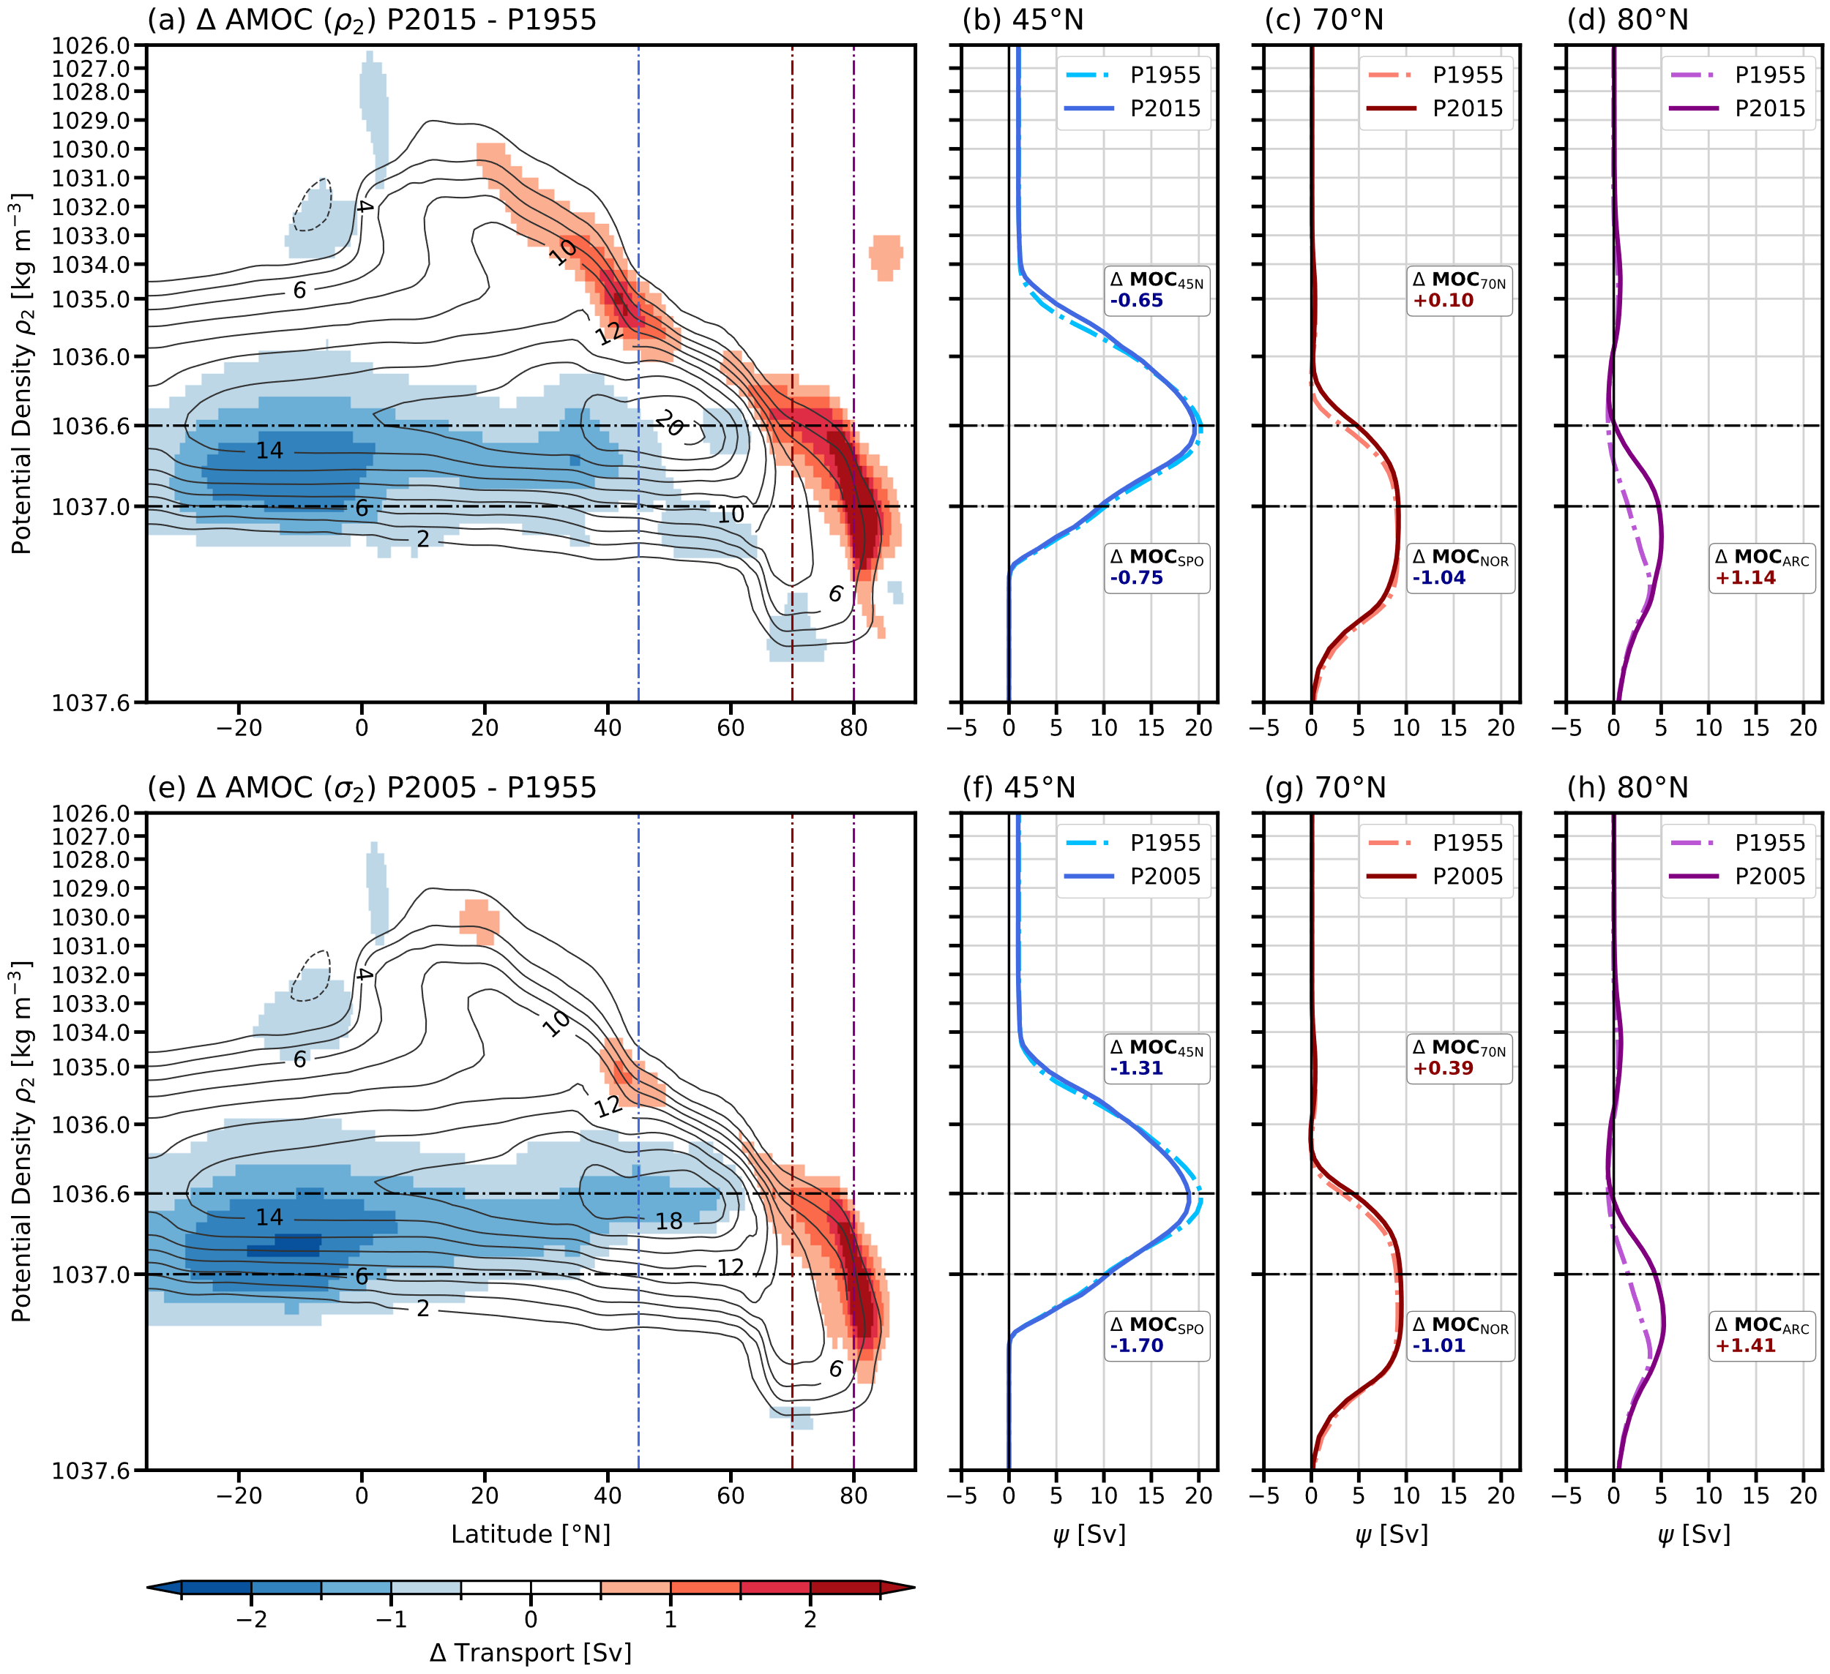
Figure S8. Same as Figure 3 except that a 1° horizonal resolution ocean model is used instead of a 0.25° horizontal resolution ocean model.

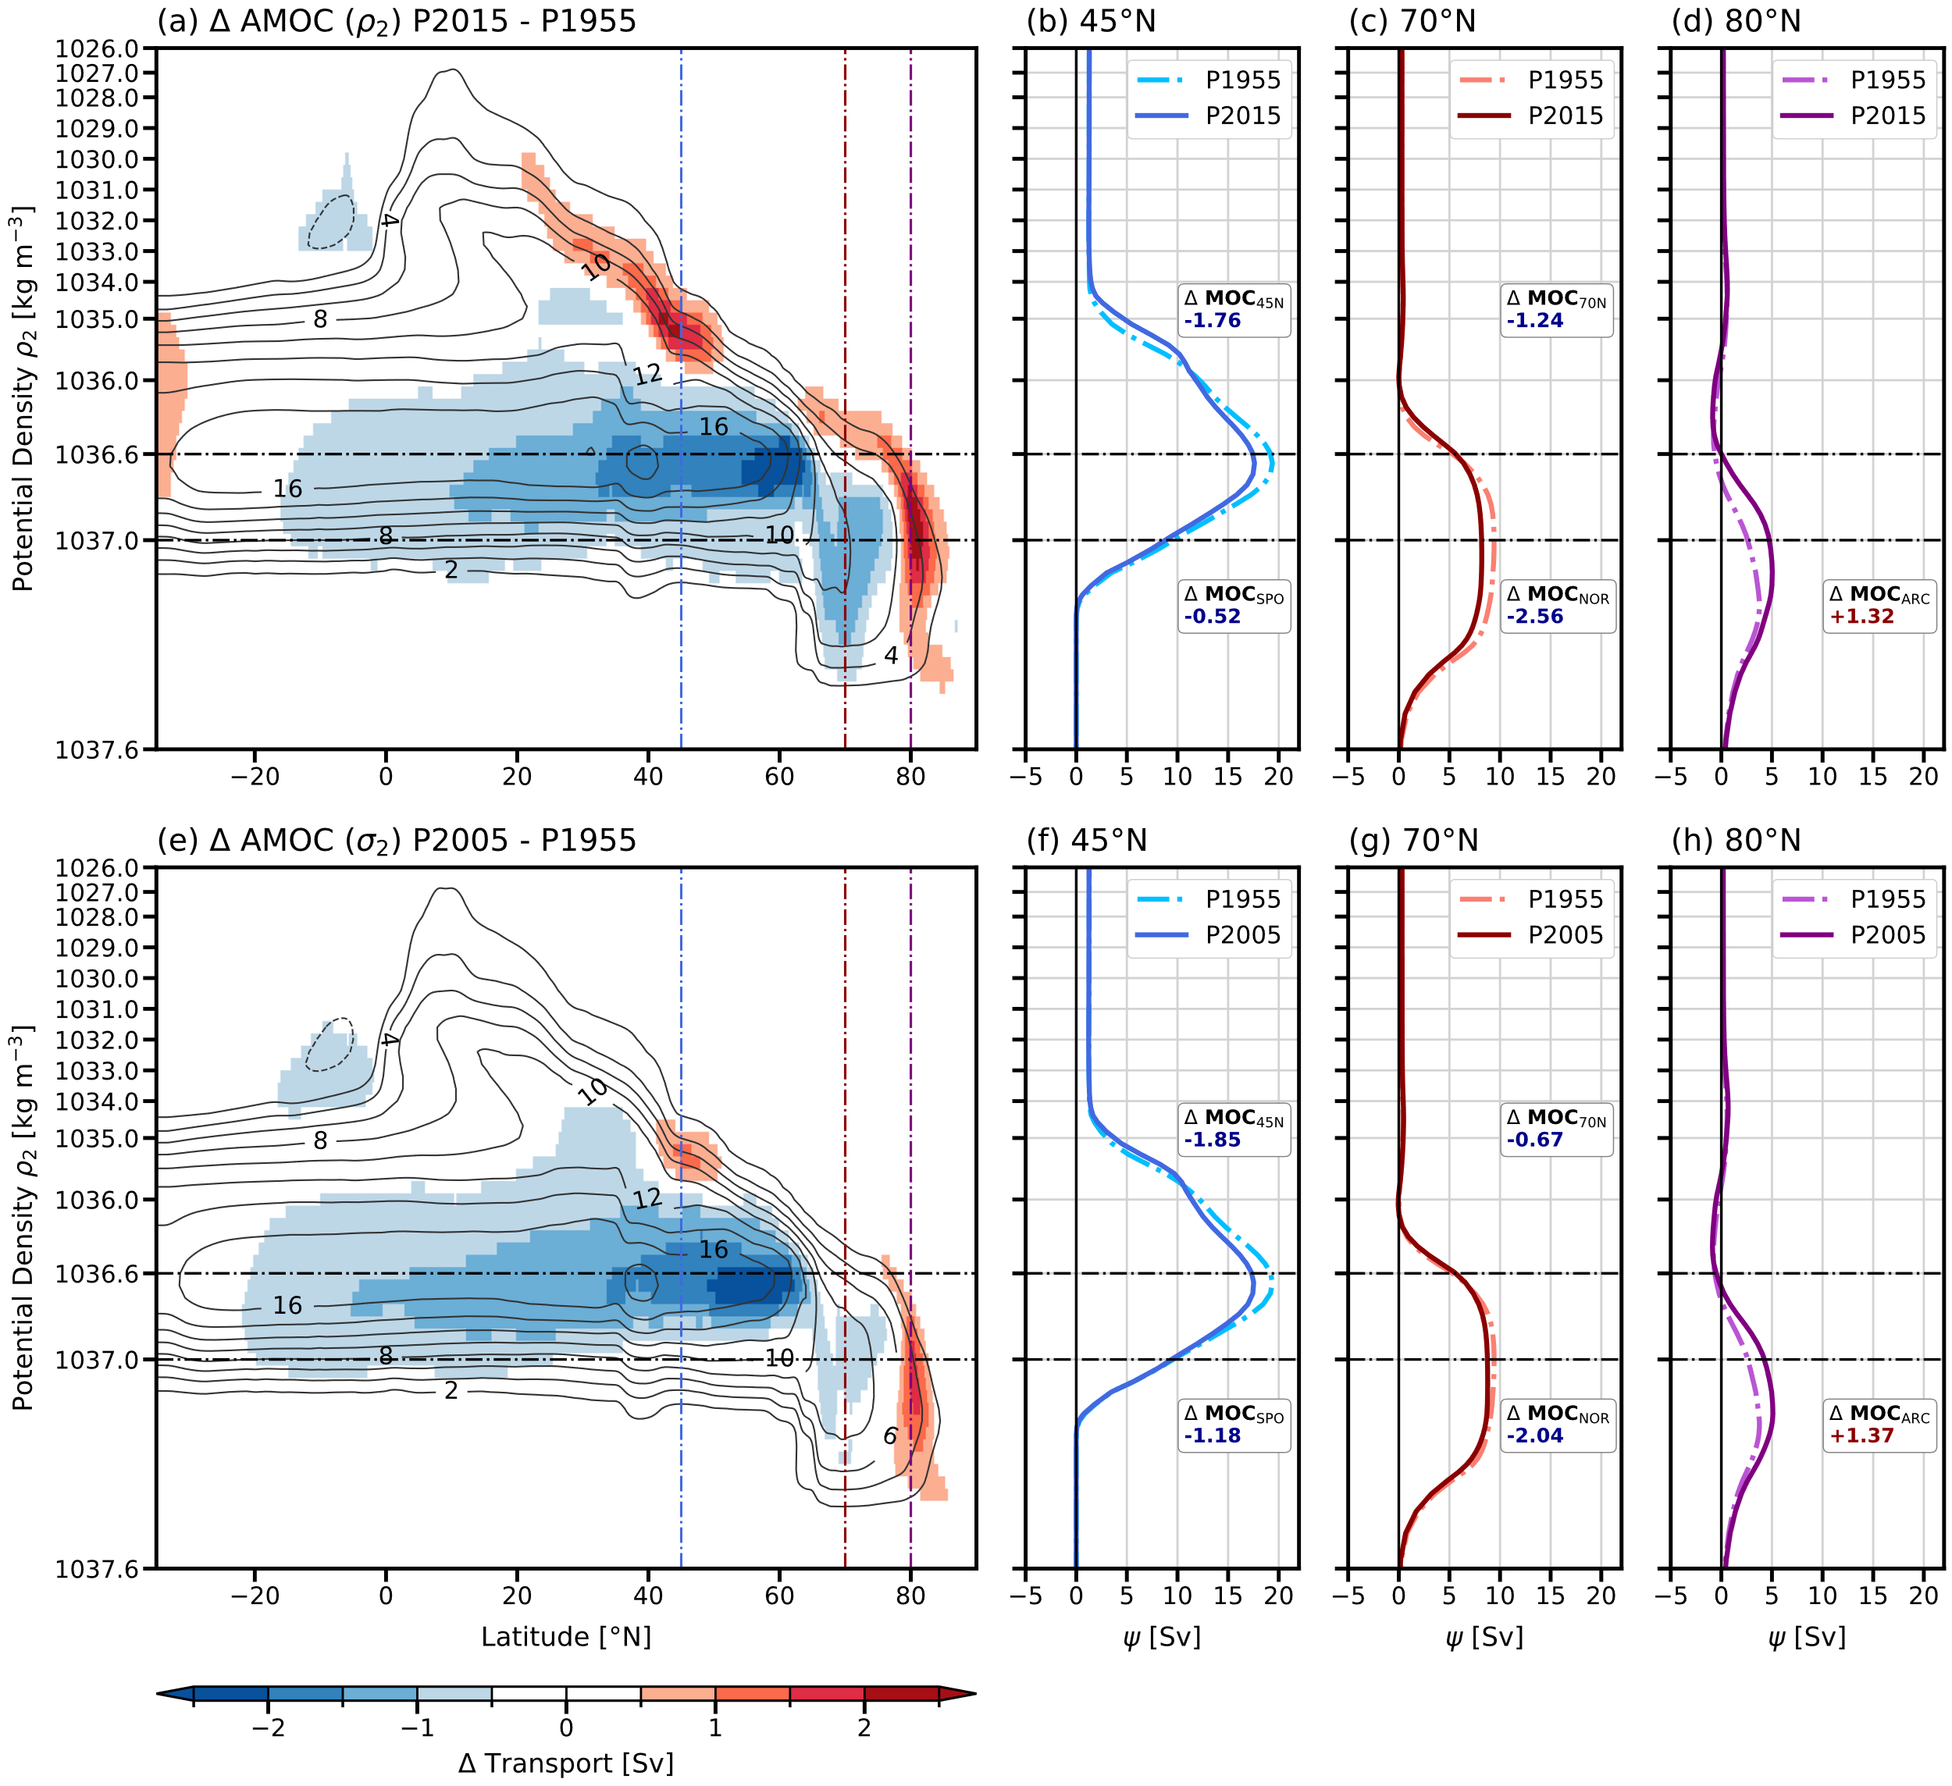
Figure S9. Same as Figure 3 except that a 0.5° horizontal resolution ocean model is used instead of a 0.25° horizontal resolution ocean model.

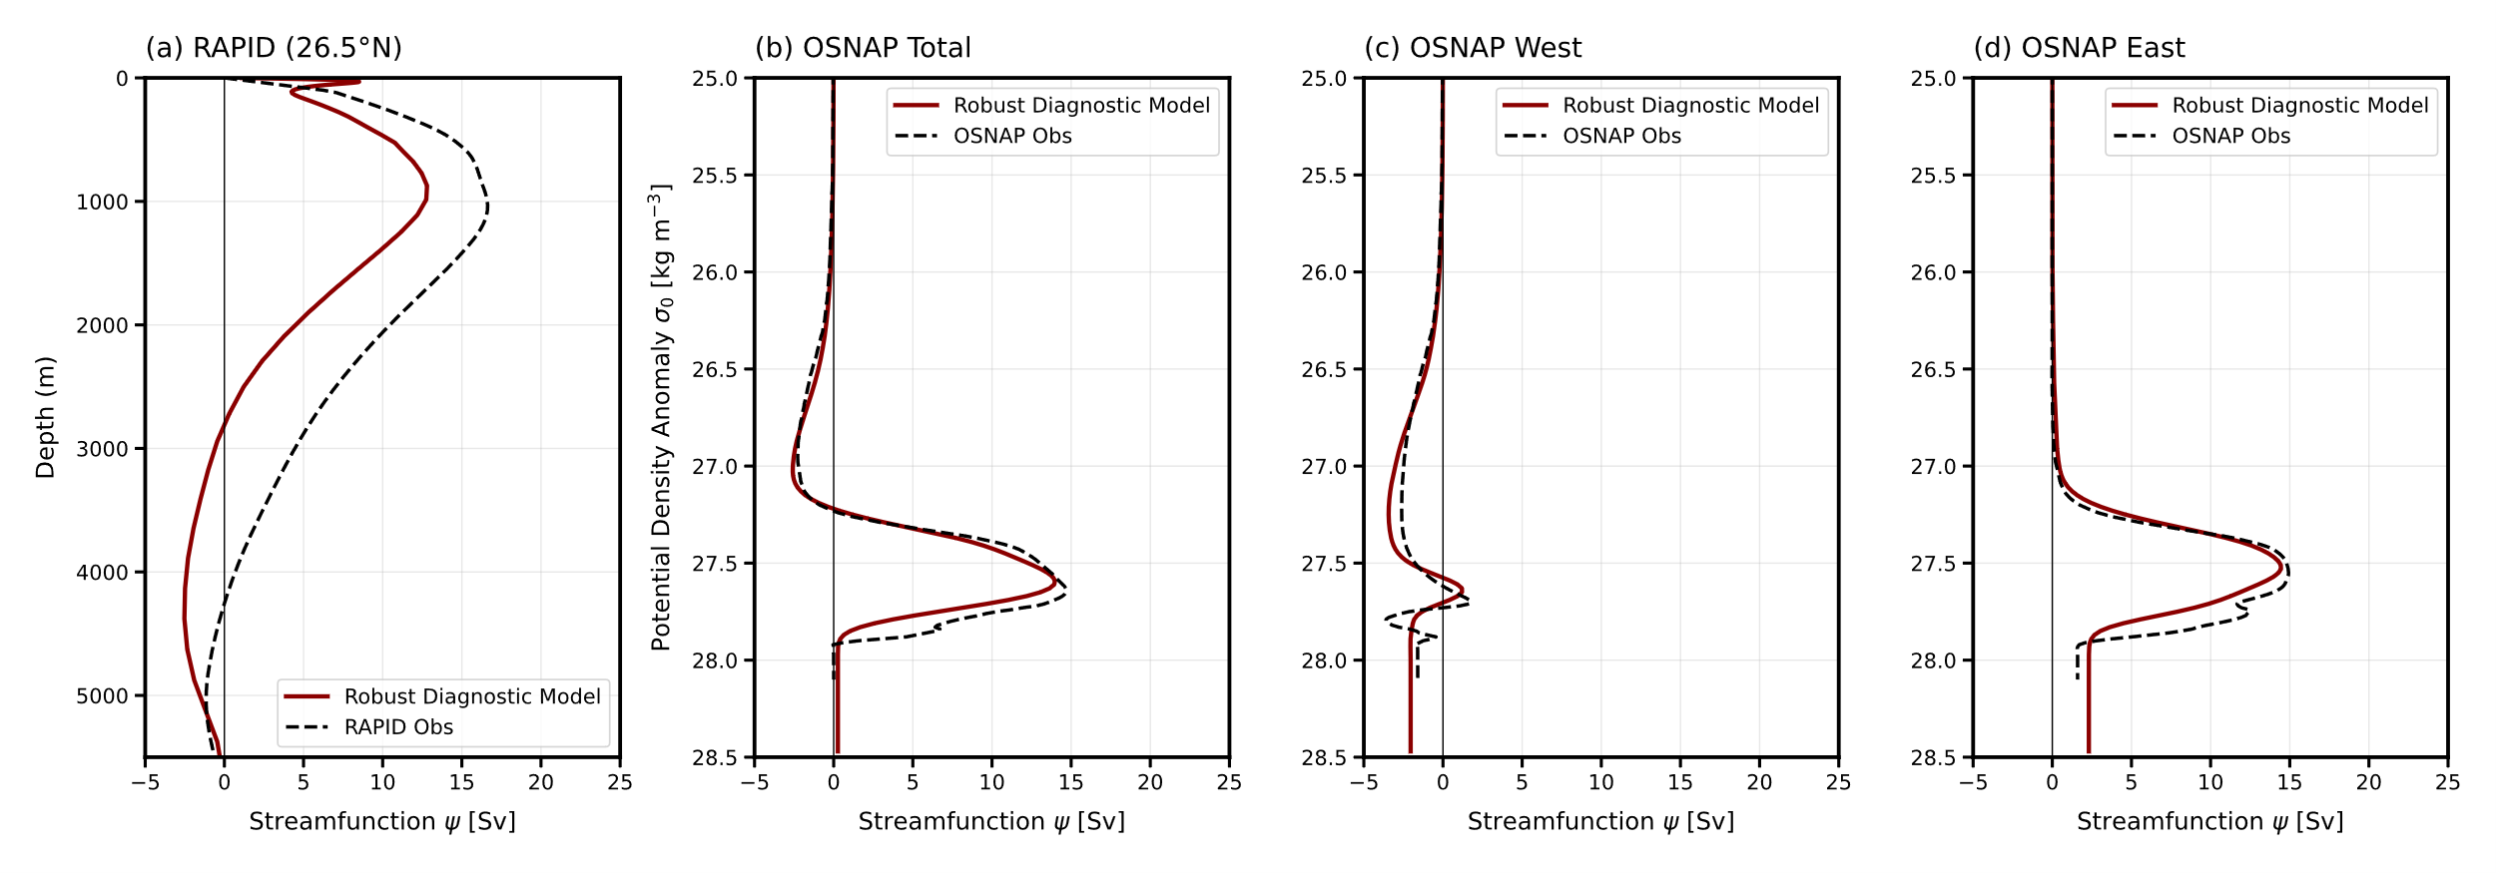
Figure S10. Comparison of AMOC streamfunctions from the initial (unoptimized) model with direct observations across the RAPID and OSNAP arrays. (a) Vertical profile of the AMOC streamfunction (Ψ, in Sv) as a function of depth (m) at 26.5°N compared with RAPID observations. (b–d) Profiles of the AMOC streamfunction against potential density anomaly (σ₀, in kg m⁻³) across the (b) entire OSNAP line, (c) OSNAP West section, and (d) OSNAP East section compared with OSNAP observations. In all panels, the solid red line represents the initial unoptimized robust diagnostic model results, and the dashed black line denotes the corresponding direct observations. The overturning streamfunctions are averaged over the 2015–2022 period.

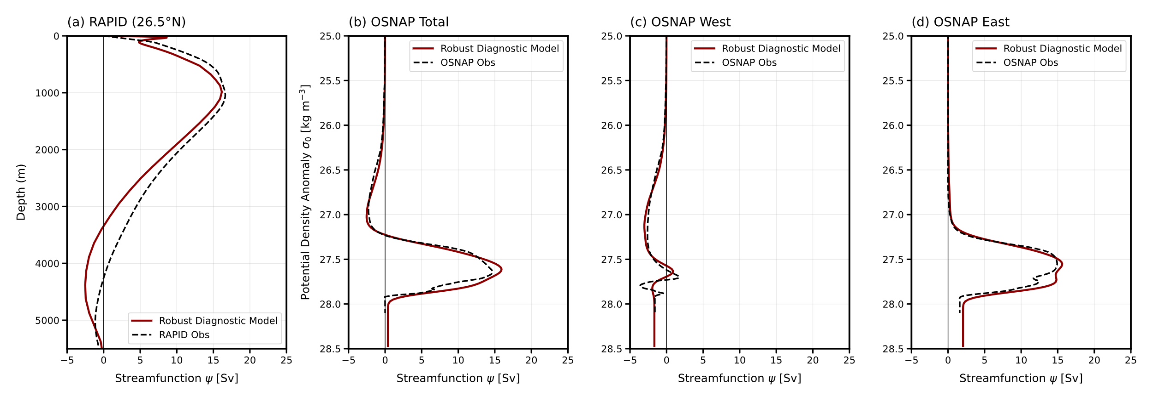
Figure S11. Comparison of AMOC streamfunctions from the optimized model with direct observations across the RAPID and OSNAP arrays. (a) Vertical profile of the AMOC streamfunction (Ψ, in Sv) as a function of depth (m) at 26.5°N compared with RAPID observations. (b–d) Profiles of the AMOC streamfunction against potential density anomaly (σ₀, in kg m⁻³) across the (b) entire OSNAP line, (c) OSNAP West section, and (d) OSNAP East section compared with OSNAP observations. In all panels, the solid red line represents the optimized robust diagnostic model results, and the dashed black line denotes the corresponding direct observations. The overturning streamfunctions are averaged over the 2015–2022 period.

