Modelo | ROC AUC | Accuracy | Sensitivity | Specificity | F1-score | MCC
Musk | 0.4411  [0.3074, 0.5749] | 0.3255  [0.0242, 0.6268] | 0.5937  [-0.0787, 1.2661] | 0.3255  [0.0242, 0.6268] | 0.4005  [-0.0519, 0.8528] | -0.0184  [-0.0774, 0.0406]
Musk+RL | 0.9154  [0.8934, 0.9374] | 0.8581  [0.8405, 0.8757] | 0.8625  [0.8442, 0.8808] | 0.8554  [0.8333, 0.8775] | 0.8578  [0.8417, 0.8739] | 0.7116  [0.6760, 0.7472]
Musk+RF | 0.8279  [0.8015, 0.8543] | 0.7620  [0.7420, 0.7820] | 0.7447  [0.7229, 0.7665] | 0.7674  [0.7383, 0.7965] | 0.7550  [0.7315, 0.7785] | 0.5167  [0.4771, 0.5593]
Musk+SVM | 0.9152  [0.8930, 0.9374] | 0.8555  [0.8379, 0.8732] | 0.8660  [0.8457, 0.8813] | 0.8511  [0.8287, 0.8735] | 0.8560  [0.8403, 0.8718] | 0.7066  [0.6706, 0.7426]
Musk+LoRA | 0.9486  [0.9369, 0.9604] | 0.9023  [0.8937, 0.9108] | 0.9238  [0.9133, 0.9344] | 0.8790  [0.8583, 0.8997] | 0.9046  [0.8970, 0.9122] | 0.8054  [0.7886, 0.8222]

Table S1. Comparative performance analysis of different classification strategies for gastric adenocarcinoma detection. Performance metrics are reported as Mean [95% Confidence Interval] across 25 independent iterations (5-fold cross-validation repeated 5 times with different seeds). Musk (Zero-shot) represents the baseline performance of the pre-trained foundation model without task-specific adaptation. Musk + RF, SVM, and RL represent the performance using Musk as a fixed feature extractor with Random Forest, Support Vector Machine, and Logistic Regression classifiers, respectively. Musk + LoRA represents our proposed end-to-end fine-tuning approach using Low-Rank Adaptation. ROC AUC: Area Under the Receiver Operating Characteristic Curve; MCC: Matthews Correlation Coefficient. The highest values for each metric are highlighted in the final row.

Musk + LoRA | ROC AUC | Accuracy | Sensitivity | Specificity | F1-score | MCC
repeat_1_fold_1 | 0.9935 [0.9887-0.9973] | 0.9491 [0.9351-0.9621] | 0.9860 [0.9746-0.9960] | 0.9122 [0.8856-0.9356] | 0.9509 [0.9377-0.9629] | 0.9007 [0.8744-0.9245]
repeat_1_fold_2 | 0.9924 [0.9876-0.9960] | 0.9441 [0.9291-0.9581] | 0.9900 [0.9801-0.9980] | 0.8982 [0.8714-0.9226] | 0.9466 [0.9315-0.9605] | 0.8920 [0.8625-0.9178]
repeat_1_fold_3 | 0.9930 [0.9895-0.9959] | 0.9561 [0.9431-0.9681] | 0.9681 [0.9525-0.9819] | 0.9441 [0.9222-0.9638] | 0.9566 [0.9435-0.9682] | 0.9124 [0.8865-0.9361]
repeat_1_fold_4 | 0.9945 [0.9911-0.9972] | 0.9561 [0.9431-0.9681] | 0.9920 [0.9839-0.9981] | 0.9202 [0.8969-0.9432] | 0.9576 [0.9446-0.9696] | 0.9145 [0.8897-0.9377]
repeat_1_fold_5 | 0.9929 [0.9890-0.9961] | 0.9421 [0.9271-0.9551] | 0.9900 [0.9814-0.9980] | 0.8942 [0.8668-0.9206] | 0.9448 [0.9297-0.9578] | 0.8883 [0.8612-0.9133]
repeat_2_fold_1 | 0.9932 [0.9879-0.9970] | 0.9481 [0.9341-0.9611] | 0.9800 [0.9671-0.9905] | 0.9162 [0.8915-0.9378] | 0.9497 [0.9354-0.9617] | 0.8980 [0.8717-0.9229]
repeat_2_fold_2 | 0.9937 [0.9887-0.9973] | 0.9361 [0.9202-0.9511] | 0.9920 [0.9835-0.9981] | 0.8802 [0.8522-0.9077] | 0.9395 [0.9235-0.9533] | 0.8778 [0.8489-0.9056]
repeat_2_fold_3 | 0.9953 [0.9913-0.9980] | 0.9581 [0.9451-0.9701] | 0.9900 [0.9804-0.9980] | 0.9261 [0.9023-0.9478] | 0.9594 [0.9464-0.9711] | 0.9180 [0.8930-0.9406]
repeat_2_fold_4 | 0.9893 [0.9839-0.9934] | 0.8952 [0.8762-0.9152] | 0.9900 [0.9812-0.9980] | 0.8004 [0.7650-0.8359] | 0.9043 [0.8863-0.9236] | 0.8050 [0.7726-0.8383]
repeat_2_fold_5 | 0.9948 [0.9914-0.9976] | 0.9611 [0.9501-0.9721] | 0.9840 [0.9724-0.9942] | 0.9381 [0.9186-0.9592] | 0.9620 [0.9502-0.9734] | 0.9231 [0.9016-0.9452]
repeat_3_fold_1 | 0.9925 [0.9873-0.9967] | 0.9471 [0.9341-0.9611] | 0.9880 [0.9770-0.9961] | 0.9062 [0.8820-0.9319] | 0.9492 [0.9356-0.9632] | 0.8972 [0.8730-0.9242]
repeat_3_fold_2 | 0.9898 [0.9839-0.9944] | 0.9481 [0.9351-0.9611] | 0.9741 [0.9600-0.9864] | 0.9222 [0.8985-0.9434] | 0.9494 [0.9361-0.9623] | 0.8974 [0.8713-0.9223]
repeat_3_fold_3 | 0.9943 [0.9890-0.9977] | 0.9531 [0.9401-0.9661] | 0.9840 [0.9722-0.9941] | 0.9222 [0.8988-0.9469] | 0.9545 [0.9420-0.9674] | 0.9079 [0.8832-0.9329]
repeat_3_fold_4 | 0.9943 [0.9895-0.9977] | 0.9291 [0.9131-0.9451] | 0.9960 [0.9899-1.0000] | 0.8623 [0.8333-0.8922] | 0.9336 [0.9170-0.9493] | 0.8661 [0.8369-0.8950]
repeat_3_fold_5 | 0.9943 [0.9889-0.9977] | 0.9581 [0.9461-0.9701] | 0.9860 [0.9754-0.9960] | 0.9301 [0.9069-0.9520] | 0.9592 [0.9463-0.9708] | 0.9176 [0.8940-0.9409]
repeat_4_fold_1 | 0.9933 [0.9890-0.9967] | 0.9321 [0.9162-0.9471] | 0.9880 [0.9777-0.9961] | 0.8762 [0.8457-0.9045] | 0.9357 [0.9197-0.9503] | 0.8697 [0.8410-0.8978]
repeat_4_fold_2 | 0.9928 [0.9891-0.9958] | 0.9381 [0.9212-0.9521] | 0.9880 [0.9772-0.9960] | 0.8882 [0.8571-0.9160] | 0.9411 [0.9253-0.9552] | 0.8806 [0.8510-0.9070]
repeat_4_fold_3 | 0.9938 [0.9886-0.9975] | 0.9012 [0.8832-0.9192] | 0.9920 [0.9839-0.9981] | 0.8104 [0.7767-0.8431] | 0.9094 [0.8916-0.9265] | 0.8160 [0.7837-0.8477]
repeat_4_fold_4 | 0.9934 [0.9891-0.9970] | 0.9401 [0.9261-0.9541] | 0.9920 [0.9840-0.9981] | 0.8882 [0.8606-0.9146] | 0.9431 [0.9286-0.9573] | 0.8850 [0.8590-0.9115]
repeat_4_fold_5 | 0.9941 [0.9890-0.9975] | 0.9691 [0.9581-0.9790] | 0.9760 [0.9619-0.9881] | 0.9621 [0.9449-0.9777] | 0.9693 [0.9579-0.9798] | 0.9382 [0.9162-0.9582]
repeat_5_fold_1 | 0.9951 [0.9902-0.9979] | 0.9701 [0.9581-0.9800] | 0.9780 [0.9654-0.9899] | 0.9621 [0.9442-0.9780] | 0.9703 [0.9580-0.9803] | 0.9402 [0.9163-0.9602]
repeat_5_fold_2 | 0.9934 [0.9880-0.9973] | 0.9511 [0.9381-0.9651] | 0.9780 [0.9637-0.9900] | 0.9242 [0.9018-0.9458] | 0.9524 [0.9388-0.9658] | 0.9035 [0.8781-0.9301]
repeat_5_fold_3 | 0.9925 [0.9875-0.9961] | 0.9611 [0.9481-0.9721] | 0.9760 [0.9601-0.9881] | 0.9461 [0.9263-0.9659] | 0.9617 [0.9489-0.9731] | 0.9226 [0.8977-0.9446]
repeat_5_fold_4 | 0.9919 [0.9868-0.9957] | 0.9401 [0.9242-0.9541] | 0.9900 [0.9807-0.9980] | 0.8902 [0.8603-0.9162] | 0.9430 [0.9271-0.9563] | 0.8847 [0.8562-0.9108]
repeat_5_fold_5 | 0.9942 [0.9894-0.9976] | 0.9162 [0.8992-0.9331] | 0.9940 [0.9860-1.0000] | 0.8383 [0.8046-0.8697] | 0.9222 [0.9053-0.9385] | 0.8426 [0.8132-0.8727]

Table S2. Performance Metrics for Tumor Identification in the Chilean Gastric Cancer Cohort using MUSK + LoRA. Performance evaluation of the MUSK model enhanced with Low-Rank Adaptation (LoRA) for the binary classification of tumor versus no-tumor gastric tissue. Data represent a 5-fold cross-validation scheme repeated over 5 independent runs (totaling 25 experimental iterations) to ensure statistical stability. For each iteration, the point estimate is provided alongside its 95% Confidence Interval [Lower Limit – Upper Limit] calculated via non-parametric bootstrapping (n=1,000 resamples). Values in bold indicate the fold with the highest Recall (Sensitivity) within each independent run, highlighting the optimal configurations for high-sensitivity tumor screening.

Ensemble | Size | Sensitivity | Specificity | MCC | ROC-AUC | FN
M1+M2 | 2 | 0.9960 | 0.9142 | 0.9132 | 0.9956 | 2
M1+M4+M5 | 3 | 0.9960 | 0.8902 | 0.8912 | 0.9959 | 2
M2+M3 | 2 | 0.9960 | 0.8862 | 0.8876 | 0.9951 | 2
M2+M3+M5 | 3 | 0.9960 | 0.8822 | 0.8840 | 0.9956 | 2
M3+M4+M5 | 3 | 0.9960 | 0.8762 | 0.8786 | 0.9956 | 2
M3+M5 | 2 | 0.9960 | 0.8623 | 0.8661 | 0.9954 | 2
M1+M2+M4+M5 | 4 | 0.9960 | 0.9042 | 0.9040 | 0.9958 | 2
M1+M4 | 2 | 0.9940 | 0.9142 | 0.9111 | 0.9955 | 3
M1+M2+M4 | 3 | 0.9940 | 0.9142 | 0.9111 | 0.9957 | 3
M1+M3 | 2 | 0.9940 | 0.9042 | 0.9018 | 0.9963 | 3
M1+M5 | 2 | 0.9940 | 0.9042 | 0.9018 | 0.9958 | 3
M1+M2+M3+M4 | 4 | 0.9940 | 0.9022 | 0.9000 | 0.9961 | 3
M2+M4 | 2 | 0.9940 | 0.9022 | 0.9000 | 0.9946 | 3
M1+M2+M3 | 3 | 0.9940 | 0.9002 | 0.8982 | 0.9962 | 3
M1+M2+M5 | 3 | 0.9940 | 0.9002 | 0.8982 | 0.9959 | 3
M1+M3+M4 | 3 | 0.9940 | 0.8962 | 0.8945 | 0.9961 | 3
M1+M2+M3+M4+M5 | 5 | 0.9940 | 0.8962 | 0.8945 | 0.9961 | 3
M1+M3+M4+M5 | 4 | 0.9940 | 0.8922 | 0.8909 | 0.9962 | 3
M2+M4+M5 | 3 | 0.9940 | 0.8922 | 0.8909 | 0.9952 | 3
M1+M2+M3+M5 | 4 | 0.9940 | 0.8862 | 0.8854 | 0.9963 | 3
M1+M3+M5 | 3 | 0.9940 | 0.8822 | 0.8818 | 0.9964 | 3
M2+M3+M4+M5 | 4 | 0.9940 | 0.8802 | 0.8800 | 0.9957 | 3
M3+M4 | 2 | 0.9940 | 0.8743 | 0.8746 | 0.9951 | 3
M2+M5 | 2 | 0.9920 | 0.8822 | 0.8796 | 0.9949 | 4
M2+M3+M4 | 3 | 0.9920 | 0.8822 | 0.8796 | 0.9954 | 4
M4+M5 | 2 | 0.9920 | 0.8762 | 0.8741 | 0.9949 | 4

Table S3. Performance of Multi-Model Soft Voting Ensembles for Gastric Adenocarcinoma Identification. Comparative performance of 26 ensemble configurations evaluated on the Chilean hold-out cohort (n = 1,002 tiles). Ensembles were constructed using Soft Voting, where the final prediction is based on the average of the predicted class probabilities from the constituent models. Each base model (M) represents the top-performing iteration (highest Recall) selected from five independent cross-validation runs of the MUSK + LoRA architecture: M1: Run 1 (Seed 42), Fold 4. M2: Run 2 (Seed 123), Fold 2. M3: Run 3 (Seed 999), Fold 4. M4: Run 4 (Seed 2026), Fold 4. M5: Run 5 (Seed 7), Fold 5.

.

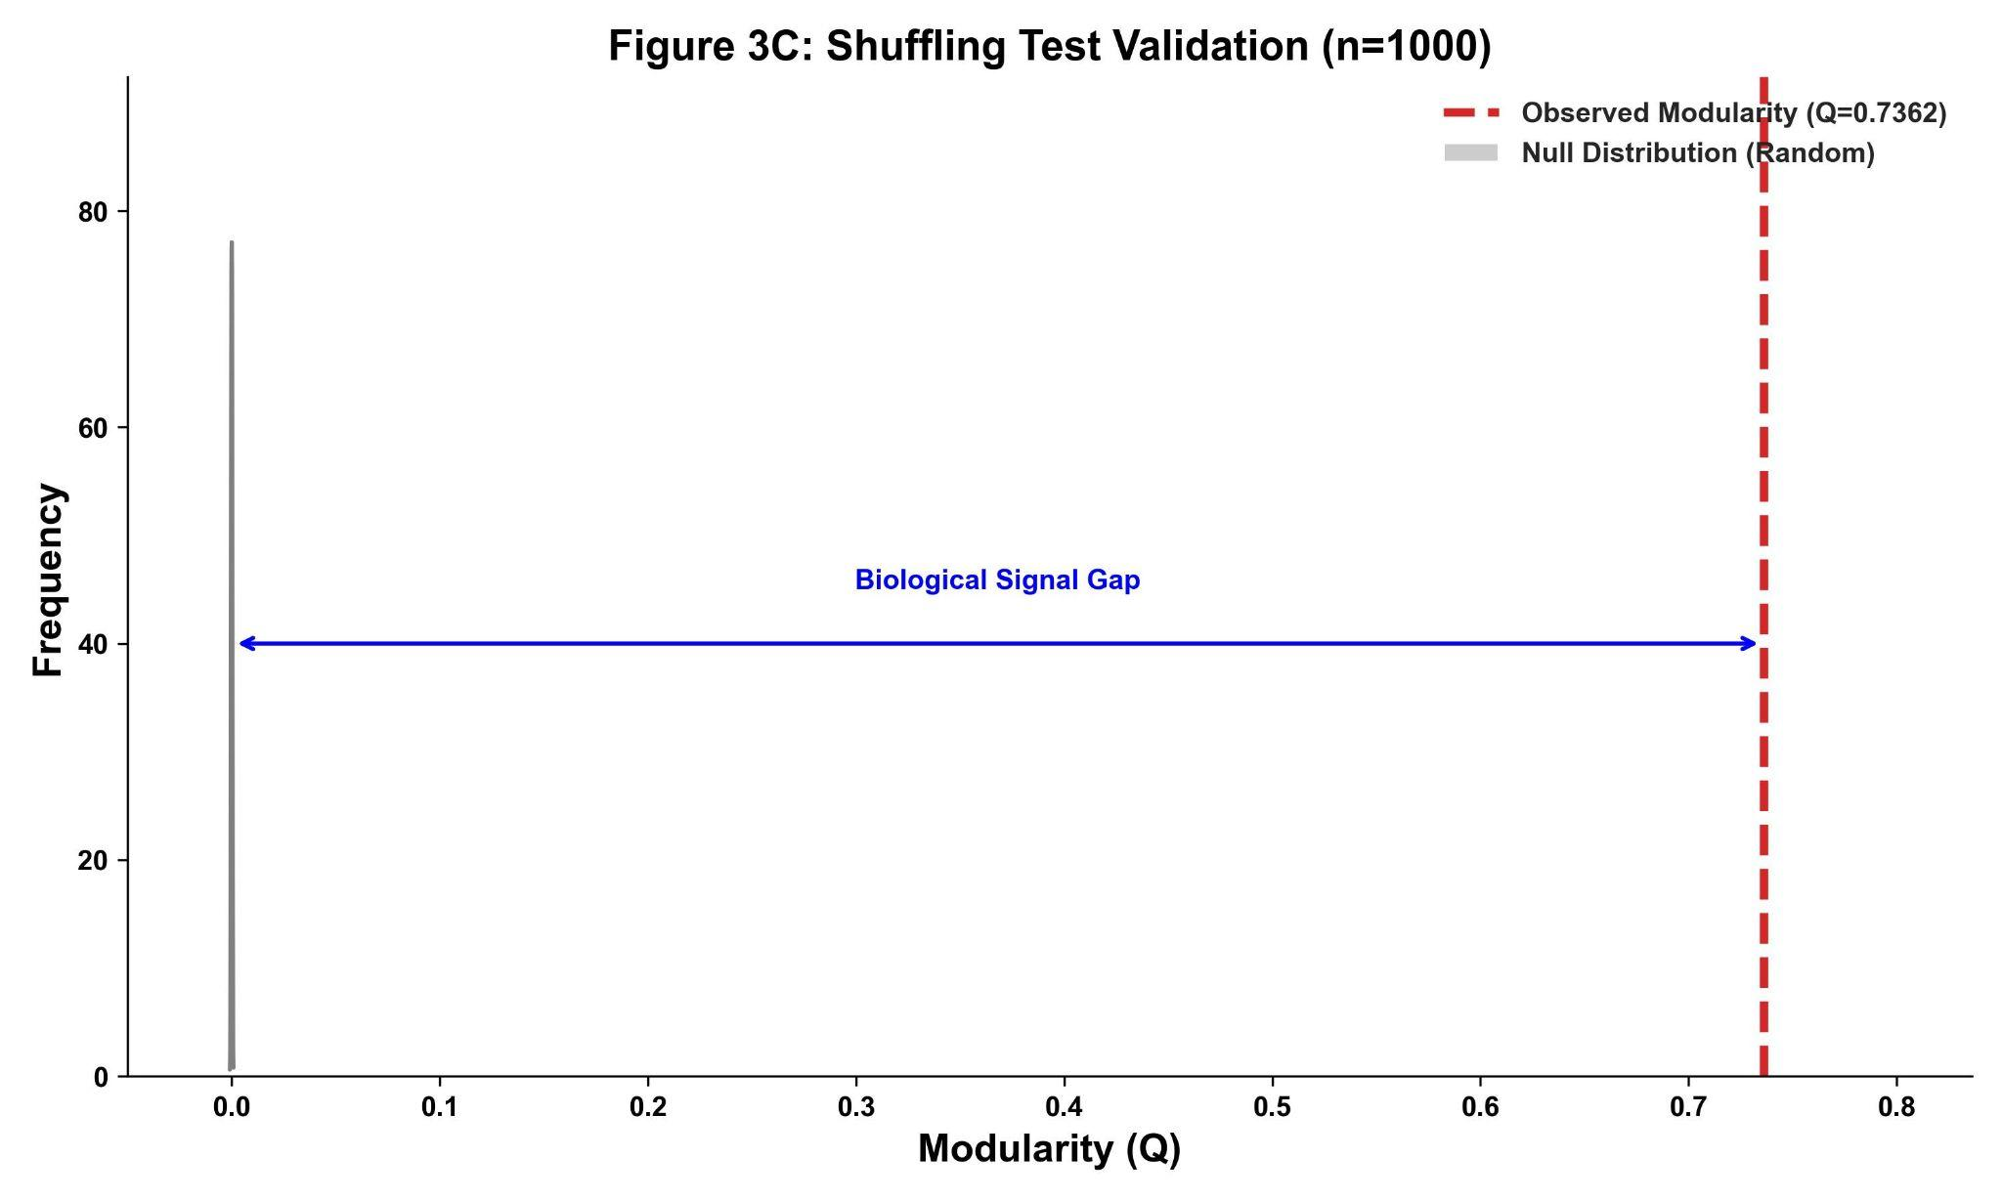
Figure S1. Permutation test for graph modularity validation.
Statistical validation of the unsupervised latent space partitioning generated by the Leiden algorithm. The histogram represents the empirical null distribution (grey bars) of modularity scores (Q) obtained from 1,000 statistical shuffling (permutation) iterations, highlighting a baseline random expectation centered at Q ≈ 0.0. The vertical red dashed line indicates the actual observed modularity achieved by the definitive digital morphotype profiling workflow (Q = 0.7362). The expansive distance between the permuted baseline and the empirical structure—denoted as the Biological Signal Gap—confirms with highly significant statistical confidence (p < 0.001) that the 29 discovered digital morphotypes reflect a robust, non-random underlying tissue organization rather than artifactual data clustering.

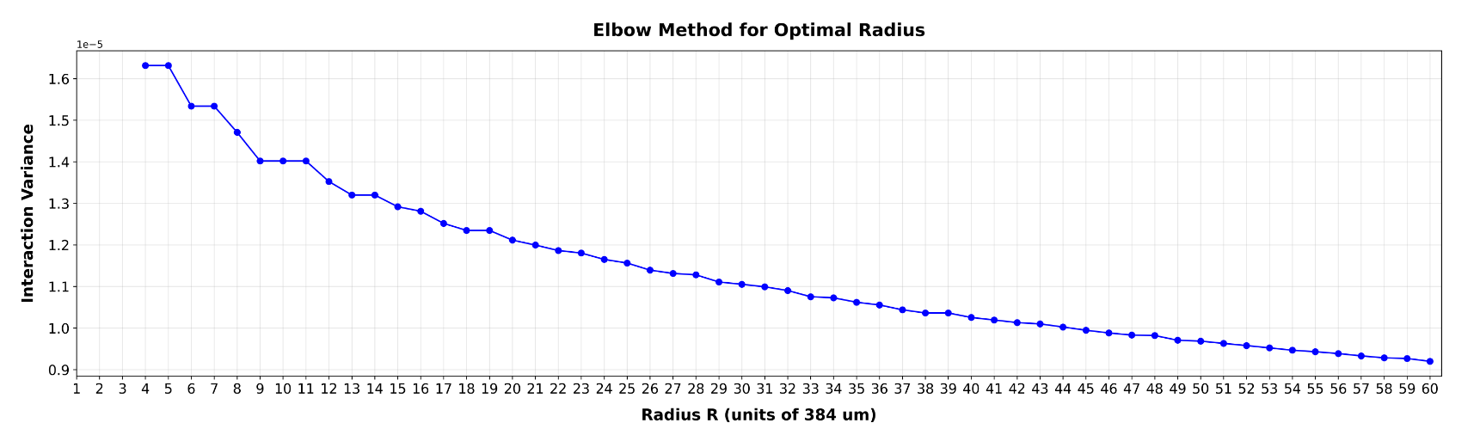
Figure S2. Optimization of the spatial interaction landscape using the elbow method.
Selection of the optimal neighborhood radius (R) for conditional adjacency probability mapping based on interaction variance. The line plot displays the total interaction variance across the MUSK-LoRA latent space configurations as a function of the radius R (measured in native patch spatial units of 384 μm). An inflection point ("elbow") is observed at Radius R = 9, representing the optimal operating threshold that maximizes the capture of localized architectural microenvironments while minimizing spatial background noise and computational redundancy. Larger radii display a stable, linear decay in variance, indicating structural diminishing returns.

Macro-domain | Digital Morphotypes | Lauren Subtype Bias | Mean Tumor Cellularity | False Positive Rate (FP %) | Dominant Non-Cellular & Stromal Structures | Key Cytomorphological & Architectural Signatures | Primary Biological / Technical Pitfalls
i) Infiltrative Diffuse Tumor Domain with High Stromal Component and Clear Space | DM0​, DM1​, DM2​, DM3​, DM4​, DM5​, DM10​, DM13​, DM14​, DM15​ | Highly skewed towards Diffuse variant | Low to Moderate | High (10% – 50%) | Abundant mucin, interstitial edema, dense collagenous stroma, empty clear spaces, and vascular lumens. | Infiltrative isolated cells, classical signet-ring cell morphology with eccentric nuclei and mucin-filled cytoplasm. Advanced sub-clusters (DM13​–DM15​) group highly atypical, large pleomorphic nuclei embedded in rigid collagenous matrices. | High FP rates (up to 50% in DM0​,DM3​) induced by optical overlap with native adipose tissue, technical tissue tears with background edema, and active infiltration into reactive smooth muscle bundles.
ii) Intestinal Tumor Domain with Well-Defined Glandular Architecture | DM6​, DM7​, DM8​, DM11​, DM12​, DM26​, DM27​ | Strongly associated with Intestinal subtype | Moderate to High | Variable (<5% – 50%) | Glandular lumens, variable collagenized stroma, and localized areas of geographic necrosis. | Well- to moderately differentiated structured glandular nests. DM8​ marks a classical phenotype with nuclear pseudostratification and amphophilic cytoplasm. DM11​ and DM27​ delimit disorganized glands intimately bound to extensive zones of necrotic debris ("dirty necrosis"). | High FP (50% in DM6​,DM12​) driven by reactive muscular proliferation, epithelial border tearing artifacts, and severe non-tumoral foveolar dysplasia. DM7​ achieves near-perfect diagnostic purity (<5% FP).
iii) Immune, Vascular, and Acute/Chronic Inflammatory Response Domain | DM9​, DM16​, DM17​, DM18​, DM19​ | Mixed / Non-classifiable | Variable (Highly dependent on host response) | Moderate (10% – 25%) | Extracellular matrix disrupted by vascular congestion, active hemorrhage, and patchy collagen. | Characterized by intense host-microenvironment crosstalk. DM9​ isolates highly cellular solid growth fields containing massive neutrophilic infiltration. DM16​,DM18​,DM19​ automatically map dense adaptive immune niches dominated by hyperchromatic lymphocytic halos. | FP rates up to 25% triggered by optical overlap with native non-neoplastic lymphoid aggregates/follicles. DM17​ uniquely captures technical/biological blood pooling, luminal congestion, and hemosiderin deposition.
iv) High Cellular Density and Scant Stroma Tumor Domain | DM20​, DM21​, DM22​, DM23​, DM24​, DM25​, DM28​ | Predominantly associated with Poorly Differentiated Intestinal / Solid variants | Critically High | Excellent Diagnostic Purity (<5% across all clusters) | Scant stroma, minimal extracellular background, and focal necrosis. | Pure neoplastic centers of gravity with the poorest histological differentiation. Characterized by dense sheets of cohesive cells, extreme nuclear basophilia, large vesicular or hyperchromatic nuclei with prominent nucleoli, and an elevated nuclear-to-cytoplasmic ratio (DM28​). | Exceptionally stable diagnostic performance. Minimal FP occurrences (<5%) restricted exclusively to areas of severe native glandular dysplasia or extensive intestinal metaplasia (DM25​).

Table S4. Histopathological taxonomy and characterization of the 29 digital morphotypes across histological macro-domains.
A comprehensive pathological audit and taxonomic classification of the unsupervised tissue clusters discovered within the HGGB gastric adenocarcinoma cohort (N = 108). The table systemizes the 29 digital morphotypes (DM0 to DM28) into four primary ecological macro-domains established via expert visual inspection of 9,000 tissue tiles (300 audited tiles per cluster). For each macro-domain, the specific digital morphotype assignments are cross-referenced with their corresponding Lauren classification subtype bias, mean estimated tumor cellularity, and empirical false-positive (FP) rates extracted during validation workflows. Additionally, the taxonomy details the dominant non-cellular and stromal architectures, alongside key cytomorphological and architectural signatures (e.g., signet-ring cell variants, glandular disorganization, and lymphocytic halos). Primary biological and technical pitfalls—including optical overlap with native tissue structures (adipose tissue, lymphoid follicles), inflammatory reactive changes, and mechanical tissue tearing artifacts—are explicitly reported to justify the geometric distribution of model classifications and explainability (XAI) mapping boundaries.

Characteristic | All Patients (N=108) | Train/Val (n=100) | Hold-out Test (n=8)
Total Patients | 108 | 100 | 8
Age (years)
<55 | 14 | 14 | 0
≥ 55 | 94 | 86 | 8
Gender
Male | 70 | 64 | 6
Female | 38 | 30 | 2
Lauren Classification
Intestinal | 49 | 45 | 4
Diffuse | 37 | 34 | 3
Mixed | 14 | 14 | 0
Unknown / No-info | 8 | 7 | 1
TNM Stage
Stage I | 24 | 22 | 2
Stage II | 32 | 31 | 1
Stage III | 39 | 34 | 5
Stage IV | 5 | 5 | 0
Unknown / No-info | 8 | 8 | 0
Invasion Level
Early | 17 | 16 | 1
Middle | 18 | 16 | 2
Late | 72 | 67 | 5
Unknown / No-info | 1 | 1 | 0
LVI
Positive | 60 | 56 | 4
Negative | 48 | 44 | 4
OS Status
Alive | 83 | 75 | 8
Deceased | 25 | 25 | 0
Follow-up Time
< 24 months | 21 | 21 | 0
≥ 24 months | 87 | 79 | 8

Table S5. Clinicopathological and Demographic Profile of the HGGB Cohort. Clinicopathological characteristics of the complete gastric cancer patient cohort (N = 108), stratified into the model development dataset (Train/Val, n = 100) and the independent validation set (Hold-out Test, n = 8). Values represent absolute patient counts. Abbreviations: TNM, Tumor-Node-Metastasis staging system; LVI, Lymphovascular Invasion; OS, Overall Survival.

Prompt Set | Description / Text Prompts
Set 1: Official | Class 0: "normal gastric tissue"  Class 1: "gastric adenocarcinoma tumor"
Set 2: Simple | Class 0: "normal tissue"  Class 1: "tumor tissue"
Set 3: Clinical | Class 0: "benign mucosa"  Class 1: "malignant neoplasm"
Set 4: Morpho | Class 0: "healthy gastric glands"  Class 1: "disorganized adenocarcinoma cells"
Set 5: Descriptive | Class 0: "histopathology of normal stomach"  Class 1: "histopathology of stomach cancer"
Table S6. Architectural Configuration and Performance Metrics of Textual Prompt Engineering for Zero-Shot Baseline Selection. Evaluated textual descriptor sets with progressive clinical specificity tested on the MUSK-Large vision-language foundation model.

