Supplementary Information
Structure and Sequence Regulated Biodegradable and Chemically Recyclable Adhesives
Beiwen Mo ^{1†}, Lin Zhu ^{1†}, Ze Xiao¹, Bixuan Wang¹, Ethan C. Quinn², Yan Cao^{1,3}, and Zhen Zhang^{1,3}*
¹ Advanced Institute for Soft Matter Science and Technology (AISMST), School of Emergent Soft Matter, State Key Laboratory of Pulp and Paper Engineering, South China University of Technology, Guangzhou 510640, China
² Division of Chemistry and Chemical Engineering, California Institute of Technology, Pasadena, California 91125, United States
³ Guangdong Provincial Key Laboratory of Functional and Intelligent Hybrid Materials and Devices, Guangdong Basic Research Center of Excellence for Energy and Information Polymer Materials
South China University of Technology, Guangzhou 510640, China
†These authors contributed equally to this work
*Correspondence to: zhenzhang@scut.edu.cn (Z. Zhang)

Table of Contents

Supplementary Figures 3
Figure S1. ¹H NMR spectrum (500 MHz, CDCl₃, 25 °C) of β^{ROH}-VL. 3
Figure S2. ¹H NMR spectrum (500 MHz, CDCl₃, 25 °C) of M₁. 3
Figure S3. ¹H NMR spectrum (500 MHz, CDCl₃, 25 °C) of M₂. 4
Figure S4. ¹H NMR spectrum (500 MHz, CDCl₃, 25 °C) of r-PVL(3C)_{1.7}. 4
Figure S5. ¹H NMR spectrum (500 MHz, CDCl₃, 25 °C) of t-PVL(OH)_{5.0}. 5
Figure S6. ¹H NMR spectrum (500 MHz, CDCl₃, 25 °C) of m-PVL(OH)_{5.3}. 5
Figure S7. SEC traces of r-PVL(OH)_{8.5(26k)}, r-PVL(OH)_{8.8(38k)}, r-PVL(OH)_{8.5(58k)} and r-PVL(OH)_{7.5(104k)} produced by ROP of δ-VL and M₁ after deprotection. 6
Figure S8. SEC traces of PVL, r-PVL(3C)_{1.7}, r-PVL(OH)_{1.5}, r-PVL(OH)_{4.9} and r-PVL(OH)_{10.0} produced by ROP of δ-VL and M₁ (after deprotection) or M₂. 6
Figure S9. Effect of molar mass on the adhesive properties of polymers on steel substrates. 7
Figure S10. Stress-strain curves of PVL. 7
Figure S11. Stress-strain curves of r-PVL(3C)_{1.7}. 8
Figure S12. Stress-strain curves of r-PVL(OH)_{1.5}. 8
Figure S13. Stress-strain curves of r-PVL(OH)_{4.9}. 9
Figure S14. Shear viscosity over shear rate of r-PVL(3C)_{1.7} in melt (65 °C). 9
Figure S15. WAXS profiles of PVL and r-PVL(OH)_{1.5,4.9,10.0}. 10
Figure S16. Water contact angle of PVL and r-PVL(OH)_{1.5,4.9,10.0}. 10
Figure S17. Storage modulus traces of PVL, r-PVL(3C)_{1.7}, and r-PVL(OH)_{1.5,4.9,10.0}. 11
Figure S18. Loss modulus traces of PVL, r-PVL(3C)_{1.7}, and r-PVL(OH)_{1.5,4.9,10.0}. 11
Figure S19. Tan (δ) traces of PVL, r-PVL(3C)_{1.7}, and r-PVL(OH)_{1.5,4.9,10.0}. 12
Figure S20. SEC traces of t-PVL(OH)_{5.0} produced by ROP of δ-VL and M₁ after deprotection. 12
Figure S21. TGA traces of t-PVL(OH)_{5.0}. 13
Figure S22. Stress-strain curves of t-PVL(OH)_{5.0}. 13
Figure S23. Shear viscosity over shear rate of t-PVL(OH)_{5.0} in melt (65 °C). 14
Figure S24. SEC traces of m-PVL(OH)_{5.3} produced by ROP of δ-VL and M₁ after deprotection. 14
Figure S25. TGA traces of m-PVL(OH)_{5.3}. 15
Figure S26. Stress-strain curves of m-PVL(OH)_{5.3}. 15
Figure S27. Shear viscosity over shear rate of m-PVL(OH)_{5.3} in melt (65 °C). 16
Figure S28. WAXS profiles of r-PVL(OH)_{4.9}, t-PVL(OH)_{5.0} and m-PVL(OH)_{5.3}. 16
Figure S29. ΔH_{f} and X_{c} values of r-PVL(OH)_{4.9}, t-PVL(OH)_{5.0} and m-PVL(OH)_{5.3}. X_{c} is calculated based on the ΔHo m value of 100% crystalline polymer, 18.2 kJ/mol. 17
Figure S30. Water contact angle of r-PVL(OH)_{4.9}, t-PVL(OH)_{5.0} and m-PVL(OH)_{5.3}. 17
Figure S31. Storage modulus traces of r-PVL(OH)_{4.9}, t-PVL(OH)_{5.0} and m-PVL(OH)_{5.3}. 18
Figure S32. Loss modulus traces of r-PVL(OH)_{4.9}, t-PVL(OH)_{5.0} and m-PVL(OH)_{5.3}. 18
Figure S33. Tan (δ) traces of r-PVL(OH)_{4.9}, t-PVL(OH)_{5.0} and m-PVL(OH)_{5.3}. 19
Supplementary Tables 20
Table S1. Mechanical performance data for PVL. 20
Table S2. Mechanical performance data for r-PVL(3C)_{1.7}. 20
Table S3. Mechanical performance data for r-PVL(OH)_{1.5}. 20
Table S4. Mechanical performance data for r-PVL(OH)_{4.9}. 20
Table S5. Mechanical performance data for t-PVL(OH)_{5.0}. 21
Table S6. Mechanical performance data for m-PVL(OH)_{5.3}. 21
Table S7. Results of depolymerization. 21

Supplementary Figures

Figure S1. ¹H NMR spectrum (500 MHz, CDCl₃, 25 °C) of β^{ROH}-VL.

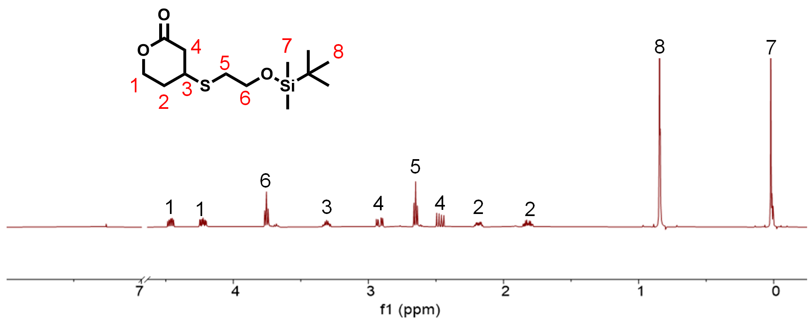

Figure S2. ¹H NMR spectrum (500 MHz, CDCl₃, 25 °C) of M₁.

Figure S3. ¹H NMR spectrum (500 MHz, CDCl₃, 25 °C) of M₂.

Figure S4. ¹H NMR spectrum (500 MHz, CDCl₃, 25 °C) of r-PVL(3C)_{1.7}.

Figure S5. ¹H NMR spectrum (500 MHz, CDCl₃, 25 °C) of t-PVL(OH)_{5.0}.

Figure S6. ¹H NMR spectrum (500 MHz, CDCl₃, 25 °C) of m-PVL(OH)_{5.3}.

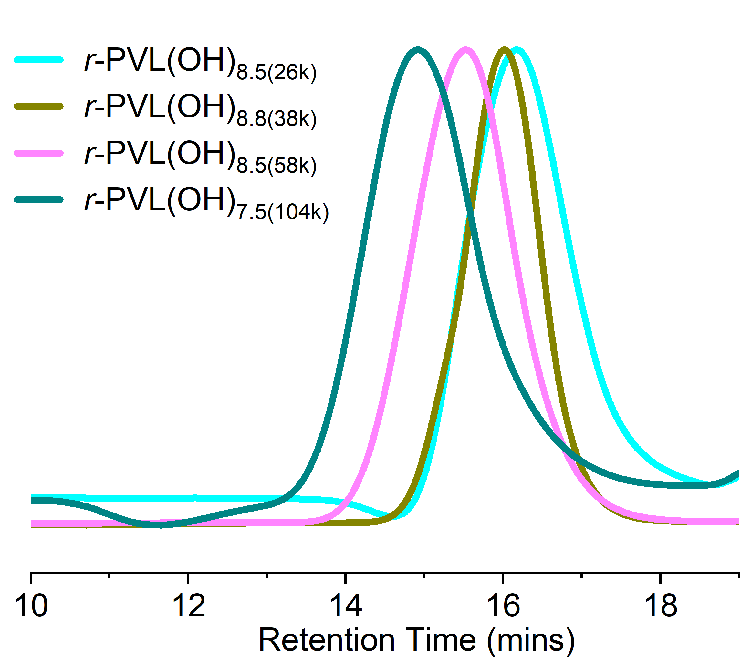

Figure S7. SEC traces of r-PVL(OH)_{8.5(26k)}, r-PVL(OH)_{8.8(38k)}, r-PVL(OH)_{8.5(58k)} and r-PVL(OH)_{7.5(104k)} produced by ROP of δ-VL and M₁ after deprotection.

Figure S8. SEC traces of PVL, r-PVL(3C)_{1.7}, r-PVL(OH)_{1.5}, r-PVL(OH)_{4.9} and r-PVL(OH)_{10.0} produced by ROP of δ-VL and M₁ (after deprotection) or M₂.

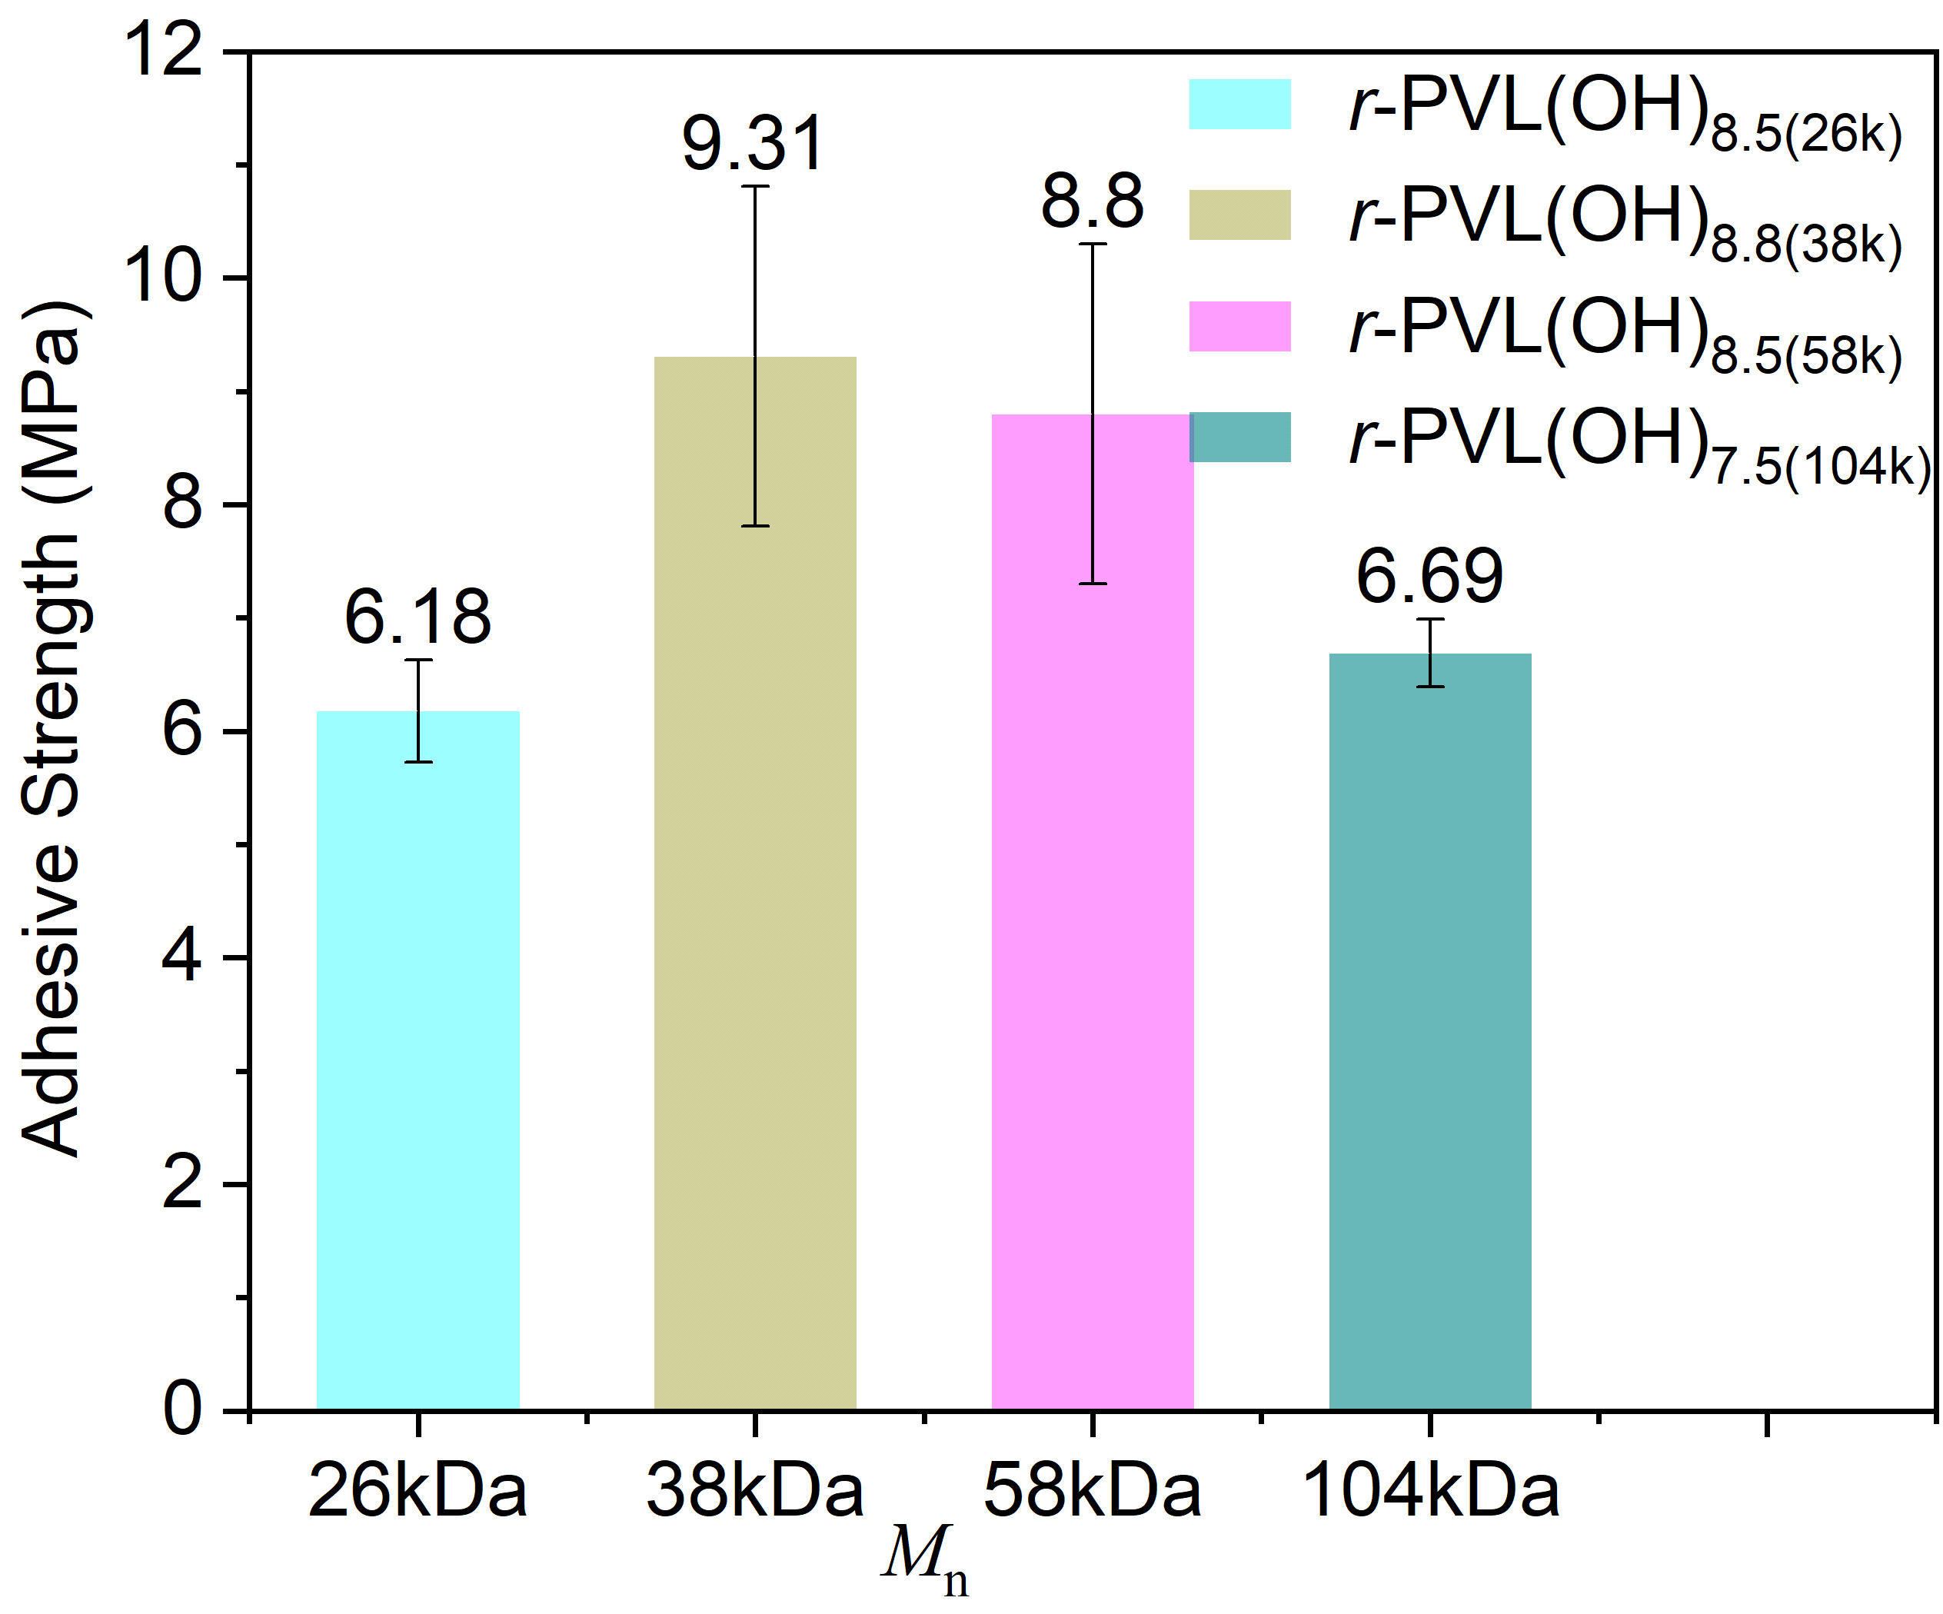

Figure S9. Effect of molar mass on the adhesive properties of polymers on steel substrates.

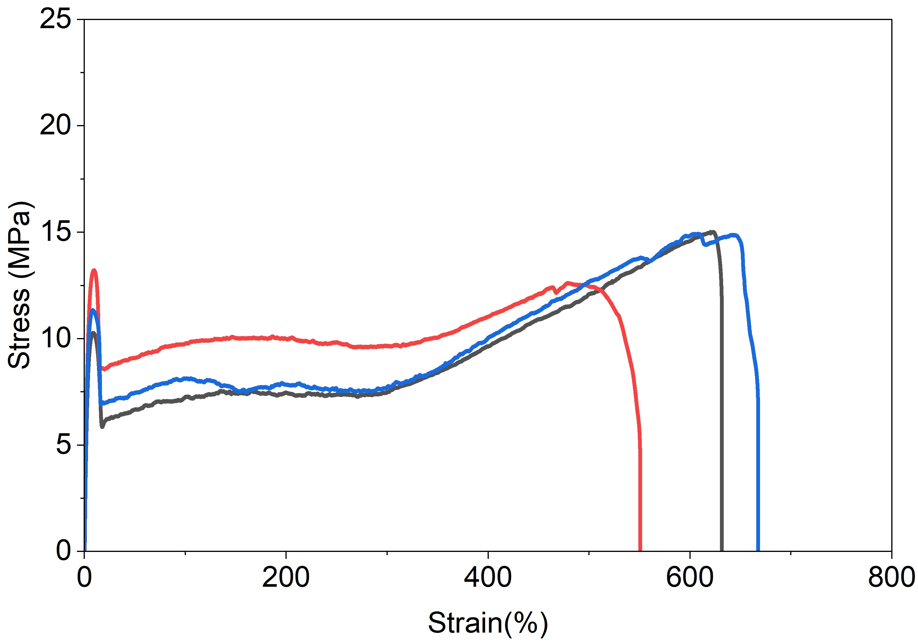

Figure S10. Stress-strain curves of PVL.

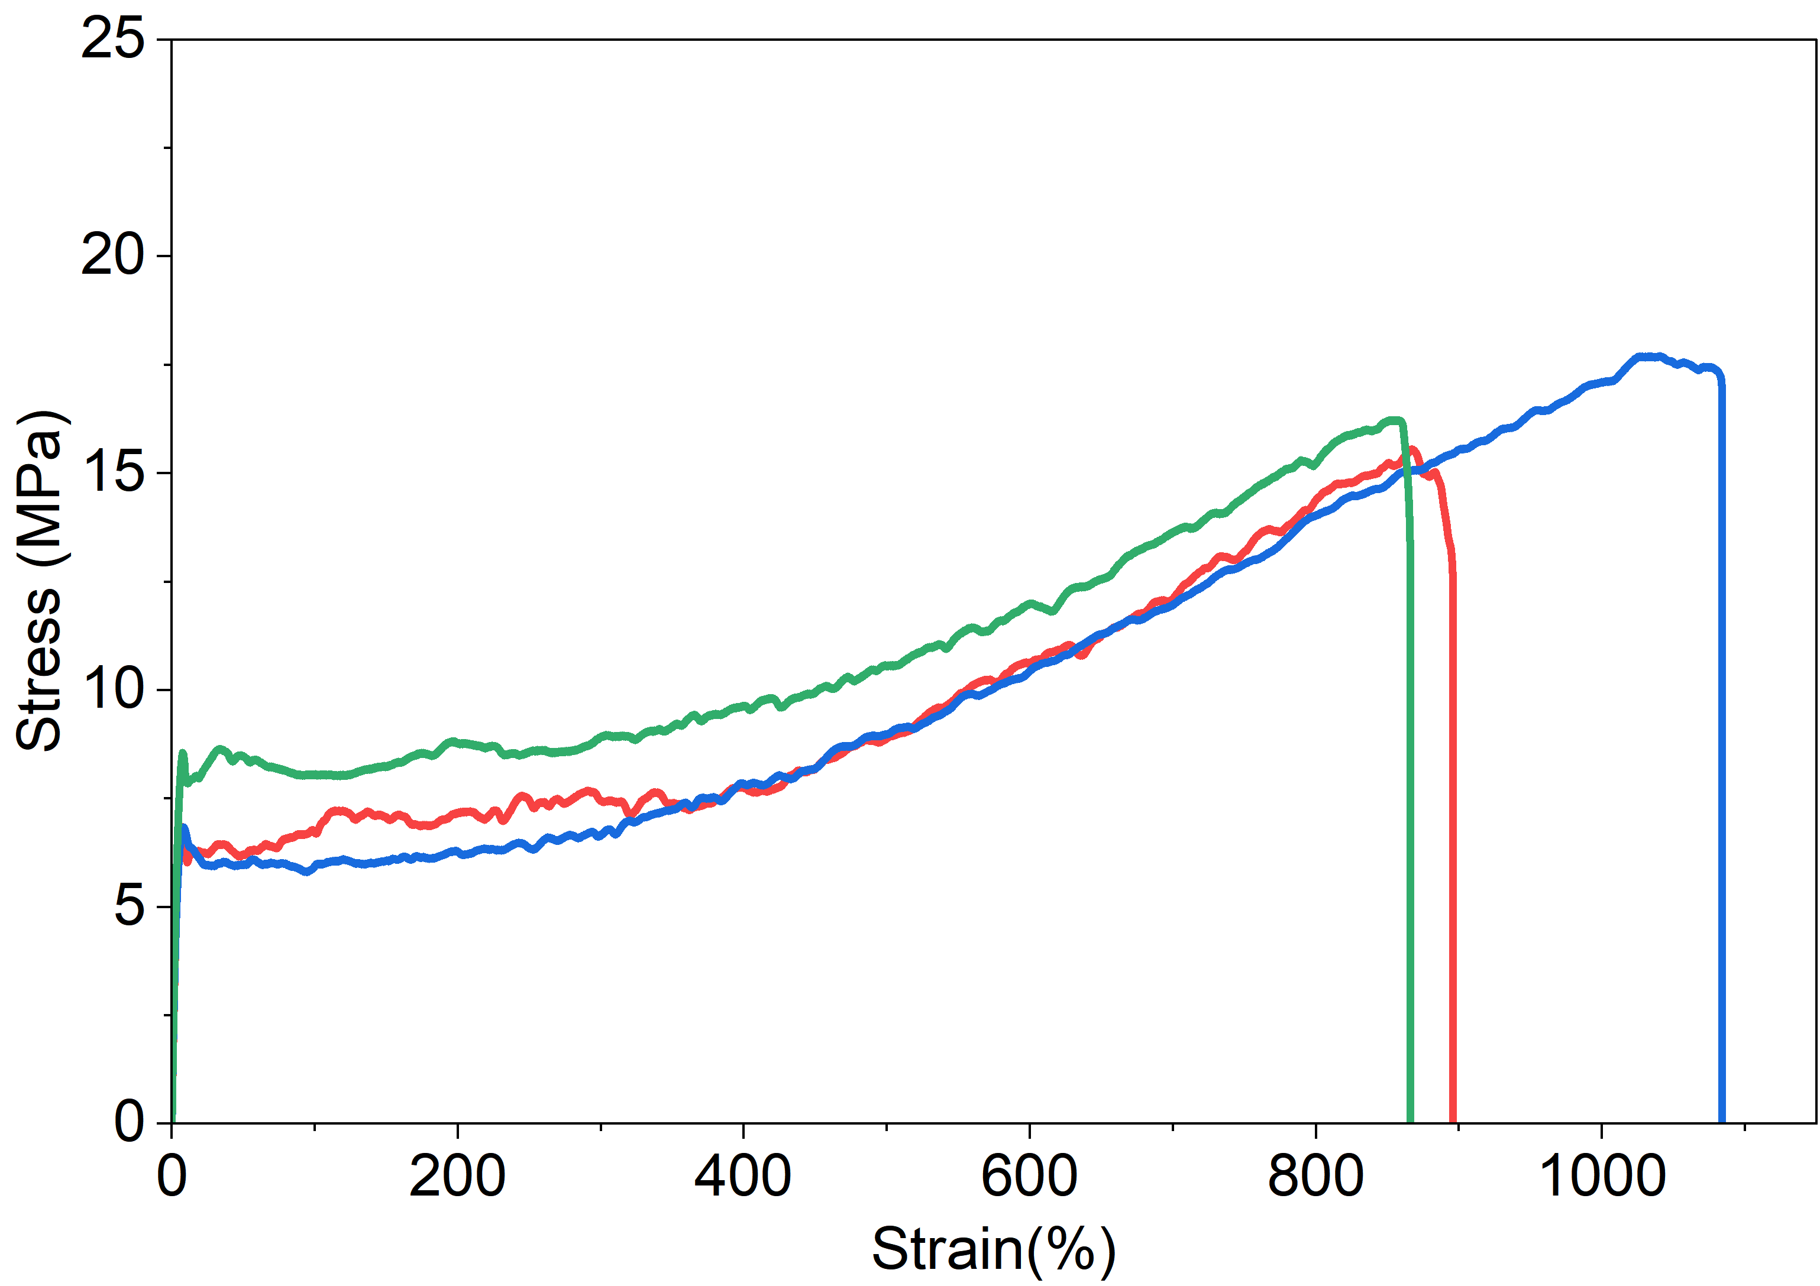

Figure S11. Stress-strain curves of r-PVL(3C)_{1.7}.

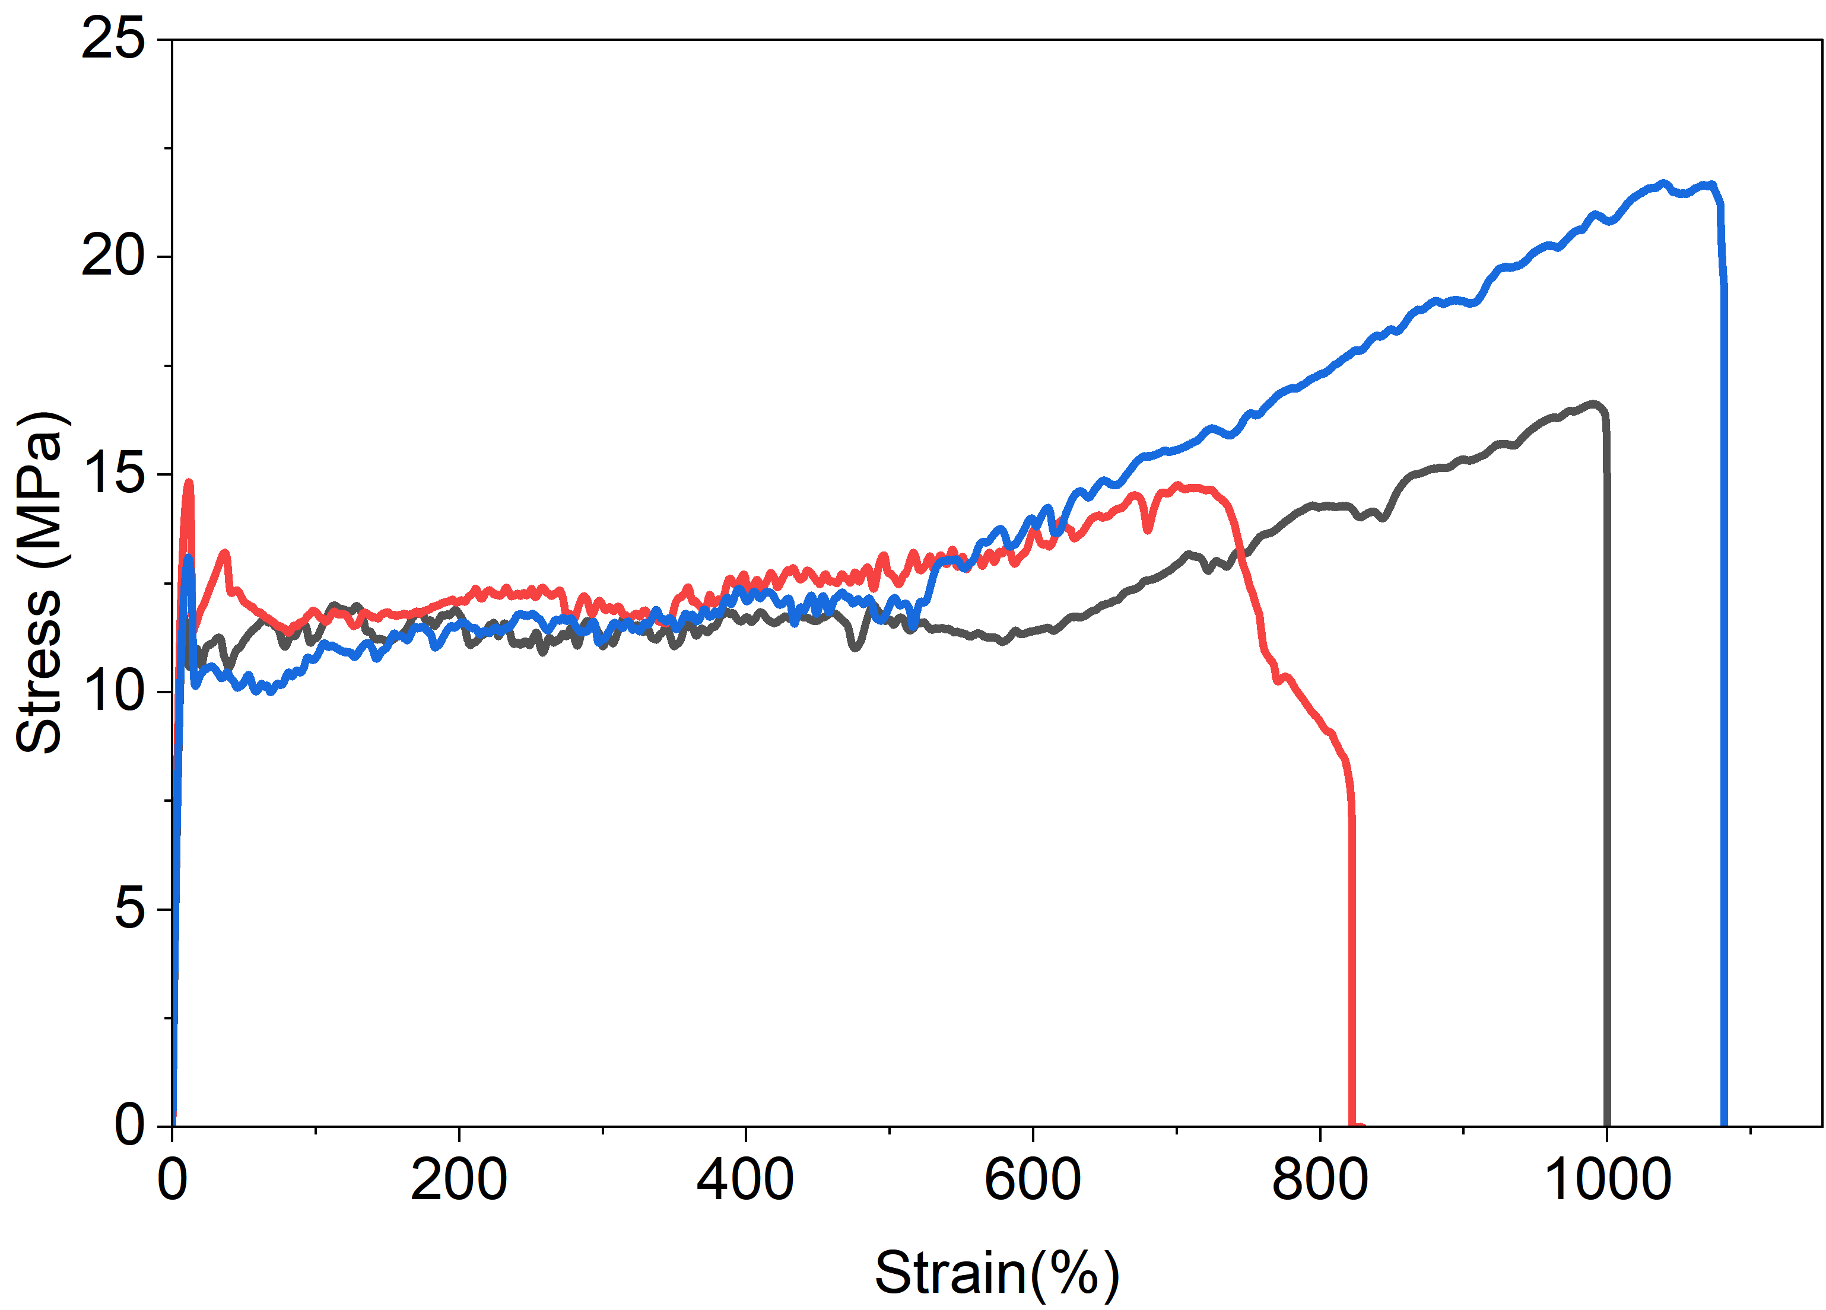

Figure S12. Stress-strain curves of r-PVL(OH)_{1.5}.

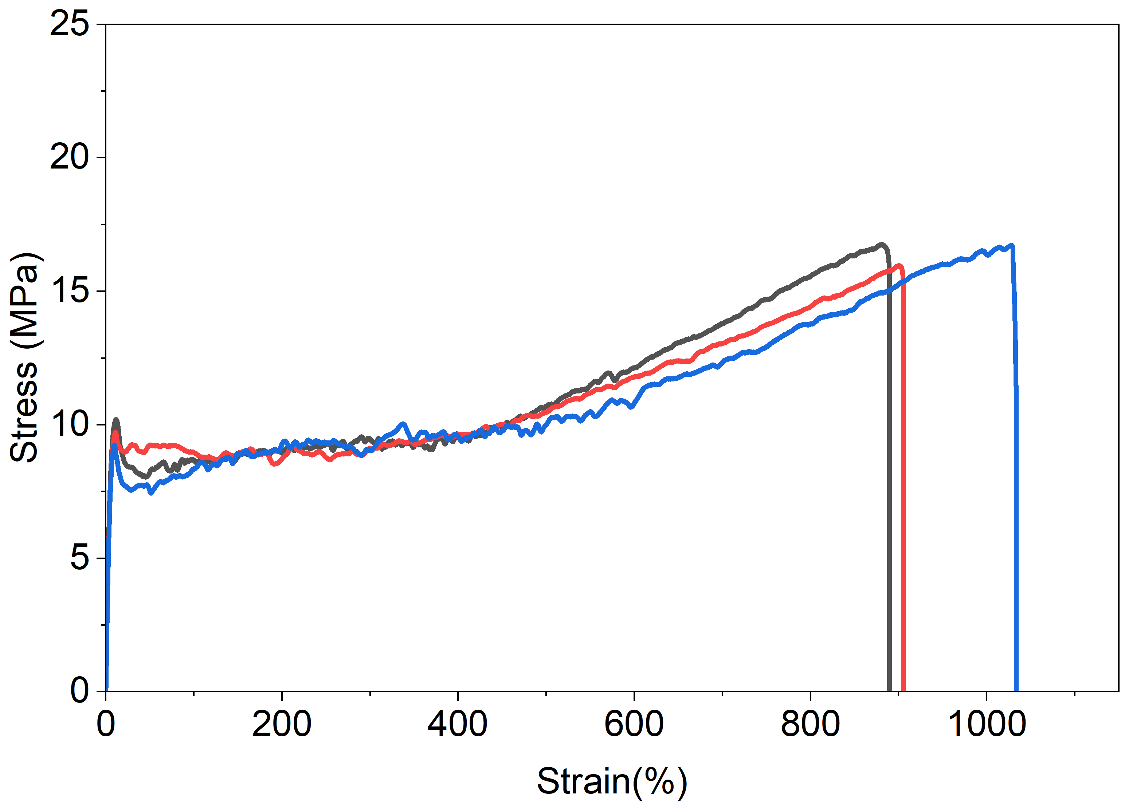

Figure S13. Stress-strain curves of r-PVL(OH)_{4.9}.

Figure S14. Shear viscosity over shear rate of r-PVL(3C)_{1.7} in melt (65 °C).

Figure S15. WAXS profiles of PVL and r-PVL(OH)_{1.5,4.9,10.0}.

Figure S16. Water contact angle of PVL and r-PVL(OH)_{1.5,4.9,10.0}.

Figure S17. Storage modulus traces of PVL, r-PVL(3C)_{1.7}, and r-PVL(OH)_{1.5,4.9,10.0}.

Figure S18. Loss modulus traces of PVL, r-PVL(3C)_{1.7}, and r-PVL(OH)_{1.5,4.9,10.0}.

Figure S19. Tan (δ) traces of PVL, r-PVL(3C)_{1.7}, and r-PVL(OH)_{1.5,4.9,10.0}.

Figure S20. SEC traces of t-PVL(OH)_{5.0} produced by ROP of δ-VL and M₁ after deprotection.

Figure S21. TGA traces of t-PVL(OH)_{5.0}.

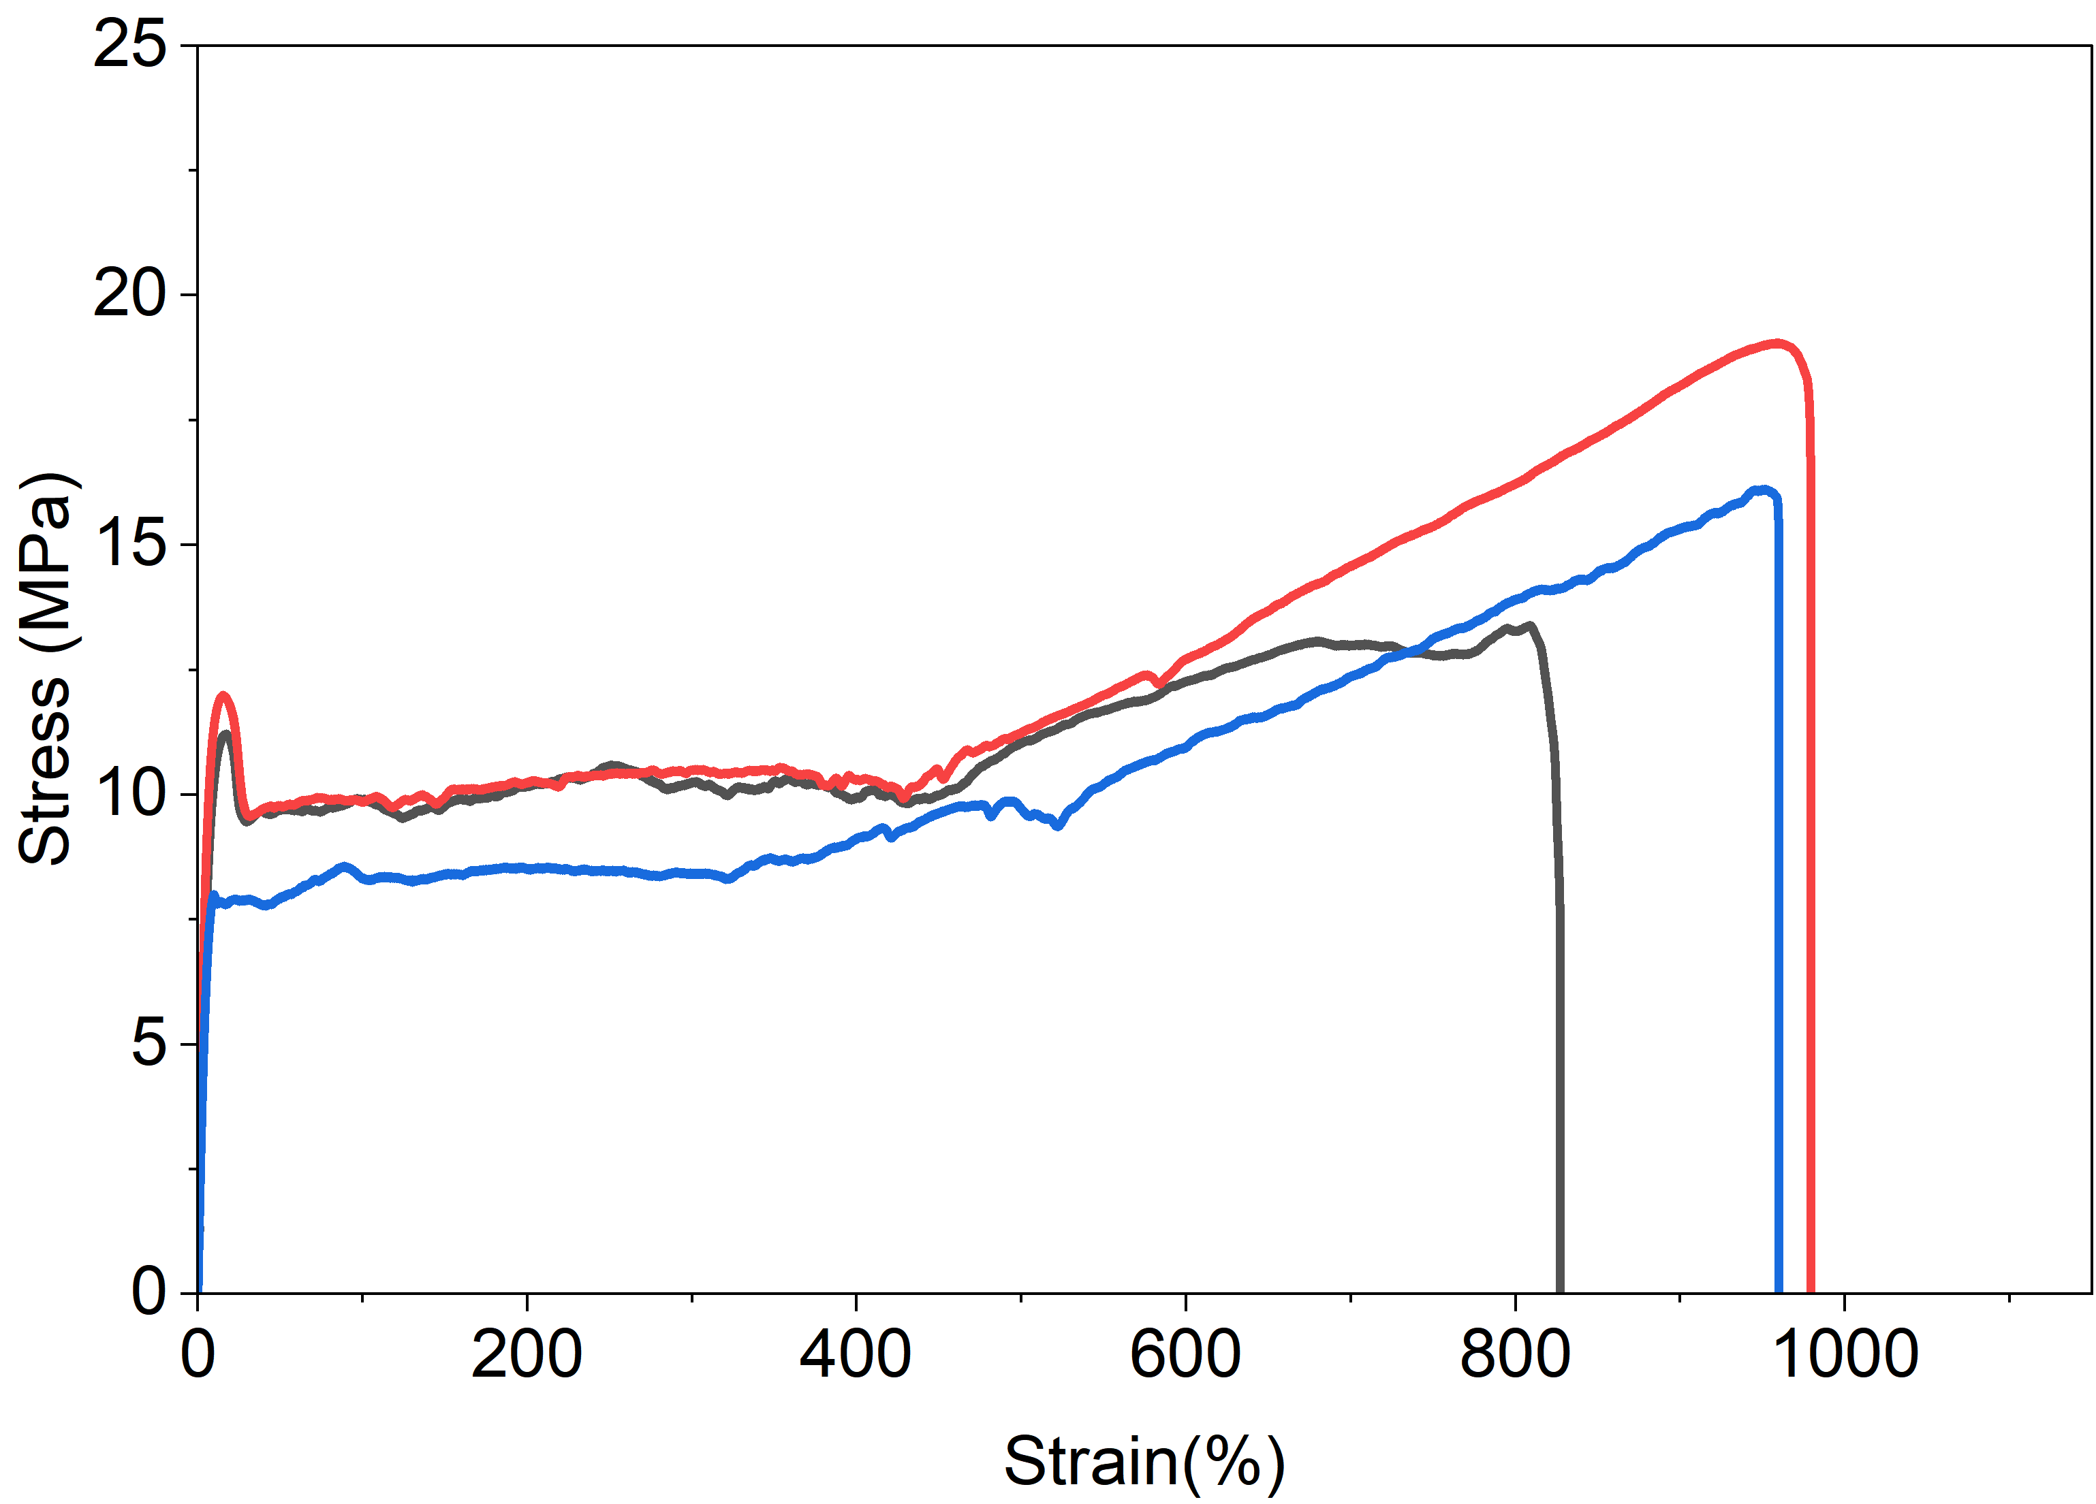

Figure S22. Stress-strain curves of t-PVL(OH)_{5.0}.

Figure S23. Shear viscosity over shear rate of t-PVL(OH)_{5.0} in melt (65 °C).

Figure S24. SEC traces of m-PVL(OH)_{5.3} produced by ROP of δ-VL and M₁ after deprotection.

Figure S25. TGA traces of m-PVL(OH)_{5.3}.

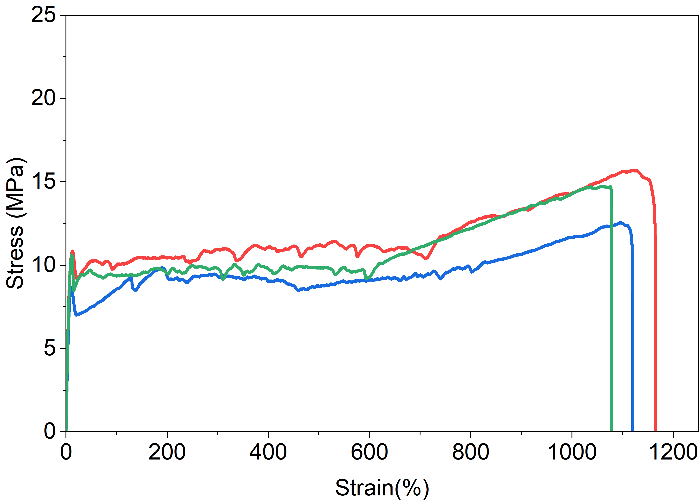

Figure S26. Stress-strain curves of m-PVL(OH)_{5.3}.

Figure S27. Shear viscosity over shear rate of m-PVL(OH)_{5.3} in melt (65 °C).

Figure S28. WAXS profiles of r-PVL(OH)_{4.9}, t-PVL(OH)_{5.0} and m-PVL(OH)_{5.3}.

Figure S29. ΔH_{f} and X_{c} values of r-PVL(OH)_{4.9}, t-PVL(OH)_{5.0} and m-PVL(OH)_{5.3}. X_{c} is calculated based on the ΔHo m value of 100% crystalline polymer, 18.2 kJ/mol.

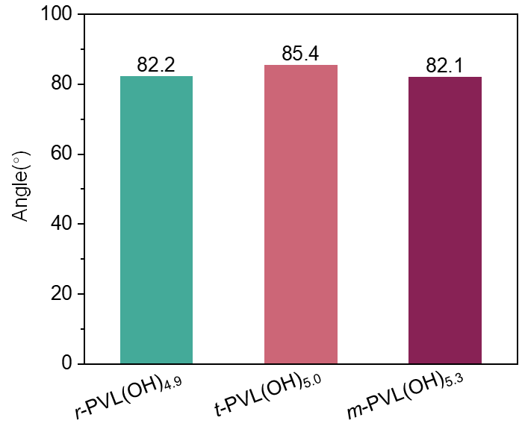

Figure S30. Water contact angle of r-PVL(OH)_{4.9}, t-PVL(OH)_{5.0} and m-PVL(OH)_{5.3}.

Figure S31. Storage modulus traces of r-PVL(OH)_{4.9}, t-PVL(OH)_{5.0} and m-PVL(OH)_{5.3}.

Figure S32. Loss modulus traces of r-PVL(OH)_{4.9}, t-PVL(OH)_{5.0} and m-PVL(OH)_{5.3}.

Figure S33. Tan (δ) traces of r-PVL(OH)_{4.9}, t-PVL(OH)_{5.0} and m-PVL(OH)_{5.3}.

Supplementary Tables

Table S1. Mechanical performance data for PVL.

Run | Young's modulus  (MPa) |  | Elongation at break (%) | Ultimate tensile strength (MPa) | Toughness  (MJ/m³) | Yield stress (MPa)
1 |  | 338.0 | 620 | 15 | 58.9 | 10.3
2 |  | 363.6 | 607 | 14.9 | 66.3 | 11.3
3 |  | 363.3 | 591 | 13.2 | 55.6 | 13.2
AVG |  | 355.0±14.7 | 606±15 | 14.4±1.0 | 60.3±5.4 | 11.6±1.5

Table S2. Mechanical performance data for r-PVL(3C)_{1.7}.

Run | Young's modulus  (MPa) | elongation at break (%) | ultimate tensile strength (MPa) | Toughness  (MJ/m³) | Yield stress (MPa)
1 | 186.1 | 895 | 15.6 | 84.9 | 6.8
2 | 184.4 | 1080 | 17.4 | 113.7 | 6.8
3 | 206.7 | 860 | 16.2 | 93.0 | 8.5
AVG | 192.4±12.4 | 945±118 | 16.4±0.9 | 97.2±14.8 | 7.4±1.0

Table S3. Mechanical performance data for r-PVL(OH)_{1.5}.

Run | Young's modulus  (MPa) | Elongation at break (%) | ultimate tensile strength (MPa) | Toughness  (MJ/m³) | Yield stress (MPa)
1 | 256.4 | 1002 | 16.6 | 124.5 | 11.8
2 | 291.4 | 829 | 14.8 | 101.8 | 14.8
3 | 261.6 | 1083 | 21.7 | 156.6 | 13.1
AVG | 269.8±18.8 | 971±129 | 17.7±3.6 | 127.7±27.5 | 13.3±1.5

Table S4. Mechanical performance data for r-PVL(OH)_{4.9}.

Run | Young's modulus  (MPa) | Elongation at break (%) | ultimate tensile strength (MPa) | Toughness  (MJ/m³) | Yield stress (MPa)
1 | 212.6 | 891 | 16.8 | 99.5 | 10.2
2 | 212.6 | 908 | 15.9 | 99.4 | 9.7
3 | 202.5 | 1035 | 16.7 | 116.3 | 9.2
AVG | 209.3±5.8 | 944±79 | 16.5±0.4 | 105.0±9.7 | 9.7±0.5

Table S5. Mechanical performance data for t-PVL(OH)_{5.0}.

Run | Young's modulus  (MPa) | Elongation at break (%) | ultimate tensile strength (MPa) | Toughness  (MJ/m³) | Yield stress (MPa)
1 | 179.9 | 838 | 13.4 | 90.8 | 11.2
2 | 240.3 | 981 | 19.1 | 124.3 | 12
3 | 165.3 | 961 | 16.1 | 101.8 | 8
AVG | 195.1±39.8 | 927±77 | 16.2±2.9 | 105.6±17.1 | 10.4±2.1

Table S6. Mechanical performance data for m-PVL(OH)_{5.3}.

Run | Young's modulus  (MPa) | Elongation at break (%) | ultimate tensile strength (MPa) | Toughness  (MJ/m³) | Yield stress (MPa)
1 | 168.0 | 1167 | 15.7 | 137.7 | 10.8
2 | 168.0 | 1118 | 12.6 | 106.5 | 8.7
3 | 191.8 | 1080 | 14.7 | 117.7 | 10.6
AVG | 175.9±13.7 | 1122±43 | 14.3±1.6 | 120.6±15.8 | 10.0±1.2

Table S7. Results of depolymerization.

Polymerª | Temp. (℃) |  | Cat. (wt%) | Time (h) | Yield^{b}  (%)
PVL | 130 |  | ZnCl₂ (2%) | 5 | 48.7
PVL |  | 130 | ZnCl₂ (6%) | 4 | 49.6
r-PVL(OH)_{1.6} |  | 150 | ZnCl₂ (2%) | 5 | 31.4
r-PVL(OH)_{1.6} |  | 120 | ZnCl₂ (2%) | 5 | 2.0
r-PVL(OH)_{1.6} |  | 150 | ZnCl₂ (2%) | 5 | 31.4
PVL |  | 130 | Zn(Oct)₂ (6%) | 4 | 86.5
r-PVL(OH)_{4.9} |  | 140 | Zn(Oct)₂ (6%) | 6 | 92.4
ª PVL (M_{n} = 48~50kDa), r-PVL(OH)_{1.6} (M_{n} = 55kDa). ^{b} The ratio of the recovered δ-VL to the comonomers (δ-VL and M1).

