Figure S1. Spatial distribution of the core flight corridors used for contrail evaluation. The red boxes delineate the five representative geographic regions selected for model performance assessment, including: (1) NAFC (North Atlantic Flight Corridor): 45°N–65°N, 60°W–10°W; (2) ANAFC (Asian-North American Flight Corridor), divided into two sub-regions: ANAFC-E (30°N–60°N, 140°E–180°) and ANAFC-W (30°N–60°N, 180°W–130°W); (3) AAFC (Australasian Flight Corridor): 15°S–25°N, 105°E–165°E; (4) NARC (North American Route Corridor): 25°N–50°N, 130°W–65°W. The background map showcases global natural topography and bathymetry, emphasizing the diverse surface types (land/ocean) within the evaluation zones.

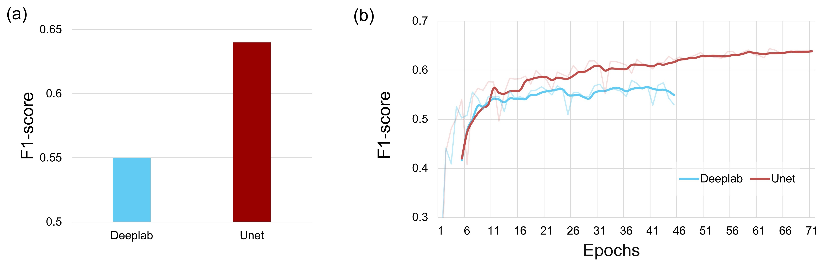
Figure S2. Accuracy comparison of DeepLab and the improved UNet during the pre-training Stage-1 on the GOES-16 dataset. (a) Optimal accuracy after convergence; (b) Pre-training curves.

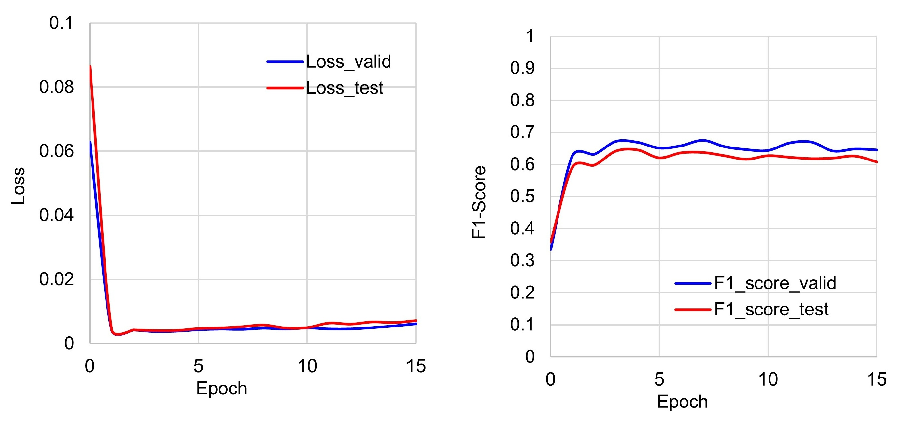
Figure S3. Learning curves during the fine-tuning Stage-3 of the model. (a) Evolution of validation loss and test loss across training epochs. (b) Progression of validation F1-score and test F1-score as a function of training epochs.
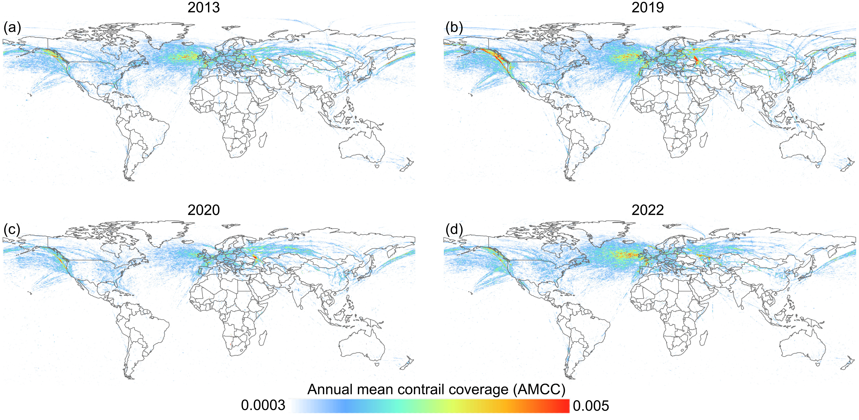
Figure S4. Annual mean contrail coverage (AMCC). Over 2013 (a), 2019 (b), 2020 (c), and 2022 (d) monitored by MODIS (Aqua satellite).

Table S1. Modis Dataset used in finetune stage. The table outlines the image counts and percentage allocations across the (1) Finetune, (2) Validation, and (3) Test subsets, categorized by scene characteristic into Contrail-containing samples, Noise-heavy background samples, and their integrated totals (Sum).
DataSet | Contrail | Percent | Noise | Percent | Sum | Percent
Finetune | 133 | 4% | 274 | 74% | 407 | 74%
Validation | 18 | 10% | 34 | 9% | 52 | 9%
Test | 28 | 16% | 64 | 17% | 92 | 17%
Sum | 179 | 100% | 372 | 100% | 551 | 100%

Table S2. The Spatio-temporal information of contrail dataset. The description details the explicit year ranges, seasonal month windows, and image quantities allocated for the core model segments, which encompass the fine-tuning and validation stages within the North Atlantic Flight Corridor (NAFC) alongside comprehensive independent evaluations of temporal generalization and spatial robustness across major global aviation corridors (ANAFC, AAFC, and NARC).
Phase | Years | Months | Pictures
Fine-tuning (Europe/America: NAFC) | 2015，2023，2024 | 20-27 Mar / Jun / Sep / Dec | 133
Valid (Europe/America: NAFC) | 2015，2023，2024 | 20-27 Mar / Jun / Sep / Dec | 18
Test Time (Europe/America: NAFC) | 2024，2022 | 1-14 Mar | 7
Test Space (Japan: ANAFC) | 2024 | 20-27 Dec | 7
Test Space (Australia: AAFC) | 2023–2024 | 20-27 Dec | 7
Test Space (North America Land: NARC) | 2024 | 20-27 Dec | 7

Table S3. Classification and statistical distribution of background noise types across dataset splits. The summary details the absolute frequencies and percentage allocations of specific false-positive interference categories within the finetuning, validation, and test subsets, explicitly breaking down the distribution of river networks, linear Conrail cirrus, sensor stripe noise, polar ice sheets, and natural cirrus clouds.
DataSetNoise | River | ConrailCirrus | Stripe noise | Ice Sheet | Nature Cirrus | Percent
Finetune | 43 | 34 | 109 | 11 | 77 | 75%
Validation | 5 | 4 | 14 | 1 | 10 | 10%
Test | 11 | 9 | 24 | 3 | 17 | 15%
Sum | 59 | 47 | 147 | 15 | 104 | 100%

Table S4. Quantitative performance validation of the proposed model across various training stages and sensor configurations. The evaluation systematically presents multiple core segmentation metrics—including AUC-PR calculated via 300 discrete sampling points, F1-Score at a classification threshold of 0.35, Precision, and Recall—to compare the U-Net and DeepLab architectures under GOES and MODIS observations across progressive pre-training, sensor transfer, and noise-adaptive fine-tuning tasks.
Task Name | AUC-PR (300-pt) | F1-Score @0.35 | Precision | Recall
stage1-unet-goes | 0.68 | 0.63 | 0.62 | 0.64
stage1-deeplab-goes | 0.57 | 0.56 | 0.58 | 0.55
stage1-unet-modis (with noise) | 0.32 | 0.36 | 0.25 | 0.61
stage1-deeplab-modis (with noise) | 0.23 | 0.19 | 0.11 | 0.82
stage1-unet_modisContrail (pure contrail, no background noise) | 0.56 | 0.56 | 0.53 | 0.61
stage2-unet_modisContrail (pure contrail, no background noise) | 0.74 | 0.69 | 0.61 | 0.80
stage2-unet-modis (with noise) | 0.28 | 0.32 | 0.20 | 0.80
stage3-unet-modis (with noise) | 0.65 | 0.64 | 0.59 | 0.69

