Construction of a convenient screening method for p-hydroxybenzoate hydroxylase to enable efficient gallic acid and pyrogallol biosynthesis

Zhenya Chen, Tongtong Chen, Shengzhu Yu, Yi-Xin Huo*

Supporting Information

Contents:
Fig. S1
Fig. S2
Fig. S3
Fig. S4
Fig. S5

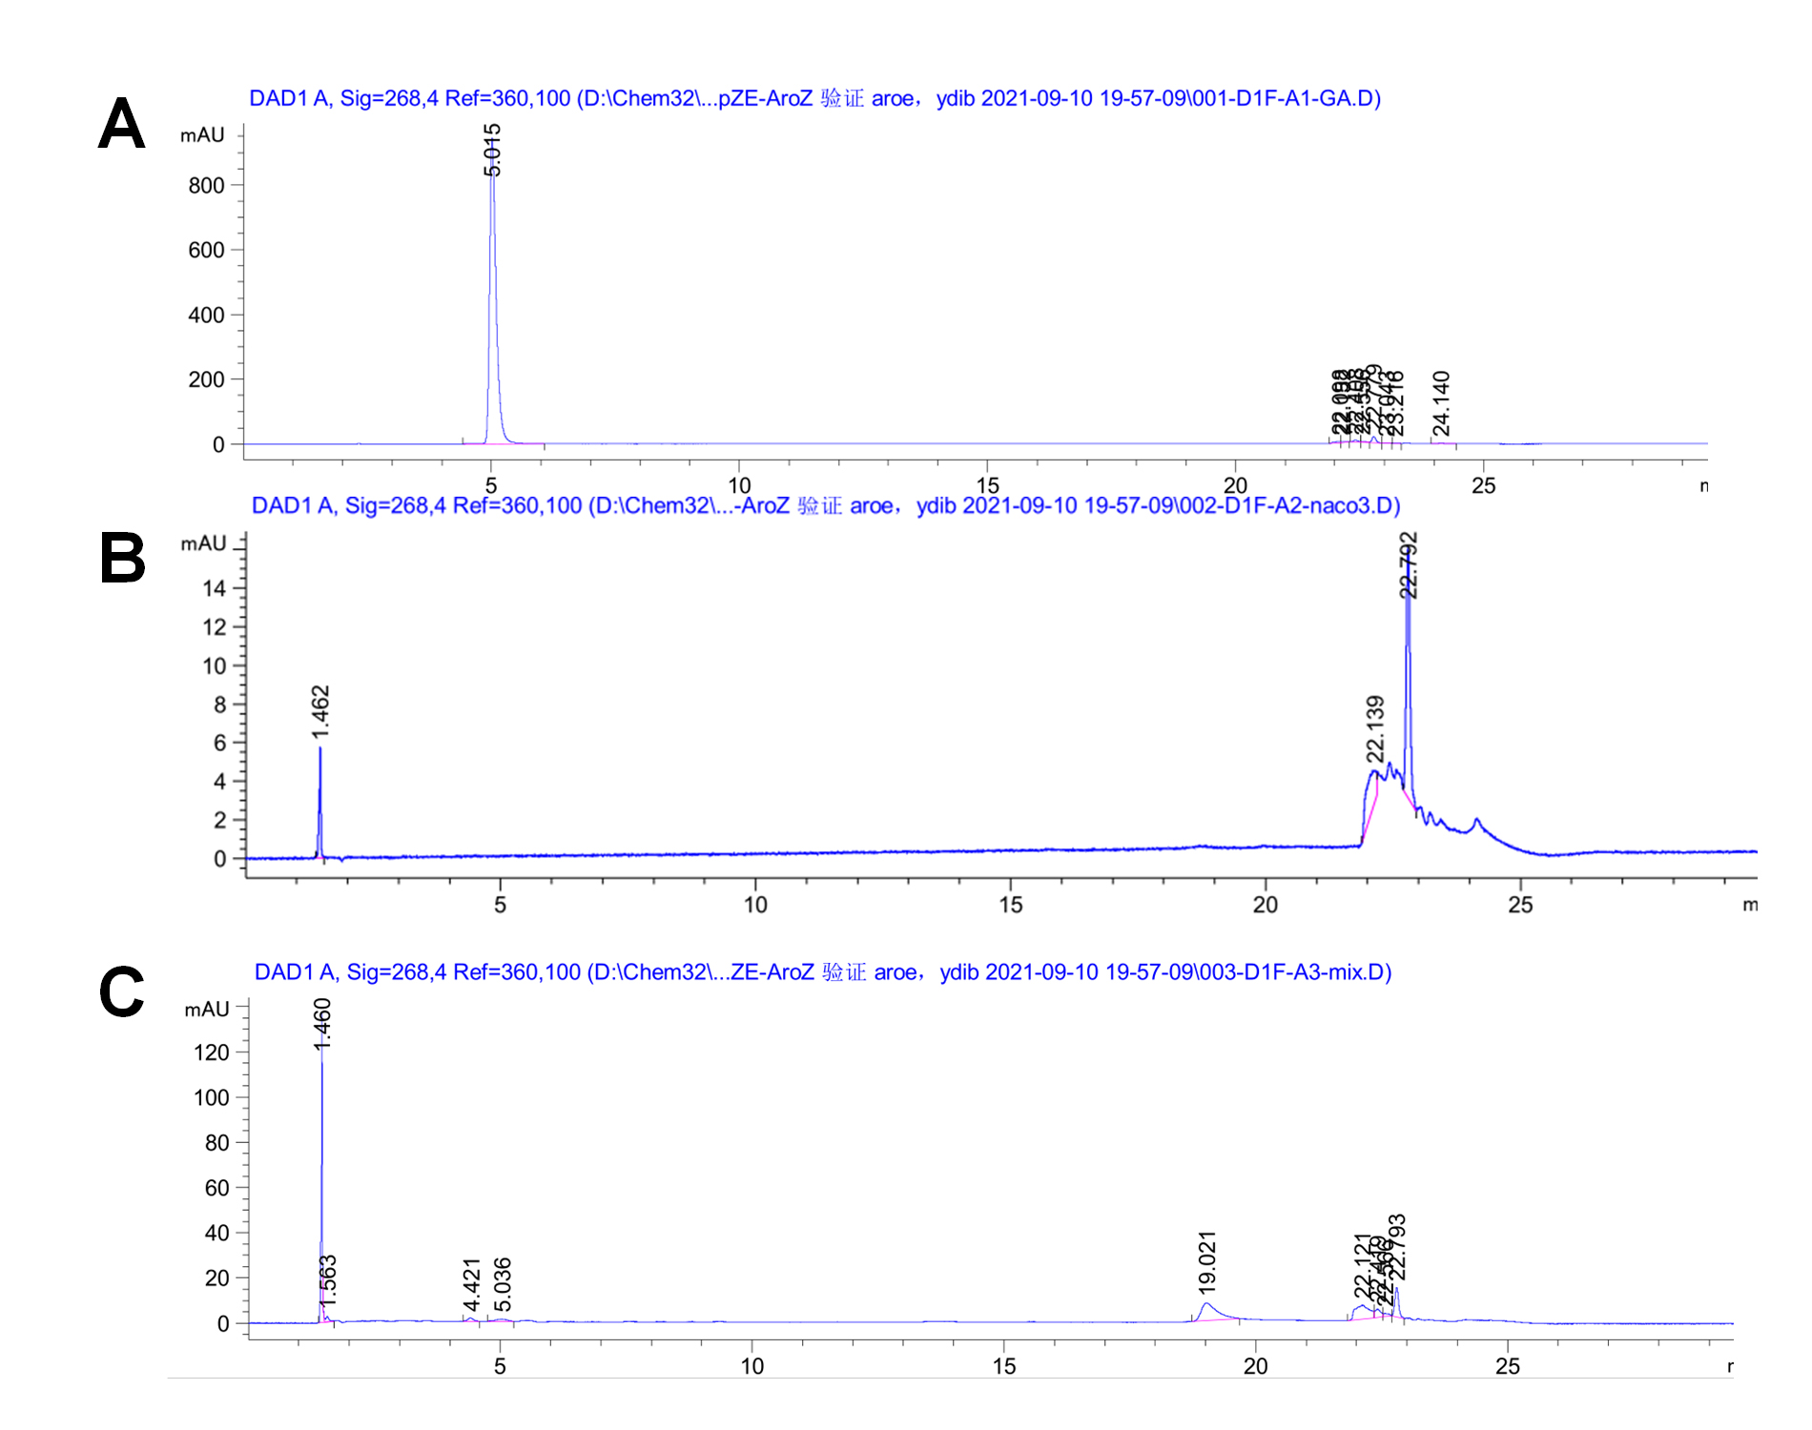
GA
Fig. S1 Analyzing the mixture of GA and NaHCO₃ by UHPLC. (A) UHPLC graph of 200 mg/L GA. (B) UHPLC graph of 0.1 M NaHCO₃. (C) UHPLC graph of the reaction mixture.

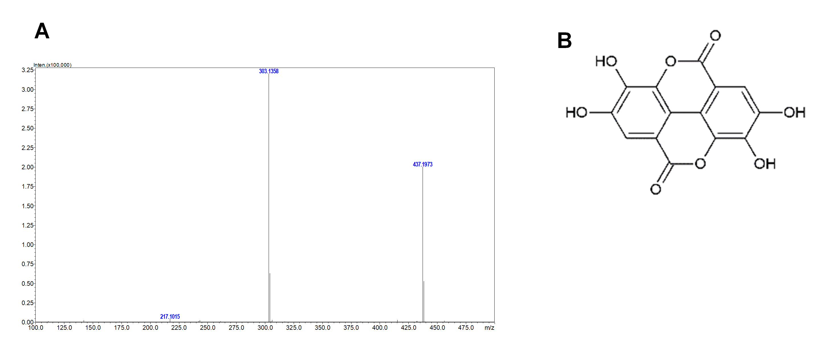
Fig. S2 MS analysis of the reaction mixture and speculation of compound in the reaction mixture. (A) MS graph of the reaction mixture. (B) The speculative structure of the new compound.

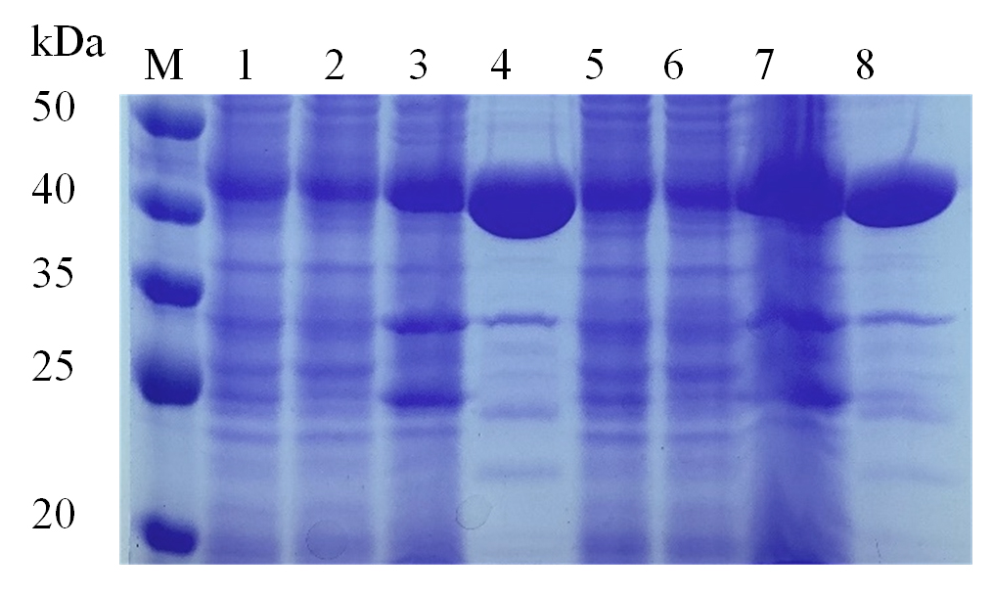
Fig. S3 SDS-PAGE of Y385F/T294A PobA and Y385F/T294A/V349A PobA. Lane M: 50 kDa protein molecular weight marker. Lane 1: the lysed mixture after ultrasonic treatment of Y385F/T294A PobA. Lane 2 and 3: the precipitate and the supernatant of the lysed mixture of Y385F/T294A PobA after centrifugation, respectively. Lane 4: the purified Y385F/T294A PobA. Lane 5: the lysed mixture after ultrasonic treatment of Y385F/T294A/V349A PobA. Lane 6 and 7: the precipitate and the supernatant of the lysed mixture of Y385F/T294A/V349A PobA after centrifugation, respectively. Lane 8: the purified Y385F/T294A/V349A PobA.

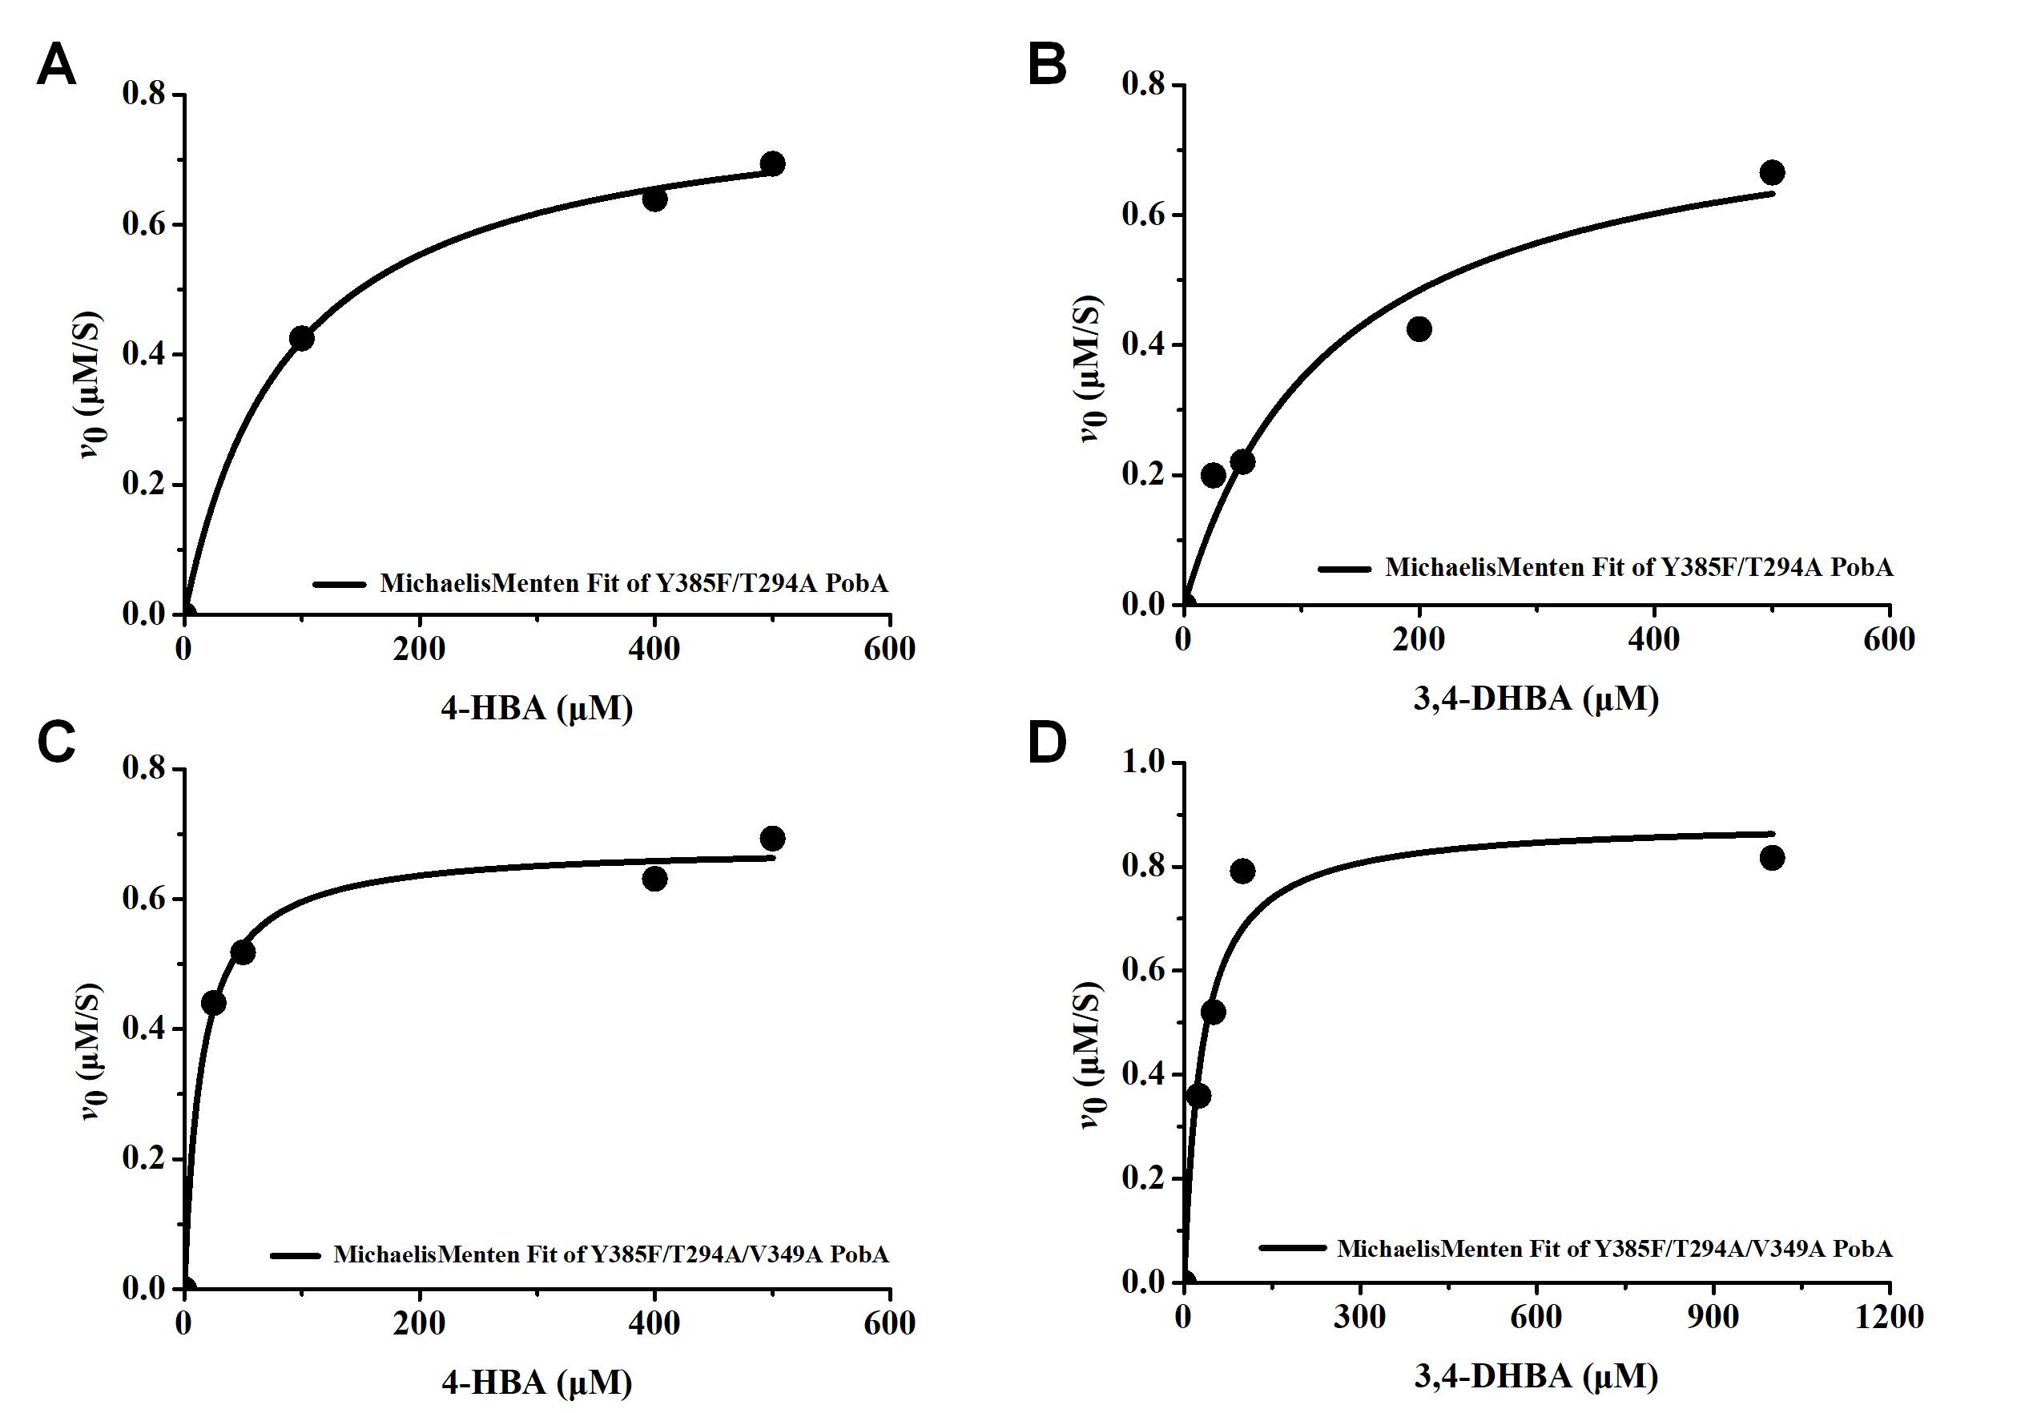
Fig. S4 The non-linear regression curves of PobA mutants towards 4-HBA and 3,4-DHBA through the Michaelis-Menten equation. (A) The non-linear regression curves of Y385F/T294A PobA towards 4-HBA. (B) The non-linear regression curves of Y385F/T294A PobA towards 3,4-DHBA. (C) The non-linear regression curves of Y385F/T294A/V349A PobA towards 4-HBA. (D) The non-linear regression curves of Y385F/T294A/V349A PobA towards 3,4-DHBA.

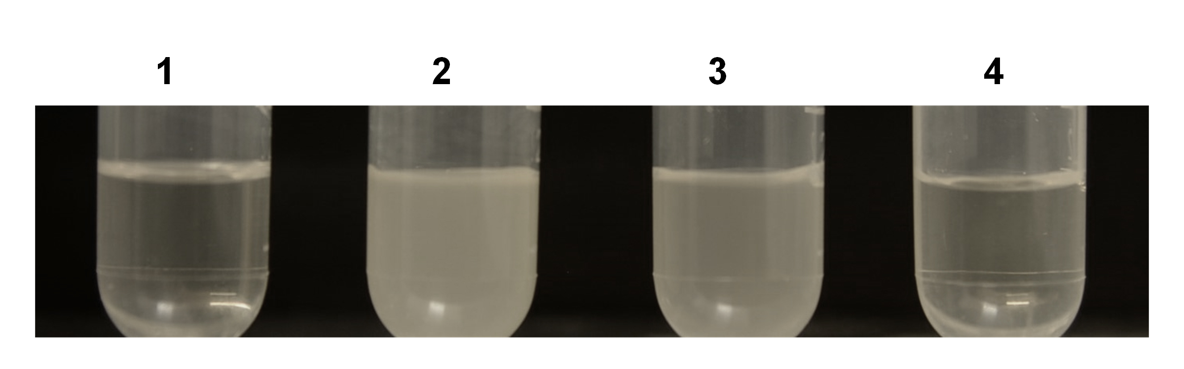
Fig. S5 Verification of E. coli BW25113 (F’), E. coli BW25113 (F’)ΔaroE (CTT5) and E. coli BW25113 (F’)ΔaroEΔydiB (CTT6). 1: Only M9Y medium without Yeast Extract. 2: E. coli BW25113 (F’) in M9Y medium without Yeast Extract. 3: CTT5 with M9Y medium without Yeast Extract. 4: CTT6 in M9Y medium without Yeast Extract.

