Supporting Information
Visible-Light-Driven Green Assembly of Anisotropic Silver Nanocrystals via Ligand-to-Metal Charge Transfer Chemistry
Jiahang Yu*, Yang Ou, Xueli Bai, Yimeng Huang, Yuanchu Li
School of Biological Science and Food Engineering, Chuzhou University, Chuzhou, 239000, Anhui, China。
*Corresponding author. E-mail addresses: yjh8319@yeah.net.

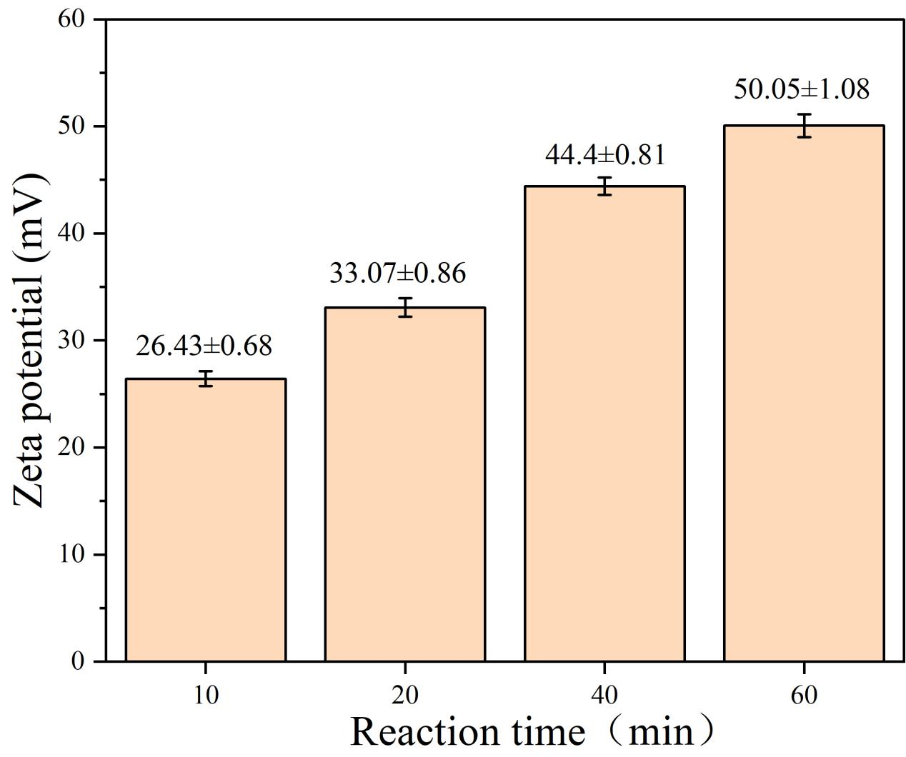
Figure S1. Surface ζ-potential evolution curves of silver nanoparticle samples under different illumination times.

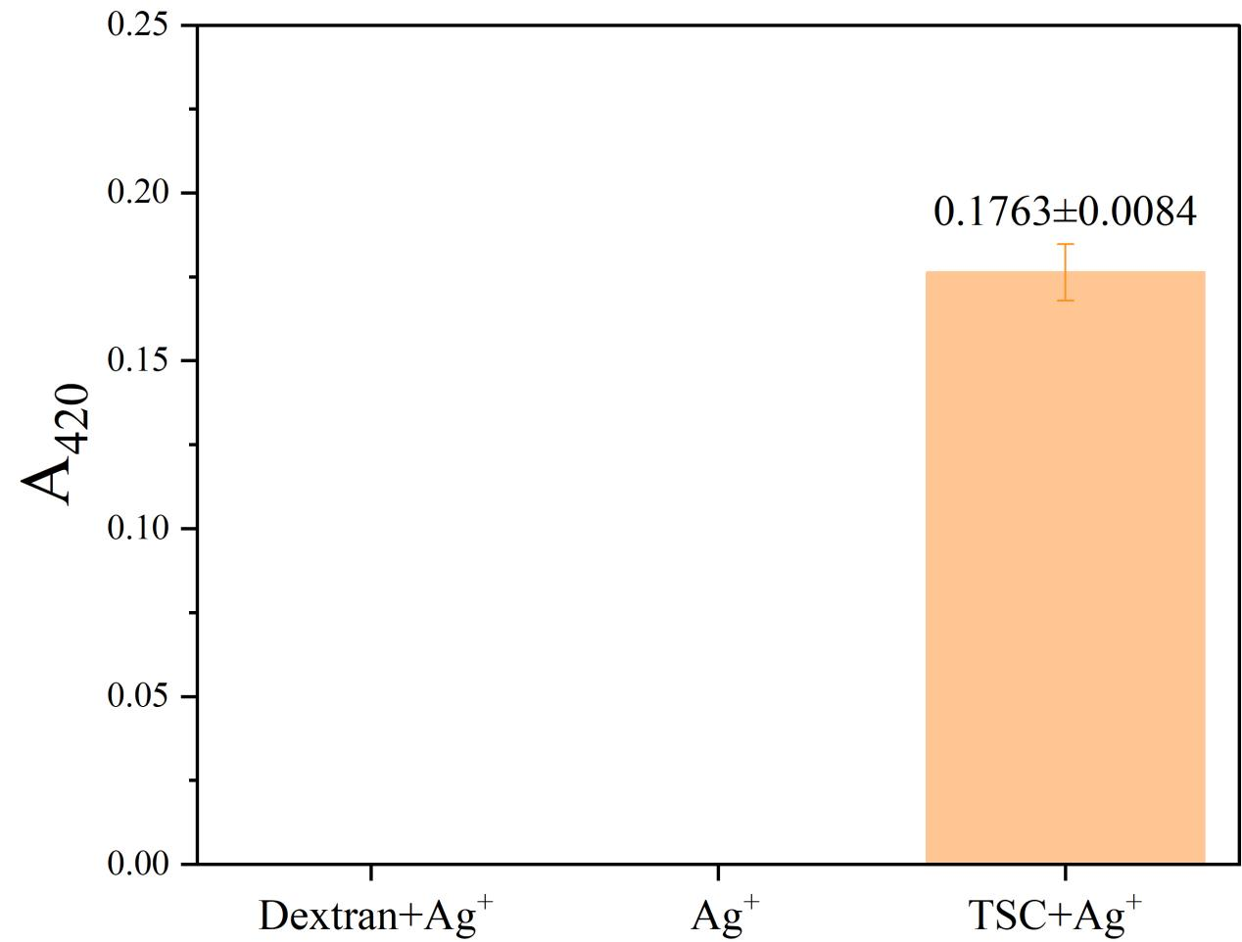
Figure S2. UV-Vis absorption spectra and sample photographs for component control experiments. Variations of A₄₂₀ under the same illumination conditions for pure Ag⁺ solution (AgNO₃ 0.01 μM), dextran/Ag⁺ dual-component system (dextran 1 mg/mL + AgNO₃ 0.01 μM), and TSC/Ag⁺ dual-component system (TSC 10 mM + AgNO₃ 0.01 μM).
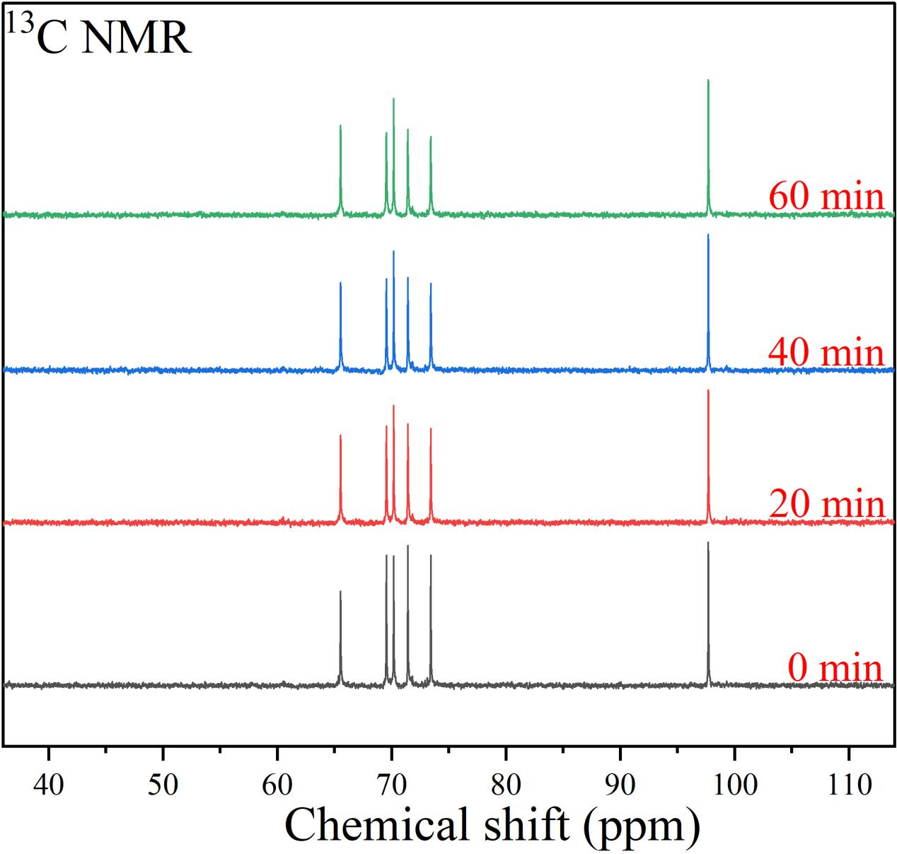
Figure S3. ¹³C NMR spectra of silver nanoparticle samples and control groups under different illumination times.
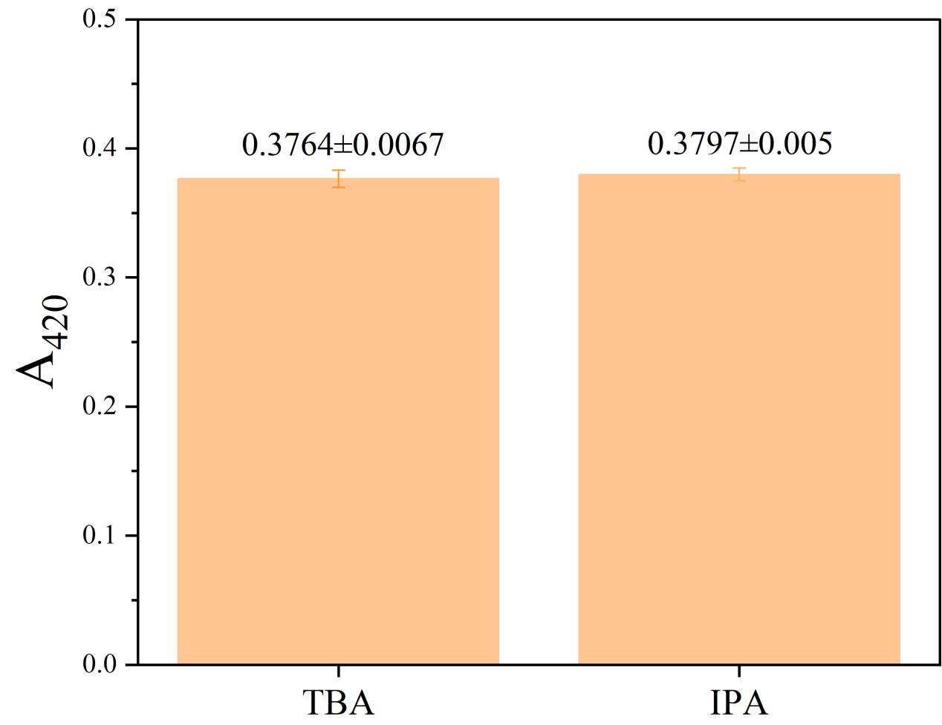
Figure S4. Effects of different ·OH scavengers on the photocatalytic yield of silver nanoparticles. Variations of A₄20 after adding tert-butanol (TBA) and isopropanol (IPA), respectively.

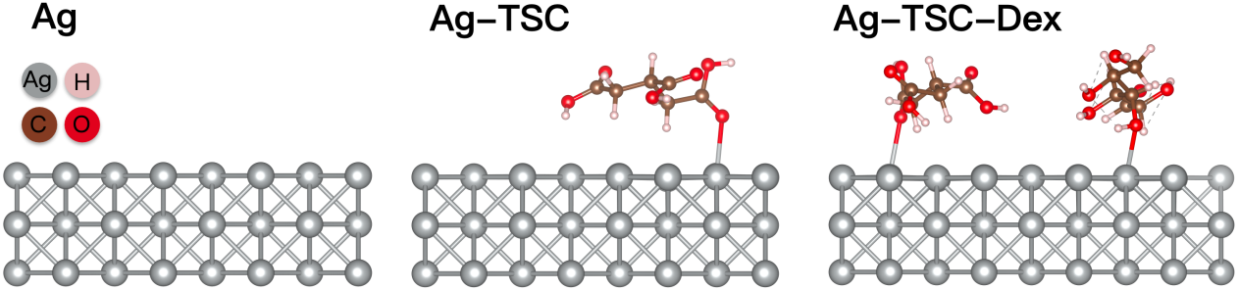
Figure S5. Geometrically optimized structure models from DFT for Ag(111), Ag-TSC, and Ag-TSC-Dex systems.

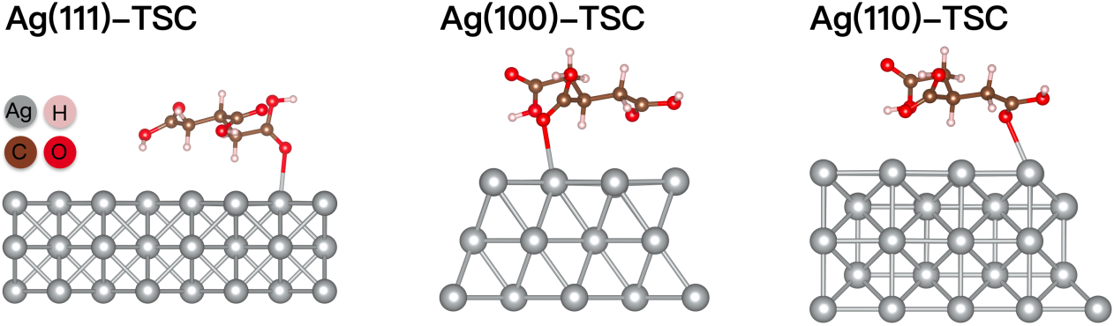
Figure S6. DFT-optimized adsorption configurations of TSC on Ag(111), Ag(100), and Ag(110) crystal facets.

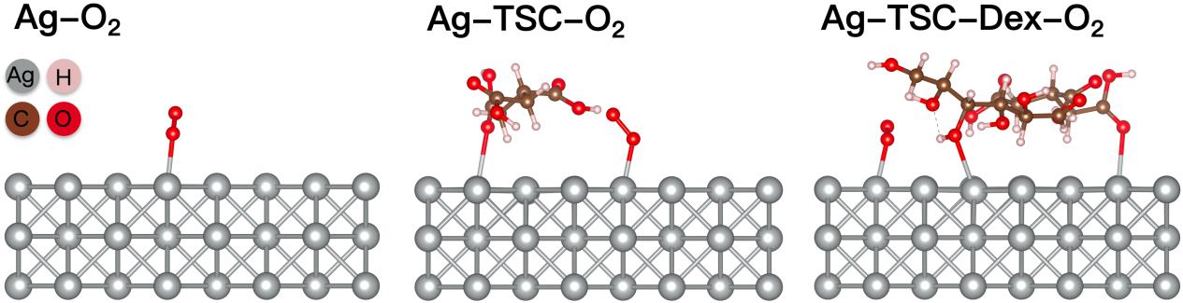
Figure S7. DFT-optimized adsorption configurations of O₂ molecules on different system surfaces.

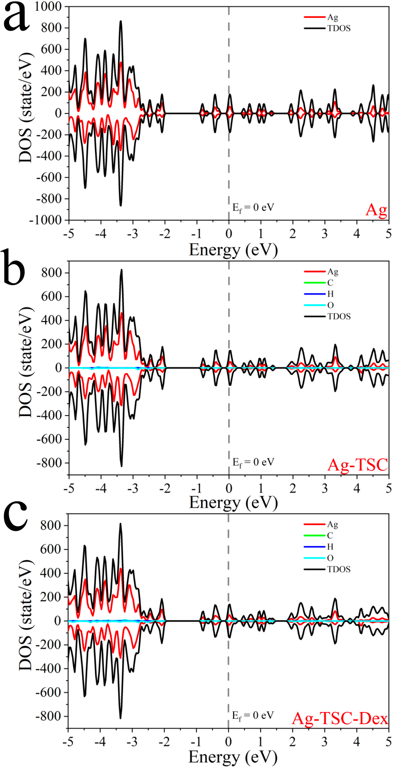
Figure S8. Total density of states (TDOS) and projected density of states (PDOS) analysis of Ag(111), Ag-TSC, and Ag-TSC-Dex systems. The vertical dashed lines indicate the shift of the d-band center.
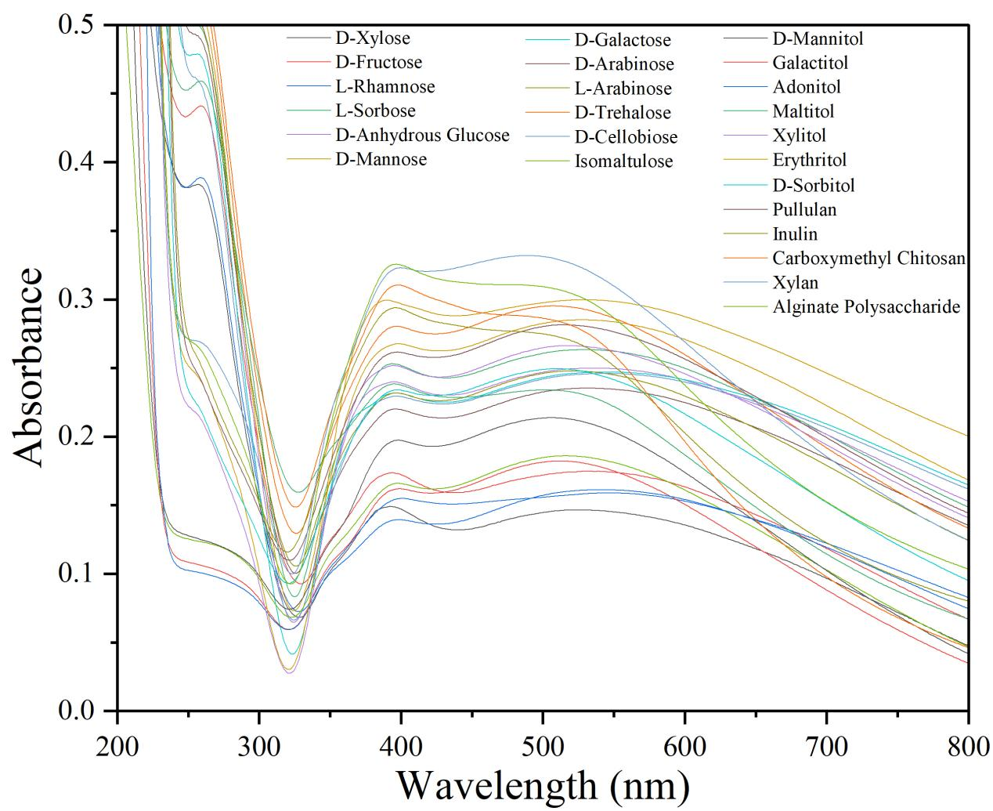
Figure S9. UV-Vis absorption spectra of AgNPs prepared via the LMCT photocatalytic system involving different carbohydrate molecules.

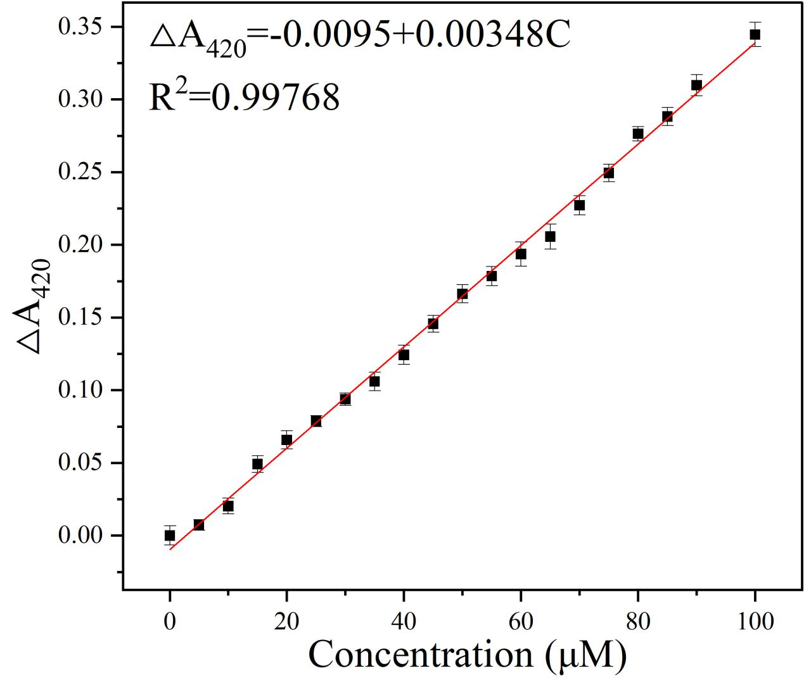
Figure S10. Linear colorimetric quantitative response curve of anisotropic spiky silver nanoparticles prepared based on 0.01 μM AgNO₃ toward Na₂S. The chart includes ΔA₄20 variations under different Na₂S concentrations and the corresponding linear fitting equation.
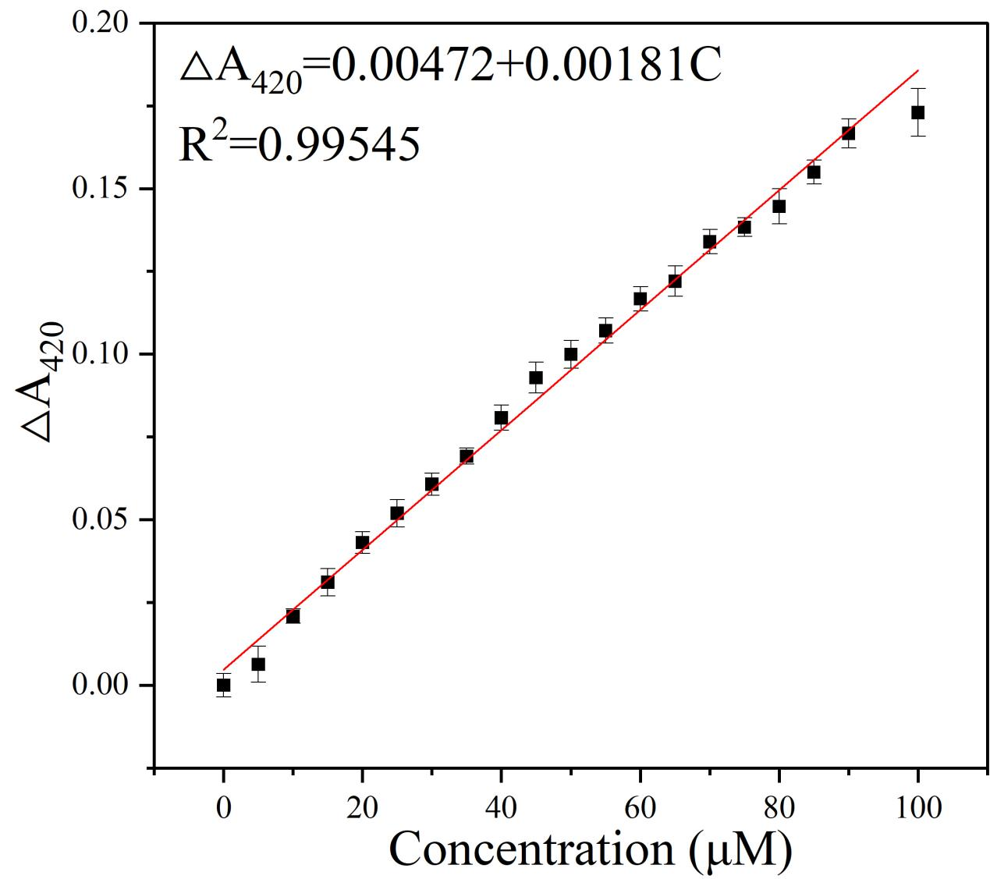
Figure S11. Linear colorimetric quantitative response curve and fitting equation of mixed-morphology silver nanoparticles prepared based on 0.03 μM AgNO₃ toward Na₂S.
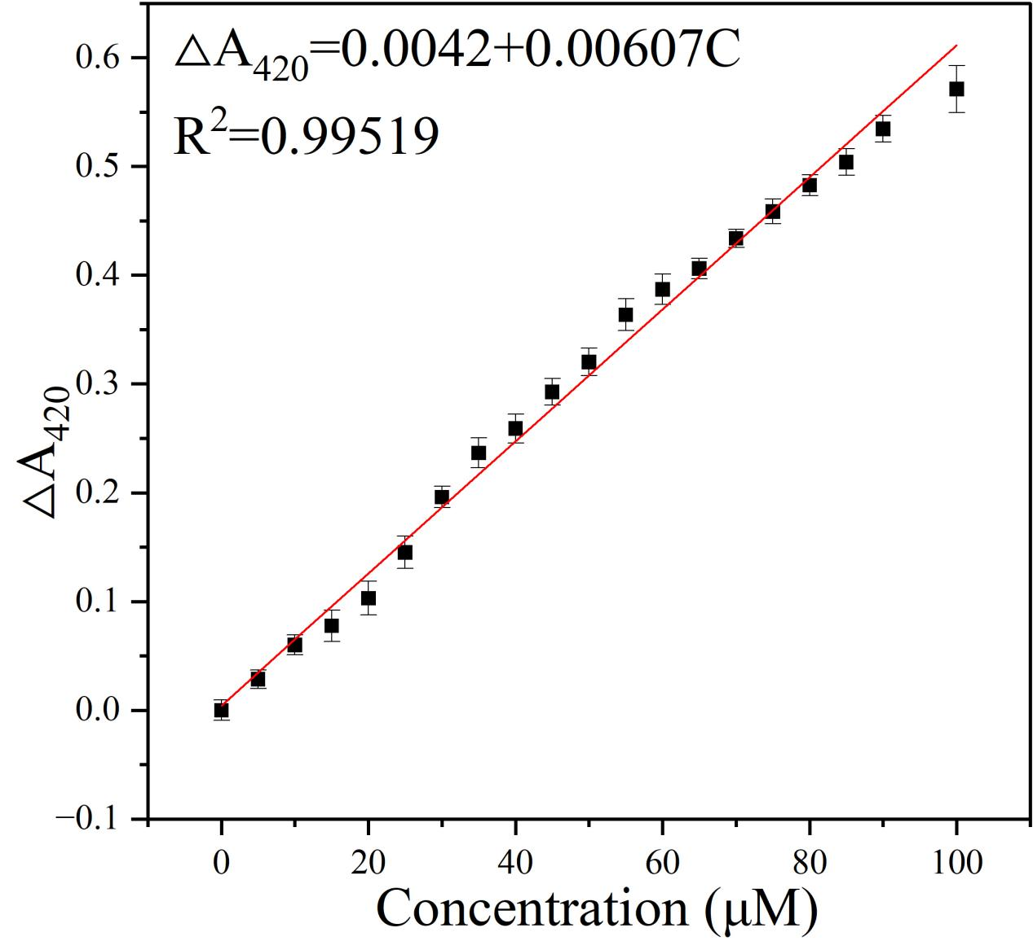
Figure S12. Linear colorimetric quantitative response curve and fitting equation of near-spherical silver nanoparticles prepared based on 0.13 μM AgNO₃ toward Na₂S.
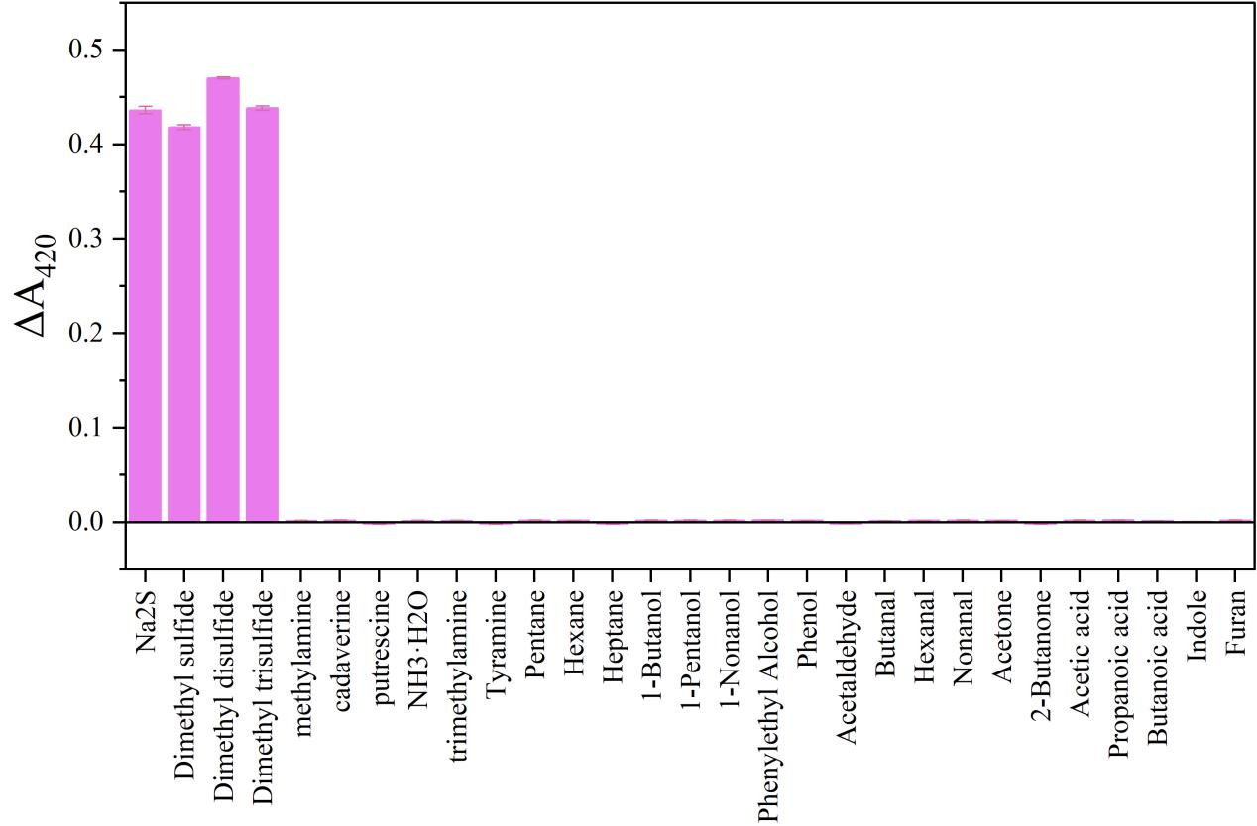
Figure S13. Selectivity validation experiments of the anisotropic silver nanoparticle colorimetric sensor toward volatile substances from meat spoilage. The chart includes a comparison of colorimetric responses to various typical volatiles such as sulfur-containing compounds, amines, and organic acids.

