Supplementary Material
Regression models for binary outcomes (P300 and Late Response)
Pulvinar Response | model | term | Beta | lower95 | upper95 | p_value
P300 | model1 | (Intercept) | -4.79262 | -11.2974 | 1.712123 | 0.149
P300 | model1 | epileptic thalamus_yes | -0.2813 | -2.93577 | 2.37317 | 0.835
P300 | model1 | age at SEEG | -0.00043 | -0.08942 | 0.088554 | 0.992
P300 | model1 | epilepsy duration | -0.0138 | -0.10783 | 0.080226 | 0.774
P300 | model1 | FSIQ | 0.04259 | -0.02207 | 0.107244 | 0.197
P300 | model1 | Engel class | 0.097165 | -0.78748 | 0.981804 | 0.83
P300 | model2 | (Intercept) | -5.08739 | -11.5221 | 1.3473 | 0.121
P300 | model2 | epileptic thalamus_yes | -0.45208 | -3.02576 | 2.121593 | 0.731
P300 | model2 | age at SEEG | 0.008191 | -0.0858 | 0.102187 | 0.864
P300 | model2 | epilepsy duration | -0.02311 | -0.12024 | 0.074014 | 0.641
P300 | model2 | FSIQ | 0.041062 | -0.02498 | 0.107103 | 0.223
P300 | model2 | Engel grouped2-4 | 0.867464 | -0.83067 | 2.565593 | 0.317
P300 | model3 | (Intercept) | -0.45502 | -3.57328 | 2.663238 | 0.775
P300 | model3 | epileptic thalamus_yes | 0.031521 | -2.86107 | 2.924114 | 0.983
P300 | model3 | age at SEEG | -0.00613 | -0.10131 | 0.089055 | 0.9
P300 | model3 | epilepsy duration | -0.00589 | -0.10369 | 0.091899 | 0.906
P300 | model3 | IQ catBorderline | -1.14139 | -3.03796 | 0.75519 | 0.238
P300 | model3 | IQ catIntellectual Disability | -17.9919 | -4837.13 | 4801.15 | 0.994
P300 | model3 | Engel class | 0.073273 | -0.86323 | 1.009781 | 0.878
P300 | model4 | (Intercept) | -0.89454 | -3.88026 | 2.091177 | 0.557
P300 | model4 | epileptic thalamus_yes | -0.16273 | -2.84384 | 2.518375 | 0.905
P300 | model4 | age at SEEG | 0.002655 | -0.09784 | 0.10315 | 0.959
P300 | model4 | epilepsy duration | -0.01846 | -0.12025 | 0.083338 | 0.722
P300 | model4 | IQ catBorderline | -1.06399 | -2.96621 | 0.83823 | 0.273
P300 | model4 | IQ catIntellectual Disability | -17.8875 | -4748.98 | 4713.201 | 0.994
P300 | model4 | Engel grouped2-4 | 0.862573 | -0.89095 | 2.616097 | 0.335
P300 | model5 | (Intercept) | -1.12995 | -4.02019 | 1.7603 | 0.444
P300 | model5 | epileptic thalamus_yes | -0.86643 | -3.25877 | 1.525904 | 0.478
P300 | model5 | age at SEEG | 0.006572 | -0.07693 | 0.090075 | 0.877
P300 | model5 | epilepsy duration | -0.02216 | -0.11175 | 0.067431 | 0.628
P300 | model5 | Engel class | 0.091853 | -0.74538 | 0.929082 | 0.83
P300 | model6 | (Intercept) | -1.66044 | -4.44781 | 1.126933 | 0.243
P300 | model6 | epileptic thalamus_yes | -1.02929 | -3.39369 | 1.335117 | 0.394
P300 | model6 | age at SEEG | 0.016396 | -0.07199 | 0.104777 | 0.716
P300 | model6 | epilepsy duration | -0.03039 | -0.1225 | 0.061717 | 0.518
P300 | model6 | Engel grouped2-4 | 0.934106 | -0.72869 | 2.596902 | 0.271
Late_Response | model1 | (Intercept) | -2.63718 | -7.61405 | 2.339693 | 0.299
Late_Response | model1 | epileptic thalamus_yes | -0.28671 | -2.41625 | 1.842837 | 0.792
Late_Response | model1 | age at SEEG | 0.099004 | 0.007215 | 0.190793 | 0.0345
Late_Response | model1 | epilepsy duration | -0.0942 | -0.18948 | 0.001088 | 0.0527
Late_Response | model1 | FSIQ | 0.023035 | -0.03176 | 0.077829 | 0.41
Late_Response | model1 | Engel class | -0.08965 | -0.8549 | 0.675595 | 0.818
Late_Response | model2 | (Intercept) | -2.86228 | -7.78818 | 2.06362 | 0.255
Late_Response | model2 | epileptic thalamus_yes | -0.48756 | -2.57835 | 1.603231 | 0.648
Late_Response | model2 | age at SEEG | 0.102544 | 0.00866 | 0.196427 | 0.0323
Late_Response | model2 | epilepsy duration | -0.09721 | -0.19298 | -0.00145 | 0.0466
Late_Response | model2 | FSIQ | 0.02114 | -0.03416 | 0.076445 | 0.454
Late_Response | model2 | Engel grouped2-4 | 0.317197 | -1.18535 | 1.819739 | 0.679
Late_Response | model3 | (Intercept) | -0.21805 | -2.97265 | 2.536558 | 0.877
Late_Response | model3 | epileptic thalamus_yes | -0.1212 | -2.29149 | 2.049096 | 0.913
Late_Response | model3 | age at SEEG | 0.100939 | 0.012362 | 0.189516 | 0.0255
Late_Response | model3 | epilepsy duration | -0.08738 | -0.18047 | 0.005714 | 0.0658
Late_Response | model3 | IQ catBorderline | -1.48032 | -3.22309 | 0.262459 | 0.0959
Late_Response | model3 | IQ catIntellectual Disability | -1.21344 | -3.31333 | 0.886444 | 0.257
Late_Response | model3 | Engel class | -0.08907 | -0.9031 | 0.724963 | 0.83
Late_Response | model4 | (Intercept) | -0.60234 | -3.15021 | 1.945524 | 0.643
Late_Response | model4 | epileptic thalamus_yes | -0.3167 | -2.43794 | 1.804536 | 0.77
Late_Response | model4 | age at SEEG | 0.104347 | 0.013226 | 0.195468 | 0.0248
Late_Response | model4 | epilepsy duration | -0.08999 | -0.18368 | 0.003693 | 0.0597
Late_Response | model4 | IQ catBorderline | -1.45212 | -3.19334 | 0.289095 | 0.102
Late_Response | model4 | IQ catIntellectual Disability | -1.14393 | -3.27495 | 0.987096 | 0.293
Late_Response | model4 | Engel grouped2-4 | 0.272027 | -1.30519 | 1.849244 | 0.735
Late_Response | model5 | (Intercept) | -0.83644 | -3.34722 | 1.674337 | 0.514
Late_Response | model5 | epileptic thalamus_yes | -0.61555 | -2.59384 | 1.362739 | 0.542
Late_Response | model5 | age at SEEG | 0.10795 | 0.017005 | 0.198895 | 0.02
Late_Response | model5 | epilepsy duration | -0.10313 | -0.19819 | -0.00807 | 0.0335
Late_Response | model5 | Engel class | -0.06866 | -0.82276 | 0.685438 | 0.858
Late_Response | model6 | (Intercept) | -1.21038 | -3.53637 | 1.115599 | 0.308
Late_Response | model6 | epileptic thalamus_yes | -0.78785 | -2.72599 | 1.150294 | 0.426
Late_Response | model6 | age at SEEG | 0.111049 | 0.01804 | 0.204059 | 0.0193
Late_Response | model6 | epilepsy duration | -0.10592 | -0.20111 | -0.01074 | 0.0292
Late_Response | model6 | Engel grouped2-4 | 0.391652 | -1.08313 | 1.866432 | 0.603

Pairwise associations between physiological responses and clinical variables

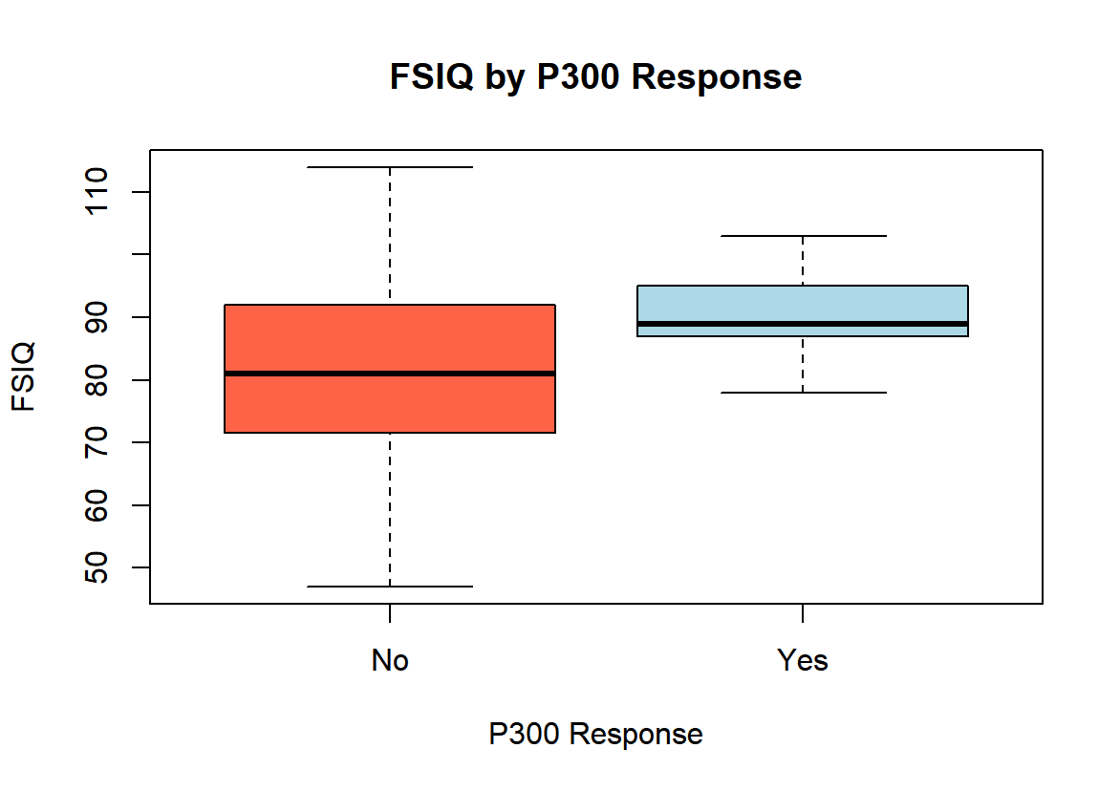
Welch Two Sample t-test

data: FSIQ by P300
t = -2.2616, df = 28.66, p-value = 0.03149
alternative hypothesis: true difference in means between group No and group Yes is not equal to 0
95 percent confidence interval:
-15.7345030 -0.7863303
sample estimates:
mean in group No mean in group Yes
81.40625 89.66667

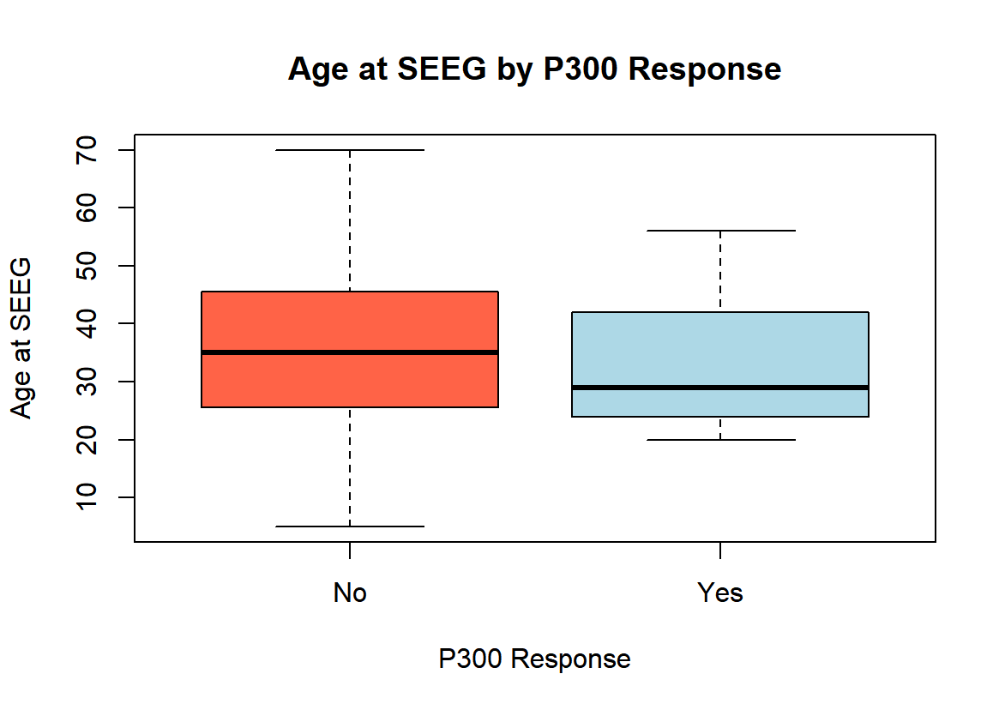

Welch Two Sample t-test

data: age_at_SEEG by P300
t = 0.34942, df = 12.571, p-value = 0.7326
alternative hypothesis: true difference in means between group No and group Yes is not equal to 0
95 percent confidence interval:
-8.355784 11.566895
sample estimates:
mean in group No mean in group Yes
35.05000 33.44444

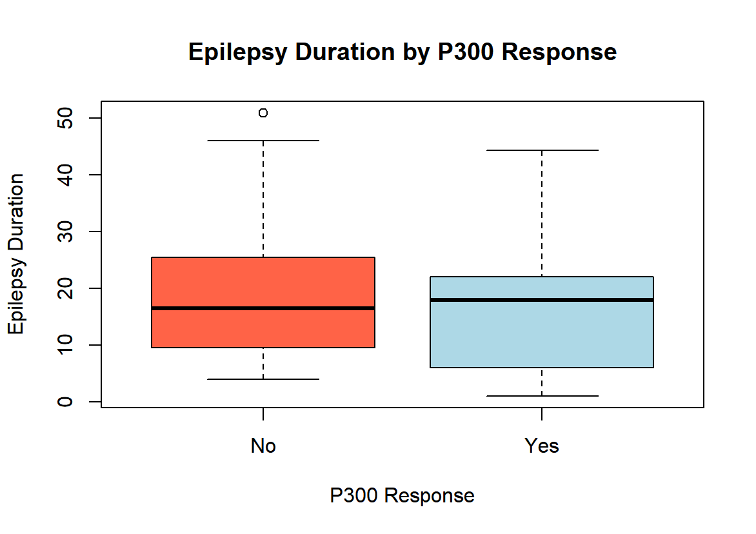
Welch Two Sample t-test

data: epilepsy_duration by P300
t = 0.41167, df = 10.797, p-value = 0.6886
alternative hypothesis: true difference in means between group No and group Yes is not equal to 0
95 percent confidence interval:
-8.649807 12.618696
sample estimates:
mean in group No mean in group Yes
18.80000 16.81556

IQ Category by P300 Response
Typical Borderline Intellectual Disability
No 14 13 9
Yes 7 2 0

Cell counts < 5, so Fisher’s exact test

Fisher's Exact Test for Count Data

data: table_P300_IQ
p-value = 0.1046
alternative hypothesis: two.sided

Epileptic Thalamus by P300 Response
no yes
No 32 8
Yes 8 1

Cell counts < 5, so Fisher’s exact test

Fisher's Exact Test for Count Data

data: table_P300_epithal
p-value = 1
alternative hypothesis: true odds ratio is not equal to 1
95 percent confidence interval:
0.01003628 4.84495100
sample estimates:
odds ratio
0.5061129

Engel Class (1 vs 2-4) by P300 Response
1 2to4
No 21 19
Yes 3 6

Cell counts < 5, so I used Fisher’s exact test

Fisher's Exact Test for Count Data

data: table_P300_Engelbina
p-value = 0.4635
alternative hypothesis: true odds ratio is not equal to 1
95 percent confidence interval:
0.3967119 15.3404012
sample estimates:
odds ratio
2.175494

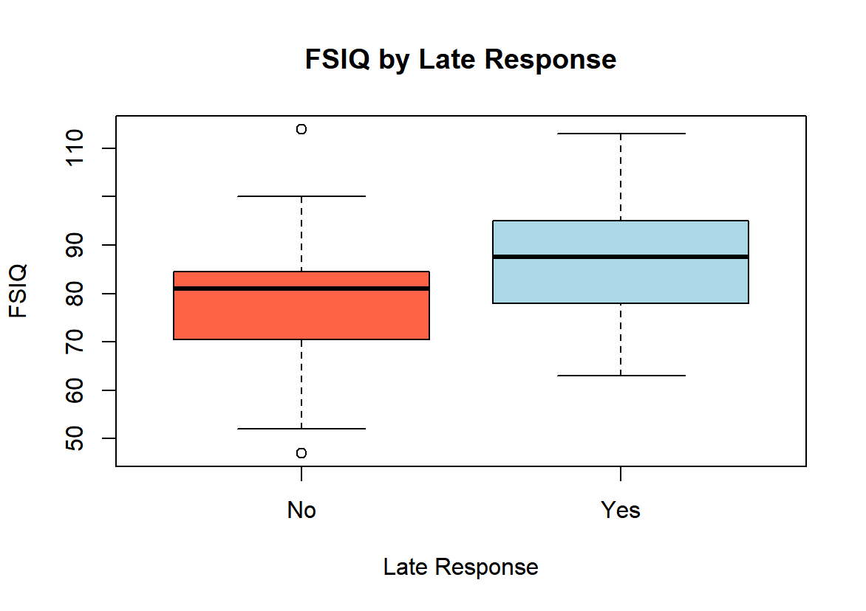

Welch Two Sample t-test

data: FSIQ by Late_response
t = -1.498, df = 22.051, p-value = 0.1483
alternative hypothesis: true difference in means between group No and group Yes is not equal to 0
95 percent confidence interval:
-17.869369 2.879625
sample estimates:
mean in group No mean in group Yes
78.46667 85.96154

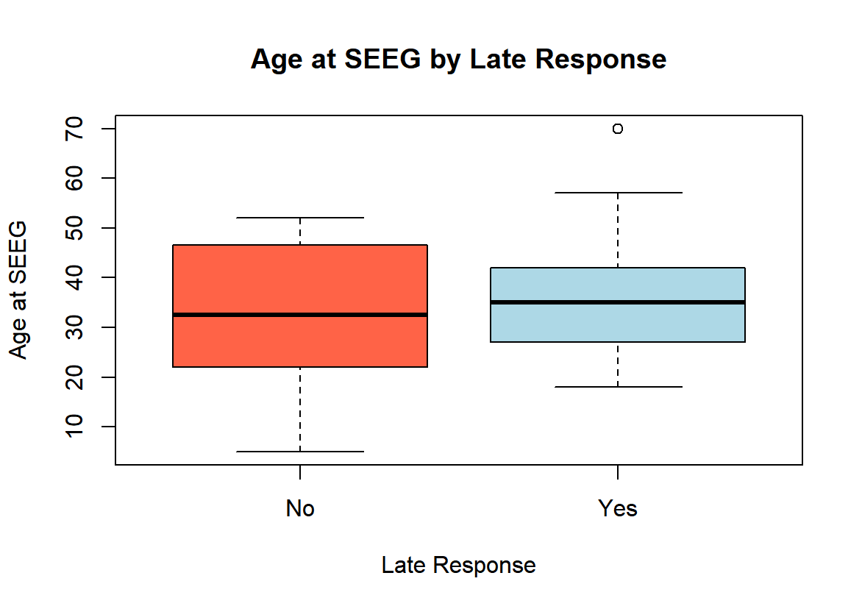
Welch Two Sample t-test

data: age_at_SEEG by Late_response
t = -1.041, df = 25.506, p-value = 0.3076
alternative hypothesis: true difference in means between group No and group Yes is not equal to 0
95 percent confidence interval:
-13.004708 4.266071
sample estimates:
mean in group No mean in group Yes
31.81250 36.18182

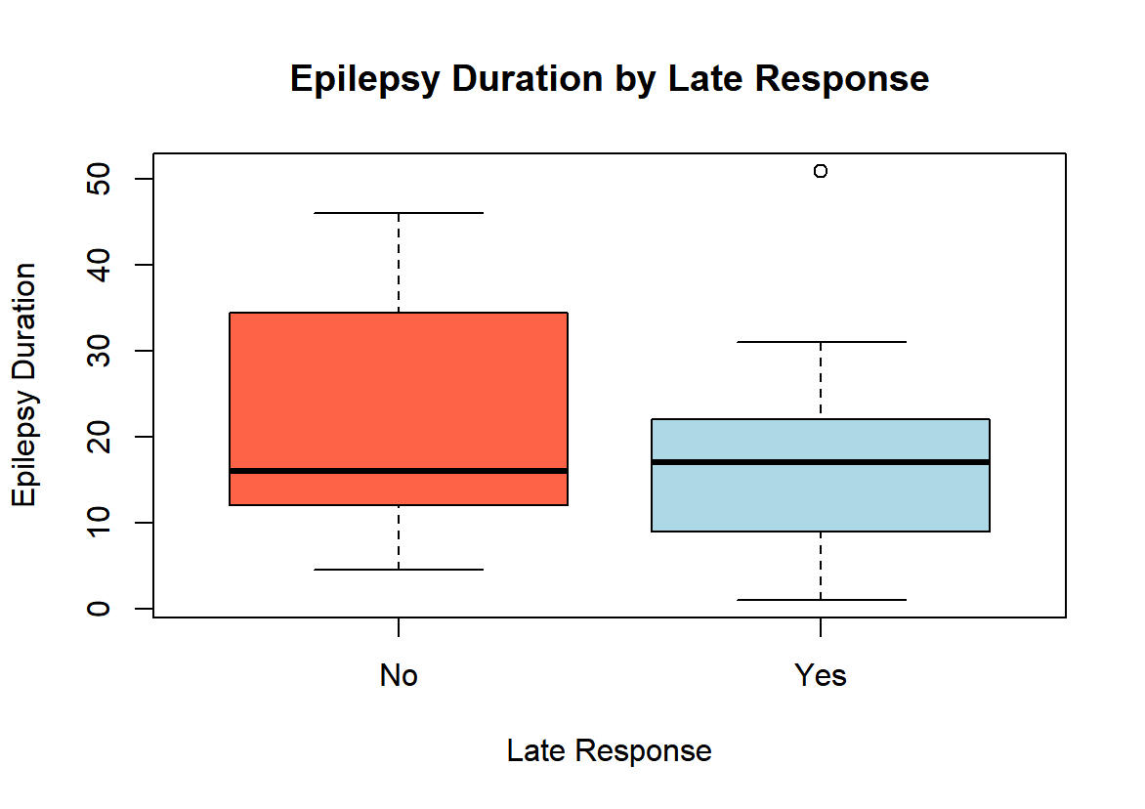

Welch Two Sample t-test

data: epilepsy_duration by Late_response
t = 1.0932, df = 23.356, p-value = 0.2855
alternative hypothesis: true difference in means between group No and group Yes is not equal to 0
95 percent confidence interval:
-3.833362 12.440256
sample estimates:
mean in group No mean in group Yes
21.33375 17.03030

IQ Category by Late Response

Typical Borderline Intellectual Disability
No 4 7 4
Yes 17 8 5

Cell counts < 5, so I used Fisher’s exact test

Fisher's Exact Test for Count Data

data: table_LateR_IQ
p-value = 0.1706
alternative hypothesis: two.sided

Epileptic Thalamus by Late Response

no yes
No 12 4
Yes 28 5

Cell counts < 5, so I used Fisher’s exact test

Fisher's Exact Test for Count Data

data: table_LateR_epithal
p-value = 0.4486
alternative hypothesis: true odds ratio is not equal to 1
95 percent confidence interval:
0.09674545 3.23797401
sample estimates:
odds ratio
0.5430364

Engel Class (1 vs 2-4) by Late Response

Engel 1 Engel 2to4
No 8 8
Yes 16 17

Pearson's Chi-squared test with Yates' continuity correction

data: table_LateR_Engelbina
X-squared = 7.8919e-31, df = 1, p-value = 1

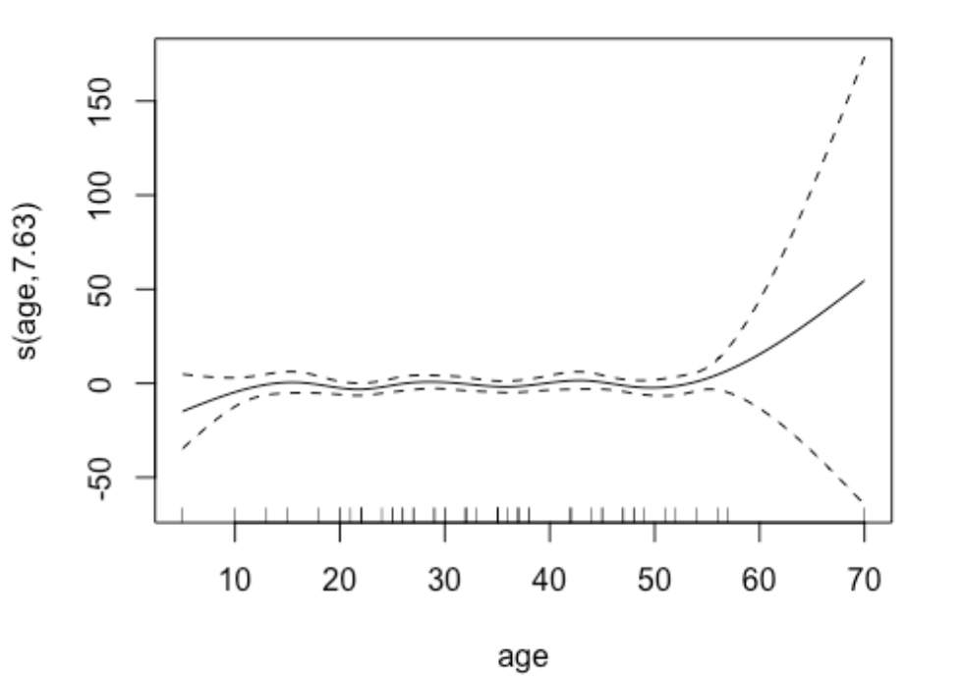
Estimated smooth effect of patient age on the log-odds of late response from the fitted regression model. The smooth is approximately flat, indicating no substantial association between age and the probability of observing a late response.

