Supporting information for
Synthesis of typical sulfonamide antibiotics with [¹⁴C]- and [¹³C]-labelling on phenyl ring for environmental studies
Xuan Wu^{1,2}, Yao Yao¹, Lianhong Wang¹, Dashun Zhou², Feifei Sun^{1*}, Jianqiu Chen², Philippe Francois-Xavier Corvini^{1,3}, Rong Ji^{1*}

1. State Key Laboratory of Pollution Control and Resource Reuse, School of the Environment, Nanjing University, Nanjing 210023, China.
2. School of Engineering, China Pharmaceutical University, Nanjing 211198, China.
3. Institute for Ecopreneurship, School of Life Sciences, University of Applied Sciences and Arts Northwestern Switzerland, Gründenstrasse 40, Muttenz CH-4132, Switzerland

Correspondence authors:
*Feifei Sun: Tel.: + 86 25 89680589, Fax: + 86 25 89680589. E-mail: sff@nju.edu.cn;
*Rong Ji: Tel.: + 86 25 89680581, Fax: + 86 25 89680581. E-mail: ji@nju.edu.cn;

SI.1. Flash column chromatography
Flash column chromatography for purification of 2a, 3a and 8a was performed on a medium pressure preparative chromatograph system (CHEETAH TMMP100; Agela, Tianjin, China) equipped with a UV detector and a fraction collector, using prepacked silica gel column (12 g, 40–60 μm; Agela, Tianjin, China) at a flow rate of 8 mL/min. UV detection was set at 230 nm and 254 nm. Fractions of 30 mL were collected.

SI.2. Thin-layer chromatography
Thin-layer chromatography (TLC) was conducted on plates of silica gel 60 F254. Analytical TLC plates (0.25 mm, 3 cm × 10 cm, Huanghai, Shandong, China) were used for purity analysis using petroleum ether: ethyl acetate (1:4 / v: v), containing 0.2% CH₃COOH as eluent. Purification of [¹⁴C]-labelled compounds 4a, 5a, 6a, and 7a was achieved by preparative TLC plates (1 mm, 20 × 20 cm; Huanghai, Shandong, China). Autoradiography of TLC plates was obtained on an imaging scanner (Typhoon Trio⁺; GE Healthcare, U.S.).

SI.3. Liquid scintillation counting
Liquid scintillation counting (LSC) was performed with a Beckman LS6500 (LS6500; Beckman Counter, USA) scintillation counter and Gold Star scintillation cocktail (Meridian Biotechnologies Ltd, UK). Counts were corrected for background activity by using blank controls. Counting efficiency and color quenching were corrected using the external standard ratio method.

SI.4. High performance liquid chromatography
High performance liquid chromatography (HPLC) for purity determination and identification of products was conducted on Agilent HPLC 1100 system (Agilent Technology, USA). Chromatographic separation was achieved by injecting the sample (10 μL) into an Eclipse XDB-C18 column (250 mm × 4.6 mm, 5 μm; Agilent) at 30 °C with a guard column (4.6 mm × 12.5 mm, 5 μm; Agilent). The flow-rate was set at 1 mL/min. The mobile phase for analyses of 5a and 10a consisted of H₂O (A) containing 0.3% (v/v) CH₃COOH and CH₃OH (B). The elution gradient for 5a analysis started with 35% B for 15 min, linearly increased to 100% B within 5 min, and maintained at 100% B for 5 min, then linearly decrease to 35% B within 5 min, and finally remained at 35% B for 5 min. The elution gradient for 10a analysis started with 20% B for 15 min, linearly increased to 100% B within 5 min, and maintained at 100% B for 5 min, then linearly decrease to 20% B within 5 min, and finally remained at 20% B for 5 min. The mobile phase for analysis of 7a consisted of H₂O (A) containing 0.3% (v/v) CH₃COOH and CH₃CN (C), running with a gradient starting with 26% C for 10 min, linear increase to 100% C within 10 min, and 100% C for 5 min, linear decrease to 26% C within 5 min, and finally 26% C for 5 min. The detection wavelength was 270 nm. The eluent fractions were collected every minute and determined for radioactivity by LSC. The mobile phase for purity determination of [¹³C]-intermediates and [¹³C]-SAs consisted of H₂O (60%) and CH₃CN (40%). The purity was calculated according to area normalization method at 270 nm.

SI.5. Nuclear magnetic resonance
¹H and ¹³C nuclear magnetic resonance (NMR) spectra were recorded on AVANCE III HD-500 spectrometer (Bruker, Germany). Samples were dissolved in CDCl₃ or DMSO-d₆ containing 1% tetramethylsilane as internal standard.

SI.6. Liquid chromatography−mass spectrometry
Q-TOF-MS/MS analysis was performed using an Agilent 1260 series HPLC system (Agilent Technology, USA) coupled to a Q-TOF-MS (triple TOF 5600 system; AB SCIEX, USA). An XBridge C18 column (100 mm × 2.1 mm, 3.5 μm; Waters) was thermostatically controlled at 30 °C. The mobile phase for identification of synthesized unlabelled 5, 7, and 10 was a mixture of Milli-Q water (50%) containing 0.1% (v/v) HCOOH and methanol (50%) running isocratically at a flow rate of 0.2 mL/min. The full scan was operated in positive ESI ionization mode with a declustering potential of 80 V and a collision energy of 10 V. The collision energy of product scan was 25 V, and collision energy spread was 15 V. The full scan and product ion scan were operated with the mass range of m/z 80–800. The mobile phase for identification of synthesized unlabelled 3 was acetonitrile (100%). And the mobile phase for other intermediates was methanol (100%) running isocratically at a flow rate of 0.2 mL/min. The full scan was operated in negative ESI ionization mode with a declustering potential of −80 V and a collision energy of −10 V. The collision energy of product scan was −35 V, and the collision energy spread was 15 V. The full scan and product ion scan were operated with the mass range of m/z 80–600. The optimal parameters for Q-TOF were as follows: a nebulizer gas (N₂) of 55 psi, a heater gas (N₂) of 55 psi, a curtain gas of 35 psi, a turbo spray temperature of 550 °C, an ionspray voltage in ESI⁺ of 5.5 kV and an ionspray voltage in ESI⁻ of −4.5 kV. The software PeakView (AB SCIEX, Foster City, CA, USA) was applied to mass spectrum analysis.

Table S1 Purification methods of [^{l4}C]-labelled intermediates and SAs
Compound | Purification conditions
2a | Flash column chromatography;  Eluent: petroleum ether / ethyl acetate;  Gradient elution program: volume fraction of ethyl acetate;  0~0%, 5 min; 20~20%, 5 min; 20~30%, 15 min; 30~30%,  5 min; 50~50%, 5 min; 100~100%, 20 min;  Fraction collection: 23~32 min.
3a | Flash column chromatography;  Eluent: n-hexane / ethyl acetate;  Gradient elution program: volume fraction of ethyl acetate;  0~0%, 5 min; 20~20%, 5 min; 20~30%, 10 min; 30~30%,  10 min; 40~40%, 10 min; 100~100%, 30 min;  Fraction collection: 26~40 min.
4a, 6a | Preparative TLC;  Eluent: petroleum ether / ethyl acetate (1:4 / v: v) containing 0.2% CH₃COOH.
9a | Recrystallization in water
5a, 7a | Preparative TLC;  Eluent: petroleum ether / ethyl acetate (1:4 / v: v) containing 0.4% CH₃COOH.
10a | Recrystallization in methanol
8a | Flash column chromatography;  Eluent: petroleum ether / ethyl acetate;  Gradient elution program: volume fraction of ethyl acetate;  0~0%, 10 min; 0~50%, 5 min; 50~50%, 10 min; 50~70%,  10 min; 70~70%, 10 min; 80~80%, 30 min; 80~100%,  10 min; 100~100%, 20 min;  Fraction collection: 28~55 min.

Table S2 The data of ¹H-NMR, ¹³C-NMR, and LC-MS/MS of synthesized unlabelled intermediates and SAs
Compound | MS fragments (m/z) | Chemical shifts (ppm)ª
Compound | MS fragments (m/z) | ¹H NMR | ¹³C NMR
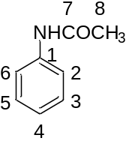  Unlabelled 2 | [C₈H₈NO]⁻, [M−H]⁻,  calculated: 134.0611,  found: 134.0617,  MS/MS:  92.0516 [M−C₂H₃O]⁻. | 7.68 (1H, s, NHCO),  7.50 (2H, d, H-2, H-6),  7.30 (2H, t, H-3, H-5),  7.10 (1H, t, H-3),  2.16 (3H, s, H-8). | /^{b}
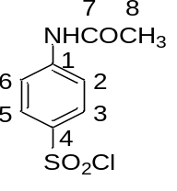  Unlabelled 3 | [C₈H₇ClNO₃S]⁻, [M−H]⁻,  calculated: 231.9841,  found: 231.9825,  MS/MS:  168.0194 [M−SO₂H]⁻,  126.0107 [M−C₂H₃O₃S]⁻. | 10.09 (1H, s, NHCO),  8.97 (4H, s, H-2, H-3, H-5, H-6), 2.03 (3H, s, H-8). | /
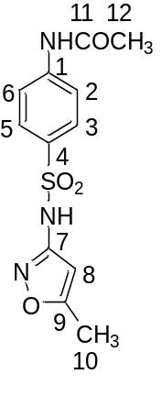  Unlabelled 4 | [C₁₂H₁₂N₃O₄S]⁻, [M−H]⁻,  calculated: 294.0554,  found: 294.0580,  MS/MS:  198.0245 [M−C₄H₅N₂O]⁻, 134.0618 [M−C₄H₅N₂O₃S]⁻,  92.0514 [M−C₆H₇N₂O₄S]⁻. | 11.32 (s, 1H, SO₂NH),  10.36 (1H, s, NHCO),  7.76 (4H, q, H-2, H-3, H-5, H-6), 6.12 (1H, s, H-8),  2.29 (3H, s, H-10),  2.07 (3H, s, H-12). | /
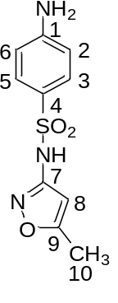Unlabelled 5 | [C₁₀H₁₂N₃O₃S]⁺, [M+H]⁺,  calculated: 254.0594,  found: 254.0595,  MS/MS:  156.0108 [M−C₄H₅N₂O]⁺,  108.0448 [M−C₄H₅N₂O₂S]⁺,  92.0538 [M−C₄H₅N₂O₃S]⁺. | 10.92 (1H, s, NH),  7.46 (2H, d, H-3, H-5),  6.57 (2H, d, H-2, H-6),  6.08 (3H, d, H-8, NH₂),  2.28 (3H, s, H-10). | 170.03 (C-9), 158.09 (C-7), 153.39 (C-1), 128.97 (C-3, C-5), 124.27 (C-4), 112.74 (C-2, C-6), 95.41 (C-8), 12.12 (C-10).
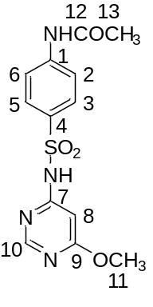  Unlabelled 6 | [C₁₃H₁₄N₄O₄S]⁻, [M−H]⁻,  calculated: 321.0663,  found: 321.0696,  MS/MS:  134.0618 [M−C₅H₆N₃O₃S]⁻,  122.0366 [M−C₈H₁₀NO₃S]⁻,  92.0507 [M−C₇H₈N₃O₄S]⁻. | 11.97 (1H, s, SO₂NH),  10.34 (1H, s, NHCO),  8.40 (1H, d, H-10),  7.85 (2H, d, H-3, H-5),  7.74 (2H, d, H-2, H-6),  6.32 (1H, d, H-8),  3.83 (3H, s, H-11),  2.06 (3H, d, H-13). | /
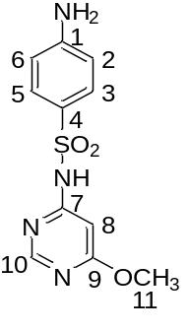Unlabelled 7 | [C₁₁H₁₃N₄O₃S]⁺, [M+H]⁺,  calculated: 281.0703,  found: 281.0703,  MS/MS:  215.0920 [M−HSO₂]⁺,  156.0102 [M−C₅H₆N₃O]⁺,  126.0662 [M−C₆H₄NO₂S]⁺,  108.0442 [M−C₅H₆N₃O₂S]⁺. | 11.36 (1H, s, NH),  8.39 (1H, d, H-10),  7.54 (2H, d, H-3, H-5),  6.58 (2H, d, H-2, H-6),  6.30 (1H, d, H-8),  6.10 (2H, s, NH₂),  3.82 (3H, s, H-11). | 169.85 (C-9), 158.83 (C-7), 157.52 (C-10), 153.41 (C-1), 129.29 (C-3, C-5), 124.16 (C-4), 112.62 (C-2, C-6), 90.69 (C-8), 53.94 (C-11).
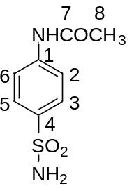  Unlabelled 8 | [C₈H₁₀N₂O₃S]⁻, [M−H]⁻,  calculated: 213.0339,  found: 231.0345,  MS/MS: 171.0236 [M−C₂H₃O]⁻, 134.0611 [M−H₂NO₂S]⁻, 92.0515 [M−C₂H₄NO₃S]⁻. | 10.27 (1H, s, NH),  7.81–7.64 (4H, m, H-2, H-3, H-5, H-6),  7.24 (2H, s, NH₂),  2.08 (3H, d, H-8). | /
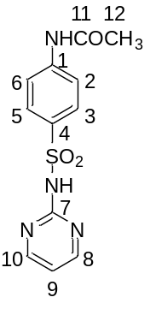  Unlabelled 9 | [C₁₂H₁₂N₄O₃S]⁻, [M−H]⁻,  calculated: 291.0557,  found: 291.0593,  MS/MS:  227.0960 [M−C₃HN₂]⁻,  184.0765 [M−C₅H₄N₂O]⁻,  134.0620 [M−C₄H₄N₃O₂S]⁻,  92.0262 [M−C₆H₆N₃O₃S]⁻. | 11.68 (1H, s, SO₂NH),  10.32 (1H, s, NHCO),  8.49 (2H, d, H-8, H-10),  7.91 (2H, d, H-3, H-5),  7.73 (2H, d, H-2, H-6),  7.03 (1H, t, H-9),  2.06 (3H, d, H-13). | /
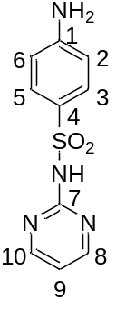Unlabelled 10 | [C₁₀H₁₁N₄O₂S]⁺, [M+H]⁺,  calculated: 251.0597,  found: 251.0584,  MS/MS:  156.0112 [M−C₄H₄N₃]⁺,  108.0442 [M−C₄H₄N₃OS]⁺, 92.0502 [M−C₄H₄N₃O₂S]⁺. | 11.27 (1H, s, NH),  8.48 (2H, d, H-8, H-10), 7.69–7.55 (2H, H-3, H-5), 7.00 (1H, t, H-9),  6.63-6.47 (2H, m, H-2, H-6), 6.01 (2H, s, NH₂). | 158.37 (C-7), 157.31 (C-8, C-10), 153.17 (C-1), 130.02 (C-3, C-5), 124.97 (C-4), 115.64 (C-9), 112.35 (C-2, C-6).
ª Positions of the numbered C-atoms are given in the corresponding structures.
^{b} “/” indicates that ¹³C NMR analysis was not performed.

