SUPPLEMENTARY MATERIAL
Table S1. Sensitivity Analyses — Full Categorical Results
Analysis | n | Parity 1 vs 2 beta (95% CI) | p | Parity 3 vs 2 beta (95% CI) | p | Parity 4+ vs 2 beta (95% CI) | p
Main model | 5762 | 1.54 (1.01, 2.08) | <0.001 | -0.85 (-1.28, -0.42) | <0.001 | -1.58 (-2.03, -1.13) | <0.001
Excl. CESD-10>=10 | 3148 | 1.53 (0.85, 2.21) | <0.001 | -0.82 (-1.42, -0.21) | 0.008 | -1.79 (-2.45, -1.14) | <0.001
Excl. multi-chronic | 4302 | 1.52 (0.92, 2.12) | <0.001 | -0.94 (-1.43, -0.44) | <0.001 | -1.28 (-1.82, -0.75) | <0.001
Rural | 4706 | 0.94 (0.26, 1.61) | 0.007 | -0.45 (-0.91, 0.01) | 0.056 | -0.83 (-1.32, -0.35) | <0.001
Urban | 1047 | 1.03 (0.19, 1.87) | 0.016 | -1.46 (-2.43, -0.48) | 0.004 | -1.66 (-2.80, -0.51) | 0.005
Note. All models adjusted for age, education, marital status, depression (CESD-10), hypertension, diabetes, heart disease, stroke, smoking, and alcohol consumption.
Table S2. Interaction Model — Full Regression Coefficients
Variable | beta | SE | p-value | 95% CI
Parity (continuous) | 0.3155 | 0.3436 | 0.359 | (-0.358, 0.989)
Age at first birth (years) | 0.1698 | 0.0538 | 0.002 | (0.064, 0.275)
Parity x Age at first birth | -0.0385 | 0.0157 | 0.014 | (-0.069, -0.008)
Age (years) | -0.2318 | 0.0122 | <0.001 | (-0.256, -0.208)
CESD-10 score | -0.1725 | 0.0117 | <0.001 | (-0.195, -0.150)
Married/partnered | 0.4506 | 0.2050 | 0.028 | (0.049, 0.852)
Education: Primary | 6.1971 | 0.2608 | <0.001 | (5.686, 6.708)
Education: Middle+ | 8.4745 | 0.5750 | <0.001 | (7.348, 9.601)
Note. Additional covariates (not shown): hypertension, diabetes, heart disease, stroke, smoking, and alcohol consumption. Model R-squared = 0.270.
Figure S3. Cognitive Score by Parity and Age at First Birth
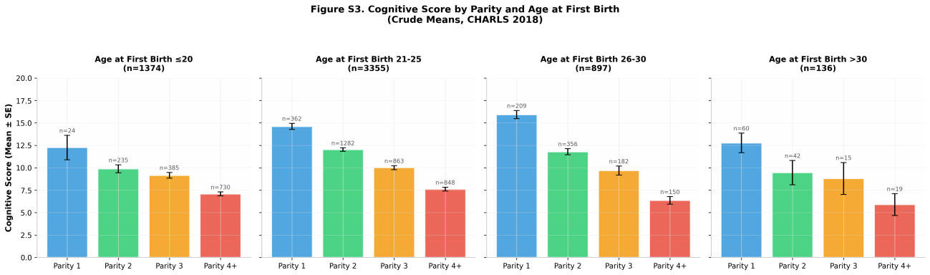
Figure S3. Cognitive score by parity and age at first birth (crude means, CHARLS 2018). Error bars represent standard errors.

