Graphical abstract

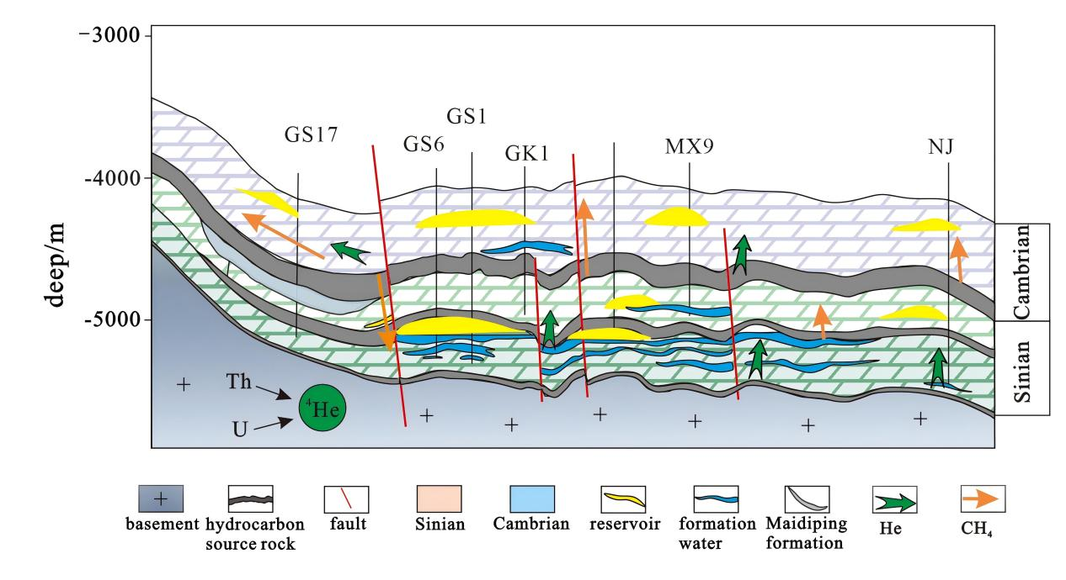
Schematic diagram of helium and natural gas migration pathways in the palaeo-uplift. Helium in the Sinian natural gas is derived from the exsolution of water-dissolved helium during near-basement water circulation; helium in the Cambrian system is derived from source rock generation and minor exsolution of water-dissolved helium.

