Supporting Information
Ion-Confined Perovskite Solar Cells with High Thermal Durability for Space Application

Guangzheng Wu^{1#}, Liangliang Deng^{2#}, Yuanjun Ma¹, Xiaoqing Chen⁵, Haoyang Zhang¹, Yuxiao Wu³, Xiaoli Gong³, Teng Wang⁴, Fan Zhang⁴, Guang Yang⁵, Tianxiang Hu¹, Yixi Wang¹, Xin Zhang², Xiaoguo Li², Zejiao Shi², Zhenru Zhang¹, Dan Li¹, Sailai, Momin¹, Hao Wang¹, Qiang Guo¹, Jia Zhang¹, Anran Yu ^{*,1}, Yuwen Zeng^{*,3}, and Yiqiang Zhan^{*,1,6}

1 The State Key Laboratory of Photovoltaic Science and Technology, College of Future Information Technology, Fudan University, Shanghai, P. R. China
2 Jiangyin Jinghao New Energy Technology Co., Ltd. Jiangyin, China
3 State Key Laboratory of Molecular Engineering of Polymers, Department of Macromolecular Science, Fudan University, Shanghai, P. R. China
4 Shanghai Fuxi Energy technology Co., Ltd. Shanghai, P. R. China
5 Key Laboratory of Opto-electronics Technology (Beijing University of Technology), Ministry of Education; School of Integrated Circuits, Beijing University of Technology, Beijing, P. R. China
6 Institute of Optoelectronics, Fudan University, Shanghai, P. R. China

#These authors contribute equally to this paper.
*Corresponding authors: Yiqiang Zhan, Email: yqzhan@fudan.edu.cn; Yuwen Zeng Email: zengy@fudan.edu.cn; Anran Yu, Email: aryu@fudan.edu.cn

Keywords: 2D polymer, perovskite solar cell, ion migration, durable

Experimental Section
Materials:
PbI₂ (≥99.99%) and Me-4PACz (≥98%) were purchased from Tokyo Chemical Industry (TCI). FAI (≥99.5%), MAI (≥99.5%), and MACl (≥99.5%) were also obtained from TCI. CsI (≥99%), PC₆₁BM (≥99%), C₆₀ (≥98%), and BCP (≥99%) were purchased from Xi’an Polymer Light Technology Corp. DMF (≥99.8%), DMSO (≥99.7%), chlorobenzene (≥99.8%), EtOH (≥99.8%), and IPA (≥99.8%) were supplied by Sigma-Aldrich. NiOₓ was purchased from Xi’an Polymer Light Technology Corp. All chemicals were used as received without further purification. Melamine (≥99.8%), trimesic acid trichloride (≥99.8%), N-methyl-2-pyrrolidone (≥98.0%), and pyridine (≥98.0%) were obtained from Sigma-Aldrich.

Synthesis of 2DPA-1：
A 40-mL vial equipped with a stir bar was charged with 126 mg of melamine (1 mmol, 1 equiv.) and 265 mg of trimesic acid trichloride (1 mmol, 1 equiv.), followed by 9 mL of N-methyl-2-pyrrolidone and 1 mL of pyridine. The mixture was stirred at room temperature (20–25 °C). After 16 h, the entire reaction mixture formed a gel. The gel was cut into small pieces and soaked in 80 mL of IPA, then subjected to bath sonication for 30 min (if necessary). The resulting cloudy suspension was filtered or centrifuged, followed by washing with 80 mL of deionized H₂O and 80 mL of acetone. A pale-yellow powder (228 mg, 81% yield) was obtained after drying under house vacuum at 100 °C for 16 h.
Device Fabrication:
Perovskite solar cells were fabricated on pre-patterned ITO or FTO glass substrates. The substrates were sequentially cleaned with detergent, water, deionized water, acetone, and isopropanol under ultrasonication for 15 min each. Afterwards, the ITO or FTO substrates were dried in an oven at 150 °C for 5 min, followed by ultraviolet–ozone (UVO) treatment for 15 min.
Small-area p–i–n structured devices were fabricated on prepatterned glass/FTO substrates with an active area of 0.1 cm². A 0.5 mg mL⁻¹ Me-4PACz ethanol solution was spin-coated onto the FTO substrate at 3000 rpm for 30 s and annealed at 120 °C for 10 min. 1.8 M Cs₀.₀₅MA₀.₁FA₀.₈₅PbI₃ perovskite precursor solution was prepared by dissolving FAI, PbI₂, MAI, and CsI in a DMF/DMSO solvent mixture (4:1 v/v). A 70 μL aliquot of the precursor was spin-coated at 1000 rpm for 10 s, followed by 4000 rpm for 40 s. During the final spin-coating stage, 160 μL of chlorobenzene (CB) antisolvent was dropped 25 s before the end of spinning. The films were then thermally annealed at 120 °C for 10 min. For the 2DPA-modified perovskite layers, 2DPA solutions of varying concentrations (in DMF:IPA = 1:200) were deposited onto the perovskite films. Subsequently, a 23 mg/mL PC₆₁BM solution was spin-coated onto the perovskite layer. Device fabrication was completed by sequential thermal evaporation of 6 nm bathocuproine (BCP) and 100 nm Ag under high vacuum (<5 × 10⁻⁶ Torr).
p–i–n structured mini-modules were fabricated on prepatterned glass/ITO substrates (5 cm × 5 cm). For the P1 patterning process, the substrates were scribed with a linewidth of 25 μm to form 7 serially connected sub-cells. Prior to use, the substrates were ultrasonically cleaned sequentially with detergent solution, deionized water, and ethanol for 15 min each, followed by UV–ozone treatment for 30 min. A 10 mg mL⁻¹ NiOₓ aqueous solution was then spin-coated onto the substrate at 3000 rpm for 30 s and annealed at 150 °C in ambient air for 10 min. The substrates were immediately transferred into an N₂-filled glovebox.
Subsequently, a 0.5 mg mL⁻¹ Me-4PACz ethanol solution was spin-coated onto the NiOₓ layer at 3000 rpm for 30 s and annealed at 100 °C for 10 min. Perovskite films were deposited by spin-coating a 1.5 M Cs₀.₀₅MA₀.₁FA₀.₈₅PbI₃ precursor solution in a DMF:DMSO mixture (4:1 v/v) at 5000 rpm for 50 s. Approximately 2 mL of chlorobenzene was employed as an antisolvent and dispensed near the end of the spin-coating step. The perovskite films were then obtained after annealing at 100 °C for 30 min. For 2DPA-modified perovskite layers, 2DPA solutions of varying concentrations (in DMF:IPA = 1:200) were deposited onto the perovskite films. For further interface modification, a 1.0 mg mL⁻¹ solution of PEACl or TEACl in anhydrous isopropanol was spin-coated at 3000 rpm for 30 s and annealed at 100 °C for 10 min. Thereafter, 20 nm C₆₀ and 20 nm SnO₂ were deposited via thermal evaporation and atomic layer deposition (ALD), respectively. In the P2 process, the stacked NiOₓ/SAMs/perovskite/C₆₀/SnO₂ layers were scribed with a width of 100 μm. Finally, a 100 nm Cu electrode was deposited by thermal evaporation and patterned via a P3 scribe with a width of 50 μm. The total dead width was 285 μm, corresponding to a geometric fill factor (GFF) of 94.3%.

Driftfusion Simulation:
The dependence of J―V on ionic doping concentration is simulated with Driftfusion ¹. The Model parameters are listed in table S3. The optical constants of FAPbI₃ were extracted from previous work ². Moderately lower mobilities were chosen for the anions and cations to reflect the prohibition of ion migration by introducing KI ³. Two thin interlayers were inserted between the SAMs/FAPbI₃ interface and the FAPbI₃/PC₆₁BM interface to model the transition across the heterointerface ¹.

Characterizations:
¹H NMR spectra were recorded on a Bruker AVANCE III (400 MHz) spectrometer using DMSO-d₆ as the solvent. Fourier transform infrared (FTIR) spectra were collected on a Nicolet 8700 spectrometer (Thermo Electron Corporation). X-ray photoelectron spectroscopy (XPS) measurements were performed on a THERMO VG ESCALAB 250 instrument. The surface morphology of the samples was characterized by scanning electron microscopy (SEM, Hitachi S-470). Steady-state photoluminescence (PL) spectra (excitation at 450 nm, front-side illumination) were acquired on a fluorescence spectrophotometer (F-7000, Hitachi). Real-time in situ PL spectroscopy was conducted on an InView-PL system (Ideaoptics Inc.) with 450 nm excitation. X-ray diffraction (XRD) patterns were recorded on an XRD-6000 diffractometer (Shimadzu) over a 2θ range of 5° to 60°. Surface potential images of the pristine and 2DPA-modified perovskite films were obtained by Kelvin probe force microscopy (KPFM) using a Bruker DMFASTSCAN2-SYS system. Current density–voltage (J–V) characteristics were measured inside a nitrogen-filled glovebox under 100 mW cm⁻² simulated AM 1.5 G irradiation from a solar simulator (Newport), which was calibrated using a standard silicon reference cell (SRC-2020, EnliTech). External quantum efficiency (EQE) spectra were recorded in the range of 300–900 nm at room temperature under ambient conditions using a QE-R measurement system (EnliTech). Atomic force microscopy (AFM) characterization was performed on a Cypher VRS1250 instrument with a sample bias of 10 V.

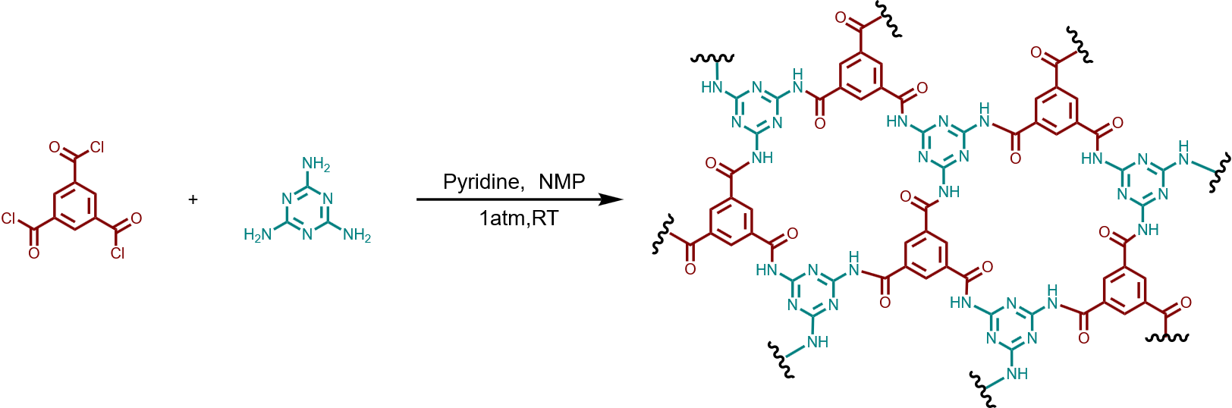
Figure S1. The synthesis steps of 2DPA.

Figure S2. AFM topography image of the 2DPA film (a) and corresponding height distribution profiles for selected regions: (b) Region 1, (c) Region 2, (d) Region 3.

Figure S3. Fourier transform infrared (FTIR) spectra of pure 2DPA and the PbI₂/2DPA mixture, with the magnified regions corresponding to the characteristic peaks of (a) C=O stretching vibration, (b) N-H bending/stretching vibration, and (c) C=N stretching vibration.

Figure S4. (a) XPS Pb 4f spectrogram of perovskite film with or without 2DPA modification. (b) Extracted from figure S4a.

Figure S5. c-AFM spectra of FAPbI₃ single crystals with and without 2DPA modification.

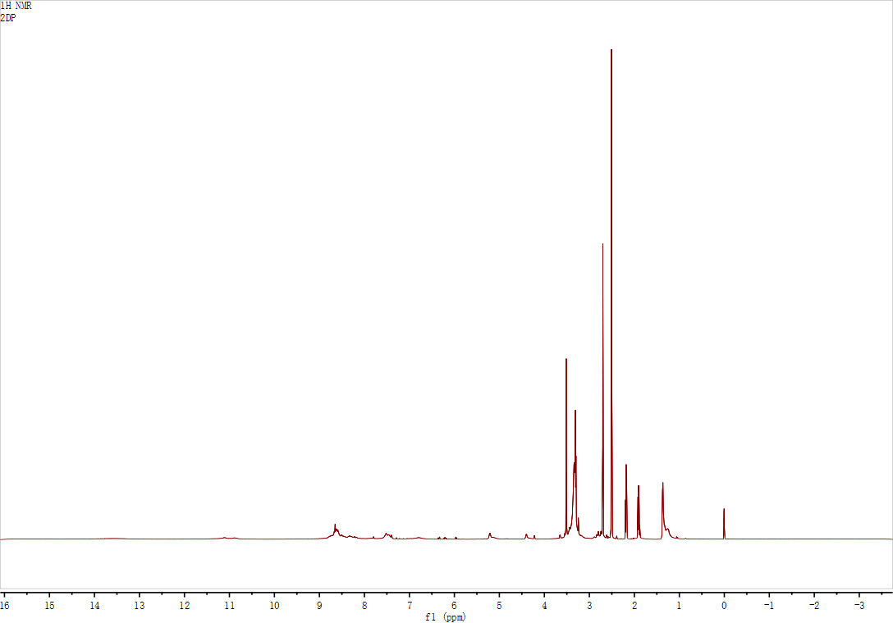
Figure S6. ¹H NMR spectrum of 2DPA in DMSO-d₆

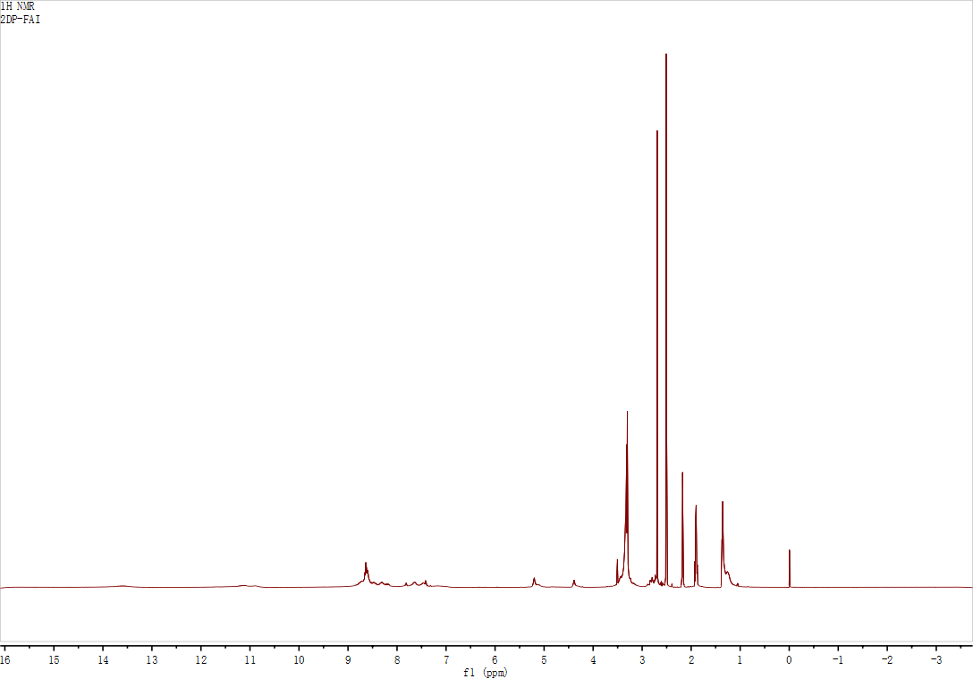
Figure S7. ¹H NMR spectra of 2DPA + FAI in DMSO-d₆.

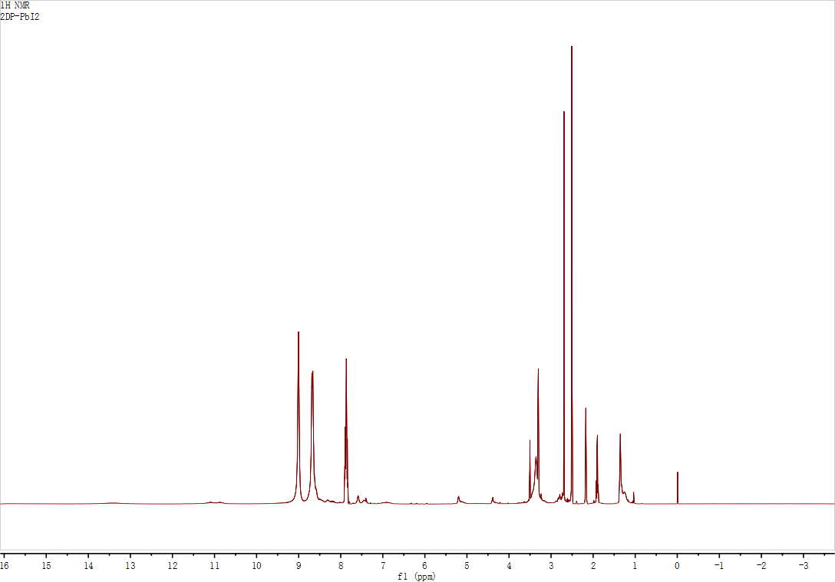
Figure S8. ¹H NMR spectra of 2DPA + PbI₂ in DMSO-d₆.

Figure S9. XRD patterns of pristine and aged perovskite films with and without 2DPA modification after aging at 150 °C for 10 min.

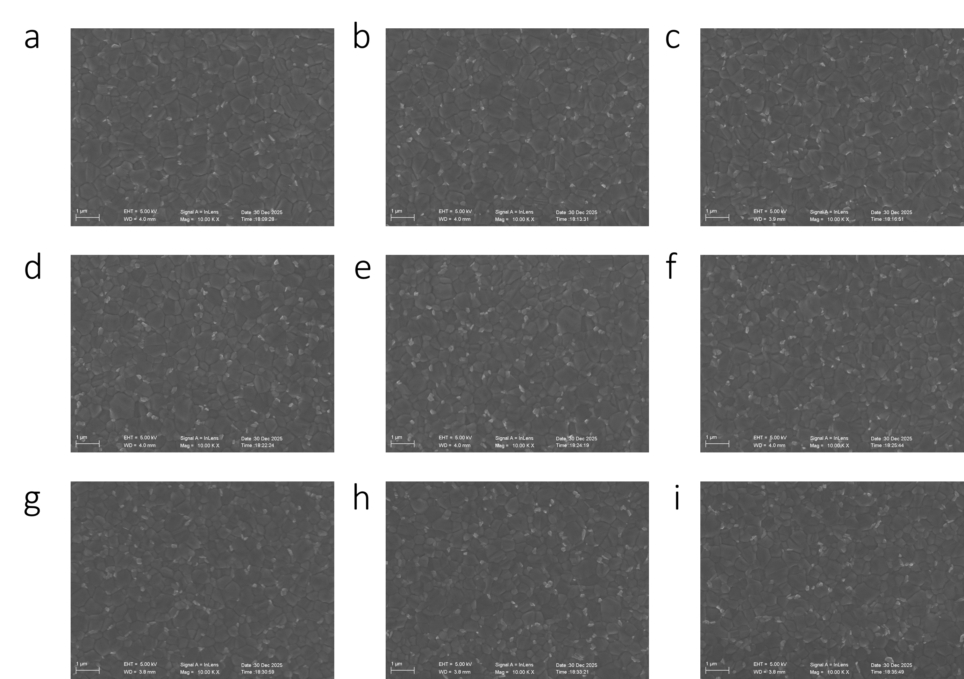
Figure S10. SEM images of the unmodified perovskite films for 9 samples (a–i).

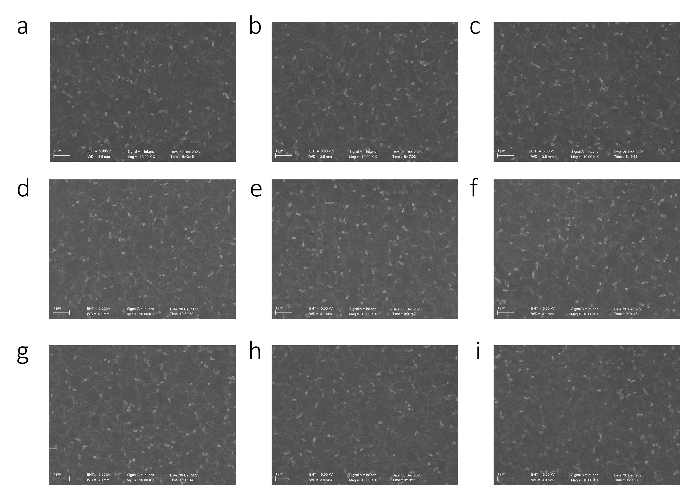
Figure S11.
SEM images of 2DPA-modified perovskite films for 9 samples (a–i).

Figure S12. Crystal size distributions of perovskite thin films (a) without modification extracted from Figure S10 and (b) with 2DPA modification extracted from Figure S11.

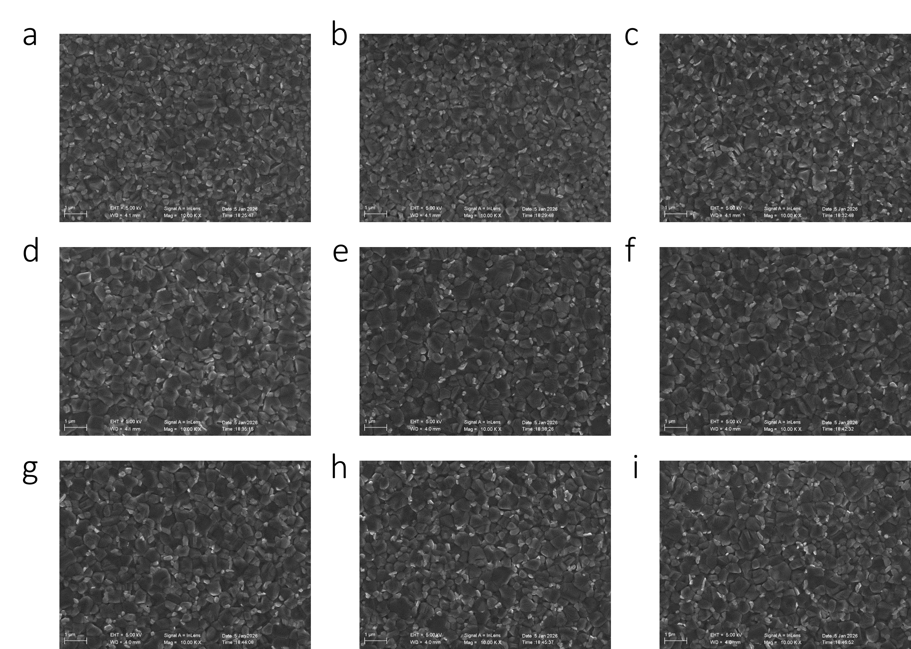
Figure S13. SEM images of aged control perovskite films without modification for 9 samples (a–i). All films were aged at 100 °C for 120 h.

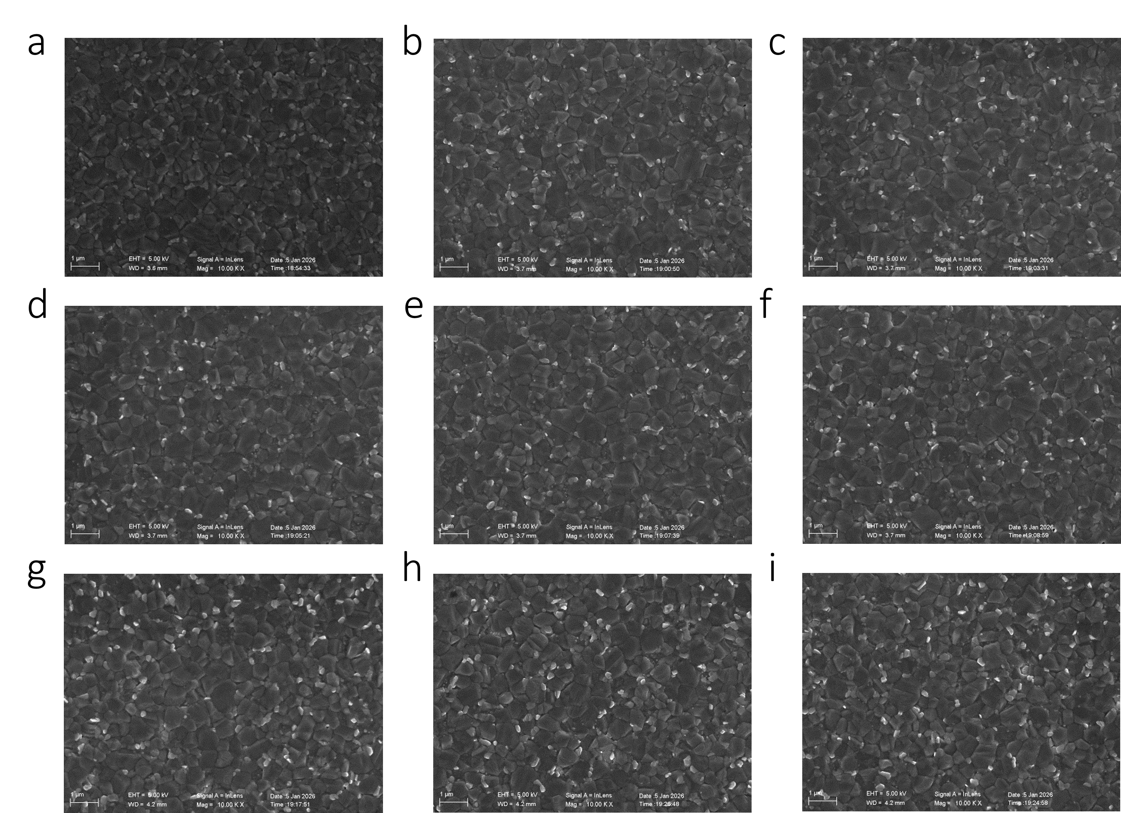 Figure S14. SEM images of aged 2DPA-modified perovskite films for 9 samples (a–i).All films were aged at 100 °C for 120 h.

Figure S15. (a) Crystal size distribution of aged unmodified perovskite thin films extracted from Figure S13 (b) Crystal size distribution of aged 2DPA-modified perovskite thin films extracted from Figure S14.

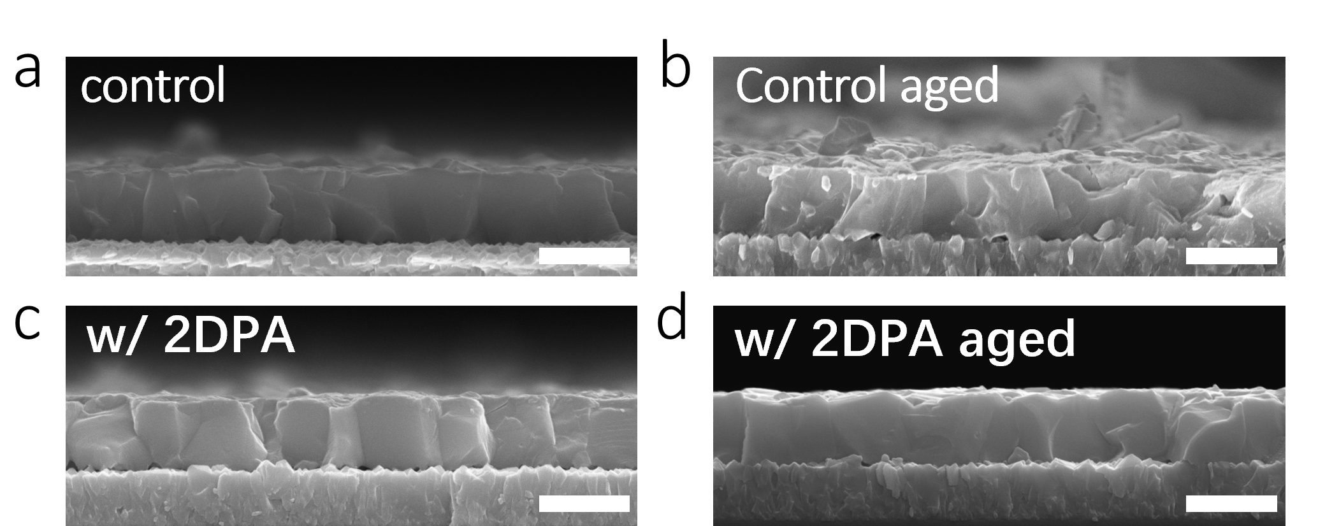
Figure S16. Cross-sectional SEM images: (a) control film; (b) control film after thermal aging at 100 °C for 120 h; (c) 2DPA-modified film; (d) 2DPA-modified film after thermal aging at 100 °C for 120 h.

Figure S17. XRD patterns of the pristine and aged perovskite films with and without 2DPA modification. Aging was performed at 65% relative humidity for 100 h.

Figure S18. Statistical photovoltaic parameters: of (a) V_{OC}, (b) FF, (c) J_{SC}, and (d) PCE with or without 2DPA modification.
Figure S19. EQE curve of the device with or without 2DPA modification.

Figure S20. Performance of p–i–n structured perovskite solar cells after extreme-temperature post-treatment at 150 °C: (a) fresh devices; (b) aged devices.
“2DPA+3” denotes 2DPA-modified perovskite films annealed at 150 °C for 3 min; “Control+3” denotes control films annealed at 150 °C for 3 min; “2DPA+7” denotes 2DPA-modified perovskite films annealed at 150 °C for 7 min; “Control+7” denotes control films annealed at 150 °C for 7 min.

Figure S21. (a) Front view of the module (b) Back view of the module

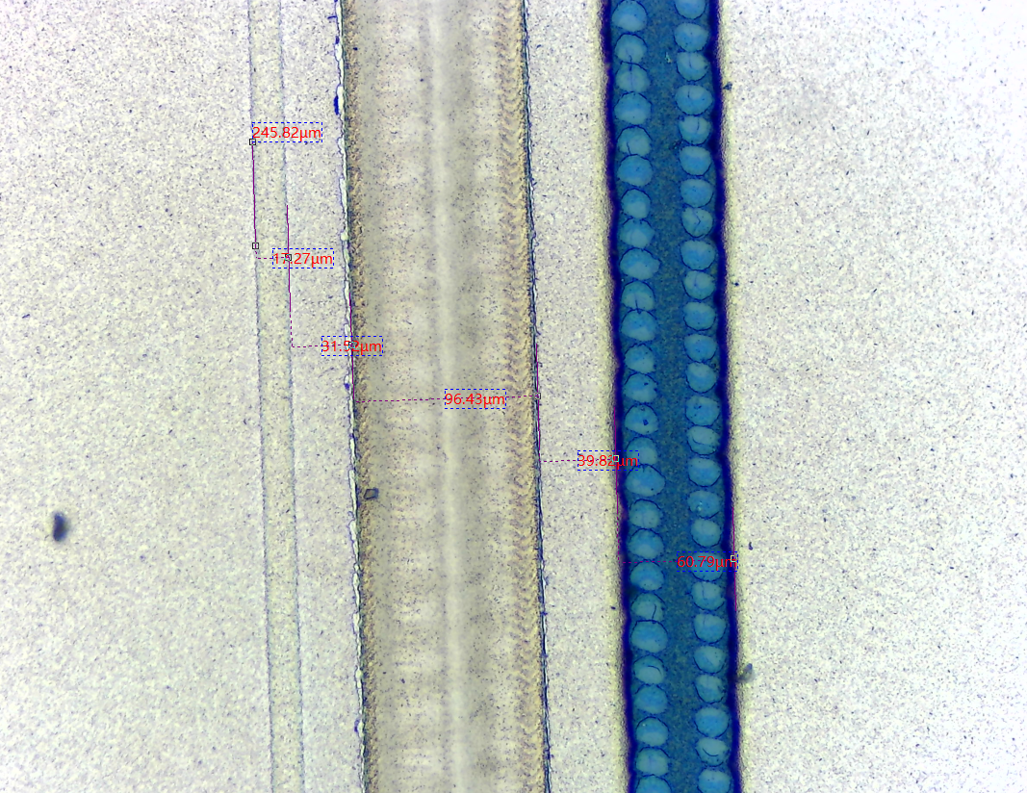
Figure S22. P1-P3 optical micrograph

Figure S23. Thermal stability test results of modules with or without 2DPA modification in 100 °C.

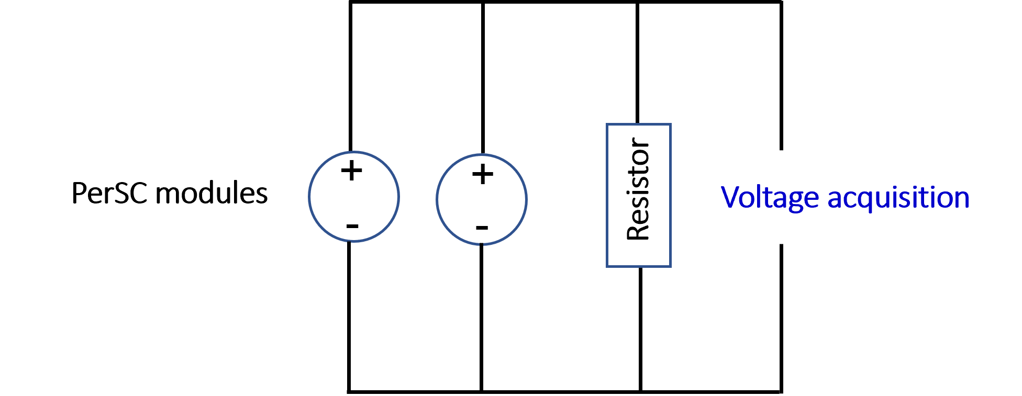
Figure S24. Load circuit diagram of two 2DPA-modified PerSC modules connected in parallel (load resistance is 40 ohms).

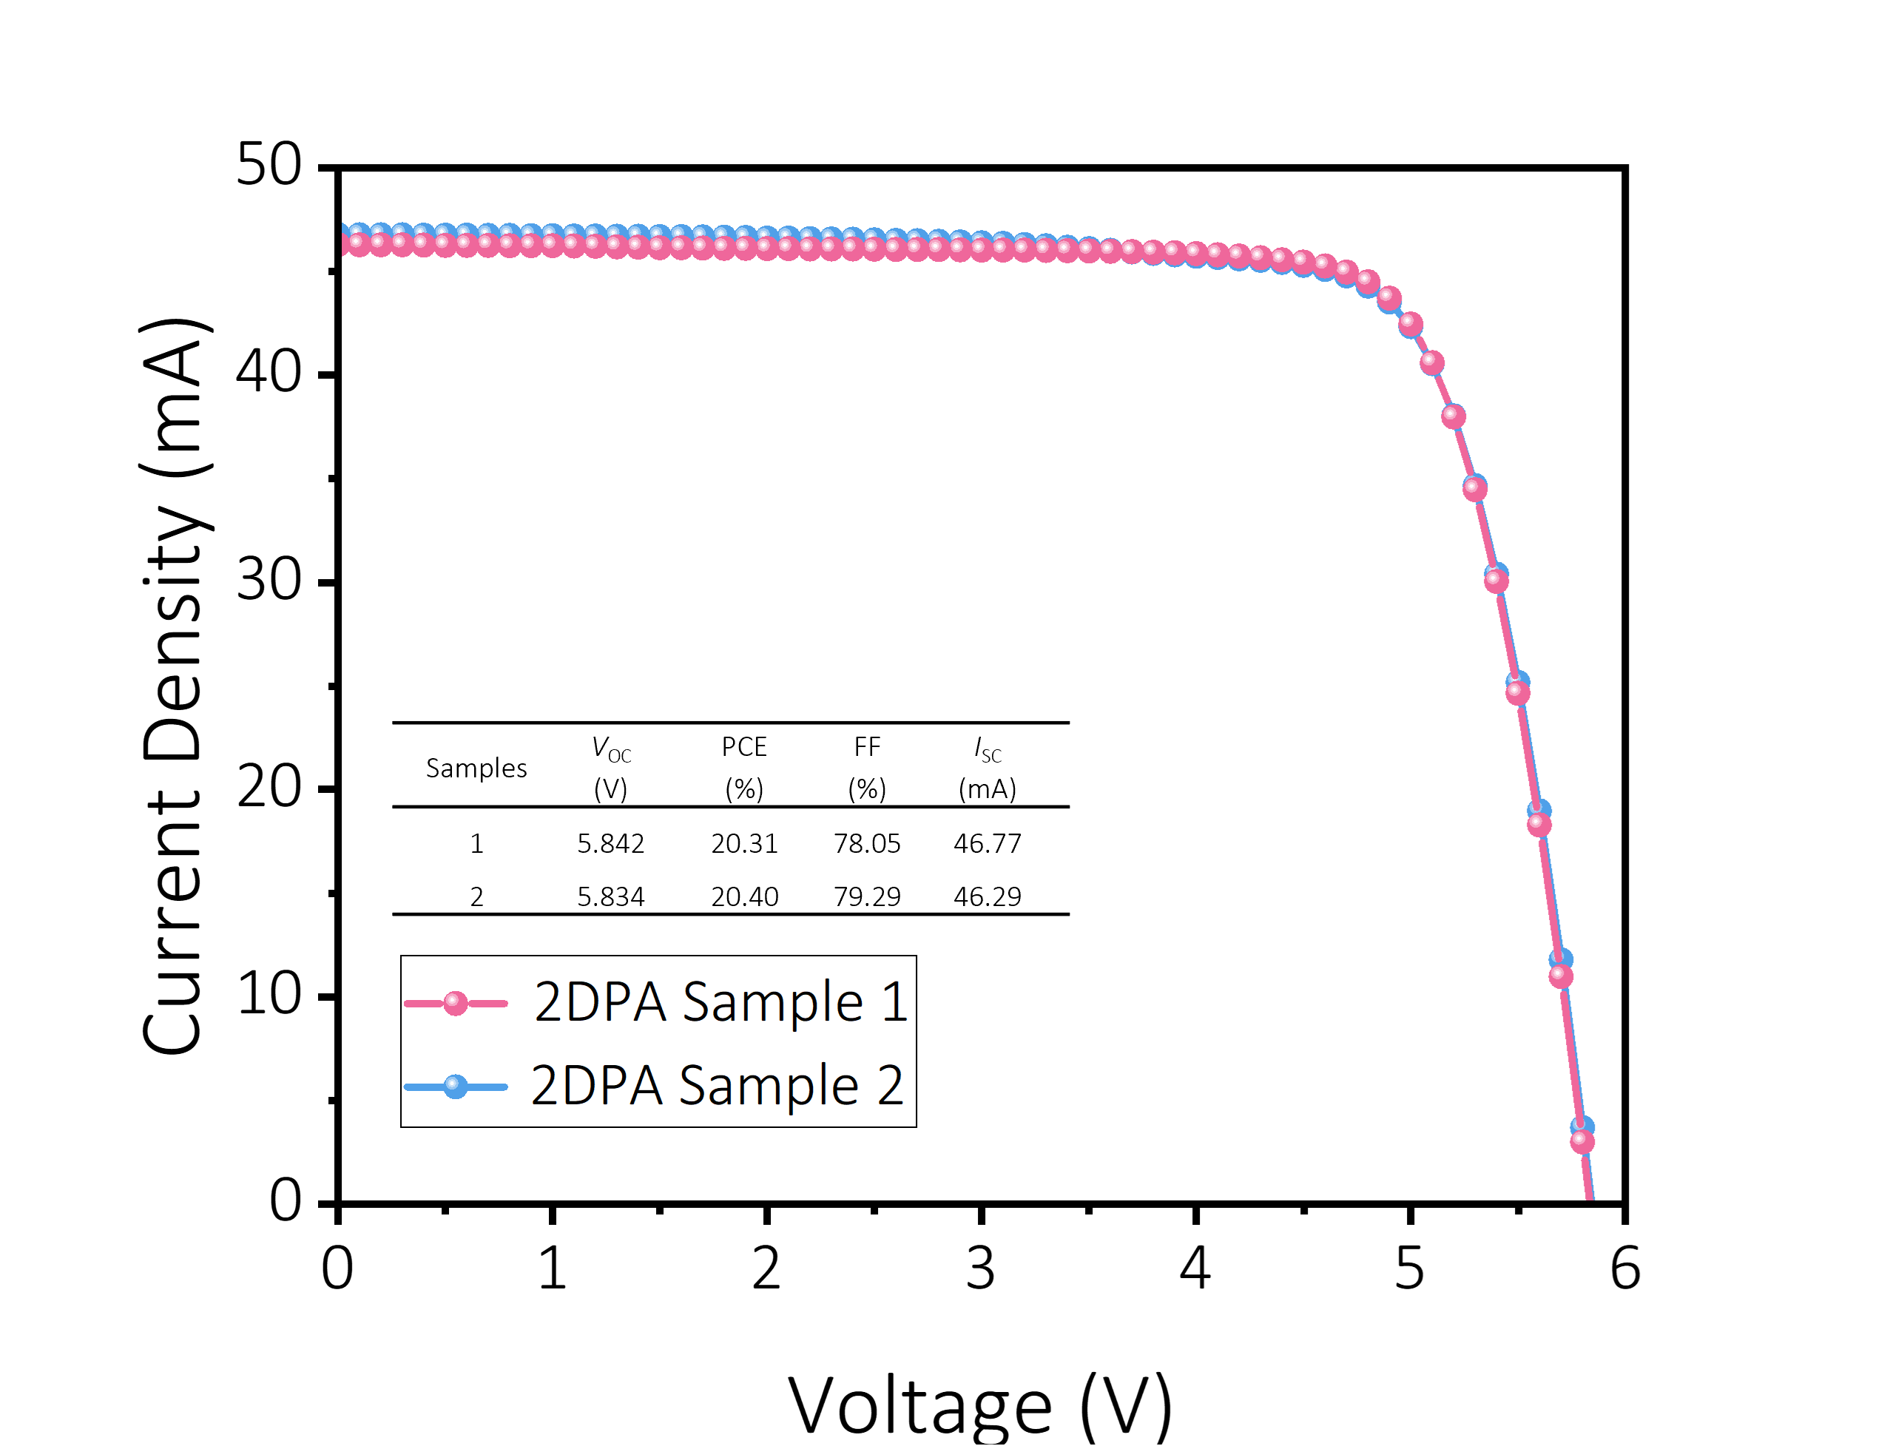
Figure S25. J–V curves of the PerSC module prior to launch of Tianyan-24 into low Earth orbit.

Figure S26. Operating voltage curve of the 2DPA-modified PerSC module in low Earth orbit at an altitude of 500 km for 8424 h.

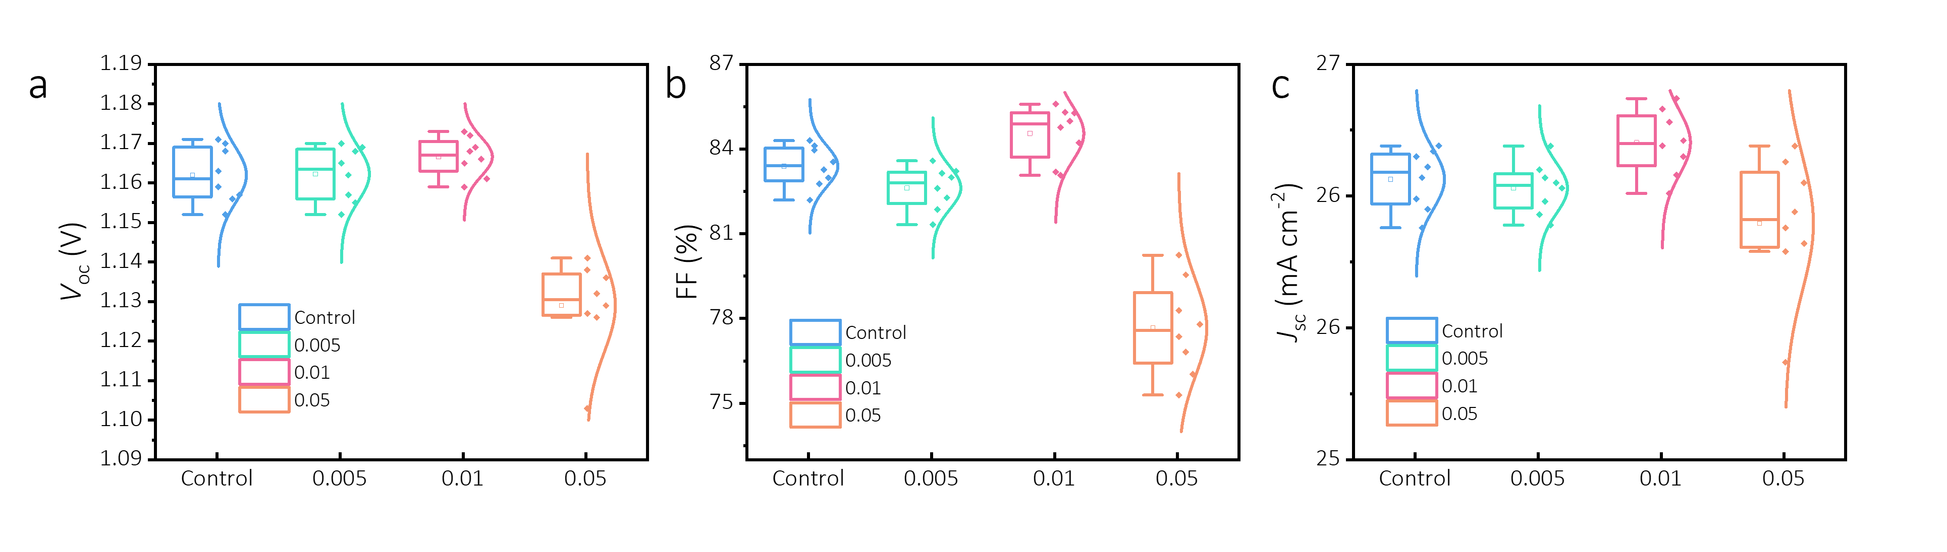
Figure S27. Statistical photovoltaic parameters: (a) V_{OC}, (b) FF, (c) J_{SC} with 2DPA modification and doping with different KI concentration.

Table S1. The calculated chemical synthesis cost for 2DPA.
Entry | Reagent | Price | Quantity | Brand | Price of 2DPA
Raw  material | Melamine | 39.8 ¥/1g | 126 mg | Innochem | 125.6 ¥/228 mg
Raw  material | Trimesic acid trichloride | 9.8 ¥/1g | 265 mg | Alfa | 125.6 ¥/228 mg
Raw  material | N-methyl-2-pyrrolidone | 9.03 ¥/mL | 9 mL | Acros | 125.6 ¥/228 mg
Solvent | pyridine | 8.76 ¥/mL | 1 mL | Alfa | 125.6 ¥/228 mg
Solvent | IPA | 0.23 ¥/mL | 80 mL | Innochem | 125.6 ¥/228 mg
Solvent | Acetone | 0.12 ¥/mL | 80 mL | Innochem | 125.6 ¥/228 mg

Table S2. Slope values of the V_{OC} versus light intensity f based on fresh and aged films to build the PerSCs.
Sample | Initial slope | aged slope
Control | 1.16 k_{B}T/q | 1.67 k_{B}T/q
W/ 2DPA | 1.12 k_{B}T/q | 1.27 k_{B}T/q

Table S3
Layers | SAMs | Inter-layer 1 | FAPbI₃ | Inter-layer 2 | PC₆₁BM/BCP
Thickness (nm) | 20 | 1 | 600 | 1 | 31
EA (eV) | -1.37 |  | -4.22 |  | -4.45
IP (eV) | -5.58 |  | -5.75 |  | -6.34
E_{f} (eV) | -5.56 |  | -5.3 |  | -4.47
E_{t} (eV) | -3.475 |  | -4.985 |  | -5.395
N_{c} (cm⁻³) | 6.30E+18 |  | 2.00E+18 ⁴ |  | 2.50E+19 ⁵
N_{v} (cm⁻³) | 1.20E+19 |  | 1.80E+18 ⁴ |  | 2.50E+19 ⁵
N_{cat}/N_{ani} (cm⁻³) | N/A |  | variable |  | N/A
μ_{e} (cm²V⁻¹s⁻¹) | 1.00E-04 ⁶ |  | 27 ⁷ |  | 2.00E-03
μ_{h} (cm²V⁻¹s⁻¹) | 1.00E-04 ⁶ |  | 27 ⁷ |  | 1.00E-05
μ_{cat} (cm²V⁻¹s⁻¹) | N/A |  | 1.00E-13 |  | N/A
μ_{ani} (cm²V⁻¹s⁻¹) | N/A |  | 4.00E-13 |  | N/A
ε_{r} | 3 |  | 23 |  | 3
B | 6.3E-11 |  | 1.10E-10 ⁷ |  | 6.3E-11
τ_{n}/τ_{p} | 1.00E-08 ¹ | 1.00E-06 | 1.00E-06 | 1.00E-06 | 1.00E-09 ¹
Surface recombination velocity (cm/s) | 1.00E+08 ¹

References

1 Calado, P. et al. Driftfusion: an open source code for simulating ordered semiconductor devices with mixed ionic-electronic conducting materials in one dimension. Journal of Computational Electronics 21, 960–991 (2022). https://doi.org/10.1007/s10825-021-01827-z
2 Ndione, P. F., Li, Z. & Zhu, K. Effects of alloying on the optical properties of organic–inorganic lead halide perovskite thin films. Journal of Materials Chemistry C 4, 7775–7782 (2016). https://doi.org/10.1039/C6TC02135B
3 Son, D.-Y. et al. Universal Approach toward Hysteresis-Free Perovskite Solar Cell via Defect Engineering. Journal of the American Chemical Society 140, 1358–1364 (2018). https://doi.org/10.1021/jacs.7b10430
4 Wang, S., Xiao, W.-b. & Wang, F. Structural, electronic, and optical properties of cubic formamidinium lead iodide perovskite: a first-principles investigation. RSC Advances 10, 32364–32369 (2020). https://doi.org/10.1039/D0RA06028C
5 Koster, L. J. A., Mihailetchi, V. D., Ramaker, R. & Blom, P. W. M. Light intensity dependence of open-circuit voltage of polymer:fullerene solar cells. Applied Physics Letters 86 (2005). https://doi.org/10.1063/1.1889240
6 Hossain, K. et al. Resolving the Hydrophobicity of the Me-4PACz Hole Transport Layer for Inverted Perovskite Solar Cells with Efficiency >20%. ACS Energy Letters 8, 3860–3867 (2023). https://doi.org/10.1021/acsenergylett.3c01385
7 Johnston, M. B. & Herz, L. M. Hybrid Perovskites for Photovoltaics: Charge-Carrier Recombination, Diffusion, and Radiative Efficiencies. Accounts of Chemical Research 49, 146–154 (2016). https://doi.org/10.1021/acs.accounts.5b00411

