Supplementary Materials
Supplemental Table 1: Algal genera observed in Skaneateles Lake from May to October, 1910 to 1965 ¹³. Referenced genera are known to produce T/O compounds or toxins based on published literature. Abbreviations: Taste and odor, T/O; Toxin producing, Txn
Genus | Phylum | T/O | Txn
Actinastrum | Chlorophyta | No | No
Amphora | Bacillariophyta | No | No
Aphanizomenon | Cyanobacteria | Yes^{1,2} | Yes^{1,2}
Aphanocapsa | Cyanobacteria | Yes³ | Yes³
Asterionella | Bacillariophyta | No | No
Ceratium | Dinoflagellata | No | No
Chroococcus | Cyanobacteria | No | No
Clathrocystis | Chlorophyta | No | No
Coelosphaerium | Cyanobacteria | No | No
Cosmarium | Chlorophyta | No | No
Cyclotella | Bacillariophyta | No | No
Cymbella | Bacillariophyta | No | No
Diatoma | Bacillariophyta | No | No
Dinobryon | Chrysophyta | Yes¹ | No
Dolichospermum | Cyanobacteria | Yes^{1,2} | Yes^{1,2}
Eudorina | Chlorophyta | No | No
Fragilaria | Bacillariophyta | No | No
Gloeocapsa | Cyanobacteria | No | No
Gloeotrichia | Cyanobacteria | Yes^{1,2} | No
Limnoraphis (formerly Lyngbya) | Cyanobacteria | Yes^{1,2} | Yes^{1,2}
Meridion | Bacillariophyta | No | No
Merismopedia | Cyanobacteria | No | No
Microcystis | Cyanobacteria | Yes^{1,2} | Yes^{1,2}
Navicula | Bacillariophyta | No | No
Oscillatoria | Cyanobacteria | Yes^{1,2} | Yes^{1,2}
Pandorina | Chlorophyta | No | No
Pediastrum | Chlorophyta | No | No
Peridinium | Dinoflagellata | No | No
Scenedesmus | Chlorophyta | No | No
Synedra | Bacillariophyta | No | No
Synura | Chrysophyta | Yes¹ | No
Tabellaria | Bacillariophyta | No | No
Uroglena | Chlorophyta | No | No
Note: References 1-⁸², 2-⁸³, 3- ⁸⁴.
Supplemental Table 2: Total unique sampling days each year.
Year | Total Unique  Sampling Days | Year | Total Unique  Sampling Days | Year | Total Unique  Sampling Days
1973 | 16 | 1992 | 9 | 2009 | 9
1976 | 9 | 1993 | 9 | 2010 | 8
1977 | 11 | 1994 | 11 | 2011 | 9
1978 | 11 | 1995 | 10 | 2012 | 11
1979 | 12 | 1996 | 9 | 2013 | 6
1980 | 12 | 1997 | 7 | 2014 | 10
1981 | 12 | 1998 | 7 | 2015 | 9
1982 | 12 | 1999 | 10 | 2016 | 10
1983 | 9 | 2000 | 9 | 2017 | 10
1984 | 13 | 2001 | 9 | 2018 | 11
1985 | 7 | 2002 | 9 | 2019 | 10
1986 | 11 | 2003 | 8 | 2020 | 11
1987 | 13 | 2004 | 4 | 2021 | 11
1988 | 8 | 2005 | 9 | 2022 | 10
1989 | 10 | 2006 | 7 | 2023 | 10
1990 | 10 | 2007 | 6 | 2024 | 10
1991 | 9 | 2008 | 8

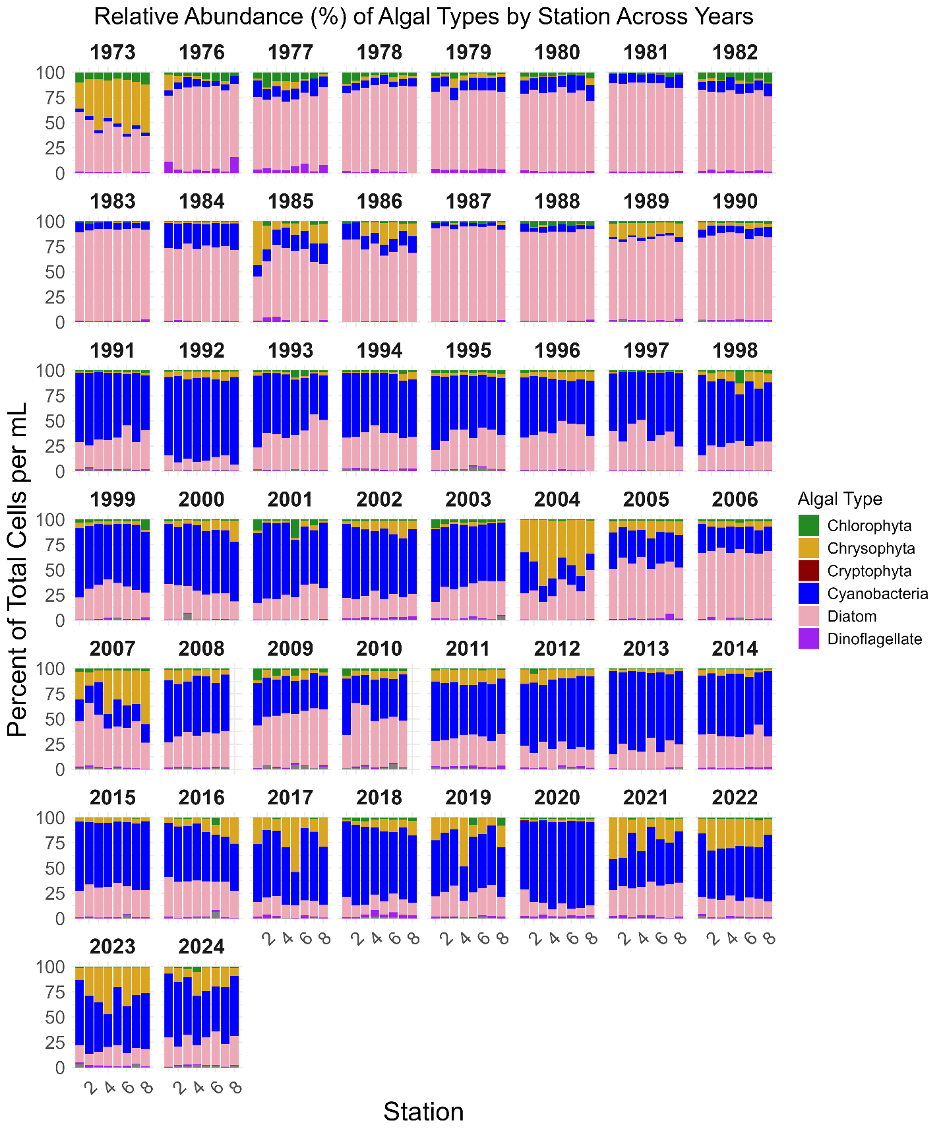
Supplemental Figure 1: Relative abundance of algal types by stations across years.
Limitations and Recommendations
This study has several limitations related to sampling methodology, data availability, and long-term data curation. Sources of variability that may confound interannual comparisons include microscope calibration, sample preservation, taxonomic changes, and microscopic procedures. A limitation that could affect algal counts is the Foerst Electric Plankton Centrifuge, which only removes 98% of the algal material after a single centrifugation ²⁹. Filamentous and colonial genera can be suspended in the supernatant.^{29,30}
Also, for historical datasets to be useful, standardization is required to ensure consistent formatting. Based on prior recommendations and using internal memos for the Skaneateles Lake dataset, we provide recommendations for the future long-term dataset best practices which includes have storage times to prevent changes in cell counts, preserve samples for future taxonomic re-evaluation and retrospective QA/QC, generate a training module including a genus inventory for technicians on algal identification, and establish standard operating procedures for counting to differentiate small colonies/short filaments from larger colonies/longer filaments. These changes can make a stronger long-term dataset for future work.

