Table 1. The aggregated LULC categories included in the simulation
LULC categories | Detailed description (level 3 of the CORINE nomenclature) | Total surface area (Ha)
Built-up areas | Discontinuous urban fabric; Continuous urban fabric; Industrial or commercial units; Green urban areas; Sport and leisure facilities; Airports; Construction sites; Port areas | 1,268,519
Arable lands | Non-irrigated arable land; Rice fields; Permanently irrigated land | 865,5431
Vineyards | Vineyards | 224,325
Orchards | Fruit trees and berry plantations | 278.588
Agricultural complex cultivation patterns | Complex cultivation patterns; Annual crops associated with permanent crops | 835,338
Heterogenous Agricultural areas | Land principally occupied by agriculture, with significant areas of natural vegetation; Agro-forestry areas | 917,063
Pastures | Pastures | 262,4181
Natural grasslands | Natural grasslands | 578,294
Transitional woodland-shrub | Transitional woodland-shrub; Moors and heathland; Sclerophyllous vegetation | 526,869
Broad-leaved forest | Broad-leaved forest | 4,895,331
Mixed forest | Mixed forest | 1,043,813
Coniferous forest | Coniferous forest | 1,189,244
Open spaces with little or no vegetation | Beaches, dunes, sands; Sparsely vegetated areas | 20,813

Key parameters required by the CLUE-s model

i) The LULC demand, which defines scenario requirements for the simulation period for each LULC class, calculated based on observed historical dynamics. These values were extrapolated to the simulation horizon using the linear trend identified for the 2006–2018 period. The assumption was that this period would provide a more reliable basis for projection, reflecting structural changes associated with Romania’s EU accession and the implementation of land-use policies and development programs;
ii) The LULC location characteristics were empirically estimated as the relationship between the current LULC pattern (here, 2018) and its determining factors. This defines the “preference” for a specific LULC category in a specific location and time, calculated using a binomial logit model (Eq. 1):

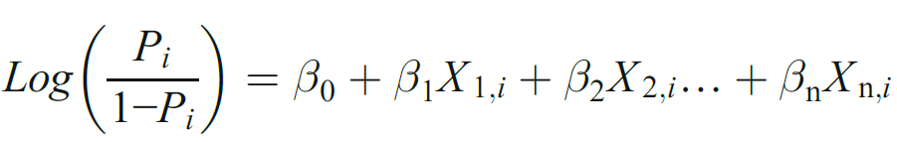 (Eq. 1)

where P represents the probability of a grid cell for the occurrence to the considered LULC category at location i; X₁ … Xₙ denote the explanatory variables; and β₀ … βₙ are the estimated coefficients.

To explain spatial LULC patterns, various independent explanatory variables were incorporated into the modelling framework (Table 2), representing relief characteristics, soil quality, actual and future growing-season climate conditions, socioeconomic factors, proximity variables, and protective measures. The datasets were selected based on their widely known relevance to LULC pattern change, as reported in previous studies before, as well as their availability at the national level at an appropriate spatial resolution. Based on the spatial resolution of the input datasets, and the extent of the study area (national coverage), a spatial resolution of 250 m was considered appropriate for the simulation to ensure a balance between spatial detail and computational efficiency.

Table 2. Determinant factors for explaining land use/land cover pattern location
Code | Variable (and data source) | Temporal coverage | Type of data
X₁ | Altitude/cell (derived from SRTM-NASA Shuttle Radar Topographic Mission) | - | continuous/static
X₂ | Slope/cell (derived from SRTM-NASA Shuttle Radar Topographic Mission) | - | continuous/static
X₃ | Average temperature in the growing season/cell (derived from CHELSA dataset) | 1981–2018 | continuous/static
X₄ | Average precipitation in the growing season/cell (derived from CHELSA) | 1981–2018 | continuous/static
X₅ | Available water capacities (<1m)/cell (extracted from the European Soil Database (ESDB) (Hiederer, 2013a) | – | continuous/static
X₆ | Organic matter content in top soil/cell (derived from Romania – Soil quality and electricity transmission grid. Geographical atlas, 2004) | – | categorical/static
X₇ | Population density/LAU (derived from NIS-tempo-online; http://statistici.insse.ro:8077/tempo-online/#/pages/tables/insse-table) | 1992–2018 | continuous/static
X₈ | Population 65+ /LAU (derived from NIS-tempo-online; http://statistici.insse.ro:8077/tempo-online/#/pages/tables/insse-table) | 1992–2018 | continuous/static
X₉ | Permanent migration/LAU (derived from NIS-tempo-online; http://statistici.insse.ro:8077/tempo-online/#/pages/tables/insse-table) | 1992–2018 | continuous/static
X₁₀ | Economically active population/LAU (derived from NIS-tempo-online; http://statistici.insse.ro:8077/tempo-online/#/pages/tables/insse-table) | 2002–2019 | continuous/static
X₁₁ | Large livestock units/LAU (derived from NIS-tempo-online; http://statistici.insse.ro:8077/tempo-online/#/pages/tables/insse-table) | 2002–2010 | continuous/static
X₁₂ | GDP ratio/county (derived from NIS-tempo-online; http://statistici.insse.ro:8077/tempo-online/#/pages/tables/insse-table) | 2000–2021 | continuous/static
X₁₃ | Distance to settlements/cell (derived from CLC, 2018; buffer = 500 m) | 2018 | continuous/static
X₁₄ | Distance to roads/cell (derived from OpenStreet; buffer = 500 m) | – | continuous/static
X₁₅ | Distance to afforested areas/cell (derived from CLC, 2018; buffer = 500 m) | 2018 | continuous/static
X₁₆ | Average farm size/LAU (derived from NIS-tempo-online; http://statistici.insse.ro:8077/tempo-online/#/pages/tables/insse-table) | 2010 | continuous/static
X₁₇ | Major protected areas: National Parks (derived from Ministry of Environment, Water and Forests) | 2024 | categorical/static
X₁₈ | Major protected areas: Natural parks (derived from Ministry of Environment, Water and Forests) | 2024 | categorical/static
X₁₉ | Major protected areas: all (including SCI & SPA, derived from Ministry of Environment, Water and Forests) | 2024 | categorical/static
X₂₀ | Distance to main cities/cell (buffer = 500m) | - | continuous/static

iii) The LULC specific conversion, which determines the temporal dynamics of the simulations, consists of two parameters: conversion elasticity (ELAS) and LULC transition sequences (TS). In Table 3, we provide the values assigned to these two parameters, calibrated using historical LULC transitions and expert knowledge of the land-use dynamics in the study area. The ELAS indicates that, in general, natural grasslands, pastures, and arable lands are considered more easily convertible to other LULC types, whereas forests and permanent crops are more resistant. At the same time, the TS shows that, with the exception of built-up areas, all other LULC types are defined as categories subject to conversion. Moreover, associated with TS, we specified the minimum and maximum number of years before a conversion. However, this represents a hypothetical assumption, as the actual timing of conversion depends on specific LULC pressures, local conditions, and LULC interactions.

Table 3. Values representing the conversion elasticity and possible transition sequences
LULC | ELAS | TS
LULC | ELAS | BA | AL | VI | OR | AC | HA | PA | NT | TW | BF | MF | CF | OS
Built-up areas (BA) | 1.0 | 1 | 0 | 0 | 0 | 0 | 0 | 0 | 0 | 0 | 0 | 0 | 0 | 0
Arable lands (AL) | 0.2 | 1 | 1 | 103 | 103 | 103 | 104 | 102 | 103 | 103 | 107 | 107 | 107 | 102
Vineyards (VI) | 0.7 | 102 | 103 | 1 | 103 | 1 | 103 | 103 | 104 | 103 | 108 | 108 | 108 | 103
Orchards (OR) | 0.7 | 102 | 103 | 103 | 1 | 1 | 103 | 103 | 104 | 104 | 108 | 108 | 108 | 103
Agricultural complex cultivation patterns (AC) | 0.3 | 1 | 1 | 103 | 103 | 1 | 103 | 102 | 103 | 104 | 108 | 108 | 108 | 103
Heterogenous Agricultural areas (HA) | 0.4 | 102 | 103 | 103 | 103 | 101 | 1 | 102 | 104 | 102 | 105 | 105 | 105 | 104
Pastures (PA) | 0.2 | 1 | 1 | 103 | 103 | 103 | 106 | 1 | 1 | 102 | 107 | 107 | 107 | 103
Natural grasslands NG) | 0.1 | 1 | 1 | 103 | 103 | 103 | 106 | 102 | 1 | 102 | 107 | 107 | 107 | 102
Transitional woodland-shrub (TW) | 0.5 | 102 | 103 | 103 | 103 | 103 | 102 | 103 | 105 | 1 | 104 | 104 | 104 | 102
Broad-leaved forest (BF) | 0.7 | 102 | 104 | 105 | 105 | 104 | 103 | 105 | 103 | 102 | 1 | 107 | 107 | 103
Mixed forest (MF) | 0.7 | 102 | 104 | 105 | 105 | 104 | 103 | 105 | 103 | 103 | 107 | 1 | 107 | 103
Coniferous forest (CF) | 0.7 | 102 | 104 | 105 | 105 | 104 | 103 | 105 | 103 | 103 | 107 | 107 | 1 | 103
Open spaces with little or no vegetation (OS) | 0.5 | 1 | 1 | 103 | 103 | 103 | 105 | 103 | 105 | 102 | 107 | 107 | 107 | 1
ELAS: 0.0 (easy to convert) to 1.0 (irreversible change)
TS: 0 (conversion is possible), 1 (conversion is not possible); values from 02 to 08 represent the hypothetical change sequence (in years; no value = no temporal constraint)

iv) Spatial policies and restrictions define areas where LULC changes are not permitted for specific conversion types (e.g., from arable land to pasture or from forest to artificial areas) due to land-use policies, environmental regulations, or land-tenure specificities. Given the objectives of the study, this modelling parameter was not explicitly included as a mandatory restriction factor. The simulations were conducted across the entire study area, independently of spatial policies and constraints, to capture the overall climatic influence on LULC dynamics. However, as mentioned above, protective measures were incorporated as explanatory variables, enabling the assessment of their influence on the dynamics of agricultural lands and forest vegetation within these areas.
Table 4. AUC-ROC values for simulated land use/land cover classes
LULC class | AUC value
Built-up areas | 0.96
Arable lands | 0.91
Vineyards | 0.84
Orchards | 0.78
Agricultural complex cultivation patterns | 0.78
Heterogenous Agricultural areas | 0.73
Pastures | 0.64
Natural grasslands | 0.86
Transitional woodland-shrub | 0.81
Broad-leaved forest | 0.93
Mixed forest | 0.92
Coniferous forests | 0.96
Open spaces with little or no vegetation | 0.85

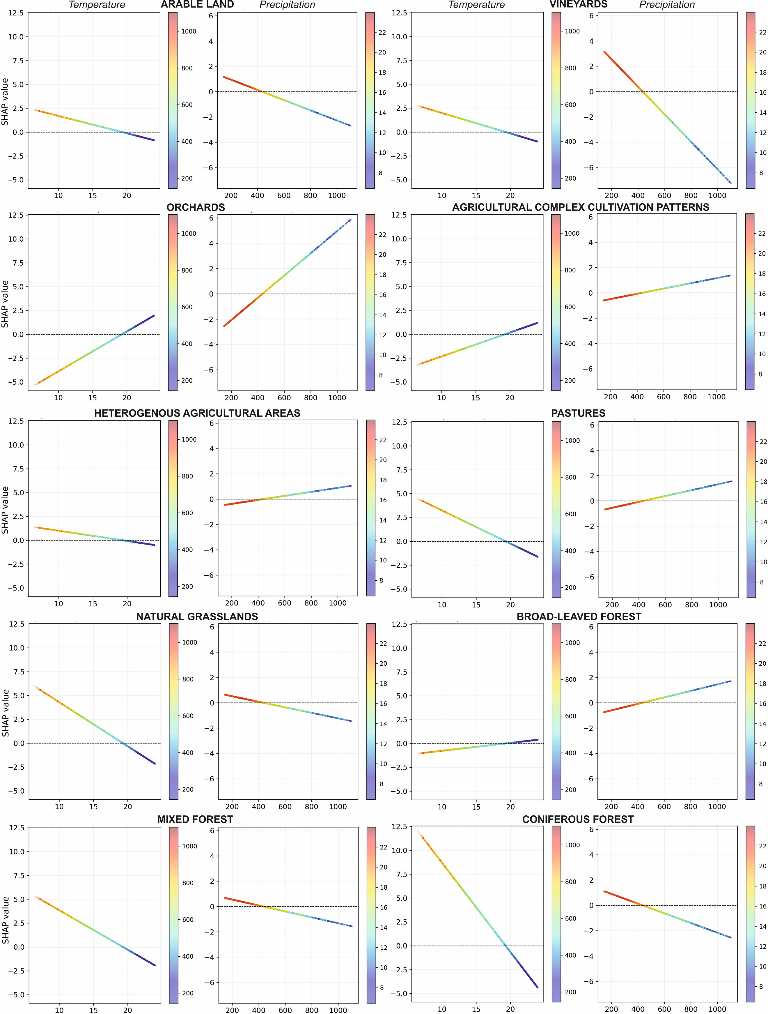
Figure 4. SHAP dependence plots showing the partial contributions of temperature and precipitation to the predicted occurrence of the agricultural and forest classes. Points in the temperature plots are colored according to precipitation, whereas points in the precipitation plots are colored according to temperature. The SHAP dependence plots and their graphical representation were generated in Python version 3.11.9 (https://www.python.org).

