Supplementary material
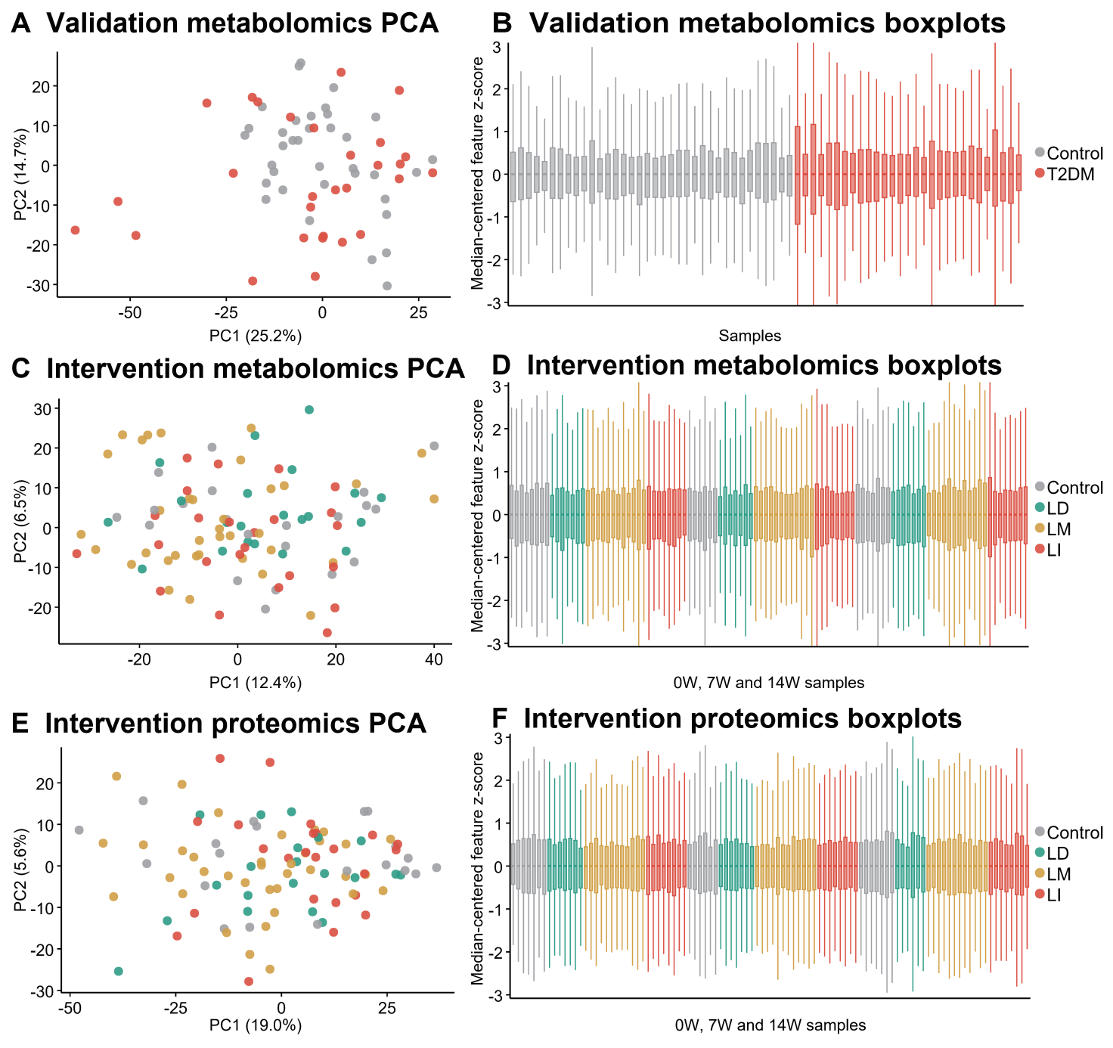
Figure S1. Omics quality assessment and abundance distributions of metabolomics and proteomics
(A, B) Principal component analysis and sample-level distributions of row-scaled metabolite abundance in the independent baseline metabolomics cohort.
(C, D) Principal component analysis and sample-level distributions of row-scaled metabolite abundance in the 14-week HIIT intervention metabolomics cohort.
(E, F) Principal component analysis and sample-level distributions of row-scaled protein abundance in the 14-week HIIT intervention proteomics cohort. PCA was used to evaluate sample clustering and potential outliers. Box plots show row-wise standardised abundance distributions across samples after preprocessing.
HIIT, high-intensity interval training; PCA, principal component analysis.
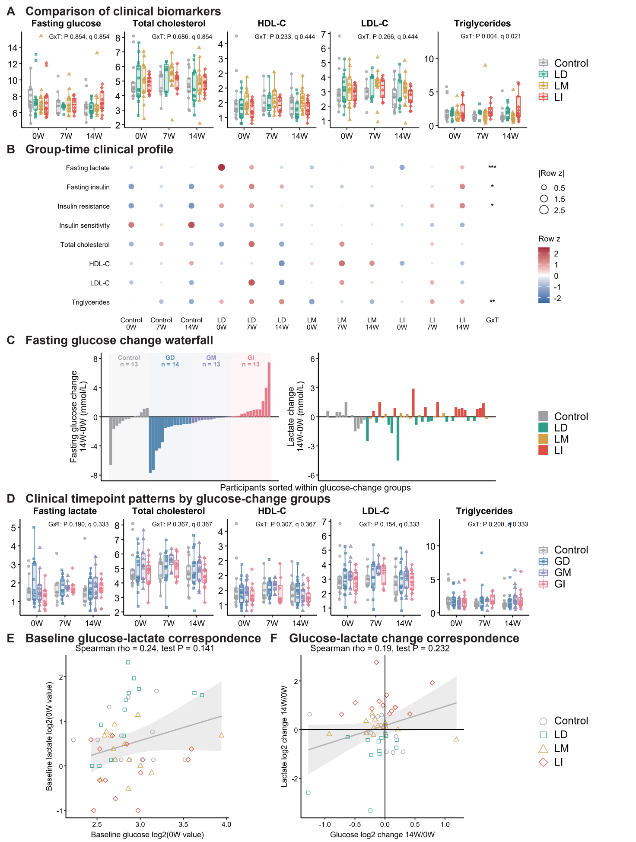
Figure S2. Glucose-related analyses of fasting lactate-response heterogeneity during the 14-week intervention.
(A) Fasting glucose and lipid trajectories across Control, LD, LM and LI groups at 0W, 7W and 14W. Boxes show median and interquartile range with individual participants overlaid. Group-by-time P and q values were estimated using linear mixed models.
(B) Group-time clinical profile across fasting lactate, insulin-related markers and lipid variables. Values are shown as row-scaled z-scores; point size indicates the absolute row z-score. Asterisks indicate nominal group-by-time effects.
(C) Waterfall plot of 0-14W fasting glucose change after regrouping intervention participants into glucose-decreased, glucose-maintained and glucose-increased tertiles, with matched 0–14W fasting lactate change shown in the same participant order.
(D) Fasting lactate and lipid trajectories after regrouping by glucose-change categories. Group-by-time P and q values are shown.
(E, F) Baseline and 0-14W change-level correspondence between fasting glucose and fasting lactate. Points are coloured and shaped by lactate-response group. Regression lines and 95% confidence bands are shown for intervention participants; Spearman tests were performed in intervention participants only. Panels E and F use log2-transformed baseline values and log2 fold changes, respectively.
CGM, continuous glucose monitoring; GD, glucose decreased; GI, glucose increased; GM, glucose maintained; GxT, group-by-time interaction; HDL-C, high-density lipoprotein cholesterol; LD, lactate decreased; LDL-C, low-density lipoprotein cholesterol; LI, lactate increased; LM, lactate maintained; T2DM, type 2 diabetes mellitus.
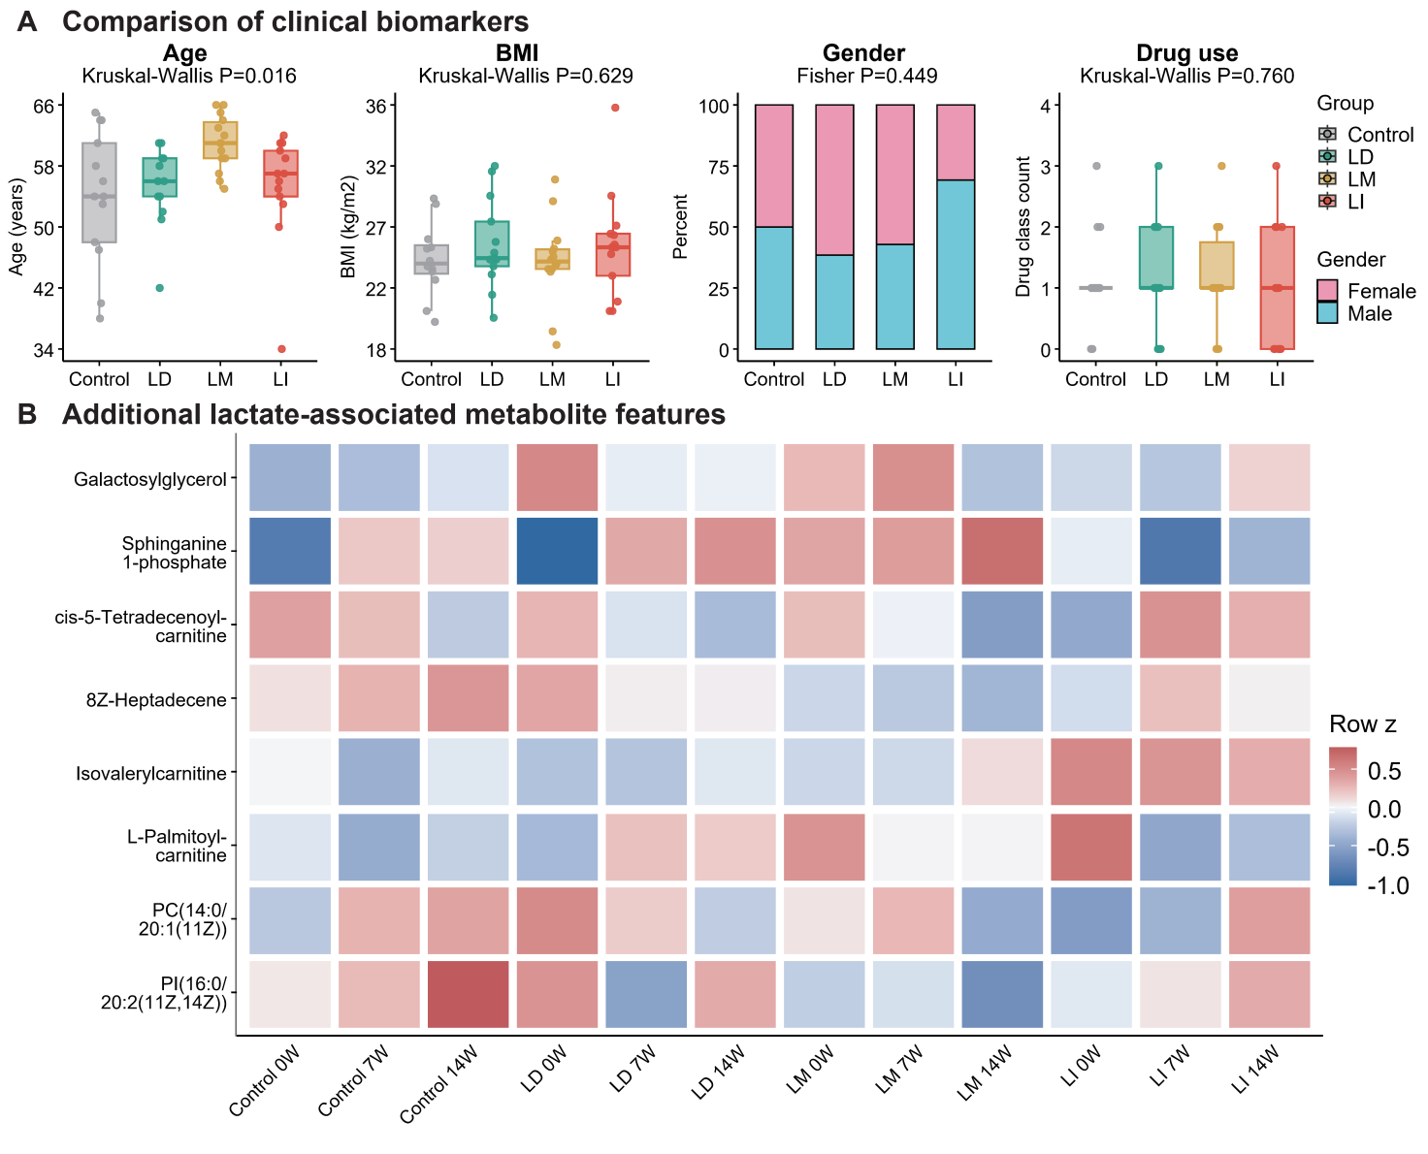
Fig. S3. Covariate comparisons and metabolite features.
(A) Comparisons of clinical covariates across the control, LD, LM and LI groups, including age, BMI, sex distribution and drug-class burden. P values were calculated using Kruskal–Wallis tests for continuous variables and Fisher’s exact test for sex distribution.
(B) Heatmap of additional lactate-associated metabolite features across group-time combinations. Values represent group-time mean row z-scores after clipping to the plotted range. Displayed features include phospholipid-, sphingolipid-, acylcarnitine- and glycolipid-related metabolites.
BMI, body mass index; LD, lactate decreased; LI, lactate increased; LM, lactate maintained. Metabolite identities were based on untargeted LC–MS annotation and should be interpreted as putative unless validated by targeted methods.
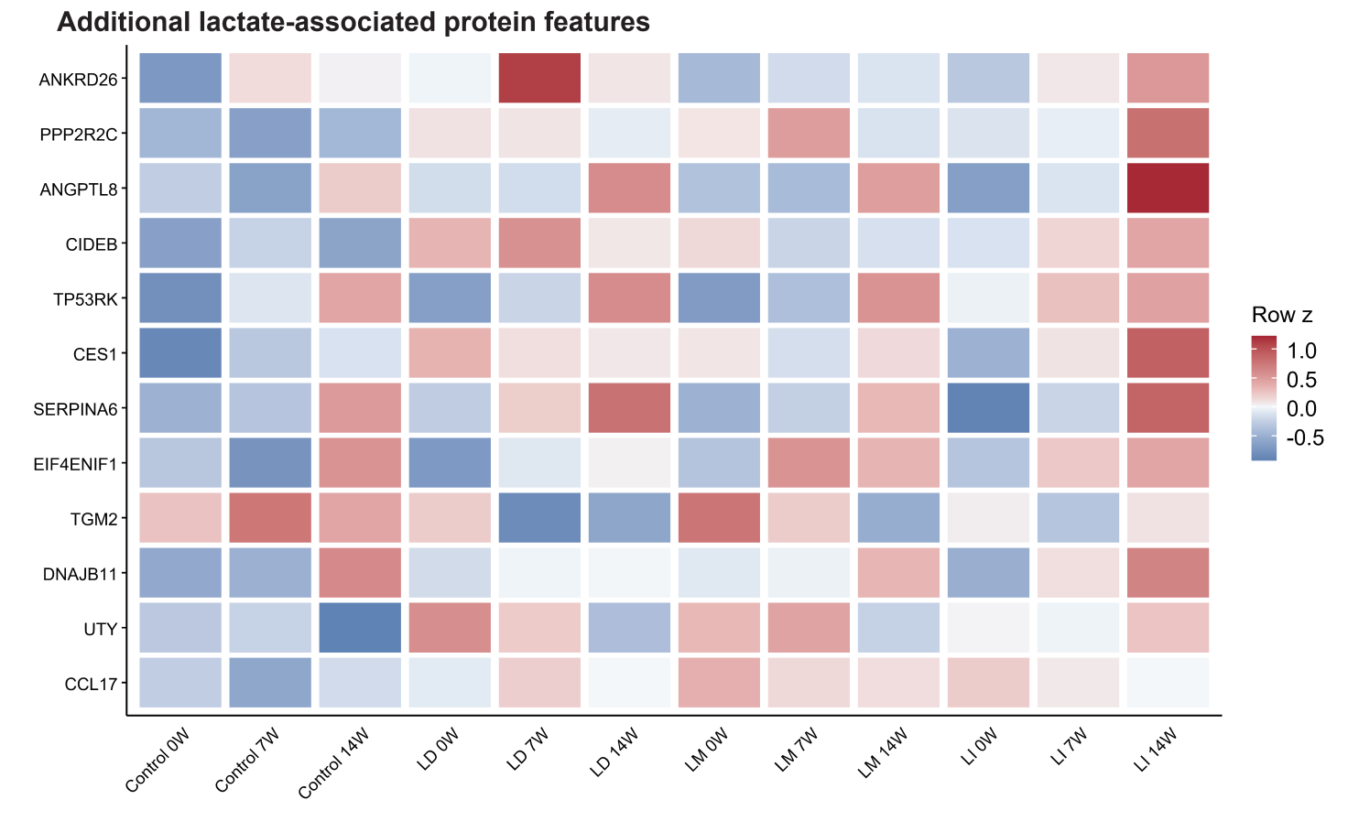
Fig. S4. Additional lactate-associated serum protein features across response groups.
Heatmap of additional lactate-associated serum protein features across group-time combinations in the control, LD, LM and LI groups. Values represent group-time mean row z-scores after clipping to the plotted range. Displayed features include proteins related to lipid/adipokine signalling, immune or inflammatory regulation, cellular stress and systemic protein remodelling.
LD, lactate decreased; LI, lactate increased; LM, lactate maintained. Protein features are reported at the feature level, with corresponding gene symbols shown where available.

Supplementary Table 1. Adjusted lactate-associated metabolite features after the 14-week HIIT intervention.
Name | Functional_Class | Direction | P_adjust | FDR_adjust | Beta | Incremental_R²
PI(17:0/14:1(9Z)) | GPLipid | + | <0.001 | 0.032 | 0.369 | 0.458
PG(14:0/0:0) | GPLipid | - | <0.001 | 0.109 | -0.343 | 0.396
PC(14:1(9Z)/22:2(13Z,16Z)) | GPLipid | + | <0.001 | 0.161 | 0.329 | 0.368
Ubiquinone Q1 | Redox/sulfur | + | <0.001 | 0.253 | 0.328 | 0.324
Galactosylglycerol | Carbon/carbohydrate | + | 0.002 | 0.362 | 0.292 | 0.270
Sphinganine 1-phosphate | Sphingolipid | - | 0.003 | 0.362 | -0.310 | 0.259
cis-5-Tetradecenoylcarnitine | Fatty acyl/carnitine | + | 0.004 | 0.362 | 0.269 | 0.249
8Z-Heptadecene | Fatty acyl/carnitine | + | 0.006 | 0.388 | 0.276 | 0.229
Isovalerylcarnitine | Fatty acyl/carnitine | - | 0.006 | 0.388 | -0.258 | 0.227
L-Palmitoylcarnitine | Fatty acyl/carnitine | - | 0.010 | 0.388 | -0.272 | 0.208
Sphingosine 1-phosphate | Sphingolipid | - | 0.010 | 0.388 | -0.262 | 0.206
PC(14:0/20:1(11Z)) | GPLipid | + | 0.012 | 0.388 | 0.246 | 0.196
PI(16:0/20:2(11Z,14Z)) | GPLipid | + | 0.013 | 0.388 | 0.243 | 0.192
PC(18:4(6Z,9Z,12Z,15Z)/20:5(5Z,8Z,11Z,14Z,17Z)) | GPLipid | + | 0.014 | 0.388 | 0.248 | 0.189
PS(18:0/18:1(9Z)) | GPLipid | + | 0.019 | 0.388 | 0.229 | 0.174
8E-Heptadecenedioic acid | Fatty acyl/carnitine | - | 0.024 | 0.388 | -0.219 | 0.163
PE(8:0/8:0) | GPLipid | - | 0.025 | 0.388 | -0.218 | 0.162
Oleic acid | Fatty acyl/carnitine | + | 0.025 | 0.388 | 0.217 | 0.162
PI(16:0/22:4(10Z,13Z,16Z,19Z)) | GPLipid | + | 0.026 | 0.388 | 0.221 | 0.159
Oleoylcarnitine | Fatty acyl/carnitine | - | 0.028 | 0.388 | -0.227 | 0.157
Corchorifatty acid F | Fatty acyl/carnitine | - | 0.031 | 0.388 | -0.217 | 0.151
(1R,2R)-3-oxo-2-pentyl-cyclopentanehexanoic acid | Fatty acyl/carnitine | + | 0.031 | 0.388 | 0.209 | 0.151
2-Methoxybenzenethiol | Redox/sulfur | + | 0.032 | 0.388 | 0.213 | 0.149
1-Stearoylglycerophosphoglycerol | GPLipid | + | 0.034 | 0.393 | 0.219 | 0.146
PC(15:0/18:2(9Z,12Z)) | GPLipid | + | 0.035 | 0.394 | 0.206 | 0.145
1(3)-glyceryl-PGF2alpha | Fatty acyl/carnitine | + | 0.035 | 0.394 | 0.214 | 0.145
Propionylcarnitine | Fatty acyl/carnitine | + | 0.037 | 0.400 | 0.215 | 0.142
PC(14:0/20:2(11Z,14Z)) | GPLipid | + | 0.038 | 0.400 | 0.211 | 0.140
Sphinganine | Sphingolipid | + | 0.039 | 0.400 | 0.204 | 0.140
D-Glucose | Carbon/carbohydrate | + | 0.039 | 0.400 | 0.202 | 0.139
PC(O-10:1(9E)/0:0) | GPLipid | - | 0.043 | 0.403 | -0.209 | 0.134
PI(22:0/22:1(11Z)) | GPLipid | - | 0.046 | 0.409 | -0.196 | 0.131
Palmitoyl glucuronide | Fatty acyl/carnitine | + | 0.049 | 0.409 | 0.199 | 0.128
Values summarize adjusted associations between 0–14W metabolite feature changes and 14W fasting lactate levels. Adjusted beta, adjusted P value, adjusted FDR and incremental R² were derived from models adjusted for baseline fasting lactate and age. The Direction column indicates the direction of the adjusted association: + indicates that a greater 0–14W increase in the metabolite feature was associated with higher 14W fasting lactate, whereas - indicates that a greater 0–14W increase in the metabolite feature was associated with lower 14W fasting lactate. Incremental R² indicates the additional variance explained by the metabolite feature beyond baseline fasting lactate and age. FDR values were calculated using the Benjamini–Hochberg procedure. Metabolite identities are based on untargeted LC–MS annotation and should be interpreted as putative unless validated by targeted methods.

Supplementary Table 2. Candidate serum protein features associated with 14W fasting lactate after HIIT.
Feature_ID | Functional_Class | Direction | P_Value | FDR_BH | Beta | Incremental_R²
DRG1_Q9Y295 | Cellular stress/RNA | - | 0.001 | 0.991 | -0.579 | 0.379
CRYBG3_Q68DQ2 | Other protein | + | 0.001 | 0.991 | 0.337 | 0.425
NOTUM_Q6P988 | Extracellular/remodelling | + | 0.003 | 0.991 | 0.331 | 0.297
FCN2_Q15485 | Immune/complement | + | 0.003 | 0.991 | 0.363 | 0.375
ANKRD26_Q9UPS8 | Other protein | + | 0.005 | 0.991 | 0.259 | 0.214
PPP2R2C_Q9Y2T4 | Cellular stress/RNA | + | 0.006 | 0.991 | 0.336 | 0.276
ANGPTL8_Q6UXH0 | Lipid/adipokine | + | 0.009 | 0.991 | 0.293 | 0.237
CIDEB_Q9UHD4 | Lipid/adipokine | + | 0.010 | 0.991 | 0.257 | 0.219
TP53RK_Q96S44 | Cellular stress/RNA | - | 0.010 | 0.991 | -0.704 | 0.488
CES1_P23141 | Lipid/adipokine | + | 0.010 | 0.991 | 0.331 | 0.263
SERPINA6_P08185 | Immune/complement | + | 0.011 | 0.991 | 0.275 | 0.225
EIF4ENIF1_Q9NRA8 | Cellular stress/RNA | - | 0.016 | 0.991 | -0.272 | 0.183
TGM2_P21980 | Other protein | + | 0.016 | 0.991 | 0.273 | 0.235
DNAJB11_Q9UBS4 | Cellular stress/RNA | + | 0.017 | 0.991 | 0.270 | 0.204
UTY_O14607 | Other protein | + | 0.017 | 0.991 | 0.269 | 0.213
CCL17_Q92583 | Immune/complement | - | 0.017 | 0.991 | -0.282 | 0.202
U2AF1_Q01081 | Cellular stress/RNA | - | 0.018 | 0.991 | -0.681 | 0.321
ENPEP_Q07075 | Extracellular/remodelling | + | 0.018 | 0.991 | 0.324 | 0.278
SNRPD2_P62316 | Cellular stress/RNA | - | 0.018 | 0.991 | -0.368 | 0.201
PRELP_P51888 | Extracellular/remodelling | + | 0.020 | 0.991 | 0.260 | 0.195
ARHGAP18_Q8N392 | Other protein | - | 0.021 | 0.991 | -0.281 | 0.190
TOR3A_Q9H497 | Other protein | + | 0.022 | 0.991 | 0.282 | 0.190
CETP_P11597 | Other protein | + | 0.023 | 0.991 | 0.253 | 0.186
LEP_P41159 | Other protein | + | 0.024 | 0.991 | 0.247 | 0.193
NUCB1_Q02818 | Other protein | + | 0.025 | 0.991 | 0.300 | 0.221
HNRNPD_Q14103 | Other protein | - | 0.025 | 0.991 | -0.275 | 0.182
CRIP2_P52943 | Other protein | - | 0.025 | 0.991 | -0.502 | 0.632
FKBP2_P26885 | Other protein | + | 0.026 | 0.991 | 0.279 | 0.102
ANGPTL2_Q9UKU9 | Lipid/adipokine | + | 0.027 | 0.991 | 0.272 | 0.218
VRK1_Q99986 | Other protein | - | 0.028 | 0.991 | -0.326 | 0.184
PLTP_P55058 | Other protein | + | 0.028 | 0.991 | 0.243 | 0.175
IGKV1-16_P04430 | Other protein | - | 0.028 | 0.991 | -0.270 | 0.232
RGPD1_P0DJD0 | Other protein | + | 0.029 | 0.991 | 0.249 | 0.199
EDF1_O60869 | Other protein | - | 0.031 | 0.991 | -0.306 | 0.170
OPTN_Q96CV9 | Other protein | + | 0.031 | 0.991 | 0.257 | 0.186
APOL3_O95236 | Other protein | + | 0.033 | 0.991 | 0.237 | 0.167
ALDOC_P09972 | Other protein | - | 0.034 | 0.991 | -0.349 | 0.309
CTSF_Q9UBX1 | Other protein | - | 0.034 | 0.991 | -0.295 | 0.154
TOP1_P11387 | Other protein | - | 0.034 | 0.991 | -0.318 | 0.190
GRAP2_O75791 | Other protein | - | 0.034 | 0.991 | -0.236 | 0.220
CCT8_P50990 | Other protein | + | 0.034 | 0.991 | 0.274 | 0.184
MAN1A1_P33908 | Other protein | + | 0.035 | 0.991 | 0.249 | 0.164
MYH7_P12883 | Other protein | + | 0.035 | 0.991 | 0.212 | 0.179
INHBC_P55103 | Other protein | + | 0.036 | 0.991 | 0.236 | 0.162
APOB_P04114 | Other protein | + | 0.036 | 0.991 | 0.250 | 0.162
IMUP_Q9GZP8 | Other protein | + | 0.036 | 0.991 | 0.378 | 0.294
VNN1_O95497 | Other protein | + | 0.039 | 0.991 | 0.318 | 0.186
IGLV7-43_P04211 | Other protein | + | 0.039 | 0.991 | 0.226 | 0.158
DIAPH2_O60879 | Other protein | + | 0.039 | 0.991 | 0.408 | 0.262
EIF4H_Q15056 | Cellular stress/RNA | - | 0.040 | 0.991 | -0.257 | 0.164
WARS1_P23381 | Other protein | + | 0.040 | 0.991 | 0.235 | 0.156
FGG_P02679 | Other protein | + | 0.041 | 0.991 | 0.226 | 0.154
LIPA_P38571 | Other protein | + | 0.042 | 0.991 | 0.232 | 0.160
SARNP_P82979 | Other protein | - | 0.042 | 0.991 | -0.283 | 0.192
LGALS3BP_Q08380 | Other protein | + | 0.044 | 0.991 | 0.227 | 0.151
C1RL_Q9NZP8 | Other protein | + | 0.044 | 0.991 | 0.210 | 0.150
ABRACL_Q9P1F3 | Other protein | - | 0.045 | 0.991 | -0.272 | 0.170
FGA_P02671 | Other protein | + | 0.045 | 0.991 | 0.222 | 0.149
LBP_P18428 | Other protein | + | 0.047 | 0.991 | 0.225 | 0.147
FGL1_Q08830 | Other protein | + | 0.048 | 0.991 | 0.224 | 0.146
DEFA4_P12838 | Other protein | + | 0.048 | 0.991 | 0.222 | 0.169
FSCN1_Q16658 | Other protein | + | 0.049 | 0.991 | 0.424 | 0.227
Values summarize adjusted associations between 0–14W serum protein feature changes and 14W fasting lactate levels. Adjusted beta, adjusted P value, adjusted FDR and incremental R² were derived from endpoint models adjusted for baseline fasting lactate, age, sex, BMI and drug-class count. The Direction column indicates the direction of the adjusted association: + indicates that a greater 0–14W increase in the protein feature was associated with higher 14W fasting lactate, whereas - indicates that a greater 0–14W increase in the protein feature was associated with lower 14W fasting lactate. Incremental R² indicates the additional variance in 14W fasting lactate explained by the protein feature beyond the covariates. FDR values were calculated using the Benjamini–Hochberg procedure.

Supplementary Table 3 medication balance table
Characteristic | Control | LD | LM | LI | P value | Test
Medication class count, mean +/- SD | 1.15 +/- 0.80 | 1.15 +/- 0.90 | 1.21 +/- 0.80 | 0.92 +/- 1.04 | 0.760 | Kruskal-Wallis
Any medication,Y/N, n(%) | 11/13 (84.6) | 10/13 (76.9) | 12/14 (85.7) | 7/13 (53.8) | 0.232 | Fisher exact
Biguanide,Y/N, n(%) | 7/13 (53.8) | 9/13 (69.2) | 11/14 (78.6) | 5/13 (38.5) | 0.168 | Fisher exact
Metformin-specific record,Y/N, n(%) | 0/13 (0.0) | 3/13 (23.1) | 1/14 (7.1) | 1/13 (7.7) | 0.308 | Fisher exact
Glinide,Y/N, n(%) | 5/13 (38.5) | 2/13 (15.4) | 3/14 (21.4) | 5/13 (38.5) | 0.437 | Fisher exact
Alpha-glucosidase inhibitor,Y/N, n(%) | 1/13 (7.7) | 1/13 (7.7) | 1/14 (7.1) | 1/13 (7.7) | 1.000 | Fisher exact
Thiazolidinedione,Y/N, n(%) | 2/13 (15.4) | 0/13 (0.0) | 0/14 (0.0) | 0/13 (0.0) | 0.170 | Fisher exact
Medication use is summarized as mean ± SD for medication class count and as Y/N, n/N (%) for binary medication variables. For binary variables, Y/N indicates the number of participants with medication use recorded as Yes versus No, and n/N (%) represents the proportion of participants with Yes. “Any medication” indicates use of at least one glucose-lowering medication class. “Biguanide” indicates medication classified within the biguanide class, whereas “Metformin-specific record” indicates records in which metformin was explicitly documented by name. P values are exploratory group-balance tests across Control, LD, LM and LI groups, using Kruskal–Wallis tests for medication class count and Fisher’s exact tests for categorical variables.

