Supplementary File

For
Atmospheric transport reshapes cross-administrative methane attribution from Shanxi coal basins to Beijing-Tianjin-Hebei

Yanqiu Liu¹, Jason Blake Cohen^{1,2*}, Kai Qin^{1,2*}, Wei Hu¹, Ge Han³, Lu Shen⁴, Hengkang Wang⁵, Kushal Tibrewal⁶, Robert A. Field⁶

¹ School of Environment and Spatial Informatics, China University of Mining and Technology, Xuzhou.
² Shanxi Key Laboratory of Environmental Remote Sensing Application, China University of Mining and Technology, Xuzhou.
³ Hubei Key Laboratory of Quantitative Remote Sensing of Land and Atmosphere, School of Remote Sensing and Information Engineering, Wuhan University, Wuhan.
⁴ Department of Atmospheric and Oceanic Sciences, School of Physics, Peking University, Beijing.
⁵ Shanxi Academy of Eco-Environmental Planning and Technology, Taiyuan.
⁶ UNEP’s International Methane Emissions Observatory, Paris, France

*Correspondence to: Jason Blake Cohen (jasonbc@alum.mit.edu) and Kai Qin (qinkai@cumt.edu.cn)

Supplementary Note 1
Statistics of the anthropogenic prior methane inventory
Simulation design. Six WRF-GHG sensitivity simulations were conducted to support the attribution analysis (Supplementary Table S1). The baseline simulation (EDGAR) uses the standard EDGAR_2024_GHG anthropogenic inventory at 0.1-degree resolution. The refined simulation (Top-down) replaces coal mine methane emissions in Shanxi Province with the satellite-constrained inventory of Hu et al. (2024), while retaining EDGAR emissions elsewhere; this substitution affects 636 coal mine grid points within Shanxi. Two perturbation experiments (Perturb±10% and Perturb±50%) apply per-grid random scaling factors drawn from a uniform distribution over the respective intervals, using a fixed random seed to ensure reproducibility; these experiments quantify the sensitivity of downwind column anomalies to Shanxi inventory uncertainty. The BTH-50% and BJ-50% experiments apply a uniform 50% reduction to anthropogenic emissions within the BTH administrative domain and the Beijing municipality, respectively, to isolate local source contributions.

Supplementary Table S1. Summary of WRF-GHG sensitivity simulations used for attribution analysis by using different anthropogenic prior inventory.
Simulation | Anthropogenic Inventory | Resolution | Purpose
EDGAR | EDGAR_2024_GHG | 1-hourly | Baseline
Top-down | Hu et al. (2024) for Shanxi coal mines  + EDGAR elsewhere | 1-hourly | Refined CMM source
Perturb±10% | Top-down with Shanxi coal mines  ±10% random perturbation | 30-min | Uncertainty propagation
Perturb±50% | Top-down with Shanxi coal mines  ±50% random perturbation | 30-min | Uncertainty propagation
BTH-50% | Top-down with BTH emissions –50% | 30-min | BTH local contribution
BJ-50% | Top-down with Beijing emissions –50% | 30-min | Beijing local contribution
Spatial distribution of inventory differences. Supplementary Fig. S1 illustrates the spatial structure of the anthropogenic methane inventory and its perturbations within the d02 domain. The WRF-GHG EDGAR and Top-down inventories show broadly similar spatial patterns across the domain (panels a and b), with high-emission clusters concentrated over Shanxi coal basins (Yangquan, Datong, Changzhi, and Jincheng) and along industrial corridors in the BTH Plain. The difference between Top-down and EDGAR (panel c) is confined exclusively to Shanxi coal mine grid points, where the satellite-constrained inventory yields systematically higher fluxes, with a mean grid-level increase of 2.46×10^{–9} kg m^{–2} s^{–1} and a maximum increase of 1.23×10^{–7} kg m^{–2} s^{–1}. This spatial confinement confirms that the Top-down substitution introduces no artefacts in the BTH domain and that any downwind concentration anomaly (Δ_{inv}) originates solely from Shanxi source modifications transported under the prevailing meteorological conditions.
Panels d and e show the per-grid perturbation fields for the ±10% and ±50% experiments relative to Top-down within the Shanxi region. The perturbation factors are spatially uncorrelated across grid cells by design, producing a zero-mean random field whose standard deviation scales with the perturbation magnitude. The domain-mean difference is near zero in both cases, consistent with the random and symmetric nature of the perturbation scheme. Panel f shows the difference between BTH-50% and EDGAR, which is uniformly negative within the BTH administrative boundary and zero elsewhere, confirming that the BTH-50% experiment correctly isolates local emission reductions without affecting upstream Shanxi fluxes.

Supplementary Fig. S1. Spatial distribution of the anthropogenic prior methane inventory and difference characteristics under perturbation scenarios (within d02 domain). (a-b) Spatial distribution of WRF-GHG EDGAR and Top-down; (c) Difference between WRF-GHG Top-down and EDGAR;(d) Difference between Top-down (±10% perturb.) and Top-down (SX region); (e) Difference between Top-down (±50% perturb.) and Top-down (SX region); (f) Difference between Top-down (BTH-50%) and EDGAR.
Flux probability density functions. Supplementary Fig. S2 summarizes the flux distributions for the Shanxi Province and BTH region in August 2022 at 0.1-degree resolution. In Shanxi (panel a), the EDGAR distribution has a mean flux of 1.57×10^{–9} kg m^{–2} s^{–1} and a standard deviation of 5.67×10^{–9} kg m^{–2} s^{–1}, reflecting the highly skewed distribution typical of fossil fuel inventories in which a small number of high-emission grid cells dominate the total. The Top-down inventory shifts the distribution toward higher values, with a mean of 4.03×10^{–9} kg m^{–2} s^{–1} and a standard deviation of 1.27×10^{–8} kg m^{–2} s^{–1}, corresponding to a 2.57-fold increase in the domain mean. The near-zero median in both cases (2.80×10⁻¹¹ and 2.85×10^{–11} kg m^{–2} s^{–1}, respectively) confirms that the majority of Shanxi grid cells carry background-level emissions, with the enhancement concentrated at point-source coal mine locations. The Diff distribution (Top-down minus EDGAR) has a median of zero, confirming that the satellite-constrained revision increases emissions at specific coal mine grids without altering the broader non-coal emission field.
In the BTH region (panel b), the EDGAR and Top-down inventories are statistically identical (mean 5.42×10^{–10} kg m^{–2} s^{–1}, standard deviation 8.50×10^{–9} kg m^{–2} s^{–1} in both cases), confirming that the Top-down substitution is confined to Shanxi and introduces no direct emission changes within the BTH domain. The BTH-50% experiment produces a difference distribution that is entirely negative within the BTH boundary, with its magnitude reflecting the local emission reduction applied. Together, these distributions establish the statistical independence of Shanxi source modifications from BTH local emissions, which is a prerequisite for the linear attribution decomposition described in the main text.

Supplementary Fig. S2. Anthropogenic methane flux probability density functions (PDFs) and statistical summaries in SX and BTH region (August, 0.1° resolution). (a) Shanxi Province: EDGAR vs.Top-down; (b) BTH region: EDGAR vs.Top-down (BTH-50%).

Validation against DaBuTou tower flux observations in the Shanxi source region. A LI-7700 Open Path CH₄ Gas Analyzer mounted at 10-m height and IRGASON combined CO₂/H₂O Open-Path Gas Analyzer and 3D Sonic Anemometer measured high-frequency raw data of three-dimensional wind and methane density. Turbulent fluxes were calculated over 30-min averaging intervals using eddy covariance. Data quality was applied: first using the Relative Signal Strength Indicator (data below 20% were excluded to eliminate bias from precipitation, cloud, and aerosol); second screening for spikes and statistical outliers (Vickers and Mahrt 1997); and third a Webb-Pearman-Leuning (WPL) and spectroscopic correction were applied. This yielded 136 valid 30-minute intervals during the simulated period (August 2022). Because the WPL-corrected flux density is footprint-independent, it is compared directly with the 3 km WRF-GHG prior emission density, avoiding the representativeness error that limits a point-versus-grid concentration comparison.

We isolate the intervals for which the wind arrived from the dominant source sector (south-west, 215 ± 45 degree), i.e., when the tower sampled the upwind coal-mine source. The source-direction flux has a median of 134 ug m^{–2} s^{–1} (5th-95th percentile 43–402; maximum 464), confirming a strong, localized coal-mine source. This magnitude is reproduced by the satellite-constrained Top-down inventory, whose resolved coal-mine cell reaches ~53 ug m^{–2} s^{–1} and remains within the observed range under the ±50% perturbation (~46 ug m^{–2} s^{–1}), whereas the corresponding EDGAR coal-mine density is an order of magnitude lower (~5 ug m^{–2} s^{–1}) and falls well below the observed source magnitude. The tower thus provides an independent, order-of-magnitude consistency check that the Top-down inventory captures a realistic Shanxi coal-mine source magnitude that EDGAR underestimates, supporting the inventory-refinement signal (Δ_{inv}) and the Δ_{SX} uncertainty range (Supplementary Fig. S3).
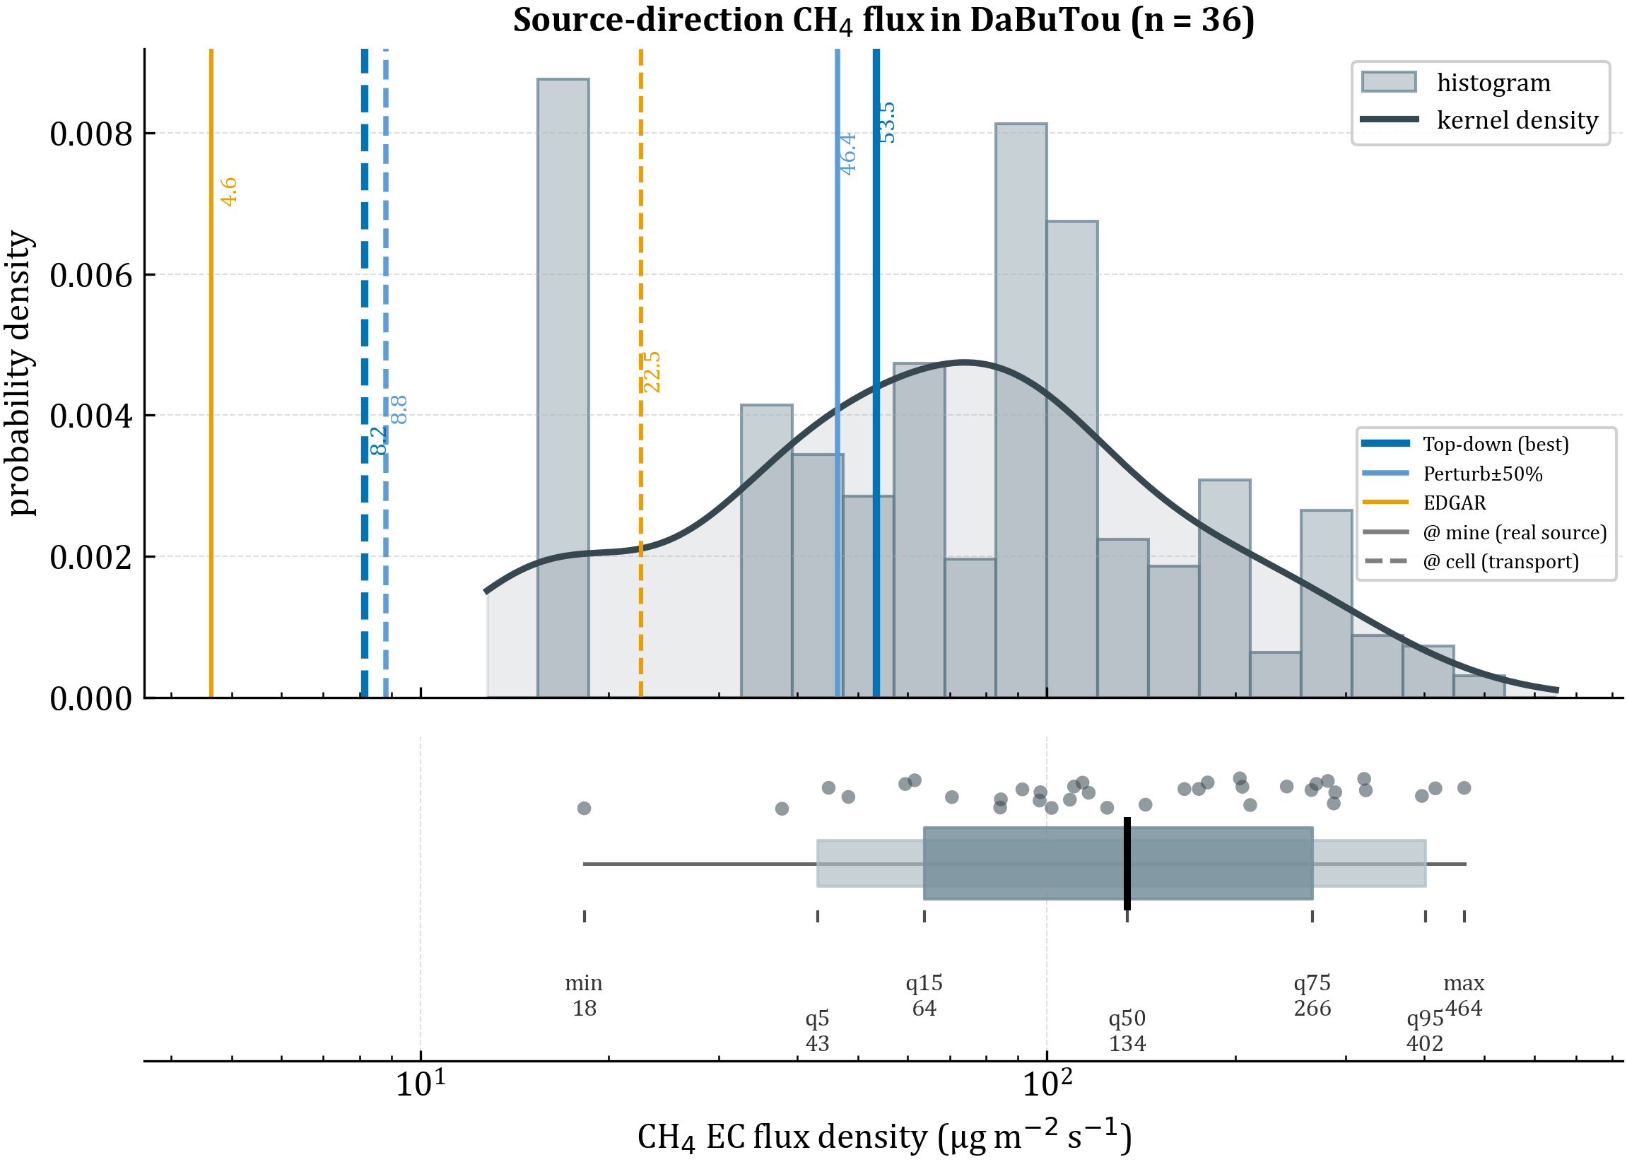

Supplementary Fig. S3. Source-direction WPL-corrected eddy-covariance CH4 flux at the DaBuTou tower (10 m a.g.l.; wind from 215 ± 45 degree, south-west; n = 36 source-capturing intervals), August 2022. (a) Probability density (histogram and kernel-density estimate); (b) percentile summary of the same data (min, 5th, 15th, 50th, 75th, 95th percentiles and maximum, in ug m^{–2} s^{–1}). Vertical lines mark the d03 (3 km) WRF-GHG prior emission density for EDGAR (orange), Top-down (dark blue) and the ±50% perturbation (light blue), at the resolved coal-mine cell (solid) and in the source-direction near-field (dashed).

Supplementary Note 2
Statistical validation of EOF mode selection and PC1-PC3 lag structure.
EOF mode selection and degeneracy test. To justify the selection of EOF1 and EOF3 for the transboundary transport attribution, we applied the North et al. (1982) sampling-error criterion to the six leading EOF modes, estimating the eigenvalue uncertainty as ${δλ}_{n}=λ_{n} \sqrt{2/N_{eff}}$, where $N_{eff}=N(1-r_{1})/(1+r_{1})$ is the effective sample size. With $r_{1}$= 0.99 (the lag-1 autocorrelation of PC1) and N = 1645 hourly steps, the strong synoptic-scale persistence of XCH₄ reduces $N_{eff}$ to approximately 8. Under this effective sample size, the leading modes (EOF1–EOF4) fall within a regime in which adjacent eigenvalue error bars overlap (Supplementary Fig. S4b), so the modes cannot be separated by eigenvalue spacing alone. Mode retention is therefore grounded in the physical interpretability of the spatial patterns rather than in formal eigenvalue separability.
On this basis, EOF1 (25.2%) is retained because it captures the large-scale southwesterly advection that mirrors the background-methane footprint, and EOF3 (8.65%) is retained because its loadings concentrate along the southeastern Shanxi–southern Hebei terrain-channeled corridor, directly tracing the pathway through which coal mine methane from the Changzhi and Jincheng basins reaches the BTH receptor region (Supplementary Fig. S4a and main text Fig. 3b). EOF2 (14.2%) is excluded despite its higher explained variance because it exhibits a north–south dipole confined to Inner Mongolia and the Bohai Sea, with negligible loadings over the Shanxi–BTH corridor, reflecting synoptic variability in the meridional background gradient rather than transboundary source–receptor exchange; EOF4 (5.96%) is excluded as its spatial pattern does not correspond to a physically interpretable transport pathway relevant to this study.
The strong temporal autocorrelation of the PC time series ($r_{1}$= 0.99) reflects the slow synoptic evolution of XCH₄ at hourly resolution and is a physical property of the data rather than a methodological limitation; the resulting $N_{eff}$ ≈ 8 also governs the 95% threshold of the PC1–PC3 cross-correlation, consistent with the event-scale (rather than climatological) interpretation of the 1–2-day lag throughout.
PC1-PC3 lag structure. To assess the sequential transport mechanism proposed in the main text, we computed the cross-correlation function between PC1 and PC3 over the full simulation period from 10 July to 15 September 2022 (Supplementary Fig. S4c). A positive lag indicates that PC3 follows PC1. The cross-correlation peaks at a lag of 28 hours (r = 0.47), with PC3 following PC1, consistent with the direction of the proposed preconditioning sequence in which large-scale synoptic circulation establishes a favorable transport window before terrain-channelled emission flushing delivers concentrated coal mine methane to the BTH receptor.
The peak correlation of r = 0.47 does not exceed the 95% confidence threshold of r = 0.69, which is computed under the assumption of independent samples with $N_{eff}$ = 8 estimated from the lag-1 autocorrelation of the PC1 time series. This outcome reflects the limited statistical power available from a two-month record with strongly autocorrelated time series, and should not be interpreted as evidence against the proposed lag structure. The 28-hour peak lag falls within the 1-to-2-day window identified from individual extreme events, including the early August episode at TCCON Xianghe. The 1-to-2-day preconditioning estimate therefore represents a physically grounded characterization derived from event-scale analysis, and its confirmation as a statistically robust climatological feature requires verification with multi-year simulation records.
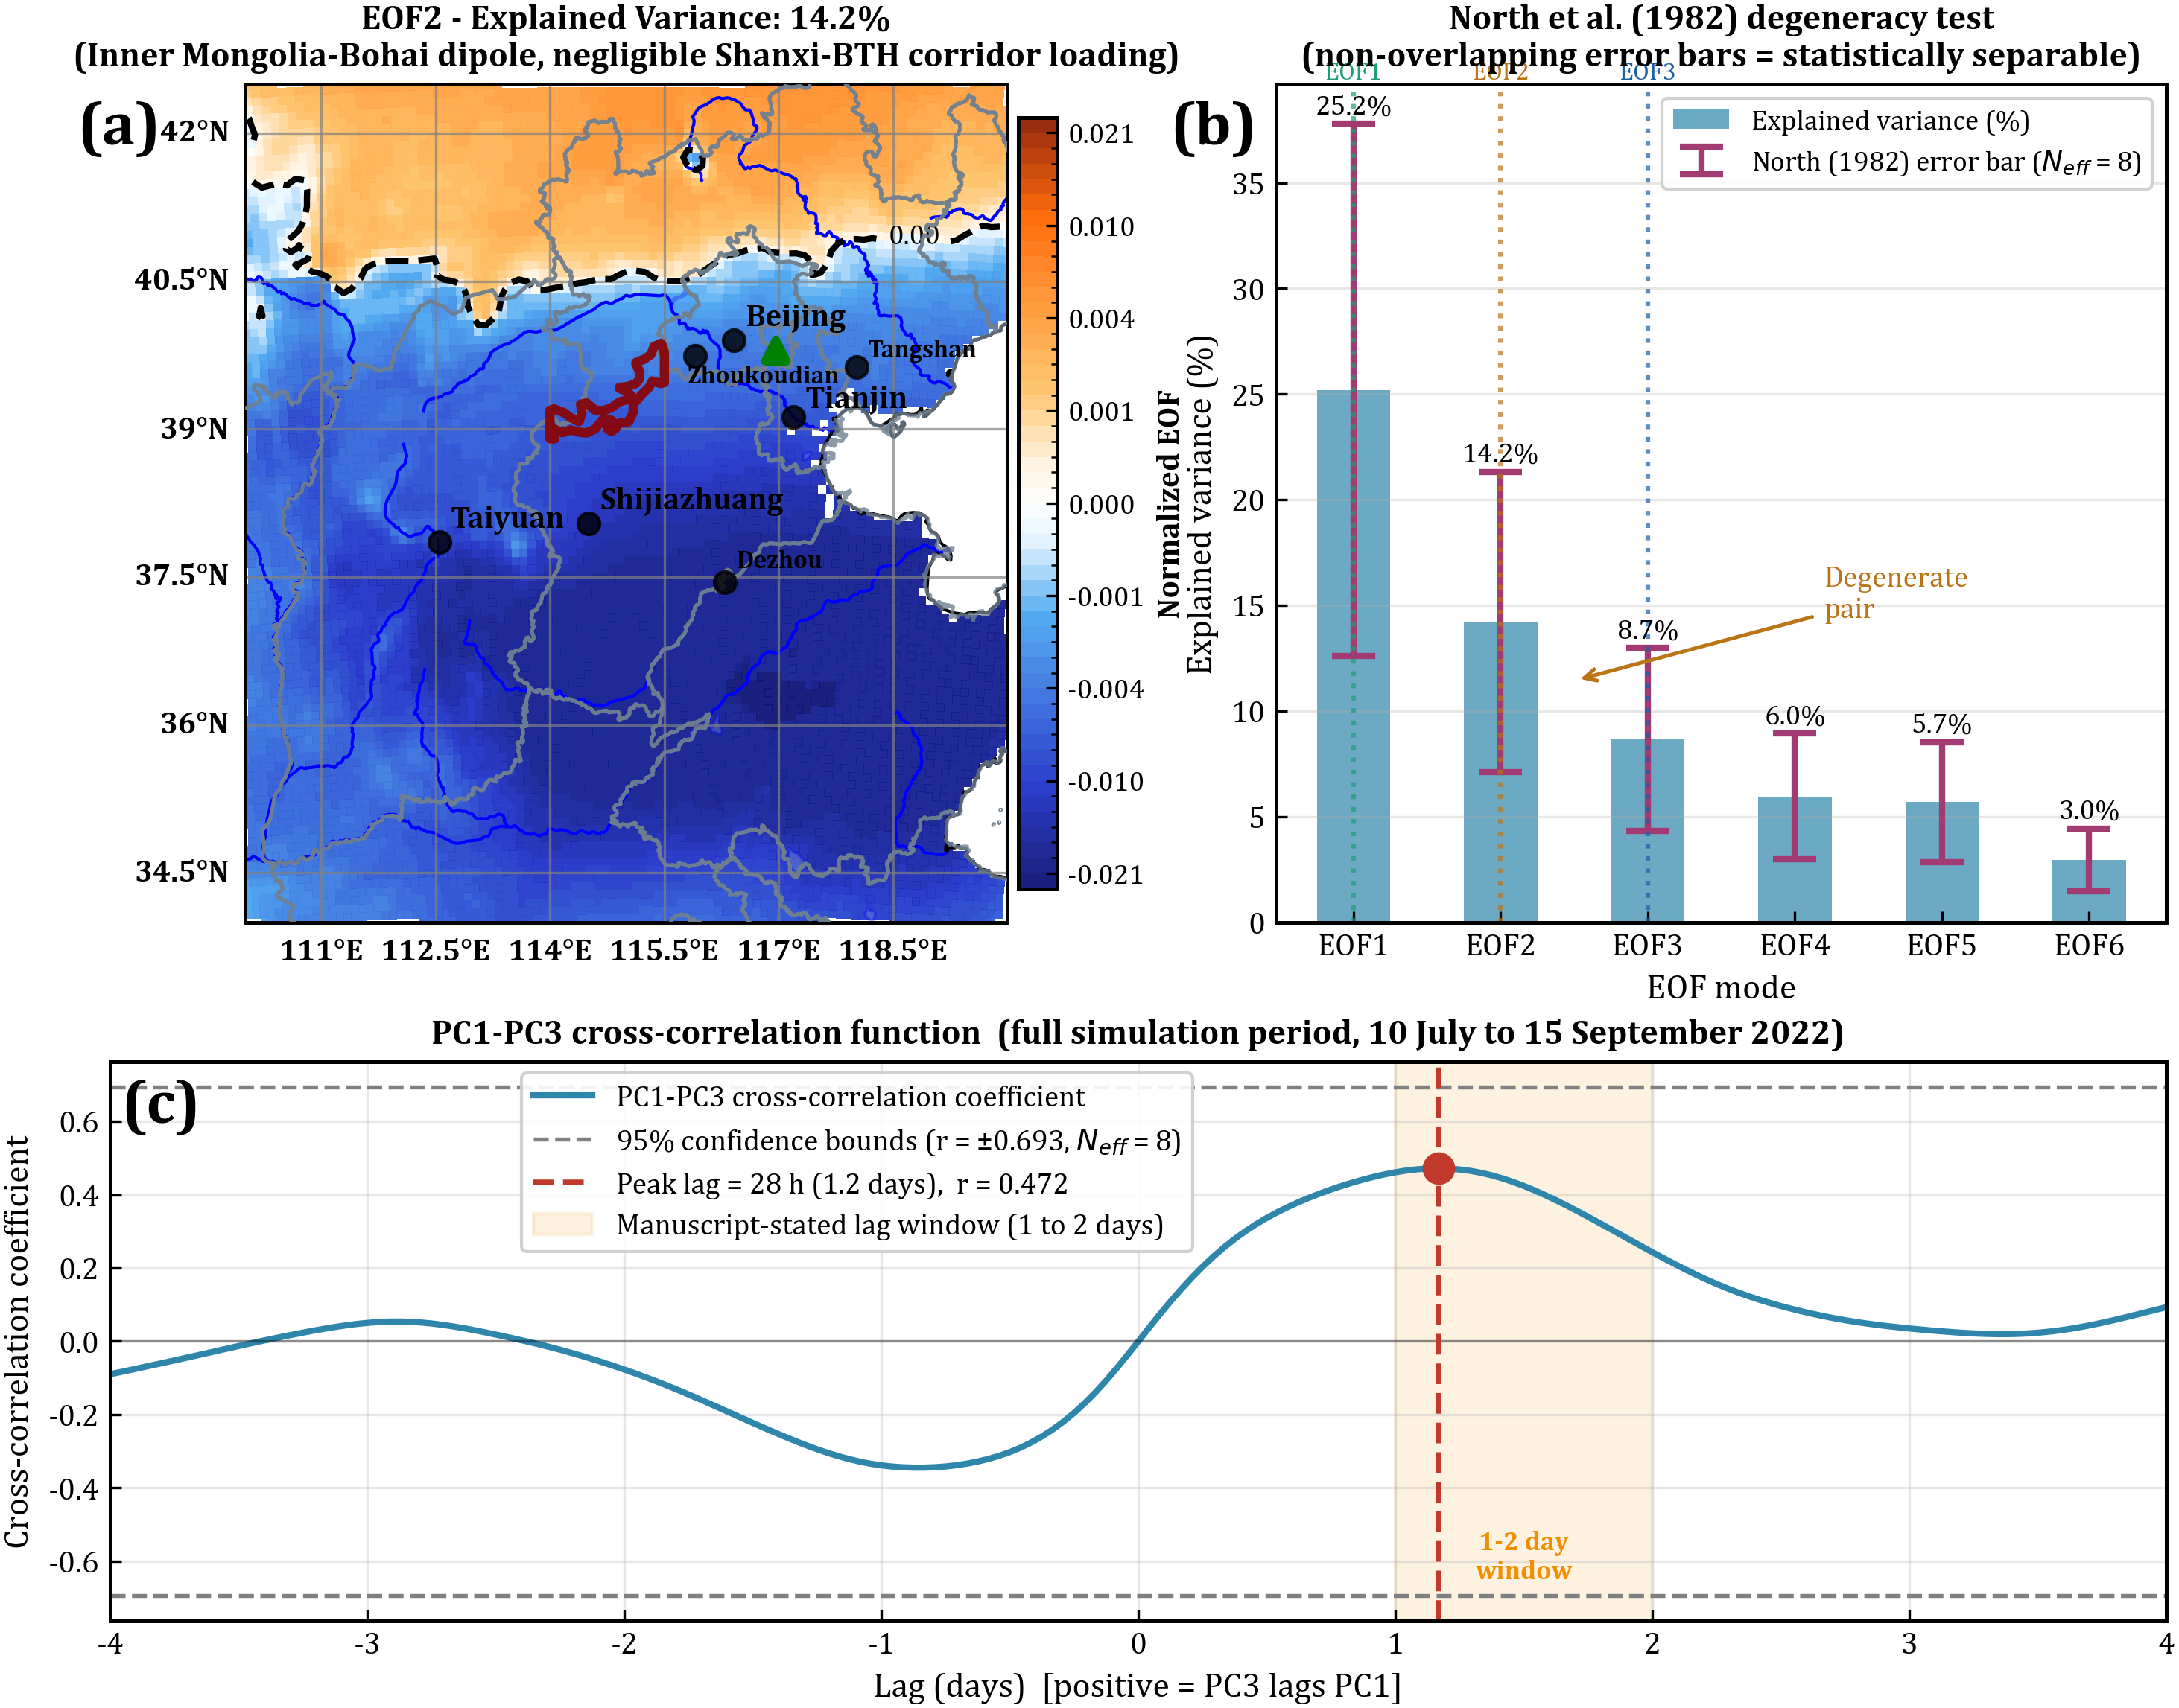

Supplementary Fig. S4. Statistical validation of EOF mode selection. (a) Spatial pattern of EOF2 (explained variance: 14.2%), showing a north-south dipole confined to Inner Mongolia and the Bohai Sea with negligible loadings along the Shanxi-BTH transport corridor. (b) North et al. (1982) degeneracy test for the six leading EOF modes; with $N_{eff}$ ≈ 8 the leading modes fall within a regime where adjacent eigenvalue error bars overlap, so modes are retained on the basis of physical interpretability rather than eigenvalue separability. EOF3 is retained because its spatial pattern directly traces the southeastern Shanxi–southern Hebei transboundary transport corridor. (c) PC1-PC3 cross-correlation function over the full simulation period; the peak positive-lag correlation of r = 0.47 occurs at 28 hours, consistent with the 1 to 2 day preconditioning sequence identified from individual peak events. The wide 95% confidence bounds reflect the strong temporal autocorrelation of both PC time series at hourly resolution and the two-month record length.

Supplementary Note 3
Detailed information of simulation results at TCCON Xianghe station.
Overview of simulation performance. The WRF-GHG simulations are evaluated against hourly XCH₄ retrievals from the TCCON Xianghe station (39.80 N, 116.96 E) over the full simulation period from 10 July to 15 September 2022. Five simulation scenarios are compared: the EDGAR baseline, the satellite-constrained Top-down inventory, two stochastic Shanxi emission perturbation experiments (±10% and ±50%), and a BTH regional reduction scenario (BTH-50%). Supplementary Fig. S5 shows the simulation-observation error time series for all five scenarios across the full simulation period, and Fig. 7b in the main text presents the corresponding scatter plots with statistical metrics.
The EDGAR simulation produces a mean bias of 12.39 ppbv, RMSE of 22.76 ppbv, and MAE of 16.77 ppbv, reflecting a systematic positive offset driven by the underrepresentation of Shanxi coal mine emission variability. The Top-down simulation yields a larger mean bias of 21.16 ppbv, RMSE of 31.74 ppbv, and MAE of 23.86 ppbv. This apparent increase relative to EDGAR does not represent a degradation of model performance; rather, it reflects the correct inclusion of the full Shanxi source contribution to the BTH column burden. The smaller EDGAR bias is a consequence of error cancellation, where systematic source underestimation fortuitously offsets other positive biases, producing a deceptively small mean error while failing to reproduce transport-driven concentration extremes. Both the EDGAR and Top-down simulations yield identical correlation coefficients of R = 0.464 with TCCON observations, confirming that the difference in bias reflects source-magnitude accuracy rather than any change in the temporal structure of simulated transport.
The ±10% and ±50% perturbation scenarios yield mean biases of approximately 21.47 ppbv and 21.38 ppbv respectively, remaining comparable to the Top-down baseline and confirming that stochastic Shanxi emission perturbations do not introduce systematic bias into the mean transport signal. The ±50% scenario achieves R = 0.483, a modest improvement over Top-down (R = 0.464), and RMSE of 32.16 ppbv with MAE of 24.57 ppbv. The BTH-50% scenario reduces the mean bias to 6.12 ppbv (a reduction of 50.6% relative to EDGAR), RMSE to 20.46 ppbv (a reduction of 10.1%), and MAE to 14.43 ppbv, with a correlation coefficient of R = 0.418. The modest RMSE reduction relative to the substantial bias reduction indicates that BTH local emissions primarily affect the mean state rather than the temporal variability of simulated XCH₄, and that the residual RMSE after BTH emission removal is driven by Shanxi-derived transport variability rather than local sources.
Peak event identification and reproduction at the 1-hour timescale. Extreme XCH₄ peak events observed at TCCON Xianghe were identified from the hourly time series using a threshold of the 90th percentile of valid observations (1,959 ppbv) with a minimum inter-event separation of 12 hours. This procedure identified 10 distinct peak events spanning the simulation period (Supplementary Table S2). A simulation was considered to have reproduced a peak event when the simulated XCH₄ at the corresponding hour equalled or exceeded 99% of the observed peak value. Under this criterion, the EDGAR simulation reproduces 6 of 10 peaks (60.0%), while the Top-down simulation reproduces 8 of 10 peaks (80.0%). The two peaks unmatched by EDGAR but matched by Top-down (09-10 03:00 and 09-12 08:00) correspond to September transport events in which the satellite-constrained source magnitude is sufficient to generate the observed column anomaly whereas the EDGAR source is not, directly demonstrating the value of inventory refinement for extreme event fidelity. Both simulations share a correlation coefficient of R = 0.464 with TCCON observations, confirming that the improvement in peak reproduction reflects source-magnitude accuracy rather than any change in transport timing.

Supplementary Table S2. Detailed information of peak events in the original EDGAR and Top-down simulations at Xianghe station.
Peak events | TCCON (ppbv) | EDGAR (ppbv) | Top-down (ppbv) | AOD 380nm | AOD 440nm | AOD 1020nm | AOD 1640nm | AAOD 440nm | AAOD 1020nm
07-16 07:00 | 1977 | 1982 | 1987 | — | — | — | — | — | —
07-20 01:00 | 1974 | 1968 | 1978 | — | — | — | — | — | —
07-26 09:00 | 1969 | 1960 | 1965 | 1.30 | 1.15 | 0.311 | 0.119 | 0.018 | 0.0065
08-02 01:00 | 1975 | 1981 | 1994 | 1.68 | 1.54 | 0.542 | 0.248 | — | —
08-04 02:00 | 2008 | 1972 | 1976 | 2.42 | 2.28 | 0.838 | 0.333 | — | —
08-07 08:00 | 1971 | 1996 | 2004 | 0.571 | 0.483 | 0.142 | 0.0608 | — | —
08-12 08:00 | 1962 | 1929 | 1929 | 0.921 | 0.805 | 0.259 | 0.116 | — | —
08-17 09:00 | 1964 | 1964 | 1971 | 1.23 | 1.05 | 0.304 | 0.146 | — | —
09-10 03:00 | 1978 | 1949 | 1989 | — | — | — | — | — | —
09-12 08:00 | 1963 | 1935 | 1945 | — | — | — | — | — | —
Peak event identification and reproduction at the 30-minute timescale. The perturbation experiment outputs are available at 30-minute resolution. Peak events were re-identified on this higher-resolution time series using the same 90th percentile threshold and a minimum inter-event separation of 24 time steps, equivalent to 12 hours, yielding 10 peak events (Supplementary Table S3). The ±50% perturbation scenario reproduces 9 of 10 peaks (90.0%), compared with 40.0% for the BTH-50% scenario. The single uncaptured peak (4 August 2022, 02:00 UTC; TCCON = 2,008 ppbv) represents the most extreme XCH₄ anomaly in the simulation period, approximately 50 ppbv above the time-series mean. The concurrent AOD₄₄₀ of 2.28, the highest value in the dataset, may introduce a positive bias of up to 5 to 10 ppbv in the TCCON retrieval under high aerosol loading, or up to a 20—30 ppbv based on a new work assessing TROPOMI over Europe (Sicsik-Paré A. et al., 2025 [in preprint]). However, this aerosol-induced effect accounts for only a fraction of the 61 ppbv model underestimate; the dominant contribution reflects the inability of monthly-mean emission inventories to capture the sub-diurnal emission pulses responsible for this extreme event.

Supplementary Table S3. Detailed information of peak events in perturbation experiments at Xianghe station.
Peak events | TCCON (ppbv) | EDGAR (ppbv) | Top-down (ppbv) | ±50% perturb  (ppbv) | BTH  -50%  (ppbv) | AOD 380  nm | AOD 440  nm | AOD 1020  nm | AOD 1640  nm | AAOD 440nm | AAOD 1020  nm
07-16 06:30 | 1986 | — | — | 1983 | 1959 | — | — | — | — | — | —
07-20 00:30 | 1982 | — | — | 1975 | 1976 | — | — | — | — | — | —
07-26 09:00 | 1969 | 1960 | 1965 | 1974 | 1967 | 1.30 | 1.15 | 0.311 | 0.119 | 0.018 | 0.0065
08-02 01:00 | 1975 | 1981 | 1994 | 2021 | 1951 | 1.68 | 1.54 | 0.542 | 0.248 | — | —
08-04 02:00 | 2008 | 1972 | 1976 | 1947 | 1960 | 2.42 | 2.28 | 0.838 | 0.333 | — | —
08-07 05:30 | 1990 | — | — | 2051 | 1970 | — | — | — | — | — | —
08-13 01:30 | 1964 | — | — | 1970 | 1943 | — | — | — | — | — | —
08-17 06:30 | 1973 | — | — | 1962 | 1940 | — | — | — | — | — | —
09-10 03:00 | 1978 | 1949 | 1989 | 1988 | 1960 | — | — | — | — | — | —
09-12 8:00 | 1963 | 1935 | 1945 | 1965 | 1932 | — | — | — | — | — | —
Aerosol co-transport characterization. AERONET Level 2.0 direct-sun AOD and AAOD retrievals at Xianghe are reported alongside the peak event statistics in Supplementary Tables S2 and S3. AOD data are unavailable for three July events (07-16, 07-20, and 07-26 in Table S2; 07-16 and 07-20 in Table S3) owing to cloud cover during the measurement window, a standard data gap in sun photometer retrievals; their absence does not affect the peak reproduction statistics. For events with available retrievals, AOD440 spans approximately 0.48 to 2.28, with the two strongest early-August peaks (2 and 4 August) coinciding with the highest aerosol loading (AOD440 up to 2.28). This co-occurrence is consistent with co-transport of methane and aerosol precursors from Shanxi industrial sources under the same southwesterly circulation, although the weaker aerosol enhancement at several later peaks indicates that elevated AOD accompanies the most intense transport episodes specifically rather than every peak. AAOD₄₄₀ = 0.018 and AAOD₁₀₂₀ = 0.0065 at 07-26 indicate the presence of absorbing aerosol, which may introduce minor positive biases in TCCON XCH₄ retrievals at the individual event level.
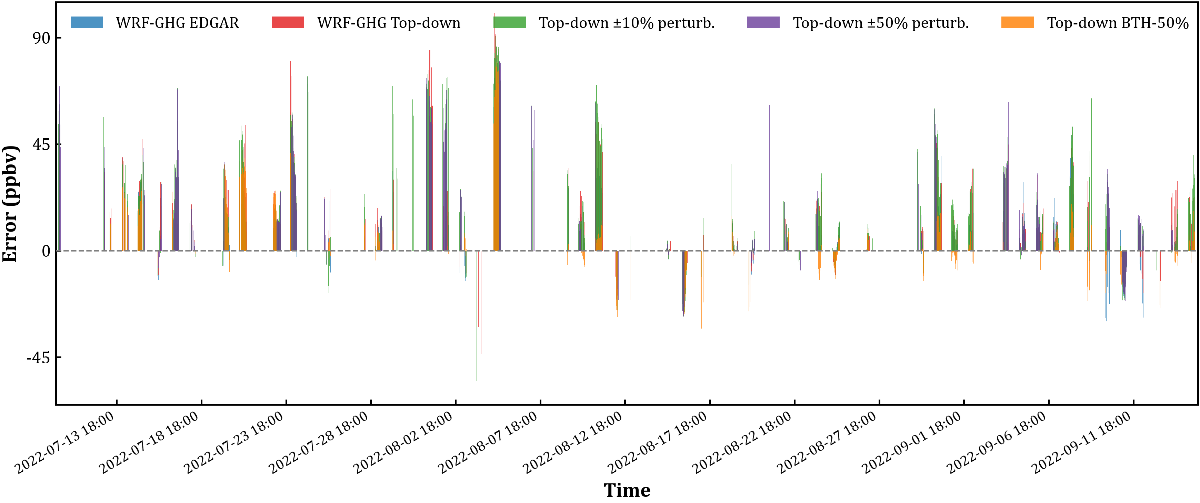

Supplementary Fig. S5. Simulation-observation XCH₄ error (model minus TCCON Xianghe, ppbv) within the full simulation period (10 July to 15 September 2022) for five WRF-GHG scenarios: EDGAR baseline (mean bias = 12.39 ppbv), Top-down refined inventory (21.16 ppbv), ±10% Shanxi perturbation (21.47 ppbv), ±50% Shanxi perturbation (21.38 ppbv), and BTH-50% regional reduction (6.12 ppbv). The dashed gray line denotes zero bias. Positive values indicate model overestimation and negative values indicate underestimation.

Supplementary Note 4
Validation of WRF-GHG’s simulation results.
Validation against background CH₄ observations at WMO Mt. Waliguan. Daily mean in-situ CH₄ observations at the WMO Mt. Waliguan (WLG) GAW Global background station (36.29° N, 100.90° E, 3810 m a.s.l.) provide an independent constraint on the simulated free-tropospheric CH₄ over the simulation period. The station is operated by the China Meteorological Administration with a Picarro G2401 cavity ring-down analyser referenced to the WMO CH₄ X2004 calibration scale, and sits on the northeastern Tibetan Plateau approximately 700 km southwest of the Shanxi coal basins, outside the modelled Shanxi-to-BTH transboundary transport corridor. Across 10 July to 15 September 2022, 68 daily means with quality-control flag 1 (background) or 2 (valid) were retained, with a mean of 1999.8 ppbv, a standard deviation of 9.5 ppbv, and a range of 1978–2010 ppbv that traces the smooth seasonal cycle of the regional CH₄ background.
The d01 (27 km) grid cell containing WLG has a smoothed terrain elevation of 3061 m a.s.l., 749 m below the true station altitude, so a direct comparison with the model surface level would confound near-ground model air with the free-tropospheric air actually sampled at the mountain top. To eliminate this representativeness error, simulated CH₄ at 3810 m a.s.l. was reconstructed at each hourly time step in three steps. First, the above-sea-level height $h_{k}$ of every mass-level centre $k$ was obtained by upward hydrostatic integration of the model pressure field, starting from the grid terrain elevation $h_{0}$ and using a virtual-temperature correction to account for moisture:
$$h_{k}=h_{k-1}+(p_{k-1}-p_{k}) / (ρ_{v}·g),$$
where $p_{k}= P_{k}+{PB}_{k}$ is the total pressure on mass level $k$, $ρ_{v}=p/(R_{a}·T_{v})$ is the moist-air density at mid-layer pressure, $T_{v}= T(1 + 0.608q)$ is the virtual temperature with $q$ the water-vapour mixing ratio, $R_{a}$ = 287 J kg⁻¹ K⁻¹ is the dry-air gas constant, and $g$= 9.81 m s⁻² is gravitational acceleration. Second, the two mass levels bracketing 3810 m a.s.l. were identified. Third, the total CH₄ mixing ratio (sum of the WRF-GHG tracers) was interpolated between those two levels linearly in the logarithm of pressure, which is the standard vertical interpolation for trace gases in hydrostatically balanced atmospheres. The resulting hourly values at 3810 m a.s.l. were aggregated to daily means and matched to the WLG record on common calendar days. Because the WLG product is itself restricted by the data provider to background-classified hours, the model daily mean and the observed daily mean are intrinsically asymmetric in their hourly sampling.
Across the 68 matched days (Fig. S6), the WRF-GHG Top-down simulation reproduces the absolute magnitude of the WLG background to within approximately 1%, with a mean bias of −21.4 ppbv and an RMSE of 41.7 ppbv, and captures the broad late-July to mid-August minimum followed by a late-August maximum. The BTH-50% scenario yields statistically equivalent results (bias −31.0 ppbv, RMSE 42.6 ppbv). The modelled day-to-day variability (standard deviation ≈ 30 ppbv) exceeds that of the observation (9.5 ppbv) by construction, because the model daily mean integrates every hour whereas the WLG product retains only the background-classified subset, by design excluding the synoptic and boundary-layer fluctuations that the simulation resolves explicitly. Consequently the fraction of model daily means falling within the narrow ±3 ppbv WLG uncertainty envelope is small (6% for Top-down, 1% for BTH-50%); this metric reflects the asymmetric hourly sampling between the two products rather than a deficiency in the simulated background level. The persistent slight negative bias is comparable in magnitude to model-observation discrepancies independently reported for column-integrated CH₄ over the topographically complex and observationally sparse Qinghai-Tibetan Plateau (Tu et al., 2025), and affects both scenarios equally because both inherit the same global boundary condition.
The primary value of the WLG comparison is as a check on the absolute background level set by the CAM-chem lateral boundary condition over the northeastern Tibetan Plateau, rather than as a test of the BTH-50% perturbation. Because WLG lies around 700 km southwest of, and upwind of, the BTH domain under the prevailing southwesterly regime, the BTH-localized emission perturbation has no expected transport pathway to this station; the small Top-down-versus-BTH-50% difference at WLG (bias difference 9.6 ppbv) is therefore consistent with the experimental geometry and should not be over-interpreted as a demonstration of spatial confinement. The persistent ~−21 ppbv low bias common to both scenarios is comparable in magnitude to model-observation discrepancies independently reported for column-integrated CH4 over this topographically complex and observationally sparse region (Tu et al., 2025), and is attributable to the shared global boundary condition rather than to the regional source configuration.
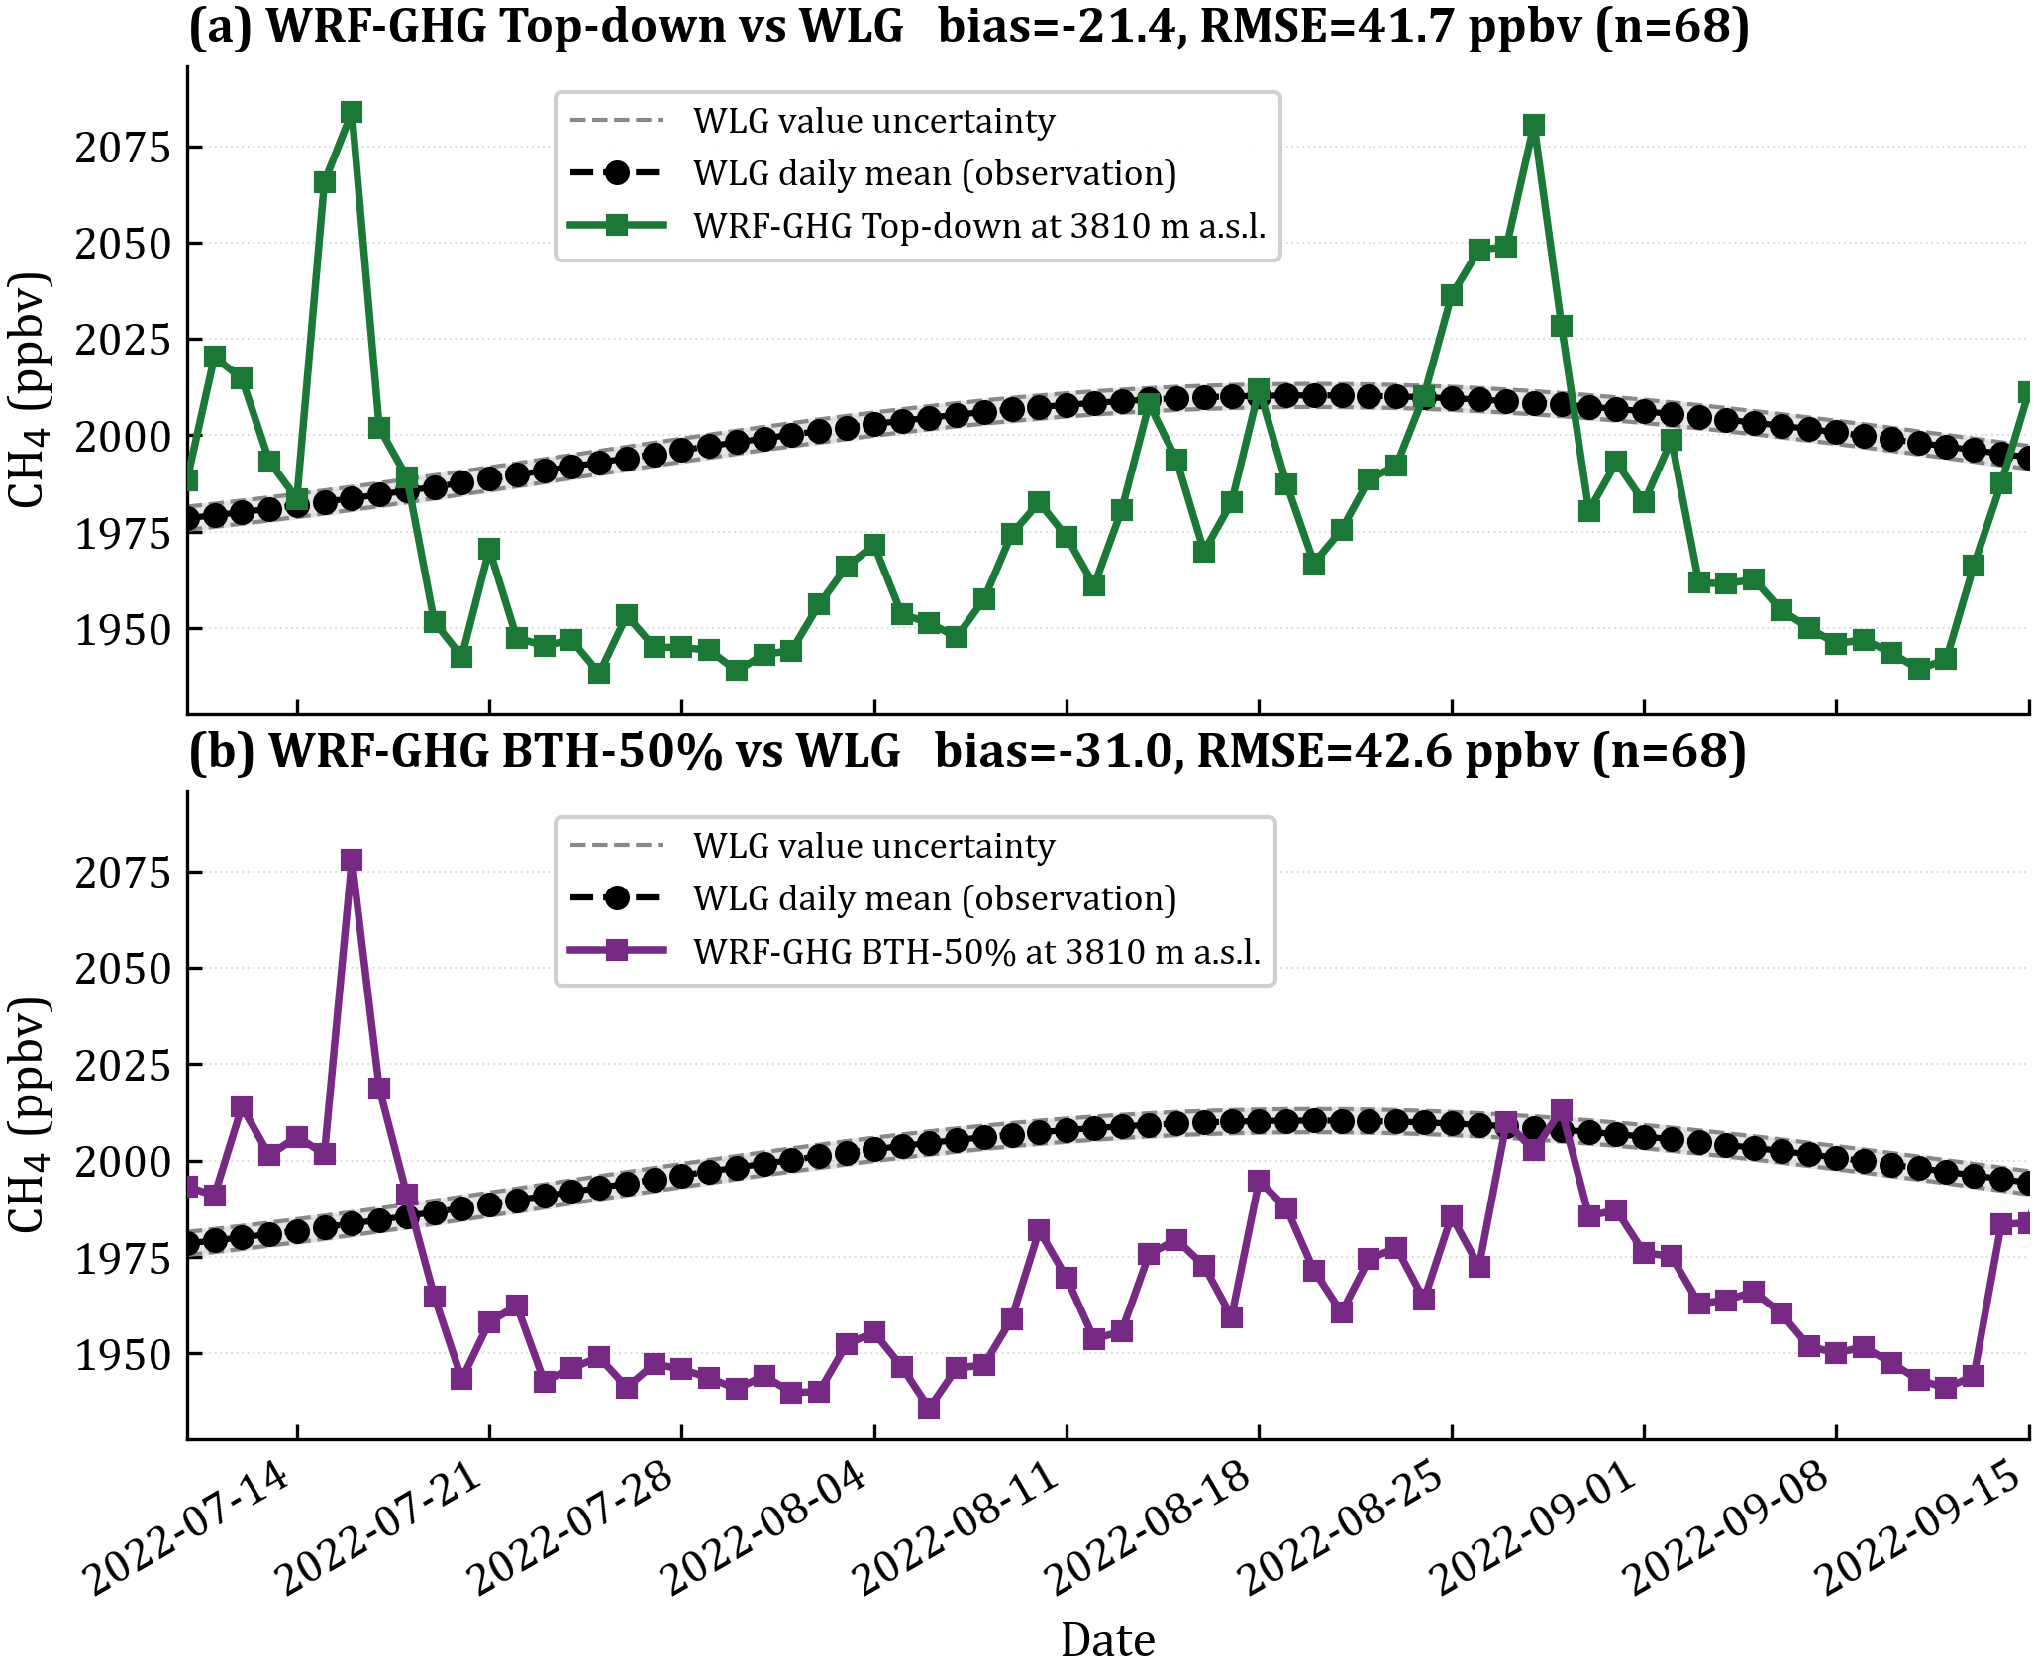

Supplementary Fig. S6. Validation of WRF-GHG simulated CH₄ at the WMO Mt. Waliguan (WLG) GAW background station (36.29 N, 100.90 E, 3810 m a.s.l.) over the simulation period (10 July to 15 September 2022). (a) WRF-GHG Top-down simulation versus WLG. (b) WRF-GHG Top-down (BTH-50%) simulation versus WLG. In both panels, WLG daily mean in-situ CH₄ from the China Meteorological Administration WDCGG record is shown as black filled circles connected by a dashed line; the daily total measurement uncertainty is indicated by two grey dashed lines bracketing a light grey envelope.
Validation against TCCON column observations at Hefei. The three WRF-GHG scenarios were further compared against TCCON Hefei daily-mean XCH₄ retrievals (31.91° N, 117.17° E), an independent column validation at a station approximately 900 km south of BTH (Liu et al., 2023). Observations from the GGG2020.R1 product were quality-controlled following GGG2020 standard criteria (xluft within [0.96, 1.04]; solar zenith angle ≤ 75°), yielding 25 daily means in the simulation period after restriction to days with at least five QC-passed sub-hourly observations. For each scenario, simulated XCH₄ at the nearest d02 (9 km) grid point was computed as the dry-air-density-weighted vertical column average of the total simulated CH₄, following manuscript Eq. 1–2, and sub-hourly model output (hourly for Top-down and BTH-50%, 30-min for ±50%) was aggregated to daily means by calendar day to match the TCCON aggregation.
Across the 25 matched days (Fig. S7), the three scenarios reproduce TCCON Hefei XCH₄ with comparable skill: mean biases of +7.9, +5.0 and −1.9 ppbv and RMSEs of 33.7, 25.6 and 24.3 ppbv for Top-down, Top-down (±50%) and Top-down (BTH-50%), respectively. The day-to-day variability shows broad agreement throughout the simulation period, with a small number of transient plume episodes (notably 4 August 2022 and 25–28 August 2022) producing the largest deviations and dominating the RMSE statistics. These episodes coincide with synoptic conditions favouring southward transport of BTH-region or Shanxi air masses to the Yangtze River Delta, during which the model resolves peak XCH₄ amplitudes that exceed what the cloud-limited TCCON sampling can independently verify at sub-daily resolution.
The Hefei comparison serves three purposes. First, it provides an independent cross-check of the dry-air-density-weighted column-XCH₄ calculation applied at TCCON Xianghe in the main text: the same methodology yields comparable skill at a second TCCON station distant from the dominant Shanxi-to-BTH transport corridor, supporting the validity of the column reconstruction used to attribute the BTH receptor-region enhancements. Second, it documents the response of simulated XCH₄ to the emission perturbation experiments at a far-field station: the spread in mean bias among the three scenarios (9.8 ppbv between Top-down and BTH-50%) is comparable in magnitude to the corresponding spread at TCCON Xianghe documented in the main text (a Top-down-minus-BTH-50% mean-bias difference of 15.0 ppbv; cf. Fig. 7b), confirming that the perturbations remain detectable downstream rather than producing a strict zero signal. Third, the smallest bias at Hefei is obtained for the BTH-50% scenario, consistent with Hefei lying within the broader regional footprint of BTH emissions approximately 900 km downstream of the perturbed corridor; the modest improvement should not be over-interpreted given the limited sample size (n = 25) and the dominant influence of a small number of plume days on the aggregate statistics. This indicates that the BTH local emission field, as configured in the Top-down baseline, exerts a regional-scale rather than corridor-confined influence on the lower-tropospheric methane column over several hundred kilometres, consistent with the atmospheric lifetime of methane and the synoptic-scale variability of the regional transport pattern. Additional signal differences are likely due to both strong sources outside of Shanxi being transported as well as a similar possible overestimation of the local emissions within Hefei itself, but this general set of findings is over and beyond the context of this work, although aligned in principle with the findings herein. We also note that during the highest peaks computed using WRF, that TCCON in Hefei has no data, as it has been filtered, possibly due to the higher aerosol or water vapor conditions consistent with air masses transported from Shanxi (Guan et al., 2026).
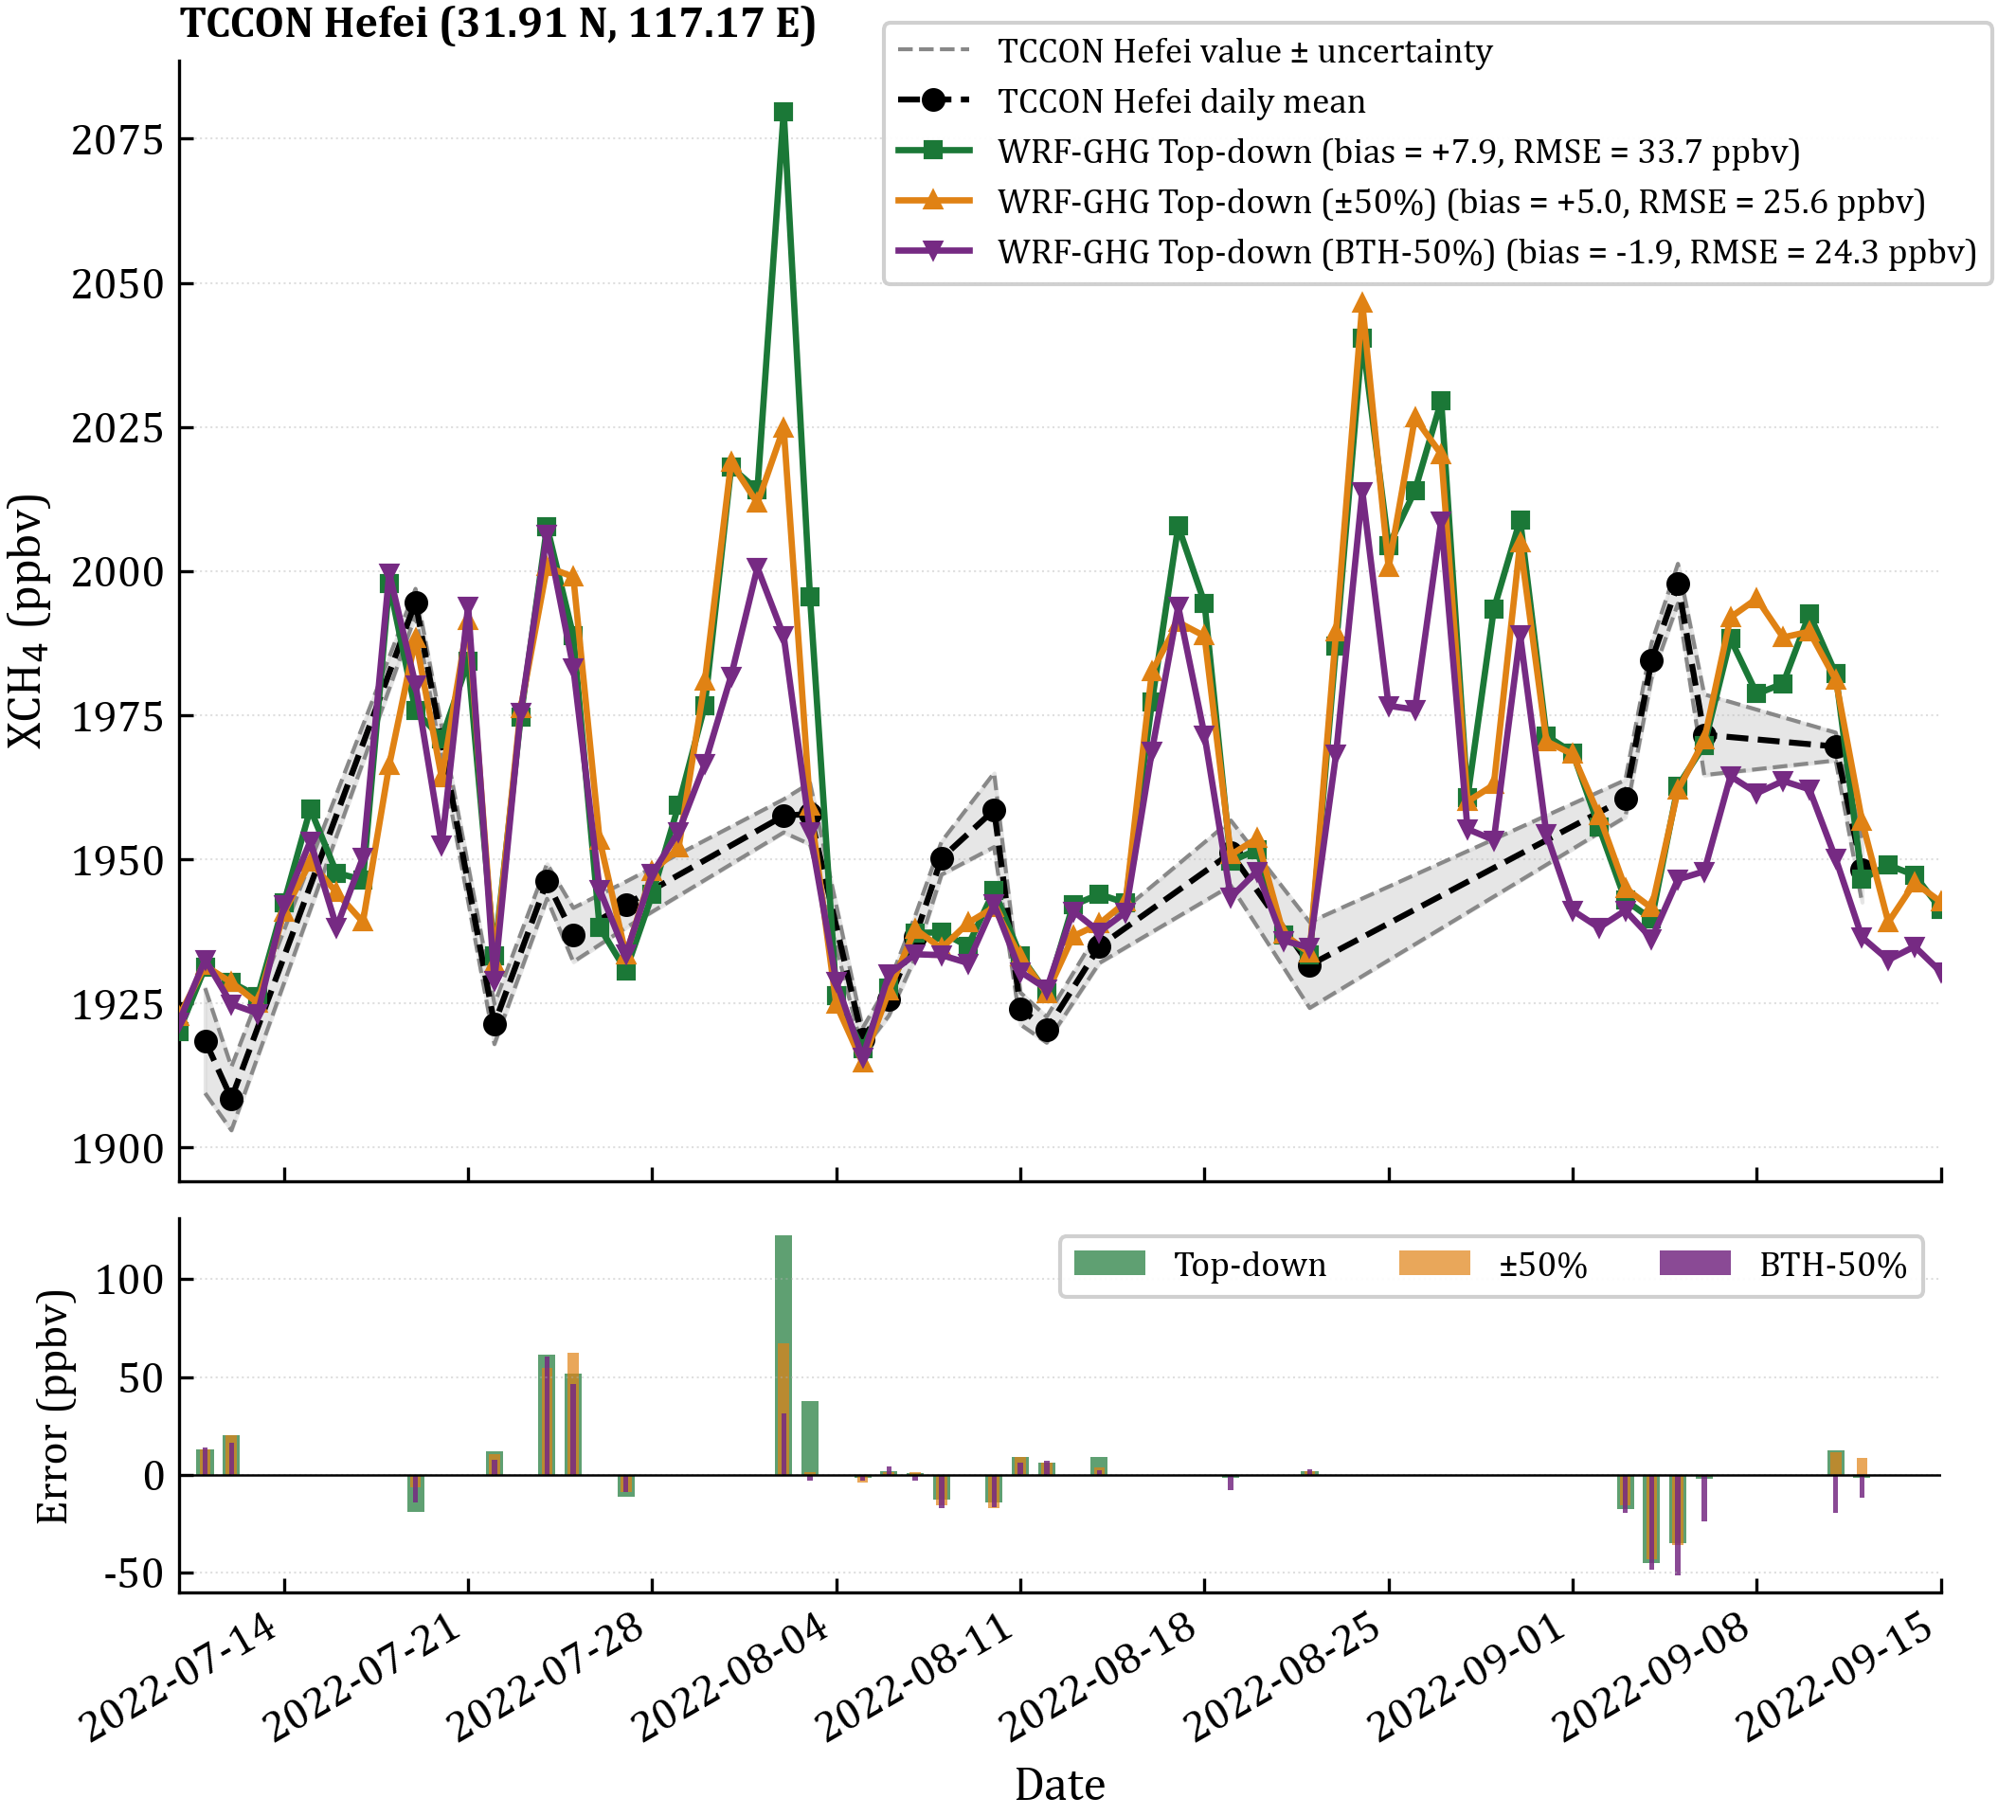

Supplementary Fig. S7. Validation of three WRF-GHG simulation scenarios against TCCON Hefei XCH₄ daily means (31.91° N, 117.17° E; Liu et al., 2023) over 10 July to 15 September 2022. (a) Daily-mean XCH₄ time series. TCCON Hefei daily mean (black filled circles connected by a dashed line) is shown with a daily uncertainty envelope (two grey dashed lines) computed by combining the mean retrieval precision and the intraday standard deviation in quadrature. The three model scenarios are plotted as coloured solid lines: Top-down (green squares; satellite-constrained Shanxi inventory), Top-down (±50%) (orange triangles; Shanxi inventory perturbed by ±50%), and Top-down (BTH-50%) (purple inverted triangles; BTH local inventory reduced by 50%). For each scenario, XCH₄ at the nearest d02 (9 km) grid point was computed as the dry-air-density-weighted column average of the total simulated CH₄ following manuscript Eq. 1–2, and sub-hourly model output was aggregated to daily means matched to TCCON daily means by calendar day. TCCON observations were quality-controlled following the GGG2020 standard (xluft within [0.96, 1.04]; solar zenith angle ≤ 75°), yielding n = 25 matched daily means. (b) Daily model-minus-TCCON difference (WRF − TCCON) for each scenario, with bar widths nested for side-by-side comparison. Per-scenario mean bias and RMSE across the 25 matched days are annotated in the legend of panel (a).
Validation against COCCON column measurements at the Shanxi source region. Column XCH₄ measurements from two portable EM27/SUN solar absorption spectrometers (COCCON SN38 and SN53) were collected at 10 field sites concentrated in the southeastern Shanxi coalfield (35.99 to 36.14 N, 112.88 to 112.96 E) from 2 August to 7 September 2022. All retrievals passed standard GGG quality control (XAIR in 0.99 to 1.01; apparent solar zenith angle below 75 degrees). After spatial filtering to the Shanxi source area, 3,672 SN38 measurements and 4,589 SN53 measurements were retained.
Inter-instrument consistency between SN38 and SN53 was assessed using 355 co-located, QC-passed measurement pairs with inter-instrument distance below 1 km. Bland-Altman analysis yields a mean bias of -0.48 ppb (SN53 minus SN38) with 95% limits of agreement of -5.09 to +4.12 ppb (Fig. S8c), confirming that the two instruments are mutually consistent within their combined measurement uncertainty.
The 10 measurement sites were grouped by location and matched to the nearest WRF-GHG grid points at both d02 (9 km) and d03 (3 km) resolutions. WRF hourly output was sampled at the same UTC hours as COCCON observations and aggregated to daily means per site-grid pairing (minimum 5 observations per day). Statistical results at both resolutions are summarized in Supplementary Table S4. Pooled SN38 daily-mean correlations against the Top-down simulation are R = 0.18 at d02 and R = 0.30 at d03, with mean biases of +5.1 and +17.0 ppbv respectively; corresponding correlations and biases against EDGAR are R = 0.34 and R = 0.52, with biases of -27.5 and -18.3 ppbv. The two resolutions yield consistent qualitative conclusions across all four model-instrument combinations.
The contrasting bias signs between Top-down (+5.1 to +17.0 ppbv) and EDGAR (-27.5 to -18.3 ppbv) at this source-region supersite reflect the differing spatial characteristics of the two inventory products. The satellite-constrained Top-down inventory resolves emission hotspots at the native retrieval resolution of approximately 7 km, and small positional offsets between the resolved hotspot and the in-situ measurement site can produce local positive biases in the simulated column. The EDGAR 0.1-degree gridded climatology, by construction, spatially smooths emission peaks across grid cells and consequently underestimates concentrations at hotspot locations such as the active coal mining clusters sampled here. The two inventories therefore bracket the source-region observations from opposite directions with comparable bias magnitudes of approximately 18 to 28 ppbv, indicating that they provide complementary rather than contradictory constraints on the Shanxi emission field.
This source-region behaviour does not contradict the BTH receptor-region validation reported in the main text. The Top-down inventory’s advantage emerges most clearly in the region-integrated transboundary transport signal at TCCON Xianghe (Fig. 2e-f and Fig. 7), where the regional total Shanxi source magnitude rather than the precise km-scale spatial distribution controls the downwind column anomaly. The two validation scenarios are therefore consistent: Top-down outperforms EDGAR at the regional and transboundary scale where total source magnitude dominates the simulated signal, while the two inventories provide complementary information at the source supersite scale where local spatial positioning becomes the controlling factor. The interquartile range of daily model-observation differences spans approximately 70 to 90 ppbv across all four model-inventory combinations (Supplementary Table S4), directly quantifying the representativeness error between point-scale column observations and grid-averaged model output in a region of strong sub-grid emission heterogeneity.
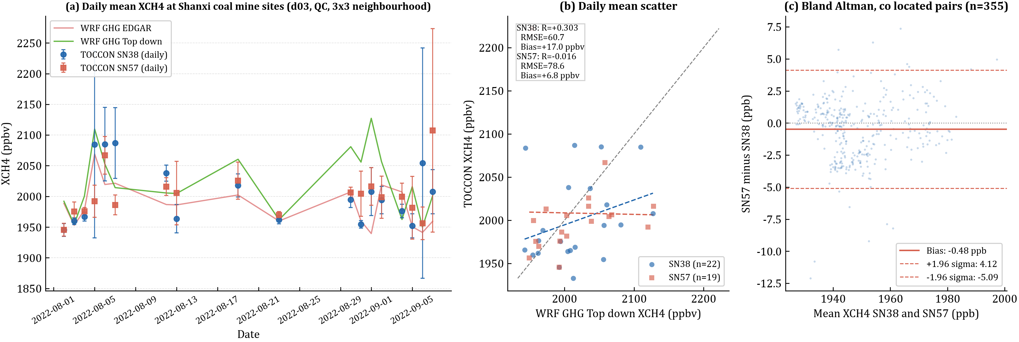

Supplementary Fig. S8. Validation of WRF-GHG d03 (3 km) simulations against COCCON EM27/SUN portable solar absorption spectrometer measurements at 10 sites in the southeastern Shanxi coal mine region (35.99 to 36.14 N, 112.88 to 112.97 E). All retrievals passed standard GGG quality control (XAIR in 0.99 to 1.01; apparent solar zenith angle below 75 degrees). (a) Daily-mean XCH₄ time series from COCCON SN38 (blue circles, error bars show daily standard deviation) and SN53 (red squares), compared with WRF-GHG EDGAR (pink) and Top-down (green) simulations averaged over the 3 by 3 d03 grid neighbourhood of each measurement site and sampled at the same UTC hours as COCCON observations. (b) Daily-mean scatter of WRF-GHG Top-down XCH₄ against COCCON XCH₄ for SN38 (n = 22 daily pairs) and SN53 (n = 19) separately, with linear regression lines and statistical metrics. (c) Bland-Altman analysis of inter-instrument consistency using co-located QC-passed measurement pairs (inter-instrument distance less than 1 km, n = 355); horizontal lines show the mean bias (-0.48 ppb) and 95% limits of agreement (-5.09 to +4.12 ppb).
Statistics are computed from daily-mean XCH₄ pairs between WRF-GHG simulations and COCCON SN38 observations at 10 measurement sites in the southeastern Shanxi coalfield, after GGG quality control (XAIR in 0.99 to 1.01; apparent solar zenith angle below 75 degrees) and aggregation over the 3 by 3 model grid neighbourhood of each site. WRF output was sampled at the same UTC hours as COCCON observations. Pearson correlation coefficient R with associated p-value, root-mean-square error (RMSE), and mean bias (WRF minus COCCON) are reported alongside the median, 25th and 75th percentiles of the daily bias distribution to characterize the non-Gaussian spread of model-observation differences. SN53 daily-mean concentration range was below 70 ppbv across the campaign, compressing the dynamic range available for the correlation statistic and yielding R values near zero at both resolutions (R = -0.012 at d02 and R = -0.016 at d03 against Top-down; R = -0.093 at d02 and R = -0.084 at d03 against EDGAR; n = 19 daily pairs).

Supplementary Table S4. Resolution-sensitivity intercomparison of WRF-GHG against COCCON EM27/SUN measurements at the Shanxi coal-mine supersite.
Model resolution | Inventory | n | R | p | RMSE (ppbv) | Mean bias (ppbv) | Median bias (Q25, Q75) (ppbv)
d02 (9 km) | Top-down | 22 | +0.175 | 0.44 | 58.4 | +5.1 | +10.5  (-26.3, +44.4)
d03 (3 km) | Top-down | 22 | +0.303 | 0.17 | 60.7 | +17.0 | +21.8  (-18.2, +46.6)
d02 (9 km) | EDGAR | 22 | +0.340 | 0.12 | 53.6 | -27.5 | -13.3  (-64.5, +4.7)
d03 (3 km) | EDGAR | 22 | +0.515 | 0.014 | 46.0 | -18.3 | -10.2  (-49.3, +11.3)

Supplementary Note 5
Evaluation the simulation performance of the WRF model: Implications for Methane Transport Reliability
WRF-GHG model configuration

Supplementary Table S5. Physical parameterization options used for WRF-GHG simulations.
Physics process | Scheme name | Option
Microphysics | Morrison two-moment | 10
Longwave radiation | RRTMG | 4
Shortwave radiation | RRTMG | 4
Surface layer | MM5 Monin-Obukhov | 2
Land surface model | Unified Noah Land Surface Model | 2
Planetary boundary layer | Mellor-Yamada-Janjic (MYJ) | 2
Cumulus convection  (only in d01) | Grell-Freitas (GF) | 5

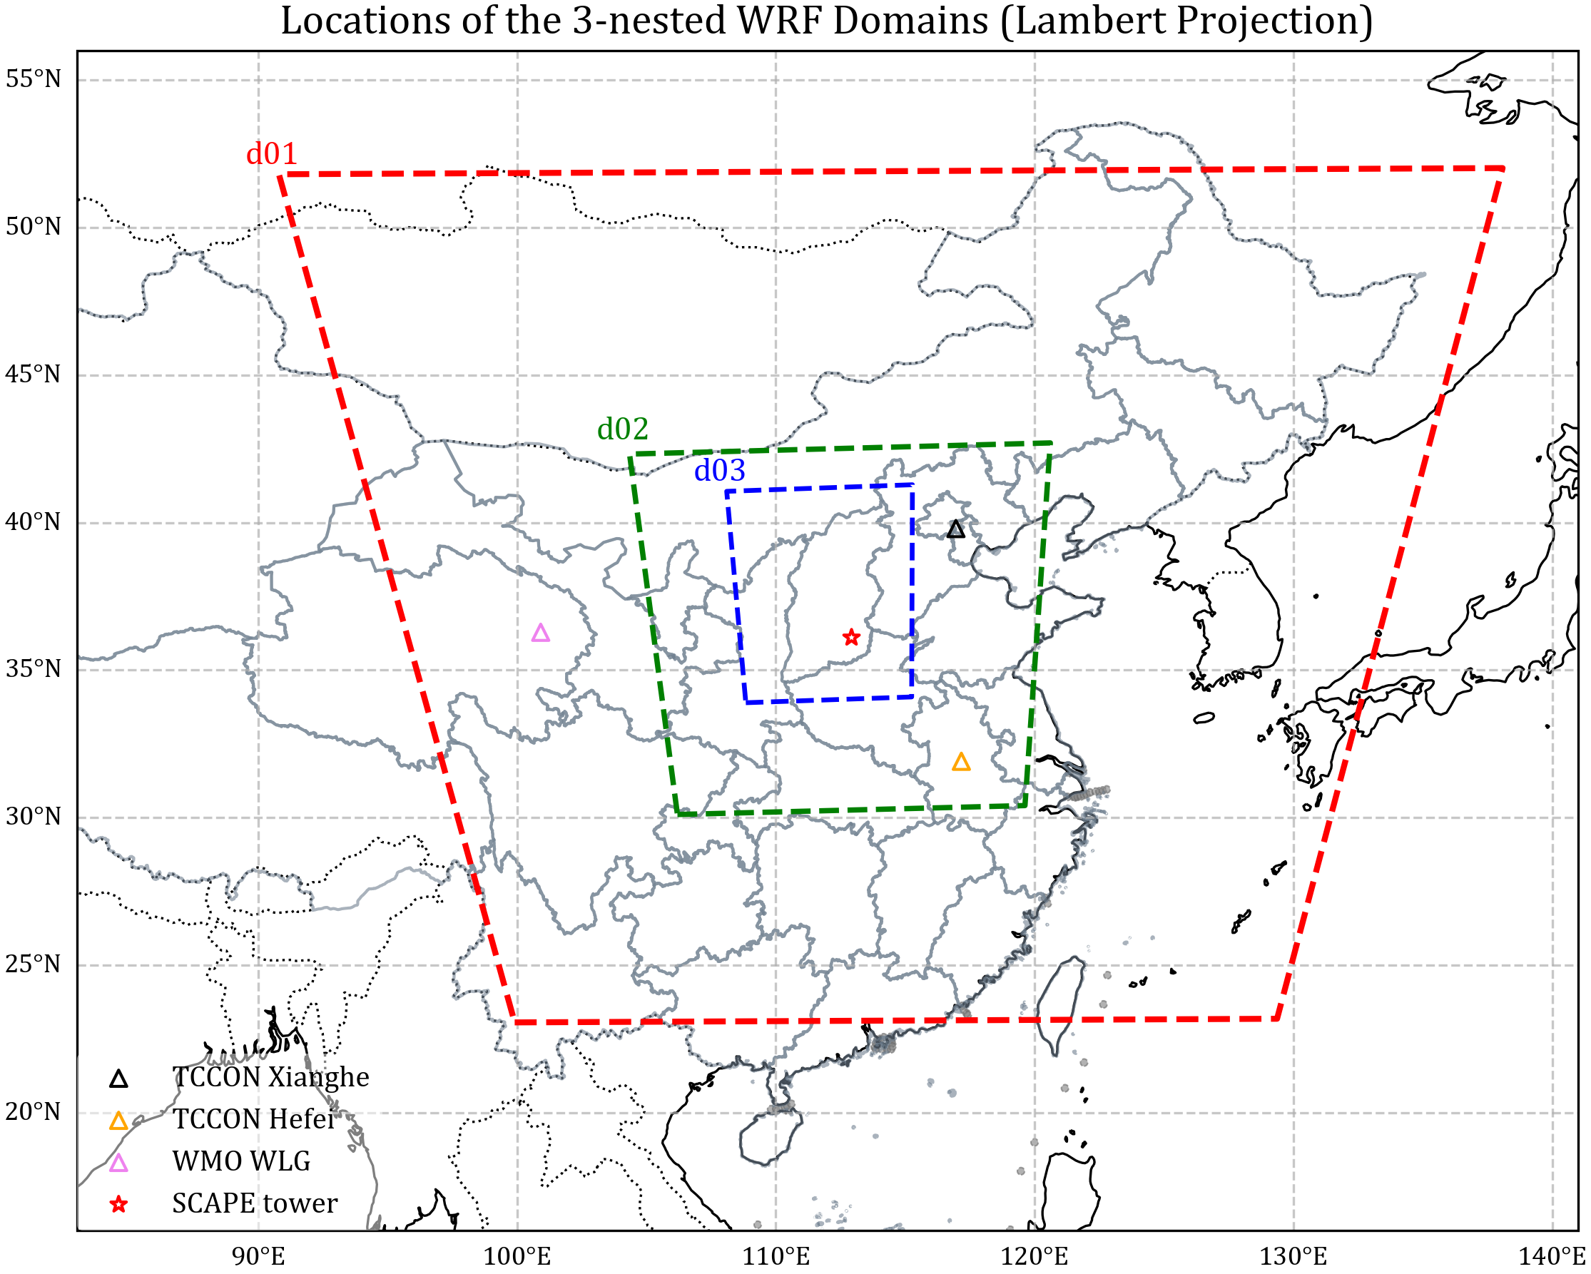

Supplementary Fig. S9. Locations of the 3-nested domains.

Validation of the Planetary Boundary Layer
Atmospheric transport models for methane rely strongly on the proper representation of the planetary boundary layer (PBL) by the numerical weather prediction (NWP) model driving them to properly account for the vertical and horizontal mixing of methane in the near-surface atmosphere. These transport models are fundamental tools for methane emission inversion using top-down approaches (Nisbet and Weiss, 2010), and their reliability is directly tied to the accuracy of simulated PBL dynamics (e.g., diurnal variations in PBL height). The simulated diurnal variations of PBL heights over the entire study period are presented in Fig. S10. Indeed, the PBL height simulated by WRF-GHG reaches its maximum in the afternoon (15:00 local time, LTC) when solar radiation and surface heating are strongest—consistent with the diurnal cycle of convective mixing in the PBL and the findings of Callewaert et al. (2025). This realistic simulation of PBL height diurnal trends confirms that WRF-GHG adequately captures the key meteorological process controlling methane mixing in the boundary layer, thereby supporting the reliability of subsequent methane transport simulations.
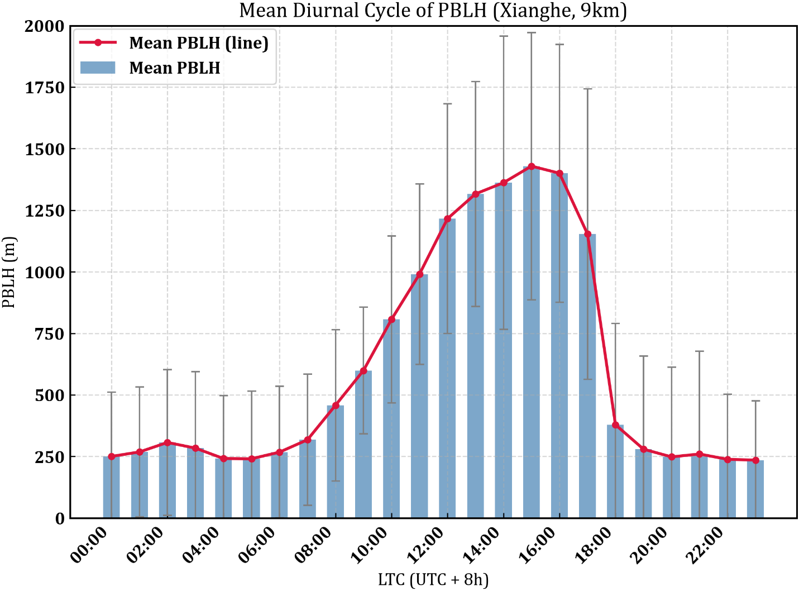

Supplementary Fig. S10. Simulated diurnal variations of PBLH at Xianghe Station.
Validation of the Meteorological Fields
To ensure the reliability of meteorological fields driving CMM transport simulations, we also validated model outputs against NCDC Integrated Surface Database (ISD) observations at four key stations along the Shanxi–BTH transport corridors: Datong (NE Shanxi core source region), Zhangzi (SE Shanxi core source region), Yuxian (terrain-modulated transitional zone), and Xingtai (EOF3-dominated transitional zone). Tree parameters were evaluated: air temperature, pressure, and wind fields, covering August 2022 with prominent transport phenomena.
For spatial interpolation, variable values at the target station were extracted from gridded WRF output via bilinear interpolation, which weighted the four nearest valid grid points by their relative latitudinal and longitudinal distances to the target location. For vertical interpolation, since the WRF model’s coordinates (sigma levels) do not explicitly coincide with the fixed heights of the tower sensor, a logarithmic height-weighted interpolation was employed to bridge the vertical gap. Furthermore, a geographic coordinate transformation was applied to align the model’s grid-relative wind vectors with the observed geographical north, ensuring a physically consistent comparison.
Validation results (Fig. S11–S14) confirm that the model’s meteorological inputs are physically consistent with observations, providing a solid foundation for both large-scale (EOF1) and local (EOF3) CMM transport analyses.
These validations strengthen the credibility of our core findings, ensuring that identified transport corridors and mitigation nodes are grounded in robust atmospheric dynamics, and supports the policy-directed trans-regional methane control strategies proposed in this study.
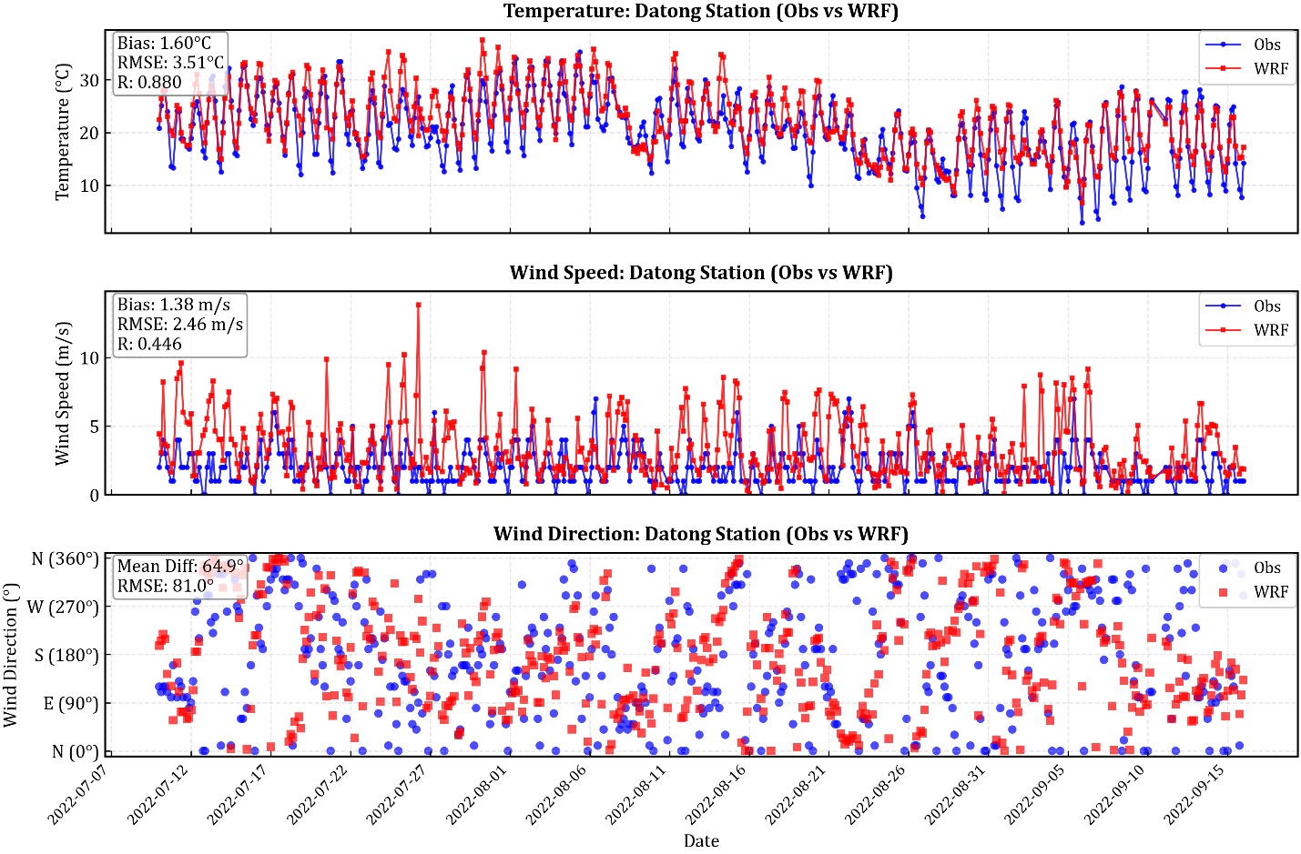

Supplementary Fig. S11. Comparison of observed and simulated meteorological variables at Datong Station (NE Shanxi core source region).
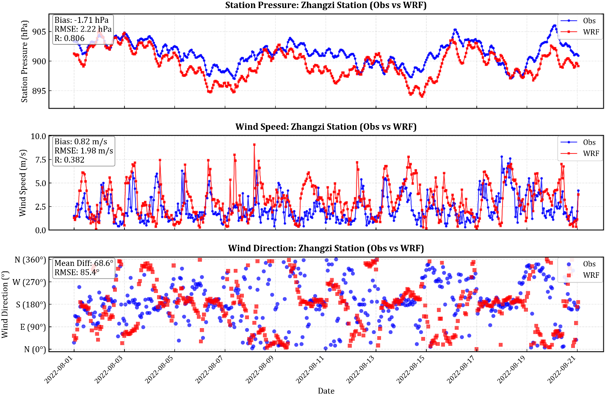

Supplementary Fig. S12. Comparison of observed and simulated meteorological variables at Zhangzi Station (SE Shanxi core source region).
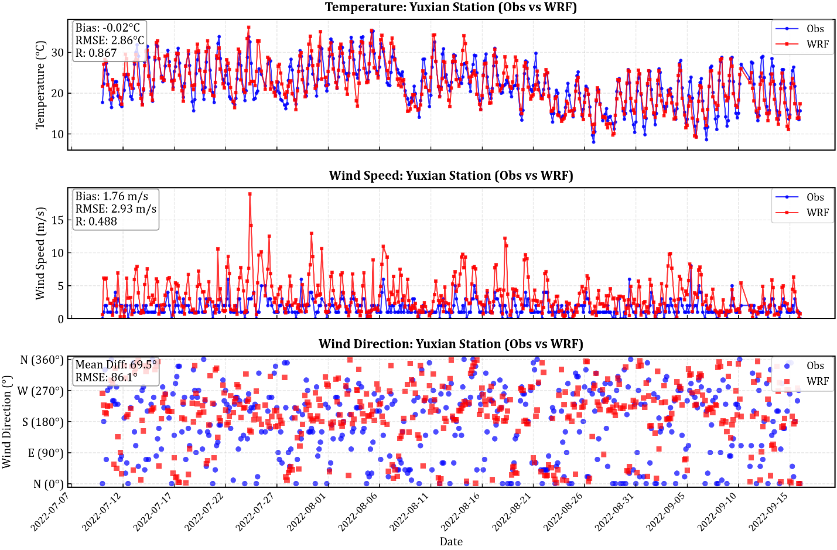

Supplementary Fig. S13. Comparison of observed and simulated meteorological variables at Yuxian Station (terrain-modulated transitional zone).
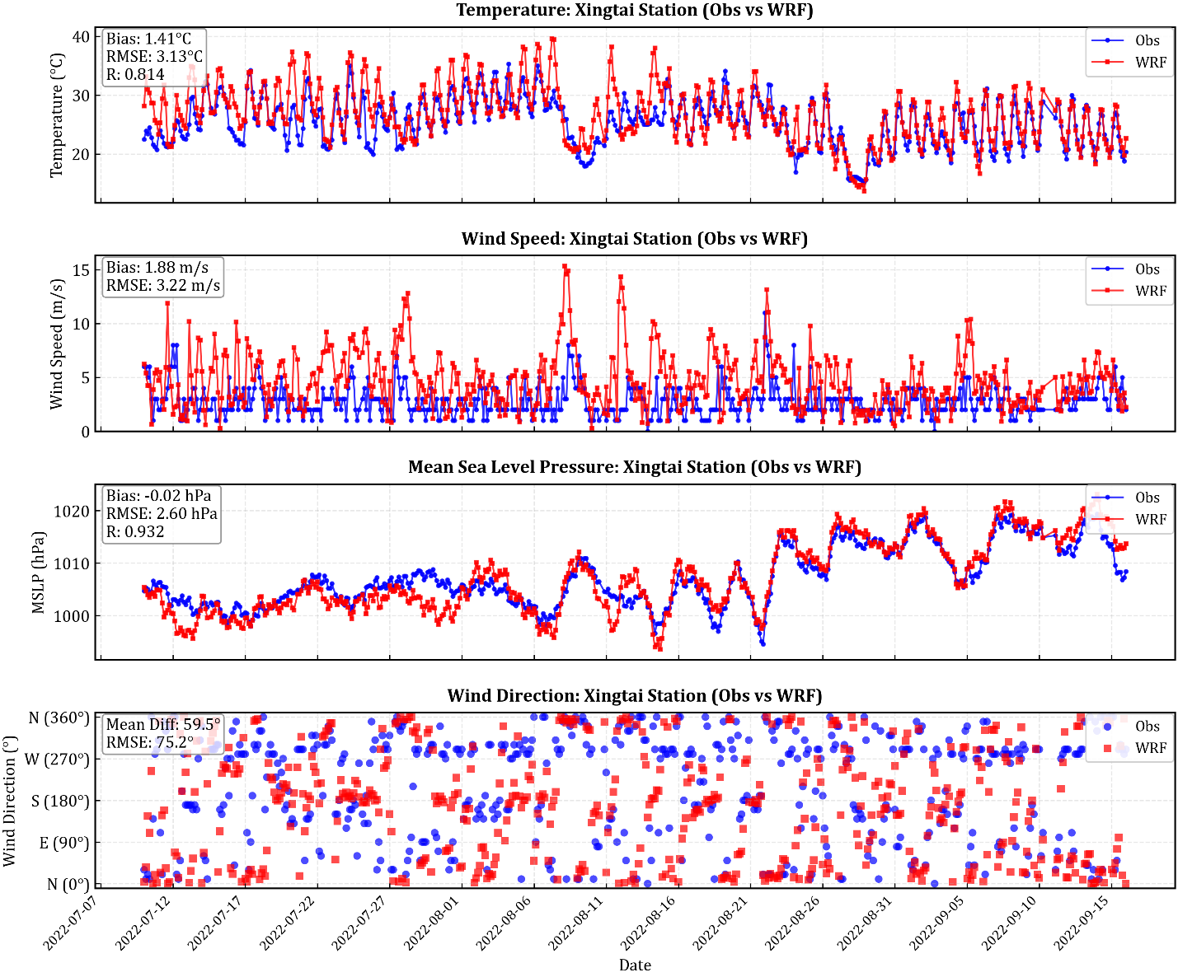

Supplementary Fig. S14. Comparison of observed and simulated meteorological variables at Xingtai Station (EOF3-dominated transitional zone).

Supplementary Note 6
Decomposition of BTH contributions and robustness of the Beijing-specific attribution at Xianghe
Rationale and attribution framework. The local contribution of emissions within the Beijing-Tianjin-Hebei (BTH) domain to the simulated XCH₄ column at the TCCON Xianghe station is isolated through the difference metrics Δ_{BTH} = Top-down − BTH-50%, Δ_{BJ} = Top-down − BJ-50%, and Δ_{TH} = Δ_{BTH} − Δ_{BJ}, where each perturbation simulation halves the anthropogenic emissions of the indicated administrative region while holding all other sources and meteorology fixed. For a passive tracer under identical transport, these differences are linear by construction, and the decomposition Δ_{BTH} = Δ_{BJ} + Δ_{TH} holds to within numerical precision (maximum residual < 10^{–13} ppbv across all matched timesteps).
Temporal alignment of the attribution. The Top-down baseline is archived at hourly resolution, whereas the BJ-50%, BTH-50% and Perturb±50% experiments are archived at 30-minute resolution. A physically meaningful tracer difference requires that both terms be sampled at an identical model output time. We therefore restrict the entire Δ_{BJ}, Δ_{TH} and Δ_{BTH} decomposition to the integer-hour timestamps present in both archives (335 common hours over 10 July to 15 September 2022, of which 134 fall in August), at which the hourly Top-down field and the corresponding half-hourly perturbation field share a true, co-incident model state. This eliminates the spurious sub-hourly drift that arises if an hourly value is carried forward to a half-hour timestamp during periods of rapid plume evolution, when the column can change by 10-30 ppbv within 30 minutes.
Full-period and August statistics. Over all 316 valid integer hours with a defined Δ_{BJ}, the Beijing-specific anomaly at Xianghe has a mean of −0.8 ppbv but a median of +0.5 ppbv, with 55.1% of hours positive (Supplementary Fig. S15a). The August subset (134 hours) is consistent, with a mean of −1.3 ppbv, a median of +0.1 ppbv, and 52.2% of hours positive. The positive median together with the majority-positive fraction demonstrates that the central tendency of the Beijing contribution is small and positive, and that the slightly negative mean is not a systematic feature but is controlled by a small number of strongly negative outlier hours in the left tail of the distribution. By contrast, the Tianjin-Hebei contribution (Δ_{TH}) is robustly positive throughout, with a domain-integrated mean of 31.9×10³ tons (10.2% of the EDGAR baseline emissions) over BTH.
Robustness to subset choice. To confirm that the near-zero Beijing attribution is not an artifact of a particular averaging window, Δ_{BJ} statistics were recomputed under three independent subsetting choices (Supplementary Table S6). Restricting to hours with a valid TCCON retrieval (n = 316) reproduces the full-period statistics identically (mean −0.8 ppbv, median +0.5 ppbv, 55.1% positive), because the model decomposition is defined at every common integer hour irrespective of TCCON sampling. Restricting to daytime UTC hours (00-09 UTC, approximately 08-17 local time; n = 295) yields a mean of −0.8 ppbv, a median of +0.5 ppbv, and 55.6% positive. The central tendency is therefore stable across all subset definitions, and the conclusion that the Beijing-specific contribution is statistically indistinguishable from zero is independent of the subsetting choice.
Behavior during extreme peak events. The ten TCCON extreme XCH₄ peak events (identified on the common integer-hour TCCON series using the 90th-percentile threshold of 1957.4 ppbv and a 12-hour minimum separation, consistent with the main-text Fig. 7c criterion) reveal a systematic divergence between the two contributions (Supplementary Fig. S15b). During these events the Tianjin-Hebei signal rises to a median of +29.4 ppbv (mean +25.2 ppbv, maximum +70.1 ppbv), whereas the Beijing term turns systematically negative (median −7.6 ppbv, mean −5.1 ppbv, with 40% of events positive). The negative Beijing contribution during these strong southwesterly regimes is a transport redistribution effect rather than a numerical error: halving Beijing’s local emissions slightly raises the simulated column at Xianghe because, under southwesterly flow, Beijing’s own emissions are advected north-eastward away from the receptor, while the column at Xianghe is dominated by the upwind Tianjin-Hebei and Shanxi plumes. This behavior is physically consistent with the location of Xianghe upwind of, and to the south of, the Beijing municipality under the prevailing transport regime.
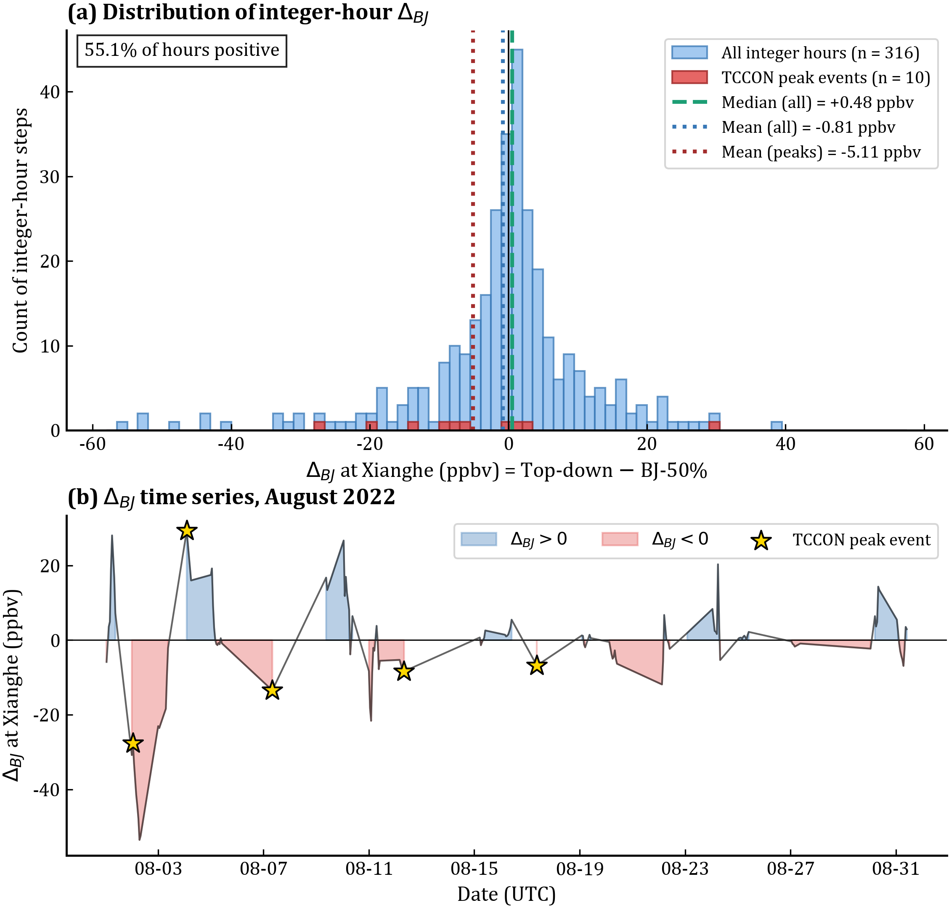

Supplementary Fig. S15. Robustness of the Beijing-specific attribution (Δ_{BJ}) at TCCON Xianghe. (a) Distribution of integer-hour Δ_{BJ} = Top-down − BJ-50% over the full simulation period (n = 316 hours; blue), with the subset of ten TCCON extreme peak events overlaid (red). Vertical lines mark the all-hour median (+0.5 ppbv), all-hour mean (−0.8 ppbv), and peak-event mean (−5.1 ppbv); 55.1% of all hours are positive. (b) Time series of integer-hour Δ_{BJ} over August 2022, with positive values shaded blue and negative values shaded red, and the TCCON extreme peak events marked by stars, showing that the Beijing contribution is small and predominantly positive outside peak events but turns negative during the strong southwesterly episodes that produce the extreme peaks.
Implication. The decomposition establishes two robust conclusions. First, the transboundary and intra-regional methane burden delivered to the BTH receptor region is overwhelmingly governed by the Tianjin-Hebei and upwind Shanxi sources rather than by Beijing’s local emissions, both in the monthly mean and, more strongly, during the extreme transport episodes that dominate the observed XCH₄ variability. Second, the apparent negative monthly-mean Δ_{BJ} reported in earlier analyses is fully explained as the combined effect of a small set of negative outlier hours on an otherwise positive-median distribution and the transport-redistribution behavior during peak events, and does not indicate any non-physical attribution. These findings support the use of high frequency observations in Xianghe as a sentinel station for monitoring the southeastern Shanxi-southern Hebei transboundary corridor.

Supplementary Table S6. Δ_{BJ} statistics at TCCON Xianghe under independent subset choices (integer-hour common grid).
Subset | n | Mean  (ppbv) | Median  (ppbv) | Positive (%) | Min | Max
Full period, TCCON-retrieval hours | 316 | −0.81 | +0.48 | 55.1 | −55.1 | +39.0
Full period, daytime UTC (00-09) | 295 | −0.84 | +0.52 | 55.6 | −55.1 | +39.0
August only, all integer hours | 134 | −1.32 | +0.10 | 52.2 | −53.5 | +29.2
August only, daytime UTC | 124 | −1.52 | +0.08 | 51.6 | −53.5 | +29.2
Peak-event hours only | 10 | −5.11 | −7.57 | 40.0 | −27.6 | +29.2

Supplementary References

1 Parrish DF, Derber JC. The National Meteorological Center’s spectral statistical-interpolation analysis system. Mon Wea Rev 120: 1747–1763 (1992).
2 Li Z, Zang ZL, Li QB, et al. A three-dimensional variational data assimilation system for multiple aerosol species with WRF/Chem and an application to PM_{2.5} prediction. Atmos. Chem. Phys. 13: 4265–4278 (2013).
3 Wang D, You W, Zang Z, et al. A three-dimensional variational data assimilation system for a size-resolved aerosol model: Implementation and application for particulate matter and gaseous pollutant forecasts across China. Sci China Earth Sci 63: 1366–1380 (2020).
4 Nisbet E, Weiss R. Top-down versus bottom-up. Science 328 (5983): 1241–1243 (2010).
5 Callewaert S, Zhou M, Langerock B, et al. A WRF-Chem study of the greenhouse gas column and in situ surface concentrations observed in Xianghe, China - Part 1: Methane (CH4). Atmos. Chem. Phys. 25: 9519–9544 (2025).
6 Tu Q, Hase F, et al. Emission characteristics of greenhouse gases and air pollutants in a Qinghai-Tibetan Plateau city using a portable Fourier transform spectrometer and TROPOMI observations, Atmos. Chem. Phys. 25: 17779–17796 (2025).
7 Sicsik-Paré A. Fortems-Cheiney A, et al. Can we obtain consistent estimates of the emissions in Europe from three different CH4 TROPOMI products?, EGUsphere [preprint] (2025).
8 Guan LY, Cohen JB., Wang S, et al. In-tandem multi-waveband particulate absorption and size observations yield substantial changes in radiative forcing over industrial Central China, Atmos. Chem. Phys 26, 3107–3123 (2026).
9 Vickers D, and L. Mahrt: Quality Control and Flux Sampling Problems for Tower and Aircraft Data. J. Atmos. Oceanic Technol. 14, 512–526 (1997).

