Atmospheric Heat Retention and Weakening Urban–Rural Thermal Contrast Driven by Surface Characteristics in the Indo-Gangetic Plains
Shahid Mirza¹, Rohini Lakshman Bhawar² and Sunil R. Patil^{1*}
¹Department of Physics, Institute of Science Nagpur, RT Road, Civil Lines, Nagpur, MS, India, 440001
²Department of Atmospheric and Space Sciences, Savitribai Phule Pune University, Ganeshkhind, Pune, MS, India, 411007

Supporting Information

S1: Climatic conditions and importance of study cities
Delhi, the national capital of India and a union territory, is a highly urbanized metropolitan region that integrates extensive historical heritage with modern infrastructure. It holds substantial political, cultural, and administrative significance(Dupont, 2011). The region experiences an extreme continental climate, characterized by very hot and dry summers, with temperatures frequently reaching up to 45 °C, and relatively cold winters (Ahmad et al., 2024). Agra is the next nearby city from Delhi (about 240 Km from the city centre), situated in the northern Indian state of Uttar Pradesh along the banks of the Yamuna River, is an internationally recognized historical city, noted for the ancient monuments. Agra possesses a rich architectural and cultural legacy and supports a predominantly tourism-driven economy (Roy et al., 2024). The city experiences an extreme continental climate with pronounced seasonal temperature variations(Mishra amishra et al., 2025).
Kanpur and Lucknow appear as the neighbouring cities as distance between these two is only 95 km from the centres. Kanpur is located on the banks of the Ganges River in Uttar Pradesh, is a prominent industrial and commercial canter. It plays a critical role in regional economic activity, particularly in textile, leather, and chemical manufacturing sectors. While, Lucknow, is the capital of Uttar Pradesh and a major urban centre in northern India and is situated along the Gomti River (Khan et al., 2024). City is recognized for its historical association with the traditional values and its importance in culture, education and commerce. An urban landscape that reflects a combination of 18th century architectural heritage and modern development. Both the cities exhibit humid and subtropical climate (Yadav & Ganguly, 2024).
Prayagraj and Varanasi are located in Uttar Pradesh and have significant religious and historical city. Prayagraj hosts three of biggest rivers such as Ganga, Yamuna and Saraswati and they met up at a junction called Triveni Sangam (Goswami, 2025). Prayagraj is globally known for hosting the Kumbh Mela, one of the largest religious gatherings in the world. City has hot summers exceeding 40°C, a pronounced monsoon season and relatively cool winters (Srivastava et al., 2023). Similarly, Varanasi is among the oldest continuously inhabited cities globally and serves as a major spiritual and cultural centre of India. Also known as Kashi or the “City of Light”. As both the cities surrounded by the rivers, the narrow urban morphology are formed in the existing landscape. Cities have a humid subtropical climate (Rajpriya & Rai, 2024; Singh, 2025).
Patna, the capital of Bihar, is a rapidly expanding urban centre located on the southern bank of the Ganges River. It holds considerable historical importance as one of the world’s oldest continuously inhabited cities and functions as a key administrative, commercia and educational hub (AAI, 2026). The city experiences a humid subtropical climate, marked by hot summers, substantial monsoonal rainfall and cool winters. Due to the large number of industries and mines in the region of Bihar state, the LST of the whole region remains elevated(Jaiswal et al., 2023).

S2: Urban boundary comparison for early and late window analysis
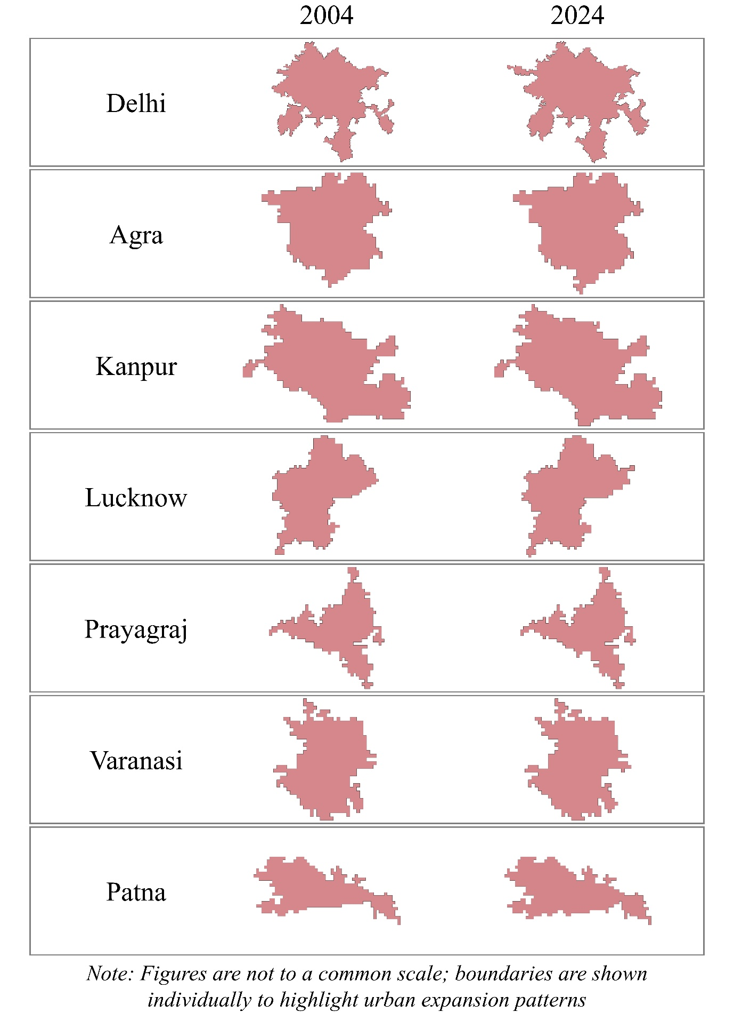
Figure S1: Urban boundary comparison for early and late window analysis

S3: Mathematical methods for the estimation of WS, RH, and PD
Near-surface wind speed (WS) is calculated from the orthogonal 10 m horizontal vector components (u: ‘u_component_of_wind_10m’ and v: ‘v_component_of_wind_10m’) using equation 4 as gridded resultant wind speed.
𝑊𝑆=𝑢²+𝑣² | (1)
Relative humidity (RH) is determined from air temperature (T) and dewpoint temperature (T_{d}) bands (from the ERA5-Land reanalysis dataset) via the Magnus–Tetens formulation (Lawrence, 2004) given by equation 5. RH is defined as the ratio of actual vapor pressure ‘$e$’ (equation 6) to the saturation vapor pressure ‘$e_{s}$’ (equation 7) over a plane water surface at a given temperature (Alduchov et al., 1996), typically expressed as a percentage.
$$RH=\left(\frac{e}{e_{s}}\right)×100$$ | (2)
$$e=0.6108×exp\left(\frac{17.27×T_{d}}{243.04+T_{d}}\right)$$ | (3)
$$e_{s}=0.6108×exp\left(\frac{17.27×T}{243.04+T}\right)$$ | (4)
Population density is extracted strictly within the exact delineated urban polygon for each city using the following procedure:
Spatial Aggregation: Total population within the urban boundary was calculated by summing the 100 m pixel values ($P=\sum{pixels}$) for the available endpoint years (2000 and 2020).
Compound Annual Growth Rate (CAGR): The 20-year annual growth rate ($r$) is determined using:
$$r={\left(\frac{P_{2020}}{P_{200}}\right)}^{\frac{1}{20}}-1$$ | (5)
Annual Projection (2020–2024): Population for each year $t∈\left[2020,2024\right]$ is projected using:
$$P_{t}=P_{2020}×{\left(1+r\right)}^{t-2020}$$ | (6)
Population Density (PD): For each year, population density was computed directly over the physical urban polygon area ($A_{urban}$ in km²):
$${PD}_{t}=\frac{P_{t}}{A_{urban}}$$ | (7)
S4: Spatial SUHI intensities across the season of all the cities
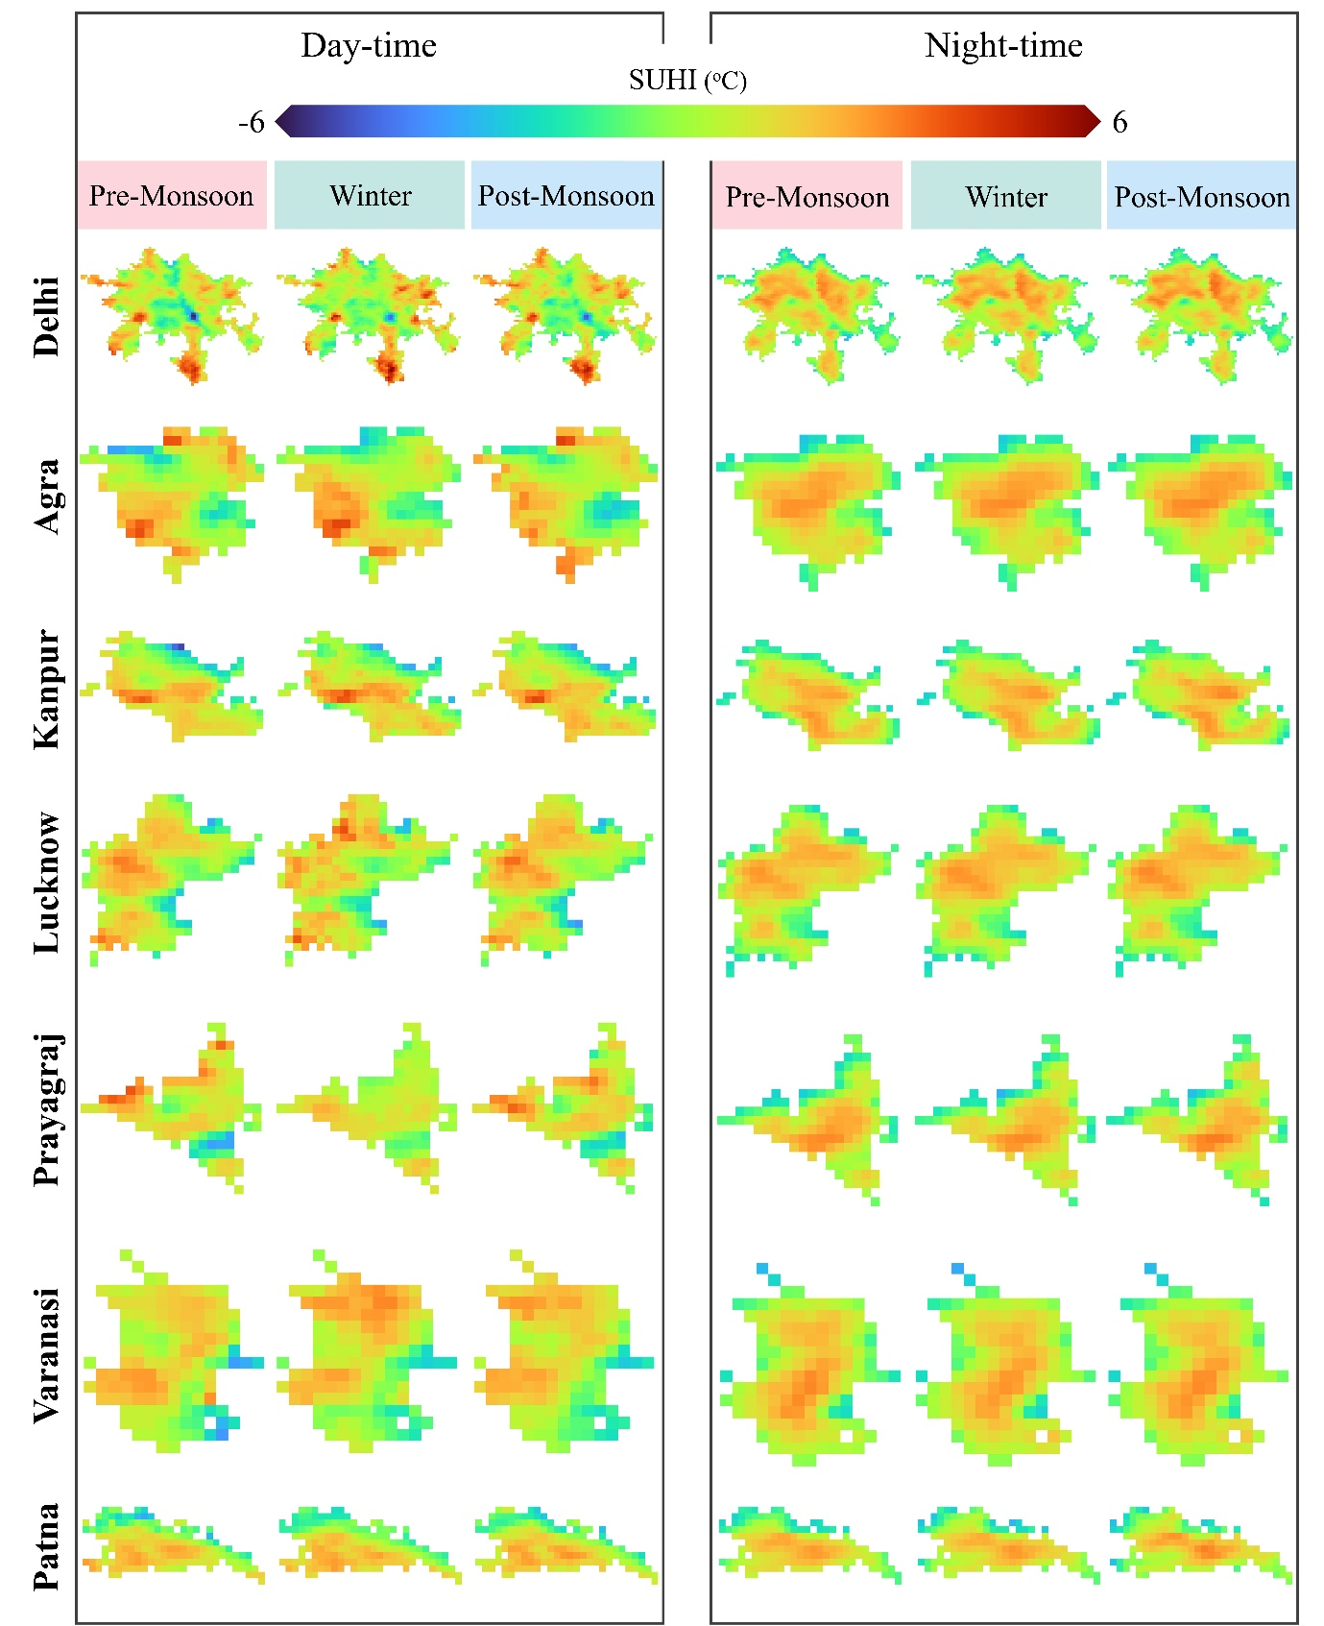
Figure S2: Seasonal diurnal SUHI intensities maps of all the cities

S5. Pearson correlation matrix
- Pre-Monsoon
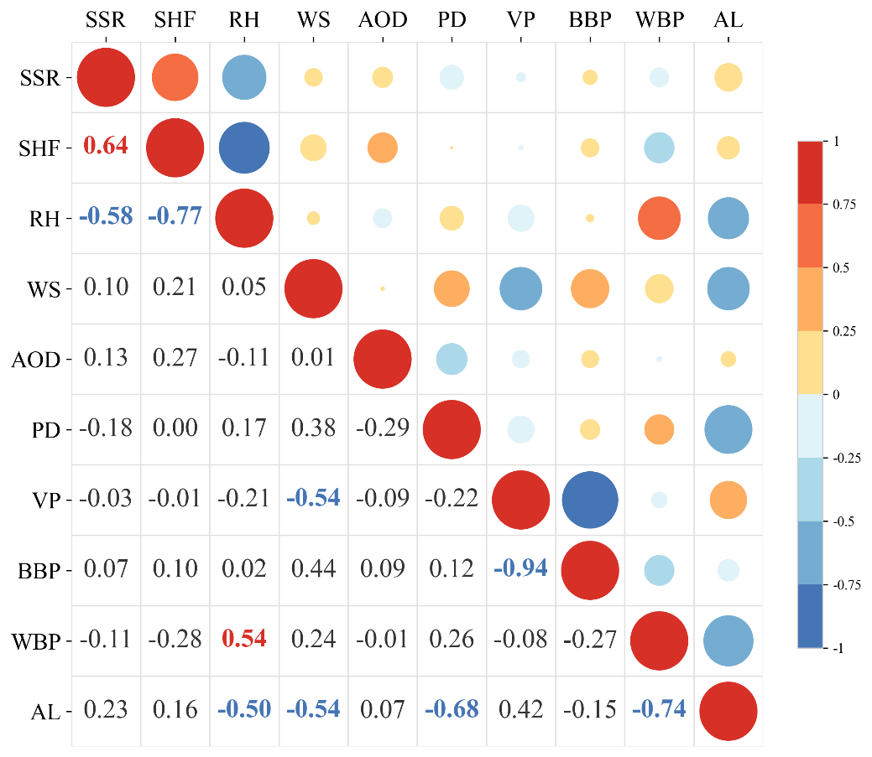

- Winter
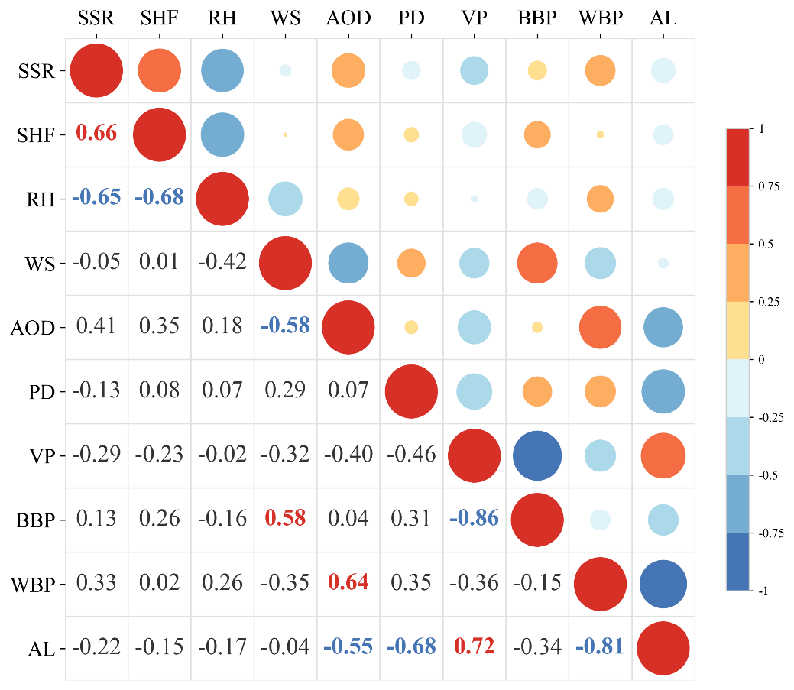

- Post-Monsoon
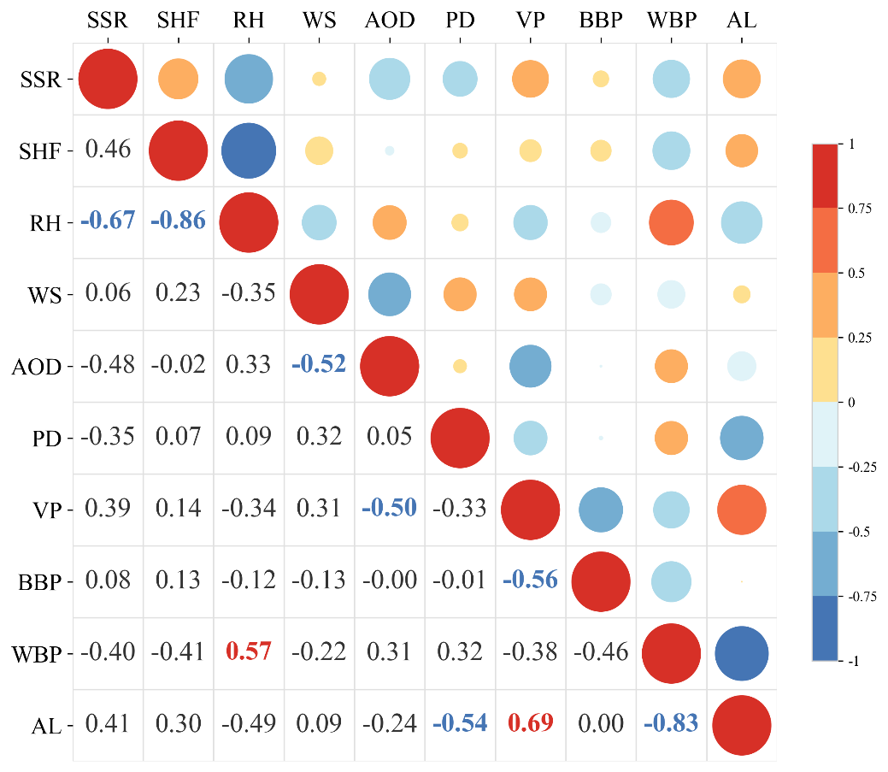

S6: PLS regression model summary
S6.1: Pre – Monsoon Season
Daytime:
Calibration Performance (R²) | 0.8378
Validation Performance (Q²) | 0.7262
Calibration Error (RMSEC) | 0.2518 °C
Cross-Validation Error (RMSECV) | 0.3271 °C

Components | R²_Calibration | Q²_Validation | RMSEC | RMSECV
1 | 0.723751 | 0.646637 | 0.32863 | 0.371678
2 | 0.789031 | 0.697689 | 0.287188 | 0.343783
3 | 0.820466 | 0.679023 | 0.26493 | 0.354237
4 | 0.824918 | 0.696412 | 0.261624 | 0.344508
5 | 0.837788 | 0.72624 | 0.251825 | 0.327146

Predictor | Standardized_Coef | Direction | VIP | VIP > 1 | Significance_level
BBP | 0.323851 | Positive (+) | 1.831302 | Yes | *** (p < 0.05)
VP | -0.14631 | Negative (-) | 1.513569 | Yes | ** (p < 0.10)
WBP | -0.52432 | Negative (-) | 1.127139 | Yes | *** (p < 0.05)
PD | -0.43835 | Negative (-) | 1.085332 | Yes | *** (p < 0.05)
WS | 0.346406 | Positive (+) | 0.718664 | No | *** (p < 0.05)
AL | 0.016364 | Positive (+) | 0.690113 | No | Not significant
SHF | -0.2523 | Negative (-) | 0.636431 | No | *** (p < 0.05)
RH | 0.29679 | Positive (+) | 0.507221 | No | ** (p < 0.10)
SSR | 0.113502 | Positive (+) | 0.367946 | No | Not significant
AOD | -0.00278 | Negative (-) | 0.341495 | No | Not significant

Nighttime:
Calibration Performance (R²) | 0.8289
Validation Performance (Q²) | 0.6986
Calibration Error (RMSEC) | 0.1956 °C
Cross-Validation Error (RMSECV) | 0.2597 °C

Components | R²_Calibration | Q²_Validation | RMSEC | RMSECV
1 | 0.615908 | 0.47105 | 0.293172 | 0.344043
2 | 0.756994 | 0.645059 | 0.233192 | 0.281827
3 | 0.797755 | 0.685971 | 0.212737 | 0.265088
4 | 0.818837 | 0.684652 | 0.201345 | 0.265644
5 | 0.828941 | 0.698588 | 0.195649 | 0.259708

Predictor | Standardized_Coef | Direction | VIP | VIP > 1 | Significance_Tier
WBP | -0.41741 | Negative (-) | 1.799624 | Yes | *** (p < 0.05)
SSR | -0.72928 | Negative (-) | 1.338665 | Yes | *** (p < 0.05)
BBP | 0.234789 | Positive (+) | 1.252625 | Yes | *** (p < 0.05)
RH | -0.4463 | Negative (-) | 1.064502 | Yes | *** (p < 0.05)
AL | 0.038669 | Positive (+) | 0.80432 | No | Not significant
VP | -0.09321 | Negative (-) | 0.721015 | No | * (p < 0.20)
SHF | 0.140474 | Positive (+) | 0.668693 | No | Not significant
PD | 0.002786 | Positive (+) | 0.506509 | No | Not significant
AOD | -0.11801 | Negative (-) | 0.502446 | No | Not significant
WS | 0.143172 | Positive (+) | 0.379673 | No | Not significant

S6.2: Winter Season
Daytime:
Calibration Performance (R²) | 0.7449
Validation Performance (Q²) | 0.6199
Calibration Error (RMSEC) | 0.3316 °C
Cross-Validation Error (RMSECV) | 0.4047 °C

Components | R²_Calibration | Q²_Validation | RMSEC | RMSECV
1 | 0.526797 | 0.430898 | 0.451561 | 0.495208
2 | 0.643574 | 0.522534 | 0.391902 | 0.453591
3 | 0.690078 | 0.554402 | 0.365443 | 0.438192
4 | 0.744856 | 0.619906 | 0.331578 | 0.404705
5 | 0.76714 | 0.582772 | 0.316767 | 0.424014

Predictor | Standardized_Coef | Direction | VIP | VIP > 1 | Significance_Tier
WBP | -0.4153 | Negative (-) | 1.603335 | Yes | *** (p < 0.05)
AL | 0.743959 | Positive (+) | 1.592069 | Yes | *** (p < 0.05)
PD | 0.136986 | Positive (+) | 1.165932 | Yes | Not significant
BBP | 0.396476 | Positive (+) | 0.919333 | No | *** (p < 0.05)
AOD | -0.16545 | Negative (-) | 0.913779 | No | *** (p < 0.05)
RH | -0.10067 | Negative (-) | 0.789147 | No | Not significant
VP | -0.17467 | Negative (-) | 0.714338 | No | * (p < 0.20)
WS | -0.12695 | Negative (-) | 0.581071 | No | Not significant
SHF | -0.1915 | Negative (-) | 0.49919 | No | Not significant
SSR | 0.09249 | Positive (+) | 0.381205 | No | Not significant

Nighttime:
Calibration Performance (R²) | 0.7563
Validation Performance (Q²) | 0.6361
Calibration Error (RMSEC) | 0.1612 °C
Cross-Validation Error (RMSECV) | 0.1970 °C

Components | R²_Calibration | Q²_Validation | RMSEC | RMSECV
1 | 0.740759 | 0.610934 | 0.166248 | 0.203665
2 | 0.756314 | 0.636077 | 0.161183 | 0.196974
3 | 0.767213 | 0.589691 | 0.157537 | 0.209151
4 | 0.775305 | 0.561092 | 0.154775 | 0.216317
5 | 0.782471 | 0.567544 | 0.152287 | 0.214721

Predictor | Standardized_Coef | Direction | VIP | VIP > 1 | Significance_Tier
WS | 0.270364 | Positive (+) | 1.549244 | Yes | *** (p < 0.05)
BBP | 0.243934 | Positive (+) | 1.47529 | Yes | *** (p < 0.05)
RH | -0.23041 | Negative (-) | 1.2977 | Yes | *** (p < 0.05)
VP | -0.14858 | Negative (-) | 1.018284 | Yes | *** (p < 0.05)
SHF | 0.131825 | Positive (+) | 0.873779 | No | *** (p < 0.05)
AOD | 0.108282 | Positive (+) | 0.90402 | No | Not significant
PD | 0.11412 | Positive (+) | 0.677689 | No | *** (p < 0.05)
SSR | 0.094036 | Positive (+) | 0.635609 | No | *** (p < 0.05)
WBP | -0.12842 | Negative (-) | 0.617794 | No | *** (p < 0.05)
AL | -0.01283 | Negative (-) | 0.305461 | No | Not significant

S6.3: Post-Monsoon Season
Daytime:
Calibration Performance (R²) | 0.6033
Validation Performance (Q²) | 0.3082
Calibration Error (RMSEC) | 0.5484 °C
Cross-Validation Error (RMSECV) | 0.7242 °C

Components | R²_Calibration | Q²_Validation | RMSEC | RMSECV
1 | 0.356987 | 0.214795 | 0.698146 | 0.771486
2 | 0.476765 | 0.276199 | 0.629774 | 0.740706
3 | 0.503121 | 0.277023 | 0.613708 | 0.740284
4 | 0.582067 | 0.270849 | 0.562846 | 0.743439
5 | 0.603261 | 0.308165 | 0.548389 | 0.724165

Predictor | Standardized_Coef | Direction | VIP | VIP > 1 | Significance_Tier
BBP | 0.310303 | Positive (+) | 1.369182 | Yes | *** (p < 0.05)
VP | 0.085518 | Positive (+) | 1.238837 | Yes | Not significant
RH | 0.883778 | Positive (+) | 1.147111 | Yes | *** (p < 0.05)
AL | -0.80542 | Negative (-) | 1.092909 | Yes | *** (p < 0.05)
SHF | 0.233827 | Positive (+) | 1.087323 | Yes | Not significant
WBP | -0.60843 | Negative (-) | 0.934587 | No | *** (p < 0.05)
AOD | -0.1721 | Negative (-) | 0.775054 | No | *** (p < 0.05)
SSR | 0.219759 | Positive (+) | 0.811522 | No | Not significant
WS | 0.179542 | Positive (+) | 0.57613 | No | Not significant
PD | -0.28981 | Negative (-) | 0.465659 | No | Not significant

Nighttime:
Calibration Performance (R²) | 0.7415
Validation Performance (Q²) | 0.5391
Calibration Error (RMSEC) | 0.1822 °C
Cross-Validation Error (RMSECV) | 0.2433 °C

Components | R²_Calibration | Q²_Validation | RMSEC | RMSECV
1 | 0.631453 | 0.511482 | 0.217576 | 0.250498
2 | 0.741526 | 0.539096 | 0.18221 | 0.243315
3 | 0.757517 | 0.509399 | 0.176484 | 0.251032
4 | 0.770656 | 0.476155 | 0.171636 | 0.259398
5 | 0.774857 | 0.428396 | 0.170057 | 0.270965

Predictor | Standardized_Coef | Direction | VIP | VIP > 1 | Significance_Tier
RH | -0.23867 | Negative (-) | 1.402204 | Yes | *** (p < 0.05)
SHF | 0.226697 | Positive (+) | 1.209581 | Yes | *** (p < 0.05)
WBP | -0.19154 | Negative (-) | 1.203932 | Yes | *** (p < 0.05)
WS | 0.27288 | Positive (+) | 1.181671 | Yes | *** (p < 0.05)
AOD | 0.146106 | Positive (+) | 0.908228 | No | ** (p < 0.10)
SSR | 0.01551 | Positive (+) | 0.847448 | No | Not significant
BBP | 0.208239 | Positive (+) | 0.825737 | No | *** (p < 0.05)
AL | 0.035462 | Positive (+) | 0.821868 | No | Not significant
VP | -0.08261 | Negative (-) | 0.687704 | No | * (p < 0.20)
PD | 0.147381 | Positive (+) | 0.584409 | No | ** (p < 0.10)

References
AAI. (2026). Details about Patna. AIRPORTS AUTHORITY OF INDIA. https://www.aai.aero/en/node/185307
Ahmad, B., Najar, M. B., & Ahmad, S. (2024). Analysis of LST, NDVI, and UHI patterns for urban climate using Landsat-9 satellite data in Delhi. Journal of Atmospheric and Solar-Terrestrial Physics, 265, 106359. https://doi.org/10.1016/J.JASTP.2024.106359
Alduchov, O. A., Eskridge, R. E., Alduchov, O. A., Eskridge, R. E., Alduchov, A., O., Eskridge, & E., R. (1996). Improved Magnus Form Approximation of Saturation Vapor Pressure. JApMe, 35(4), 601–609. https://doi.org/10.1175/1520-0450(1996)035
Dupont, V. D. N. (2011). The Dream of Delhi as a Global City. International Journal of Urban and Regional Research, 35(3), 533–554. https://doi.org/10.1111/J.1468-2427.2010.01027.X;WGROUP:STRING:PUBLICATION
Goswami, A. (2025). Prayagraj and the Kumbha Melā: The Transformation and Prospects for Cultural Tourism. Urban Book Series, Part F1080, 375–395. https://doi.org/10.1007/978-3-031-97137-2_19
Jaiswal, T., Jhariya, D., & Kishore, N. (2023). The Effects of Coal Mining on Land Use and Land Surface Temperature: A Case Study of Korba District, Chhattisgarh. Journal of Environmental Informatics Letters, 10(1), 53–62. https://doi.org/10.3808/jeil.202300112
Khan, D., Khan, N., Choudhury, U., Singh, S. K., Kanga, S., Kumar, P., & Meraj, G. (2024). Urban Expansion and Spatial Growth Patterns in Lucknow: Implications for Sustainable Development (1991–2021). Sustainability 2025, Vol. 17, 17(1). https://doi.org/10.3390/SU17010227
Lawrence, M. G. (2004). The Relationship between Relative Humidity and the Dewpoint Temperature in Moist Air A Simple Conversion and Applications. AMERICAN METEOROLOGICAL SOCIETY. https://doi.org/10.1175/BAMS-86-2-225
Mishra amishra, A., S Arya, hyiitracin D., Jaiswal, S., Singh Pushkar, D., Mishra, A., Arya, D. S., & Kumar, A. (2025). Investigating the effects of land use, land cover change, and urban heat island effects in Agra city, India, using a remote sensing approach. Discover Cities 2025 2:1, 2(1), 105-. https://doi.org/10.1007/S44327-025-00149-0
Rajpriya, & Rai, V. K. (2024). Groundwater and Sustainable Development Goals: Water Table Characteristics in Varanasi City. 245–267. https://doi.org/10.1007/978-981-97-1685-2_14
Roy, U. K., Roy, U. K., & Sharma, D. (2024). Economic Implications and Public Readiness for Urban Green Space Development in Agra: A Strategic Evaluation in the City of Taj. Journal of Contemporary Urban Affairs, 8(2), 529–545. https://doi.org/10.25034/ijcua.2024.v8n2-14
Singh, K. K. (2025). Assessment of the cooling effect of urban green spaces (UGS) and urban parks in Varanasi City, India. Theoretical and Applied Climatology 2025 156:7, 156(7), 400-. https://doi.org/10.1007/S00704-025-05618-5
Srivastava, A., Shukla, S., Singh, P., & Jha, P. K. (2023). Spatio-temporal dynamics of land use/cover and land surface temperature in Prayagraj city, India. Indoor and Built Environment, 32(6), 1250–1268. https://doi.org/10.1177/1420326X231159633;PAGE:STRING:ARTICLE/CHAPTER
Yadav, V., & Ganguly, R. (2024). Variation of ambient air pollutants and their impacts on Kanpur city, India, during 2016–2020. Journal of Earth System Science 2024 133:3, 133(3), 145-. https://doi.org/10.1007/S12040-024-02350-Y

