Figure 1. Study sample selection flowchart
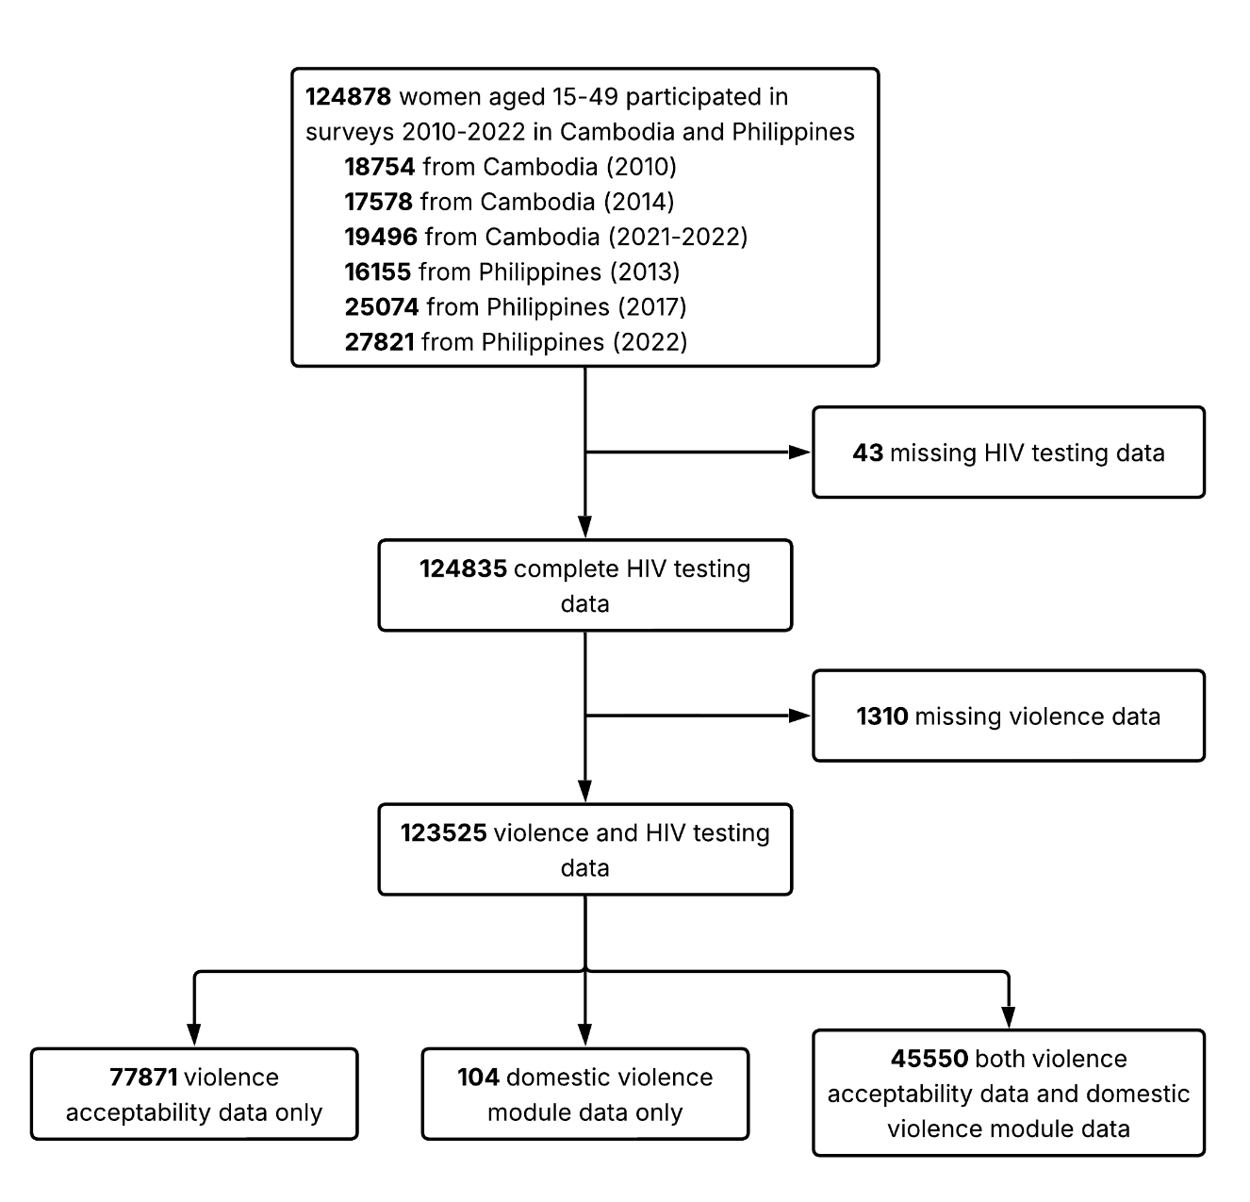

Table 1. Experiences of all forms of violence and attitudes towards violence among women aged 15–49 in the Philippines and Cambodia, overall and by country
Violence exposure | Philippines, n (%) | Cambodia, n (%) | Overall, n (%)
Experienced any violence
Yes | 8,272 (23.0%) | 2,298 (23.7%) | 10,570 (23.2%)
No | 27,686 (77.0%) | 7,398 (76.3%) | 35,084 (76.8%)
Experienced any emotional violence
Yes | 7085 (19.7%) | 2036 (21.0%) | 9121 (20.0%)
No | 28872 (80.3%) | 7660 (79.0%) | 36532 (80.0%)
Experienced any physical violence
Severe physical violence | 1431 (4.0%) | 411 (4.2%) | 1842 (4.0%)
Less severe physical violence | 2088 (5.8%) | 706 (7.3%) | 2794 (6.1%)
No physical violence | 32433 (90.2%) | 8579 (88.5%) | 41012 (89.8%)
Experienced any sexual violence
Yes | 1385 (3.9%) | 332 (3.4%) | 1717 (3.8%)
No | 34571 (96.1%) | 9364 (96.6%) | 43935 (96.2%)
Wife beating justified: any reason
Yes | 8,113 (11.9%) | 24,269 (44.0%) | 32,382 (26.2%)
No | 6,0190 (88.1%) | 30,849 (56.0%) | 91,039 (73.8%)
Wife beating justified: goes out without telling husband
Yes | 2657 (3.9%) | 15126 (27.9%) | 17783 (14.6%)
No | 65291 (96.1%) | 39053 (72.1%) | 104344 (85.4%)
Wife beating justified: neglects children
Yes | 6272 (9.3%) | 20830 (38.2%) | 27102 (22.2%)
No | 61519 (90.7%) | 33638 (61.8%) | 95157 (77.8%)
Wife beating justified: argues with husband
Yes | 1898 (2.8%) | 11688 (21.6%) | 13586 (11.1%)
No | 65881 (97.2%) | 42443 (78.4%) | 108324 (88.9%)
Wife beating justified: refuses sex with husband
Yes | 1064 (1.6%) | 6516 (12.3%) | 7580 (6.3%)
No | 66509 (98.4%) | 46597 (87.7%) | 113106 (93.7%)
Wife beating justified: burns the food
Yes | 1002 (1.5%) | 6395 (11.7%) | 7397 (6.0%)
No | 67075 (98.5%) | 48259 (88.3%) | 115334 (94.0%)
Can respondent refuse husband sex
Yes | 27195 (89.9%) | 33237 (91.9%) | 60432 (91.0%)
No | 3044 (10.1%) | 2943 (8.1%) | 5987 (9.0%)

Table 2. Association between attitudes to violence and HIV testing among women aged 15–49 in the Philippines, by marital status
Violence type | Currently married |  |  |  | Never married |  |  |  | Formerly married
 | Exposed, n | HIV tested, n (%) | OR (95% CI) | aOR (95% CI) | Exposed, n | HIV tested, n (%) | OR (95% CI) | aOR (95% CI) | Exposed, n | HIV tested, n (%) | OR (95% CI) | aOR (95% CI)
Wife beating justified: any reason
No | 35757 | 2365 (6.6%) | ref. | ref. | 22131 | 508 (2.3%) | ref. | ref. | 2302 | 177 (7.7%) | ref. | ref.
Yes | 5014 | 282 (5.6%) | 0.84 (0.74–0.95) | 0.99 (0.86–1.13) | 2755 | 52 (1.9%) | 0.82 (0.61–1.08) | 1.01 (0.74–1.34) | 344 | 26 (7.6%) | 0.98 (0.63–1.48) | 1.05 (0.65–1.61)
Wife beating justified: argues with husband
No | 39430 | 2574 (6.5%) | ref. | ref. | 23902 | 550 (2.3%) | ref. | ref. | 2549 | 196 (7.7%) | ref. | ref.
Yes | 1153 | 64 (5.6%) | 0.84 (0.65–1.08) | 0.95 (0.72–1.24) | 661 | 6 (0.9%) | 0.39 (0.15–0.80) | 0.47 (0.18–0.96) | 84 | 5 (6.0%) | 0.76 (0.26–1.72) | 0.93 (0.32–2.15)
Wife beating justified: burns the food
No | 40142 | 2627 (6.5%) | ref. | ref. | 24327 | 555 (2.3%) | ref. | ref. | 2606 | 201 (7.7%) | ref. | ref.
Yes | 583 | 17 (2.9%) | 0.43 (0.25–0.67) | 0.61 (0.36–0.96) | 380 | 4 (1.1%) | 0.46 (0.14–1.07) | 0.64 (0.20–1.53) | 39 | 2 (5.1%) | 0.65 (0.10–2.13) | 0.45 (0.02–2.17)
Wife beating justified: neglects children
No | 36691 | 2422 (6.6%) | ref. | ref. | 22449 | 516 (2.3%) | ref. | ref. | 2379 | 184 (7.7%) | ref. | ref.
Yes | 3871 | 219 (5.7%) | 0.85 (0.73–0.98) | 1.01 (0.87–1.17) | 2141 | 41 (1.9%) | 0.83 (0.59–1.13) | 1.01 (0.71–1.38) | 260 | 18 (6.9%) | 0.89 (0.52–1.43) | 0.93 (0.54–1.52)
Wife beating justified: goes out without telling husband
No | 38839 | 2582 (6.6%) | ref. | ref. | 23933 | 553 (2.3%) | ref. | ref. | 2519 | 196 (7.8%) | ref. | ref.
Yes | 1792 | 57 (3.2%) | 0.46 (0.35–0.60) | 0.63 (0.47–0.83) | 748 | 6 (0.8%) | 0.34 (0.14–0.70) | 0.56 (0.22–1.16) | 117 | 5 (4.3%) | 0.53 (0.19–1.18) | 0.78 (0.27–1.79)
Wife beating justified: refuses sex with husband
No | 39984 | 2603 (6.5%) | ref. | ref. | 23948 | 552 (2.3%) | ref. | ref. | 2577 | 200 (7.8%) | ref. | ref.
Yes | 665 | 34 (5.1%) | 0.77 (0.54–1.08) | 0.99 (0.68–1.40) | 336 | 5 (1.5%) | 0.64 (0.23–1.40) | 0.84 (0.30–1.86) | 63 | 3 (4.8%) | 0.59 (0.14–1.62) | 0.80 (0.19–2.24)
Can respondent refuse husband sex
No | 3047 | 127 (4.2%) | ref. | ref. | - | - | - | - | - | - | - | -
Yes | 27202 | 2258 (8.3%) | 2.08 (1.74–2.51) | 1.59 (1.32–1.92)

Table 3. Association between attitudes to violence and HIV testing among women aged 15–49 in Cambodia, by marital status
Violence type | Currently married |  |  |  | Never married |  |  |  | Formerly married
 | Exposed, n | HIV tested, n (%) | OR (95% CI) | aOR (95% CI) | Exposed, n | HIV tested, n (%) | OR (95% CI) | aOR (95% CI) | Exposed, n | HIV tested, n (%) | OR (95% CI) | aOR (95% CI)
Wife beating justified: any reason
No | 19658 | 10372 (52.8%) | ref. | ref. | 9202 | 771 (8.4%) | ref. | ref. | 1989 | 873 (43.9%) | ref. | ref.
Yes | 17111 | 7677 (44.9%) | 0.73 (0.70–0.76) | 0.83 (0.80–0.87) | 5514 | 398 (7.2%) | 0.85 (0.75–0.96) | 0.90 (0.79–1.03) | 1644 | 625 (38.0%) | 0.78 (0.69–0.90) | 0.86 (0.75–0.99)
Wife beating justified: argues with husband
No | 27853 | 14466 (51.9%) | ref. | ref. | 11840 | 1014 (8.6%) | ref. | ref. | 2750 | 1195 (43.5%) | ref. | ref.
Yes | 8455 | 3378 (40.0%) | 0.62 (0.59–0.65) | 0.71 (0.67–0.74) | 2410 | 141 (5.9%) | 0.66 (0.55–0.79) | 0.71 (0.59–0.85) | 823 | 282 (34.3%) | 0.68 (0.58–0.80) | 0.78 (0.65–0.92)
Wife beating justified: burns the food
No | 32034 | 16284 (50.8%) | ref. | ref. | 13115 | 1086 (8.3%) | ref. | ref. | 3110 | 1324 (42.6%) | ref. | ref.
Yes | 4504 | 1674 (37.2%) | 0.57 (0.54–0.61) | 0.67 (0.62–0.72) | 1395 | 78 (5.6%) | 0.66 (0.51–0.83) | 0.70 (0.55–0.88) | 496 | 165 (33.3%) | 0.67 (0.55–0.82) | 0.73 (0.59–0.90)
Wife beating justified: neglects children
No | 21735 | 11298 (52.0%) | ref. | ref. | 9716 | 816 (8.4%) | ref. | ref. | 2187 | 954 (43.6%) | ref. | ref.
Yes | 14736 | 6634 (45.0%) | 0.76 (0.73–0.79) | 0.85 (0.81–0.89) | 4686 | 339 (7.2%) | 0.85 (0.74–0.97) | 0.90 (0.78–1.03) | 1408 | 532 (37.8%) | 0.78 (0.68–0.90) | 0.85 (0.74–0.99)
Wife beating justified: goes out without telling husband
No | 25134 | 13128 (52.2%) | ref. | ref. | 11379 | 945 (8.3%) | ref. | ref. | 2540 | 1106 (43.5%) | ref. | ref.
Yes | 11169 | 4741 (42.4%) | 0.67 (0.64–0.71) | 0.77 (0.73–0.81) | 2923 | 207 (7.1%) | 0.84 (0.72–0.98) | 0.88 (0.75–1.04) | 1034 | 369 (35.7%) | 0.72 (0.62–0.84) | 0.79 (0.67–0.92)
Wife beating justified: refuses sex with husband
No | 31260 | 16026 (51.3%) | ref. | ref. | 12322 | 1062 (8.6%) | ref. | ref. | 3015 | 1309 (43.4%) | ref. | ref.
Yes | 4821 | 1739 (36.1%) | 0.54 (0.50–0.57) | 0.62 (0.58–0.66) | 1171 | 60 (5.1%) | 0.57 (0.43–0.74) | 0.63 (0.48–0.82) | 524 | 170 (32.4%) | 0.63 (0.51–0.76) | 0.70 (0.56–0.86)
Can respondent refuse husband sex
No | 2968 | 1012 (34.1%) | ref. | ref. | - | - | - | - | - | - | - | -
Yes | 33306 | 16916 (50.8%) | 1.99 (1.84–2.16) | 1.79 (1.64–1.95)

Table 4. Association between experiences of violence and HIV testing among women aged 15–49 in the Philippines, by marital status

Violence type | Currently married |  |  |  | Never married |  |  |  | Formerly married
 | Exposed, n | HIV tested, n (%) | OR (95% CI) | aOR (95% CI) | Exposed, n | HIV tested, n (%) | OR (95% CI) | aOR (95% CI) | Exposed, n | HIV tested, n (%) | OR (95% CI) | aOR (95% CI)
Experienced any violence
No | 25262 | 1641 (6.5%) | ref. | ref. | 1467 | 80 (5.5%) | ref. | ref. | 957 | 56 (5.9%) | ref. | ref.
Yes | 7174 | 444 (6.2%) | 0.95 (0.85–1.06) | 0.93 (0.83–1.03) | 213 | 23 (10.8%) | 2.10 (1.26–3.37) | 1.86 (1.09–3.05) | 885 | 88 (9.9%) | 1.78 (1.26–2.53) | 1.64 (1.15–2.35)
Experienced any emotional violence
No | 26351 | 1700 (6.5%) | ref. | ref. | 1490 | 85 (5.7%) | ref. | ref. | 1031 | 61 (5.9%) | ref. | ref.
Yes | 6084 | 385 (6.3%) | 0.98 (0.87–1.10) | 0.95 (0.84–1.07) | 190 | 18 (9.5%) | 1.73 (0.99–2.88) | 1.55 (0.87–2.65) | 811 | 83 (10.2%) | 1.81 (1.29–2.57) | 1.67 (1.17–2.39)
Experienced any physical violence
No | 29426 | 1896 (6.4%) | ref. | ref. | 1641 | 99 (6.0%) | ref. | ref. | 1366 | 97 (7.1%) | ref. | ref.
Less severe | 1847 | 111 (6.0%) | 0.93 (0.76–1.13) | 0.91 (0.74–1.11) | 24 | 2 (8.3%) | 1.42 (0.22–4.90) | 1.02 (0.16–3.80) | 217 | 21 (9.7%) | 1.40 (0.83–2.26) | 1.31 (0.77–2.16)
Severe | 1158 | 78 (6.7%) | 1.05 (0.82–1.32) | 1.07 (0.83–1.35) | 15 | 2 (13.3%) | 2.40 (0.37–8.83) | 1.47 (0.22–5.70) | 258 | 26 (10.1%) | 1.47 (0.91–2.28) | 1.42 (0.86–2.25)
Experienced any sexual violence
No | 31308 | 2018 (6.4%) | ref. | ref. | 1655 | 95 (5.7%) | ref. | ref. | 1608 | 112 (7.0%) | ref. | ref.
Yes | 1126 | 67 (6.0%) | 0.92 (0.71–1.17) | 0.91 (0.69–1.17) | 25 | 8 (32.0%) | 7.73 (3.09–17.85) | 6.74 (2.58–16.40) | 234 | 32 (13.7%) | 2.12 (1.37–3.18) | 2.05 (1.30–3.15)

Table 5. Association between experiences of violence and HIV testing among women aged 15–49 in Cambodia, by marital status
Violence type | Currently married |  |  |  | Never married |  |  |  | Formerly married
 | Exposed, n | HIV tested, n (%) | OR (95% CI) | aOR (95% CI) | Exposed, n | HIV tested, n (%) | OR (95% CI) | aOR (95% CI) | Exposed, n | HIV tested, n (%) | OR (95% CI) | aOR (95% CI)
Experienced any violence
No | 6851 | 4051 (59.1%) | ref. | ref. | 132 | 16 (12.1%) | ref. | ref. | 415 | 183 (44.1%) | ref. | ref.
Yes | 2006 | 996 (49.7%) | 0.68 (0.62–0.75) | 0.75 (0.67–0.84) | 10 | 3 (30.0%) | 3.11 (0.62–12.48) | 3.45 (0.56–18.17) | 282 | 152 (53.9%) | 1.48 (1.09–2.01) | 1.52 (1.09–2.11)
Experienced any emotional violence
No | 7085 | 4172 (58.9%) | ref. | ref. | 133 | 16 (12.0%) | ref. | ref. | 442 | 199 (45.0%) | ref. | ref.
Yes | 1772 | 875 (49.4%) | 0.68 (0.61–0.76) | 0.76 (0.68–0.85) | 9 | 3 (33.3%) | 3.66 (0.72–15.38) | 4.07 (0.64–23.68) | 255 | 136 (53.3%) | 1.40 (1.02–1.90) | 1.45 (1.04–2.03)
Experienced any physical violence
No | 7911 | 4594 (58.1%) | ref. | ref. | 139 | 18 (12.9%) | ref. | ref. | 529 | 247 (46.7%) | ref. | ref.
Less severe | 623 | 306 (49.1%) | 0.70 (0.59–0.82) | 0.72 (0.60–0.86) | 3 | 1 (33.3%) | 3.36 (0.15–36.86) | 3.68 (0.13–55.05) | 80 | 46 (57.5%) | 1.54 (0.96–2.50) | 1.49 (0.89–2.50)
Severe | 323 | 147 (45.5%) | 0.60 (0.48–0.75) | 0.77 (0.61–0.99) |  |  |  |  | 88 | 42 (47.7%) | 1.04 (0.66–1.64) | 0.99 (0.61–1.62)
Experienced any sexual violence
No | 8601 | 4920 (57.2%) | ref. | ref. | 141 | 18 (12.8%) | ref. | ref. | 622 | 297 (47.7%) | ref. | ref.
Yes | 256 | 127 (49.6%) | 0.74 (0.57–0.94) | 0.78 (0.60–1.02) | 1 | 1 (100.0%) | 39345054.55 (0.00–NA) | 285316336.71 (0.00–NA) | 75 | 38 (50.7%) | 1.12 (0.70–1.82) | 1.07 (0.64–1.79)

