Supplementary material for
“Substrate preference, phylogenetic and biochemical properties of proteolytic bacteria present in the digestive tract of Nile tilapia”
Tanim Jabid Hossain^{1,2*}, Mukta Das^{1,2}, Ferdausi Ali³, Sumaiya Islam Chowdhury^{1,2}, Subrina Akter Zedny^{1,2}
¹ Department of Biochemistry and Molecular Biology, University of Chittagong, Chattogram 4331, Bangladesh
² Biochemistry and Pathogenesis of Microbes Research Group, Chattogram 4331, Bangladesh
³ Department of Microbiology, University of Chittagong, Chattogram 4331, Bangladesh
* Correspondence: Tanim Jabid Hossain
E-mail: tanim.bmb@gmail.com

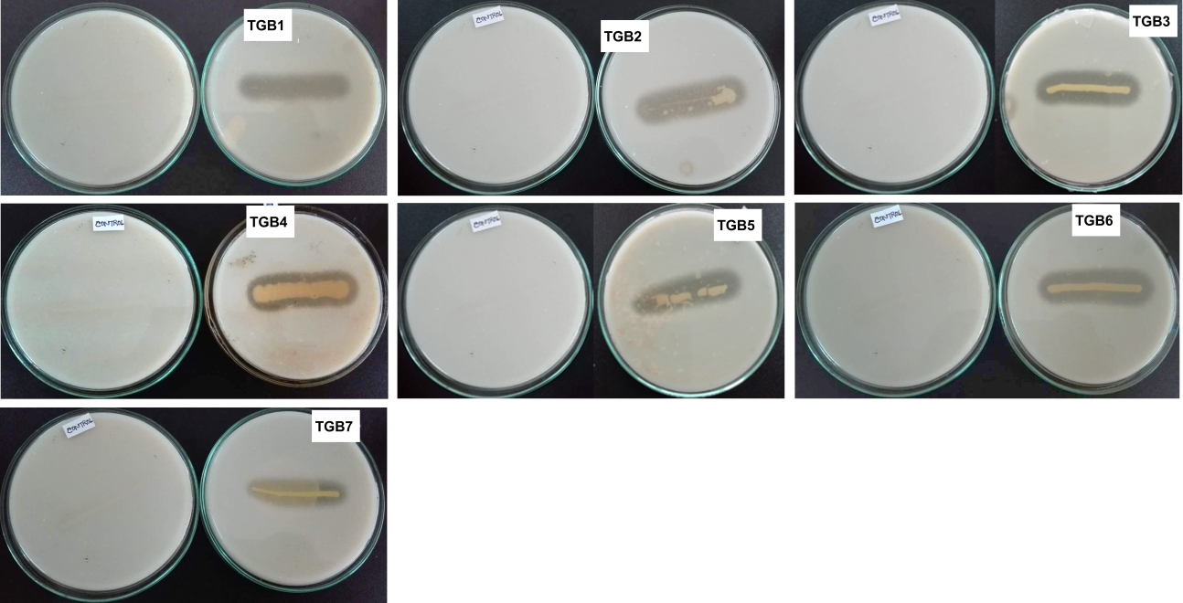

Supplementary Figure S1. Screening for proteolytic activity of the isolates, indicated by clear zones around the colonies grown on media containing casein. For each isolate, the plate at the left shows negative control in which bacteria without proteolytic activity was streaked on the media.

