Supplementary information
Figure S1
Risk score distribution of the m6A-related lncRNA signature in the trainning dataset (A) and testing dataset (B), respectively. The upper panel represent the risk score distribution from low-risk group to high risk group. The middle panel represent the cases distribution and the lower panel represent the expression of each lncRNA in the dataset.
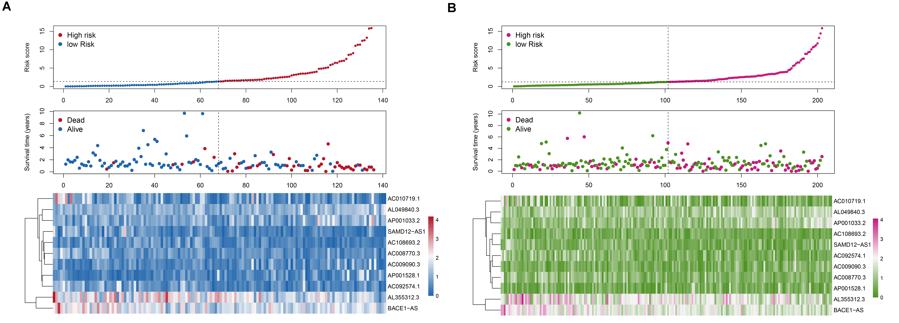
Figure S2
Area under curves of risk scores and prognostic lncRNAs for patients with GC in training set.
