High Siglec15 Expression in Triple Negative Breast Cancer Predicts Poor Prognosis

——Supplementary Data

Supplementary Figure 1. Siglec-15 antibody and immunohistochemical staining in preliminary experiments

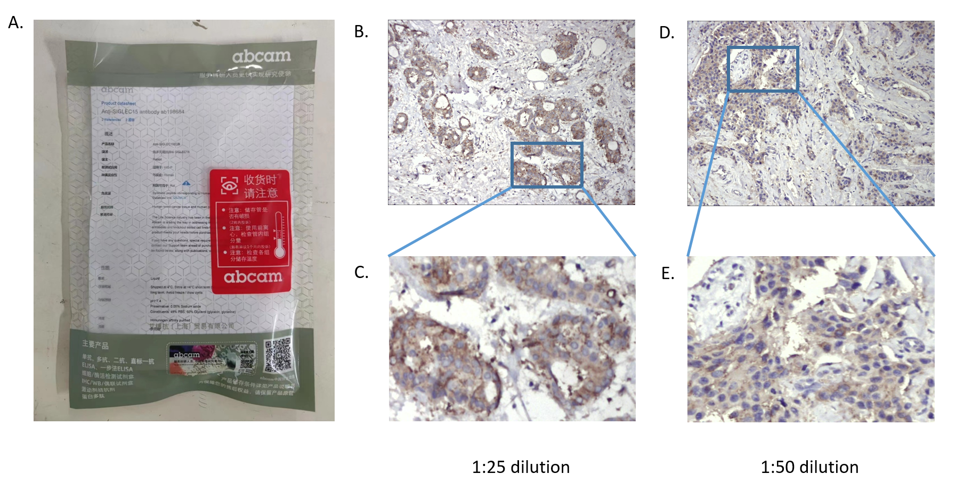

A. Rabbit polyclonal anti-human Siglec-15 antibody (Abcam, # ab198684) was ordered for this study.
B. and C. Immunohistochemical staining with 1:25 diluted Siglec-15 antibody. The staining was too strong.
D. and E. Immunohistochemical staining with 1:50 diluted Siglec-15 antibody. The staining was appropriate for formal study.

Supplementary Figure 2. Approval document of the Institutional Review Board

A. Chinese version: (approval document number: 050432-4-1911D)
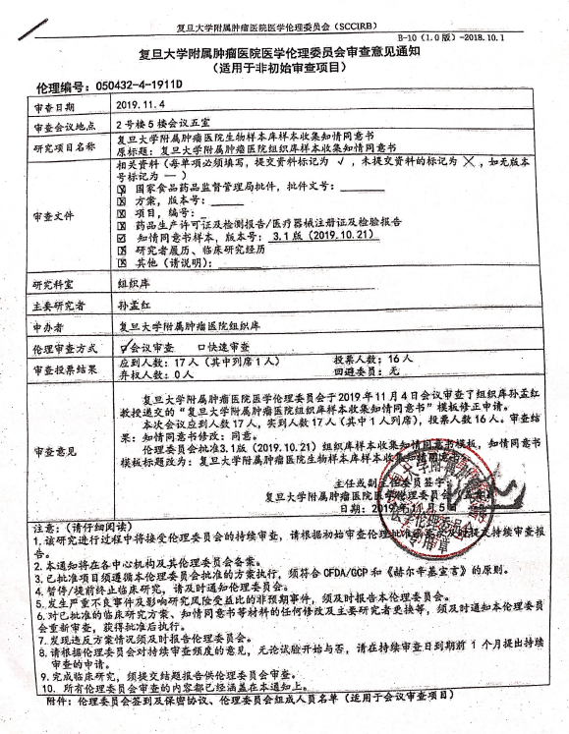

B. Translation version:

The Review Advice Inform of the Medical Ethics Committee of Fudan University Shanghai Cancer Center
(Available to non-initial review project)
Ethics Number: 050432-4-1911D
Review Date: | 2019.11.04
Venue: | Conference Room 5, 5th Flour, Building 2
Title of Research Study: | Informed Consent Form of Sample Collection in Biological Sample Bank of FUSCC  Original Title: Informed Consent Form of Sample Collection in Tissue Bank of FUSCC
Review File | Relative Information(Each item must be filled out, the submitted marks √,not submitted marks ×, if not available marks --)  - State Food and Drug Administration Approval Document, Approval Document No.:_  - Program, Version No. :  - Item, No.:_  - Pharmaceutical Manufacturing License and Test Report / Medical Device Registration Certificate and Inspection Report  - Sample Informed Consent Form, Version No.: Version 3.1 (2019. 10.21).  - Investigator's Curriculum Vitae, Clinical Research Experience  - Other (please specify):
Research Department | Tissue Bank
Main Researcher | Sun Menghong
Applicant | Tissue Bank of FUSCC
Ethic Review Method | - Meeting Review  - Quick Review
Vote Result | Attendance: 17(including attendance without voting rights:1 ) Voter: 16  Abstention: 0 Avoided Member: 0
Review Advice | The Medical Ethics Committee of Fudan University Shanghai Cancer Center reviewed the application for template updating of "Informed Consent Form of Sample Collection in Tissue Bank of FUSCC" submitted by Professor Sun Menghong from Tissue Bank at the meeting on November 4, 2019.  The number of attendance at the meeting was 17, and attendees was 17 (1 of whom was present), and the number of voters was 16. Review result: Informed Consent Form Amendment: Consent.  The Ethics Committee approved version 3.1 (2019. 10.21) of the informed consent template for tissue bank sample collection, and the title of the informed consent template was changed to: Informed Consent Form of Sample Collection in Biological Sample Bank of FUSCC.  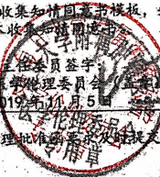  Signed by Director or Vice Director:  Medical Ethics Committee of Fudan University Shanghai Cancer Center  Date: November 6, 2019
Note: (Please read carefully)
- The study will be subject to continuous review by the Ethics Committee, please submit the review report in time refer to initial review ethics approval letter.
2. This notice will be filed in each center institution and its Ethics Committee.
3. Approved projects must follow the protocol approved by this ethics committee and must comply with the principles of CFDA/GCP and the Helsinki Manifesto.
4. If clinical research is suspended or early terminated, please inform the Ethics Committee in time.
5. The occurrence of serious adverse events counteracting unintended events affecting the risk-benefit ratio of the study shall be reported to this Ethics Committee in a timely manner.
6. Any modification of the approved clinical research protocol, informed consent form and other materials, as well as the replacement of the principal investigator, please notice to the Ethics Committee for re-examination promptly and implement after approval.
7. Any violation of the protocol must be reported to the Ethics Committee in a timely manner.
B. Please apply for continuous review one month before the expiration of the continuous review date according to the opinion of the Ethics Committee on the frequency of continuous review, regardless of whether the trial is started or not.
9. Upon completion of the clinical study, a final report must be submitted for review by the Ethics Committee.
10. All ethics committee reviews are covered in the notice.
Appendix: Registration and Confidentiality Agreement of the Ethics Committee, List of Members of the Ethics Committee (applicable to the meeting review project)

Supplementary Figure 3. High Siglec-15 expression TNBC patients had a poorer survival

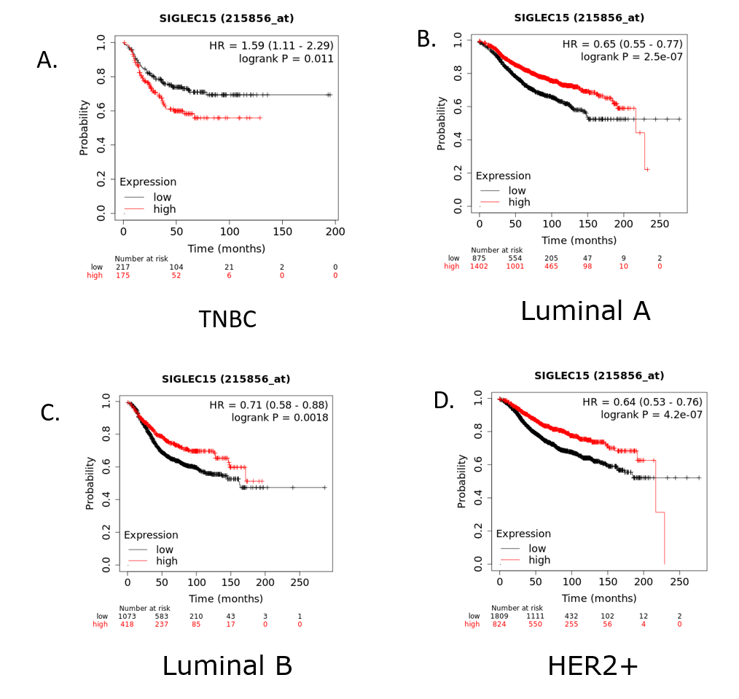
The Kaplan–Meier Plotter database (https://kmplot.com) was used to validate the survival analysis and calculate the hazard ratio.
A. Triple-negative breast cancer patients with high Siglec-15 expression had a poorer prognosis than those with low Siglec-15 expression (HR=1.59, 95% confidence interval 1.11-2.29. p=0.011).
B. Low Siglec-15 expression had a poorer prognosis in luminal A subtypes.
C. Low Siglec-15 expression had a poorer prognosis in luminal B subtypes.
D. Low Siglec-15 expression had a poorer prognosis in Her2+ subtypes.

