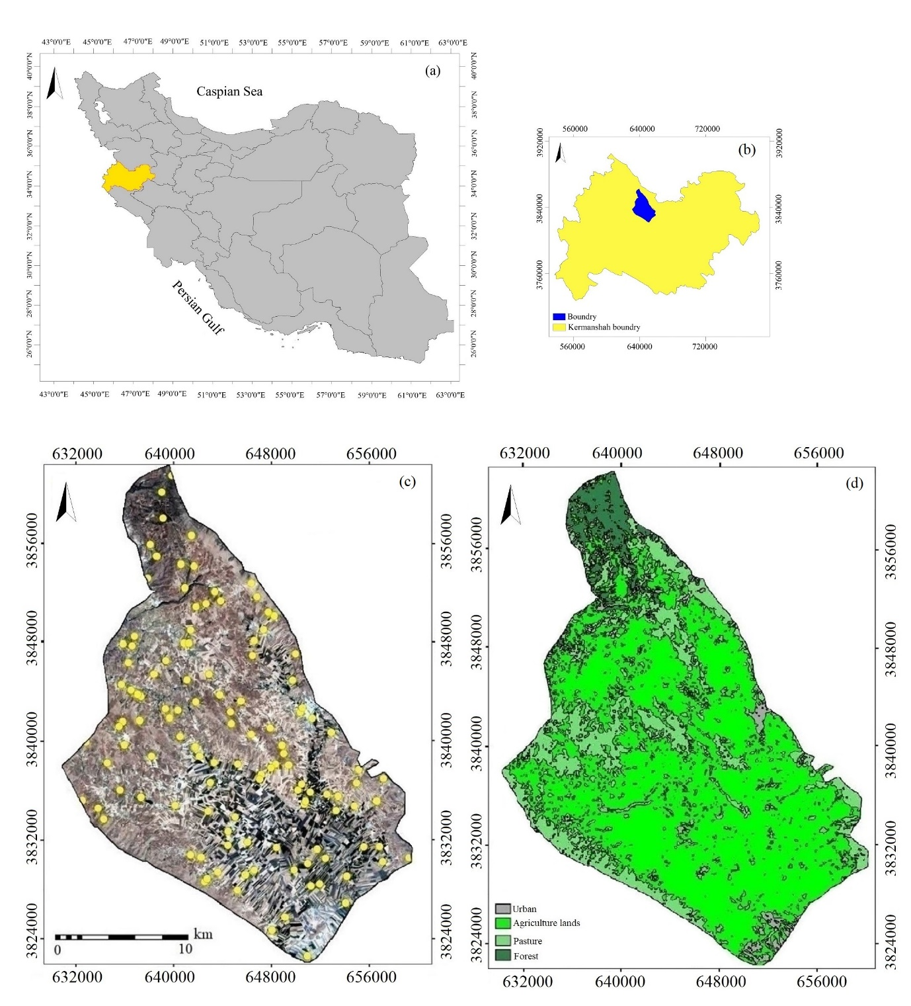
Fig. 1. (a) Location of Kermanshah Province within Iran; (b) location of the study area within Kermanshah Province; (c) spatial distribution of soil sampling points; and (d) land-use map of the study area (UTM projection, and Zone 38).
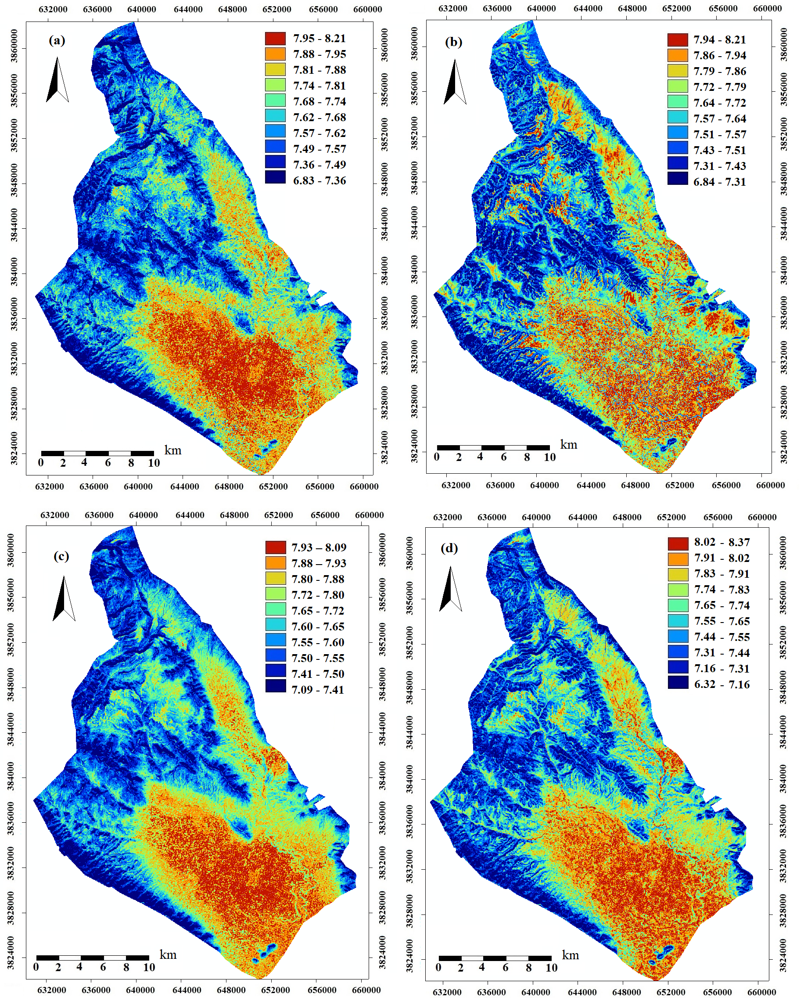
Fig 2. Spatial prediction maps of soil pH produced by (a) XGBoost, (b) SVM, (c) RF, and (d) Cubist models using the VIF method.

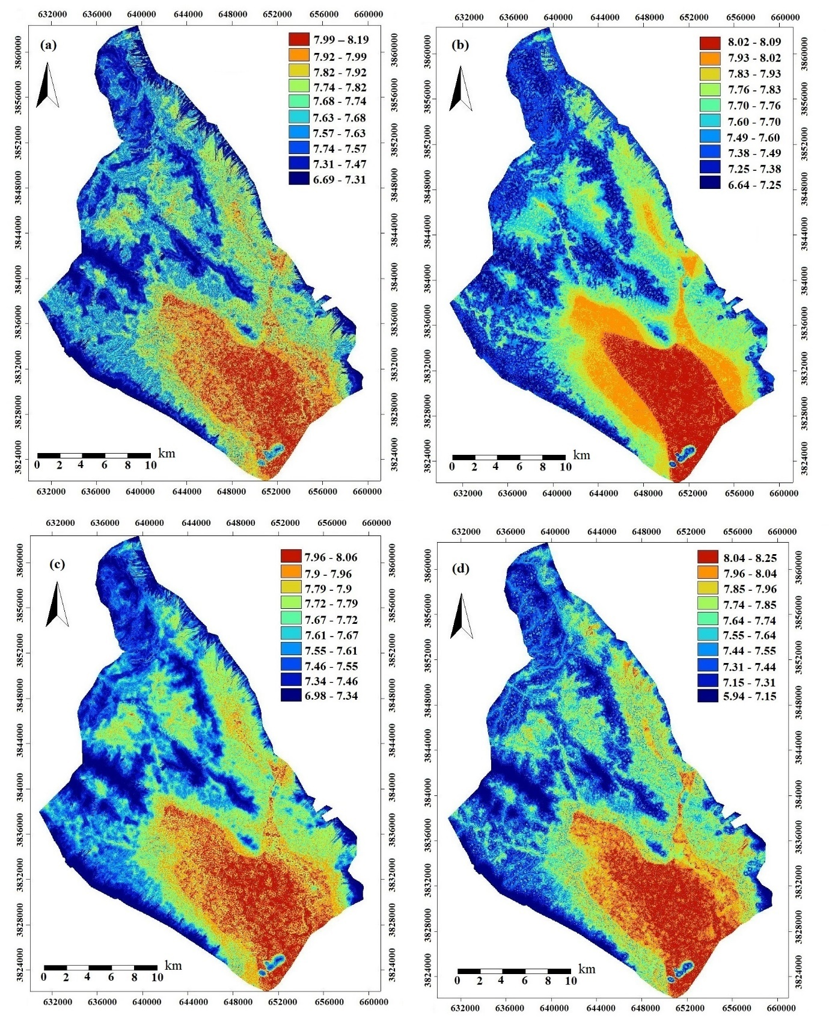
Fig 3. Spatial prediction maps of soil pH produced by (a) XGBoost, (b) SVM, (c) RF, and (d) Cubist models using the RFE method.

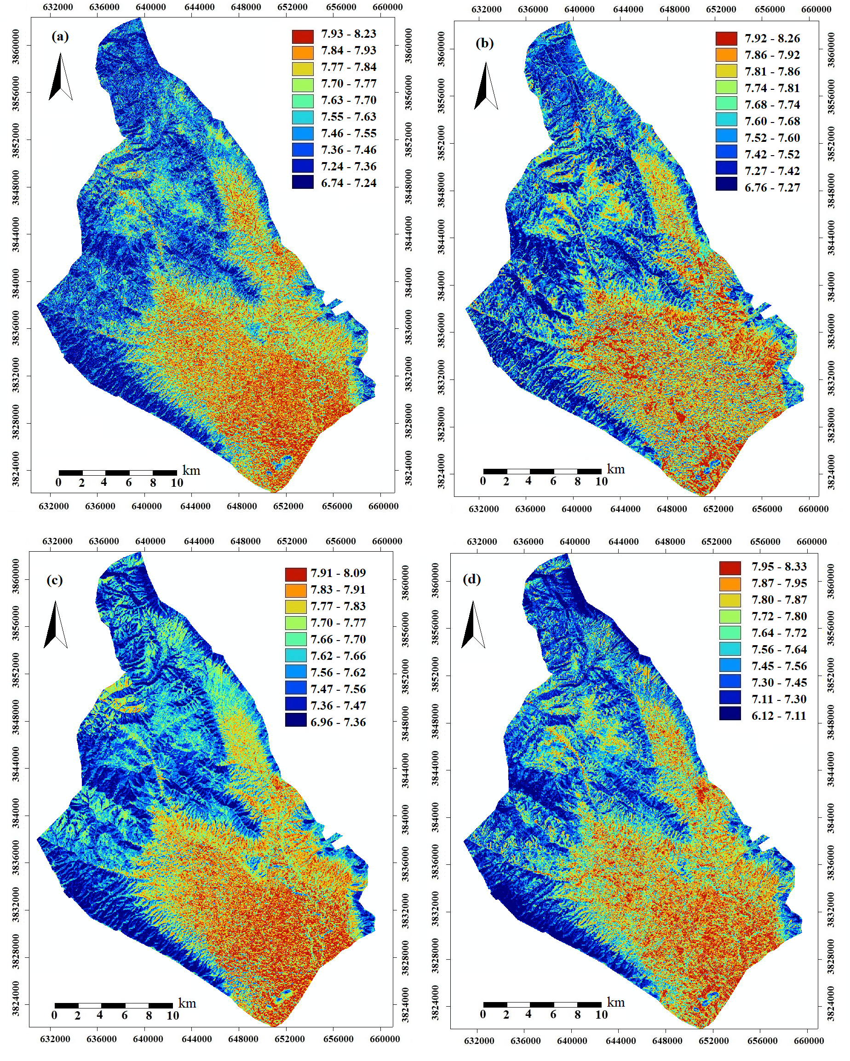
Fig 4. Spatial prediction maps of soil pH produced by (a) XGBoost, (b) SVM, (c) RF, and (d) Cubist models using the SA-FS1 method.

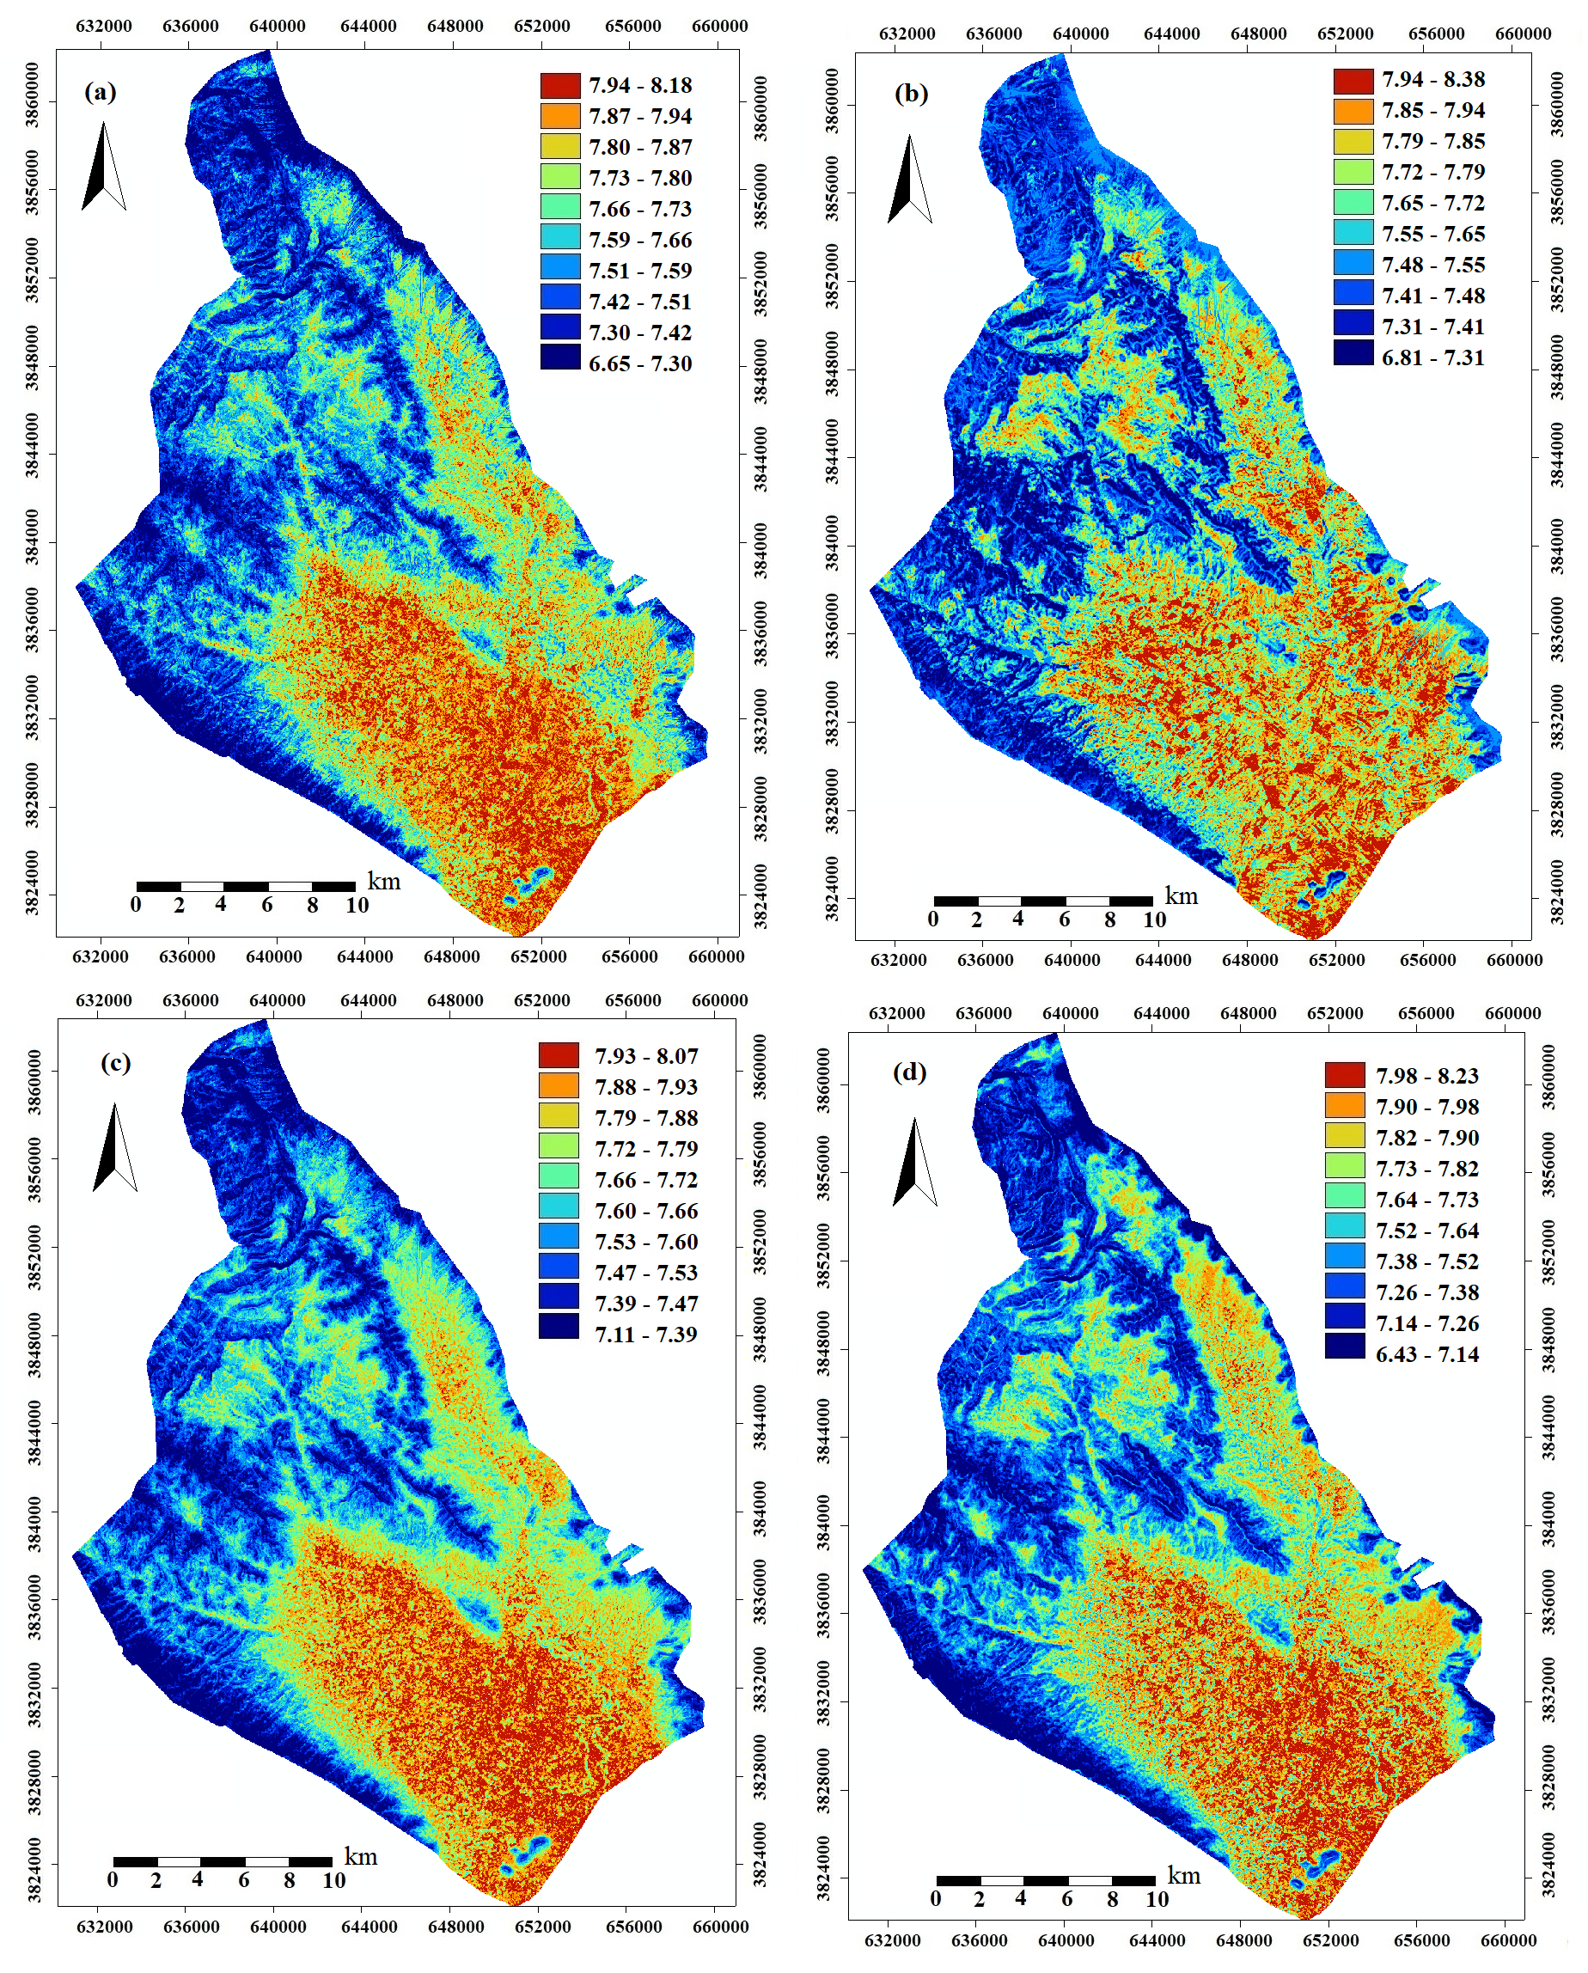
Fig 5. Spatial prediction maps of soil pH produced by (a) XGBoost, (b) SVM, (c) RF, and (d) Cubist models using the SA-FS2 method.

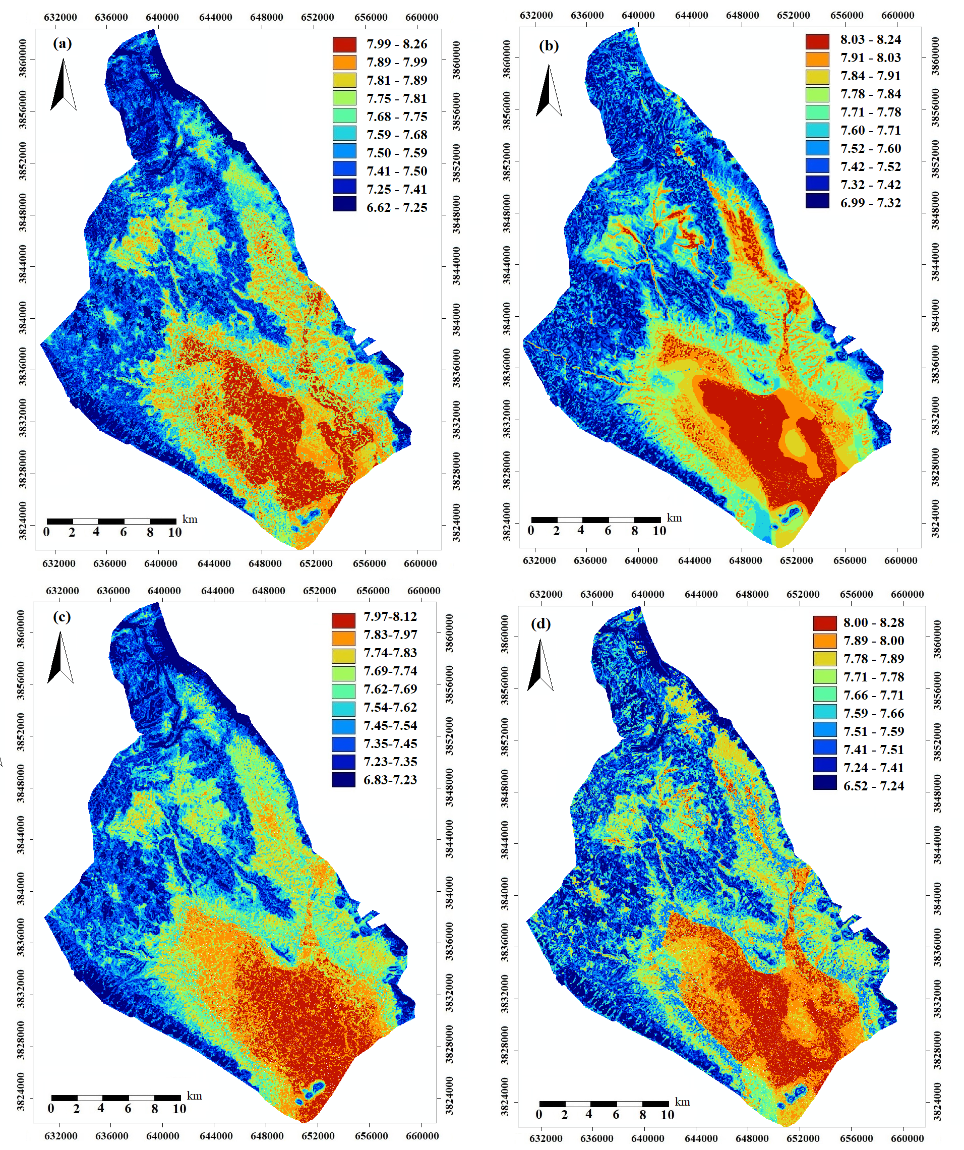

Fig 6. Spatial prediction maps of soil pH produced by (a) XGBoost, (b) SVM, (c) RF, and (d) Cubist models using the GA-FS1 method.
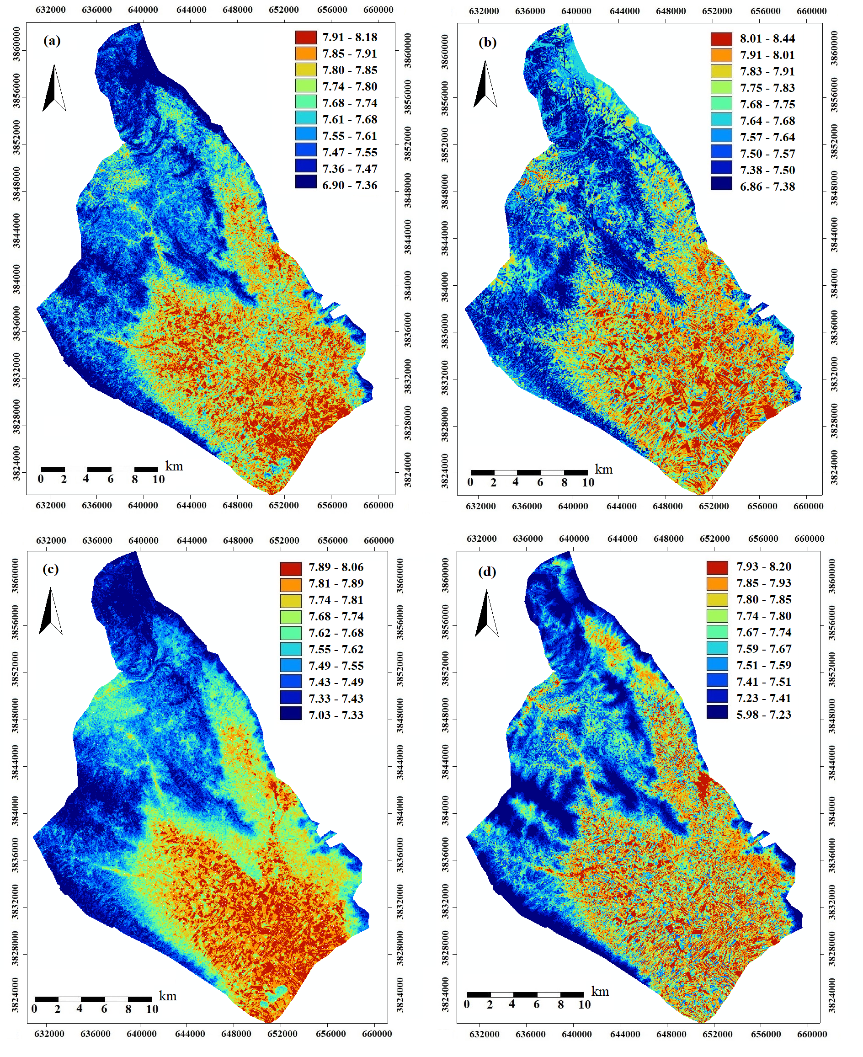
Fig 7. Spatial prediction maps of soil pH produced by (a) XGBoost, (b) SVM, (c) RF, and (d) Cubist models using the GA-FS2 method.

