Supplementary Information
Gluten free diet does not fully restore the faecal metabolome in paediatric coeliac disease

Table S1. LC-MS Instrumentation and Acquisition Parameters for Untargeted Metabolomics Analysis.
Category | Parameter | Setting
Chromatography | Column | Vanquish Accucore C18 UHPLC column (ThermoScientific, 100 mm x 2.1 mm, 2.6 μM)
 | Flow rate | 400 μL min ⁻¹
Mobile Phase | Mobile phase A | 99.9% water + 0.1% formic acid
 | Mobile phase B | 99.9% MeOH + 0.1% formic acid
Ionisation | Source type | Heated electrospray ionisation
 | Spray voltage (positive mode) | 3900 V
 | Spray voltage (negative mode) | 2500 V
Temperature | Transfer tube temperature | 320°C
 | Vaporiser temperature | 300°C
Gas settings | Sheath gas | 40 arbitrary units
 | Auxiliary gas | 10 arbitrary units
 | Sweep gas | 1 arbitrary unit
Acquisition | Mode | Data-dependent acquisition (top 5)
 | MS1 resolution | 60,000
 | MS/MS resolution | 30,000
Collision | Gas | Nitrogen
 | Fragmentation method | High energy collisional dissociation (HCD)
Nebulisation | Gas | Nitrogen

Table S2. Data pre-processing and statistical configuration settings for metabolomics analysis. QC, quality control; QC-RSC, quality control-based robust signal correction; MPV, missing value placeholder; LOD, limit of detection.
Category | Parameter | Setting
Data Filtering | Missing Value Threshold | >20% excluded
Data Transformation | Log Transformation | Enabled (LogTransform = TRUE)
Data Cleaning | Zero Removal | Enabled (RemoveZeros = TRUE)
Outlier Detection | Scope | Local (OutlierScope = Local)
 | Method | Linear (OutlierMethod = Linear)
 | Confidence Interval | 0.95 (OutlierCI = 0.95)
Outlier Handling | Post Hoc Replacement | MPV (OutlierPostHoc = MPV)
Signal Correction | QC-Based Robust Signal Correction | Spline (QCRSCmode = Spline)
 | Gamma Range | 1:0.5:4 (QCRSCgammaRange)
 | Cross-Validation | 5-fold (QCRSCcvMethod = 5-Fold)
 | Monte Carlo Repetitions | 5 (QCRSCmcReps = 5)
 | Correction Type | Subtract (QCRSCtype = subtract)
Background Filtering | Blank Ratio Method | QC (BankRatioMethod = QC)
 | Relative Limit of Detection | 1.5 (RelaiveLOD = 1.5)
Missing Data Handling | Imputation Method | k-Nearest Neighbours (KNN)
Statistical Analysis | Parametric Testing | Enabled (StatsParametric = TRUE)
Computational Settings | Parallel Processing | Enabled (ParallelProcess = TRUE)

Table S3. Parameters of Compound Discoverer workflow.
Workflow Node | Workflow Parameter | Workflow Information
Input files |  | .raw data
Select Spectra | Spectrum Properties Filter | Lower RT limit: 0  Upper RT limit: 0
Select Spectra | Scan Event Filters | Polarity Mode: Is +
Align Retention Times | General Settings | Alignment Model: Adaptive curve  Maximum Shift [min]: 0.3  Mass Tolerance: 2 ppm
Detect Compounds | General Settings | Mass Tolerance: 2 ppm  Intensity Tolerance [%]: 30  S/N Threshold: 5  Min. Peak Intensity: 500 000  Ions: [2M + FA + H]-1; [2M + H]+1; [2M + K]+1; [2M + Na]+1; [2M - H]-1; [M + 2H]+2; [M + Cl]-1; [M + FA - H]-1; [M + H]+1; [M + H + K]+2; 2M + H + MeOH]+1; [M + H + Na]+2; [M + H – H2O]+1; [M + K]+1; [M + Na]+1; [M - 2H]-2; [M + 2H + K]-1; [M -H]-1; [M -H2O]-1  Min. Element Counts: C H  Max. Element Counts: C90 H190 Br3 Cl4 K2 N10 Na2 O15 P5 S5
Group Compounds | Compound Consolidation | Mass Tolerance: 2 ppm  RT Tolerance [min]: 0.2
Group Compounds | Fragment Data Selection | Preferred Ions: [M - H] +1; [M- H] -1
Search mzCloud | General Settings | Compound Classes: Endogenous Metabolites, Excipients/ Additives/ Colourants, Extractables/ Leachables, Natural Products/ Medicines, Natural Toxins, Personal Care Products/ Cosmetics, Small Molecule Chemicals, Steroids/ Vitamins/ Hormones, Therapeutic/ Prescription Drugs  Precursor Mass Tolerance: 10 ppm  FT Fragment Mass Tolerance: 10 ppm  Library: Autoprocessed, Reference  Post. Processing: Recalibrated  Annotation Matching. Fragments: True
Search mzCloud | DDA Search | Identity Search: Cosine  Match Activation Type: True  Match Activation Energy: Match with Tolerance  Activation Energy: 20
Search mzCloud | DIA Search | Use DIA Scans: False  Max. Isolation Width [Da]: 500  Match Activation Type: False  Match Activation Energy: Any Activation Energy Tolerance: 100  Apply Intensity Threshold: False  Match Factor Threshold: 20
Predict Compositions | Prediction Settings | Mass Tolerance: 2 ppm  Min. Element Counts: C. H  Max. Element Counts: C90 H190 Br3 Cl4 K2 N10 Na2 O15 P5 S5  Min. RDBE: 0  Max. RDBE: 40  Min. H/C: 0.1  Max. H/C: 4  Max.# Candidates: 10  Max.# Internal Candidates: 200
Predict Compositions | Pattern Matching | Intensity Tolerance [%]: 30  Intensity Threshold [%]: 0.1  S/N Threshold: 3 Min. Spectral Fit [%]: 30  Min. Pattern Cov. [%]: 90  Use Dynamic Recalibration: True
Predict Compositions | Fragments Matching | Use Fragments: True  Mass Tolerance: 2 ppm S/N Threshold: 5
Map to Metabolika Pathways | Search Settings | Metabolika pathways: All  Search Mode: By Formula or Mass
Map to Metabolika Pathways | By Mass Search Settings | Mass Tolerance: 2 ppm
Map to Metabolika Pathways | By Formula Search Settings | Max. # of Predicted Compositions to be searched per Compound: 3
Map to Metabolika Pathways | Display Settings | Max. # of Pathways in ‘Pathways’ column: 20
Apply mzLogic | General Settings | FT Fragment Mass Tolerance: 10 ppm  IT Fragment Mass Tolerance: 0.4 Da  Max. # Compounds: 0  Max. # mzCloud Similarity Results to consider per Compound: 10  Match Factor Threshold: 30
Assign Compound Annotations | General Settings | Mass Tolerance: 2 ppm
Assign Compound Annotations | Data Sources | Data source #1: mzCloud Search  Data source #2: Predicted Compositions  Data source #3: MassList Search
Assign Compound Annotations | Sorting Rules | Use mzLogic: True  Use Spectral Distance: True  SFit Threshold: 20  SFit Range: 20
Fill Gaps | General Settings | Mass Tolerance: 2 ppm  S/N Threshold: 5  Use Real Peak Detection: True
Apply QC Correction | General Settings | Min. QC Coverage [%]: 30  Max. QC Area. RSD [%]: 30  Max. Corrected QC Area RSD [%]: 25  Max. # Files Between QC Files: 15
Mark Background Compounds | General Settings | Max. Sample/ Blank: 5  Max. Blank/ Sample: 0  Hide Background: True
Differential Analysis | General Settings | Log10 Transform Values: True

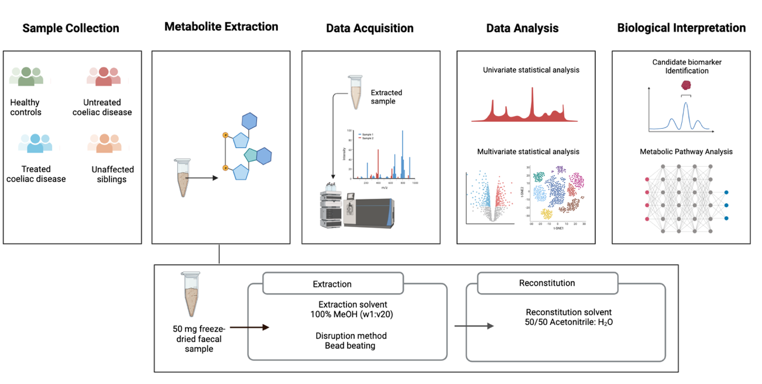

Figure S1. Overall experimental workflow following stages of sample collection, metabolite extraction using optimised method, data acquisition and analysis, and biological interpretation.

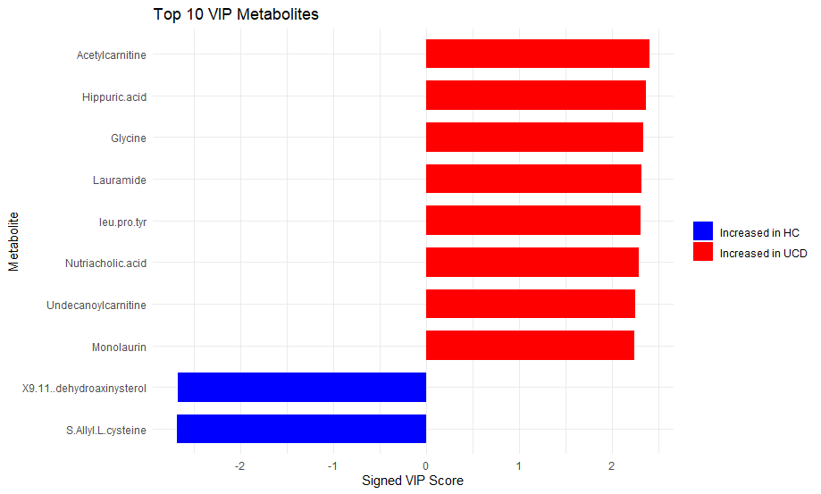

Figure S2. Variable importance in projection (VIP) plot showing the top differential metabolites from the orthogonal partial least square discriminant analysis (OPLS-DA) model comparing UCD vs. HC.

Supplementary Table S4. Significantly altered metabolites between UCD patients and HCs.
Metabolite | Group Comparison
Leu-Pro-Tyr | Decreased in UCD
Ornithine | Decreased in UCD
Ferulic acid | Decreased in UCD
N-Acetyl-L-glutamic acid | Decreased in UCD
Methyl 3-methanesulfonamidobenzoate | Decreased in UCD
Palmitoleoylglycine | Decreased in UCD
3-Oxocholic acid | Decreased in UCD
2-Isobutyl-3-methylpyrazine | Decreased in UCD
Bz-Arg-OEt | Decreased in UCD
2-Aminoethyl 4,6-dideoxy-4-(3-hydroxy-3-methylbutanoyl)amino-2-O-methyl-Î±-D-glucoside | Decreased in UCD
Leu-Leu-Asp | Decreased in UCD
Bussealin E | Decreased in UCD
9-Methyluric acid | Decreased in UCD
4-Hydroxyprolylleucine | Decreased in UCD
N-(3-Indolylacetyl)valine | Decreased in UCD
Leu-Ala-Ser | Decreased in UCD
Caffeine | Decreased in UCD
Trileucine | Decreased in UCD
N-Acetyltyramine | Decreased in UCD
Uric acid | Decreased in UCD
N-Acetylglucosaminitol | Decreased in UCD
Hippuric acid | Increased in UCD
Undecanoylcarnitine | Increased in UCD
Glycodeoxycholic acid | Increased in UCD
Glycine | Increased in UCD
8-Carboxy-3-oxooctanoyl-L-homoserine lactone | Increased in UCD
7,8-Dihydroxy-3,7-dimethyl-6-oxo-7,8-dihydro-6H-isochromene-5-carbaldehyde | Increased in UCD
Monolaurin | Increased in UCD
N-(Indole-3-acetyl)leucine | Increased in UCD
Methyl 2-acetamido-2-deoxy-Î±-D-galactopyranoside | Increased in UCD
N-Acetylhistamine | Increased in UCD
O-Î±-D-mannosyl-L-threonine | Increased in UCD
Aspartic acid | Increased in UCD
Galactosylhydroxylysine | Increased in UCD
Isovalerylglutamic acid | Increased in UCD
3-Oxodocosanoic acid | Increased in UCD
E-2-Butenyl-4-methylthreonine | Increased in UCD
3,5-Dimethoxyphenyl-4-methylsulfonyl-1-piperazinyl methanone | Increased in UCD

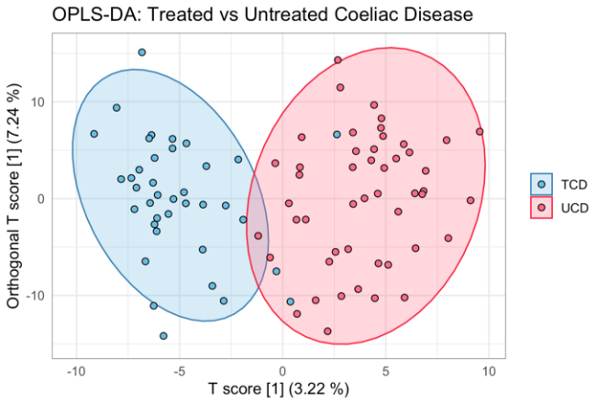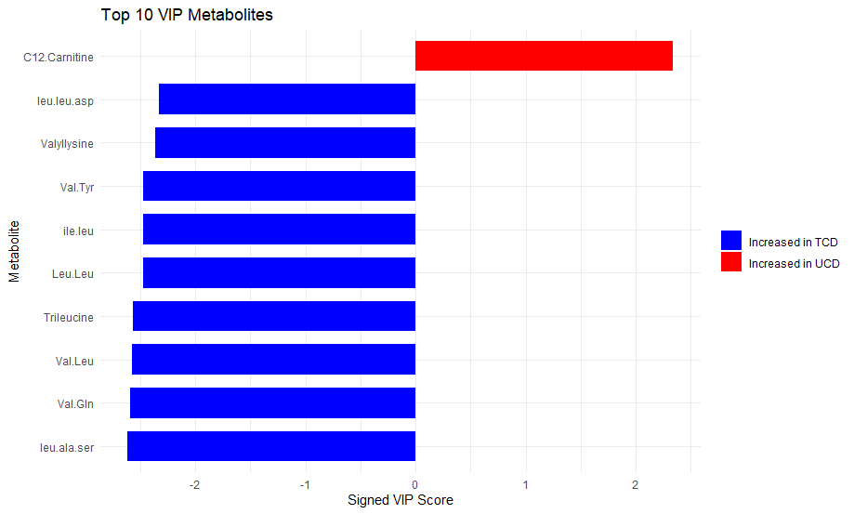
B
A
C
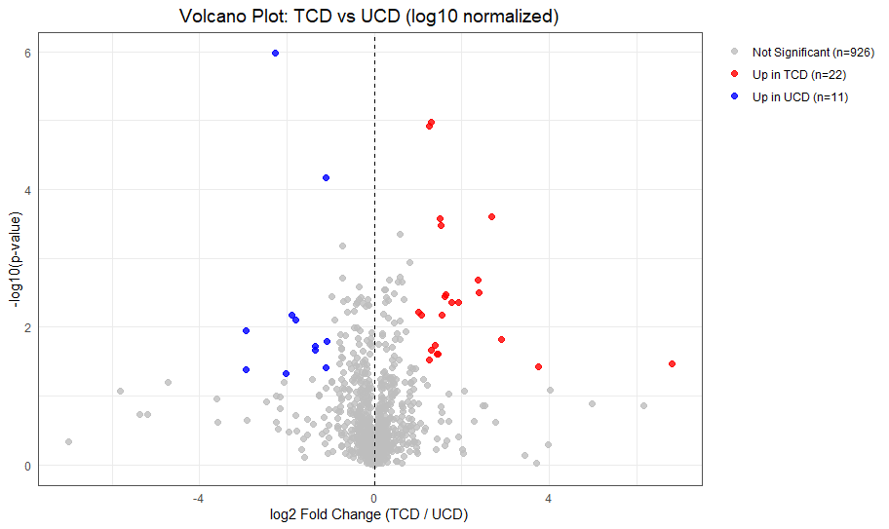

Figure S3. Orthogonal partial least square discriminant analysis (OPLS-DA) and variable importance for treated vs untreated coeliac disease (TCD vs UCD). (A) OPLS-DA scores plot comparing TCD vs UCD with points representing individual samples and ellipses showing 95% confidence intervals, R2Y = 0.767, Q2 = 0.0963. (B) Variable importance in projection (VIP) plot showing the top differential metabolites from the orthogonal partial least square discriminant analysis (OPLS-DA) model comparing TCD vs. UCD. (C) Volcano plot displaying the significantly altered metabolites between TCD and UCD patients.

B
A
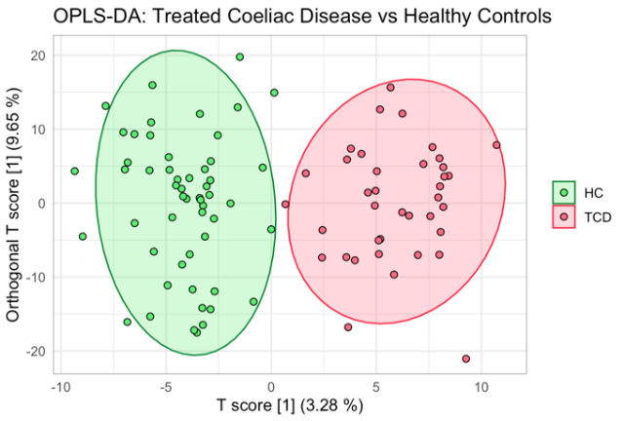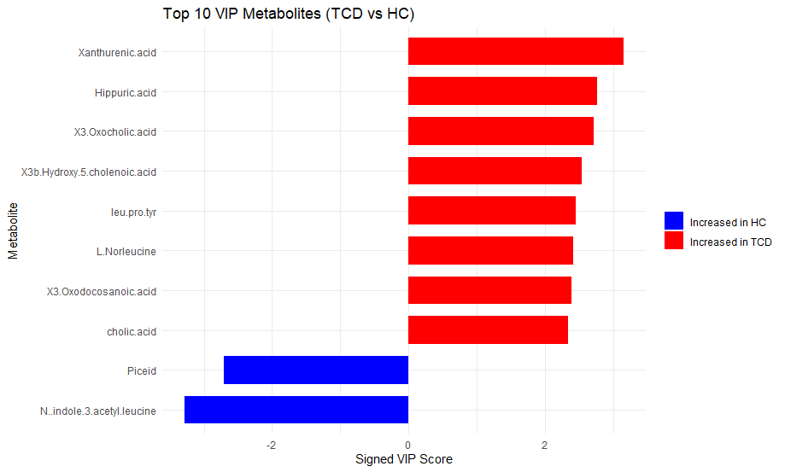
C
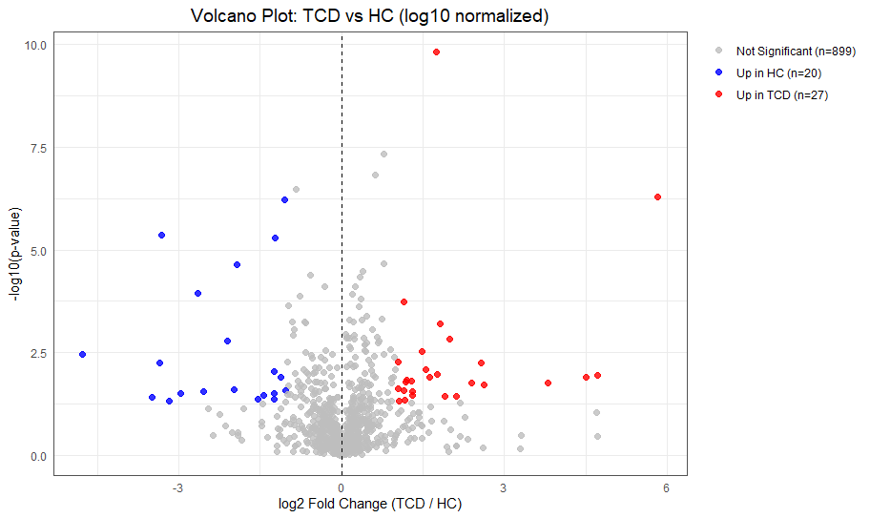
Figure S4. Orthogonal partial least square discriminant analysis (OPLS-DA) and variable importance for treated coeliac disease (TCD) vs HCs. (A) OPLS-DA scores plot comparing TCD vs HC with points representing individual samples and ellipses showing 95% confidence intervals, R2Y = 0.843, Q2 = 0.548. (B) Variable importance in projection (VIP) plot showing the top differential metabolites from the orthogonal partial least square discriminant analysis (OPLS-DA) model comparing TCD vs. HC. (C) Volcano plot displaying the significantly altered metabolites between TCD patients and HCs.

Supplementary Table S5. Top differentially abundant metabolites identified in the prospective cohort, with corresponding VIP scores in the cross-sectional cohort. Metabolites with VIP > 1.2 were considered contributors to group separation, those with VIP values between 1.0 and 1.2 were classed as low model contributors, and metabolites with VIP < 1.0 were considered to have no appreciable contribution to the multivariate model.
Variable | Direction | VIP Score
Monolinolenin | Low model contribution | 1.055896
N-Acetyl-L-glutamic acid | No effect | VIP < 1
N-[(2S)-2-Hydroxypropanoyl]-L-phenylalanine | Increased in TCD | 1.465013
Xanthurenic acid | Increased in TCD | 1.956463
Methyl-alpha-aspartyl phenylalaninate | No effect | VIP < 1
3-Amino-4,7-dihydroxy-8-methylcoumarin | No effect | VIP < 1
L-Alanyl-L-proline | No effect | VIP < 1
Phenylalanine | Low model contribution | 1.009252
O-alpha-D-mannosyl-L-threonine | No effect | VIP < 1
Galactosylhydroxylysine | Increased in UCD | 2.110364
N-indole-3-acetyl-leucine | Increased in UCD | 2.199974
Pyridoxine | Low model contribution | 1.177892
Butyryl-L-homoserine-lactone | Increased in UCD | 1.268518
9(11)-dehydroaxinysterol | Increased in UCD | 2.040323
N-alpha-methyl-L-lysine | No effect | VIP < 1
Bz-Arg-OEt | Low model contribution | 1.140965

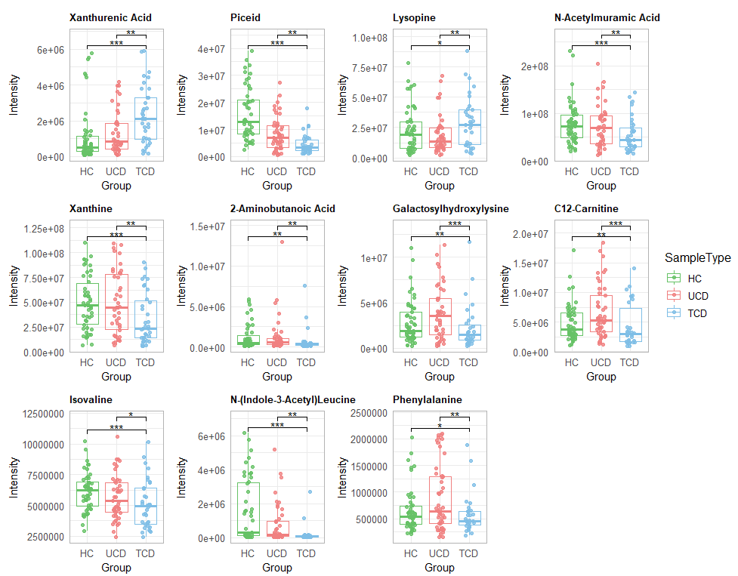

Figure S5. Treatment responsive metabolites in all participants. Boxplots showing the relative intensities of metabolites significantly altered in both untreated coeliac disease (UCD) and HCs compared with treated coeliac disease (TCD). Statistical significance is indicated by *p < 0.05, **p < 0.01, ***p < 0.001.

A
B
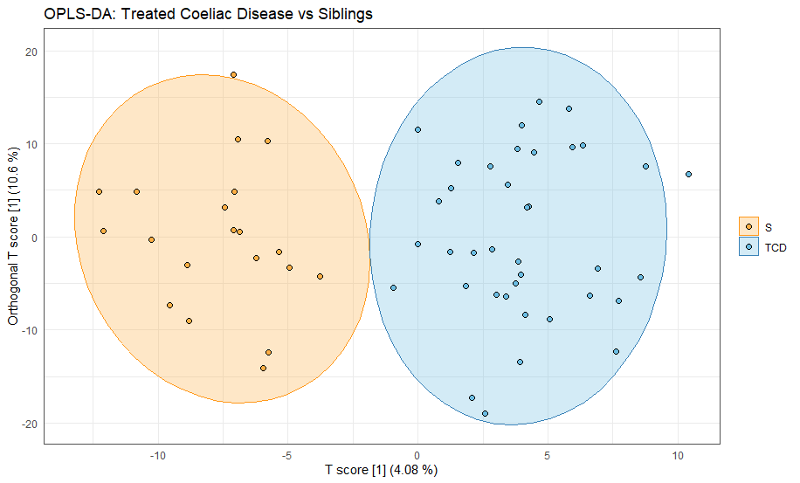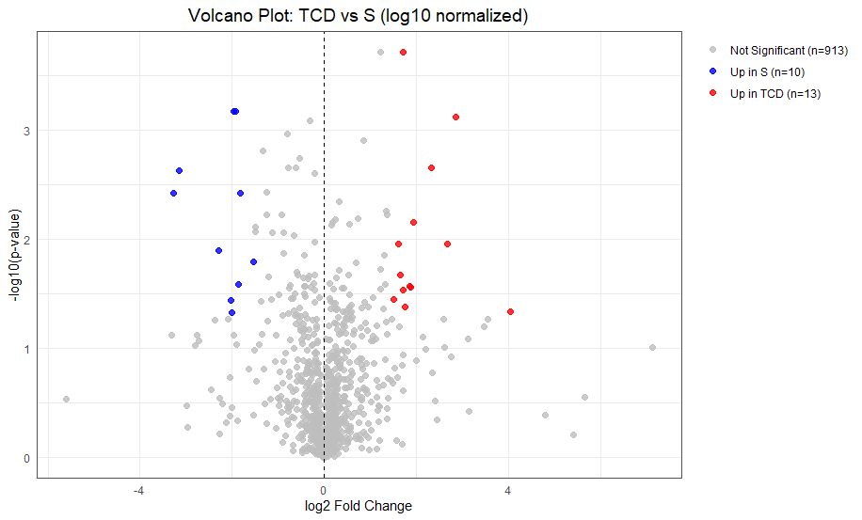
D
C

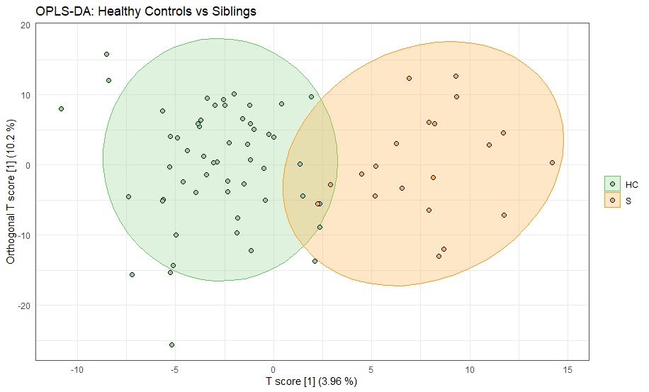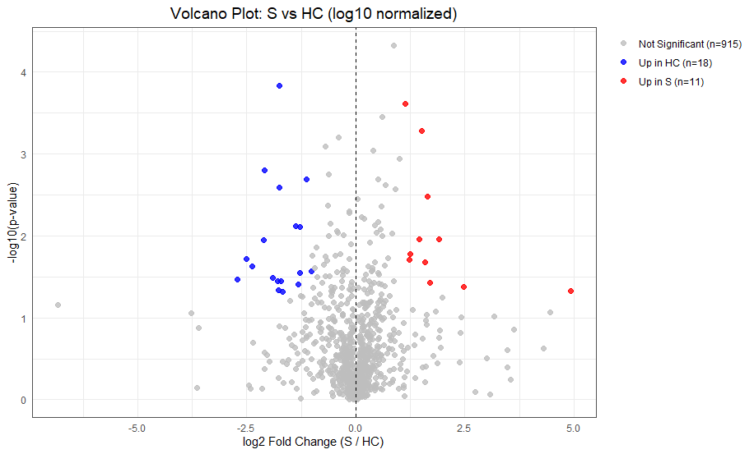

Figure S6. Metabolomics differences in unaffected siblings compared with TCD patients and HCs. (A)
Orthogonal partial least square discriminant analysis (OPLS-DA) scores plot comparing unaffected siblings (S) with treated TCD patients (TCD). Each point represents an individual sample, with 95% confidence ellipses shown for each group (R²Y = 0.834, Q² = 0.212). (B) Volcano plot showing metabolites significantly altered between TCD patients and unaffected siblings. (C) OPLS-DA scores plot comparing unaffected siblings (S) with healthy controls (HC). Each point represents an individual sample, with 95% confidence ellipses shown for each group (R²Y = 0.733, Q² = 0.031). (D) Volcano plot showing metabolites significantly altered between HCs and unaffected siblings.

