Supplementary materials
SERS chemical tongue for rapid detection of chili oils assisted with convolutional neural network

Peng Wang • Cun-Fang Zhang • Yu Qin • Xiao-Lan Wei

College of Food Science and Engineering, Chongqing Technology and Business University, Chongqing 400067, China
Corresponding authors: Xiao-Lan Wei, weishine@ctbu.edu.cn

Table S1. Chili oil compositions
Series | Category | Base Oil¹ | Capsaicin Concentration (μg/mL) | Additives²
1 |  | RO | 0、0.3、1.0、2.0、3.0、4.0、5.0、6.0
2 |  | 1 RO + 1 SO | 0、0.3、1.0、2.0、3.0、4.0、5.0、6.0
3 | A | RO | 3.0
3 | B | SO | 3.0
3 | C | 1 RO + 1 SO | 3.0
3 | D | 2 RO + 1 SO | 3.0
3 | E | 1 RO + 2 SO | 3.0
4 | A | RO | Erjingtiao (LS)
4 | B | RO | Slender (MS)
4 | C | RO | Frutescens (HS)
4 | D | SO | Erjingtiao (LS)
4 | E | SO | Slender (MS)
4 | F | SO | Frutescens (HS)
4 | G | 1 RO + 1 SO | Erjingtiao (LS)
4 | H | 1 RO + 1 SO | Slender (MS)
4 | I | 1 RO + 1 SO | Frutescens (HS)
5 |  | 1 RO + 3 BT | 0、0.5、1.0、2.0、3.0、4.0、5.0、6.0
6 |  | 1 RO + 1.5 LO + 1.5 BT | 0、0.5、1.0、2.0、3.0、4.0、5.0、6.0
7 | A | RO | 3.0 | SGG + SP + Suc
7 | B | 1 RO + 3 BT | 3.0 | SGG + SP + Suc
7 | C | 1 RO + 1.5 LO + 1.5 BT | 3.0 | SGG + SP + Suc
8 | A | 1 RO + 1.5 LO + 1.5 BT | 3.0 | SGG
8 | B | 1 RO + 1.5 LO + 1.5 BT | 3.0 | SP
8 | C | 1 RO + 1.5 LO + 1.5 BT | 3.0 | SGG + SP
8 | D | 1 RO + 1.5 LO + 1.5 BT | 3.0 | SGG + SP + Suc
9 | A | RO | Erjingtiao (LS) | SGG + SP + Suc
9 | B | RO | Slender (MS) | SGG + SP + Suc
9 | C | RO | Frutescens (HS) | SGG + SP + Suc
9 | D | 1 RO + 3 BT | Erjingtiao (LS) | SGG + SP + Suc
9 | E | 1 RO + 3 BT | Slender (MS) | SGG + SP + Suc
9 | F | 1 RO + 3 BT | Frutescens (HS) | SGG + SP + Suc
9 | G | 2 RO + 3 LO + 3 BT | Erjingtiao (LS) | SGG + SP + Suc
9 | H | 2 RO + 3 LO + 3 BT | Slender (MS) | SGG + SP + Suc
9 | I | 2 RO + 3 LO + 3 BT | Frutescens (HS) | SGG + SP + Suc
¹RO: Rapeseed oil; SO: Soybean Oil; LO: Lard Oil; BT: Beef Tallow. ²S: Scallion; G: Ginger; G: Garlic; SP: Sichuan pepper; Suc: Sucrose. ³LS: Low Spicy; MS: Medium Spicy; HS: High Spicy.
Table S2. Comparison of vibration assignments for FTIR analysis
Compound | Wavenumber(cm⁻¹) | Vibration Distribution | Compound | Wavenumber(cm⁻¹) | Vibration Distribution
ATP | 815 | C-H bending vibration | MNP@Ag-CPDA | 812 | C-H bending vibration
ATP | 1382 | C-N stretching vibration | MNP@Ag-CPDA | 1084 | C-O stretching vibration
ATP | 1490 | C=C bending vibration | MNP@Ag-CPDA | 1272 | C-N stretching vibration
ATP | 1589 | C=C bending vibration | MNP@Ag-CPDA | 1484、 1630 | C=C bending vibration
ATP | 3332、3414 | N-H stretching vibration | MNP@Ag-CPDA | 2969.75 | C-H bending vibration
ATP+BA | 750-650 | O-H bending vibration | MNP@Ag-CPDA | 3428.93 | N-H stretching vibration
ATP+BA | 1047、1084 | C-O stretching vibration | MNP@Ag-CPDAB | 1046.96、 1083.73 | C-O stretching vibration
ATP+BA | 1482、1630 | C=C bending vibration | MNP@Ag-CPDAB | 1482.34 | C=C bending vibration
ATP+BA | 1715 | C=O bending vibration | MNP@Ag-CPDAB | 1629.97 | -C=O bending vibration
ATP+BA | 2970 | C-H bending vibration | MNP@Ag-CPDAB | 2971.35 | C-H bending vibration
ATP+BA | 3353 | N-H stretching vibration | MNP@Ag-CPDAB | 3428.25 | N-H stretching vibration
HTP | 1050 | C-O stretching vibration | MNP@Ag-CPDH | 1039.13、1083.48 | C-O stretching vibration
HTP | 1230 | C-O stretching vibration | MNP@Ag-CPDH | 1247.82 | C-O stretching vibration
HTP | 1315 | O-H bending vibration | MNP@Ag-CPDH | 1430.43、1485.77 | C=C bending vibration
HTP | 1402、1540 | C=C in benzene ring | MNP@Ag-CPDH | 1631.65 | C=C bending vibration
HTP | 3350 | O-H stretching vibration | MNP@Ag-CPDH | 3432.30 | O-H stretching vibration

Table S3. Ratios of various chemical bonding states in three sensors
C1s |  |  |  | O1s |  | N1s
CPD_{ATP}:9.9% |  |  |  | CPD_{ATP}:38.83% |  | CPD_{ATP}:0.2%
CPD_{ATP-BA}: 10.69% |  |  |  | CPD_{ATP-BA}: 38.33% |  | CPD_{ATP-BA}:0.86%
CPD_{HTP}: 9.77% |  |  |  | CPD_{HTP}: 44.45% |  | CPD_{HTP}: ─
 | C-C/C=C | C-C | C=O | MetalO | C-O | C=O | MetalN | C-NH2
CPD_{ATP} | 57.07% | 33.23%  9.24% | 9.7% | 57.22% | 42.78% | ─ | 25% | 75%
CPD_{ATP-BA} | 75% | 33.23%  9.24% | 10.01% | 41.65% | 37.15% | 21.20% | 8.7% | 91.3%
CPD_{HTP} | 65.92% | 23.65% | 10.43% | 41.57% | 58.43% | ─ | ─ | ─

Table S4. Assignments of characteristic peaks of SERS sensors.
Sensor | Wavenumber(cm⁻¹) | Vibration Distribution
MNP@Ag-CPDAB | 404  661  732  1078  1173  1340  1488  1430  1558  1614 | C-S stretching vibration  C-H stretching vibration  C-OH Out-of-plane bending vibration  loop breathing + C-S stretching vibration  CH bend + C-N stretch  C-OH bending vibration  C-C stretch +CH bending vibration  C-OH bending vibration  benzene ring C-C- stretching vibration  C=O stretching vibration
MNP@Ag-CPDH | 385  632  1005  1076  1167  1290  1490  1597 | C-S stretching vibration  C-S stretching vibration  C-C stretching vibration  loop breathing + C-S stretching vibration  O-H bending vibration  C-OH bending vibration  CH bending vibration  benzene ring C-C- stretching vibration
MNP@Ag-CPDA | 403  659  1008  1078  1171  1488  1554  1590  1609 | C-S stretching vibration  C-H stretching vibration  C-C stretching vibration  loop breathing + C-S stretching vibration  CH bend + C-N stretch  C-C stretch +CH bending vibration  benzene ring C-C stretching vibration  benzene ring C-C stretching vibration  C–C stretching vibration +NH₂ deformation vibration
Table S5. Detailed information of representative flavor components in chili oil.
Molecule | Structure |  | Interaction
Unsaturated fatty acids  （USFA） |  |  |  | hydrogen bond  electrostatic interaction  π-π interaction
Saturated fatty acid  (SFA) |  |  |  | hydrogen bond  electrostatic interaction  hydrogen bond  electrostatic interaction  π-π interaction
Capsaicin

Table S6. Detailed numerical results of CNN and PLS-R for quantitative detection series 1, 2, 5, and 6.
Series | Model | Regression Equation | R² | RMSE (μg/mL) | MAE (μg/mL)
Series1 | CNN | y = 0.9736x + 0.0451 | 0.9907 ± 0.0021 | 0.2048 ± 0.0106 | 0.1526 ± 0.0081
Series1 | PLS-R | y = 0.9557x + 0.1112 | 0.9850 ± 0.0034 | 0.2602 ± 0.0148 | 0.2001 ± 0.0115
Series2 | CNN | y = 0.9939x + 0.0506 | 0.9784 ± 0.0048 | 0.3118 ± 0.0184 | 0.2127 ± 0.0136
Series2 | PLS-R | y = 0.9715x + 0.1073 | 0.9613 ± 0.0062 | 0.4176 ± 0.0267 | 0.3310 ± 0.0214
Series5 | CNN | y = 0.9536x + 0.0988 | 0.9787 ± 0.0051 | 0.3059 ± 0.0192 | 0.2188 ± 0.0145
Series5 | PLS-R | y = 0.8386x + 0.4004 | 0.8889 ± 0.0147 | 0.6993 ± 0.0528 | 0.5325 ± 0.0416
Series6 | CNN | y = 0.9553x + 0.1340 | 0.9767 ± 0.0056 | 0.3205 ± 0.0208 | 0.2260 ± 0.0153
Series6 | PLS-R | y = 0.9144x + 0.2537 | 0.9466 ± 0.0089 | 0.4847 ± 0.0342 | 0.3832 ± 0.0276

Table S7. Detailed numerical results of qualitative detections in series 3, 4, 7, 8, and 9 using CNN, KNN, LDA, and SVM.
Series | Model | Accuracy | Macro Precision | Macro Recall | Macro F1 | Weighted F1
series3 | CNN | 100.00 ± 0.00 | 100.00 ± 0.00 | 100.00 ± 0.00 | 100.00 ± 0.00 | 100.00 ± 0.00
series3 | KNN | 86.67 ± 1.85 | 87.27 ± 1.72 | 86.67 ± 1.85 | 86.71 ± 1.79 | 86.71 ± 1.79
series3 | LDA | 99.33 ± 0.47 | 99.35 ± 0.45 | 99.33 ± 0.47 | 99.33 ± 0.47 | 99.33 ± 0.47
series3 | SVM | 95.33 ± 1.12 | 95.75 ± 1.05 | 95.33 ± 1.12 | 95.31 ± 1.09 | 95.31 ± 1.09
series4 | CNN | 100.00 ± 0.00 | 100.00 ± 0.00 | 100.00 ± 0.00 | 100.00 ± 0.00 | 100.00 ± 0.00
series4 | KNN | 90.00 ± 1.88 | 90.12 ± 1.79 | 90.00 ± 1.88 | 89.87 ± 1.91 | 89.87 ± 1.91
series4 | LDA | 99.26 ± 0.44 | 99.28 ± 0.42 | 99.26 ± 0.44 | 99.26 ± 0.44 | 99.26 ± 0.44
series4 | SVM | 94.44 ± 1.25 | 95.04 ± 1.13 | 94.44 ± 1.25 | 94.38 ± 1.28 | 94.38 ± 1.28
series7 | CNN | 100.00 ± 0.00 | 100.00 ± 0.00 | 100.00 ± 0.00 | 100.00 ± 0.00 | 100.00 ± 0.00
series7 | KNN | 97.78 ± 0.84 | 97.92 ± 0.78 | 97.78 ± 0.84 | 97.79 ± 0.82 | 97.79 ± 0.82
series7 | LDA | 100.00 ± 0.00 | 100.00 ± 0.00 | 100.00 ± 0.00 | 100.00 ± 0.00 | 100.00 ± 0.00
series7 | SVM | 100.00 ± 0.00 | 100.00 ± 0.00 | 100.00 ± 0.00 | 100.00 ± 0.00 | 100.00 ± 0.00
series8 | CNN | 100.00 ± 0.00 | 100.00 ± 0.00 | 100.00 ± 0.00 | 100.00 ± 0.00 | 100.00 ± 0.00
series8 | KNN | 90.00 ± 1.76 | 91.27 ± 1.62 | 90.00 ± 1.76 | 89.96 ± 1.81 | 89.96 ± 1.81
series8 | LDA | 98.33 ± 0.69 | 98.44 ± 0.65 | 98.33 ± 0.69 | 98.33 ± 0.69 | 98.33 ± 0.69
series8 | SVM | 99.17 ± 0.52 | 99.19 ± 0.50 | 99.17 ± 0.52 | 99.17 ± 0.52 | 99.17 ± 0.52
series9 | CNN | 99.63 ± 0.31 | 99.64 ± 0.30 | 99.63 ± 0.31 | 99.63 ± 0.31 | 99.63 ± 0.31
series9 | KNN | 84.44 ± 2.16 | 85.69 ± 2.04 | 84.44 ± 2.16 | 84.21 ± 2.22 | 84.21 ± 2.22
series9 | LDA | 96.67 ± 0.98 | 97.28 ± 0.86 | 96.67 ± 0.98 | 96.80 ± 0.93 | 96.80 ± 0.93
series9 | SVM | 88.15 ± 1.94 | 91.62 ± 1.58 | 88.15 ± 1.94 | 88.31 ± 1.89 | 88.31 ± 1.89

Table S8. Apparent recovery analysis for CNN-based capsaicin quantification in different chili oil matrices.
Matrix | Series | Spiked concentration (μg/mL) | Predicted concentration (μg/mL) | RSD (%) | Apparent recovery (%)
Simple oil matrix | Series 1 | 1.0 | 0.98 ± 0.04 | 4.08 | 98.00
Simple oil matrix | Series 1 | 3.0 | 2.95 ± 0.08 | 2.71 | 98.33
Simple oil matrix | Series 1 | 5.0 | 5.06 ± 0.11 | 2.17 | 101.20
Complex oil matrix | Series 5 | 1.0 | 0.93 ± 0.07 | 7.53 | 93.00
Complex oil matrix | Series 5 | 3.0 | 2.88 ± 0.12 | 4.17 | 96.00
Complex oil matrix | Series 5 | 5.0 | 4.91 ± 0.18 | 3.67 | 98.20

Table S9. Capsaicin contents (HPLC) and predicted values (array method) for seven brands of chili oil.
No. | Brand | Category | HPLC Capsaicin (μg/mL) | Array Method Capsaicin (μg/mL)
1 | Lee Kum Kee | Pure chili oil | 92.6 ± 0.626 | 93.4 ± 2.06
2 | Yao Ma Zi | Pure chili oil | 108 ± 0.872 | 107 ± 1.35
3 | Rongxiang Zhuoyue | Pure chili oil (Spicy) | 176 ± 2.31 | 176 ± 1.26
4 | Qiaotou | Composite chili oil | 88.2 ± 0.749 | 87.5 ± 2.27
5 | Ya Er Ye | Composite chili oil | 93.7 ± 1.67 | 93.9 ± 1.48
6 | Jiao Huan Tian | Composite chili oil | 170 ± 1.44 | 170 ± 1.35
7 | Shu Wei Ji | Composite chili oil | 99.3 ± 1.58 | 97.5 ± 0.941

Table S10. Fortified concentrations, mean measured values, and recoveries for seven brands
No. | Brand | Sample Background (μg/mL) | Spiked Amount (μg/mL) | Mean Measured Value (μg/mL) | Recovery ± RSD (%)
1 | Lee Kum Kee | 92.6 | 20.0 | 114 ± 0.281 | 105 ± 1.41
2 | Yao Ma Zi | 108 | 20.0 | 126 ± 0.442 | 92.2 ± 2.21
3 | Rongxiang Zhuoyue | 176 | 20.0 | 193 ± 0.478 | 84.8 ± 2.39
4 | Qiaotou | 88.2 | 20.0 | 109 ± 0.653 | 103 ± 3.27
5 | Ya Er Ye | 93.7 | 20.0 | 115 ± 0.524 | 106 ± 2.62
6 | Jiao Huan Tian | 170 | 20.0 | 189 ± 0.758 | 93.0 ± 3.79
7 | Shu Wei Ji | 99.3 | 20.0 | 120 ± 0.184 | 101 ± 0.92

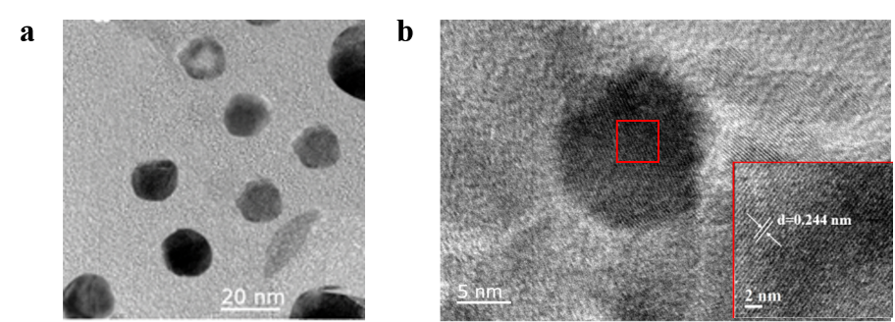
Figure S1. TEM(a) and HR-TEM(b) images of MNP@Ag nanoparticles.

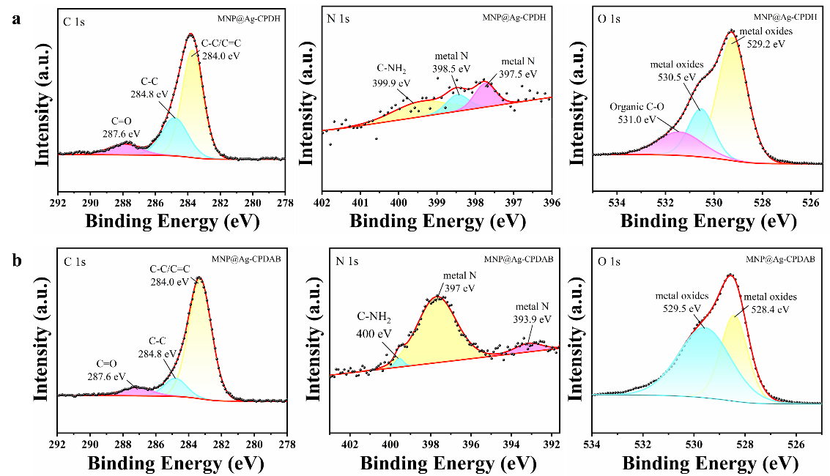
Figure S2. High-resolution XPS spectra of (a) MNP@Ag-CPDH and (b) MNP@Ag-CPDAB.

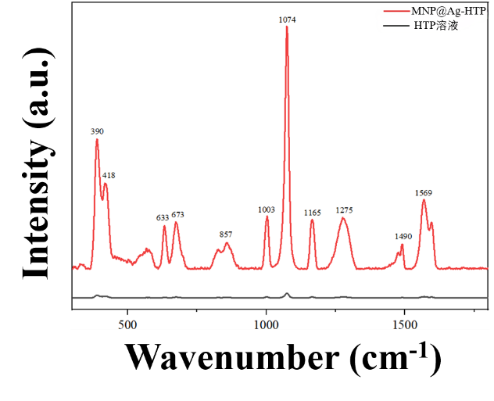
Figure S3. Enhanced Raman spectrum of HTP by the MNP@Ag substrate.
The SERS enhancement factor (EF) is key to assessing substrate performance. Here, we evaluated the Raman signal enhancement of HTP probe molecules by MNP@Ag nanoparticles and calculated the EF. The calculation method is as follows:
(1)
where I_{SERS} is the SERS intensity of HTP on MNP@Ag, I_{Raman} is the normal Raman intensity of HTP in solution, N_{SERS} is the number of molecules probed on the substrate, and N_{Raman} is the number of molecules probed in solution. The intensity at 1074 cm⁻¹ was used, giving I_{SERS} = 4.90 × 10⁴ and I_{Raman} = 309. N_{Raman} was obtained from
(2)
with V_{laser} = π × x/2 × y/2 × z = 9.55 × 10⁻¹⁸ m³, where x = 910 nm, y = 680 nm, and z = 4320 nm are the confocal resolutions in solution, and C_{Receptor} = 1 mol·m⁻³. N_{A} is Avogadro's no. N_{Raman} = 5.75 × 10⁶ molecules.
N_{SERS} was calculated by
(3)
where P_{MNP@Ag} = 16 nanoparticles/μm², A_{MNP@Ag} = 3.14 × 10⁻⁴ μm², A_{laser} = π × x/2 × y/2 = 0.155 μm² with x = 520 nm and y = 380 nm in air, and D_{receptors} = 3.29 × 10¹³ molecules/cm². The resulting N_{SERS} is 256 molecules. Substitution into (1) gives EF = (3.56 ± 0.037) × 10⁶.
Figure S4. (a) Raman spectra of the MNP@Ag substrate for detecting different concentrations of HTP, (b) linear relationship between Raman intensity at 1074 cm⁻¹ and −log[c] of HTP, (c) SERS intensity of the 1074 cm⁻¹ peak based on 15 repeated measurements, and (d) RSD at 1074 cm⁻¹ among 15 independent batches of SERS substrates.

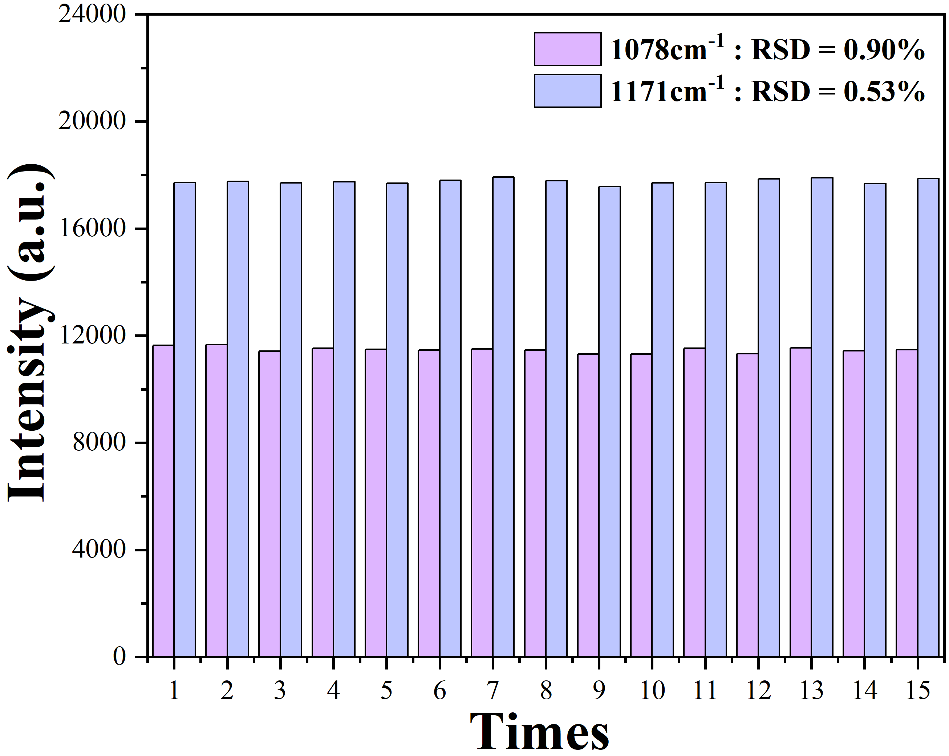
Figure. S5 Batch-to-batch reproducibility of SERS intensities at 1078 and 1171 cm⁻¹ for MNP@Ag-CPDA.
Figure. S6 (a) Stability of MNP@Ag-CPDs over 0–28 days (left), (b) SERS intensity of 1078 and 1171 cm⁻¹ characteristic peaks as a function of sensor storage time (right).
Figure. S7 Calibration plots of capsaicin concentration obtained using PLS-R for (a, c) sensor array and (b, d) single MNP@Ag-CPDH sensor

Fig S8. Super spectrum of different chili oil series.

Fig S9. Principal component analysis (PCA) diagram of nine chili oil series.

Fig S10. Chili oil SERS heatmap before and after data augmentation

Fig S11. Training loss iteration curve of the CNN model on the training set and validation set.

