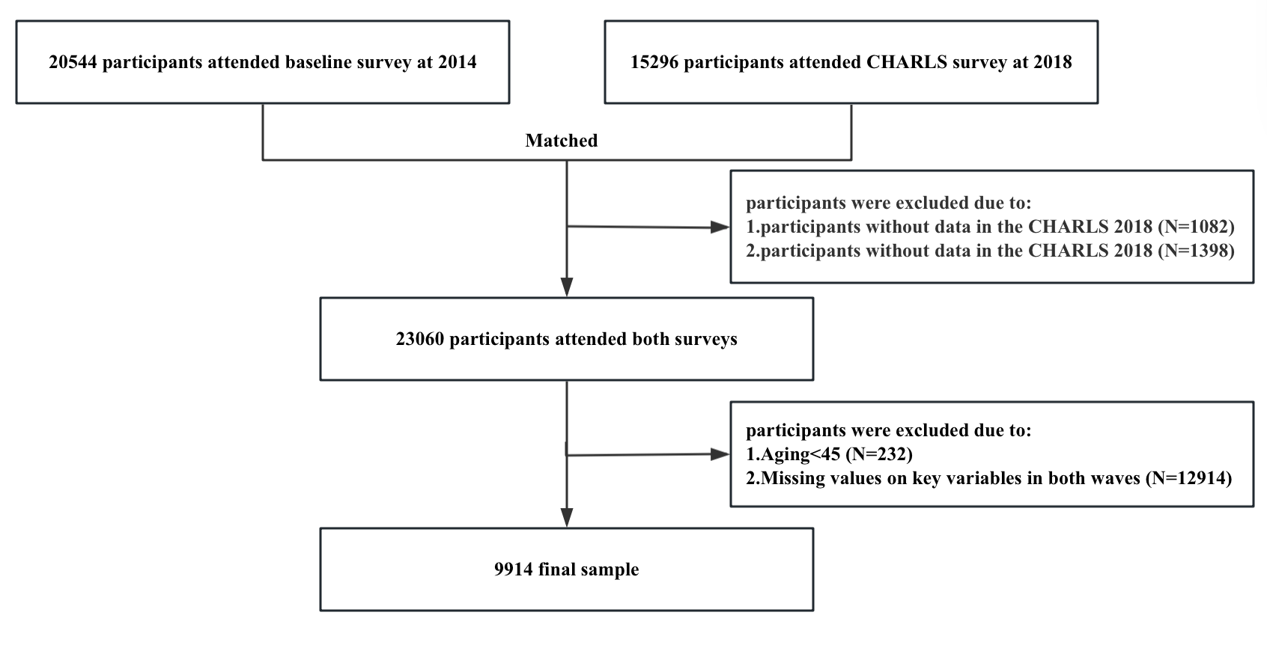
Figure S1. Flow of participants into study sample

Table S1. Variables and related question in CHARLS survey to assess childhood adversities
Independent variables | Question/Information * | Assessment method
Childhood Adversities
Childhood socioeconomic disadvantage |  | Aggregated count (0-4)
Parental illiteracy | Both parents of respondents were illiterate | Yes (1), no (0)
Hunger experience | "Was there ever a time when your family did not have enough food to eat?” | Yes (1), no (0)
Flee from famine | "Between 1958-1962 did you and your family move away from the famine-stricken area?" | Yes and the respondent was 17 years old or younger in 1958(1), no or respondents was 18 years old or older in 1958 (0)
Worse economic situation than neighbors' | "Compared to the average family in the same community/village at that time, how as your family’s financial situation? "((1=a lot better than other families to 5= a lot worse than other family)) | 4-5(1), 1-3(0)
Childhood trauma
Parental involved trauma |  | Aggregated count (0-4)
Parental death | One or both of respondent's parents passed away. | Yes (1), no (0)
Parental mental illness | One or both of respondent's parents feel nervous, anxious, panicky, sadness, depression or low energy in a good part of the time or most of the time, or his/her parents have abnormality of mind in his/her childhood. | Yes (1), no (0)
Parental substance abuse | One or both of his/her parents ever had alcoholism or drug | Yes (1), no (0)
Domestic violence | "Have your father (mother) ever beat up your mother (father)? " (1=often to 4= never) | 1-2(1), 3-4(0)
Maladaptive parental trauma |  | Aggregated count (0-2)
Physical abuse | "Did your male (female) guardian ever hit you?"(1=often to 4= never) | 1-2(1), 3-4(0)
Neglect | 1.“How much love and affection did your female guardian give you while you were growing up?” (1=often to 4= never) 2.“How much effort did your female guardian put into watching over you?” (1=a lot to 4= Not at all) | Answered 3-4 for one or both questions (1), 1-2 for both questions (0)
Other trauma |  | Aggregated count (0-2)
Being bullied | "How often were you picked on or bullied by kids in your school?" (1=often to 4= never) | 1-2(1), 3-4(0)
Serious physical illness | Respondent ever confined to bed or home/ hospitalized for a month or more, or hospitalized more than three times within a 12-month period before 15 years old. | Yes (1), no (0)
* All the questions were based in childhood period (0-17 years old).

