Protein profiling of Bt isolates by SDS PAGE
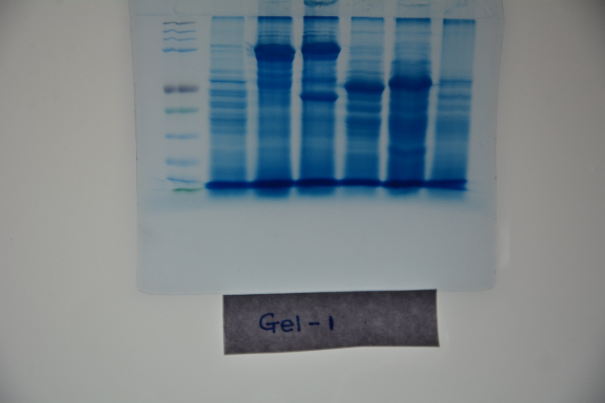

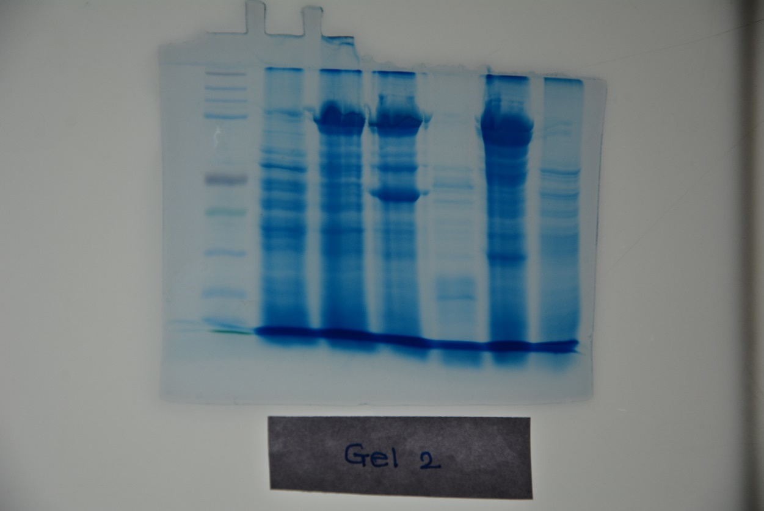

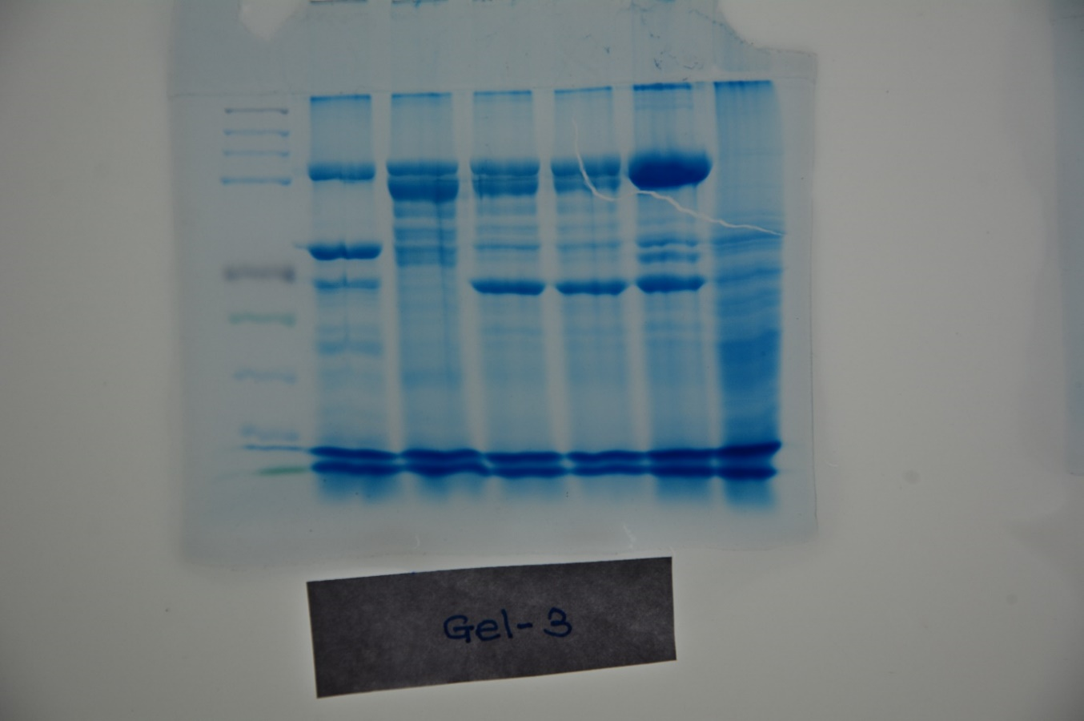

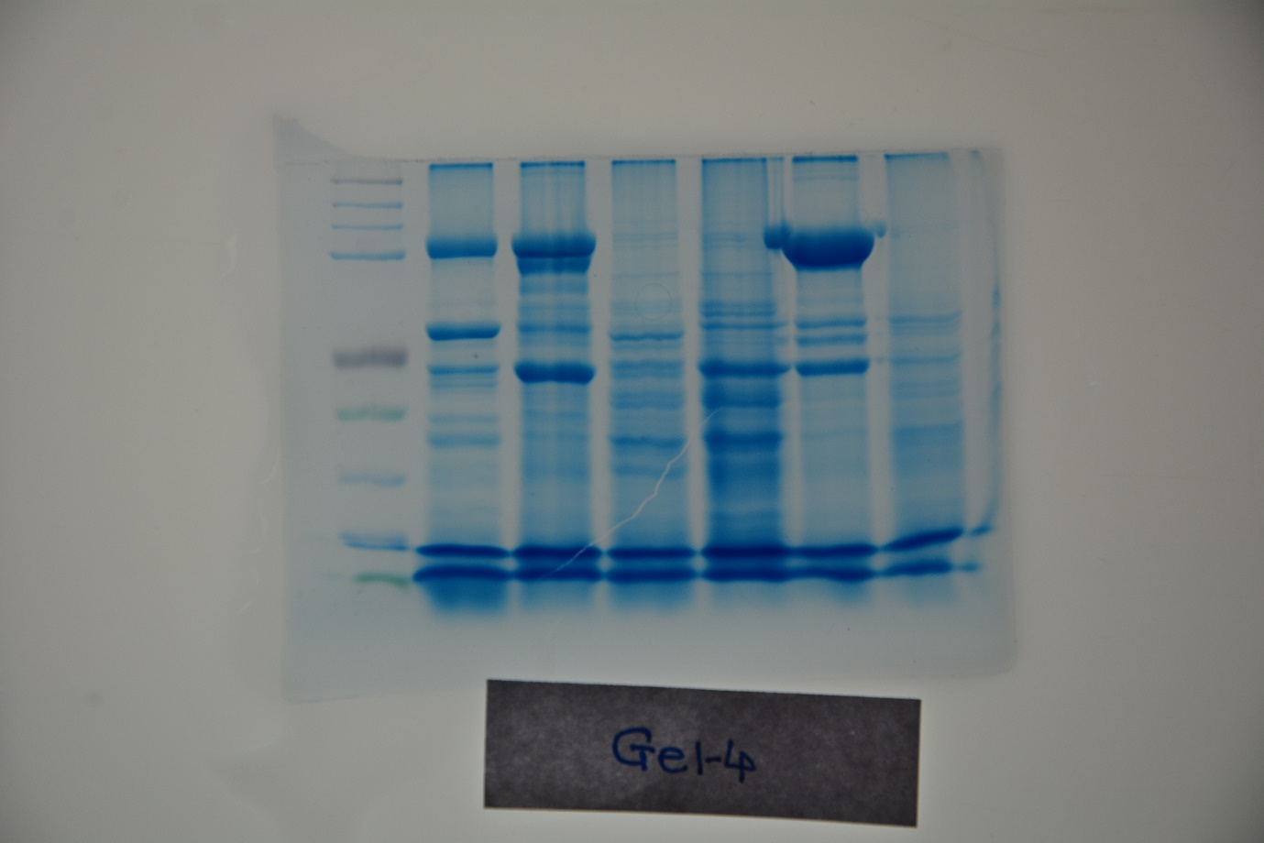

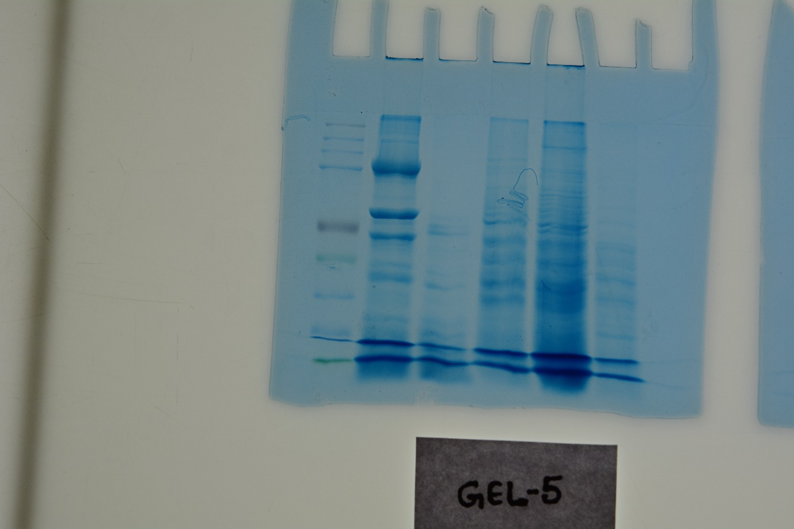

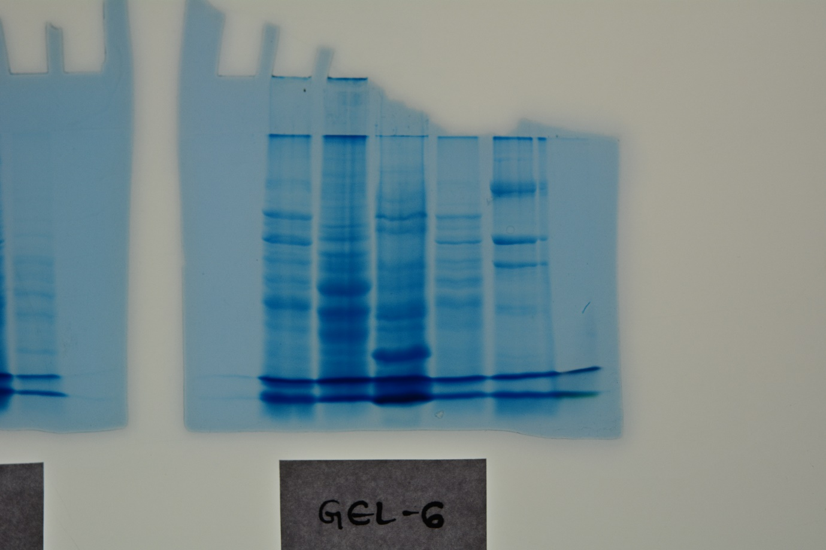

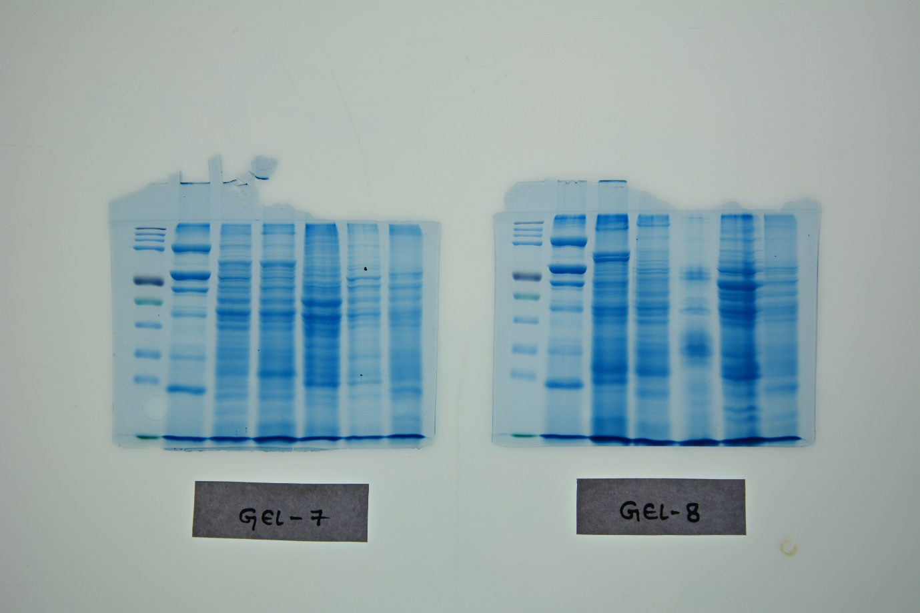

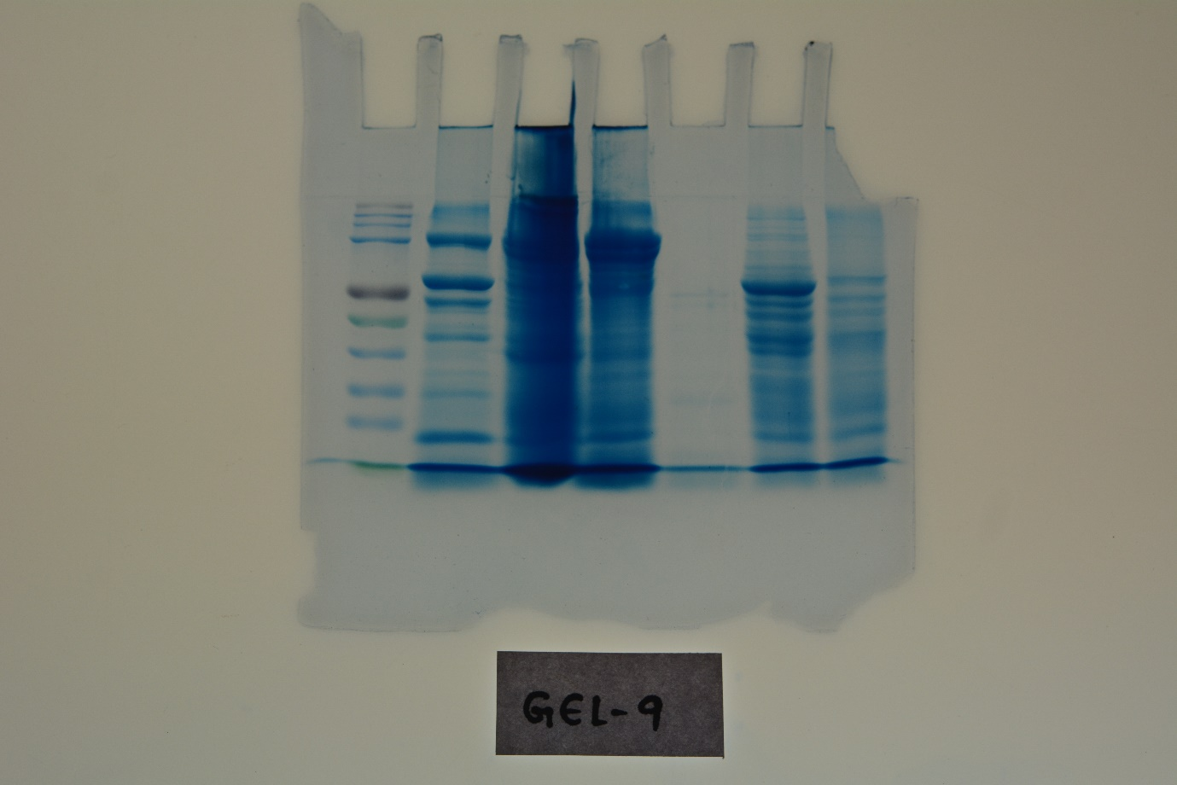

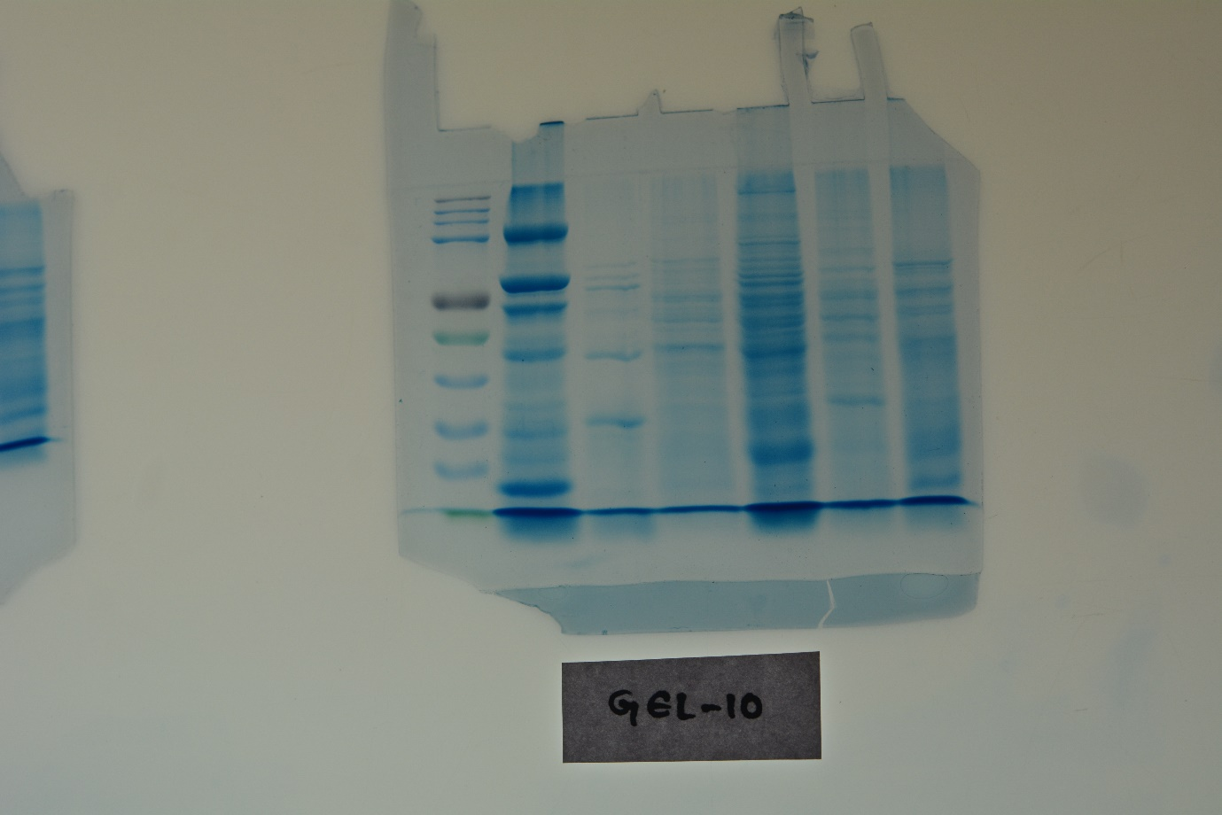

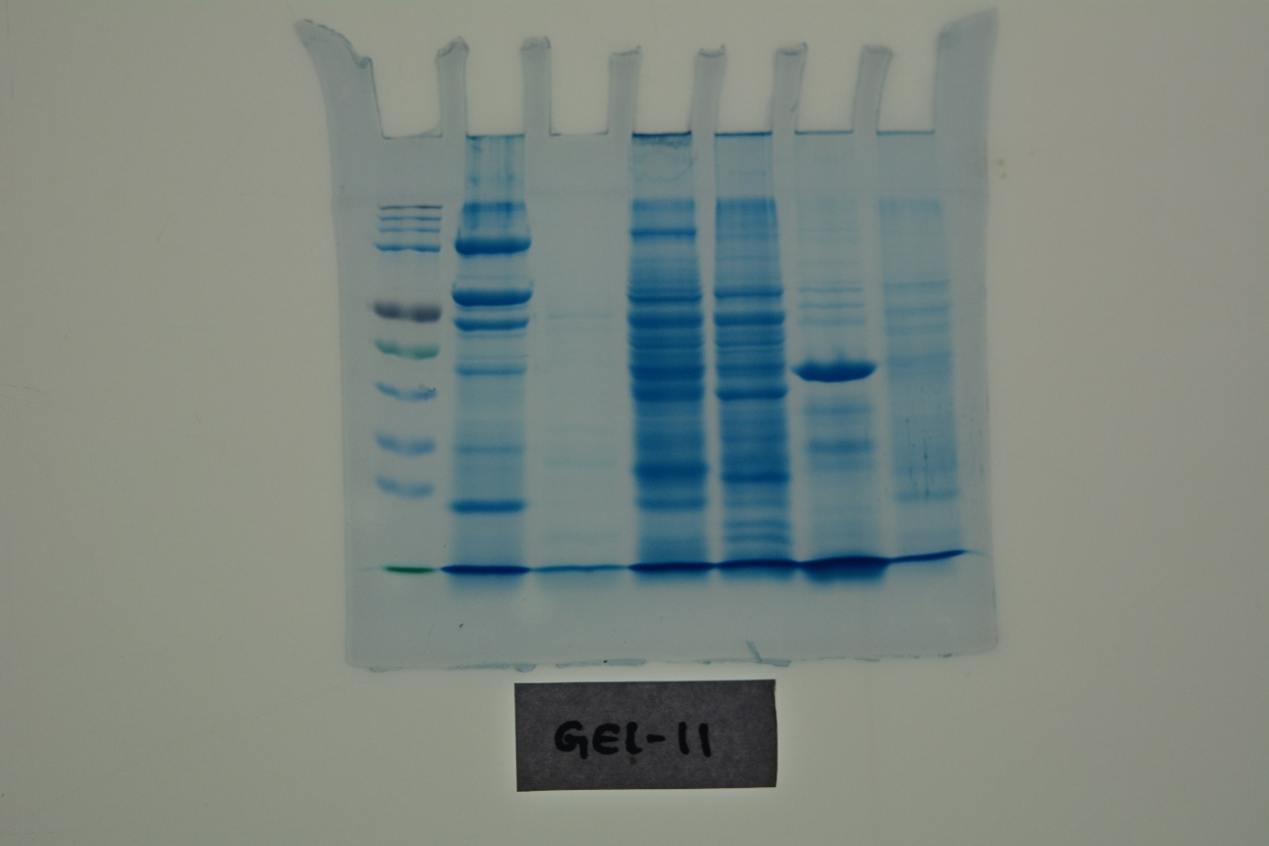

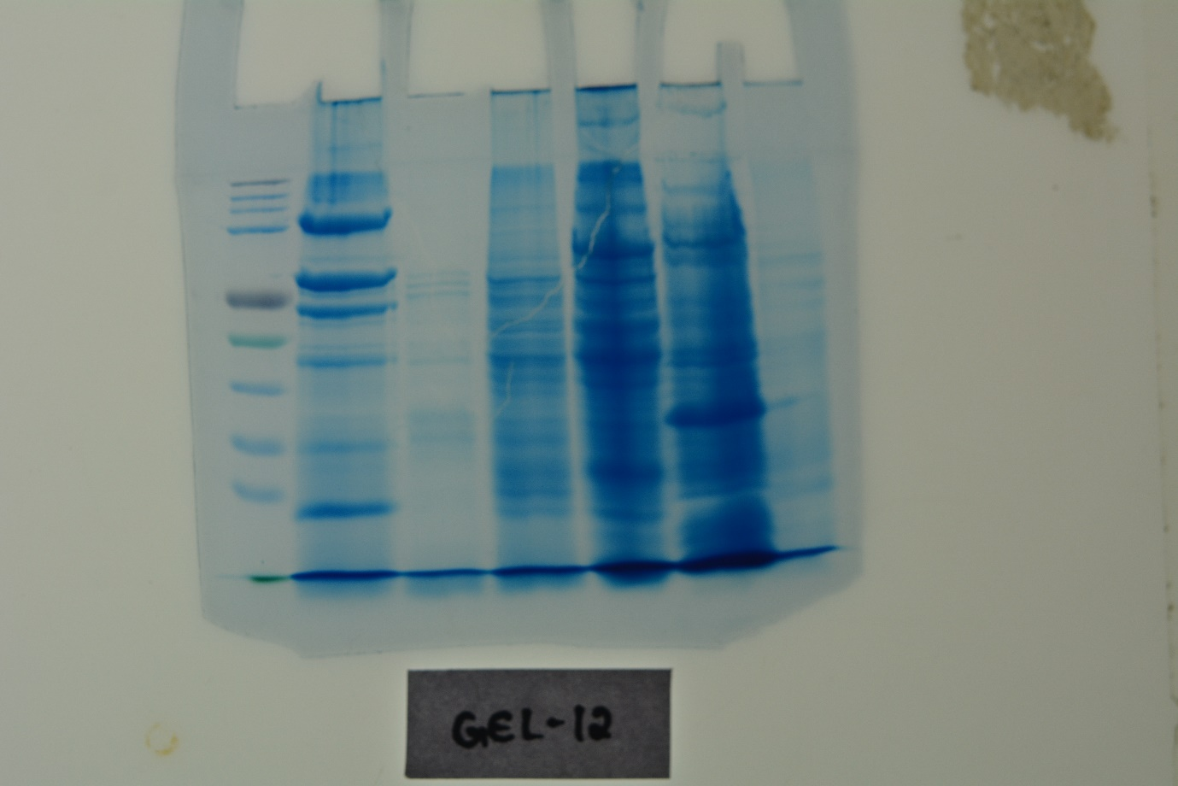

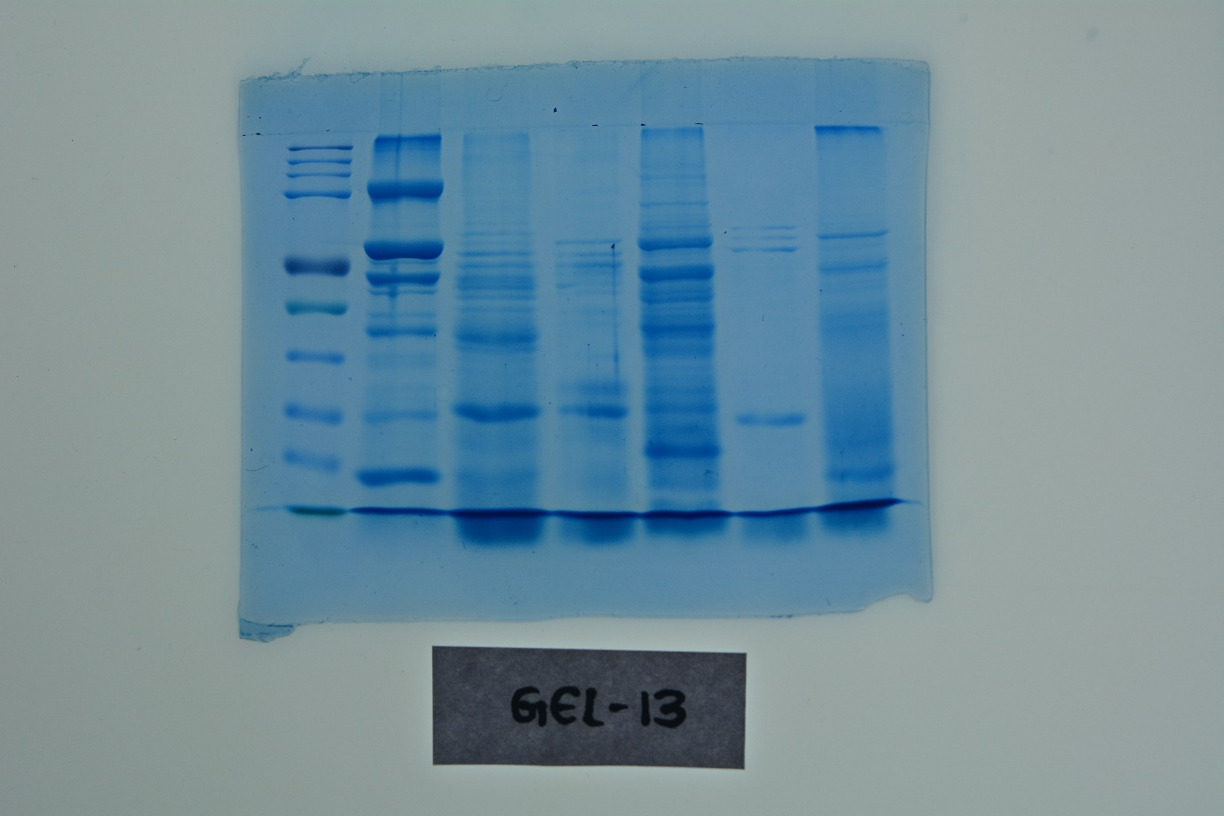

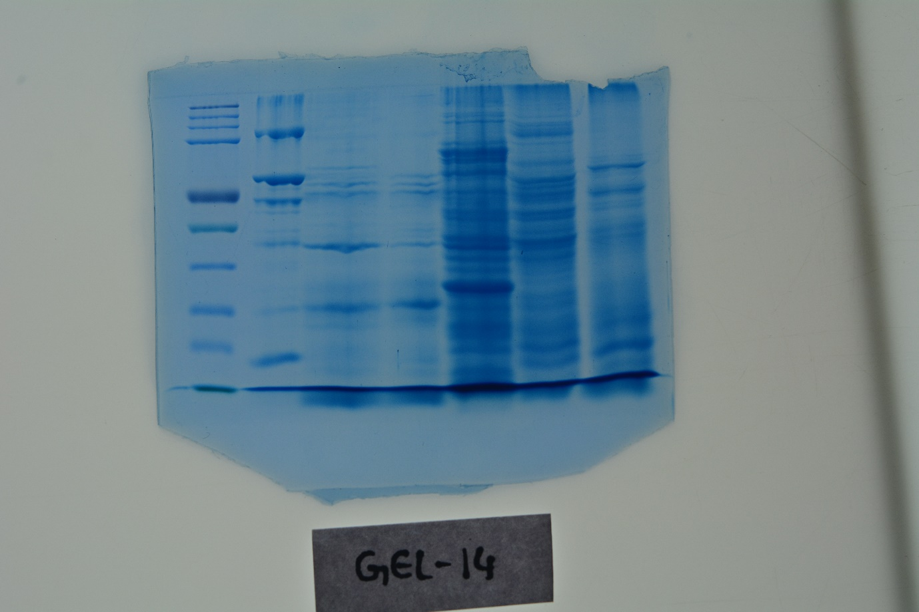

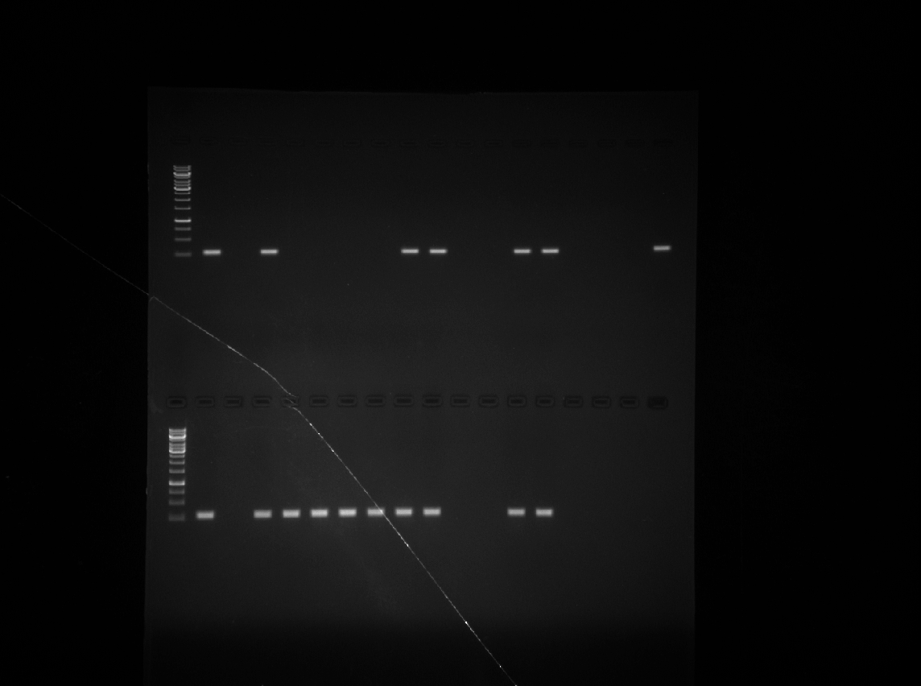  M P N 1 2 3 4 5 6 7 8 9 10 11 12 13 14 15 | 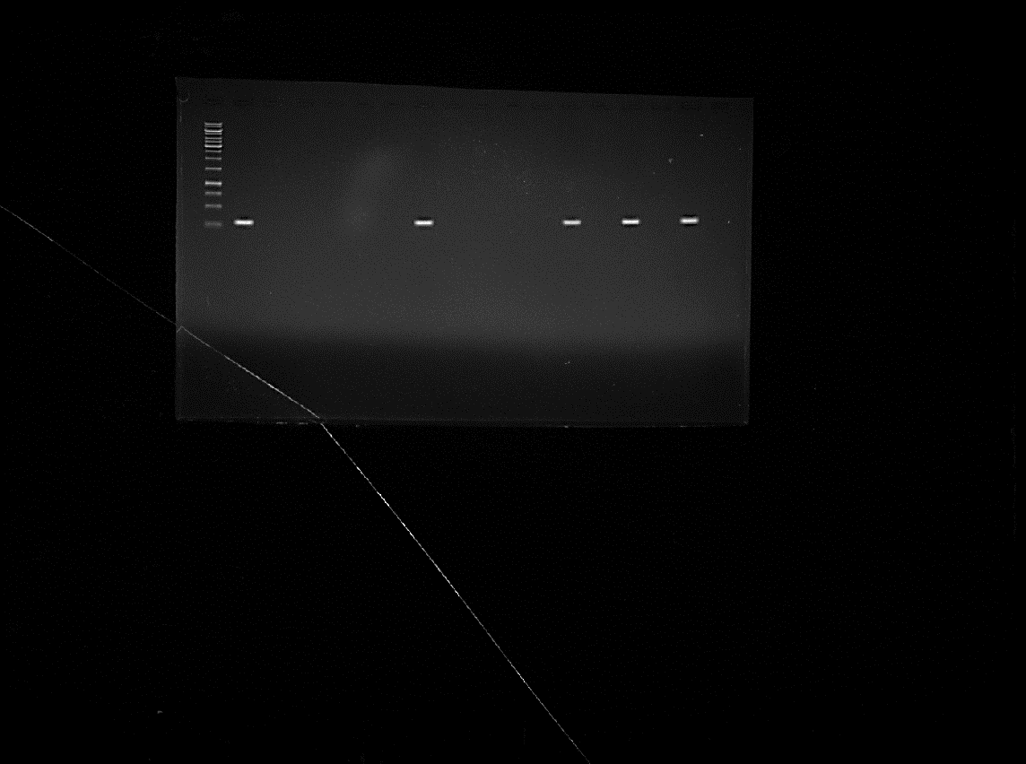  M P N 16 17 18 19 20 21 22 23 24 25 26 27 28 29 30
a. cry1 | b. cry1
M – 1Kb ladder, P -HD1, N- 78/11, Lane 1 – RM1, Lane 2 – RM2, Lane 3 - RM3, Lane 4 – RM5, Lane 5 - RM6, Lane 6 – RM7, Lane 7 – RM8, Lane 8 – RM9, Lane 9 – RM10, Lane 10 – RM11, Lane 11 – RM12, Lane 12 – RM13, Lane 13 – RM14, Lane 14 – RM15, Lane 15 – RM17, Lane 16 – RM 18, Lane 17 – RM19, Lane 18 – RM20, Lane 19 – RM21, Lane 20 – RM22, Lane 21 – RM23, Lane 22 – RM24, Lane 23 – RM25, Lane 24 – RM26, Lane 25 – RM27, Lane 26 – RM28, Lane 27 – RM29, Lane 28– RM30, Lane 29 – RM1R1, Lane 30 – RM1R2
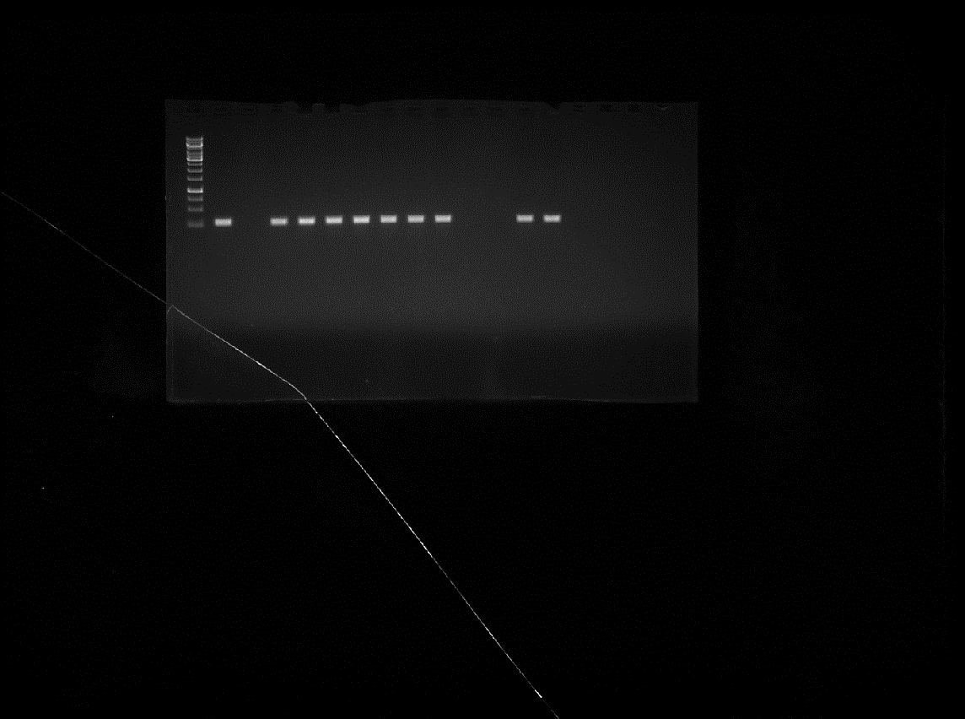  M P N 31 32 33 34 35 36 37 38 39 40 41 42 43 44 45 | 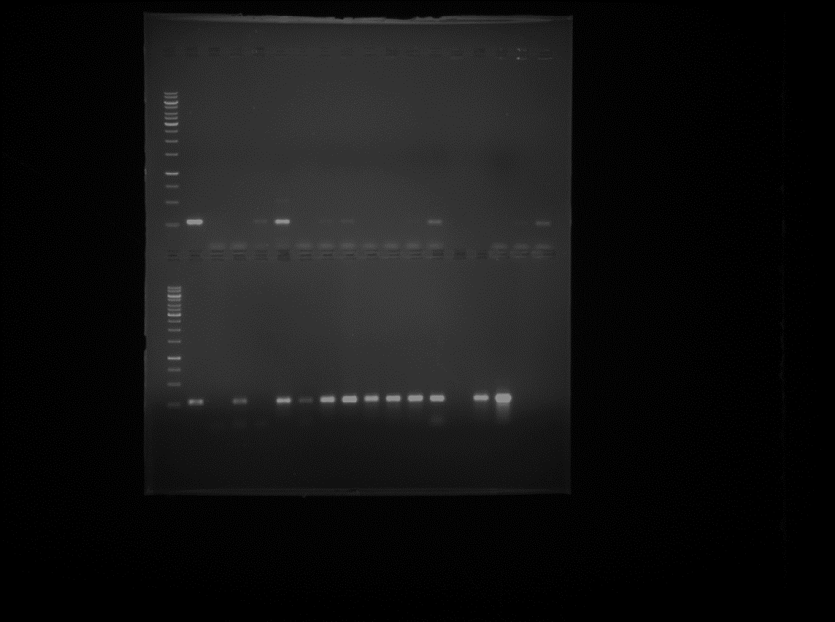  M P N 46 47 48 49 50 51 52 53 54 55 56 57 58
c. cry1 | d. cry1
M – 1Kb ladder, P – HD1, N – 78/11, Lane 31 – T15, Lane 32 – T16, Lane 33 – T20B, Lane 34 – T29, Lane 35 – T32, Lane 36 – T152, Lane 37 – T191, Lane 38 – T210, Lane 39 – T354, Lane 40 – T380, Lane 41 – , T405, Lane 42 – VB1, Lane 43 – VB2, Lane 44 – VB3, Lane 45 – VB4, Lane 46 – VB5, Lane 47 – VB6, Lane 48 – VB7, Lane 49 – VB8, Lane 50 – VB9, Lane 51 – VB10, Lane 52 – VB11, Lane 53 – VB12, Lane 54 – VB16, Lane 55 – VB17, Lane 56 – VB18, Lane 57 – VB19, Lane 58 – VB20
PCR screening of indigenous Bt isolates for cry1 gene

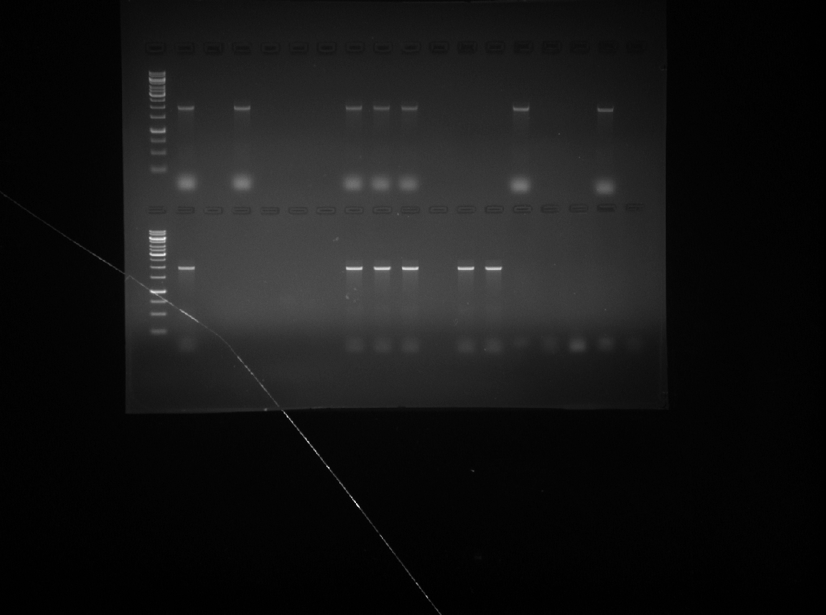  M P N 1 2 3 4 5 6 7 8 9 10 11 12 13 14 15 | 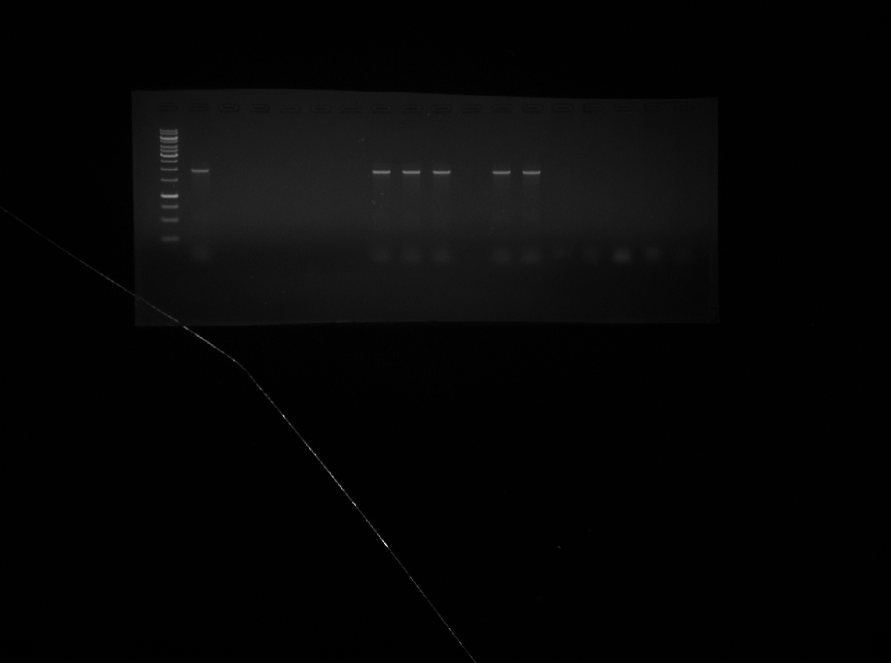  M P N 16 17 18 19 20 21 22 23 24 25 26 27 28 29 30
a. cry1Ab | b. cry1Ab
M – 1Kb ladder, P – HD1, N – 78/11, Lane 1 – RM1, Lane 2 – RM7, Lane 3 – RM8, Lane 4 – RM11, Lane 5 – RM12, Lane 6 – RM17, Lane 7 – RM22, Lane 8 – RM27, Lane 9 – RM29, Lane 10 – RM1R1, Lane 11 – T15, Lane 12 – T16, Lane 13 – T20B, Lane 14 – T29, Lane 15 – T32, Lane 16 – T152, Lane 17 – T191, Lane 18 – T380, Lane 19 – T405, Lane 20 – VB5, Lane 21 – VB7, Lane 22 – VB8, Lane 23 – VB9, Lane 24 – VB10, Lane 25 – VB11, Lane 26 – VB12, Lane 27 – VB16, Lane 28 – VB17, Lane 29 – VB19, Lane 30 – VB20
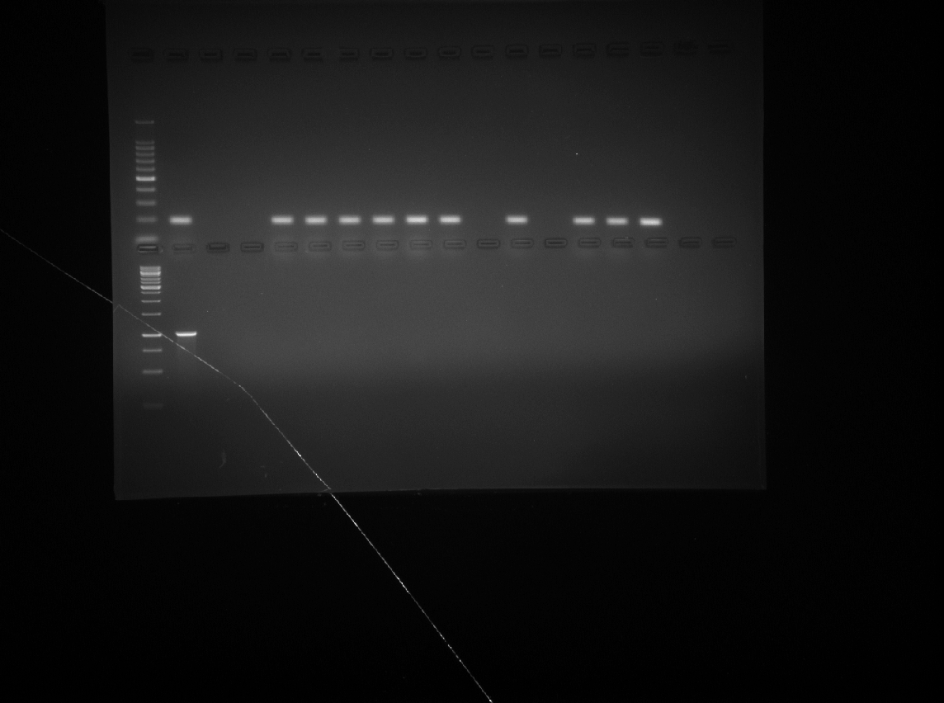  M P N 1 2 3 4 5 6 7 8 9 10 11 12 13 14 15 | 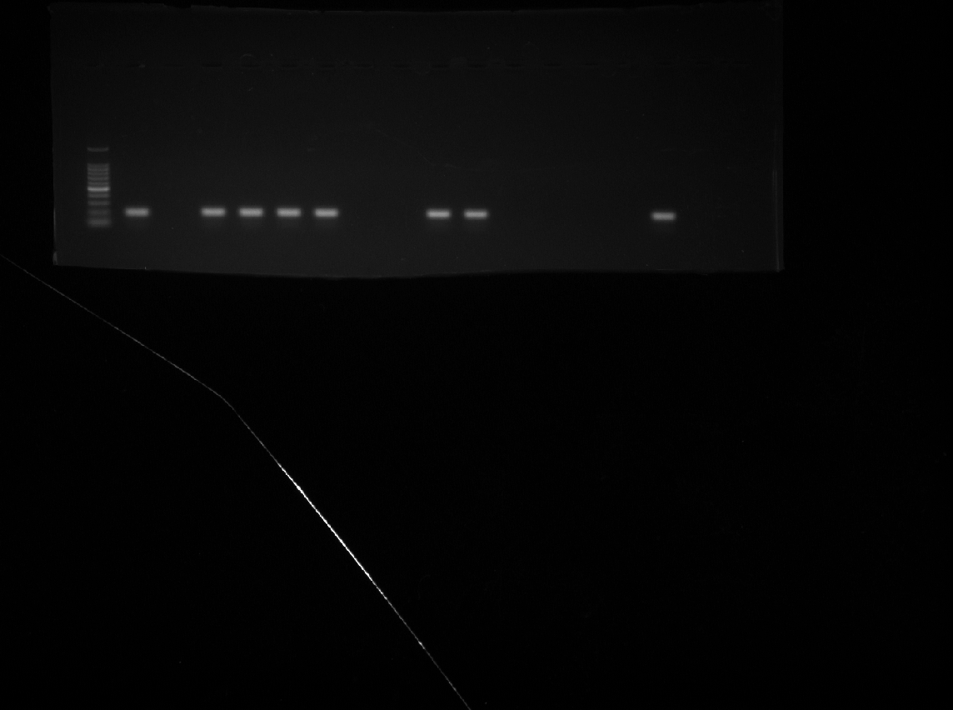  M P N 16 17 18 19 20 21 22 23 24 25 26 27 28 29 30
c. cry1Ac | d. cry1Ac
M – 1Kb ladder, P – HD1, N – 78/11, Lane 1 – RM1, Lane 2 – RM7, Lane 3 – RM8, Lane 4 – RM11, Lane 5 – RM12, Lane 6 – RM17, Lane 7 – RM22, Lane 8 – RM27, Lane 9 – RM29, Lane 10 – RM1R1, Lane 11 – T15, Lane 12 – T20B, Lane 13 – T29, Lane 14 – T16, Lane 15 – T32, Lane 16 – T152, Lane 17 – T191, Lane 18 – T380, Lane 19 – T405, Lane 20 – VB5, Lane 21 – VB7, Lane 22 – VB8, Lane 23 – VB9, Lane 24 – VB10, Lane 25 – VB11, Lane 26 – VB12, Lane 27 – VB16, Lane 28– VB17, Lane 29 – VB19, Lane 30 – VB20
PCR screening of indigenous Bt isolates for cry1Ab and cry1Ac genes

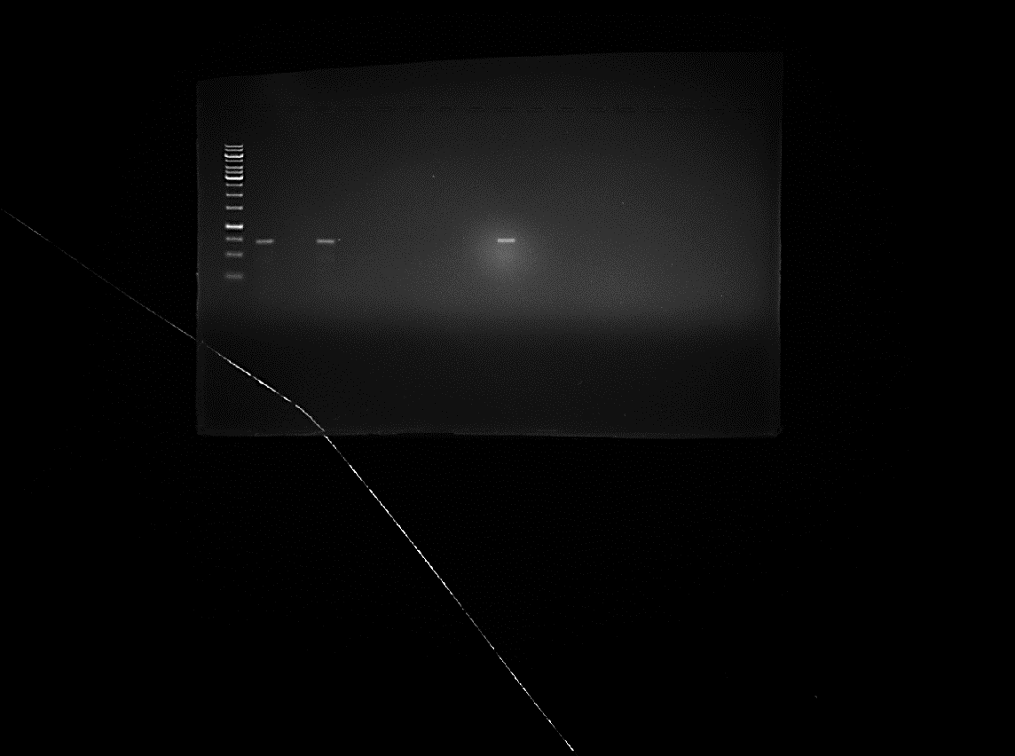  M P N 1 2 3 4 5 6 7 8 9 10 11 12 13 14 15 | 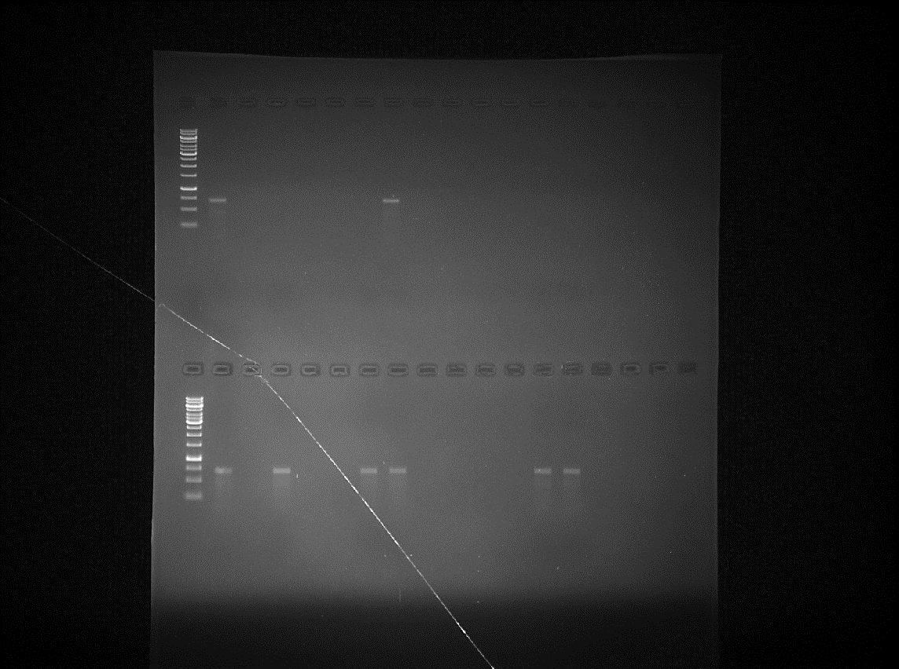  M P N 16 17 18 19 20 21 22 23 24 25 26 27 28 29 30
a. cry2 | b. cry2
M – 1Kb ladder, P -HD1, N- 78/11, Lane 1 – RM1, Lane 2 – RM2, Lane 3 - RM3, Lane 4 – RM5, Lane 5 -RM6, Lane 6 – RM7, Lane 7 – RM8, Lane 8 – RM9, Lane 9 – RM10, Lane 10 – RM11, Lane 11 – RM12, Lane 12 – RM13, Lane 13 – RM14, Lane 14 – RM15, Lane 15 – RM17, Lane 16 – RM 18, Lane 17 – RM19, Lane 18 – RM20, Lane 19 -RM21, Lane 20 – RM22, Lane 21 – RM23, Lane 22 – RM24, Lane 23 – RM25, Lane 24 – RM26, Lane 25 – RM27, Lane 26 – RM28, Lane 27 – RM29, Lane 28– RM30, Lane 29 – RM1R1, Lane 30 – RM1R2
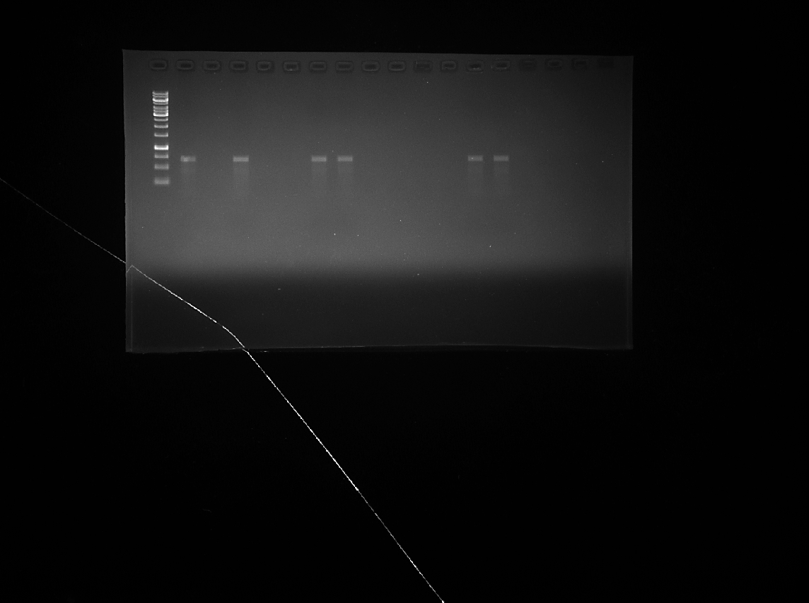  M P N 31 32 33 34 35 36 37 38 39 40 41 42 43 44 45 | 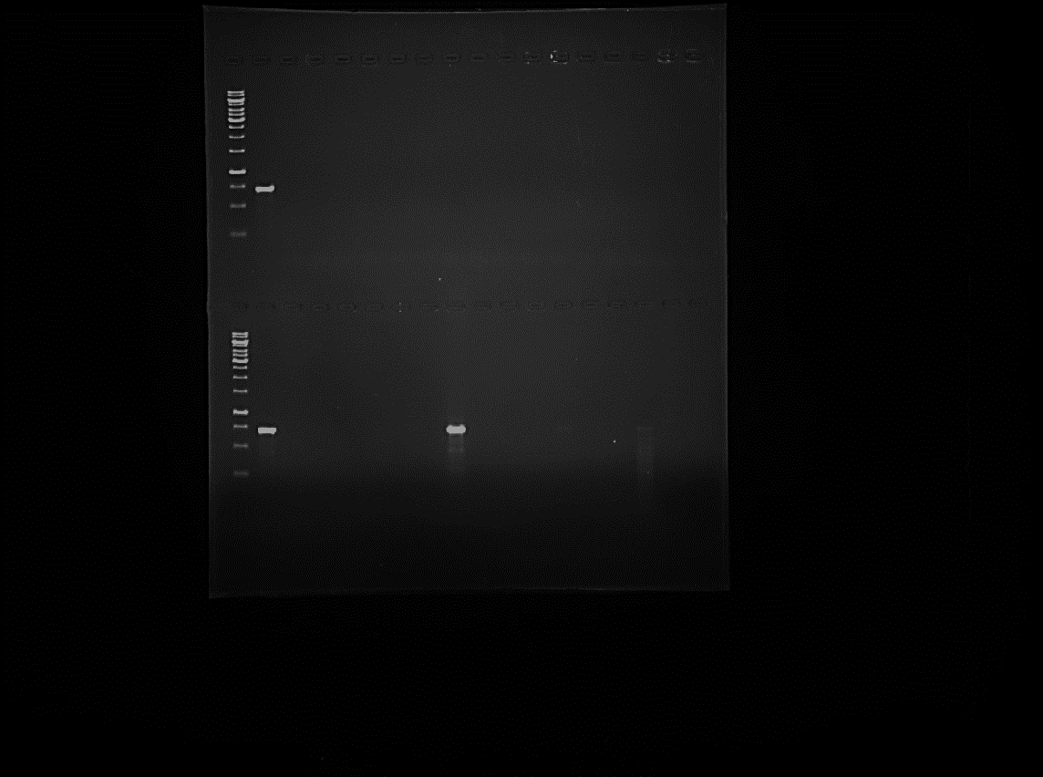  M P N 46 47 48 49 50 51 52 53 54 55 56 57 58
c. cry2 | d. cry2
M – 1Kb ladder, P – HD1, N – 78/11, Lane 31 – T15, Lane 32 – T16, Lane 33 – T20B, Lane 34 – T29, Lane 35 – T32, Lane 36 – T152, Lane 37 – T191, Lane 38 – T210, Lane 39 – T354, Lane 40 – T380, Lane 41 – , T405, Lane 42 – VB1, Lane 43 – VB2, Lane 44 – VB3, Lane 45 – VB4, Lane 46 – VB5, Lane 47 – VB6, Lane 48 – VB7, Lane 49 – VB8, Lane 50 – VB9, Lane 51 – VB10, Lane 52 – VB11, Lane 53 – VB12, Lane 54 – VB16, Lane 55 – VB17, Lane 56 – VB18, Lane 57 – VB19, Lane 58 – VB20
PCR screening of indigenous Bt isolates for cry2 gene

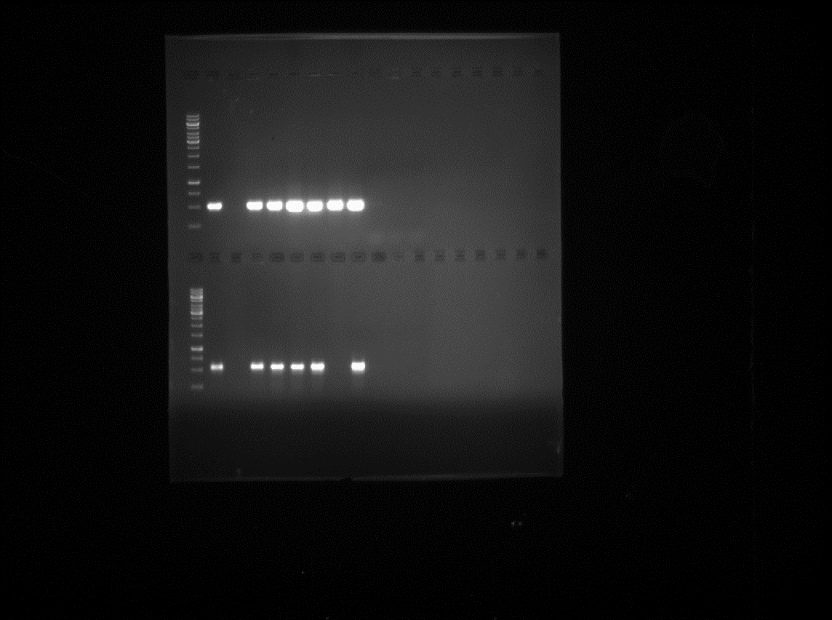  M P N 1 2 3 4 5 6 7 8 9 | 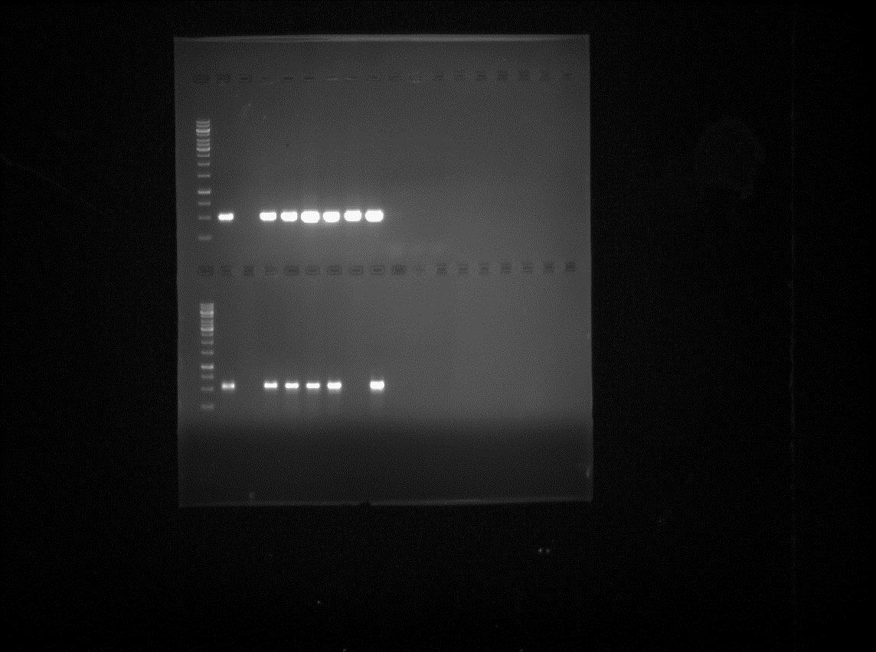  M P N 1 2 3 4 5 6 7 8 9
a. cry2Aa | b. cry2Ab
M – 1Kb ladder, P – HD1, N – 78/11, Lane 1 – RM22, Lane 2 – T15, Lane 3 – T29, Lane 4 – T32, Lane 5 – T380, Lane 6 – T405, Lane 7 – RM1, Lane 8 – RM8, Lane 9 – VB9
PCR screening of indigenous Bt isolates for cry2Ab gene

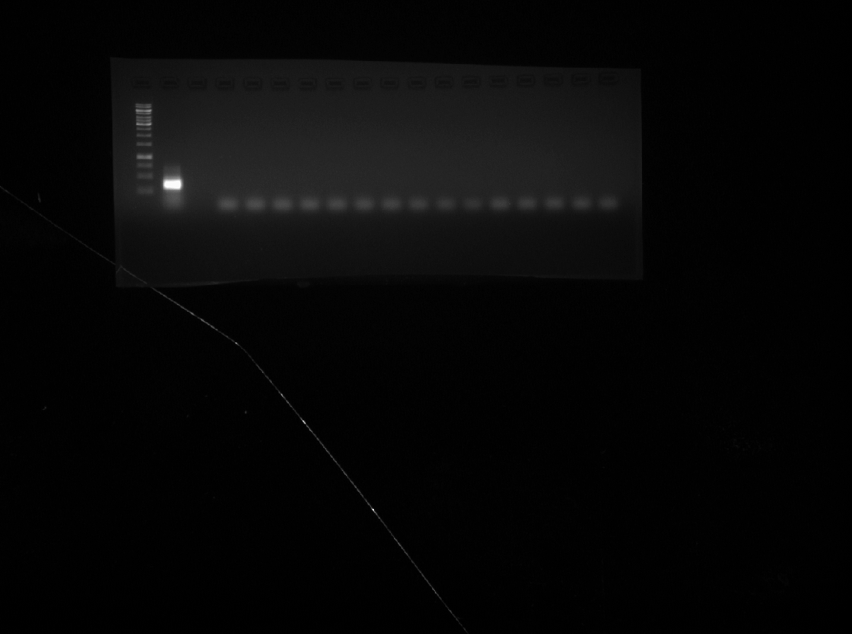  M P N 1 2 3 4 5 6 7 8 9 10 11 12 13 14 15 | M P N 16 17 18 19 20 21 22 23 24 25 26 27 28 29 30
a. cry9 | b. cry9
M – 1Kb ladder, P – HD1, N – 78/11, Lane 1 – RM1, Lane 2 – RM2, Lane 3 - RM3, Lane 4 – RM5, Lane 5 – RM6, Lane 6 – RM7, Lane 7 – RM8, Lane 8 – RM9, Lane 9 – RM10, Lane 10 – RM11, Lane 11 – RM12, Lane 12 – RM13, Lane 13 – RM14, Lane 14 – RM15, Lane 15 – RM17, Lane 16 – RM 18, Lane 17 – RM19, Lane 18 – RM20, Lane 19 -RM21, Lane 20 – RM22, Lane 21 – RM23, Lane 22 – RM24, Lane 23 – RM25, Lane 24 – RM26, Lane 25 – RM27, Lane 26 – RM28, Lane 27 – RM29, Lane 28– RM30, Lane 29 – RM1R1, Lane 30 – RM1R2
M P N 31 32 33 34 35 36 37 38 39 40 41 42 43 44 45 | M P N 46 47 48 49 50 51 52 53 54 55 56 57 58
c. cry9 | d. cry9
M – 1Kb ladder, P – HD1, N – 78/11, Lane 31 – T15, Lane 32 – T16, Lane 33 – T20B, Lane 34 – T29, Lane 35 – T32, Lane 36 – T152, Lane 37 – T191, Lane 38 – T210, Lane 39 – T380, Lane 40 – T405, Lane 41 – , T354, Lane 42 – VB1, Lane 43 – VB2, Lane 44 – VB3, Lane 45 – VB4, Lane 46 – VB5, Lane 47 – VB6, Lane 48 – VB7, Lane 49 – VB8, Lane 50 – VB9, Lane 51 – VB10, Lane 52 – VB11, Lane 53 – VB12, Lane 54 – VB16, Lane 55 – VB17, Lane 56 – VB18, Lane 57 – VB19, Lane 58 – VB20
PCR screening of indigenous Bt isolates for cry9 gene

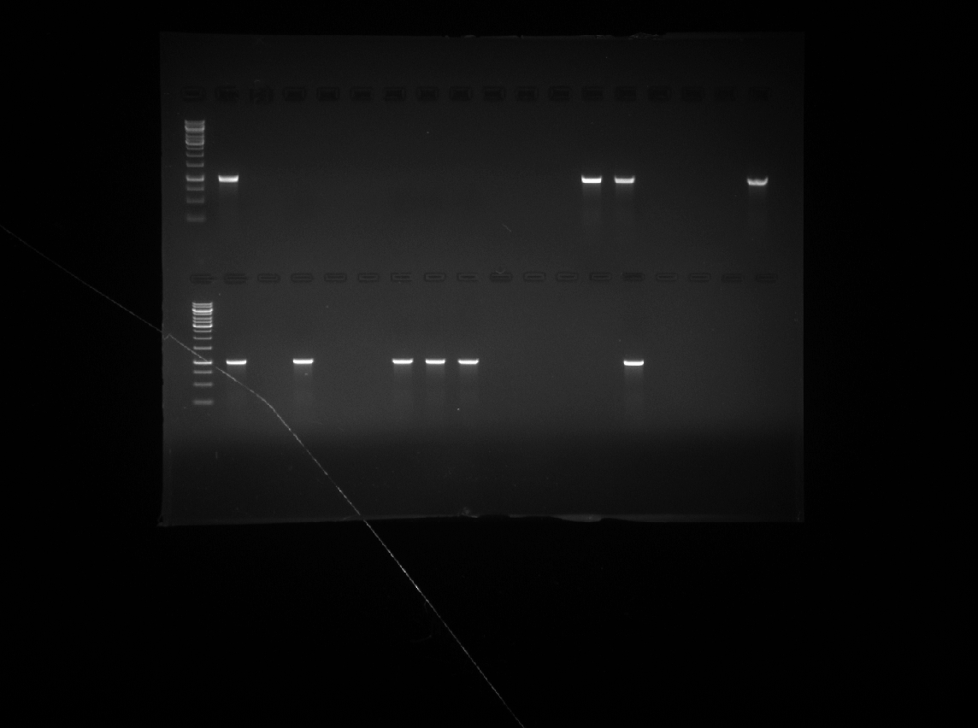  M P N 1 2 3 4 5 6 7 8 9 10 11 12 13 14 15 | 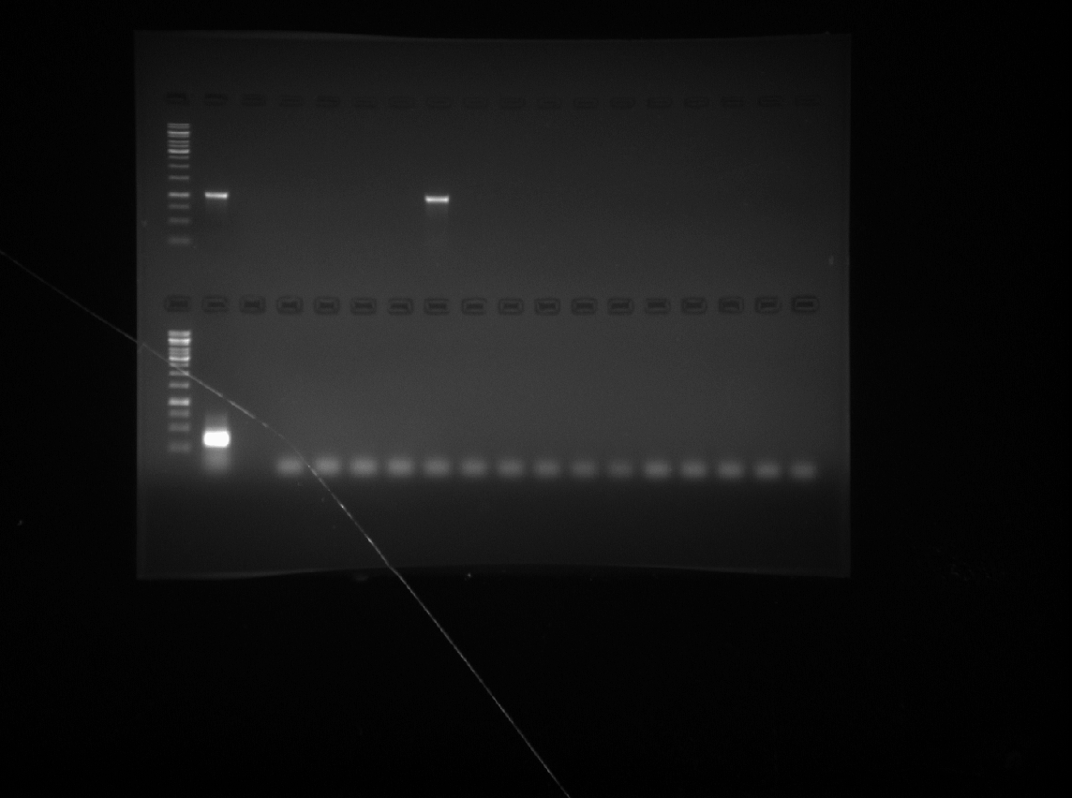  M P N 16 17 18 19 20 21 22 23 24 25 26 27 28 29 30
a. vip3Aa | b. vip3Aa
M – 1Kb ladder, P – HD1, N – 78/11, Lane 1 – RM1, Lane 2 – RM2, Lane 3 – RM3, Lane 4 – RM5, Lane 5 – RM6, Lane 6 – RM7, Lane 7 – RM8, Lane 8 – RM9, Lane 9 – RM10, Lane 10 – RM11, Lane 11 – RM12, Lane 12 – RM13, Lane 13 – RM14, Lane 14 – RM15, Lane 15 – RM17, Lane 16 – RM 18, Lane 17 – RM19, Lane 18 – RM20, Lane 19 – RM21, Lane 20 – RM22, Lane 21 – RM23, Lane 22 – RM24, Lane 23 – RM25, Lane 24 – RM26, Lane 25 – RM27, Lane 26 – RM28, Lane 27 – RM29, Lane 28– RM30, Lane 29 – RM1R1, Lane 30 – RM1R2
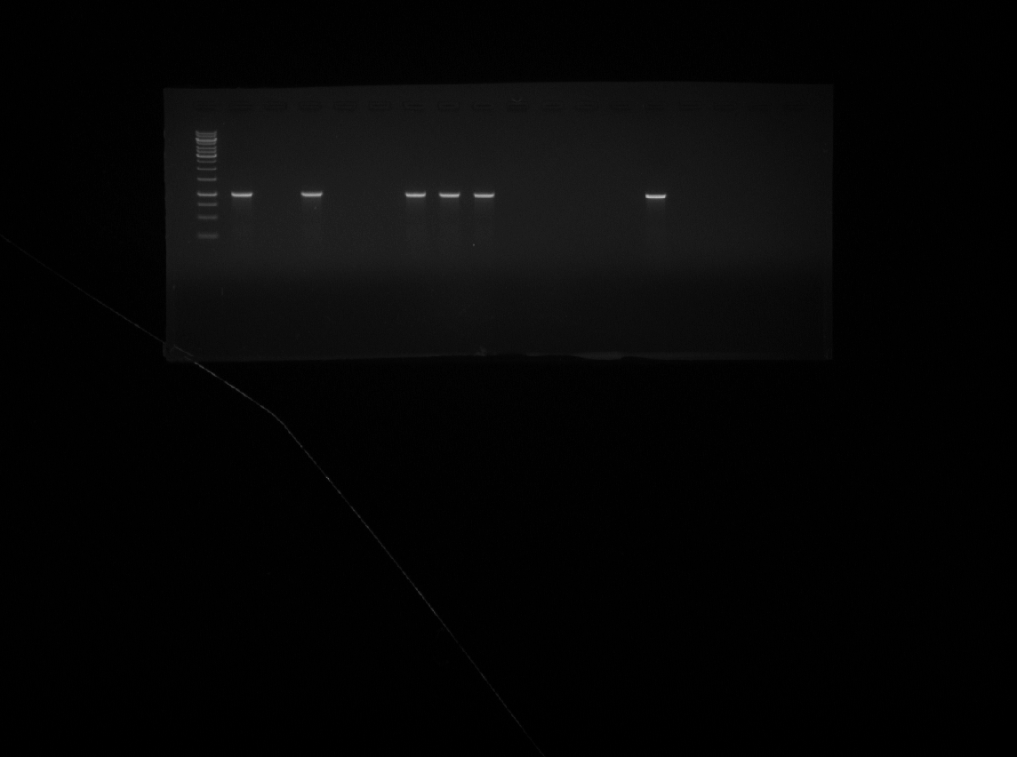  M P N 31 32 33 34 35 36 37 38 39 40 41 42 43 44 45 |   M P N 46 47 48 49 50 51 52 53 54 55 56 57 58
c. vip3Aa | d. vip3Aa
M – 1Kb ladder, P – HD1, N – 78/11, Lane 31 – T15, Lane 32 – T16, Lane 33 – T20B, Lane 34 – T29, Lane 35 – T32, Lane 36 – T152, Lane 37 – T191, Lane 38 – T210, Lane 39 – T380, Lane 40 – T354, Lane 41 – T405, Lane 42 – VB1, Lane 43 – VB2, Lane 44 – VB3, Lane 45 – VB4, Lane 46 – VB5, Lane 47 – VB6, Lane 48 – VB7, Lane 49 – VB8, Lane 50 – VB9, Lane 51 – VB10, Lane 52 – VB11, Lane 53 – VB12, Lane 54 – VB16, Lane 55 – VB17, Lane 56 – VB18, Lane 57 – VB19, Lane 58 – VB20
PCR screening of indigenous Bt isolates for vip3Aa gene

