Table S1. sPESI score
Variables | Score
Age > 80 years | 1
Systolic blood pressure (SBP) < 100 mmHg | 1
Pulse oxygen saturation (SpO2)< 90%, | 1
Heart rate ≥ 110 bpm | 1
History of cancer | 1
History of chronic cardiopulmonary disease | 1

Table S2. Baseline characteristics and comparisons between 30-day survivors and non-survivors in the external validation cohort
Variables | Total (n = 215) | 30-day survival (n = 191) | 30-day mortality (n = 24) | P
Demographic variables
Age, years | 64.00 (52.50, 72.00) | 64.00 (51.00, 72.00) | 68.50 (56.00, 74.25) | 0.112
Weight, Kg | 65.00 (59.00, 70.00) | 65.00 (60.00, 70.00) | 63.00 (55.00, 70.00) | 0.357
Male, n(%) | 113 (52.56) | 100 (52.36) | 13 (54.17) | 0.867
Vital signs
Heart rate, bpm | 84.00 (75.00, 96.00) | 83.00 (74.00, 94.50) | 100.50 (81.50, 110.25) | 0.002
SBP, mmHg | 128.00 (114.00, 139.00) | 128.00 (114.00,139.00) | 128.50 (99.75,137.50) | 0.603
RR, bpm | 20.00 (20.00, 21.00) | 20.00 (20.00, 21.00) | 21.00 (18.00, 24.25) | 0.909
PO₂, mmHg | 87.00 (72.70, 114.00) | 87.00 (73.00, 114.00) | 86.40 (59.95, 118.95) | 0.734
PCO₂, mmHg | 36.80 (32.90, 40.30) | 36.40 (32.55, 40.00) | 44.30 (36.00, 56.50) | <.001
Comorbidities
Sepsis, n(%) | 20 (9.30) | 16 (8.38) | 4 (16.67) | 0.345
Cancer, n(%) | 29 (13.49) | 27 (14.14) | 2 (8.33) | 0.640
Hypertension, n(%) | 67 (31.16) | 60 (31.41) | 7 (29.17) | 0.823
CAD, n(%) | 20 (9.30) | 18 (9.42) | 2 (8.33) | 1.000
Heart failure, n(%) | 7 (3.26) | 6 (3.14) | 1 (4.17) | 0.560
CKD, n(%) | 15 (6.98) | 10 (5.24) | 5 (20.83) | 0.016
Diabetes, n(%) | 29 (13.49) | 28 (14.66) | 1 (4.17) | 0.271
Stroke, n(%) | 27 (12.56) | 25 (13.09) | 2 (8.33) | 0.737
CPD, n(%) | 13 (6.05) | 10 (5.24) | 3 (12.50) | 0.341
Laboratory tests
WBC, ×10⁹/L | 8.27 (6.17, 10.64) | 8.04 (6.11, 10.08) | 11.63 (10.43, 16.54) | <.001
HGB, g/L | 130.00 (115.50, 141.00) | 130.00 (118.00, 141.00) | 130.00 (105.25, 137.50) | 0.353
Platelet, ×10⁹/L | 207.00 (169.50, 260.50) | 206.00 (169.50, 259.50) | 218.00 (171.50, 283.00) | 0.464
Albumin, g/L | 36.00 (32.80, 39.47) | 36.10 (33.40, 39.52) | 32.70 (28.56, 37.12) | 0.013
Lactate, mmol/L | 1.30 (1.00, 1.85) | 1.30 (0.95, 1.75) | 4.40 (1.45, 6.92) | <.001
D-Dimer, mg/L | 3.70 (1.87, 9.73) | 3.58 (1.94, 9.66) | 7.37 (1.52 13.10) | 0.006
ALT, U/L | 24.00 (16.00, 41.00) | 23.00 (14.50, 39.50) | 36.00 (27.50, 59.50) | 0.005
AST, U/L | 25.00 (20.00, 39.00) | 25.00 (20.00, 36.50) | 33.00 (23.75, 58.25) | 0.012
BUN, mmol/L | 5.16 (3.94, 7.10) | 5.06 (3.90, 6.91) | 7.37 (5.20, 11.94) | <.001
Creatinine, μmol/L | 77.60 (63.34, 95.69) | 77.00 (63.34, 92.95) | 90.26 (66.88, 133.75) | 0.080
Total Cholesterol, | 4.58 (3.8, 5.40) | 4.63 (3.92, 5.45) | 3.98 (3.44, 4.82) | 0.048
HDL-C, mmol/L | 0.98 (0.80, 1.16) | 1.01 (0.83, 1.17) | 0.71 (0.60, 0.88) | <.001
LDL-C, mmol/L | 2.89 (2.44, 3.47) | 2.92 (2.49, 3.52) | 2.56 (2.07, 3.19) | 0.101
Triglycerides, mmol/L | 1.37 (1.04, 1.93) | 1.40 (1.04, 1.94) | 1.34 (0.99, 1.84) | 0.636
Severity
sPESI | 0.00 (0.00, 1.00) | 0.00 (0.00, 1.00) | 1.00 (1.00, 1.00) | <.001
Positive cardiac troponin，n (%) | 127 (59.07) | 104 (54.45) | 23 (95.83) | <.001
Positive NT-proBNP, n (%) | 149 (69.30) | 126 (65.97) | 23 (95.83) | 0.003
RVD, n(%) | 136 (63.26) | 115 (60.21) | 21 (87.50) | 0.009
Risk stratification, n(%) |  |  |  | <.001
Low risk | 31 (14.42) | 30 (15.71) | 1 (4.17)
Intermediate-low risk | 84 (39.07) | 81 (42.41) | 3 (12.50)
Intermediate-high risk | 91 (42.33) | 76 (39.79) | 15 (62.50)
High risk | 9 (4.19) | 4 (2.09) | 5 (20.83)
Therapy
Reperfusion, n(%) | 23 (10.70) | 14 (7.33) | 9 (37.50) | <.001
SBP, systolic blood pressure; RR, respiratory rate; PCO₂, partial pressure of carbon dioxide; PO₂, partial pressure of oxygen; WBC, white blood cell; HGB, haemoglobin; BUN, blood urea nitrogen; ALT, alanine aminotransferase; AST, aspartate aminotransferase; HDL-C. high-density lipoprotein cholesterol; LDL-C. low-density lipoprotein cholesterol; sPESI, simplified pulmonary embolism severity index; CAD, coronary artery disease; CPD, chronic pulmonary disease; CKD, chronic kidney disease; NT-proBNP, N-terminal pro–B-type natriuretic peptide; RVD, right ventricular dysfunction

Table S3. Basic characteristics of the study participants stratified by the HDL-C

Variables | Total (n = 1231) | HDL-C>0.94mmol/L (n = 810) | HDL-C≤0.94mmol/L (n = 421) | P
Demographic variables
Age, years | 69.00 (60.00, 76.00) | 69.00 (60.00, 76.00) | 68.00 (59.00, 76.00) | 0.521
Weight, Kg | 65.00 (58.00, 74.00) | 65.00 (58.08, 74.00) | 66.80 (58.00, 74.50) | 0.412
Male, n(%) | 630 (51.18) | 388 (47.90) | 242 (57.48) | 0.001
Vital signs
Heart rate, bpm | 86.00 (76.00, 100.00) | 84.00 (76.00, 96.00) | 88.00 (78.00, 105.00) | <.001
SBP, mmHg | 124.00 (110.00, 136.00) | 124.00 (111.00, 136.50) | 122.00 (110.00, 136.00) | 0.223
RR, bpm | 20.00 (18.00, 21.00) | 20.00 (18.00, 21.00) | 20.00 (18.50, 22.00) | 0.108
PO₂, mmHg | 71.50 (60.95, 88.45) | 71.85 (61.80, 88.00) | 71.00 (58.60, 89.10) | 0.198
PCO₂, mmHg | 34.90 (30.80, 39.10) | 35.35 (31.42, 39.90) | 33.40 (29.00, 38.00) | <.001
Comorbidities
Sepsis, n(%) | 46 (3.74) | 19 (2.35) | 27 (6.41) | <.001
Cancer, n(%) | 316 (25.67) | 201 (24.81) | 115 (27.32) | 0.341
Hypertension, n(%) | 454 (36.88) | 296 (36.54) | 158 (37.53) | 0.734
CAD, n(%) | 224 (18.20) | 161 (19.88) | 63 (14.96) | 0.034
Heart failure, n(%) | 41 (3.33) | 26 (3.21) | 15 (3.56) | 0.743
CKD, n(%) | 47 (3.82) | 35 (4.32) | 12 (2.85) | 0.201
Diabetes, n(%) | 173 (14.05) | 105 (12.96) | 68 (16.15) | 0.127
Stroke, n(%) | 193 (15.68) | 120 (14.81) | 73 (17.34) | 0.248
CPD, n(%) | 61 (4.96) | 44 (5.43) | 17 (4.04) | 0.285
Laboratory tests
WBC, ×10⁹/L | 7.40 (5.63, 10.21) | 7.21 (5.51, 9.73) | 7.96 (6.09, 11.05) | <.001
HGB, g/L | 124.00 (107.80, 138.00) | 125.00 (110.00, 139.00) | 123.00 (102.00, 137.00) | <.001
Platelet, ×10⁹/L | 204.00 (155.00, 265.00) | 203.00 (156.00, 261.50) | 204.00 (153.00, 270.25) | 0.769
Albumin, g/L | 37.10 (33.10, 40.52) | 37.70 (34.00, 41.10) | 35.50 (31.10, 39.10) | <.001
Lactate, mmol/L | 1.40 (1.00, 1.96) | 1.35 (1.00, 1.90) | 1.50 (1.10, 2.10) | <.001
D-Dimer, mg/L | 3.53 (1.67, 7.56) | 3.39 (1.52, 7.06) | 3.85 (2.04, 8.73) | 0.013
ALT, U/L | 22.50 (14.25, 39.75) | 21.00 (14.00, 36.00) | 26.00 (16.00, 45.00) | <.001
AST, U/L | 22.00 (16.00, 32.00) | 21.00 (16.00, 29.00) | 24.00 (17.00, 38.00) | <.001
BUN, mmol/L | 5.30 (4.00, 7.20) | 5.10 (3.90, 6.70) | 5.78 (4.20, 8.20) | <.001
Creatinine, μmol/L | 67.00 (54.00, 83.00) | 66.03 (54.00, 81.00) | 67.00 (54.00, 85.75) | 0.244
Total Cholesterol, | 4.07 (3.31, 4.97) | 4.33 (3.68, 5.23) | 3.61 (2.86, 4.37) | 0.048
LDL-C, mmol/L | 2.38 (1.84, 3.02) | 2.54 (1.95, 3.18) | 2.18 (1.68, 2.81) | <.001
Triglycerides, mmol/L | 1.23 (0.93, 1.77) | 1.19 (0.92, 1.72) | 1.29 (0.94, 1.86) | 0.166
Severity
sPESI | 1.00 (0.00, 1.00) | 1.00 (0.00, 1.00) | 1.00 (0.00, 1.00) | <.001
Positive cardiac troponin, n (%) | 386 (31.36) | 168 (20.74) | 218 (51.78) | <.001
Positive NT-proBNP , n (%) | 564 (45.82) | 298 (36.79) | 266 (63.18) | <.001
RVD, n(%) | 616 (50.04) | 343 (42.35) | 273 (64.85) | <.001
Risk stratification, n(%) |  |  |  | <.001
Low risk | 254 (20.63) | 214 (26.42) | 40 (9.50)
Intermediate-low risk | 659 (53.53) | 471 (58.15) | 188 (44.66)
Intermediate-high risk | 260 (21.12) | 102 (12.59) | 158 (37.53)
High risk | 58 (4.71) | 23 (2.84) | 35 (8.31)
Therapy
Reperfusion, n(%) | 76 (6.17) | 43 (5.31) | 33 (7.84) | 0.080
Outcome
30-day mortality, n(%) | 107 (8.69) | 34 (4.20) | 73 (17.34) | <.001
SBP, systolic blood pressure; RR, respiratory rate; PCO₂, partial pressure of carbon dioxide; PO₂, partial pressure of oxygen; WBC, white blood cell; HGB, haemoglobin; BUN, blood urea nitrogen; ALT, alanine aminotransferase; AST, aspartate aminotransferase; HDL-C. high-density lipoprotein cholesterol; LDL-C. low-density lipoprotein cholesterol; sPESI, simplified pulmonary embolism severity index; CAD, coronary artery disease; CPD, chronic pulmonary disease; CKD, chronic kidney disease; NT-proBNP, N-terminal pro–B-type natriuretic peptide; RVD, right ventricular dysfunction

Table S4. Associations of HDL-C, LDL-C, and TC with 30-day mortality
 | Model 1 |  | Model 2 |  | Model 3
Variable | HR (95% CI) | P | HR (95% CI) | P | HR (95% CI) | P
HDL-C | 0.10 (0.05-0.21) | <.001 | 0.10 (0.05-0.22) | <.001 | 0.36 (0.13-0.98) | 0.046
LDL-C | 0.66 (0.51-0.84) | <.001 | 0.76 (0.54-0.90) | 0.005 | 0.86 (0.64-1.15) | 0.302
TC | 0.69 (0.57-0.83) | <.001 | 0.73 (0.60-0.88) | 0.001 | 0.90 (0.73-1.13) | 0.357
Model 1 was an unadjusted model;
Model 2 was adjusted for age, sex, and weight;
Model 3 was adjusted for the variables in Model 2 and heart rate, RR, SBP, PO₂, PCO₂, HGB, platelet count, white blood cell count, D-dimer, ALT, AST, lactate, creatinine, BUN, positive cardiac troponin, positive NT-proBNP, RVD, sepsis, heart failure, CPD, hypertension, CAD, diabetes, stroke, CKD, and cancer.

Table S5. Performance of the sPESI , ESC risk stratification model and combined model for predicting 30-day mortality in the external validation cohort
Model | AUC (95% CI) | Cut-off | Sensitivity (95% CI) | Specificity (95% CI) | PPV (95% CI) | NPV (95% CI)
sPESI | 0.708 (0.608-0.808) | 1 | 0.79 (0.63-0.95) | 0.59 (0.52-0.61) | 0.19 (0.12-0.27) | 0.96 (0.92-0.99)
ESC Risk stratification model | 0.743 (0.647-0.839) | Intermediate-high risk | 0.83 (0.68-0.78) | 0.58 (0.51-0.65) | 0.20 (0.12-0.28) | 0.97 (0.93-1.00)
Combined model | 0.774 (0.675-0.872) | Intermediate-low risk and HDL-C ≤0.94mmol/L | 0.88 (0.68-0.97) | 0.45 (0.38-0.52) | 0.17 (0.10-0.23) | 0.97 (0.93-1.00)
sPESI, simplified pulmonary embolism severity index; ESC, European Society of Cardiology; AUC, area under the curve; PPV, positive predictive value; NPV, negative predictive value

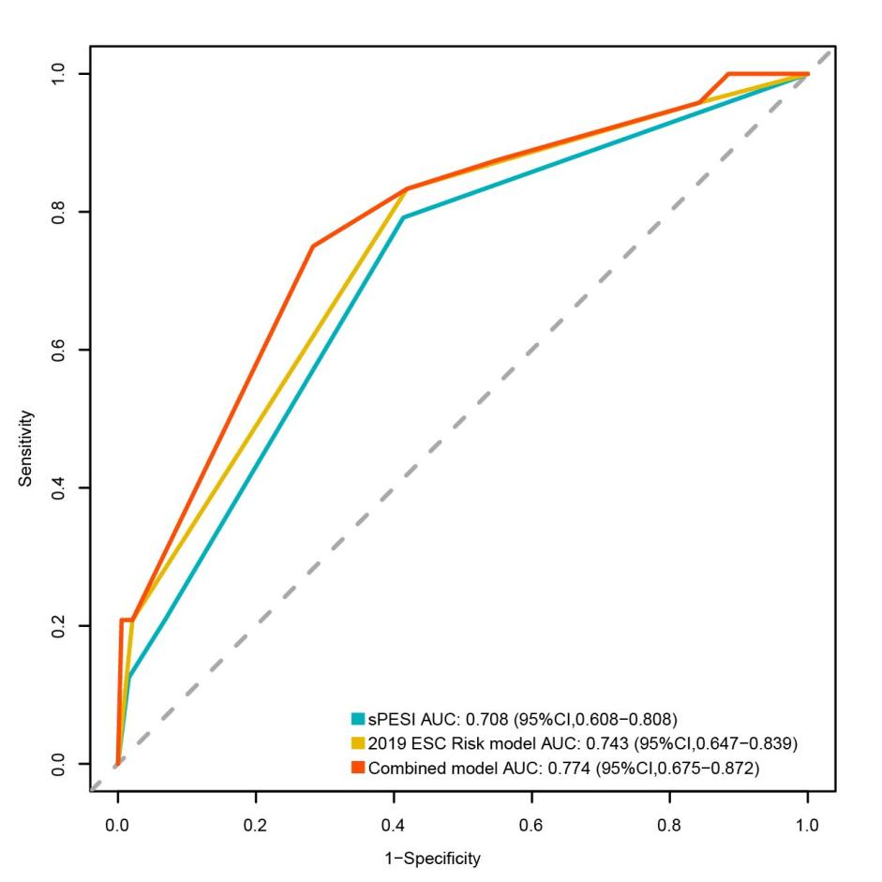
Figure S1 ROC curves of the sPESI, 2019 ESC risk model, and combined model for the external validation cohort. The AUC with 95% CI for each model was: sPESI, 0.708 (0.608-0.808); 2019 ESC risk model, 0.743 (0.647-0.839); Combined model, 0.774 (0.675-0.872). Statistical comparison by DeLong's test confirmed that the combined model demonstrated a significant improvement over the 2019 ESC risk model (P < 0.05).

