Additional file 4. Calibration curve and decision curve analysis for the combined model
Analyses were recalculated in the baseline nonsolid cohort after excluding baseline solid nodules (N = 354; IAC events = 91).
Figure S1. Calibration curve for the combined model.
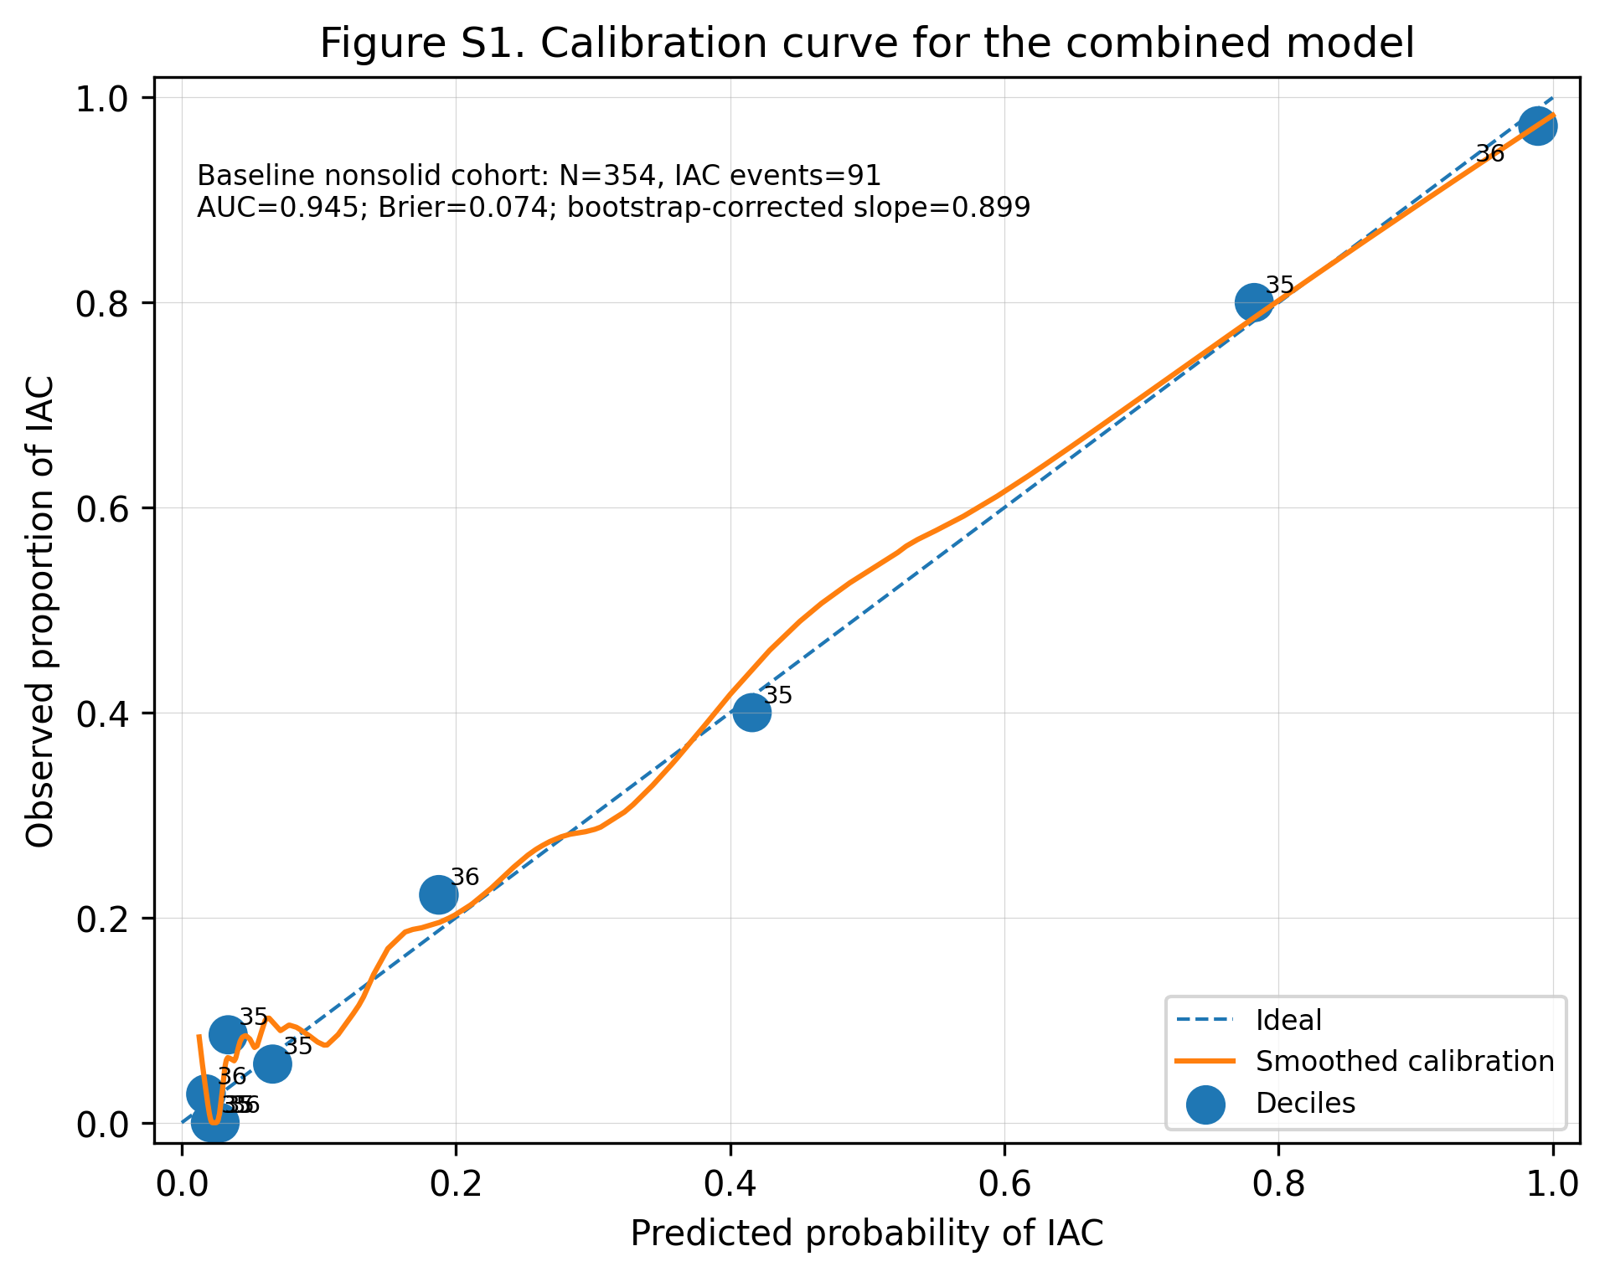

Figure S2. Decision curve analysis for the combined model.
