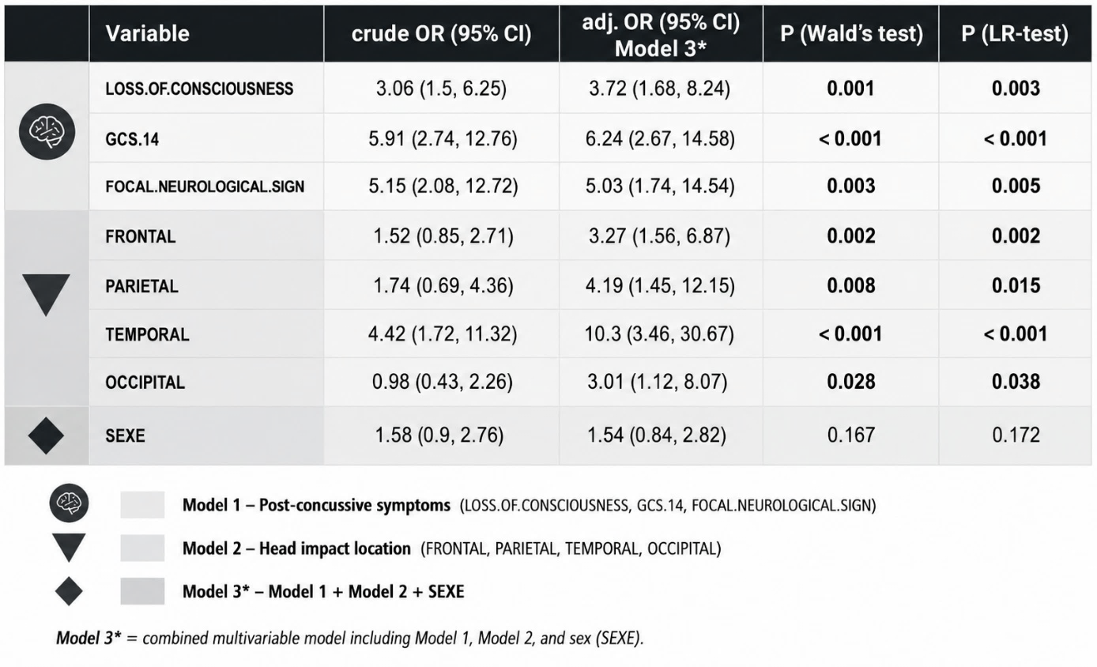
Table 4. Components of the three predictive models for traumatic intracranial haemorrhage

