Supplementary Information
Mid-infrared spectroscopy and supervised machine learning can determine age class of arboviral vector Culex pipiens at high age resolution
Ryan M. Carmichael^{1,2,3*}, Mauro Pazmiño-Betancourth³, Jean-Philippe Parvy², Sai Kulkarni², Jaimie T.A. Dick¹, Katarzyna Modrzynska⁴, Simon Babayan³, Ross N. Cuthbert¹, Heather M. Ferguson³, Francesco Baldini³, Emilie Pondeville^{2*}
¹Institute for Global Food Security, School of Biological Sciences, Queen’s University Belfast, BT9 7BL, UK
²MRC-University of Glasgow Centre for Virus Research, 464 Bearsden Road, G61 1QH, UK
³School of Biodiversity, One Health and Veterinary Medicine, University of Glasgow, Graham Kerr Building, Glasgow, G12 8QQ, UK
⁴School of Infection and Immunity, University of Glasgow, Sir Graeme Davies Building, Glasgow, G12 8TA

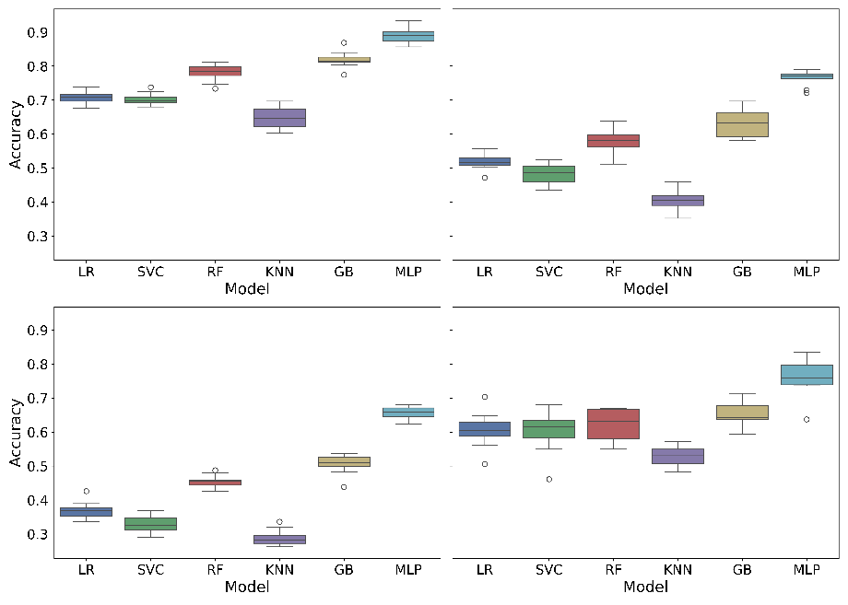
Supplementary Figure 1: Comparison of ML algorithms baseline performance in accurately classifying mosquito age class. LR, Logistic Regression; SVC, Support Vector Classifier; RF, Random Forest; KNN, k-Nearest Neighbours; GB, Gradient Boosting Classifier; MLP, Multi-Layer Perceptron Classifier. (Left to right, up to down): Comparison of efficacy on Cx. pipiens female mosquito age classes at low resolution (two age classes); medium resolution (four age classes); and high resolution (eight age classes), comparison of efficacy in classifying Cx. pipiens male mosquito age class (three age classes).
Supplementary Table 1: Optimised model hyperparameters identified using GridSearchCV and cross-validation training scores for each MLP model. The model activation was ‘tanh’ and the model solver was ‘lbfgs’ for all models.
Model | Alpha | Batch size | Hidden layer | Learning rate
Females – low resolution | 0.1 | 32 | (100,50) | 0.001
Females – medium resolution | 0.1 | 32 | (50,50) | 0.001
Females – high resolution | 0.01 | 32 | (50,) | 0.001
Males | 0.1 | 32 | (50,50) | 0.001
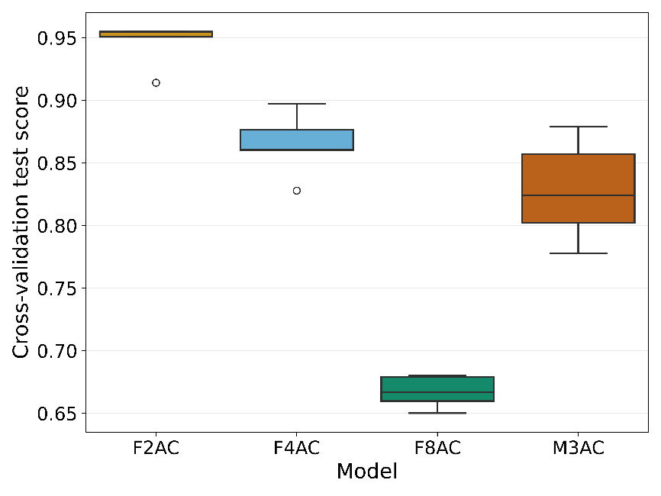
Supplementary Figure 2: Comparison of cross-validation scores on each data-fold for each model on the final chosen hyperparameters. F2AC, females two age classes; F4AC, females four age classes; F8AC, females eight age classes; and M3AC, males three age classes.
A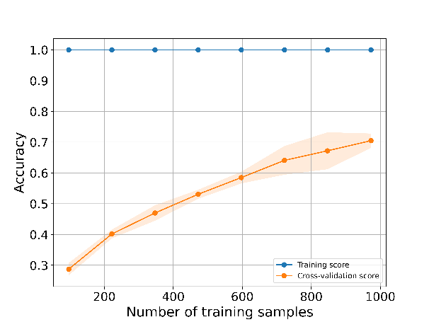 | B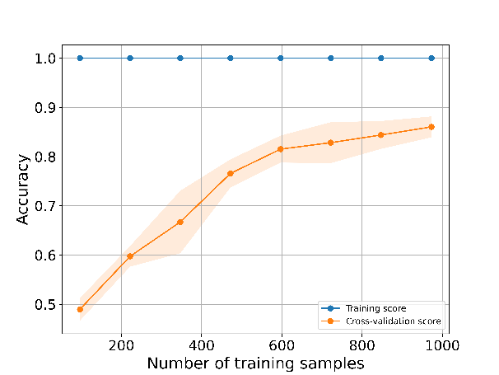
C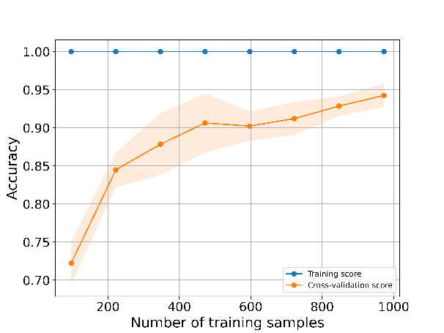 | D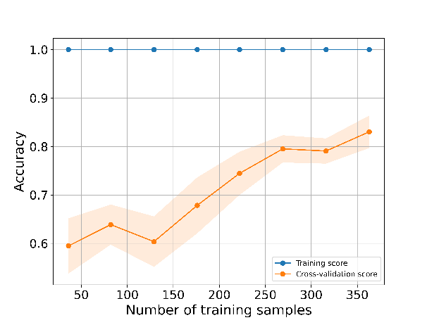
Supplementary Figure 3: Learning curves comparing the training score and cross-validation score for classifications of Cx. pipiens mosquito age class when increasing the number of training samples provided to the model. Learning curves are displayed for females at (A) low resolution (two age classes); (B) medium resolution (four age classes); (C) and high resolution (eight age classes), (D) and in males (three age classes).
Supplementary Table 2: Precision, recall and F1 score of optimised MLP models for predicting age classes of Cx. pipiens mosquitoes.
Model | Age class (chronological days) | Precision | Recall | F1-Score
Low resolution | 1-35 | 0.935484 | 0.923567 | 0.929487
 | 44-79 | 0.920000 | 0.932432 | 0.926174
Medium resolution | 1-13 | 0.971429 | 0.906667 | 0.937931
 | 22-35 | 0.865854 | 0.876543 | 0.871166
 | 44-57 | 0.851852 | 0.873418 | 0.862500
 | 66-79 | 0.875000 | 0.900000 | 0.887324
High resolution | 1-3 | 0.939394 | 0.911765 | 0.925373
 | 11-13 | 0.829268 | 0.829268 | 0.829268
 | 22-24 | 0.780488 | 0.780488 | 0.780488
 | 33-35 | 0.720930 | 0.775000 | 0.746988
 | 44-46 | 0.650000 | 0.634146 | 0.641975
 | 55-57 | 0.818182 | 0.710526 | 0.760563
 | 66-68 | 0.743590 | 0.805556 | 0.773333
 | 77-79 | 0.885714 | 0.911765 | 0.898551
Males | 1-3 | 0.860465 | 0.880952 | 0.870588
 | 11-13 | 0.800000 | 0.857143 | 0.827586
 | 22-24 | 0.807692 | 0.700000 | 0.750000

