Response to Reviewer #3’s comments for the manuscript (CLDY-21-00295)

We wish to express our appreciation to Reviewer#3 for his/her another round of insightful review. His/her constructive comments have helped to improve our understanding about the PNA pattern and the differences between the background state and the composite results. In the following, the black texts are original comments, and the blue texts are our responses.

The authors have responded to all my comments to some extent. Both methodology and analysis are better described. However, there are still two apparent flaws in this manuscript. Therefore, I recommend a major revision.

Question 1:
My Previous Comment
9. L355-362 and Fig. 11: If the Z500 patterns between the CP and EP El Niño have a large difference, do both really resemble a PNA pattern? Are the two Z500 patterns consistent with the tropical heating associated with different El Niño flavors? Is there any difference in the wave activity flux between the two Z500 patterns? It would be better to also use a polar projection map for Fig. 11e and f.
Authors’ Response
Thank you for your useful suggestions.
Generally speaking, the typical PNA+ pattern presented in this paper is a composite result of all PNA+ events. It does not imply that the spatial shape of the PNA+ is not varied, even though the PNA+ is an internal mode. The spatial pattern of the PNA+ can show a case-to-case variability when the background condition is different. For example, the PNA+ pattern can become different under different Pacific SST conditions. Although the Z500 patterns between the CP and EP El Niño have a large difference, it does not imply that they do not belong to the PNA patterns. While the 79 PNA+ events during 1950-2018 are selected based on the daily PNA index, they can be classified into six clustering regimes (Fig. 6). In Yu et al. (2012b) and Feng et al. (2017), they have examined the tropical heating, divergent wind anomalies and Rossby wave source associated with different El Niño influences influence the Z500 patterns. However, Feldstein (2002) and Franzke et al. (2011) pointed out that the synoptic-scale eddy forcing can excite PNA. Thus, the tropical heating with different El Niño flavors is not the only driving factor of the PNA. In this paper, we didn’t investigate what factors drive the PNA. Instead, our focus is placed on examining the modulation of the El Niño type on the PNA⁺ and associated sub-seasonal SAT anomalies via changes in interannual Hadley cell and zonal winds. In other words, the purpose of this paper is to provide an explanation for why the PNA+ has different spatial shape and zonal position between the CP- and EP-type El Niño winters.
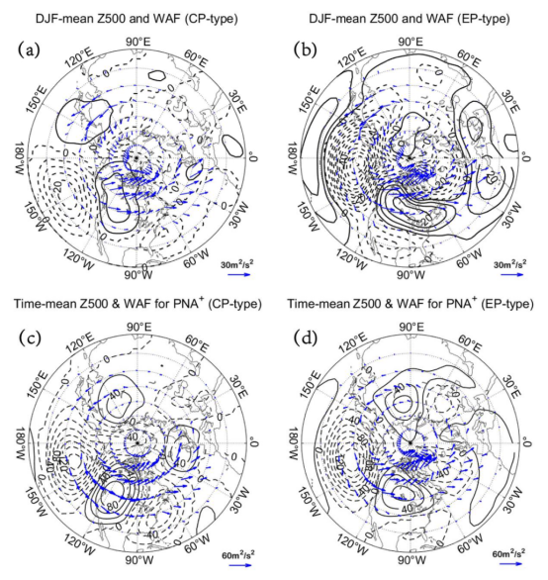
Figure C1. (a, b) Composite DJF-mean Z500 anomalies (contours, CI=5 gpm) and horizontal wave activity flux (WAF) vector (arrows; units: m²/s²) based on Takaya and Nakamura (2001) for the (a) CP- and (b) EP-type El Niño winters. (c, d) Same as (a, b) but for a time-mean composite daily Z500 anomaly fields (contours, CI=20 gpm) from lag-5 to 5 days of PNA⁺ events for (c) CP- and (d) EP-type El Niño winters.

Fig. C1 shows the DJF-mean Z500 anomaly and wave activity flux (WAF) vector fields; and time-mean composite daily Z500 anomaly and WAF vectors averaged from lag -5 to 5 days of PNA+ events during the CP- and EP-type El Niño winters. Because the WAF is another description of the Z500 anomaly as a wave train, the large difference (spatial shape and location) of the Z500 anomaly associated with PNA⁺ between CP and EP-type El Niño SSTs can have a large difference of the WAF vectors. In particular, The WAF vectors tend to be more zonally oriented over North America during the CP-type El Niño winters (Figs. C1a, c) than during the EP-type El Niño winter (Figs. C1b, d). The figure about the WAF vectors are not given in our new manuscript.
My New Comment
a. The authors’ interpretation of the PNA pattern and its variability is not correct.
Response:
Thank you for your valuable comments. Firstly, we want to apologize for our former description about the PNA pattern. In the new manuscript, we have revised the description about PNA pattern in lines 82-84.
b. First, the PNA+ pattern is not a composite result of PNA+ events as the authors claimed.
Response:
We agree with you that our description of the “PNA pattern” in last version might be inaccurate. However, the time-mean or monthly PNA pattern can be obtained by performing EOFs or a composite. The composite result does not contradict the EOF result. For example, the spatial structure of the composite Z500 anomaly of all PNA⁺ events resemble the PNA⁺ pattern obtained by the rotated EOF, as shown in Fig. C2. Of course, the PNA⁺ event can become different under different conditions.
Figure C2. (a) Time-mean fields of composite daily Z500 (contours, contour interval is 20gpm) and SAT (color shading in the unit of K) anomalies averaged from lag-5 to 5 days of PNA⁺ events. (b) The loading pattern for January based on the Rotated Principal Component Analysis (RPCA) applied to monthly standardized 500-mb height anomalies obtained in 20°N-90°N.
c. The PNA pattern is defined based on a rotated EOF of 500-hPa height between 20oN and 90oN (e.g.,https://www.cpc.ncep.noaa.gov/products/precip/CWlink/daily_ao_index/history/method.shtml).
d. The spatial pattern of the PNA is thus fixed, with well-defined centers of action over the Pacific/North American region.
Response:
We agree with your viewpoint that the PNA is obtained based on the rotated EOF and it shows four well-defined centers of action over the Pacific/North American region. However, it does not imply that the PNA pattern is fixed and not changed with the background condition. For example, ENSO can modulate the PNA in strength, position (Straus and Shukla 2002). We have added some descriptions about PNA pattern in Lines 82-84 in our new manuscript.
Reference:
Straus, D. M., J. Shukla (2002), Does ENSO force the PNA? Journal of Climate, 15(17), 2340-2358, http://dx.doi.org/10.1175/1520-0442(2002)015<2340:Deftp>2.0.Co;2.
e. The projection coefficient (daily PNA index) can be different from case to case, but not the PNA spatial pattern (e.g.,https://www.cpc.ncep.noaa.gov/products/precip/CWlink/pna/pna.shtml).
Response:
In this study, individual PNA events are selected based on the daily PNA index. Thus, obtained different daily PNA index reflects the case-to-case variability of the PNA event or the evolution of the daily PNA pattern. Such a treatment has been used in Feldstein (2002) and Franzke et al. (2011). In this revised manuscript, we have modified “variability of PNA pattern” into “variability of PNA events” in the new manuscript to make it clearer according to your comment.
Reference:
Feldstein, S. B. (2002), Fundamental mechanisms of the growth and decay of the PNA teleconnection pattern, Quarterly Journal of the Royal Meteorological Society, 128(581), 775-796, https://doi.org/10.1256/0035900021643683.
Franzke, C., S. B. Feldstein, and S. Lee (2011), Synoptic analysis of the Pacific–North American teleconnection pattern, Quarterly Journal of the Royal Meteorological Society, 137(655), 329-346, https://doi.org/10.1002/qj.768.
Question 2:
My Previous Comment
10. Section 4c: The authors claim that different type of El Niño affects PNA through altering background zonal wind. My understanding of background flow is basically a long-term mean flow which doesn’t change. What changed is the tropical heating location and intensity during different type of El Niño, which forces the Z500 anomalies. The authors should discuss the mechanisms along this direction. In addition, the authors haven’t provided the physical mechanism that is responsible for the changes in the meridional cells between the CP and EP El Niño.
Authors’ Response
Thank you for your useful suggestions.
Although the background zonal wind is a long-term mean flow, it does not imply that the interannual timescale zonal flow is the same between CP- and EP-type El Niño winters. For all the CP-type El Niño winters, the composite winter-averaged zonal wind can be considered as the interannual background zonal wind of PNA⁺ (10-20 days) during the CP-type El Niño winter. Similarly, the interannual zonal flow can be obtained as a background condition of PNA⁺ (10-20 days) for an EP-type El Niño. Such a treatment is reasonable. “What changed is the tropical heating location and intensity during different type of El Niño, which forces the Z500 anomalies. The authors should discuss the mechanisms along this direction. In addition, the authors haven’t provided the physical mechanism that is responsible for the changes in the meridional cells between the CP and EP El Niño.” has been discussed in detail in Feng et al. (2017), Yu et al. (2012b) and Wang et al. (2013) from observation and numerical modelling. This issue is not discussed in our manuscript again. Instead, in this revised manuscript (lines 350-371), we only cited their results to support our study.
My New Comment
a. The authors’ concept of the background zonal flow is not correct.
Response:
Thank you for your useful suggestions. The understanding about the background zonal flow might be a bit different. In our manuscript, because our emphasis is focused on the variability of PNA⁺ with a sub-seasonal time scale of 10-20 days, the interannual zonal wind associated with the type of El Niño can be considered as a background zonal flow of PNA⁺. The description has been added in lines 359-362 of the new manuscript.
b. Again, the background flow should be the long-term mean circulation averaged over consecutive years, not the composite of the circulation conditional to some events (over nonconsecutive years), like the selected ENSO years in this paper. Basically, it should be a long term mean climatology.
Response:
We agree with you that the composite winter zonal flow in CP/EP El Niño winters is not climatology, which consists of both the climatological mean zonal wind and the response to El Niño. However, because the PNA⁺ is of 10-20-days timescale, the interannual zonal wind based on the composite of winter zonal winds in CP/EP El Niño winters can be considered as a background condition of PNA⁺. we have pointed out it in lines 362-366. We think that the background zonal wind used in this paper cannot be simply considered as the climatological zonal wind.
c. The authors define different background zonal flow for CP-El Niño and EP-El Niño winters, respectively, based on the corresponding composite of the zonal wind. In this way, the background flow consists of both the climatology and the response to ENSO. The procedure mixes up the mean component with the ENSO-induced anomalous component.
Response:
Here, we think that it is unnecessary to distinguish the climatology and response to ENSO. Instead, we only examine the difference of the winter zonal wind between CP and EP-type El Niño. In fact, the winter zonal winds in the CP and EP-type El Niño winters can be expressed as
.
,
where denotes the climatological zonal wind during El Nino, which is the same between the CP and EP-type El Niño winters. and represent the interannual zonal wind responses to the CP and EP-type El Niño SSTs respectively.
Because CP and EP-type El Niño SSTs correspond to different Hadley cells as shown in Fig. 10a-c and are inevitably different so that CP and EP-type El Niño winters correspond to different interannual zonal winds over Pacific midlatitudes as shown in Fig. 10d-f. Thus, the winter-mean zonal winds in CP and EP-type El Niño winters could be considered as the different background winds of sub-seasonal PNA⁺ events.
d. A classic approach demonstrating an extratropical response to tropical heating is a linear model, which is linearized about a specified background flow (e.g., Ting and Held 1990, JAS, Vol. 47, 2546-2566; Ting and Sardeshmukh 1993, JAS, Vol 50, 907-918). If the background flow is derived in the way as the authors described and is used in the linear model, the anomalous circulation response, including the SAT response, would represent the anomalies of the inter-El Niño variability. Therefore, the SAT anomalies in this framework (different background flow for EP and CP El Niño) is inconsistent with those SAT anomalies presented in Figs. 1 and 2.
Response:
As described in our revised manuscript, the tropical heating associated with El Nino is not the only factor driving the PNA⁺ (Feldstein 2002; Franzke et al. 2011). In fact, some PNA⁺ events also exist in the neutral years even the presence of tropical cooling for La Nina as shown in Fig. C3. Thus, one cannot use an extratropical response to tropical heating is a linear model with a long-term mean climatological state to completely explain observations (e.g., Figs.1 and 2). However, Figs.1 and 2 are presented to indicate that the PNA⁺ events and associated SAT anomalies on sub-seasonal timescales of 10-20 days are modulated by Pacific SST anomalies (Fig.C3). In this paper, our attention is placed on explaining why the sub-seasonal PNA⁺ events and associated WWCE SAT dipoles show a notable interannual variability.
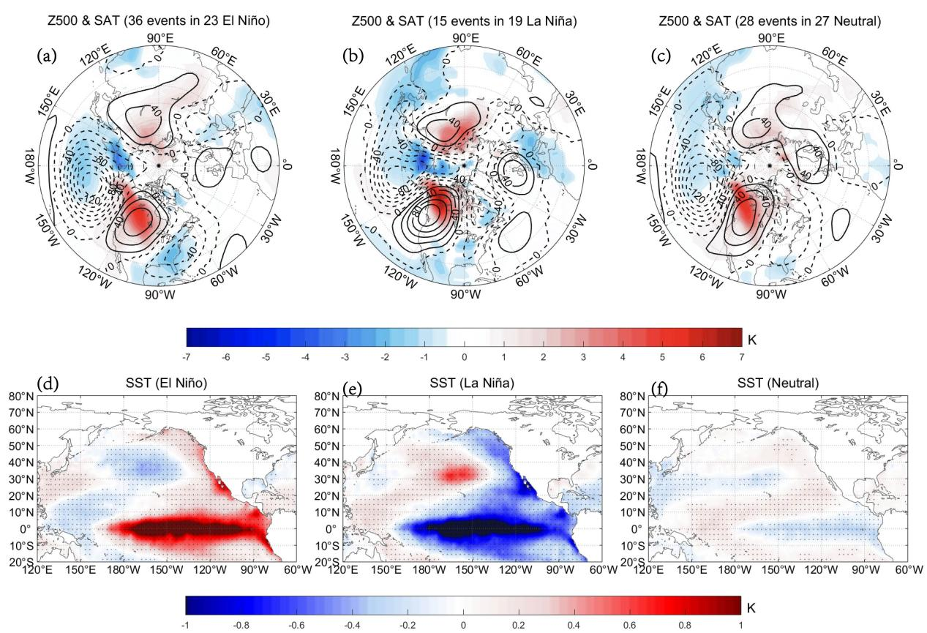
Figure C3. (a, b, c) Time-mean fields of composite daily Z500 (contour interval=20gpm) and SAT (color shading) anomalies from lag-5 to 5 days of PNA⁺ (36, 15 and 28 cases) events in (a) El Niño (23 cases), (b) La Niña (19 cases) and (c) Neutral (27 cases) winters, and the region with the 95% confidence level based on a two-sided Student’s t-test is plotted with color shading. The DJF-mean composite SST anomalies for (d) El Niño, (e) La Niña and (f) Neutral winters. In panels d-f, the dot represents the region above the 95% confidence level based on a two-sided Student’s t-test. An El Niño (La Niña) event is defined if the threshold of the ONI is 0.5℃ (-0.5℃) at least 5 months.
Reference:
Feldstein, S. B. (2002), Fundamental mechanisms of the growth and decay of the PNA teleconnection pattern, Quarterly Journal of the Royal Meteorological Society, 128(581), 775-796, https://doi.org/10.1256/0035900021643683.
Franzke, C., S. B. Feldstein, and S. Lee (2011), Synoptic analysis of the Pacific–North American teleconnection pattern, Quarterly Journal of the Royal Meteorological Society, 137(655), 329-346, https://doi.org/10.1002/qj.768.
e. By just considering SST instead of the zonal wind, for example, no one would take the composite of El Niño SST as an SST background state (or an SST mean state, an SST climatology).
Response:
We also consider SST and zonal wind conditions in our manuscript. In this paper, the composite of El Niño SST is considered as an SST background state of PNA⁺ with a lifetime of 10-20 days. Such a consideration is reasonable because the interannual El Niño SST is not changed with the evolution of sub-seasonal PNA⁺ with a lifetime of 10-20 days as shown in Fig. C4. For example, when the time scale of variable A is much larger than variable B, A could be considered as background of B if B is modulated by A. Thus, the inter-annual ENSO could be considered as an SST background modulating PNA⁺.
The physical process of the El Niño type on PNA⁺ can be described as follows: the type of El Niñointerannual Hadley cellinterannual Pacific midlatitude zonal windssub-seasonal PNA⁺ in spatial shape and location. Please see lines 404-408.
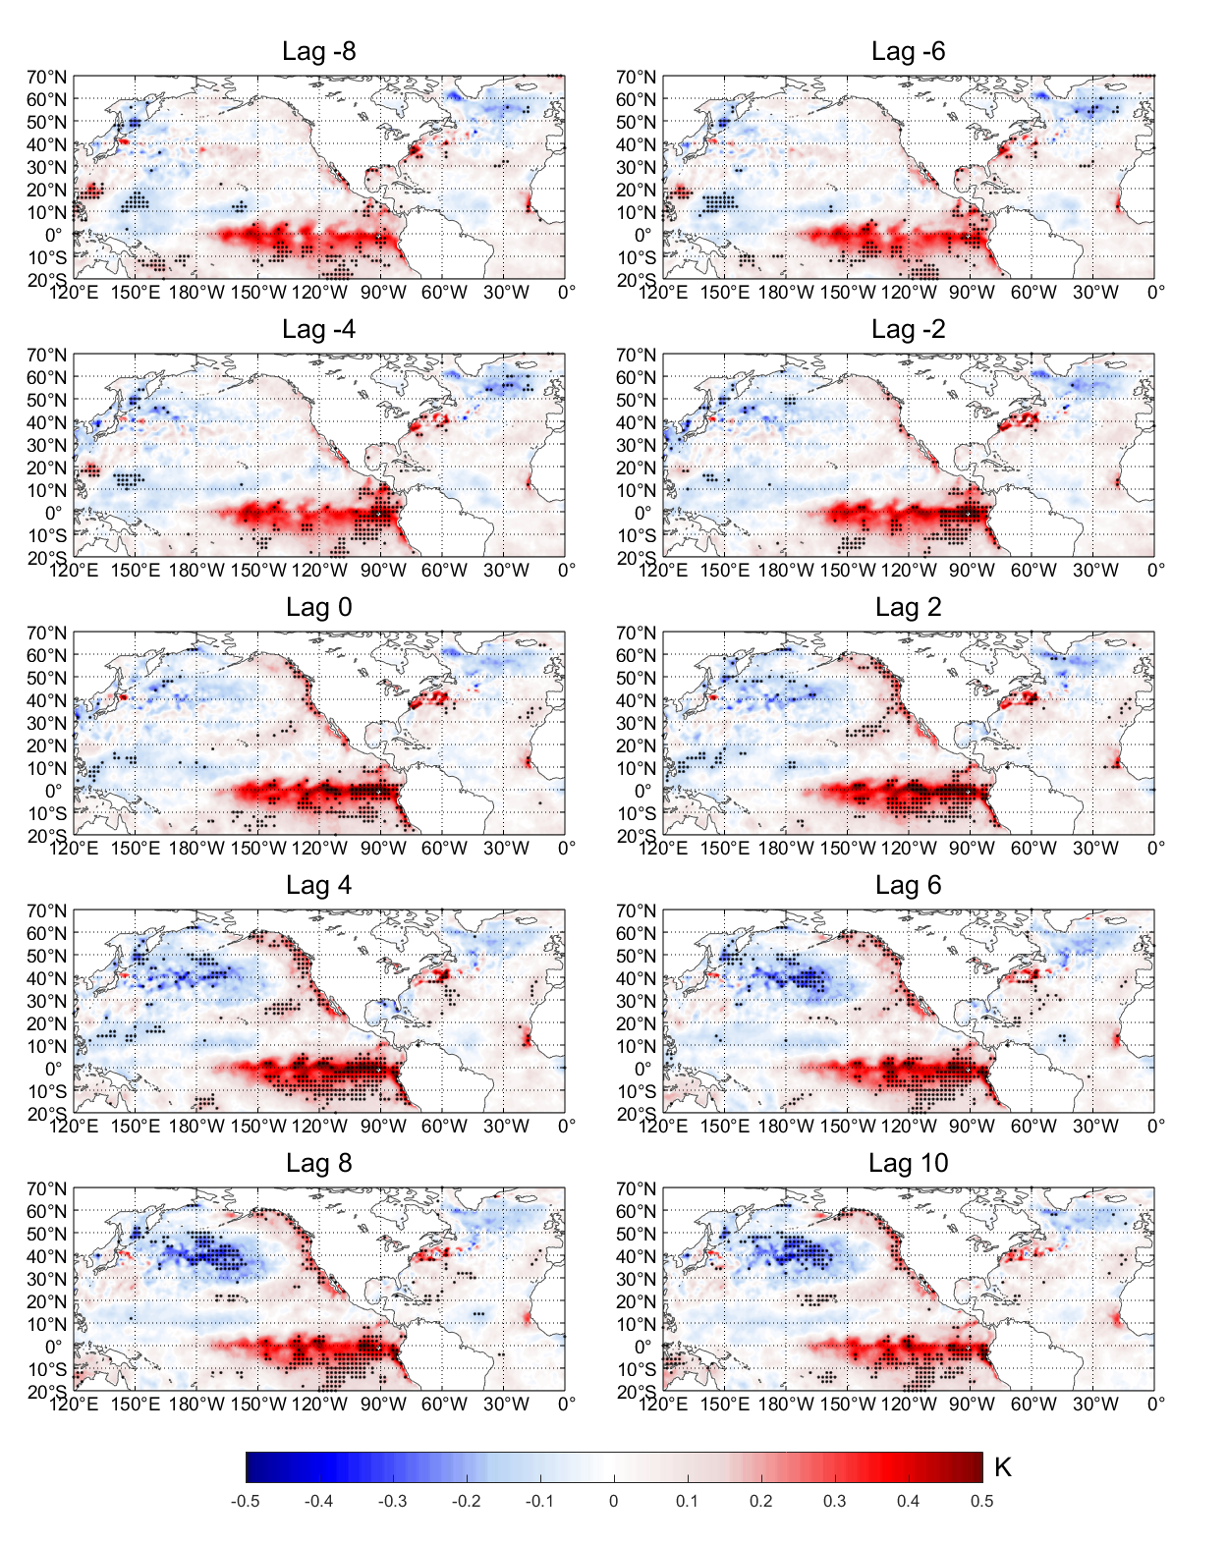
Figure C4. The variation of composite SST anomalies from lag -8 to lag 10 of the PNA⁺ event during 1979-2018 winters. The dot represents the region above the 95% confidence level based on a two-sided Student’s t-test.
f. The authors argued that “such a treatment is a well-known method”, but the statement does not prove that the concept is correct.
Response:
In this revised manuscript, we have removed this sentence.

