Supplementary Materials

Supplementary materials providing additional ecological, taxonomic, and statistical analyses are presented below.

Supplementary Table S1: Post hoc pairwise comparison results following Kruskal–Wallis testing of fungal alpha diversity across decomposition stages

Stages of Decomposition | Fresh | Bloat | Active Decay | Advanced Decay | Dry / Remains | Control_ Fresh | Control_ Bloat | Control_ Active_ Decay | Control_ Advanced_ Decay | Control_ Dry / Remains
Fresh | 0 | - | p = 0.04 | p = 0.04 | p = 0.04 | - | - | - | - | -
Bloat |  | 0 | - | - | - | - | - | - | - | -
Active Decay | p = 0.04 | - | 0 | - | - | - | - | - | - | -
Advanced Decay | p = 0.04 | - | - | 0 | - | - | - | - | - | -
Dry/Remains | p = 0.04 | - | - | - | 0 | - | - | - | - | -
Control_Fresh | - | - | - | - | - | 0 | - | - | - | -
Control_ Bloat | - | - | - | - | - | 0 | 0 | - | - | -

Supplementary Table S2: Soil pH and moisture measurements recorded for control soil samples throughout the sampling period.

PMI (Days) | pH | Moisture (%)
0 | 4.87 | 3.96
1 | 6.46 | 8.88
4 | 6.21 | 6.76
5 | 7.23 | 7.93
8 | 6.51 | 4.12
13 | 7.44 | 10.95
18 | 7.46 | 4.87
42 | 5.89 | 4.12
63 | 5.56 | 9.09

Supplementary Figures
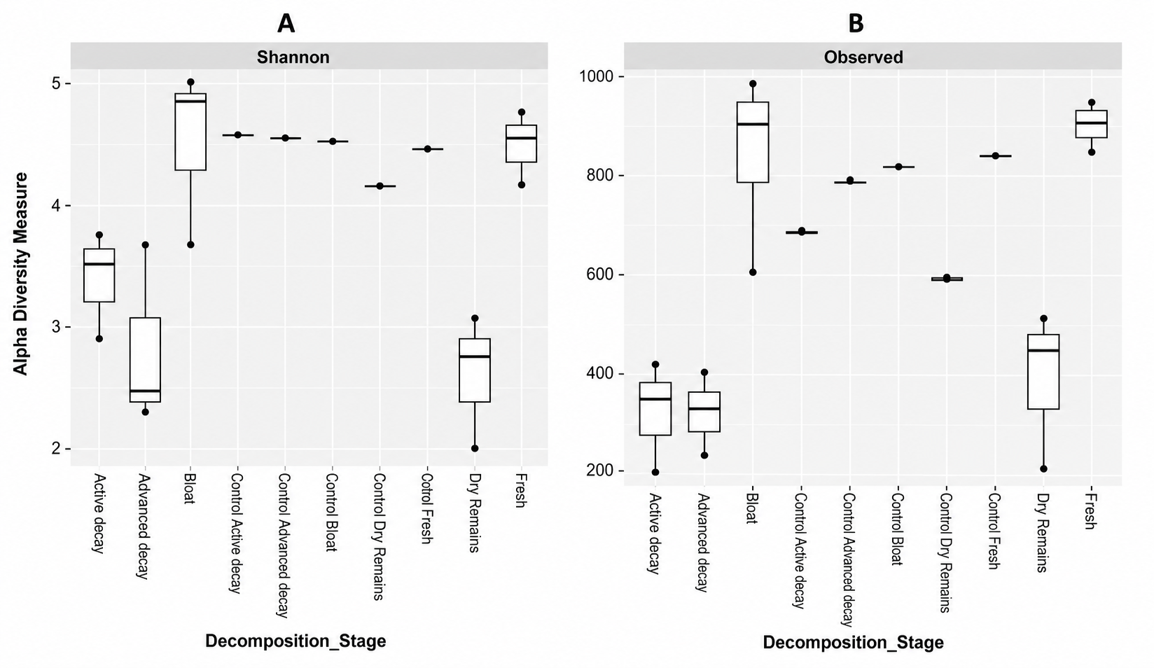
Supplementary Fig. S1 Boxplots of Shannon diversity (A) and observed taxonomic richness (B) across decomposition stages
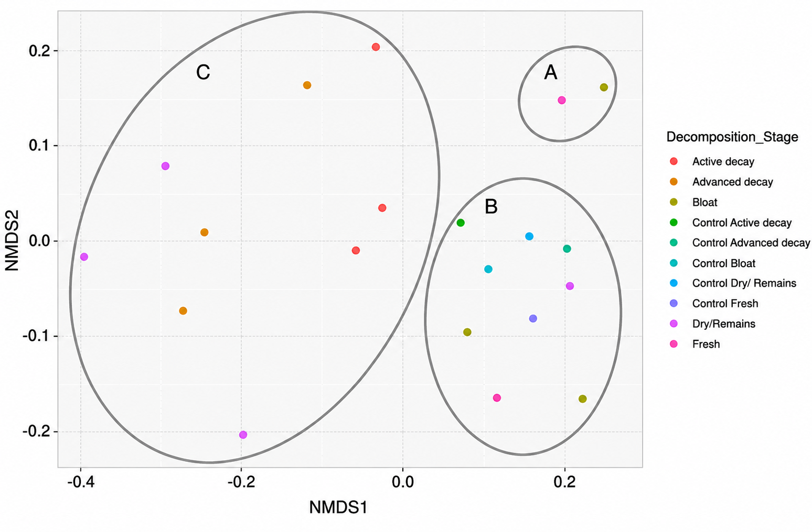
Supplementary Fig. S2 NMDS ordination based on Bray–Curtis dissimilarity showing fungal community clustering across decomposition stages. Clusters A and B represent fresh-stage, bloat-stage, and control-associated samples, whereas Cluster C represents active decay, advanced decay, and dry/remains samples.
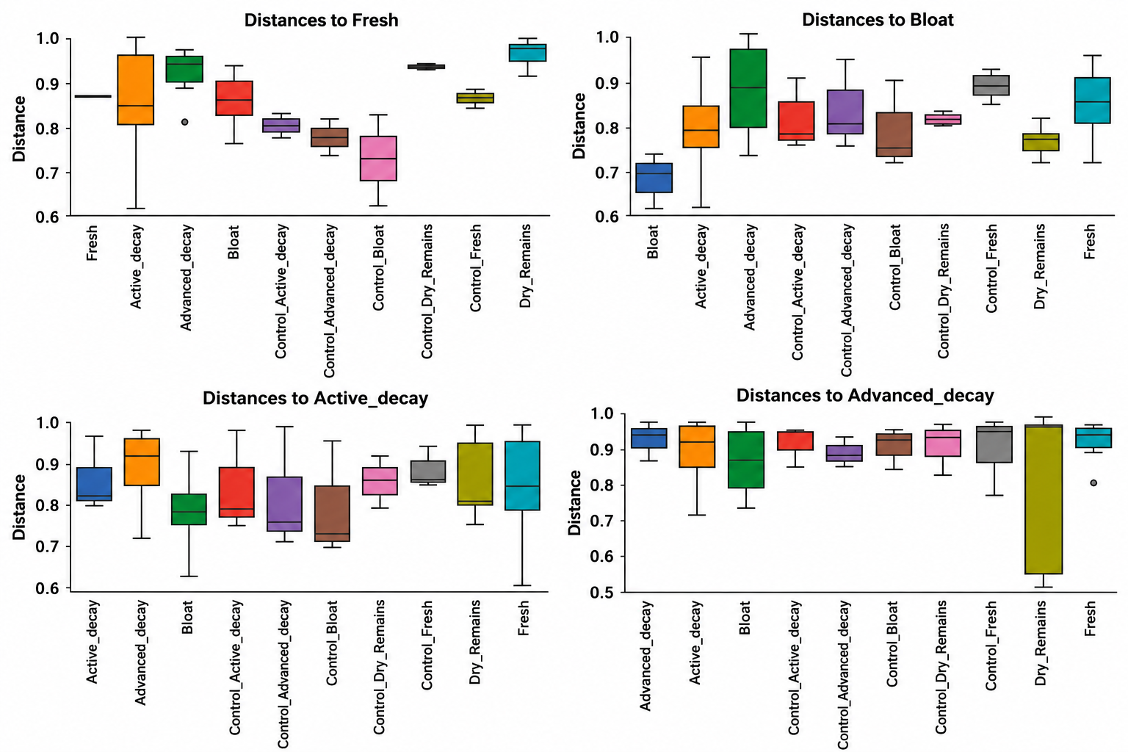

Supplementary Figure S3: Bray Curtis distance similarity for each of the recorded decomposition stages displayed as boxplots

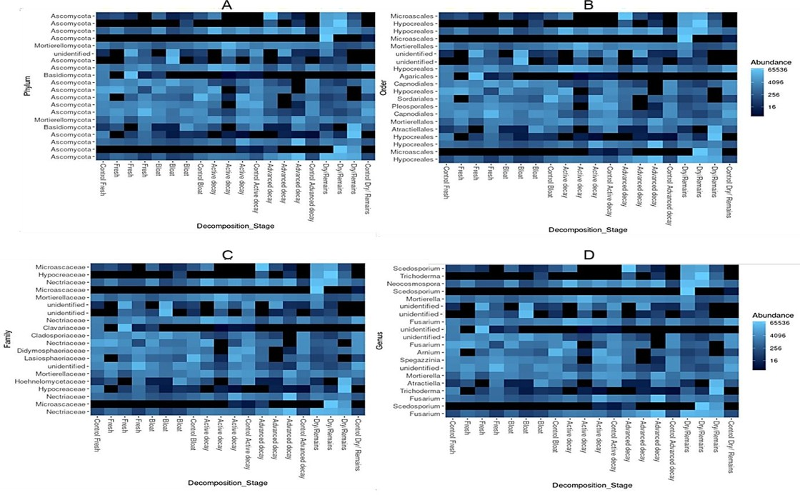

Supplementary Figure S4: Heatmaps of the Top 20 ASVs, Grouped according to Phylum (A), Order (B), Family (C) and Genus (D)
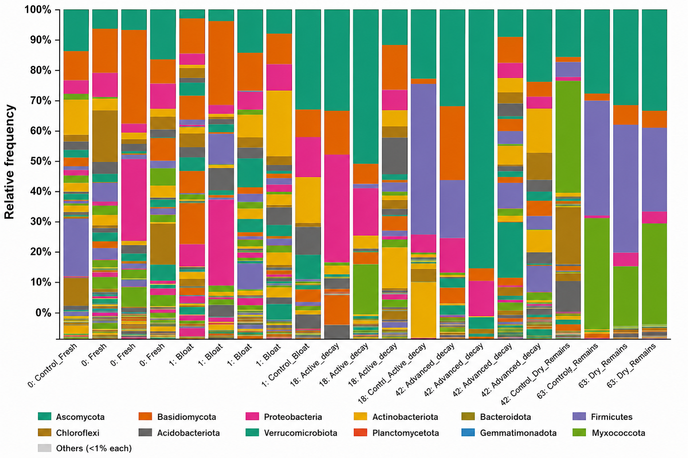
Supplementary Figure S5: Bar chart representing distinct family-level relative abundance patterns were observed across decomposition stages.
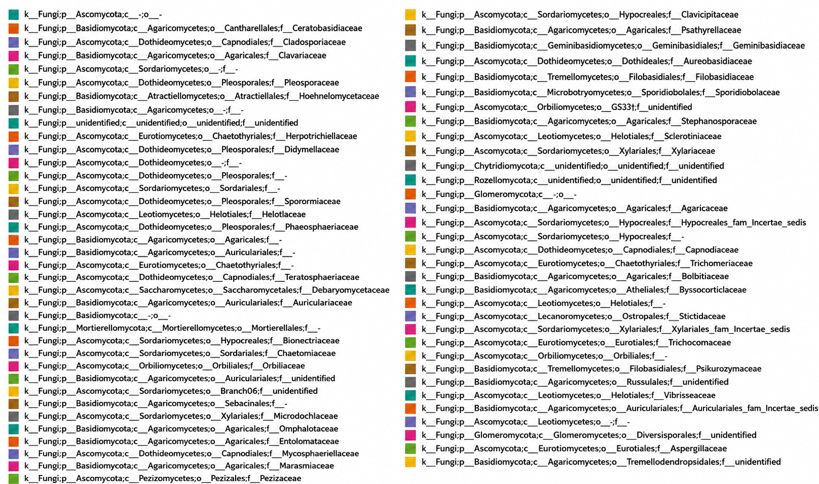

Supplementary Figure S6: Indicator fungal ASVs identified across decomposition stages, showing taxonomic classification and decomposition-stage associations

