Supplementary Material to:

Rapid declines in a regionally important plant across an aridity gradient and associated with increasing temperatures and decreasing precipitation

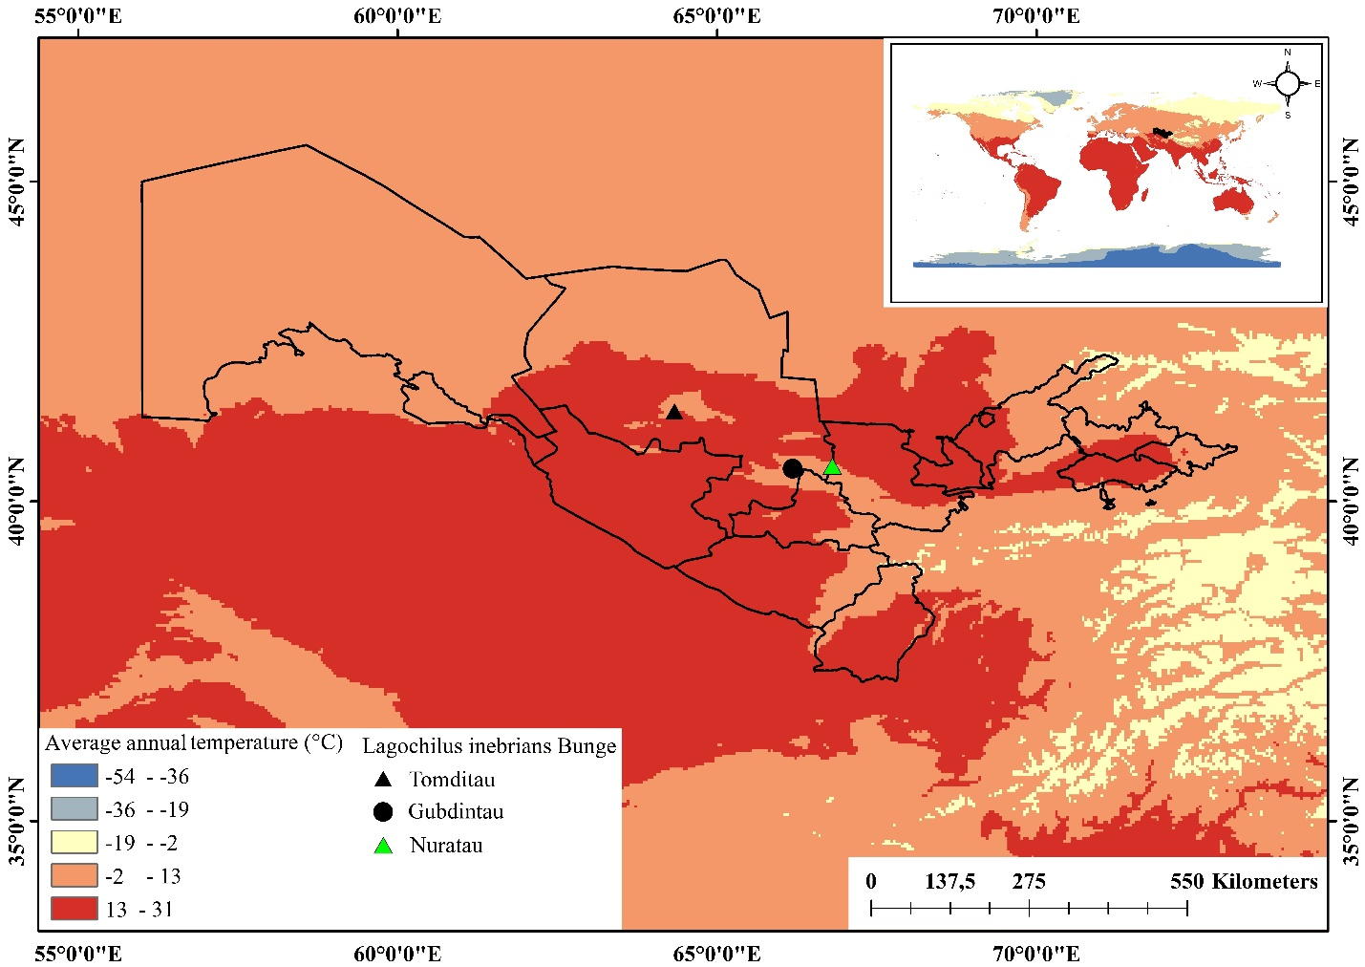

Fig. S1. Regional climates and sampling sites of the investigated Lagochilus inebrians species
(retrieved from https://worldclim. org/data/index.html#google_vignette, processed and mapped in Arc-GIS 10.8).

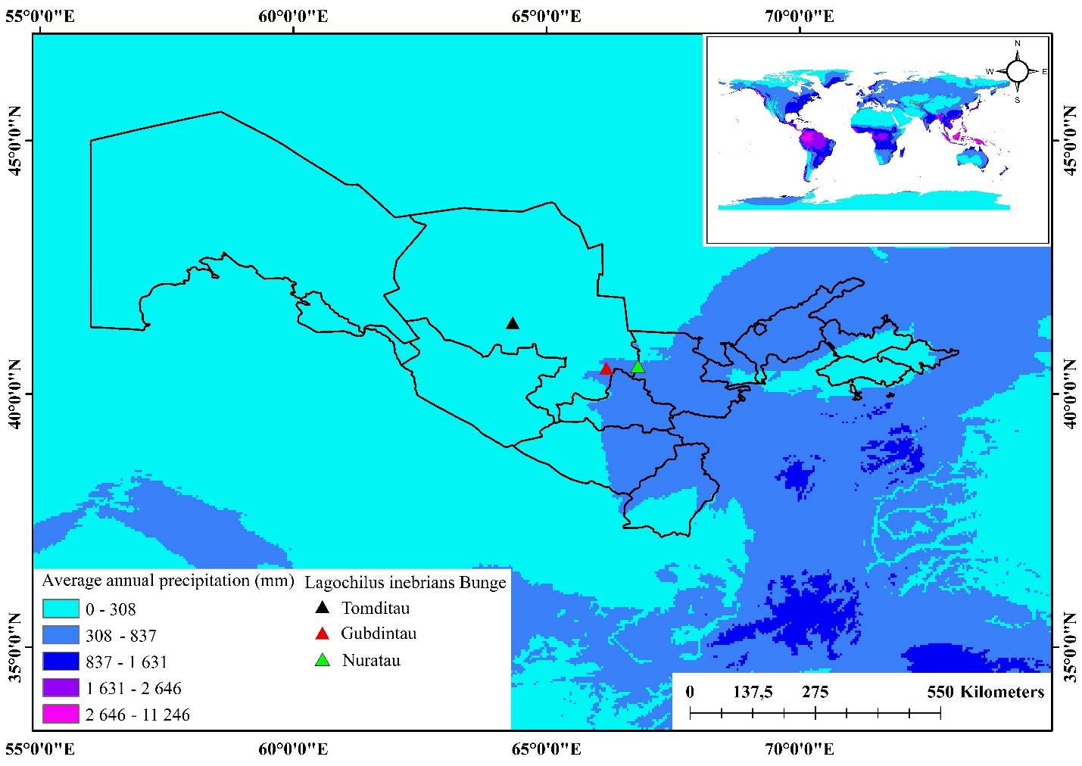
Fig. S2. Distribution map of L. inebrians with precipitation (retrieved from https://worldclim. org/data/index.html#google_vignette, processed and mapped in Arc-GIS 10.8).

Table S1 List of species and life forms at the L. inebrians study sites

L. inebrians
Species | The life forms  of plants | Tomditau | Gubdintau | Nuratau
Ephedra equisetina Bunge | Shrub | x
Lycium ruthenicum Murray | Shrub | x
Xylosalsola arbuscula Pall. | Shrub | x
Astragalus centralis E. Sheld. | Semi-shrub | x
Artemisia juncea Kar & Kir. | Dwarf-shrub | x
Artemisia turanica Kasch. | Dwarf-shrub | x
Lagochilus inebrians Bunge | Dwarf-shrub | x | x | x
Crambe cordifolia Steven. | Perennial | x
Ferula kyzylkumica Korov. | Perennial | x
Poa bulbosa L. | Perennial | x | x | x
Thalictrum isopyroides C.A.Mey. | Perennial | x
Lepidium subcordatum Botsch. & Vved. | Perennial | x
Gelasia gageoides Boiss. | Perennial | x
Tulipa biflora Boiss. | Perennial | x
Rhaponticum repens (L.) DC. | Perennial | x
Gagea deserticola Levichev | Perennial | x
Carex physodes M. Bieb. | Perennial | x
Allium filidens Regel | Perennial | x
Silene tomentella Schischk | Perennial | x
Leontice ewersmannii Bunge | Perennial | x
Tortula desertorum Broth. | Perennial | x
Rheum turkestanicum Janisch. | Perennial | x
Verbascum songaricum Schrenk | Biennial | x
Ranunculus falcatus (L.) | Annual | x
Strigosella grandiflora Botsch. | Annual | x
Valerianella sp. | Annual | x
Rochelia bungei Trautv. | Annual | x
Alyssum desertorum Stapf | Annual | x |  | x
Artemisia diffusa Krach ex Poljakov | Dwarf-shrub |  | x
Carex pachystylis J. Gay | Perennial |  | x | x
Iris songarica Schrenk | Perennial |  | x
Stipa sp. | Perennial |  | x
Polygonum aviculare L. | Perennial |  | x
Elaeosticta allioides (Regel & Schmalh.) Kljuykov, Pimenov & V.N.Tikhom. | Perennial |  | x
Gentiana olivieri Griseb. | Perennial |  | x
Ziziphora tenior L. | Annual |  | x
Alhagi pseudalhagi (M. Bieb.) Desv. Ex Wangerin. | Perennial |  |  | x
Cynodon dactylon (L.) Pers. | Perennial |  |  | x
Cousinia resinosa Juz. | Perennial |  |  | x
Bromus danthoniae Trin. | Perennial |  |  | x
Boraginaceae sp | Perennial |  |  | x
Eremostachys sp | Perennial |  |  | x
Phlomis thapsoides Bunge | Perennial |  |  | x
Ixiolirion tataricum (Pall.) Schult. & Schult.f. | Perennial |  |  | x
Sophora pachycarpa (Schrenk ex C.A. Mey.) | Perennial Goebelia pachycarpa |  |  | x
Malva neglecta Wallr. | Annual |  |  | x
Althaea sp. | Perennial |  |  | x

Table S2 Types of ontogenetic spectra
N | Ontogenetic spectrum | Ontogenetic stages | Dominant stages
1. | Left sided | j, im, v and g1 | Regenerative and generative
2. | Bimodal | j, im with g2 or g3 | Regenerative, generative or post-generative
3. | Centered | g2 | Generative
4. | Right sided | g3, ss and s | Generative and post-generative

Table S3 Population stages at the study sites in 2019-2023

Stages % | Tomditau |  |  |  |  | Gubdintau |  |  |  |  | Nuratau
Stages % | 2019 | 2020 | 2021 | 2022 | 2023 | 2019 | 2020 | 2021 | 2022 | 2023 | 2019 | 2020 | 2021 | 2022 | 2023
j | 0 | 0 | 0 | 0 | 0 | 1 | 0 | 0 | 0 | 0 | 0 | 0 | 0 | 0 | 0
im | 0 | 0 | 0 | 0 | 0 | 1 | 2 | 0 | 0 | 0 | 2 | 1 | 0 | 0 | 0
v | 1 | 1 | 0 | 0 | 0 | 6.9 | 5 | 1 | 1 | 0 | 9 | 8 | 3 | 2 | 3
g1 | 19 | 16 | 3.1 | 1 | 0 | 30 | 29 | 4.5 | 12 | 8 | 30 | 21 | 6 | 13 | 10
g2 | 71 | 72 | 72 | 75 | 78 | 45 | 48 | 59 | 55 | 58 | 49 | 55 | 68 | 70 | 72
g3 | 9 | 11 | 19.8 | 20 | 13 | 16.1 | 14 | 23 | 21 | 22 | 10.1 | 15 | 21 | 15 | 12
ss | 0 | 0 | 4 | 3 | 5 | 0 | 2 | 10 | 9 | 11 | 0 | 0 | 2 | 0 | 3
s | 0 | 0 | 1 | 1 | 4 | 0 | 0 | 2.5 | 2 | 1 | 0 | 0 | 0 | 0 | 0

