Supporting Information: in situ Growth of and Proximity-induced Superconductivity in Al-Ge Quantum Well Heterostructures

Han Gao¹, Jie-Yin Zhang^{2,3}, Jian-Huan Wang¹, Haitian Su¹, Junze Zhang¹, Ding-Ming Huang¹, Yi Luo¹, Shili Yan¹, Xing-Jun Wu¹, Ji-Yin Wang^{1,*}, Jian-Jun Zhang^{2,*}, and Hongqi Xu^{1,4,*}

¹ Beijing Academy of Quantum Information Sciences, Beijing 100193, China
² Beijing National Laboratory for Condensed Matter Physics and Institute of Physics, Chinese Academy of Sciences, Beijing 100190, China
³ Dongguan Institute of Materials Science and Technology, Chinese Academy of Sciences, Dongguan, Guangdong 523808, China
⁴ Beijing Key Laboratory of Quantum Devices, Peking University, Beijing 100871, China

*wang_jy@baqis.ac.cn; jjzhang@iphy.ac.cn; hqxu@pku.edu.cn
(Dated: June 26 2026)
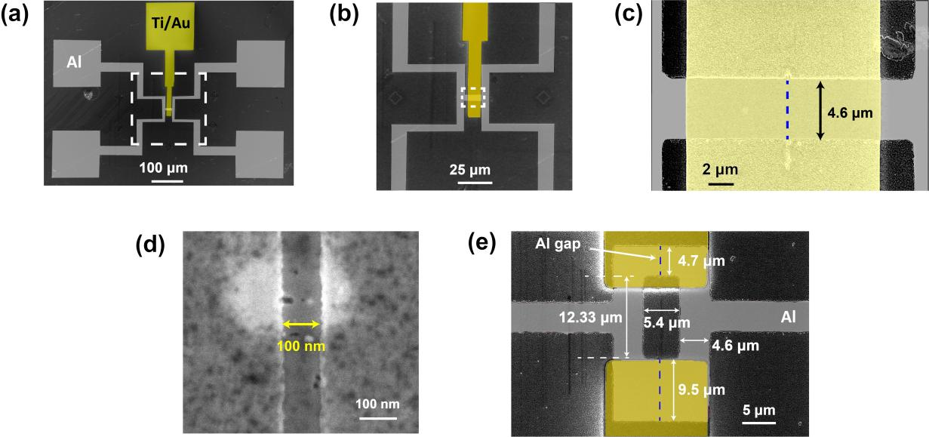
Fig. S1. SEM images of the Josephson junction (device D1) and the SQUID studied in the main article. (a) False-colored SEM image of device D1 studied in the main article. The Al electrodes and Ti/Au gate are colored in gray and yellow, respectively. (b) Magnified false-colored SEM image of device D1 in the region marked by the dashed square in (a). (c) Further magnified false-colored SEM image of device D1 in the region marked by the dashed square in (b). Here, the blue dashed line marks the location of the Al gap in the Josephson junction. The junction width is ~4.6 µm. (d) High-magnification SEM image of the Al gap in device D1. The gap size approximately defines the junction channel length, which is ~100 nm. (e) SEM image of the SQUID studied in the main article. The SQUID consists of two Josephson junctions with an equal junction channel length of $\sim$100 nm but different channel widths of $\sim$4.7 µm and $\sim$9.5 µm. The physical area enclosed by the Al loop in the SQUID is ~66.6 μm².
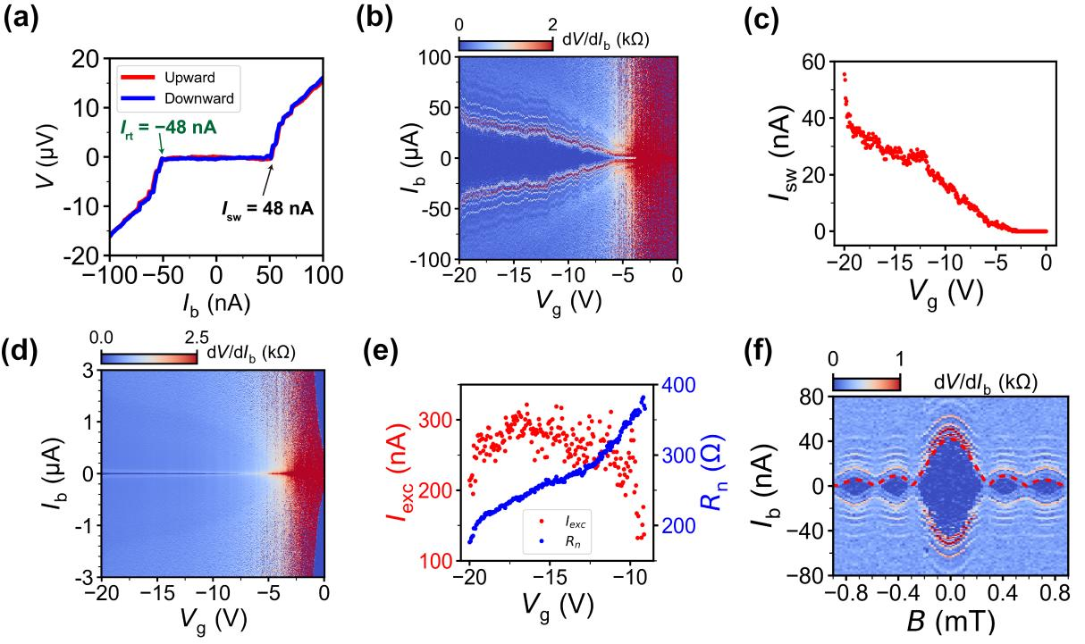
Fig. S2. Current-bias measurements of device D2. (a) Measured voltage V across the junction as a function of bias current I_{b} at V_{g} = $−$20 V. The red and blue curves are measured in the upward and downward biased current sweeps, respectively. The switching current I_{sw} and retrapping current I_{rt} extracted from the upward biased current sweeping measurements are marked in the figure. (b) Color map of differential resistance dV/dI_{b} measured as a function of I_{b} and V_{g}. (c) Extracted switching current I_{sw} as a function of V_{g} based on the measured data shown in (b). The switching current can be tuned from zero to 58 nA. (d) Differential resistance dV/dI_{b} versus I_{b} and V_{g}, measured in a current-bias range which is much larger than that in (b). (e) Excess current I_{exc} (red dots) and normal state resistance R_{n} (blue dots) versus V_{g}. The data are extracted from the measurement results shown in (d). The maximum I_{exc}R_{n} product value is found to be $\sim$100 μV for device D2. (f) Differential resistance dV/dI_{b} as a function of I_{b} and out-of-plane magnetic field B. The red dashed line is the fit to the measurements using the standard Fraunhofer equation. The extracted effective junction area is $\sim$5.9 μm². This value is much larger than the actual junction area and is commonly seen in a planar Josephson junction due to the magnetic flux focusing effect and/or significantly enhanced London penetration length in ultra-thin Al film.

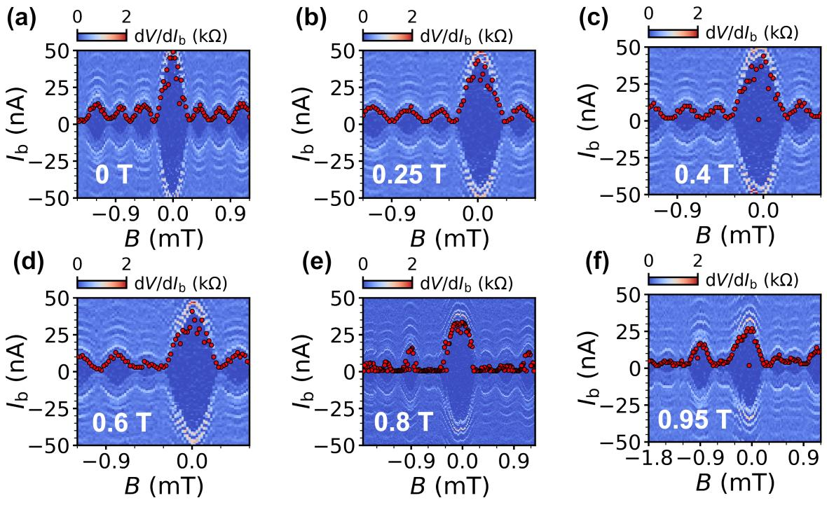
Fig. S3. Coherent supercurrent interference of device D2 under fixed but different in-plane magnetic fields. (a)-(f) Color maps of differential resistance dV/dI_{b} as a function of I_{b} and out-of-plane magnetic field B under various fixed in-plane magnetic fields as indicated by white labels in the panels. The red circles track the modulation of the switching current I_{sw} as a function of B. Distinct diffraction patterns remain clearly resolvable even at the in-plane magnetic field of 0.95 T, demonstrating robust coherent supercurrent transport under a large in-plane magnetic field.

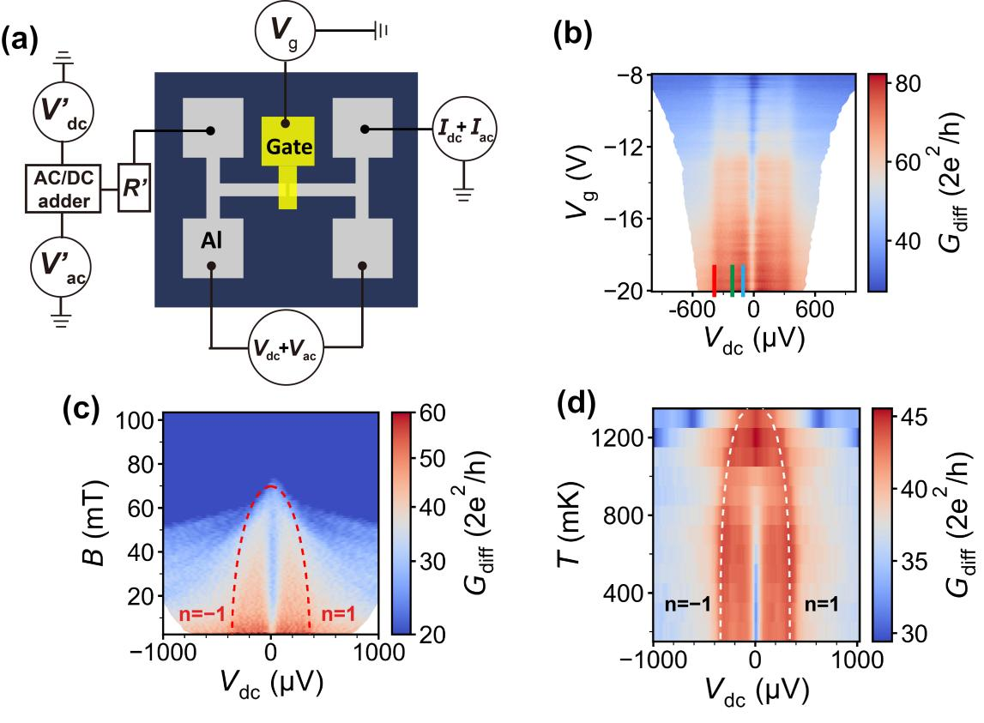
Fig. S4. Voltage-bias measurements of device D2. (a) Device schematic and circuit setup for the voltage-bias measurements. (b) Color map of differential conductance G_{diff} versus V_{dc} and V_{g}. The red, green and blue markers shown in the bottom of the figure denote the MAR conductance peak positions of orders n = $−$1, $−$2, and $−$4, respectively. The extracted superconducting gap from the measurements is ∆ ~180 μeV, the same as the value obtained from device D1. (c) Color map of G_{diff} versus V_{dc} and B, where B is the out-of-plane magnetic field. The red dashed lines are the fit to the measurements according to the BCS theory, which yields the critical magnetic field of B_{c} ~70 mT. (d) Color map of G_{diff} vs V_{dc} and temperature T. The white dashed lines are the fit to the measurements according to the BCS theory, which yields the critical temperature of T_{c} ~1.4 K.

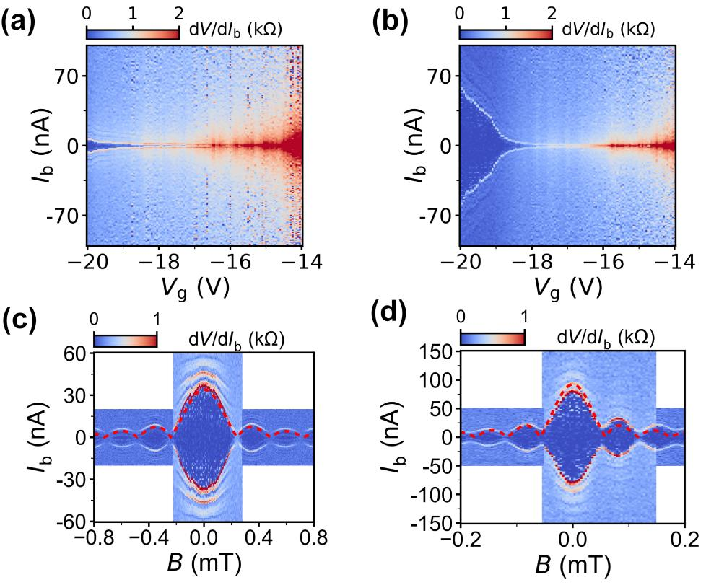
Fig. S5. Characteristics of the two Josephson junctions in the SQUID studied in the main article. (a-b) Color maps of differential resistance dV/dI_{b} of the two Josephson junctions, defined as JJ1 and JJ2, measured versus I_{b} and corresponding gate voltage V_{g}. (c-d) Differential resistance dV/dI_{b} measured for JJ1 and JJ2 as a function of I_{b} and out-of-plane magnetic field B. The red dashed lines in the positive current regions are the fits to the measured switching currents based on the standard Fraunhofer equation. The fits yield effective channel areas of $\sim$10 μm² and $\sim$35 μm² in the two junctions, respectively. In panels (a-d), one junction is measured while the other is fully pinched off by its local gate.

