Supplementary Information
Porous, Crystalline and Macrocycle-Free Rectilinear Organic Frameworks

Chenghang Qi^{1, #}, Shitao Wu^{1, #}, Chengxi Zhao^{2, #}, Yufei Liu^{1, #}, Dingrui Fan², Linjiang Chen^{2,*}, Yanhang Ma^{1, *}, Yingbo Zhao^{1, *}

¹School of Physical Science and Technology, Shanghai Key Laboratory of High-Resolution Electron Microscopy, ShanghaiTech University, Shanghai, 201210, P. R. China.
²State Key Laboratory of Precision and Intelligent Chemistry, Hefei National Research Center for Physical Sciences at the Microscale, School of Chemistry and Materials Science, University of Science and Technology of China, Hefei, China
*Corresponding authors: linjiangchen@ustc.edu.cn; mayh2@shanghaitech.edu.cn; zhaoyb2@shanghaitech.edu.cn;
#These authors contributed equally.

Table of Contents
Supplementary Note 1. Materials and Methods 3
Supplementary Note 2. Synthetic Procedures 6
Supplementary Note 3. Computational methods 11
Supplementary Figures and Tables 17
References 120

Supplementary Note 1. Materials and Methods
Materials
All solvents, reagents, and chemicals were purchased from commercial suppliers, and used without further purification.
Methods
Fourier-transform infrared (FT-IR) spectra were recorded on neat samples in the range of 800–4,000 cm-1 on a Bruker VERTEX 70 FT-IR Spectrometer equipped with single reflection diamond ATR module.
Solid-state ¹³C nuclear magnetic resonance (¹³C SSNMR) spectra were recorded on a Bruker ADVANCE 400 MHz Solid NMR spectrometer with cross-polarization magic angle-spinning (CP/MAS) and 3.2-mm double-resonance MAS probe. The samples were loaded in the zirconia rotor with a sample spinning rate of 10.0 kHz.
Thermal gravimetric analyses (TGA) were carried out using a Discovery TGA-550 instrument from 25 to 800 °C under N₂ atmosphere with a temperature ramping rate of 5 °C/min.
Low-pressure gas adsorption isotherms were measured volumetrically using a Microtac BELsorp Max (N₂,CO₂) gas sorption analyzer. Liquid nitrogen bath and dry ice-methanol baths was used for the temperatures controlled at 77K and 195K. Water bath with circulator were used for temperatures controlled at 298 K.
High-pressure gas adsorption isotherms of 50 bar were measured on a BSD-PH instrument from BSD Instrument.
CO₂/CH₄ breakthrough measurement. High pressure column breakthrough measurement were carried out using an automated breakthrough analyzer-ABR systems (manufactured by Hiden Isochema, Warrington, U.K.).
Powder X-ray diffraction (PXRD) were measured in either transmission mode using a Rigaku SmartLab X-ray diffraction system with Cu-Kα1 radiation and the sample was loaded in a 0.8 mm (outer diameter) borosilicate glass capillary mounted on the goniometer head, rotated during data collection and the scanning speed is 0.1 °/min or a Rigaku MiniFlex instrument using CuKα (λ = 1.5418 Å) radiation at a power of 600 W (40 kV, 15 mA) and the scanning speed is 10 °/min.
Three-dimensional electron diffraction (3D ED) data were collected either on a JEOL JEM-2100 Plus transmission electron microscope (TEM) using a TVIPS camera or a JEOL JEM-F200 using an ASI Cheetah 1800 hybrid pixel detector. For the sample preparation of most ROF specimens, one drop of THF dispersion containing the ROF sample was dropped onto a carbon film-supported TEM copper grid. After the evaporation of the solvent in air, the grid was transferred to a TEM high-tilt holder and loaded into the TEM for 3D ED data collection. For ROF-212-h, the sample was prepared by a plunge freezing method ^{1,2}. A drop of H₂O containing ROF sample was deposited onto a carbon film-supported TEM copper grid. After removal of excess H₂O, the grid was transferred under water-vapor-saturated conditions to a Gatan 914.6 cryogenic holder in a Gatan cryo-sample preparation workstation. After insertion into the workstation, the sample-containing part of the cryogenic holder was immersed in liquid nitrogen. The Dewar tank was then cooled with liquid nitrogen until the cryogenic holder stabilized at liquid-nitrogen temperature. The cryogenic holder was subsequently loaded rapidly into the TEM for cryo-3D ED data collection.
The 3D ED datasets were collected through a modified INSTAMATIC software³. The 3D ED datasets were processed using an XDS data processing software⁴. The initial structure was resolved by either direct methods using SIR2019 software⁵ or an intrinsic phasing method using SHELXT⁶ program in OLEX2 software⁷, followed by a refinement least-square procedure using SHELXL⁸. 3D ED reconstruction was visualized in PETS2 software⁹.
Photoluminescence (PL). PL spectra were obtained with a HORIBA Fluorolog-3 Photoluminescence Spectrometer.
Photoluminescence quantum yield (PLQY). HORIBA Fluorolog-3 is used to measure PLQY. The sample is evenly dispersed on a quartz glass substrate while taking a blank quartz glass sheet of the same size as the reference. The prepared sample is placed in the integrating sphere, and the monochromatic light of 370 nm is introduced into the sample in the integrating sphere through the optical fiber. By keeping the excitation wavelength unchanged at 370 nm, the number of photons absorbed by the sample can be determined by integrating the fluorescence spectrum of the sample and the blank reference at 350-390 nm, and the number of photons emitted by the sample can be determined by integrating the fluorescence spectrum between 400 and 700 nm with the same method.
Proton Conductivity Characterizations. After the ground powder sample (ROF-212) was fully exposed to an aqueous environment, it was loaded into a 10-mm test mold and pressed under high pressure for 1 min to form a pellet. Then, the proton conductivities were determined using a.c. impedance spectroscopy (Solartron SI 1260 Impedance/Gain-Phase analyser) over the frequency range 1 Hz–10 MHz and with an input voltage amplitude of 100 mV. ZView software was used to extrapolate impedance data results by means of an equivalent circuit simulation to complete the Nyquist plot and obtain the resistance values. The proton conductivity ($σ$) was calculated using the following equation: $σ=\frac{L}{R∙S}$ , where L is the pellet thickness, R is the pellet resistance, and S is the pellet area.
Scanning electron microscopy (SEM) were captured using JSM-IT500HR/LA and JSM-6010PLUS/LA.

Supplementary Note 2. Synthetic Procedures
Synthesis of ROF-102. 2,2'-bipyridine-5,5'-diamine (BPDA,11.1mg,0.06mmol) and 2,5-bis(4-methoxyphenyl) terephthalaldehyde (MPTA,17.3mg,0.05mmol) were weighed and placed in a 10mL glass vial. A solvent mixture(1,4-dioxane : mesitylene =1:2,3mL) was added, and the mixture was ultrasonically dissolved at room temperature to form a uniformly dispersed suspension. Then, 0.2mL of acetic acid(12 M) was added. The solution was subsequently placed in an oven at 80 °C for 3days,the orange-colored solid was separated by centrifugation, and washed with tetrahydrofuran (THF) for three times. The solid was then evacuated at 80 °C overnight to obtain ROF-102.Elemental analysis calcd (%) for C₃₂H₂₄N₄O₂·2H₂O: C 72.18, H 5.26, N 10.53; found: C 72.24, H 4.81, N 9.33.
Synthesis of ROF-105. MPTA(17.3mg,0.05mmol) and 4,4''-Diamino-p- terphenyl (DAT,13mg,0.05mmol) were weighed and placed in a 10mL glass vial. A solvent mixture(1,4-dioxane : mesitylene =1:2,3mL) was added, and the mixture was ultrasonically dissolved at room temperature to form a uniformly dispersed suspension. Then, 0.2mL of acetic acid(12 M) was added. The solution was subsequently placed in an oven at 80 °C for 3days,the solid was separated by centrifugation, and washed with THF for three times. The solid was then evacuated at 80 °C overnight to obtain ROF-105. Elemental analysis calcd (%) for C₄₀H₃₀N₂O₂: C 84.21, H 5.26, N 4.91; found: C 82.18, H 5.644, N 4.06.
Synthesis of ROF-113. MPTA(17.3mg,0.05mmol) and 4,4'-(anthracene-9,10-diyl)dianiline (ADA,18mg,0.05mmol) were weighed and placed in a 10mL glass vial. A solvent mixture(1,4-dioxane : mesitylene =1:2,3mL) was added, and the mixture was ultrasonically dissolved at room temperature to form a uniformly dispersed suspension. Then, 0.2mL of acetic acid(12 M) was added. The solution was subsequently placed in an oven at 80 °C for 3days,the solid was separated by centrifugation, and washed with THF for three times. The solid was then evacuated at 80 °C overnight to obtain ROF-113. Elemental analysis calcd (%) for C₂₄H₁₇NO: C 85.97, H 5.07, N 4.18; found: C 84.3, H 4.9, N 4.04.
Scalable Synthesis of ROF-113. MPTA(346mg,1mmol) and 4,4'-(anthracene-9,10-diyl)dianiline (ADA,360mg,1mmol) were weighed and placed in a 100mL glass vial.60mL ethanol(EtOH) was added, and the mixture was ultrasonically dissolved at room temperature to form a uniformly dispersed suspension. Then, 2mL of acetic acid(12 M) was added. The solution was subsequently placed in fume hood at room temperature for 30 minutes, the solid was separated by centrifugation, and washed with EtOH for three times. The solid was then evacuated at 80 °C overnight to obtain scalable prepared ROF-113.
Synthesis of ROF-201. A 1,4-dioxane/mesitylene(0.4mL/0.8mL) mixture of 4,4'-(anthracene-9,10-diyl)dibenzaldehyde (ADBA,9.7mg,0.025mmol) and p-phenylenediamine (PDA,3.2mg,0.03mmol) and 0.1mL of acetic acid(12 M) were added to an ampoule(2mL).The ampoule was degassed by three freeze-pump-thaw cycles and sealed by flame. The ampoule was subsequently placed in an oven at 80 °C for 3days,the solid was separated by centrifugation, and washed with THF for three times. The solid was then evacuated at 80 °C overnight to obtain ROF-201. Elemental analysis calcd (%) for C₁₇H₁₁N: C 89.08, H 4.8, N 6.11; found: C 87.19, H 5.723, N 5.09.
Synthesis of ROF-211. 2,5-bis(2-methoxyethoxy)terephthalohydrazide (TPHA-OCH₂CH₂OCH₃,17.1mg,.0.05mmol) and ADBA(17.3mg,0.05mmol) were weighed and placed in a 10mL glass vial. A solvent mixture(1,4-dioxane : mesitylene =1:2,3mL) was added, and the mixture was ultrasonically dissolved at room temperature to form a uniformly dispersed suspension. Then, 0.2mL of acetic acid(12 M) was added. The solution was subsequently placed in an oven at 80 °C for 3days,the solid was separated by centrifugation, and washed with THF for three times. The solid was then evacuated at 80 °C overnight to obtain ROF-211. Elemental analysis calcd (%) for C₂₁H₁₈N₂O₃·H₂O: C 69.23, H 5.49, N 7.69; found: C 70.68, H 5.4, N 7.9.
Synthesis of ROF-212. 2,5-bis(3-hydroxypropoxy)terephthalohydrazide (TPHA-OCH₂CH₂CH₂OH,17.1mg,.0.05mmol) and ADBA(17.3mg,0.05mmol) were weighed and placed in a 10mL glass vial. A solvent mixture(1,4-dioxane : mesitylene =1:2,3mL) was added, and the mixture was ultrasonically dissolved at room temperature to form a uniformly dispersed suspension. Then, 0.2mL of acetic acid(12 M) was added. The solution was subsequently placed in an oven at 80 °C for 3days,the solid was separated by centrifugation, and washed with THF for three times. The solid was then evacuated at 80 °C overnight to obtain ROF-212. Elemental analysis calcd (%) for C₂₁H₁₈N₂O₃·1.5H₂O: C 67.56, H 5.63, N 7.51; found: C 67.54, H 5.01, N 7.88.
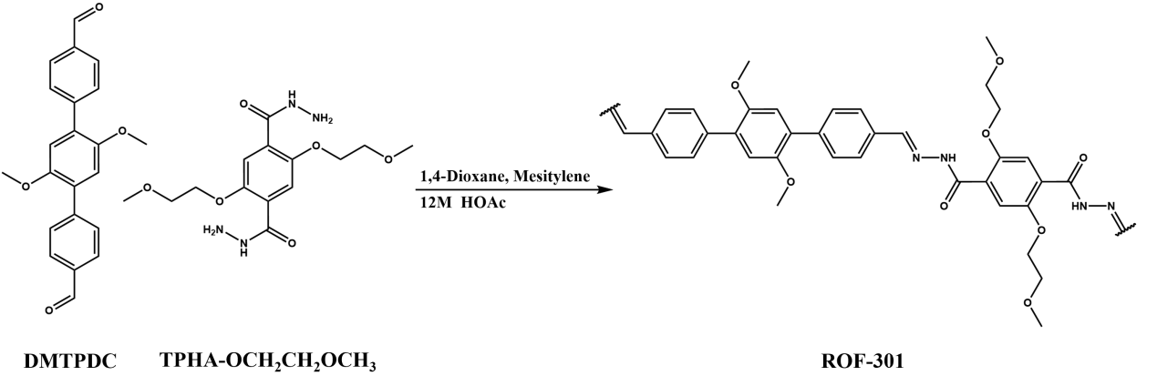
Synthesis of ROF-301. TPHA-OCH₂CH₂OCH₃(17.1mg,.0.05mmol) and 2’,5’-dimethoxy-[1,1’:4’,1’’-terphenyl]-4,4’’-dicarbaldehyde(DMTPDC,17.3mg,0.05mmol) were weighed and placed in a 10mL glass vial. A solvent mixture(1,4-dioxane : mesitylene =1:2,3mL) was added, and the mixture was ultrasonically dissolved at room temperature to form a uniformly dispersed suspension. Then, 0.2mL of acetic acid(12 M) was added. The solution was subsequently placed in an oven at 80 °C for 3days,the solid was separated by centrifugation, and washed with THF for three times. The solid was then evacuated at 80 °C overnight to obtain ROF-301. Elemental analysis calcd (%) for C₁₈H₁₈N₂O₄: C 66.26, H 5.52, N 8.59; found: C 64.19, H 5.97, N 8.21.
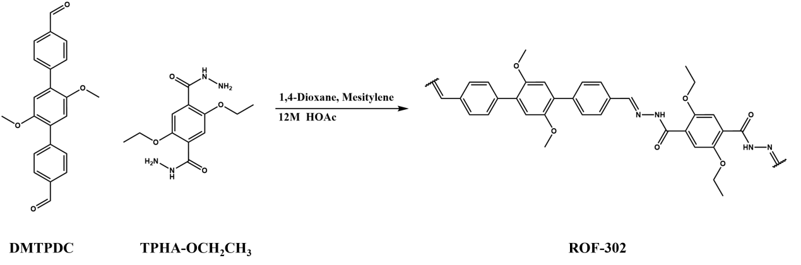
Synthesis of ROF-302. TPHA-OCH₂CH₃(14.1mg,.0.05mmol) and DMTPDC(17.3mg,0.05mmol) were weighed and placed in a 10mL glass vial. A solvent mixture(1,4-dioxane : mesitylene =1:2,3mL) was added, and the mixture was ultrasonically dissolved at room temperature to form a uniformly dispersed suspension. Then, 0.2mL of acetic acid(12 M) was added. The solution was subsequently placed in an oven at 80 °C for 3days,the solid was separated by centrifugation, and washed with THF for three times. The solid was then evacuated at 80 °C overnight to obtain ROF-302. Elemental analysis calcd (%) for C₁₇H₁₆N₂O₃·4H₂O: C 61.45, H 6.02, N 8.43; found: C 59.34, H5.97, N 8.21.
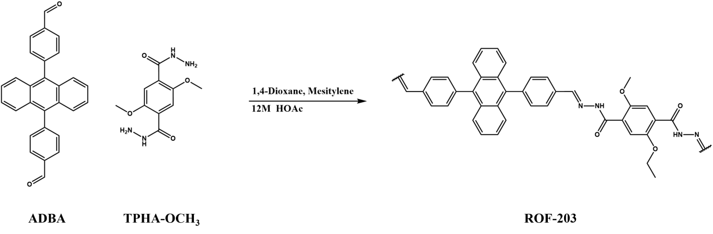
Synthesis of ROF-203. TPHA-OCH₃(12.7mg,.0.05mmol) and ADBA (17.3mg,0.05mmol) were weighed and placed in a 10mL glass vial. A solvent mixture(1,4-dioxane : mesitylene =1:2,3mL)was added, and the mixture was ultrasonically dissolved at room temperature to form a uniformly dispersed suspension. Then, 0.2mL of acetic acid(12 M) was added. The solution was subsequently placed in an oven at 80 °C for 3days,the solid was separated by centrifugation, and washed with THF for three times. The solid was then evacuated at 80 °C overnight to obtain ROF-203.
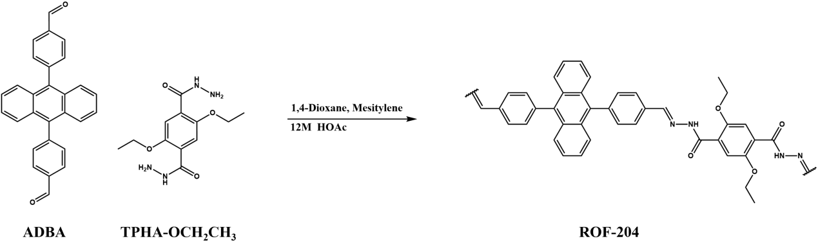
Synthesis of ROF-204. TPHA-OCH₂CH₃(14.1mg,.0.05mmol) and ADBA (17.3mg,0.05mmol) were weighed and placed in a 10mL glass vial. A solvent mixture(1,4-dioxane : mesitylene =1:2,3mL)was added, and the mixture was ultrasonically dissolved at room temperature to form a uniformly dispersed suspension. Then, 0.2mL of acetic acid(12 M) was added. The solution was subsequently placed in an oven at 80 °C for 3days,the solid was separated by centrifugation, and washed with THF for three times. The solid was then evacuated at 80 °C overnight to obtain ROF-204.
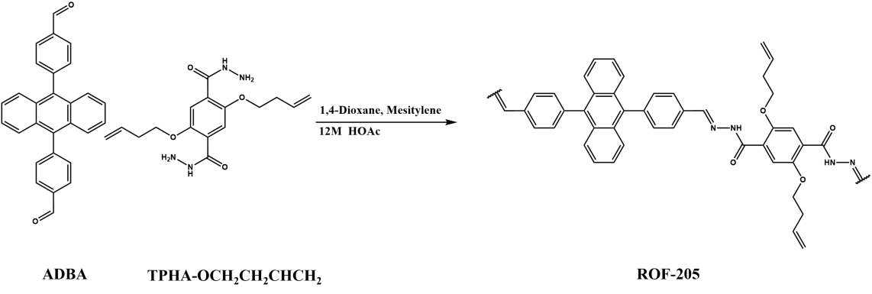
Synthesis of ROF-205. TPHA-OCH₂CH₂CHCH₂(16.7mg,.0.05mmol) and ADBA (17.3mg,0.05mmol) were weighed and placed in a 10mL glass vial. A solvent mixture(1,4-dioxane : mesitylene =1:2,3mL)was added, and the mixture was ultrasonically dissolved at room temperature to form a uniformly dispersed suspension. Then, 0.2mL of acetic acid(12 M) was added. The solution was subsequently placed in an oven at 80 °C for 3days,the solid was separated by centrifugation, and washed with THF for three times. The solid was then evacuated at 80 °C overnight to obtain ROF-205.
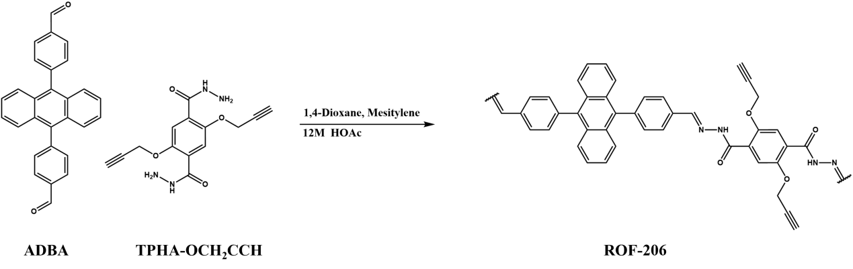
Synthesis of ROF-206. TPHA-OCH₂CCH(15.1mg,.0.05mmol) and ADBA (17.3mg,0.05mmol) were weighed and placed in a 10mL glass vial. A solvent mixture(1,4-dioxane : mesitylene =1:2,3mL)was added, and the mixture was ultrasonically dissolved at room temperature to form a uniformly dispersed suspension.Then,0.2mL of acetic acid(12 M) was added. The solution was subsequently placed in an oven at 80 °C for 3days,the solid was separated by centrifugation, and washed with THF for three times. The solid was then evacuated at 80 °C overnight to obtain ROF-206.

Supplementary Note 3. Computational methods
Molecular Simulations and Interaction Analyses
Density Functional Theory (DFT) calculation for Interaction Analyses. Structures obtained experimentally via single crystal structure were optimized by performing DFT calculations with the CP2K software¹⁰ to calculate the energy and force and refine the positions of hydrogen atoms.
For Kohn-Sham Density Functional Theory energy and force calculations, we used the DZVP-MOLOPT-SR-GTH basis set¹¹ and the GTH-PBE pseudopotential^{12,13}. Atoms were constrained during the evaluation of forces using the QUICKSTEP method, which utilizes the Density Functional Theory with Gaussian and Planewaves (GPW) method. The exchange correlation density functional we use is PBE¹⁴ along with the D3(BJ)¹⁵ dispersion correction which is consistent with the basis set and pseudopotential we have chosen.
Geometry optimization calculations are performed to find the local minima and the cell dimensions are chosen to be fixed. The parameter for the section of energy and force calculation are the same above. The algorithm for finding the stationary points is LBFGS method. When refining the positions of hydrogen atoms, the movements of all other atoms are constrained.
Independent Gradient Model based on Hirshfeld partition of molecular density (IGMH) Analyses. The independent gradient model based on Hirshfeld partition of molecular density (IGMH) method¹⁶ reported by Lu et al. in 2022 was used to exploring the framework-framework interactions. IGMH method is an improved version of independent gradient mode (IGM)¹⁷ which replaces the free-state atomic densities involved in the IGM method with the atomic densities derived by Hirshfeld partition of actual molecular electron density.
The $δg$ function are defined as the difference between IGM type of density gradient ($g^{IGM}$) and the gradient of promolecular density ($g$). This parameter has a positive correlation with the strength of intermolecular interactions within an interatomic interaction region and can thus be used to measure the relative strength of these interactions.¹⁸
The intermolecular interactions can be expressed as¹⁶

$$δg^{inter}(r)=g^{IGM,inter}(r)−g^{inter}(r)$$
with

$$g^{inter}(r)=\left|\sum_{A}{\sum_{i∈A}{∇}}ρ_{i}^{free}(r)\right|$$
where $r$ represents the Cartesian coordinate vector, $A$ loops over all fragments, $i$ loops all atom in the corresponding fragment and $ρ_{i}^{free}$represents the spherically averaged density of atom $i$ in its free state.
Intercepting the part of ROF-102 and ROF-113 for IGM calculations, we focus only on the intermolecular interactions, denoted as $δg$-inter. and decompose the inter-framework interactions into the contribution of each atom, denoted as $δg$-index, the larger the $δg$-index, the larger the contribution of the atom to the interactions. And use VMD to color the atoms by $δg$-index to show in the structure.

Polymer CSP
Overall Workflow of Crystal Structure Prediction for Polymer. The crystal structure prediction (CSP) strategy employed in this study uses a quasi-random search algorithm, which was adapted and further developed from the protocol previously established BOMLIP-CSP¹⁹ by our group for molecular crystals. Similar to conventional CSP workflows, the procedure begins with the identification of conformers of the minimum repeating unit, followed by the generation of a large number of potential crystal structures using a quasi-random sampling approach. The candidate structures are then geometrically optimized and ranked according to their lattice energies. After the removal of duplicate structures, low-energy candidates are further re-optimized using density functional theory (DFT)-level calculations. Where possible, the predicted structures are subsequently validated against the target structures by comparing their PXRD patterns.
Generation of Polymer-chain Repeat-unit Conformers. Similar to molecular CSP, conformational searching was first performed to construct the repeat units for subsequent packing-structure generation. Conventional conformational searching may cause the chain segment to fold into a ring-like conformation in order to minimize the energy of the building unit, which is clearly unfavorable for reproducing low-energy structures during subsequent packing. Given the absence of standardized methods for determining the conformers of infinite chains, we adopted the following procedure to determine the conformers.
First, monomer conformers were generated using the ETKDGv3²⁰ method in RDKit²¹, with an RMSD threshold of 0.2 Å for duplicate removal. The top-ranked monomers were then selected or removed according to the following principles. First, structures in which the two linking bonds of the repeat unit were not nearly parallel were removed to ensure the formation of one-dimensional polymer chains in the constructed periodic structures. Second, conformers with internal folding of a single repeat unit caused by strong intramolecular interactions were removed to avoid generating clearly unreasonable packing structures. Third, conformers in which the distance between the two linking atoms of a single repeat unit was significantly shorter than in the other cases were excluded to ensure that the chain was as extended as possible.
These principles were established based on our previous survey and summary of existing single-crystal structures. Although they may not be applicable to all known polymer systems in the CCDC, they were verified to be effective for the series of systems reported in this work.
Generation of Chain Polymer Crystal Structures. The structure-generation stage incorporates substantial modifications to conventional small-molecule CSP protocols to avoid isolated repeat-unit fragments in the generated structures and to preserve the physical integrity of polymer chains. To this end, we adopted two related but distinct strategies for different situations.
Each polymer chain is represented by a chain vector, defined by the length and direction of its periodic repeat unit. A physically valid polymer crystal must simultaneously satisfy the periodicity imposed by the chain vector and that of the crystal lattice. Violation of either constraint leads to either physically unrealistic structures or fragment-containing structures. In our original strategy, the search space is classified according to the number of distinct chain directions and the number of chains associated with each direction. By gradually increasing the complexity of chain orientations and the number of chains, the algorithm samples structures ranging from common to rare packing motifs. The remaining unit-cell parameters, whether chains are arranged parallel or antiparallel along the chain axis, the rotation angle of the repeat unit around the chain axis, chain position, chain phase and helical handedness (if present) were randomized. Trial structures were generated for all selected combinations of chain directionality and chain number until the predefined number of generated structures was reached.
This method was found to be highly effective for the uniaxial series of systems, including ROF-102, ROF-105, and ROF-113. In principle, it can also be applied to non-uniaxial cases. However, in our tests, this sampling approach was found to be highly inefficient for non-uniaxial systems. Therefore, to improve efficiency, we introduced the concept of space groups into the generation procedure. In this new strategy, a finite chain segment is treated as a single molecule in a conventional molecular CSP framework, and trial structures are randomly generated under space-group constraints. The chain segments in the resulting crystals are then connected to form infinite chains using a dedicated bonding procedure, which creates bonds between predefined linkage sites. A subsequent optimization based on the classical DREIDING²² force field is performed using the predefined bonds to relax the newly formed bonds to chemically reasonable lengths, which means that the unit cell can automatically adapt to the periodic chain length rather than requiring it to be predefined. The number of structures generated for different molecular systems using different generation method and different parameters is summarized in Table 4.
Structure Optimization. Structural optimization was performed using the MACE-OFF²³ pretrained machine-learning interatomic potential. We used the small-scale model with 694k parameters through the ASE interface²⁴. The structures were first optimized under an external pressure of 0.1 GPa using the BFGS Line Search optimizer to eliminate physically unrealistic vacuum layers introduced during structure generation. They were then fully relaxed to equilibrium at zero pressure using the BFGS algorithm.
Post-processing. To remove duplicate structures, PXRD patterns are used as structural descriptors. Some established algorithms were found to be unsuitable for periodic chain polymers. Instead, similarity is estimated by comparing calculated PXRD patterns using Dynamic Time Warping (DTW) with a Sakoe-Chiba constraint. Patterns are calculated over a 2-theta range of 2° to 45° (0.01° step size) and broadened using a Gaussian function with 0.1° FWHM. The Sakoe-Chiba radius is set to 2° (200 points). Structures with high PXRD similarity (low DTW distance) are identified as duplicates.
DFT level recalculation. After duplicate removal, the 100 lowest-energy structures are re-optimized using the Vienna ab initio simulation package (VASP) code version 5.4.4²⁵. Projector augmented-wave²⁶ (PAW) method was applied to describe the electron–ion interactions. Generalized gradient approximation (GGA)^{[14]} with the Perdew–Burke–Ernzerhof (PBE) exchange correlation functional was adopted to treat electron interaction energy. Grimme's semi-empirical DFT-D3 scheme with Becke–Johnson damping functions was used here to give a better description of interactions^{27,28}. A kinetic-energy cut-off of 600 eV was used to define the plane-wave basis set. Electronic Brillouin zone was integrated with the smallest allowed spacing between k-points (KSPACING) being 0.4 Å⁻¹ and the generated grid is centred at the Γ-point. Convergence threshold of self-consistency was set to 10⁻⁶ eV during total energy and force calculation and the Hellmann-Feynman force convergence criterion on each atom was set to smaller than 0.01 eV/Å when geometry optimizations are needed. These high-accuracy structures are then re-evaluated against the target structure using DTW-PXRD, and the most similar candidates are visually inspected in descending order of similarity using the structure overlay function in Mercury until a matching structure is identified.
It should be noted that, for ROF-201, in addition to the 100 lowest-energy structures, the two structures with the best PXRD pattern matches with MLIP level were also included in the DFT re-optimization step. This is because the ROF-201 structure exhibits a large number of local minima, and the experimental structure is ranked above 500 in energy; therefore, it was not included among the 100 lowest-energy structures.
Visualization of the SOAP space. The UMAP technique was used for dimensionality reduction for mapping high-dimensional data to 2D representations, while preserving both global and local topological structures of the data in the high-dimensional space as much as possible. That is, the points are arranged spatially such that the closer the two points are on the 2D plot, the more similar the two molecules are, as described by the encoding descriptors. SOAP descriptors were generated for all atoms in the crystal structure. The average kernel was used to measure global similarity between crystal structures from SOAP-encoded local atomic environments.

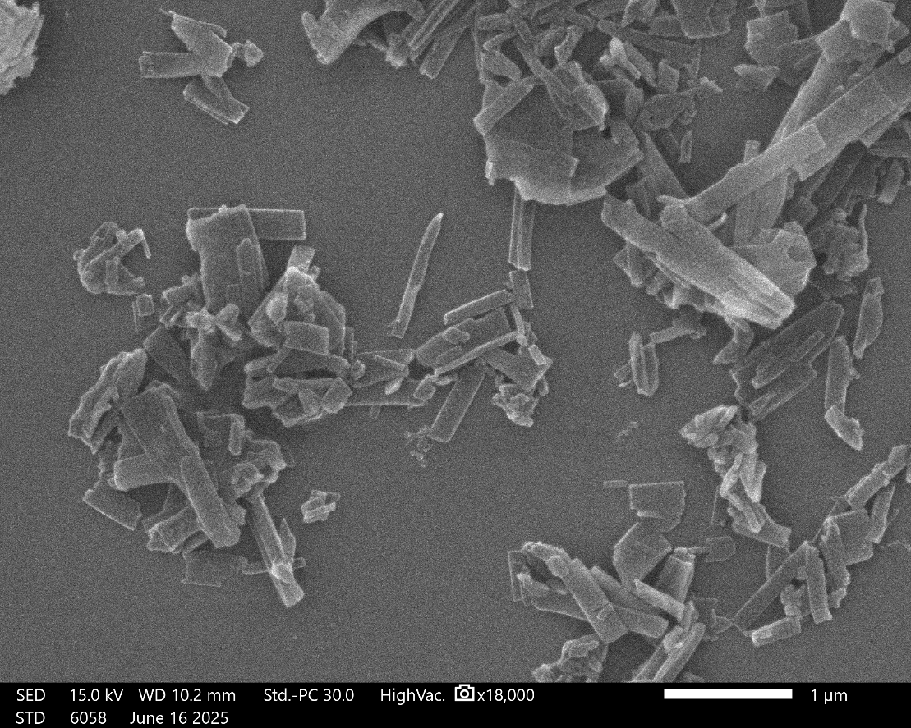
Supplementary Figure 1. SEM image of ROF-102.

Table 1. The refinement statistics of sample ROF-102
Sample name | ROF-102
CCDC Deposit No. | 2539225
Chemical formula | C₃₂H₂₄N₄O₂
Temperature | 293(2) K
Crystal system | triclinic
Space group | P -1
Cell parameters | a = 9.558 Å, b = 11.509 Å, c = 12.767 Å, α = 96.37°, β = 95.66°, γ = 90.96°
Cell volume | 1388.4 Å³
Diffractometer | F200 Transmission electron microscope
Radiation | Electron (λ = 0.02508 Å)
Data reduction | XDS
Reflections collected | 2489
Completeness | 0.595
Max indices | (8, 10, 10)
Min indices | (-8, -10, -10)
I/Sigma | 3.8 to 1.06 Å
Solution method | Intrinsic Phasing using SHELXT
Refinement method | Least Square using SHELXL
Unique reflections | 1440
R1 | 0.2167
wR₂ | 0.5431
R_{int} | 0.1624
GooF | 1.442

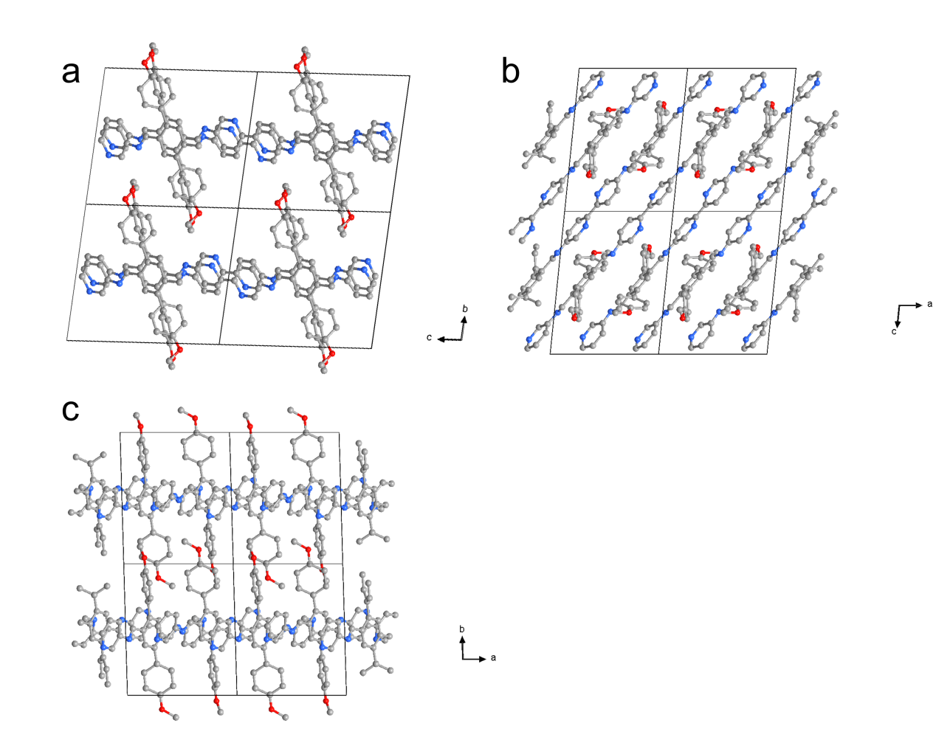
Supplementary Figure 2. Crystallographic structure of ROF-102 viewed from a-axis (a), b-axis (b) and c-axis (c).

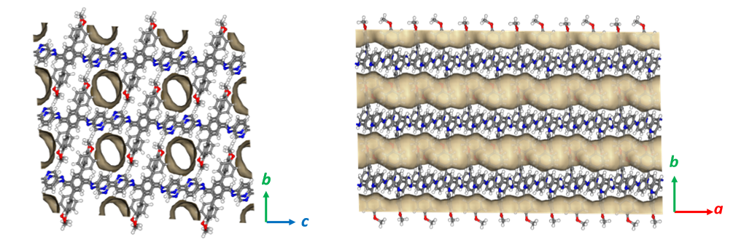
Supplementary Figure 3. Top view and side view of the 1D channel for ROF-102.

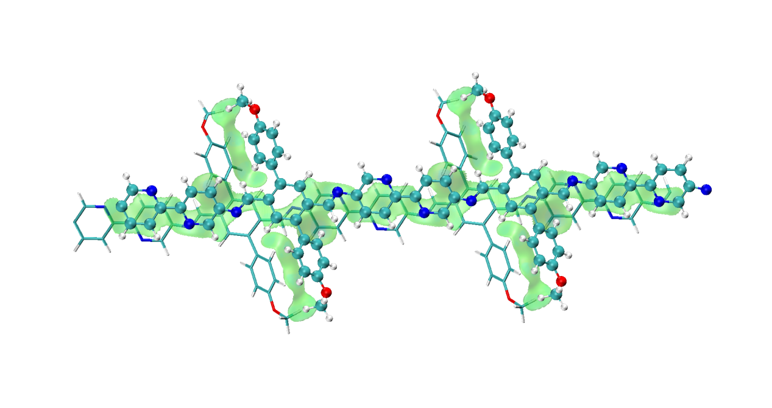
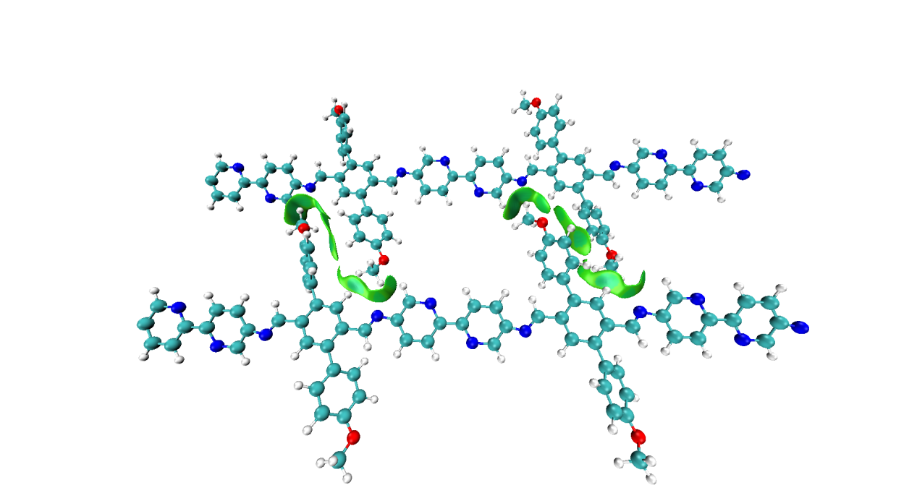
Supplementary Figure 4. Sign($δ_{2}$)$ρ$ colored isosurfaces of $δg$-inter = 0.005 a.u. of interactions via IGMH method for ROF-102.

Supplementary Figure 5. CO₂ sorption isotherms of ROF-102 at 195K.

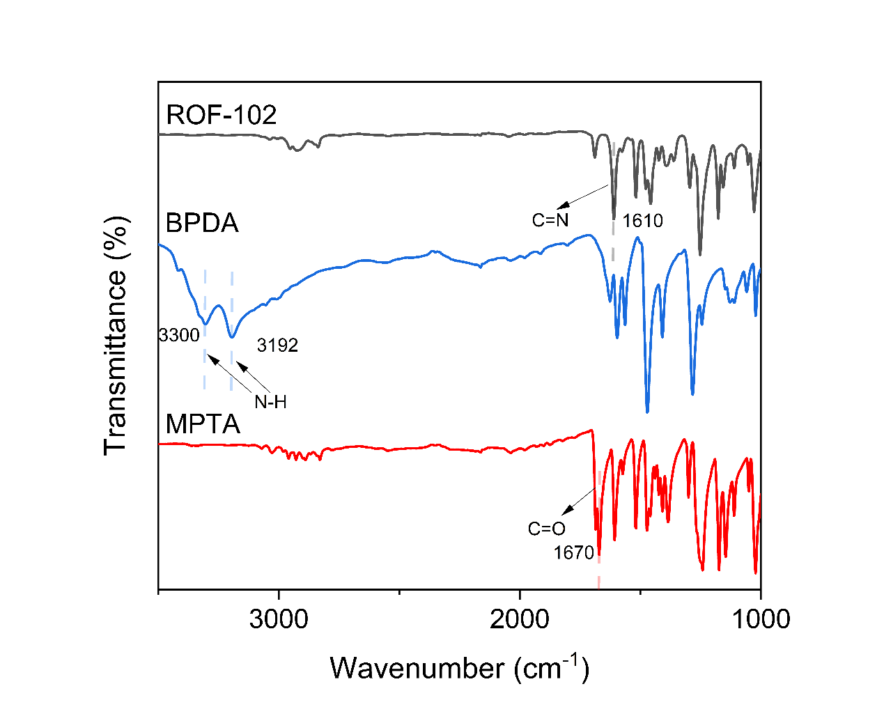
Supplementary Figure 6. The FT-IR spectrum of the starting materials, BPDA and MPTA, and the products, ROF-102. The -C=N- stretching vibration at 1610 cm⁻¹ indicated the formation of imine linkages.

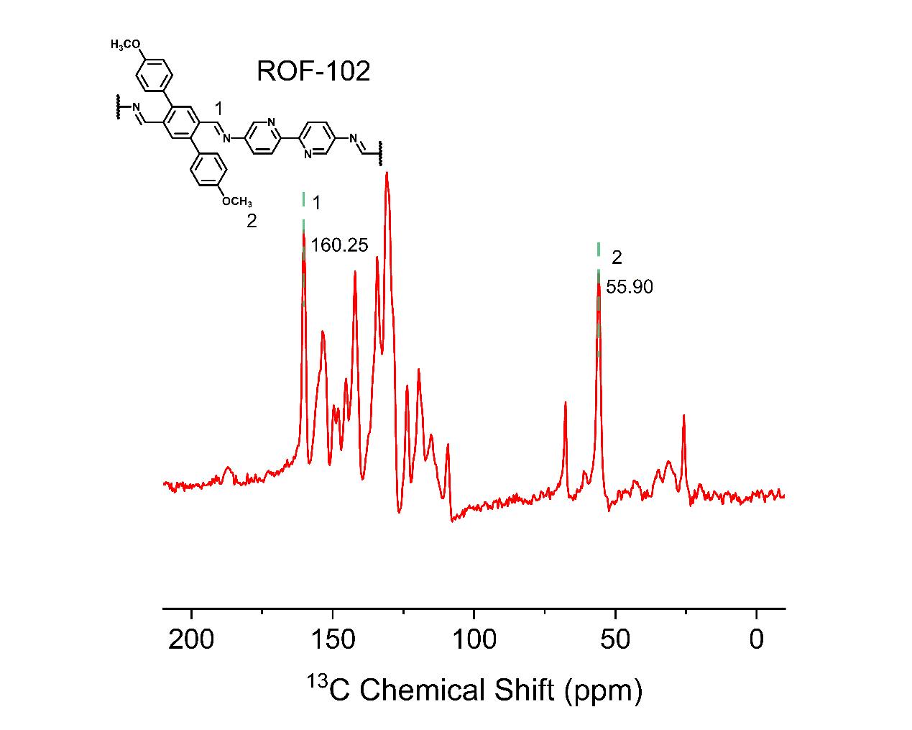
Supplementary Figure 7. ¹³C CP-MAS NMR of ROF-102.
The spectrum exhibited the corresponding imine peak at 160.25ppm.

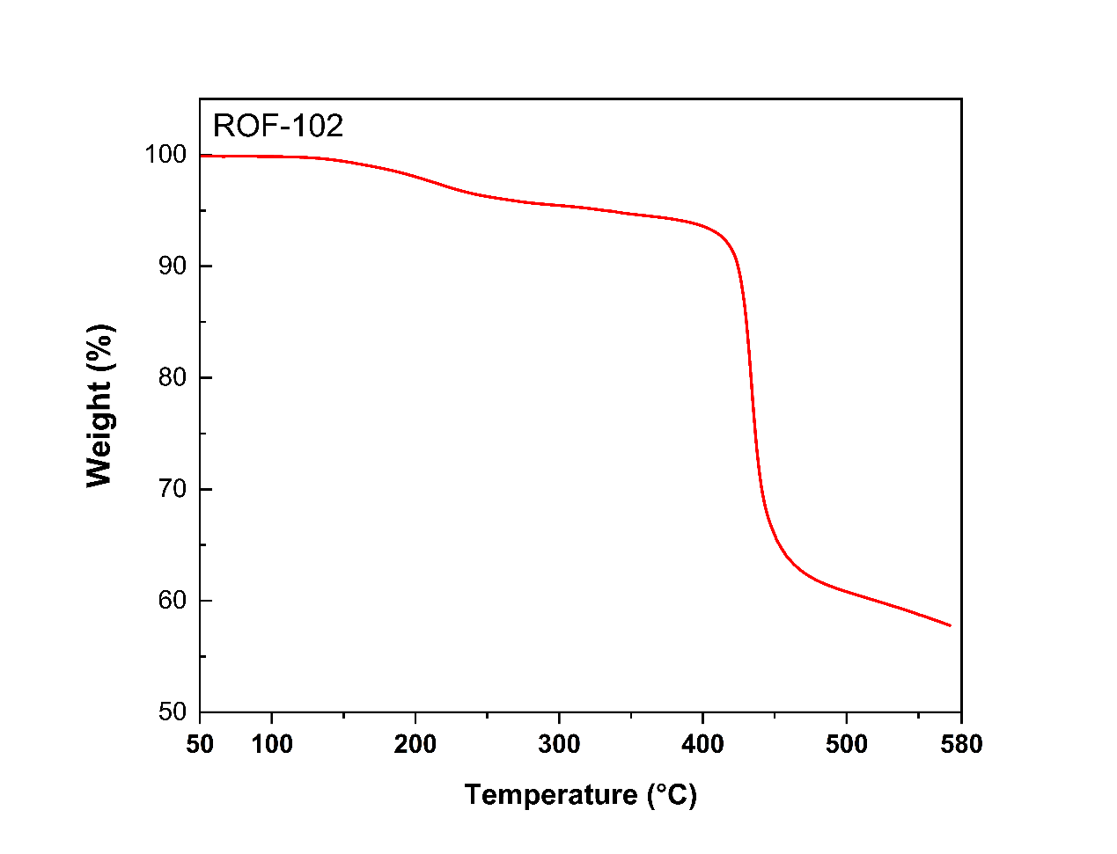
Supplementary Figure 8. The TGA profile of ROF-102.

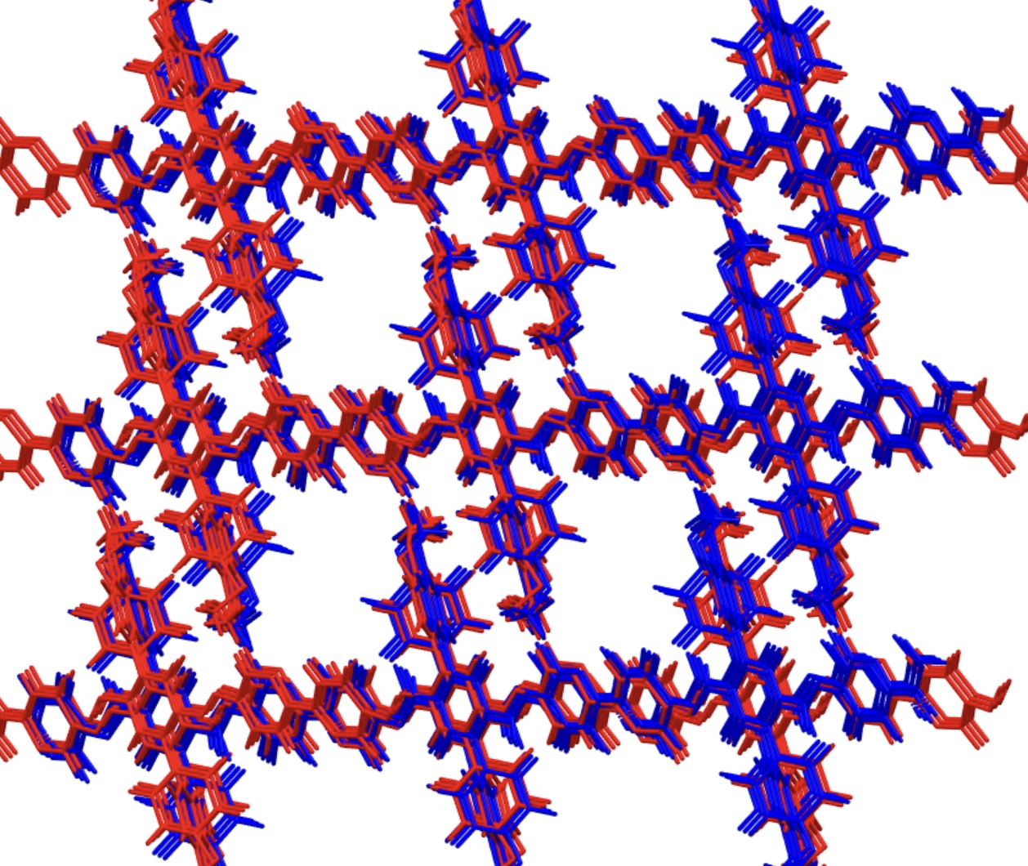
Supplementary Figure 9. Overlays of predicted and experimental structures for system ROF-102.

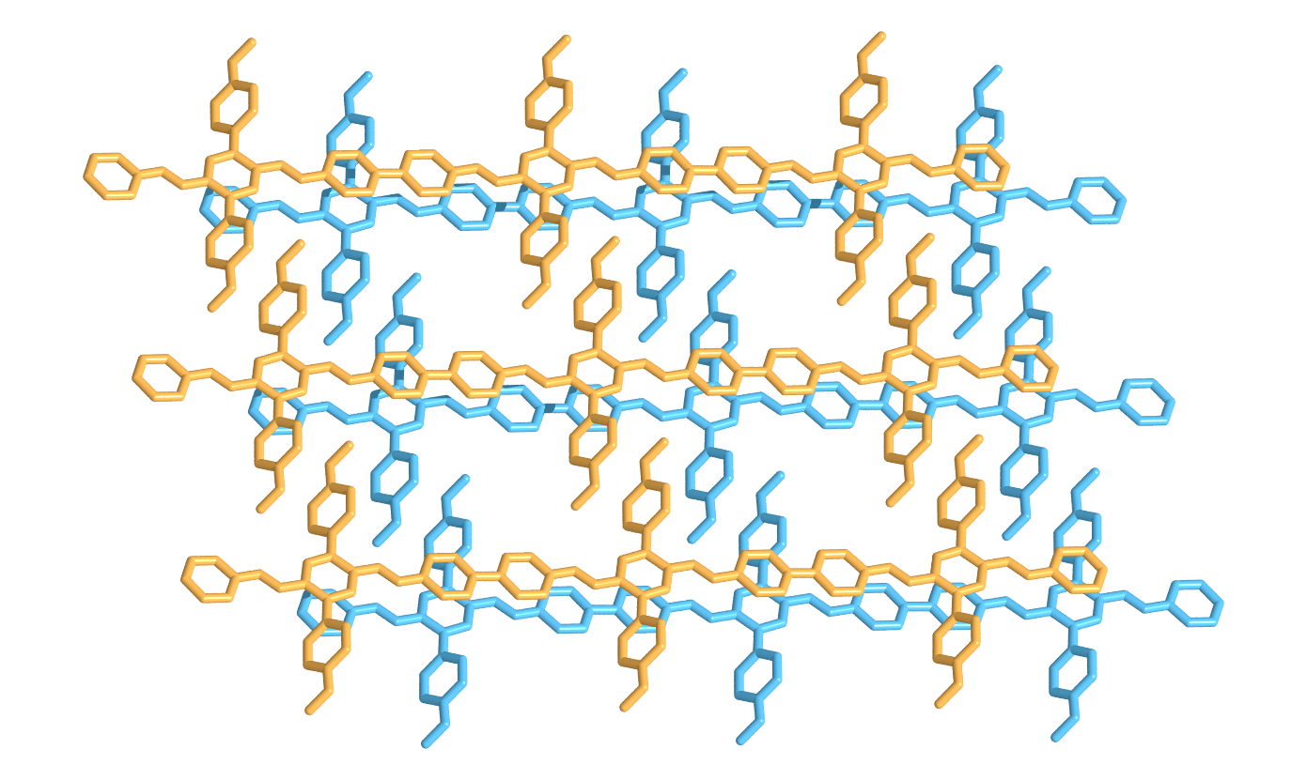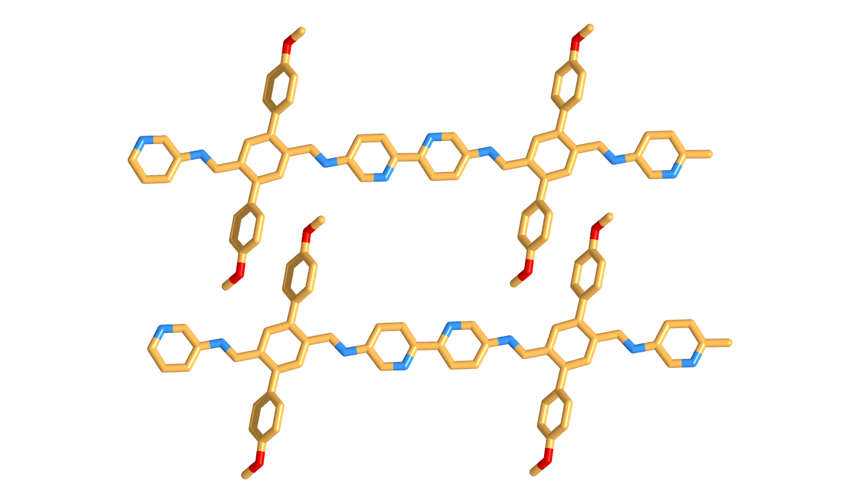
Supplementary Figure 10. Global minimum-energy structure of ROF-102 predicted by CSP.

Supplementary Figure 11. Pawley refinement of ROF-105.

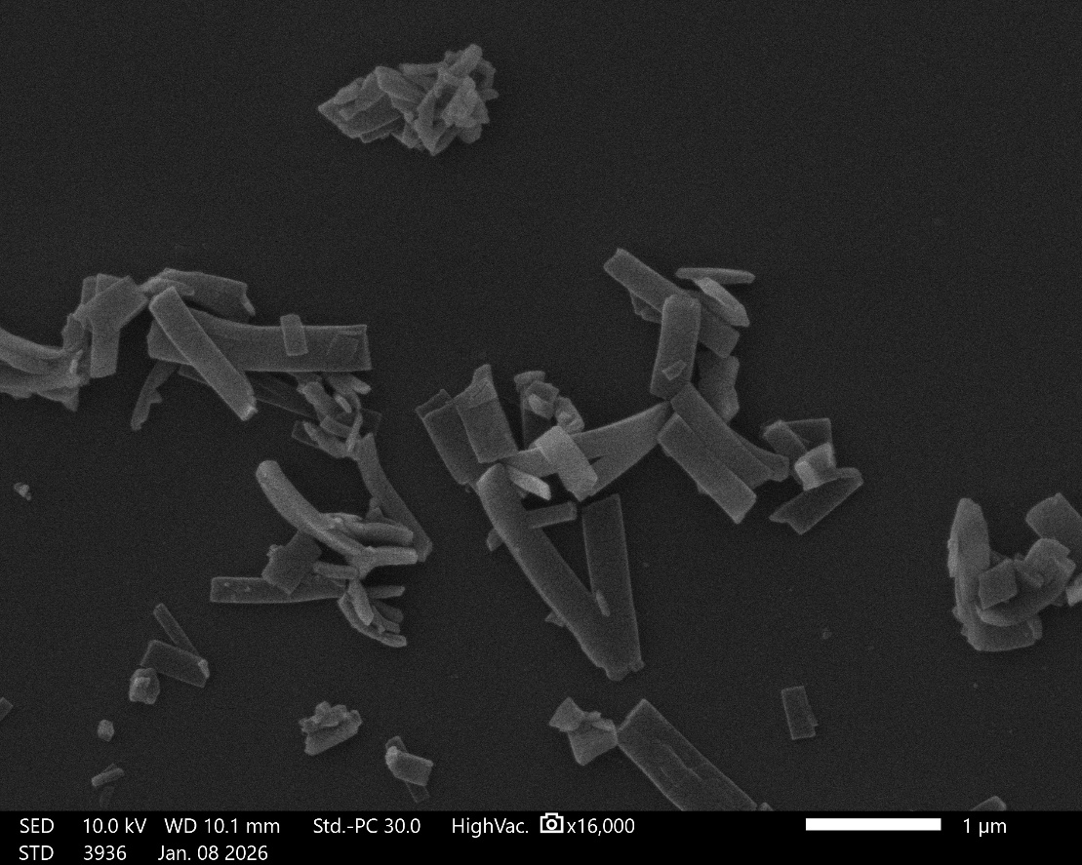
Supplementary Figure 12. SEM image of ROF-105.

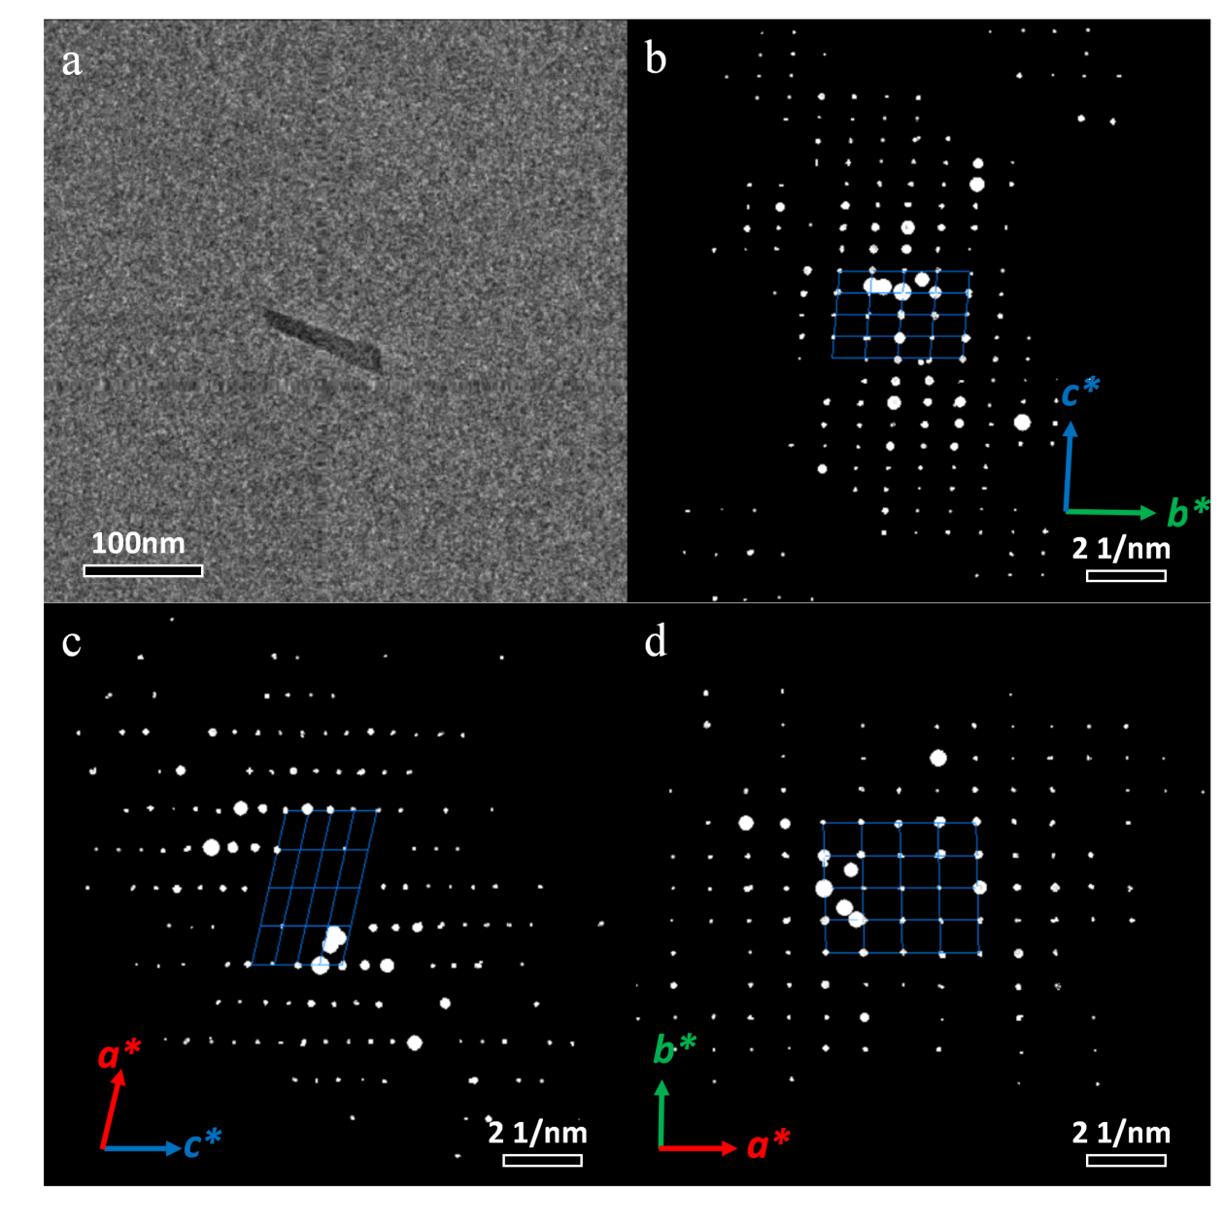
Supplementary Figure 13. (a)Low-mag TEM image of one ROF-105 crystal. Projections of 3D ED data of ROF-105 along (b) [100], (c) [010] and (d) [001] directions.

Table 2. The refinement statistics of sample ROF-105
Sample name | ROF-105
CCDC Deposit No. | 2539303
Chemical formula | C₄₀H₃₀N₂O₂
Temperature | 293(2) K
Crystal system | triclinic
Space group | P-1
Cell parameters | a = 10.199 Å, b = 11.604 Å, c = 17.024 Å, α = 94.68°, β = 102.50°, γ = 88.12°
Cell volume | 1960.1 Å³
Diffractometer | F200 Transmission electron microscope
Radiation | Electron (λ = 0.02508 Å)
Data reduction | XDS
Reflections collected | 14085
Completeness | 0.885
Max indices | (10, 11, 17)
Min indices | (-10, -11, -17)
I/Sigma | 3.98 to 0.96 Å
Solution method | Intrinsic Phasing using SHELXT
Refinement method | Least Square using SHELXL
Unique reflections | 4103
R1 | 0.2161
wR₂ | 0.5345
R_{int} | 0.2433
GooF | 1.249

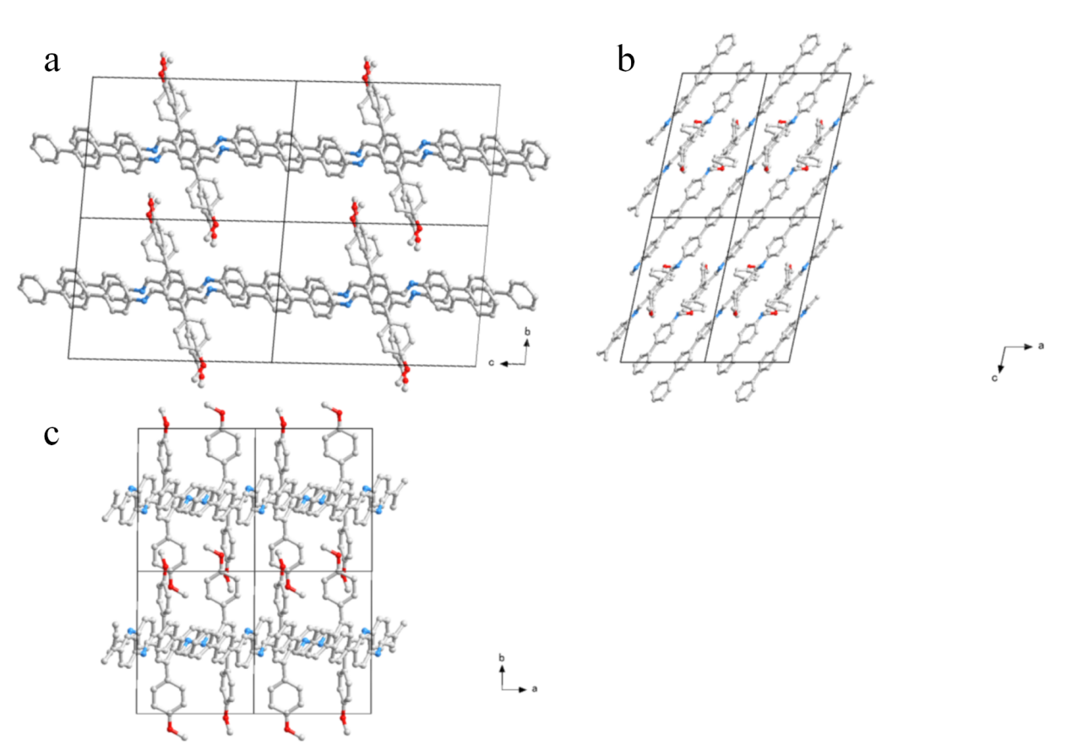
Supplementary Figure 14. Crystallographic structure of ROF-105 viewed from a-axis (a) ,b-axis (b) and c-axis (c).

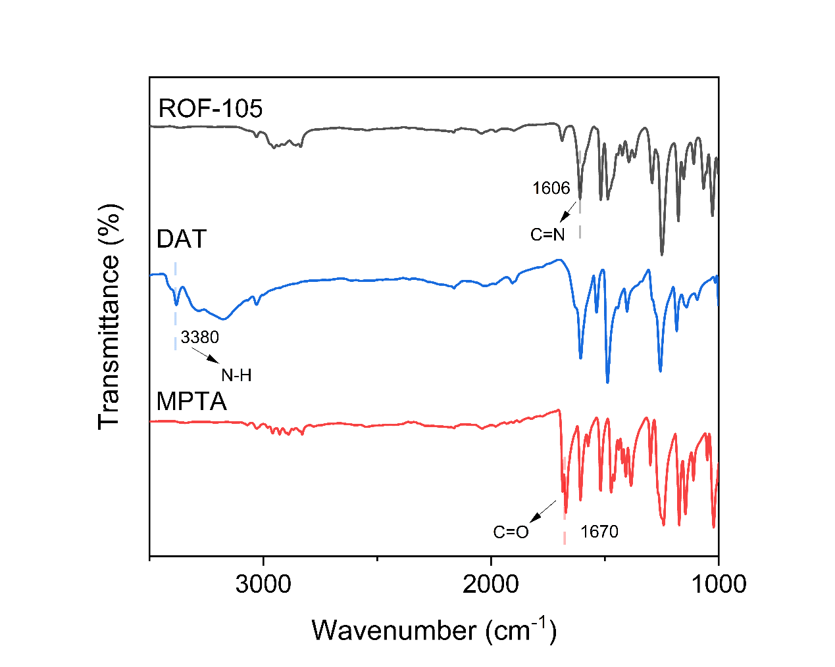
Supplementary Figure 15. The FT-IR spectrum of the starting materials, DAT and MPTA, and the products, ROF-105. The -C=N- stretching vibration at 1606 cm⁻¹ indicated the formation of imine linkages.

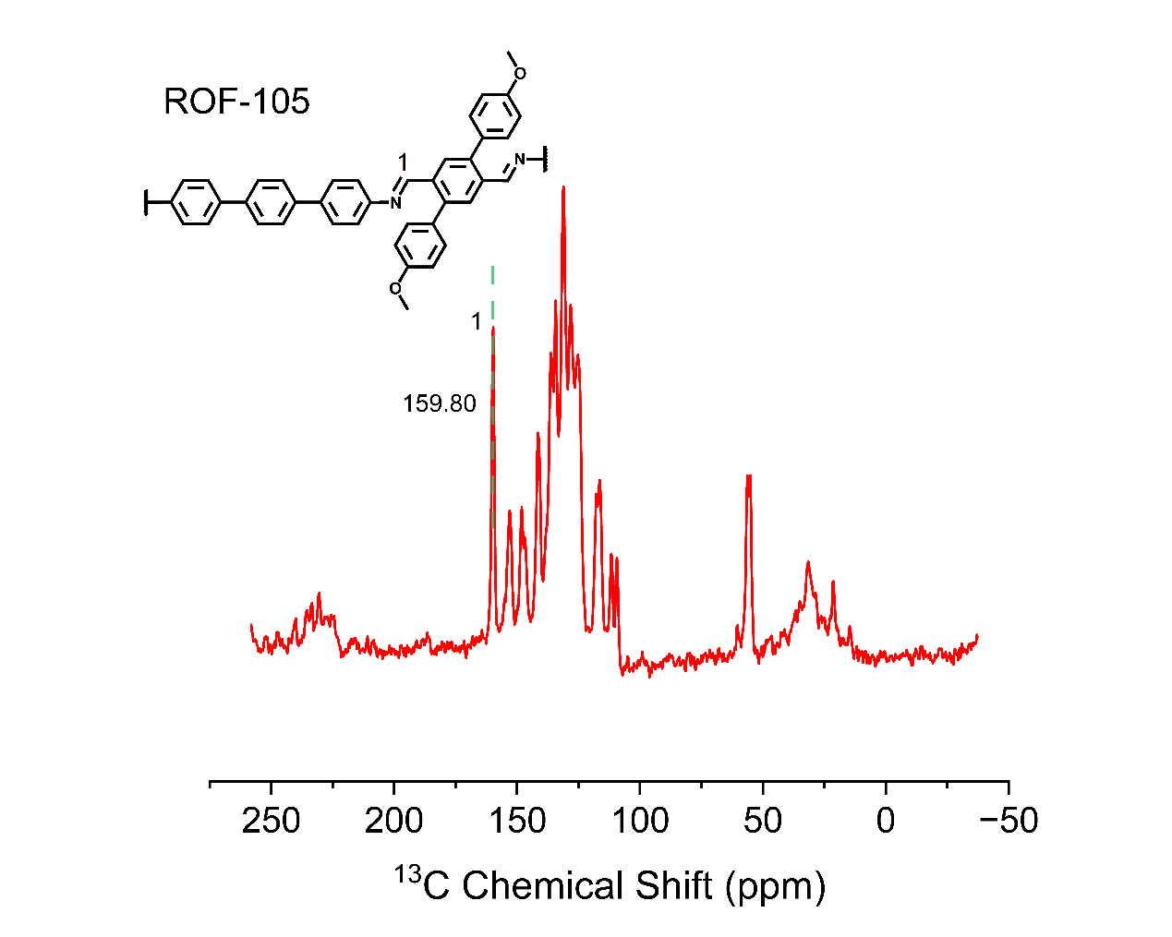
Supplementary Figure 16. ¹³C CP-MAS NMR of ROF-105.
The spectrum exhibited the corresponding imine peak at 159.8ppm.

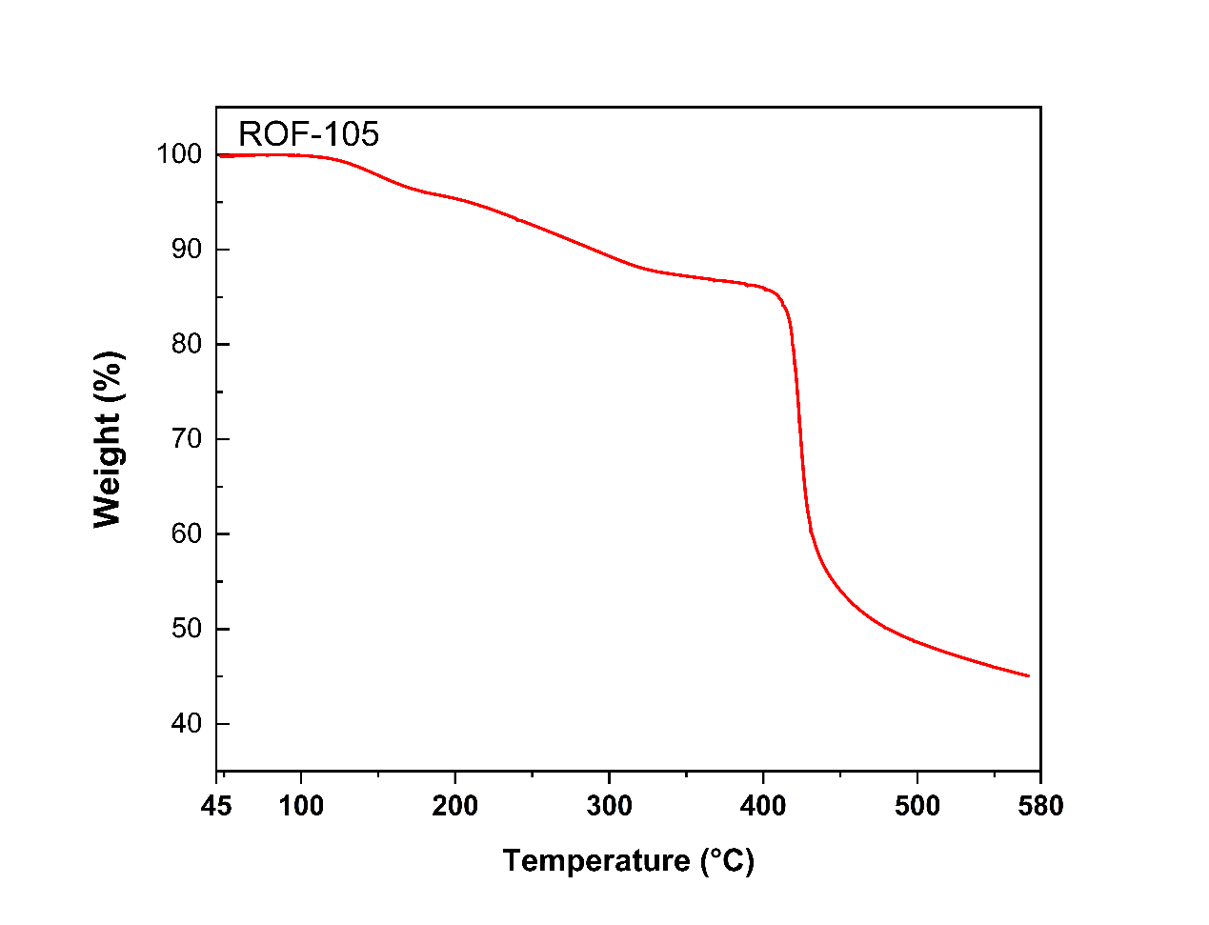
Supplementary Figure 17. The TGA profile of ROF-105.

Supplementary Figure 18. CSP energy landscape of ROF-105 evaluated using a machine-learning interatomic potential. Structures are colored according to their axial dimensionality.

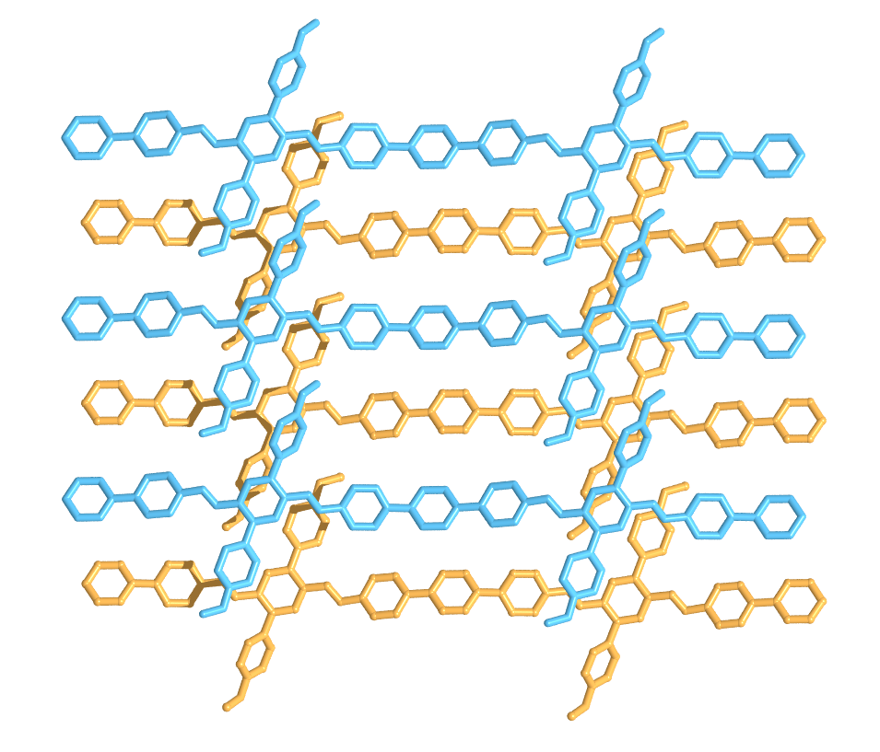
Supplementary Figure 19. Global minimum-energy structure of ROF-105 predicted by CSP.

Supplementary Figure 20. Pawley refinement of ROF-113 PXRD patterns .

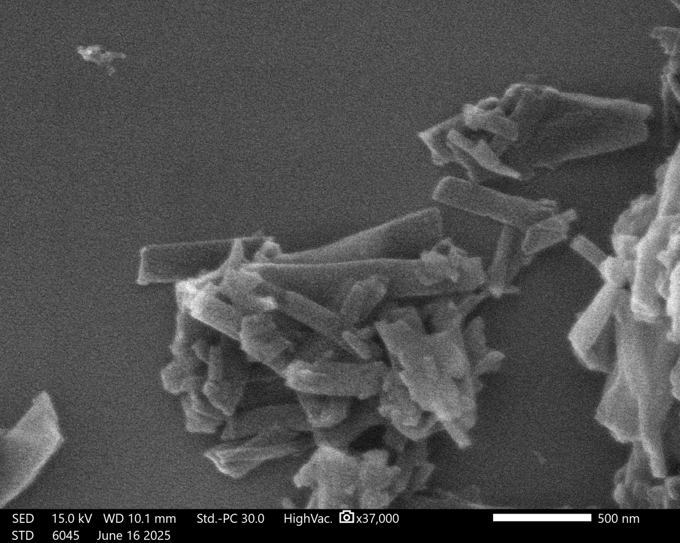
a

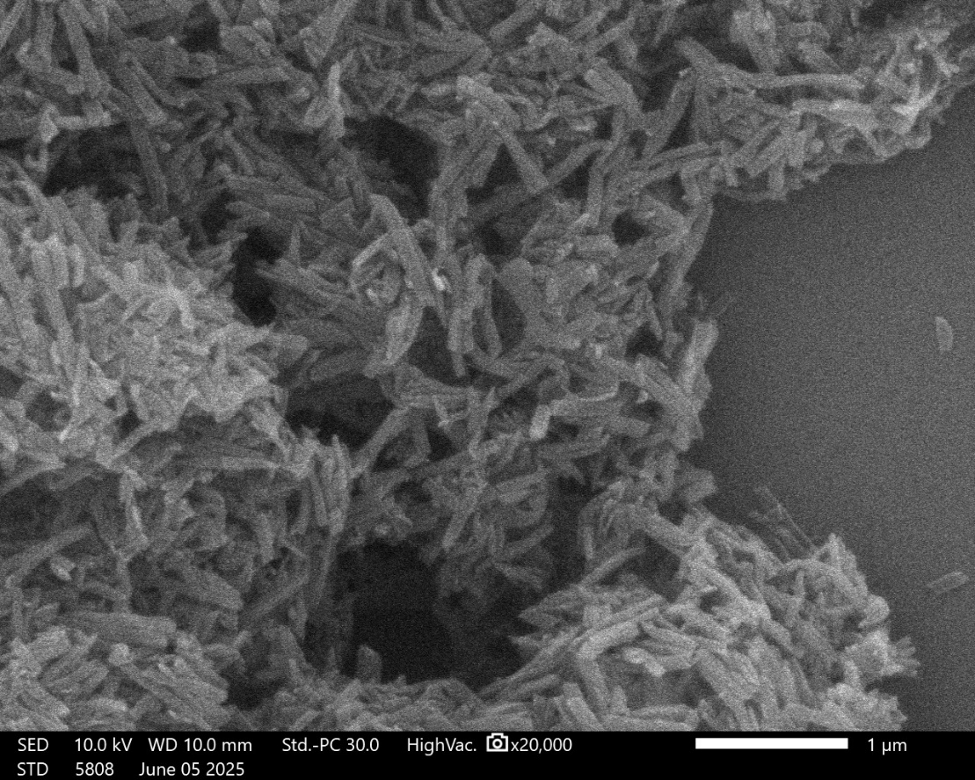
b

Supplementary Figure 21. (a) SEM image of ROF-113. (b) SEM image of ROF-113-scalable.

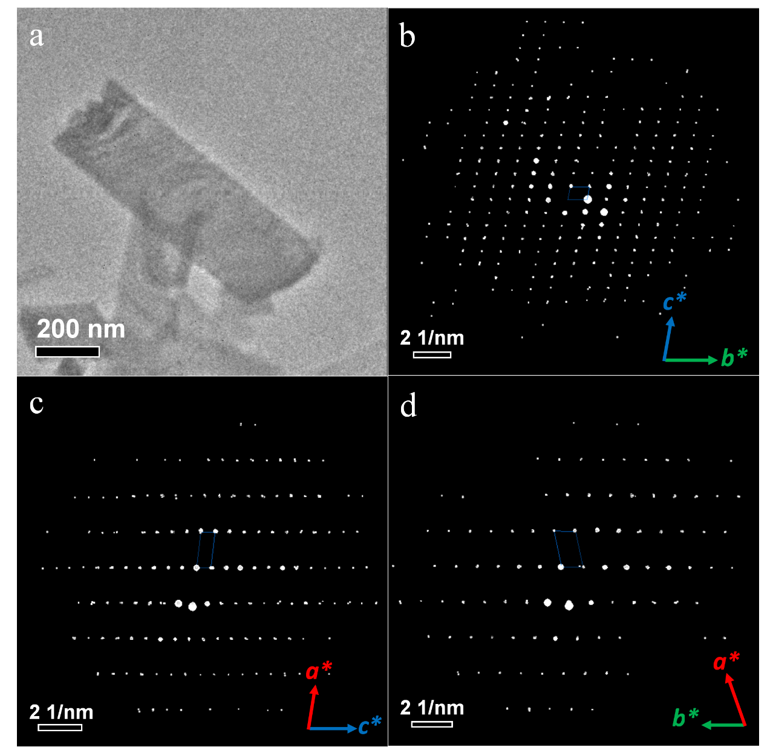
Supplementary Figure 22. (a)Low-mag TEM image of one ROF-113 crystal. Projections of 3D ED data of ROF-113 along (b) [100], (c) [010] and (d) [001] directions.

Table 3. The refinement statistics of sample ROF-113
Sample name | ROF-113
CCDC Deposit No. | 2539226
Chemical formula | C₂₄H₁₈NO
Temperature | 293(2) K
Crystal system | triclinic
Space group | P-1
Cell parameters | a = 6.260 Å, b = 10.718 Å, c = 15.912 Å, α = 99.22°, β = 97.26°, γ = 102.59°
Cell volume | 1014.0 Å³
Diffractometer | F200 Transmission electron microscope
Radiation | Electron (λ = 0.02508 Å)
Data reduction | XDS
Reflections collected | 1805
Completeness | 0.599
Max indices | (5, 10, 14)
Min indices | (-5, -10, -14)
I/Sigma | 9.7 to 1.05 Å
Solution method | Intrinsic Phasing using SHELXT
Refinement method | Least Square using SHELXL
Unique reflections | 1084
R1 | 0.2023
wR₂ | 0.5366
R_{int} | 0.0649
GooF | 1.879

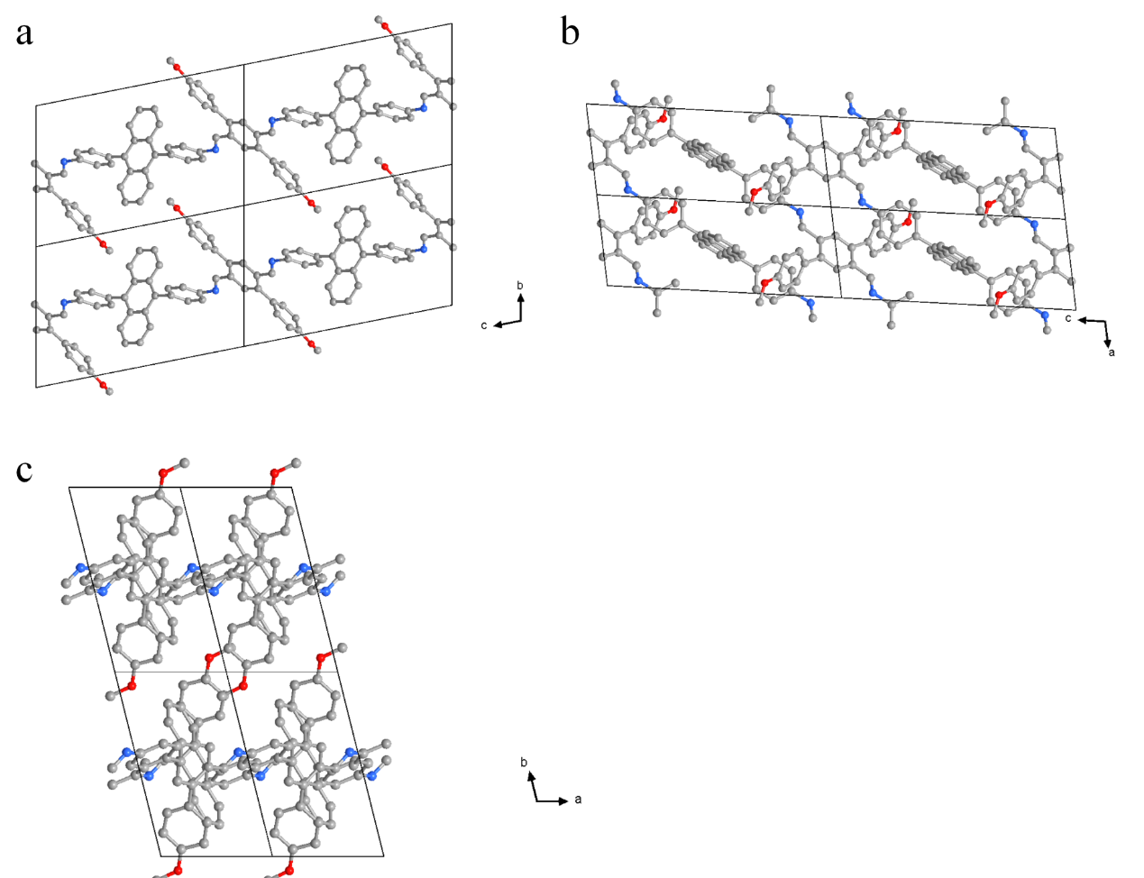
Supplementary Figure 23. Crystallographic structure of ROF-113 viewed from a-axis (a) ,b-axis (b) and c-axis (c).

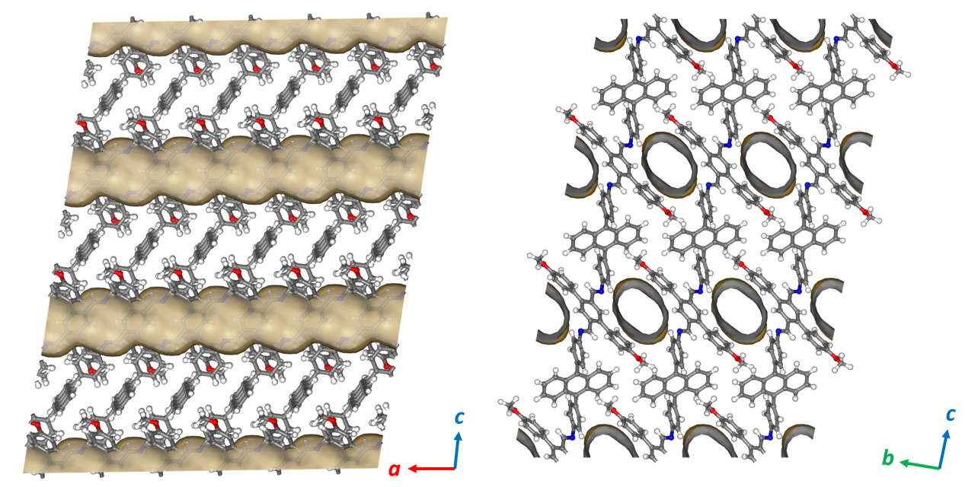
Supplementary Figure 24. Top view and side view of the Schematic illustration of pore simulations of ROF-113.

Supplementary Figure 25. CO₂ sorption isotherms of ROF-113 at 195K.

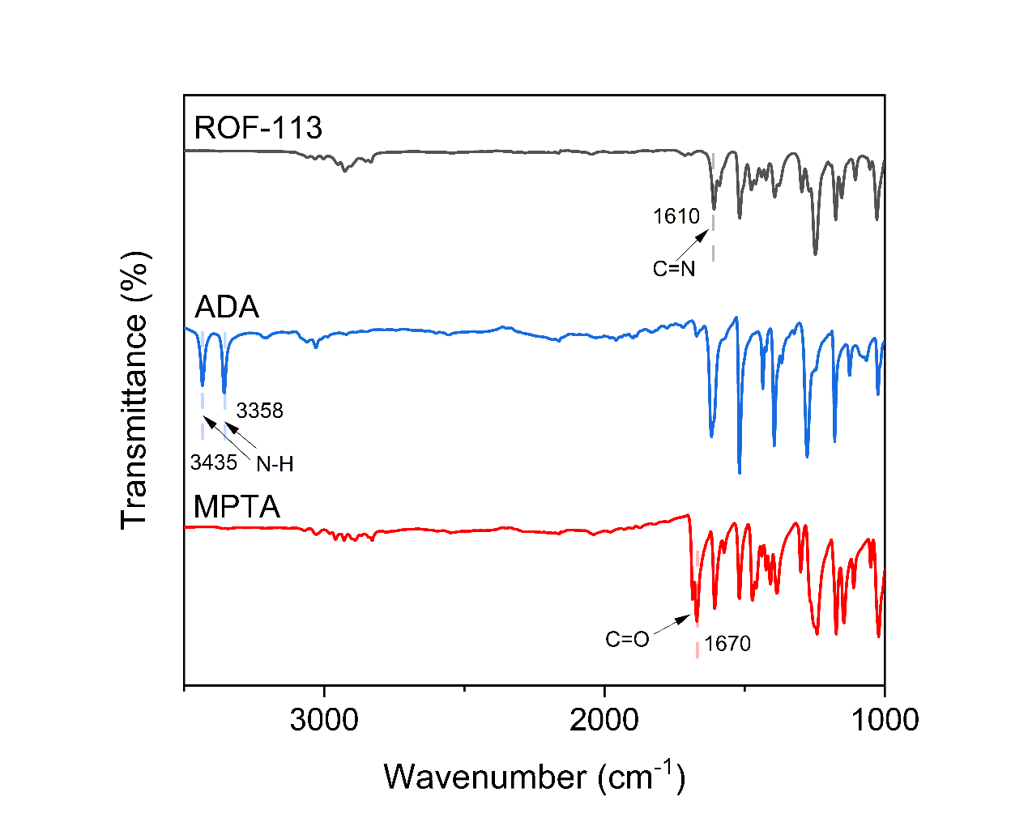
Supplementary Figure 26. The FT-IR spectrum of the starting materials, ADA and MPTA, and the products, ROF-113. The -C=N- stretching vibration at 1610 cm⁻¹ indicated the formation of imine linkages.

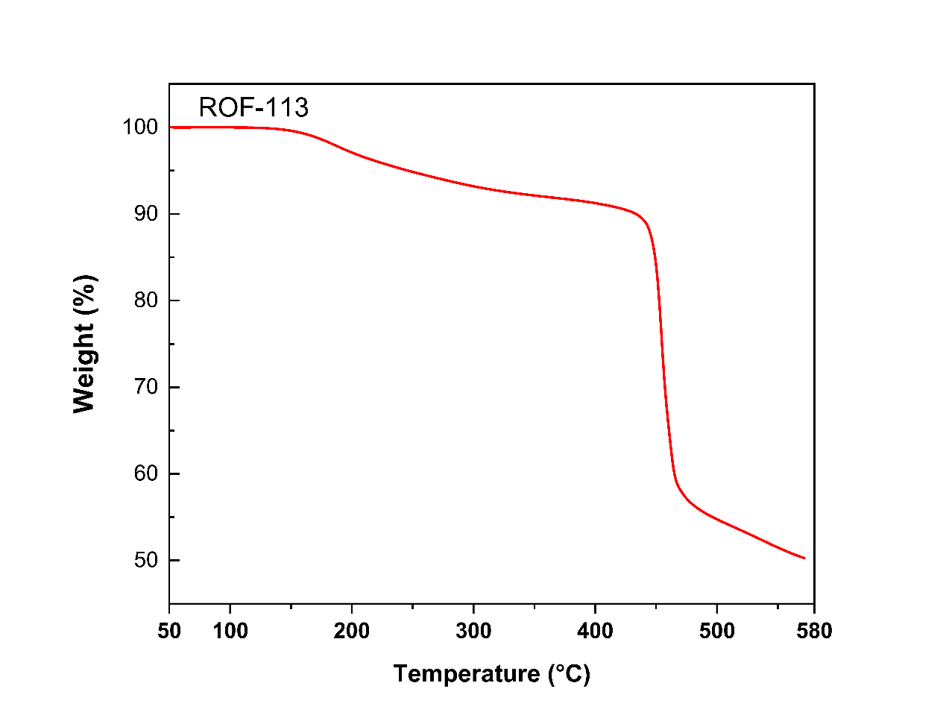
Supplementary Figure 27. The TGA profile of ROF-113.

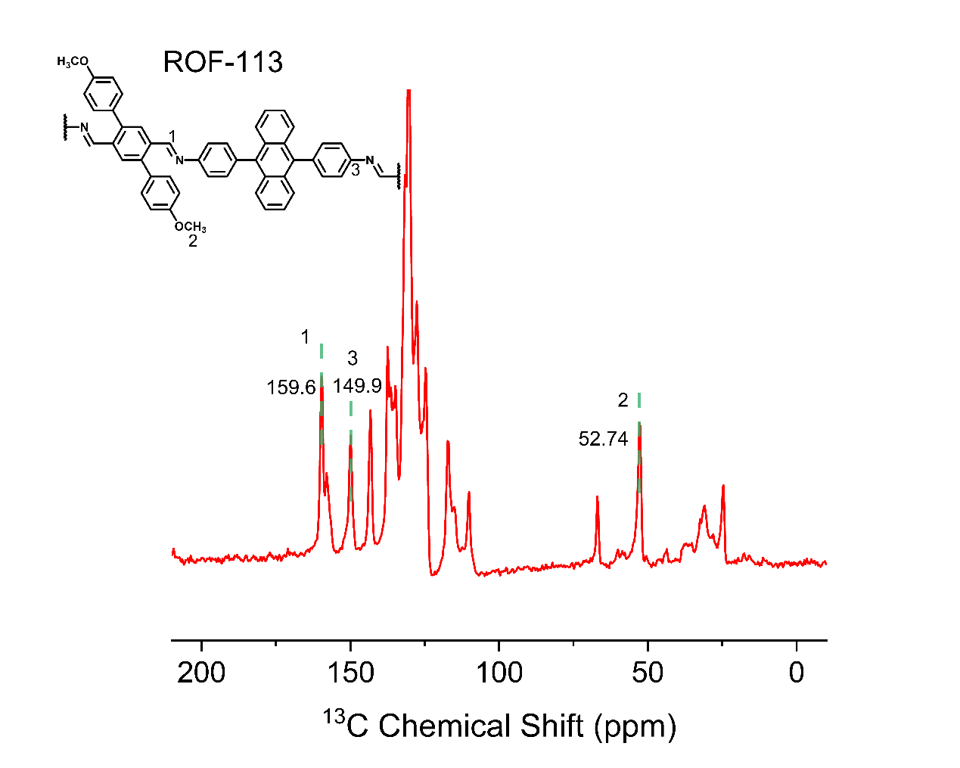
Supplementary Figure 28. ¹³C CP-MAS NMR of ROF-113. The spectrum exhibited the corresponding imine peak at 159.6ppm.

Supplementary Figure 29. PXRD patterns of ROF-113 obtained from standard synthesis (blue), after 50 bar pressure (black), and scalable synthesis (red).

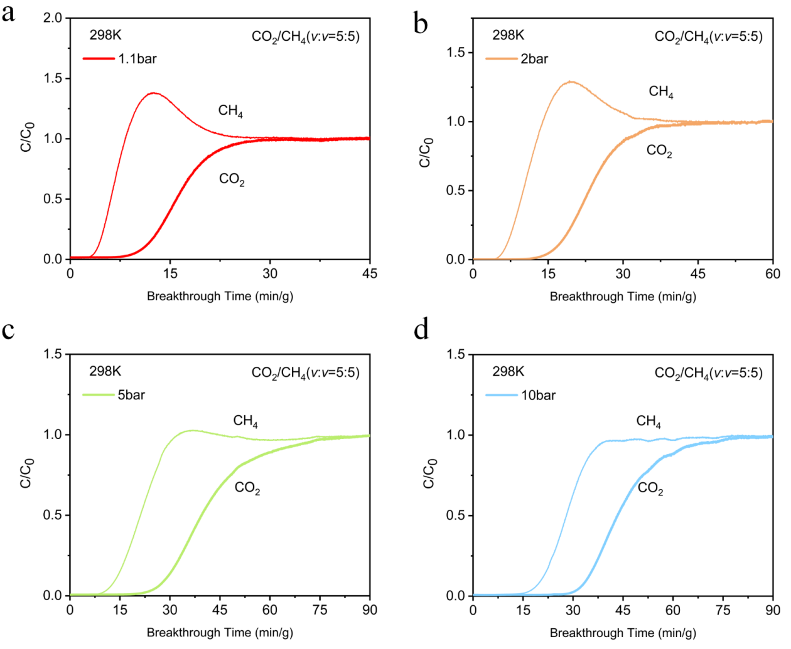

Supplementary Figure 30. Dynamic CO₂/CH₄ adsorption breakthrough curve of ROF-113 at 298K at a flow rate of 3mL min⁻¹ under various pressures. C₀ is the inlet concentration, C is the outlet concentration.

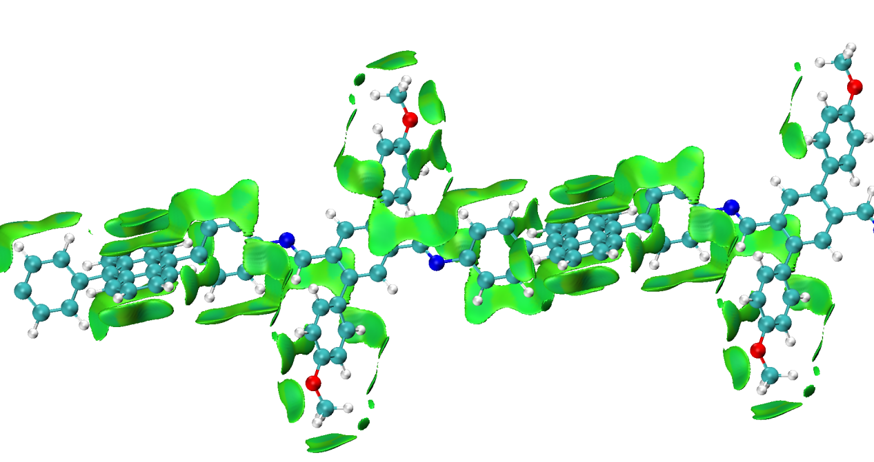
Supplementary Figure 31. Sign($δ_{2}$)$ρ$ colored isosurfaces of $δg$-inter = 0.005 a.u. of interactions via IGMH method for ROF-113.

Supplementary Figure 32. CO₂ and CH₄ sorption isotherms of ROF-113 at 298K.

Table 4. The number of structures generated for different molecular systems using different generation method and different parameters.

Parameters | ROF-102 | ROF-105 | ROF-113 | ROF-203 | ROF-201 | ROF-204
1 direction, 1 chain per direction | 5000 | 5000 | 5000
1 direction, 2 chains per direction | 20000 | 20000 | 20000
2 directions, 1 chain per direction | 5000 | 5000 | 5000
2 directions, 2 chains per direction | 5000 | 5000 | 5000
3 directions in a 2d plane, 1 chain per direction | 5000 | 5000 | 5000
3 directions in 3d space, 1 chain per direction | 5000 | 5000 | 5000
Space group in:  14, 2, 19, 4, 33, 9, 1, 5, 29, 7 |  |  |  | 30000 | 30000 | 30000
Total number | 45000 | 45000 | 45000 | 30000 | 30000 | 30000

Supplementary Figure 33. CSP energy landscape of ROF-113 evaluated using a machine-learning interatomic potential. Structures are colored according to their axial dimensionality.

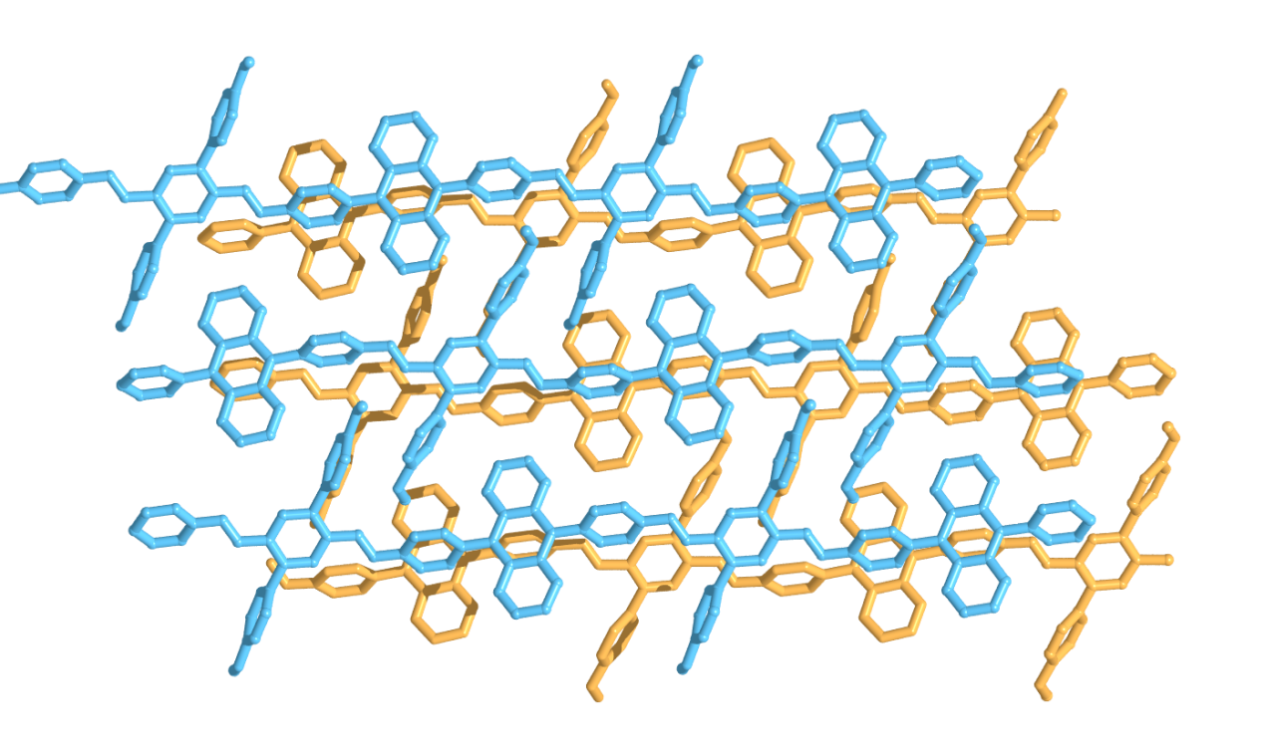
Supplementary Figure 34. Global minimum-energy structure of ROF-113 predicted by CSP.

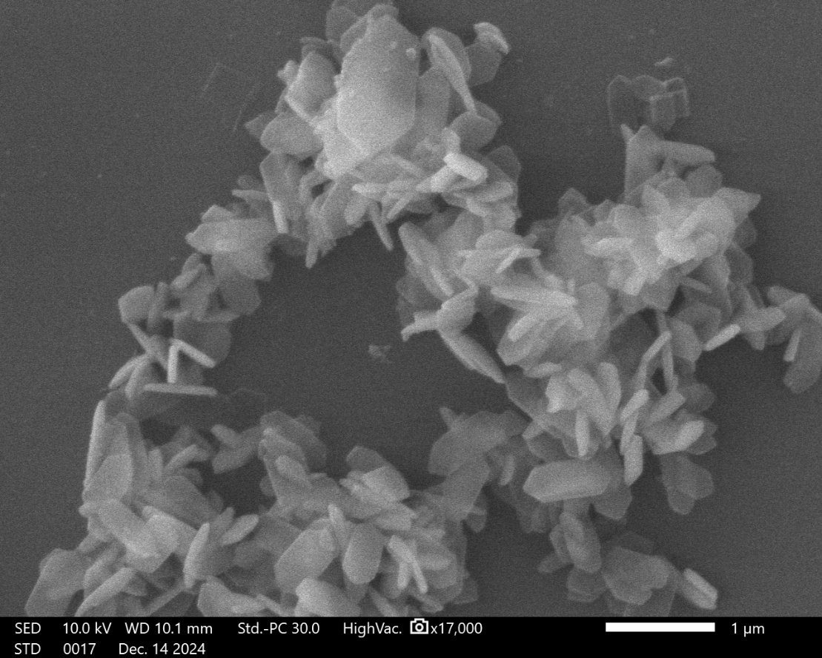
Supplementary Figure 35. SEM image of ROF-201.

Supplementary Figure 36. Pawley refinement of ROF-201.

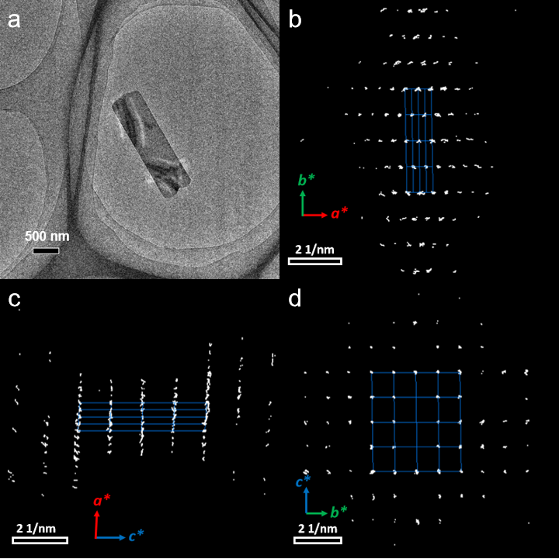
Supplementary Figure 37. (a)Low-mag TEM image of one ROF-201 crystal. Projections of 3D ED data of ROF-201 along (b) [001], (c) [010] and (d) [100] directions.

Table 5. The refinement statistics of sample ROF-201
Sample name | ROF-201
CCDC Deposit No. | 2539307
Chemical formula | C₁₇H₁₂N
Temperature | 293(2) K
Crystal system | monoclinic
Space group | C2/c
Cell parameters | a = 37.850 Å, b = 9.542 Å, c = 8.402 Å, α = 90°, β = 93.29°, γ = 90°
Cell volume | 3029.6 Å³
Diffractometer | JEOL JEM-2100P transmission electron microscope
Radiation | Electron (λ = 0.02508 Å)
Data reduction | XDS
Reflections collected | 1958
Completeness | 0.577
Max indices | (26, 8, 7)
Min indices | (-25, -8, -7)
I/Sigma | 7.9 to 1.06 Å
Solution method | Intrinsic Phasing using SHELXT
Refinement method | Least Square using SHELXL
Unique reflections | 754
R1 | 0.2038
wR₂ | 0.5399
R_{int} | 0.0956
GooF | 1.458

Supplementary Figure 38. N₂ sorption isotherms of ROF-201 at 77K.

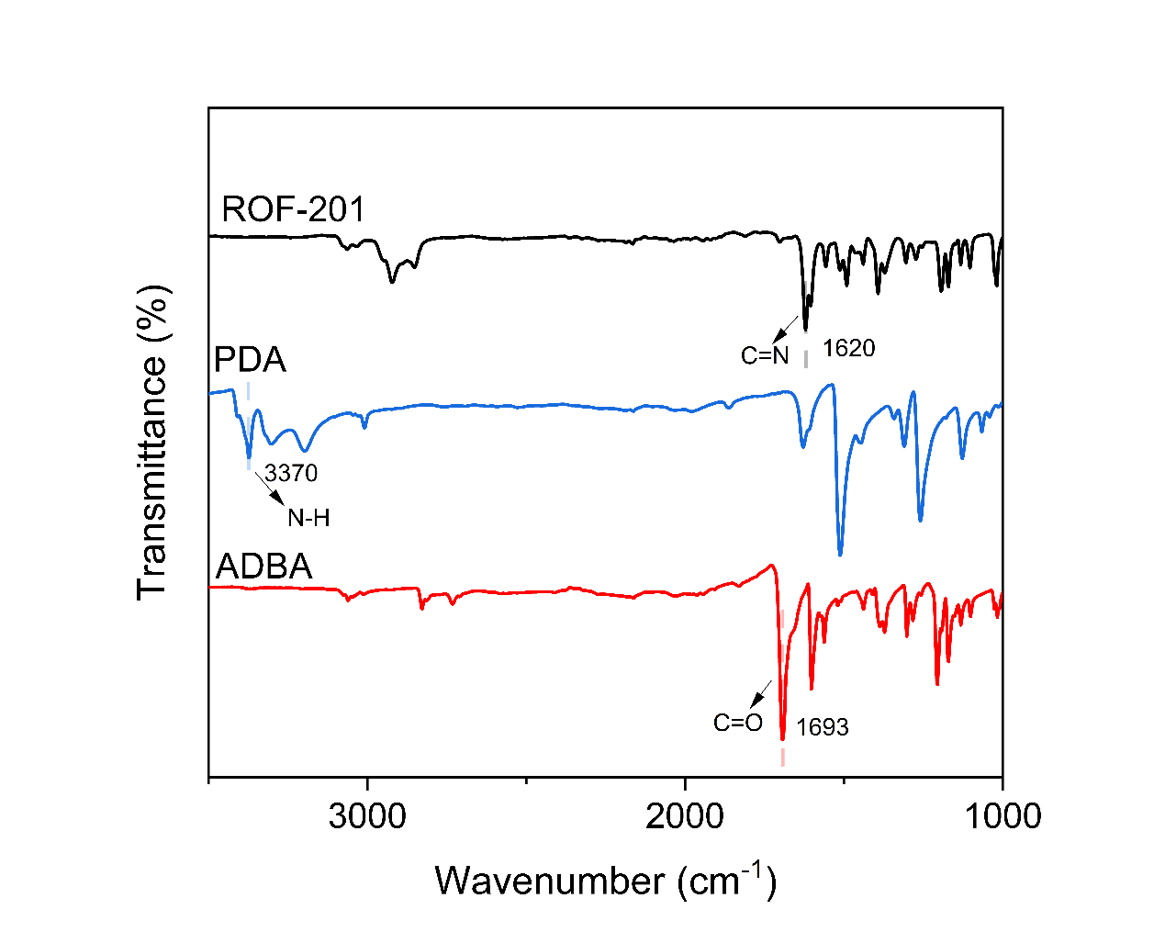
Supplementary Figure 39. The FT-IR spectrum of the starting materials, PDA and ADBA, and the products, ROF-201. The -C=N- stretching vibration at 1620 cm⁻¹ indicated the formation of imine linkages.

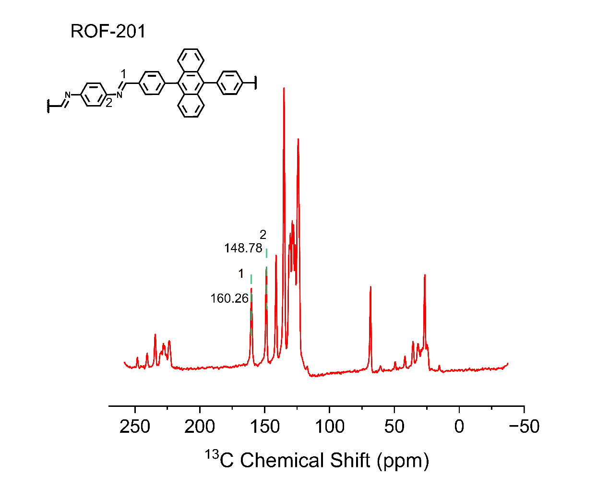
Supplementary Figure 40. ¹³C CP-MAS NMR of ROF-201.
The spectrum exhibited the corresponding imine peak at 160.26 ppm.

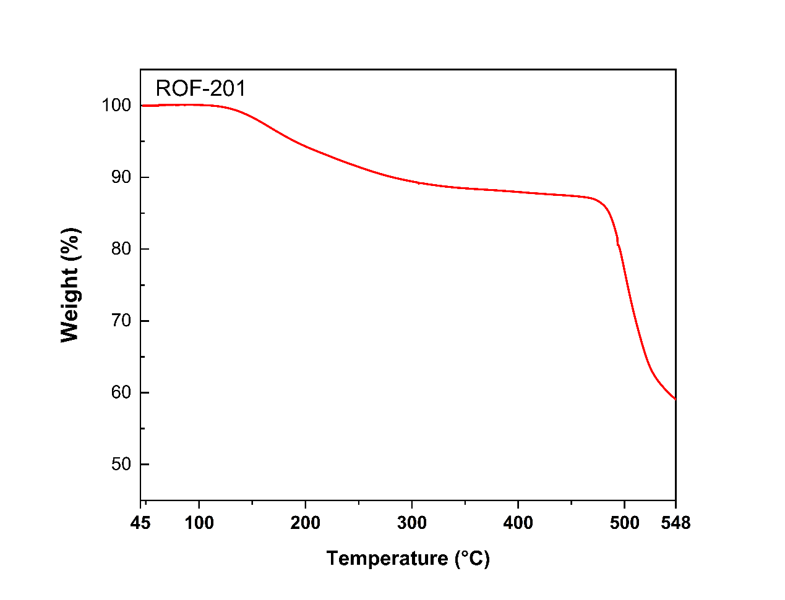
Supplementary Figure 41. The TGA profile of ROF-201.

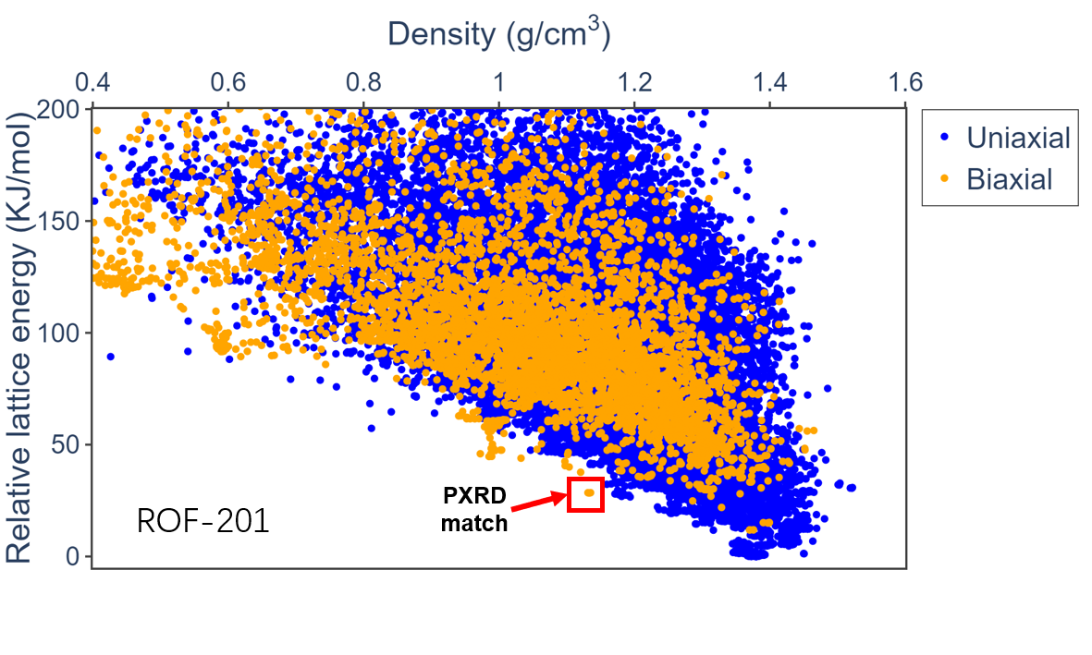
Supplementary Figure 42. CSP energy landscape of ROF-201 evaluated using a machine-learning interatomic potential. Structures are colored according to their axial dimensionality.

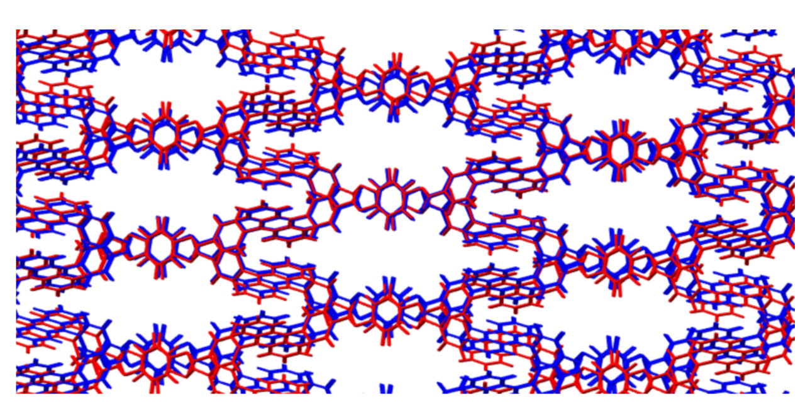
Supplementary Figure 43. Overlays of predicted and experimental structures for system ROF-201.

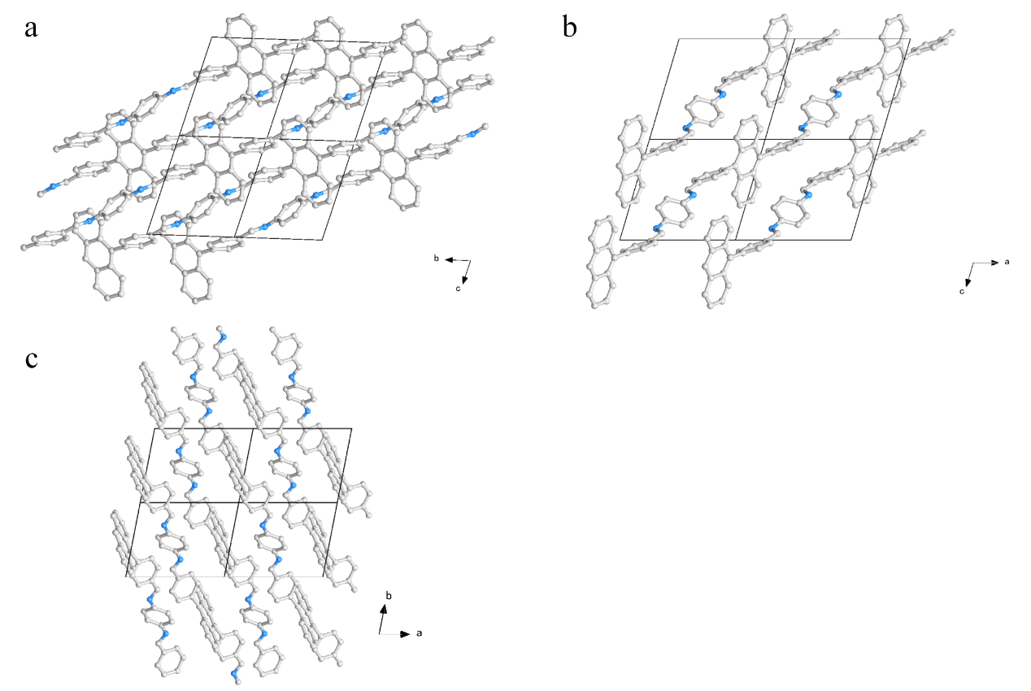
Supplementary Figure 44. Global minimal structure from CSP of ROF-201 viewed from a-axis (a), b-axis (b) and c-axis (c).

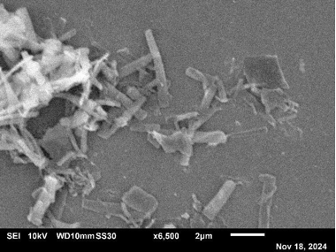
Supplementary Figure 45. SEM image of ROF-204.

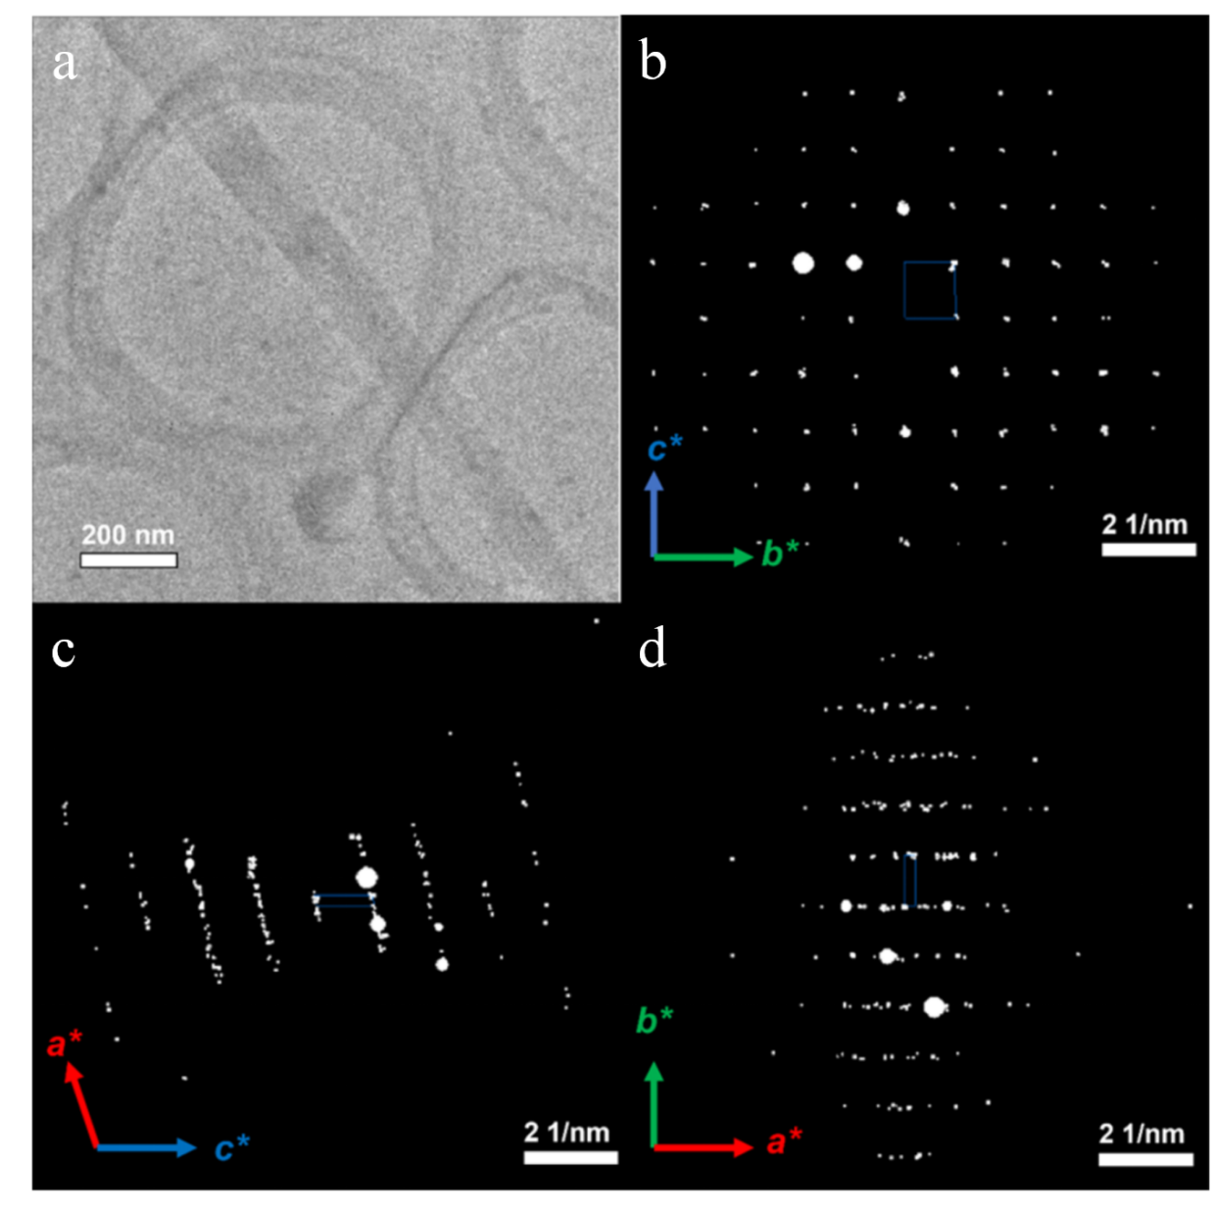
Supplementary Figure 46. (a)Low-mag TEM image of one ROF-204 crystal. Projections of 3D ED data of ROF-204 along (b) [100], (c) [010] and (d) [001] directions.

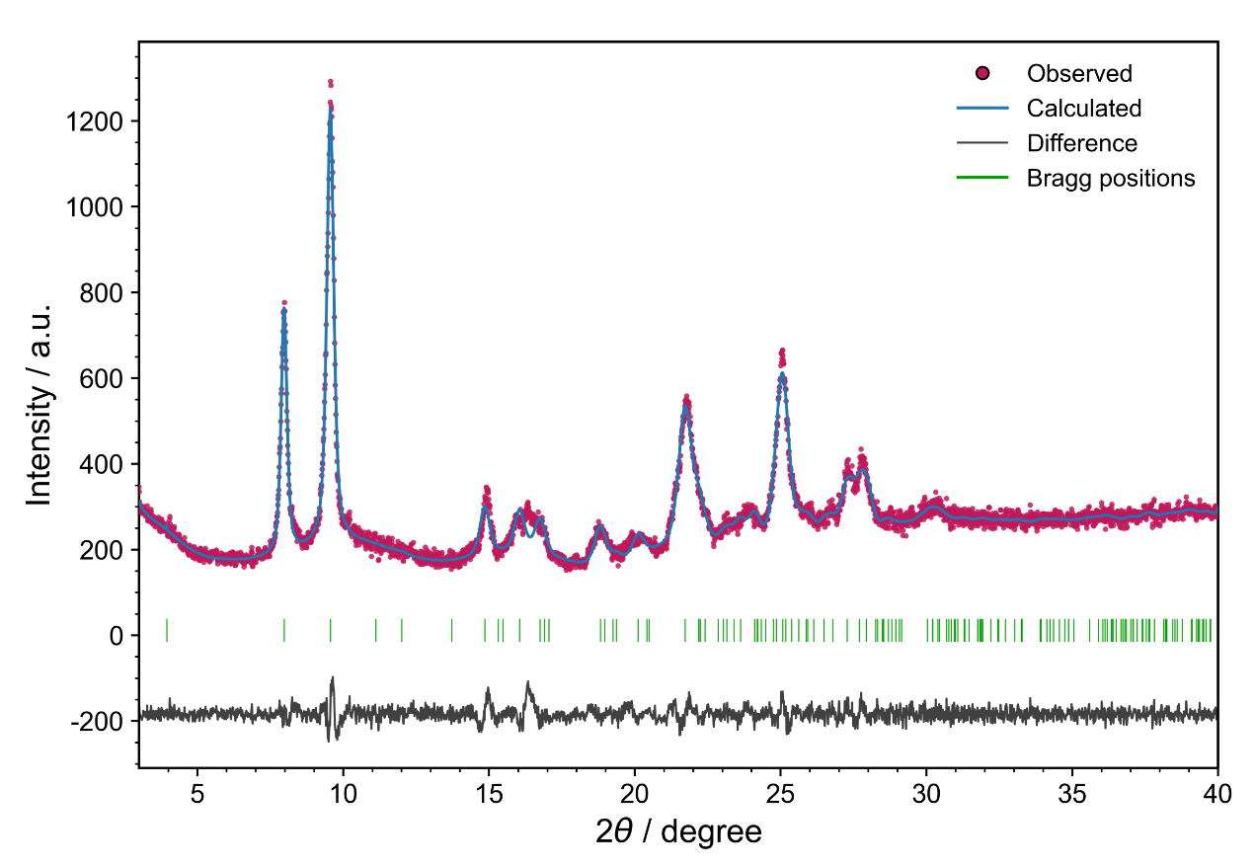
Supplementary Figure 47. PXRD profile matching of ROF-204. Comparison between the experimentally measured powder X-ray diffraction pattern of ROF-204 and the calculated pattern derived from the structure predicted by our 1D-CSP workflow. The magenta points, blue line, black line, and green ticks represent the observed pattern, calculated pattern, difference curve, and Bragg reflection positions, respectively.

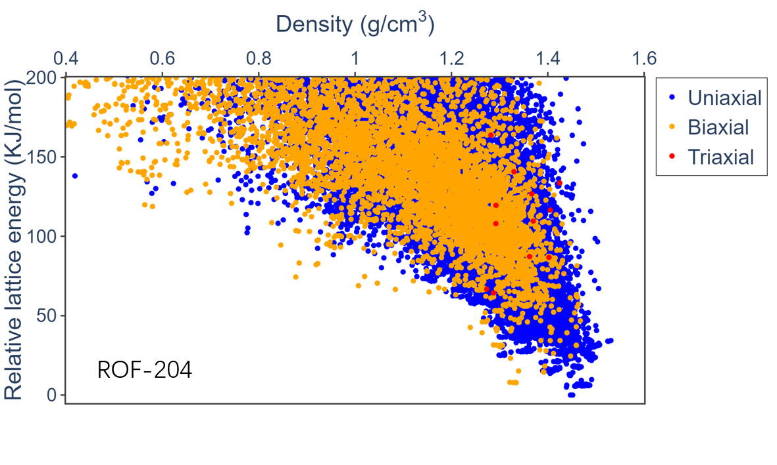
Supplementary Figure 48. CSP energy landscape of ROF-204 evaluated using a machine-learning interatomic potential. Structures are colored according to their axial dimensionality.

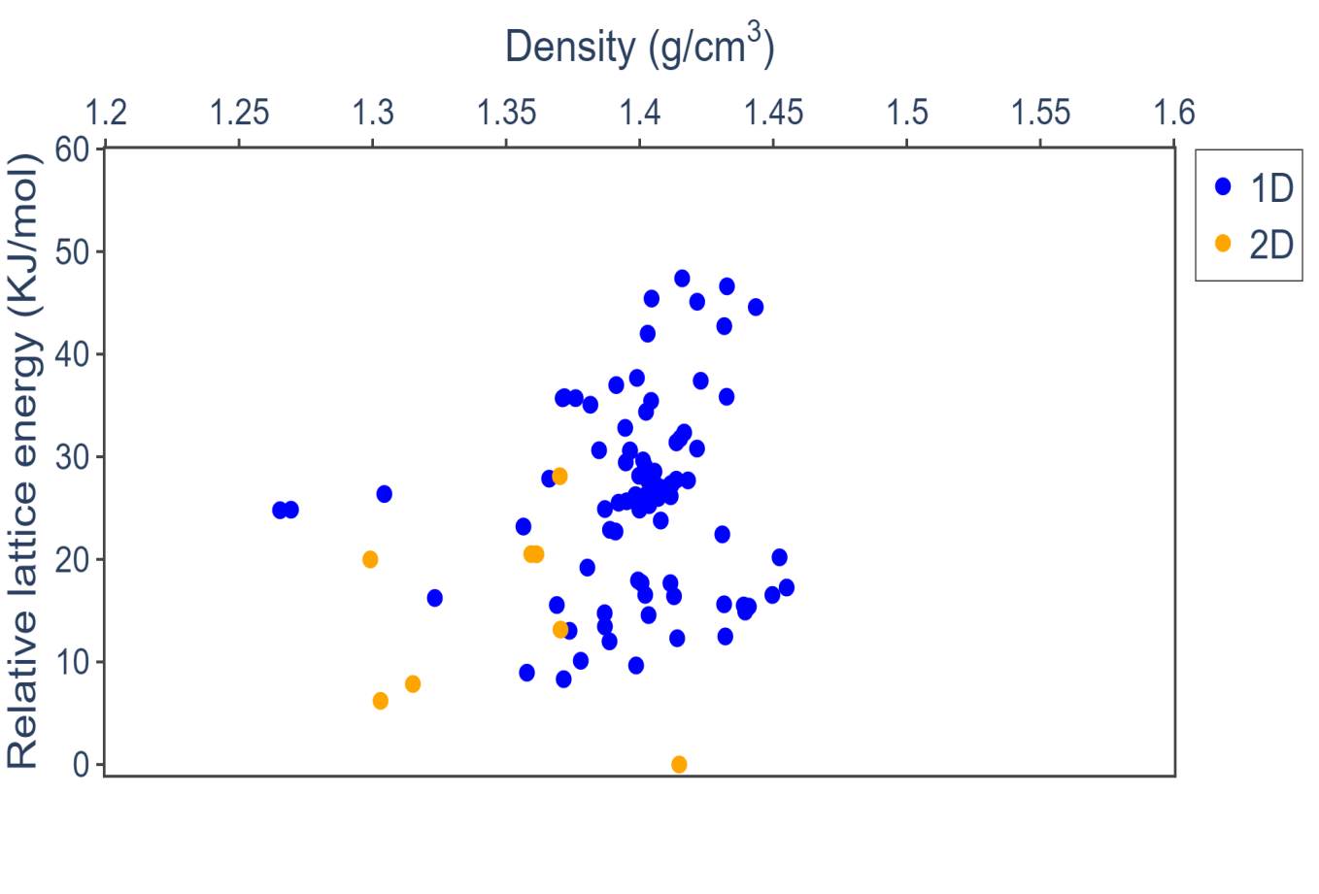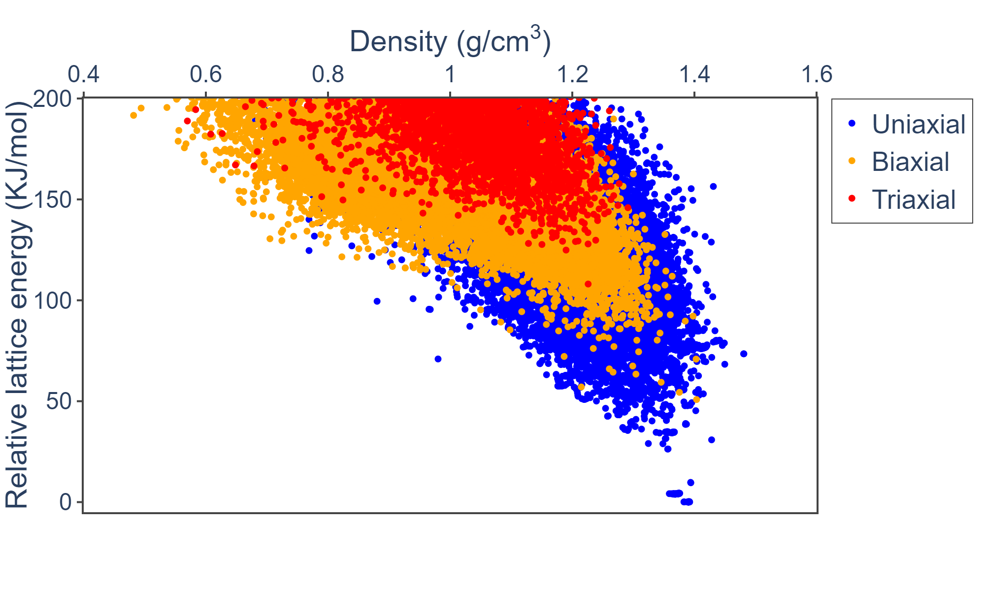
ROF-204
PXRD
match
Supplementary Figure 49. Energy landscape of the selected low-energy structures after DFT re-optimization for system ROF-204, with structures colored according to their axial dimensionality.
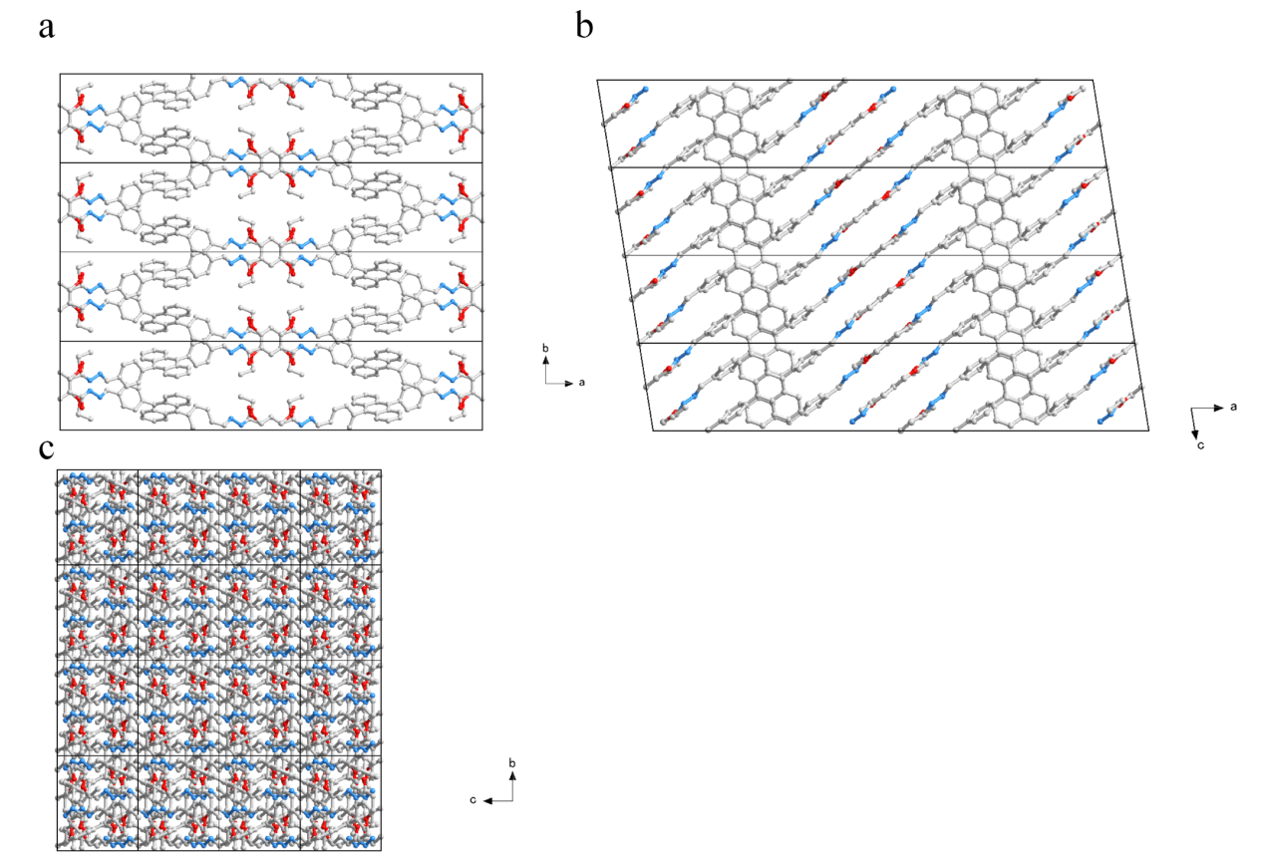

Supplementary Figure 50. Crystallographic structure of ROF-204 viewed from c-axis (a) ,b-axis (b) and a-axis (c).

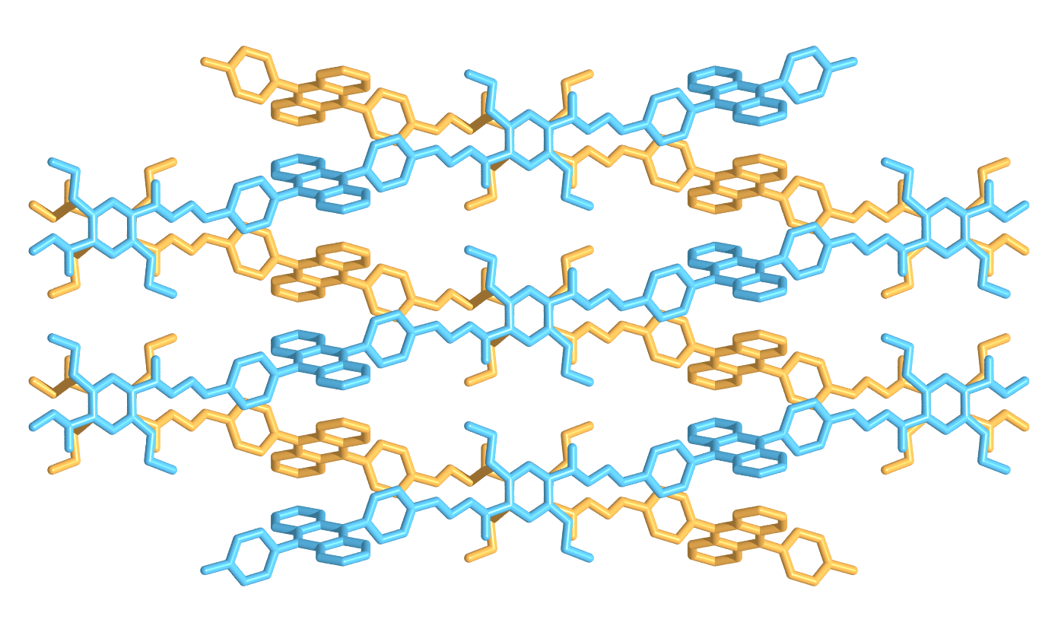
Supplementary Figure 51. Crystallographic structure of ROF-204.

Table 6. The refinement statistics of sample ROF-204

Sample name | ROF-204
CCDC Deposit No. | 2547691
Chemical formula | C₂₀H₁₆N₂O₂
Temperature | 293(2) K
Crystal system | monoclinic
Space group | C2/c
Cell parameters | a = 44.851 Å, b = 9.351 Å, c = 8.038 Å, α = 90°, β = 80.94°, γ = 90°
Cell volume | 3329.1 Å³
Diffractometer | JEOL JEM-2100P transmission electron microscope
Radiation | Electron (λ = 0.02508 Å)
Data reduction | XDS
Reflections collected | 3051
Completeness | 0.701
Max indices | (41, 9, 7)
Min indices | (-42, -9, -7)
I/Sigma | 3.2 to 1.00 Å
Solution method | Intrinsic Phasing using SHELXT
Refinement method | Least Square using SHELXL
Unique reflections | 1222
R1 | 0.1913
wR₂ | 0.5996
R_{int} | 0.2833
GooF | 0.955

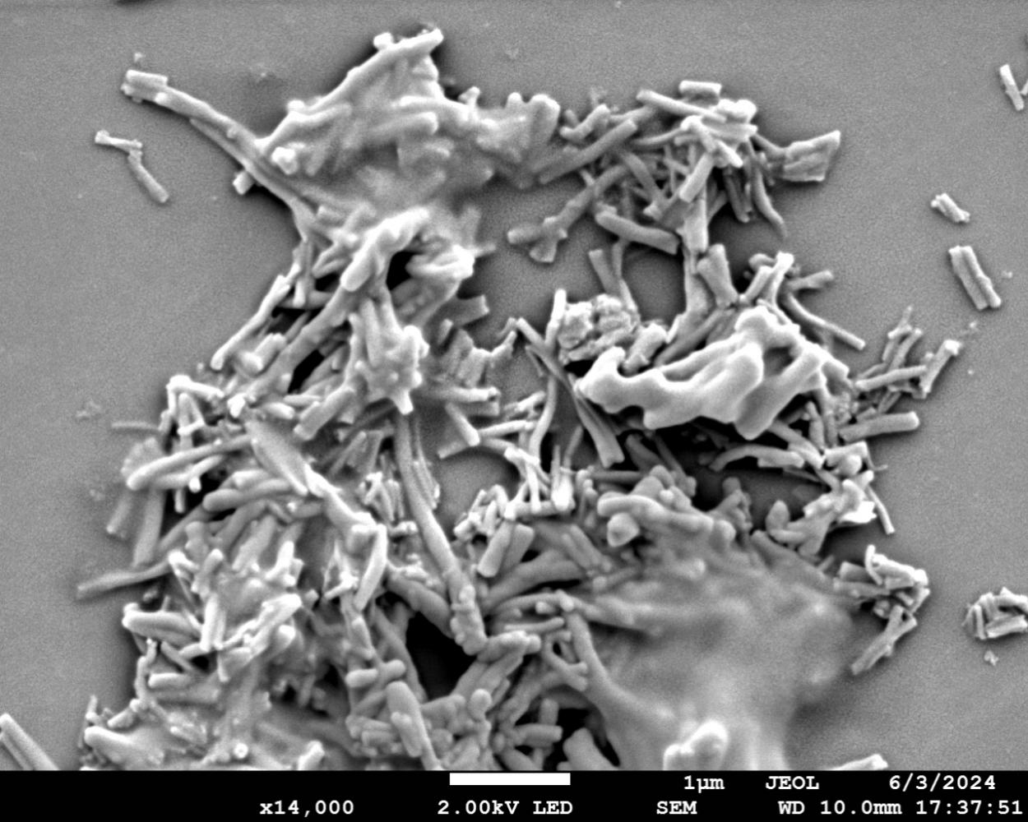
Supplementary Figure 52. SEM image of ROF-203.

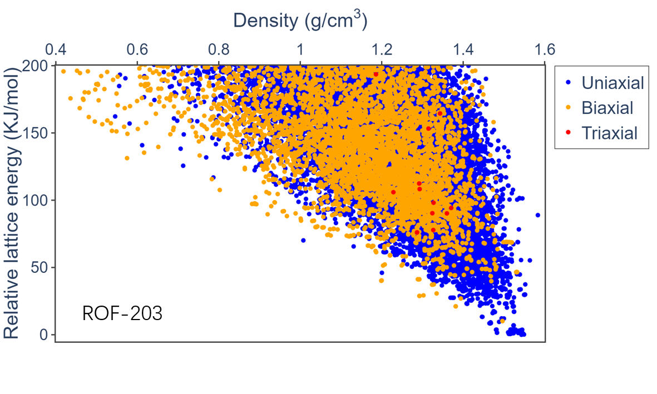
Supplementary Figure 53. CSP energy landscape of ROF-203 evaluated using a machine-learning interatomic potential. Structures are colored according to their axial dimensionality.

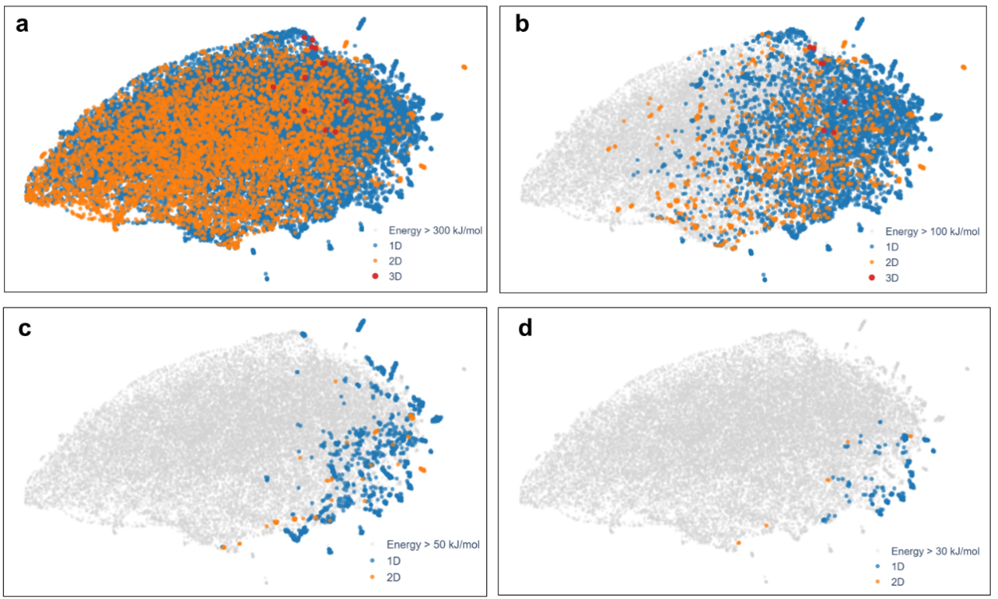
Supplementary Figure 54. UMAP projection of the crystal structure prediction (CSP) results for ROF-203 based on SOAP descriptor. Panels show the distributions of structures with relative energies below (a) 300, (b) 100, (c) 50, and (d) 30 kJ mol⁻¹, respectively. In each panel, structures with energies above the corresponding threshold are shown as grey points. Colored points denote structures below the threshold and are classified according to the number of crystallographic directions along which one-dimensional polymer chains propagate.

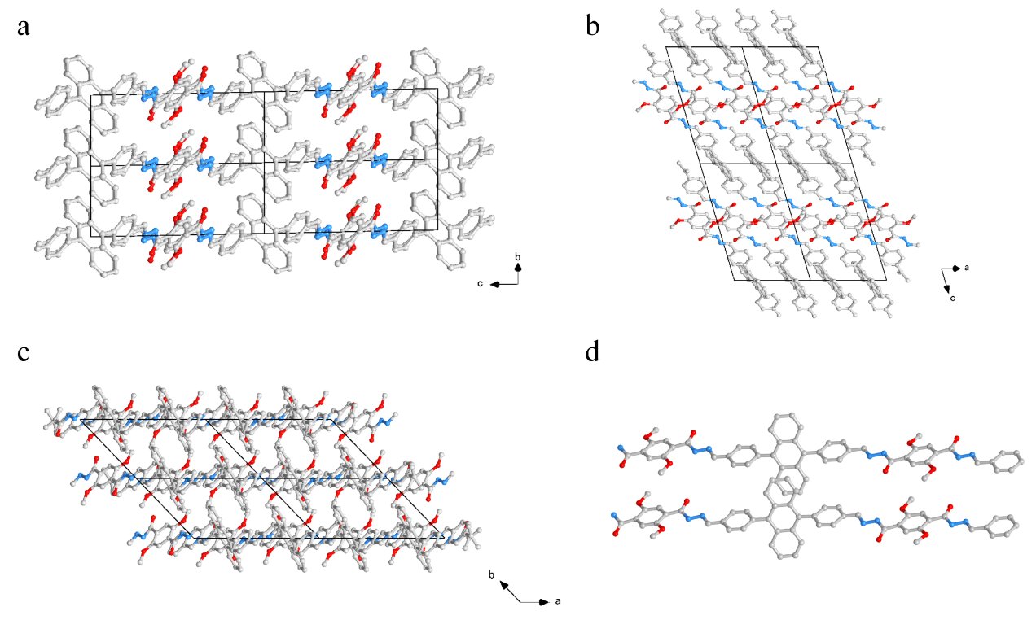
Supplementary Figure 55. Global minimal structure from CSP of ROF-203 viewed from a-axis (a) ,b-axis (b) and c-axis (c).

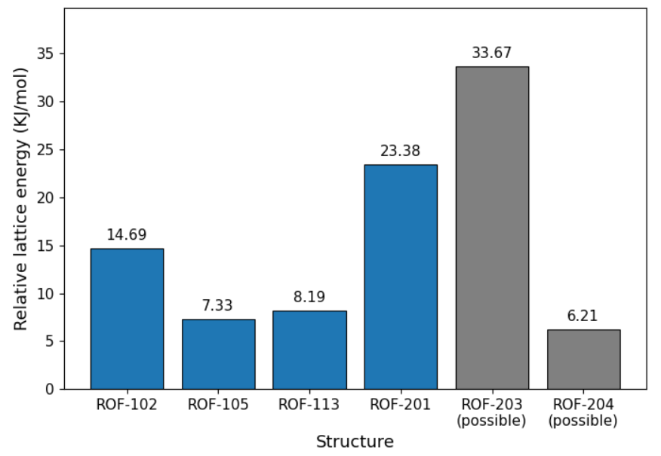
Supplementary Figure 56. DFT-level relative lattice energies of the obtained ROF structures. The energy differences are given relative to the global minimum structure at the DFT level. The structures of ROF-203 and ROF-204 were obtained from the 1D-CSP results through comparison with the experimental PXRD patterns, whereas the remaining structures correspond to experimentally determined crystal structures.

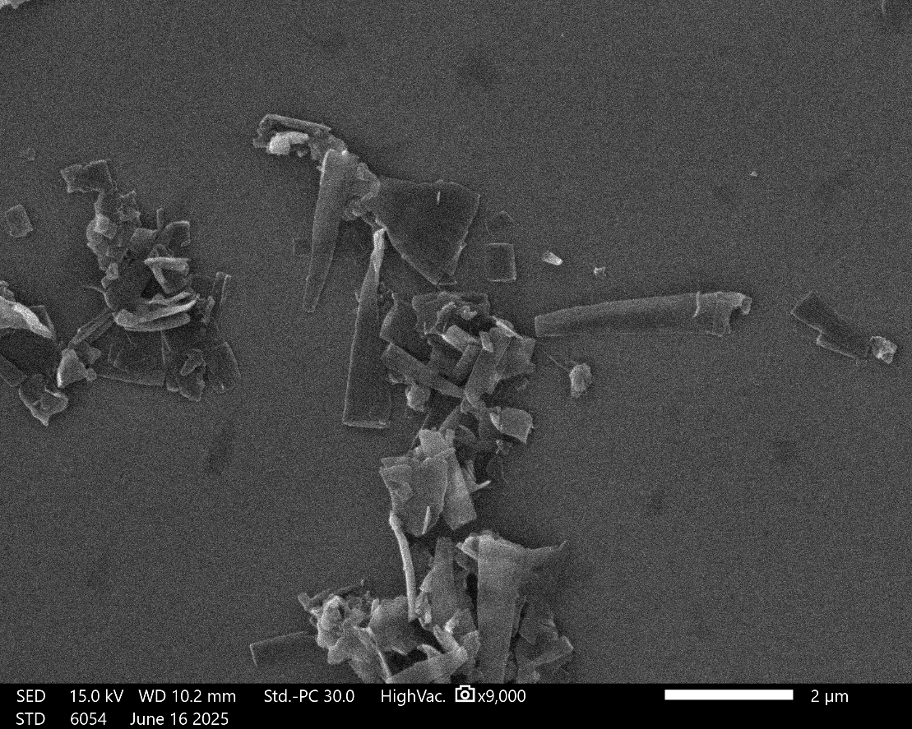
Supplementary Figure 57. SEM image of ROF-211.

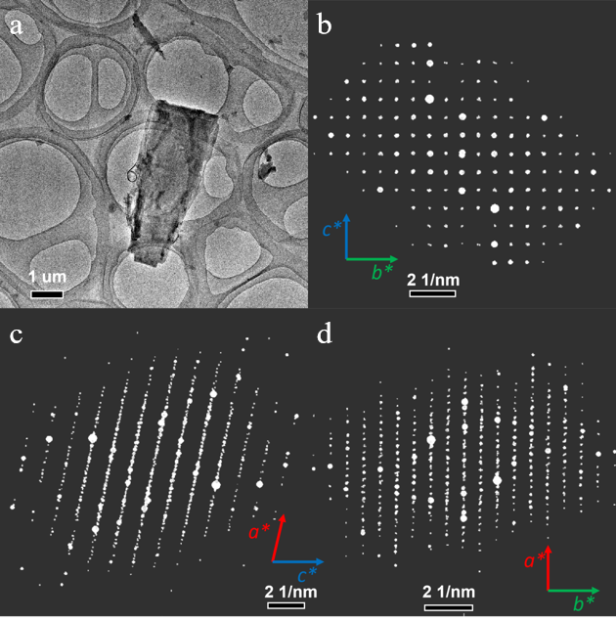
Supplementary Figure 58. (a)Low-mag TEM image of one ROF-211 crystal. Projections of 3D ED data of ROF-211 along (b) [100], (c) [010] and (d) [001] directions.

Table 7. The refinement statistics of sample ROF-211
Sample name | ROF-211
CCDC Deposit No. | 2539308
Chemical formula | C₂₁H₁₈N₂O₃
Temperature | 293(2) K
Crystal system | monoclinic
Space group | C2/c
Cell parameters | a = 45.873 Å, b = 9.430 Å, c = 8.342 Å, α = 90°, β = 98.44°, γ = 90°
Cell volume | 3569.6 Å³
Diffractometer | JEOL JEM-2100P transmission electron microscope
Radiation | Electron (λ = 0.02508 Å)
Data reduction | XDS
Reflections collected | 3517
Completeness | 0.772
Max indices | (43, 9, 8)
Min indices | (-43, -9, -8)
I/Sigma | 6.6 to 1.00 Å
Solution method | Intrinsic Phasing using SHELXT
Refinement method | Least Square using SHELXL
Unique reflections | 1469
R1 | 0.2551
wR₂ | 0.6093
R_{int} | 0.1297
GooF | 1.359

Supplementary Figure 59. Pawley refinement of ROF-211.

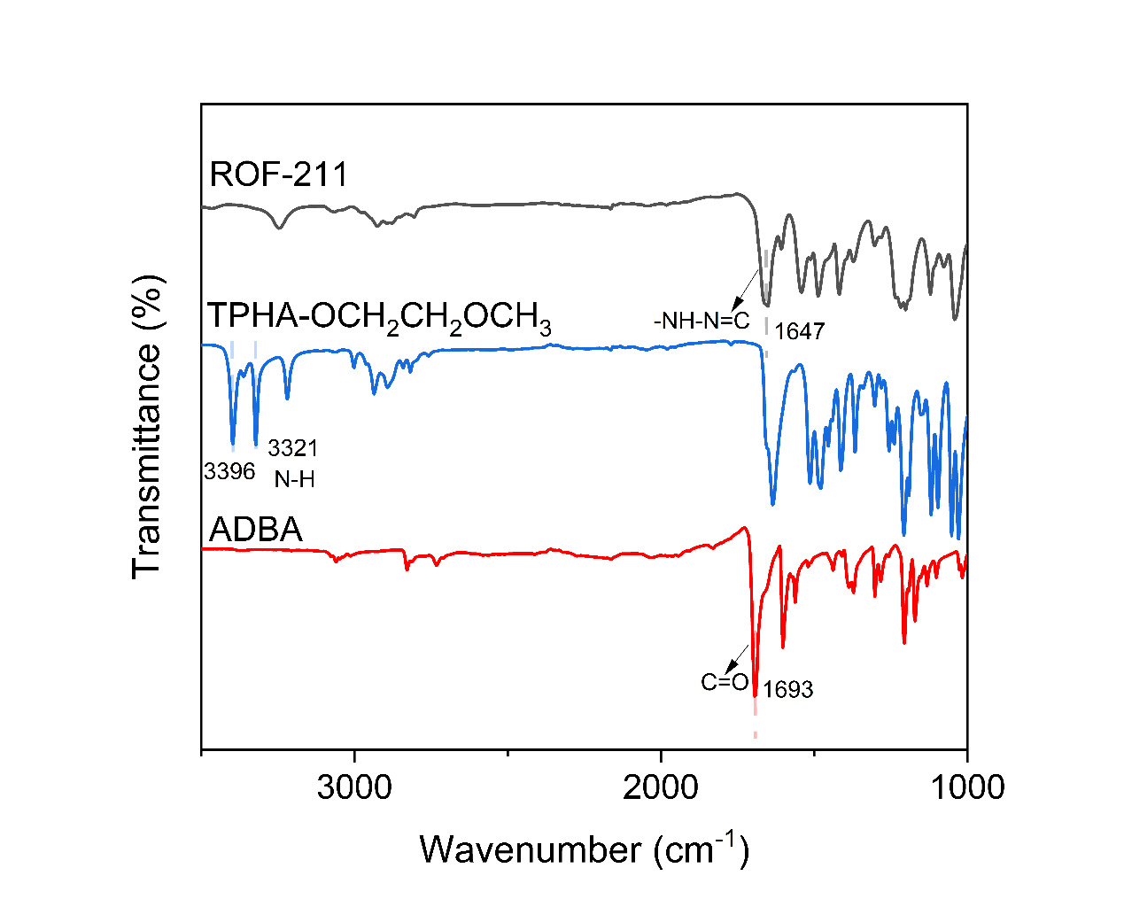
Supplementary Figure 60. The FT-IR spectrum of the starting materials, TPHA-OCH₂CH₂OCH₃ and ADBA, and the products, ROF-211. The -C=N-NH- stretching vibration at 1647 cm⁻¹ indicated the formation of hydrazone linkages.

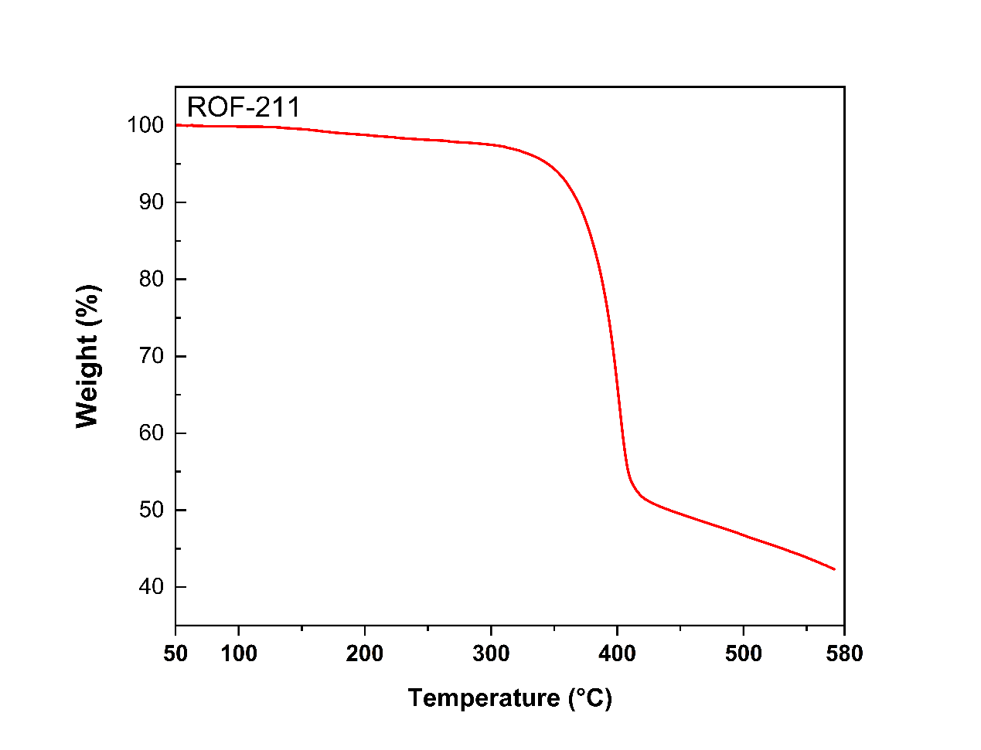
Supplementary Figure 61. The TGA profile of ROF-211.

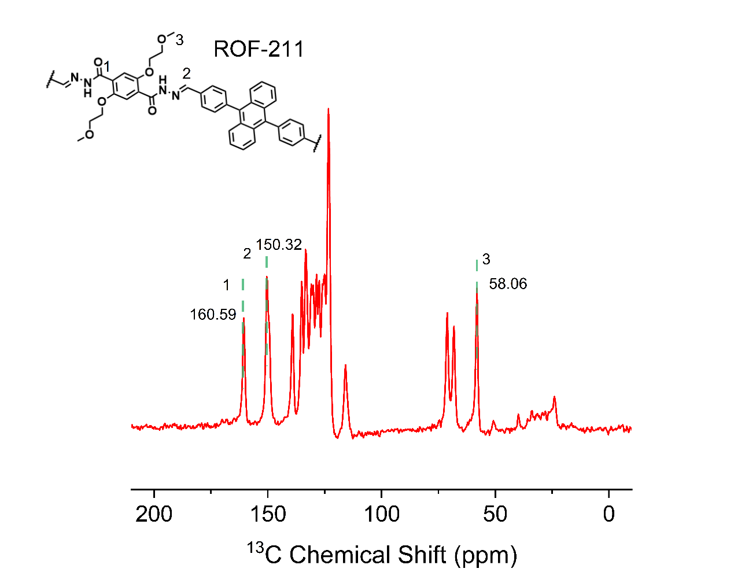
Supplementary Figure 62. ¹³C CP-MAS NMR of ROF-211.
The spectrum exhibited the corresponding hydrazone peak at 150.32 ppm and carbonyl peak at 160.59 ppm.

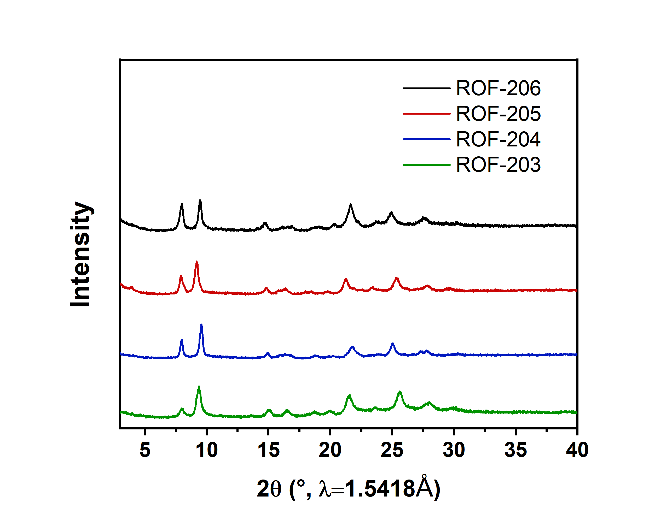
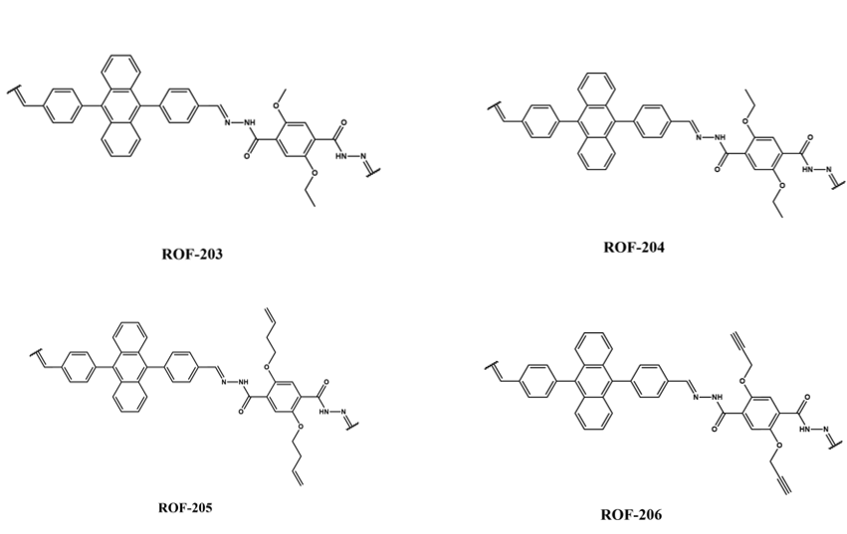

Supplementary Figure 63. PXRD patterns and structures of ROF-203, ROF-204, ROF-205, ROF-206.

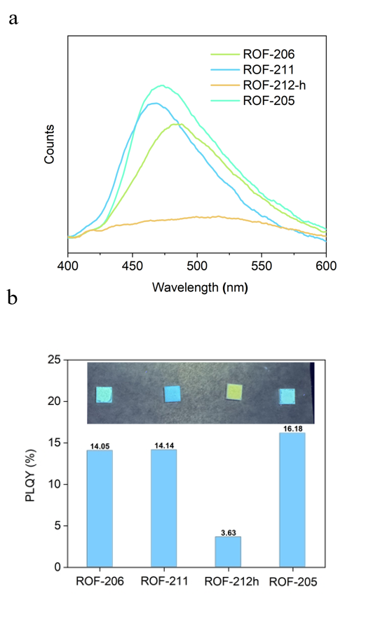
Supplementary Figure 64. (a) Fluorescence spectra, (b) PLQY and optic image of ROF-206, ROF-211, ROF-212h, ROF-205.
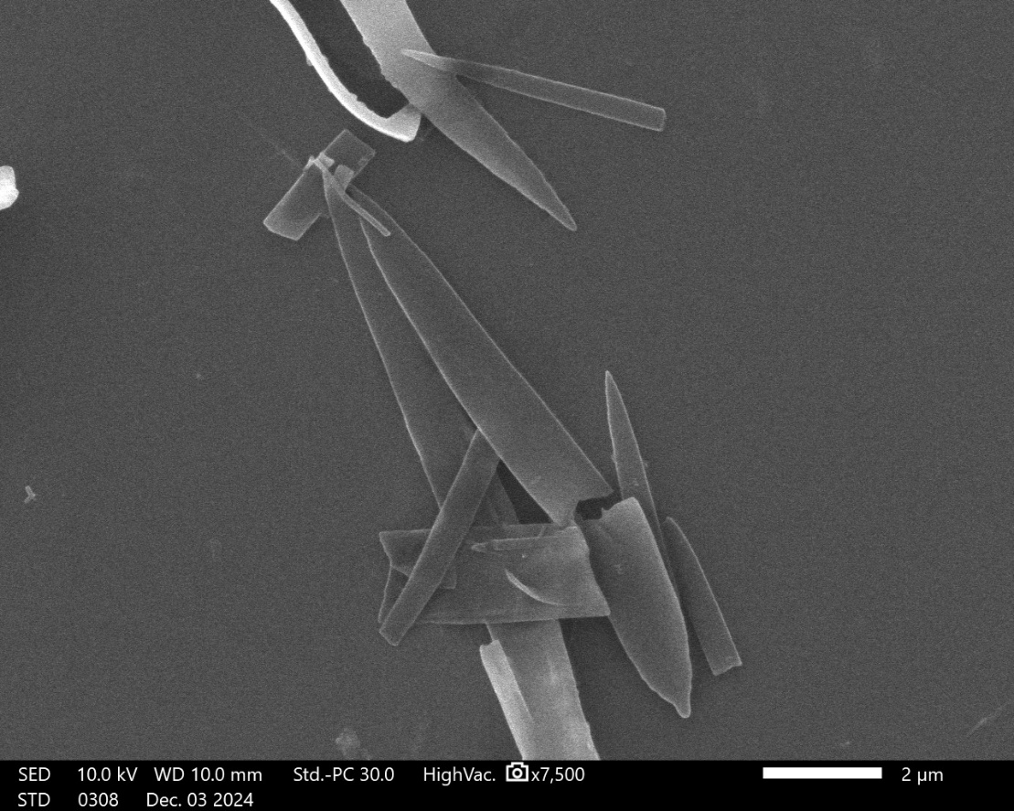
Supplementary Figure 65. SEM image of ROF-212.

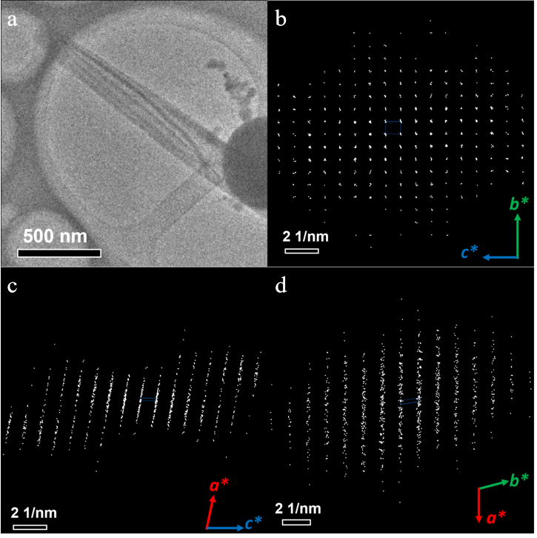
Supplementary Figure 66. (a) Low-mag TEM image of one ROF-212-h crystal. Projections of 3D ED data of ROF-212-h along (b) [100], (c) [010] and (d) [001] directions.

Table 8. The refinement statistics of sample ROF-212-h

Sample name | ROF-212-h
CCDC Deposit No. | 2540426
Chemical formula | C₂₁H₂₀N₂O₄
Temperature | 100 K
Crystal system | monoclinic
Space group | C2/c
Cell parameters | a = 45.095 Å, b = 9.721 Å, c = 8.046 Å, α = 90°, β = 99.59°, γ = 90°
Cell volume | 3477.9 Å³
Diffractometer | F200 Transmission electron microscope
Radiation | Electron (λ = 0.02508 Å)
Data reduction | XDS
Reflections collected | 7702
Completeness | 0.694
Max indices | (44, 12, 10)
Min indices | (-44, -12, -10)
I/Sigma | 7.3 to 0.8 Å
Solution method | Intrinsic Phasing using SHELXT
Refinement method | Least Square using SHELXL
Unique reflections | 2429
R1 | 0.2949
wR₂ | 0.6326
R_{int} | 0.1620
GooF | 2.274

Supplementary Figure 67. Pawley refinement of ROF-212-h

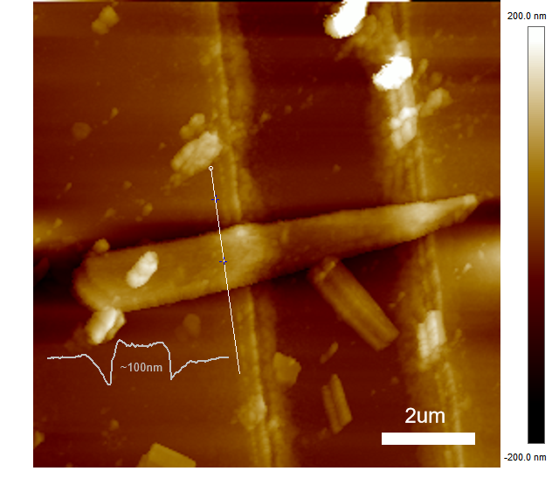
Supplementary Figure 68. The AFM image of ROF-212 single crystal on a proton conductivity testing device with the scale bar of 2 μm. The thickness of ROF-212 single crystal is estimated to be 100nm.The effective length of the single crystal was estimated to be 900 nm.

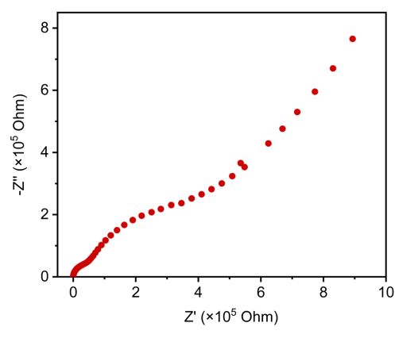
Supplementary Figure 69. Nyquist plots of ROF-212 through a proton conductivity testing device. The proton conductivity is determined to be 3.5E-4 S/cm.

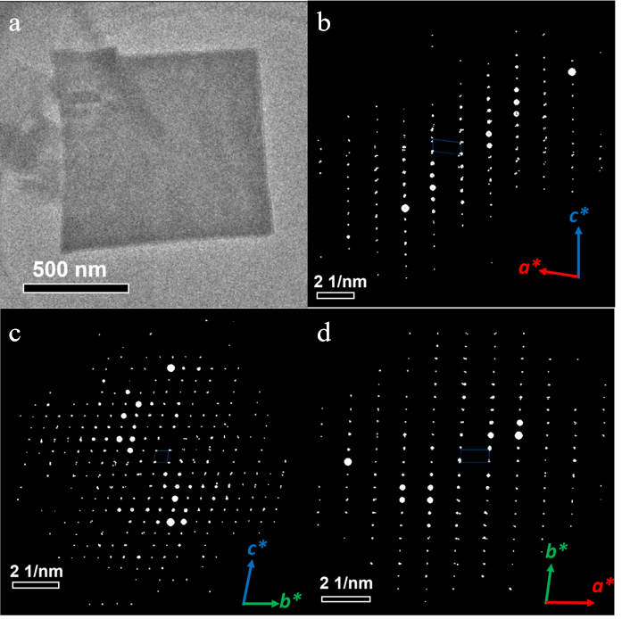
Supplementary Figure 70. (a)Low-mag TEM image of one ROF-212-v crystal. Projections of 3D ED data of ROF-212-v along (b) [010], (c) [100] and (d) [001] directions.

Table 9. The refinement statistics of sample ROF-212-v

Sample name | ROF-212-v
CCDC Deposit No. | 2543345
Chemical formula | C₈₄H₇₂N₈O₁₂
Temperature | 293.00 K
Crystal system | triclinic
Space group | P -1
Cell parameters | a = 9.055 Å, b = 19.797 Å, c = 21.625 Å, α = 100.41°, β = 96.92°, γ = 92.40°
Cell volume | 3776.7 Å³
Diffractometer | JEOL JEM-F200 Transmission electron microscope
Radiation | Electron (λ = 0.02508 Å)
Data reduction | XDS
Reflections collected | 9516
Completeness | 0.698
Max indices | (8, 17, 19)
Min indices | (-8, -17, -19)
I/Sigma | 4.1 to 1.10 Å
Solution method | Intrinsic Phasing using SHELXT
Refinement method | Least Square using SHELXL
Unique reflections | 4103
R1 | 0.2296
wR₂ | 0.5639
R_{int} | 0.1658
GooF | 1.616

Supplementary Figure 71. Pawley refinement of ROF-212-v.

Supplementary Figure 72. Water vapor adsorption isotherm of ROF-212 at 298K.

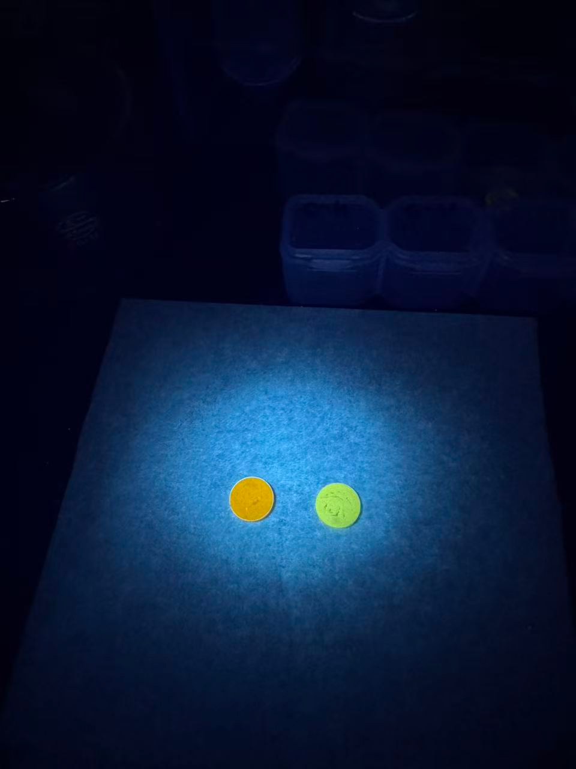

Supplementary Figure 73. Fluorescence spectra and optic image of ROF-212-v and ROF-212-h.

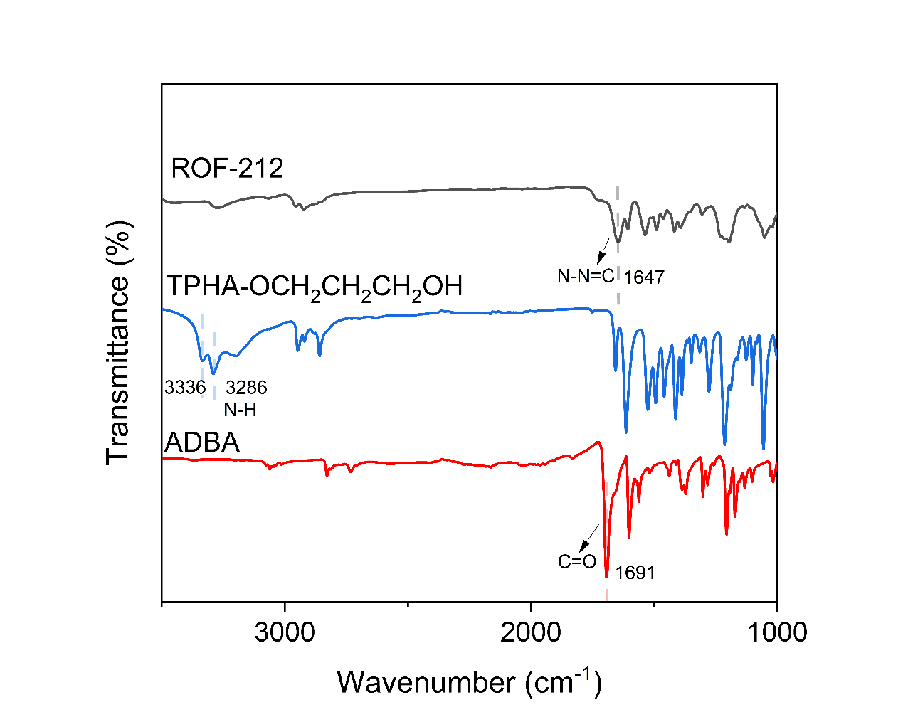
Supplementary Figure 74. The FT-IR spectrum of the starting materials, TPHA-OCH₂CH₂CH₂OH and ADBA, and the products, ROF-212. The -C=N-NH- stretching vibration at 1647 cm⁻¹ indicated the formation of hydrazone linkages.

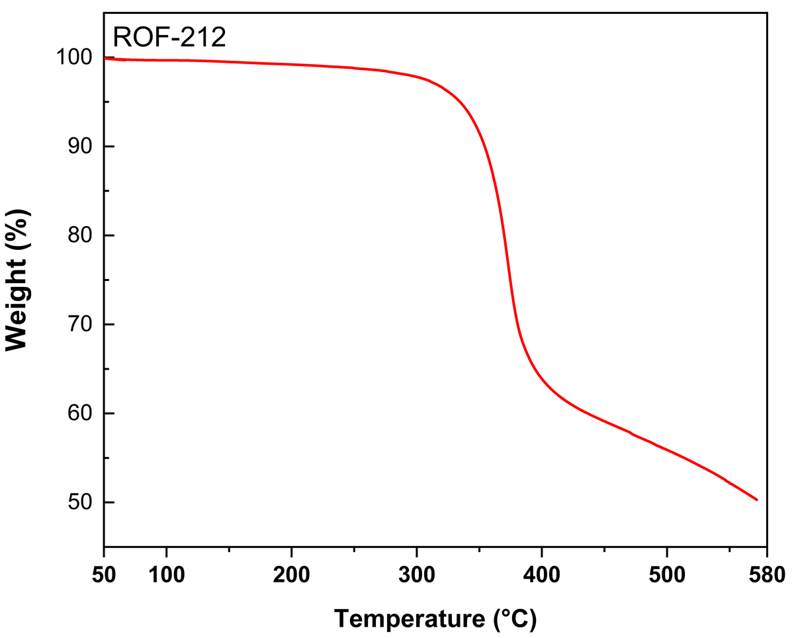
Supplementary Figure 75. The TGA profile of ROF-212.

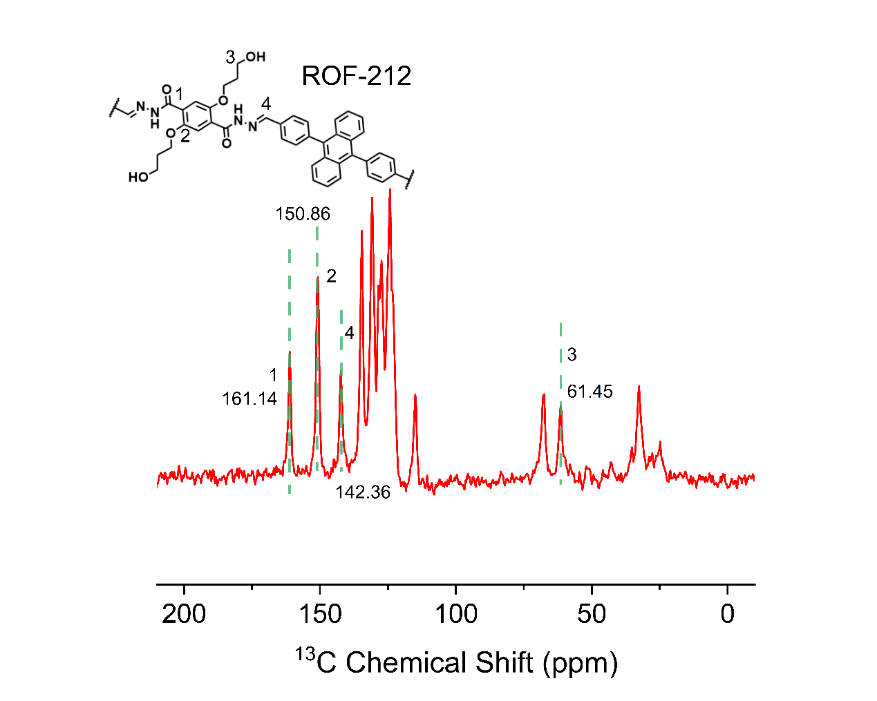
Supplementary Figure 76. ¹³C CP-MAS NMR of ROF-212.
The spectrum exhibited the corresponding hydrazone peak at 142.36 ppm and carbonyl peak at 161.14 ppm.

Supplementary Figure 77. SEM image of ROF-301.

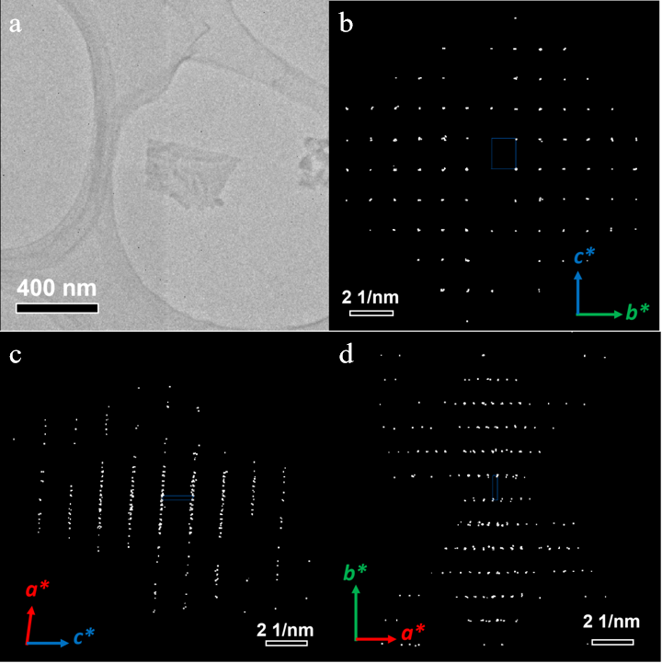
Supplementary Figure 78. (a)Low-mag TEM image of one ROF-301 crystal. Projections of 3D ED data of ROF-301 along (b) [100], (c) [010] and (d) [001] directions.

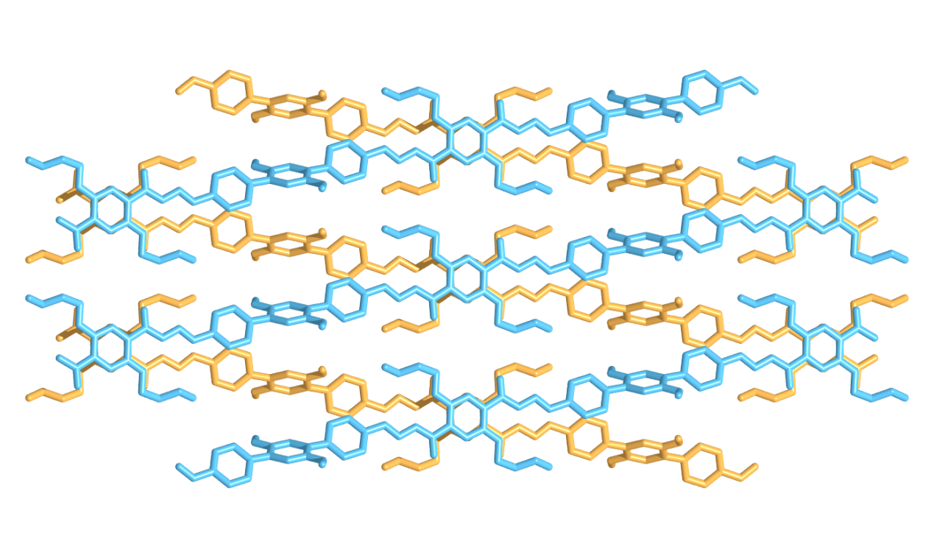
Supplementary Figure 79. Crystallographic structure of ROF-301.

Table 10. The refinement statistics of sample ROF-301

Sample name | ROF-301
CCDC Deposit No. | 2539874
Chemical formula | C₁₈H₁₈N₂O₄
Temperature | 293(5) K
Crystal system | monoclinic
Space group | C2/c
Cell parameters | a = 47.277 Å, b = 9.145 Å, c = 7.291 Å, α = 90°, β = 93.55°, γ = 90°
Cell volume | 3146.2 Å³
Diffractometer | F200 Transmission electron microscope
Radiation | Electron (λ = 0.02508 Å)
Data reduction | XDS
Reflections collected | 2271
Completeness | 0.666
Max indices | (37, 8, 6)
Min indices | (-34, -8, -6)
I/Sigma | 4.8 to 1.10 Å
Solution method | Intrinsic Phasing using SHELXT
Refinement method | Least Square using SHELXL
Unique reflections | 830
R1 | 0.1784
wR₂ | 0.5152
R_{int} | 0.2086
GooF | 1.506

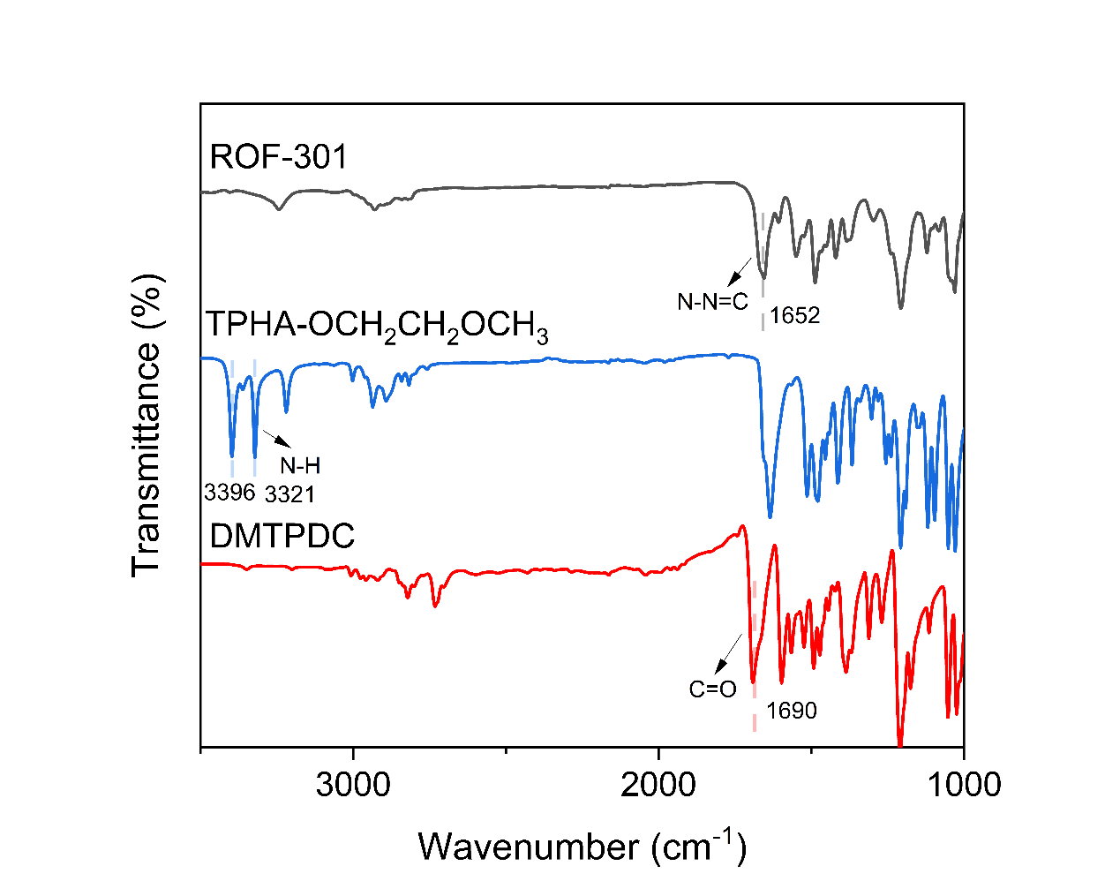
Supplementary Figure 80. The FT-IR spectrum of the starting materials, TPHA-OCH₂CH₂OCH₃ and DMTPDC, and the products, ROF-301. The -C=N-NH- stretching vibration at 1652 cm⁻¹ indicated the formation of hydrazone linkages.

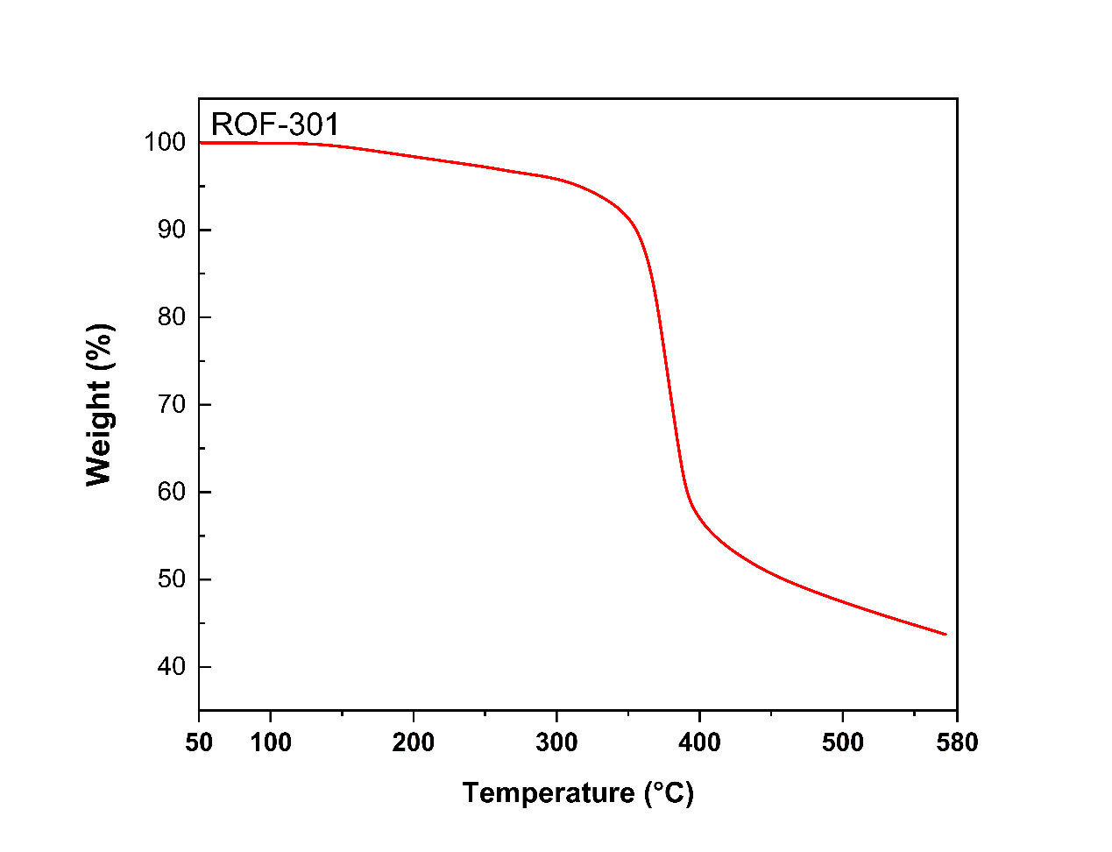
Supplementary Figure 81. The TGA profile of ROF-301.

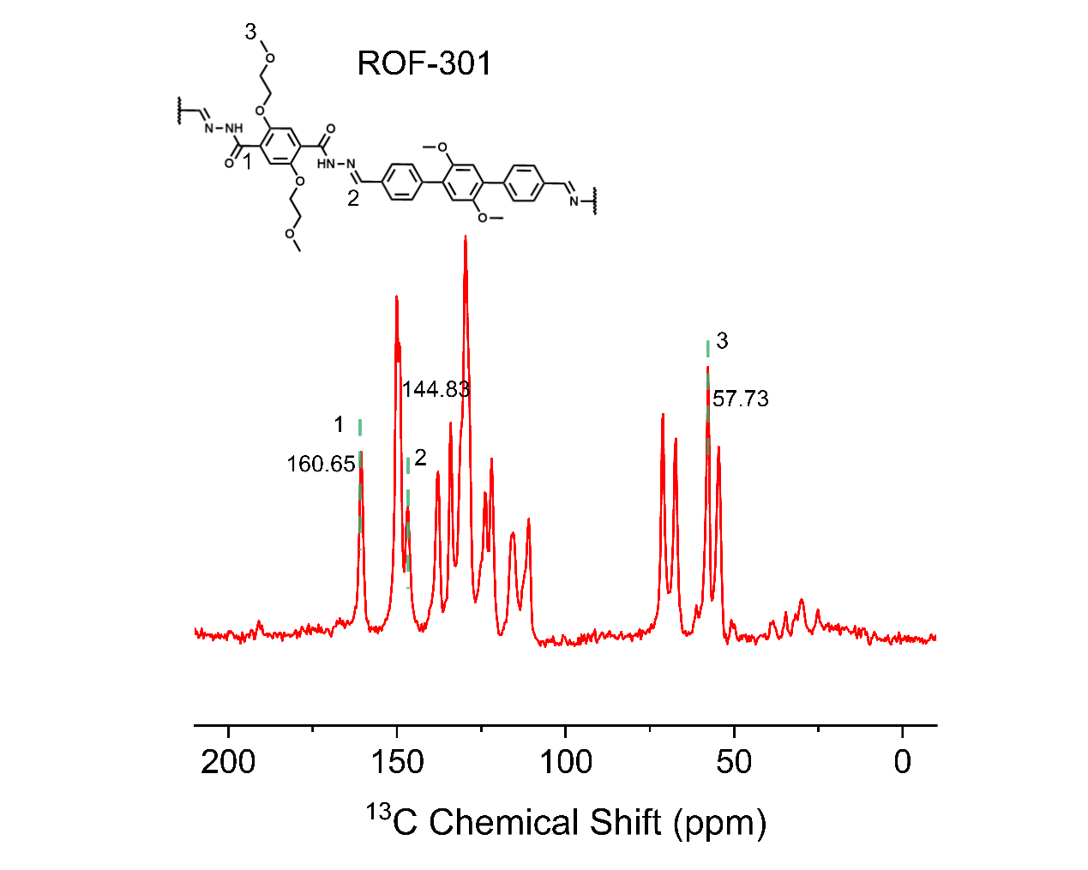
Supplementary Figure 82. ¹³C CP-MAS NMR of ROF-301.
The spectrum exhibited the corresponding hydrazone peak at 144.83 ppm and carbonyl peak at 160.65 ppm.

Supplementary Figure 83. PXRD patterns of ROF-301 from simulated and experiment.

Supplementary Figure 84. Water vapor adsorption isotherm of ROF-301 at 298K.

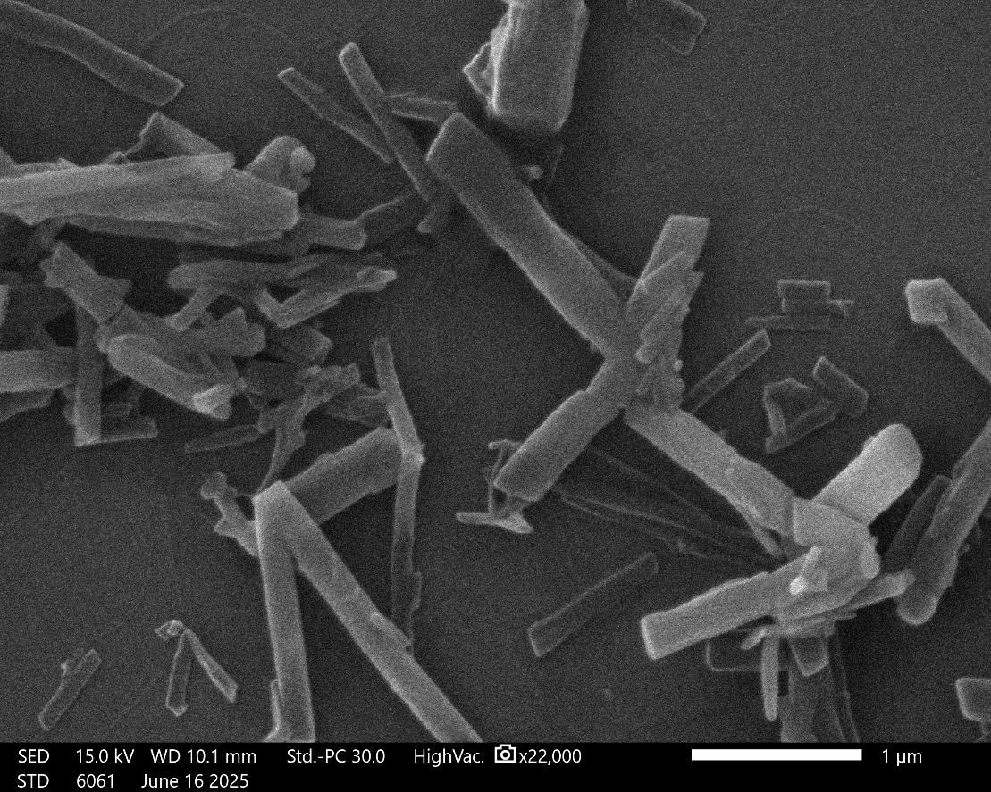
Supplementary Figure 85. SEM image of ROF-302.

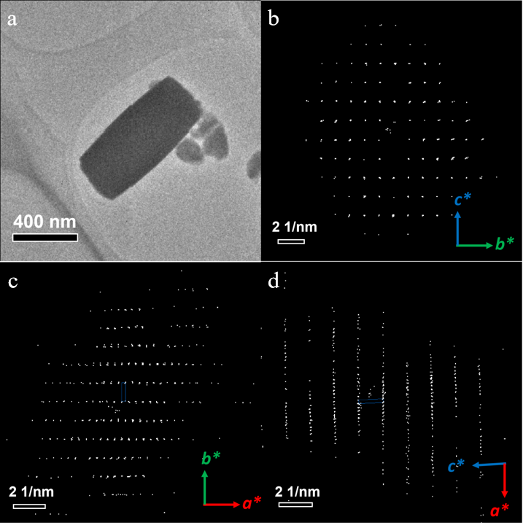
Supplementary Figure 86. (a) Low-mag TEM image of one ROF-302 crystal. Projections of 3D ED data of ROF-302 along (b) [100], (c) [001] and (d) [010] directions.

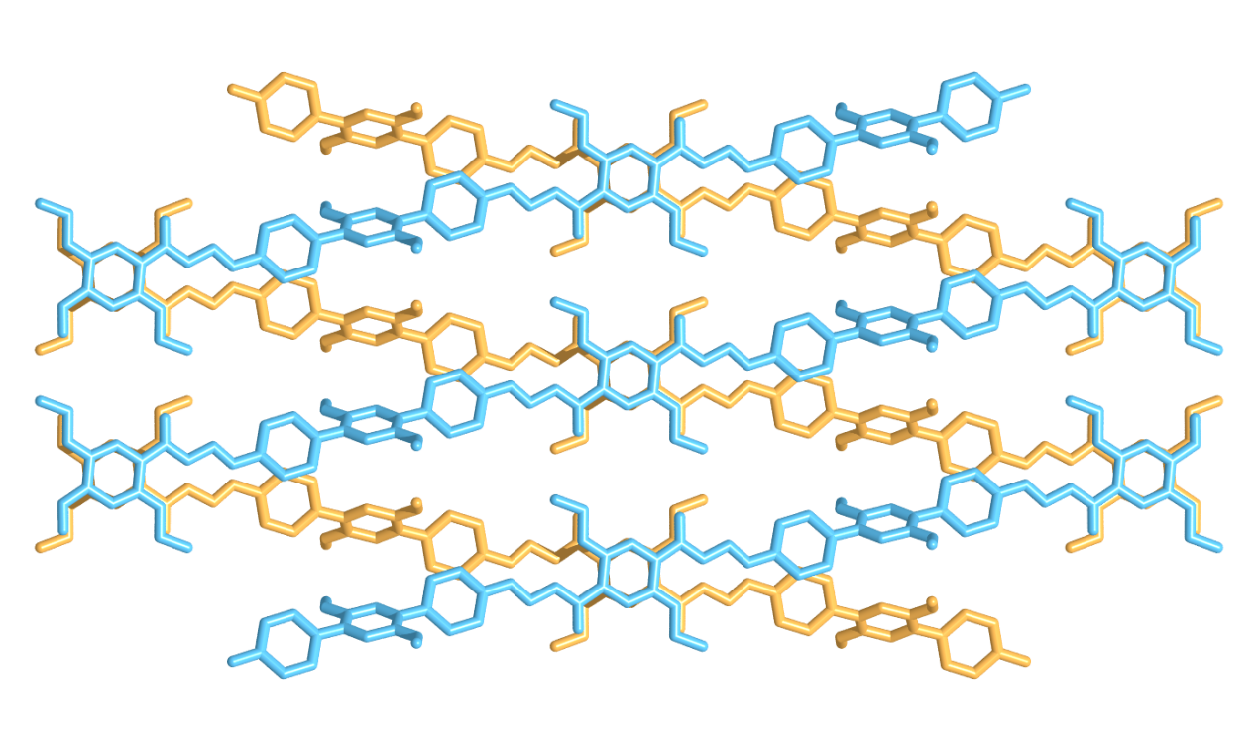
Supplementary Figure 87. Crystallographic structure of ROF-302.

Table 11. The refinement statistics of sample ROF-302

Sample name | ROF-302
CCDC Deposit No. | 2539875
Chemical formula | C₁₇H₁₆N₂O₃
Temperature | 293 K
Crystal system | monoclinic
Space group | C2/c
Cell parameters | a = 45.799 Å, b = 8.783 Å, c = 6.755 Å, α = 90°, β = 92.22°, γ = 90°
Cell volume | 2715.2 Å³
Diffractometer | JEOL JEM-F200 Transmission electron microscope
Radiation | Electron (λ = 0.02508 Å)
Data reduction | XDS
Reflections collected | 2877
Completeness | 0.776
Max indices | (40, 8, 6)
Min indices | (-42, -8, -6)
I/Sigma | 6.2 to 1.00 Å
Solution method | Intrinsic Phasing using SHELXT
Refinement method | Least Square using SHELXL
Unique reflections | 1111
R1 | 0.1541
wR₂ | 0.4627
R_{int} | 0.1372
GooF | 1.332

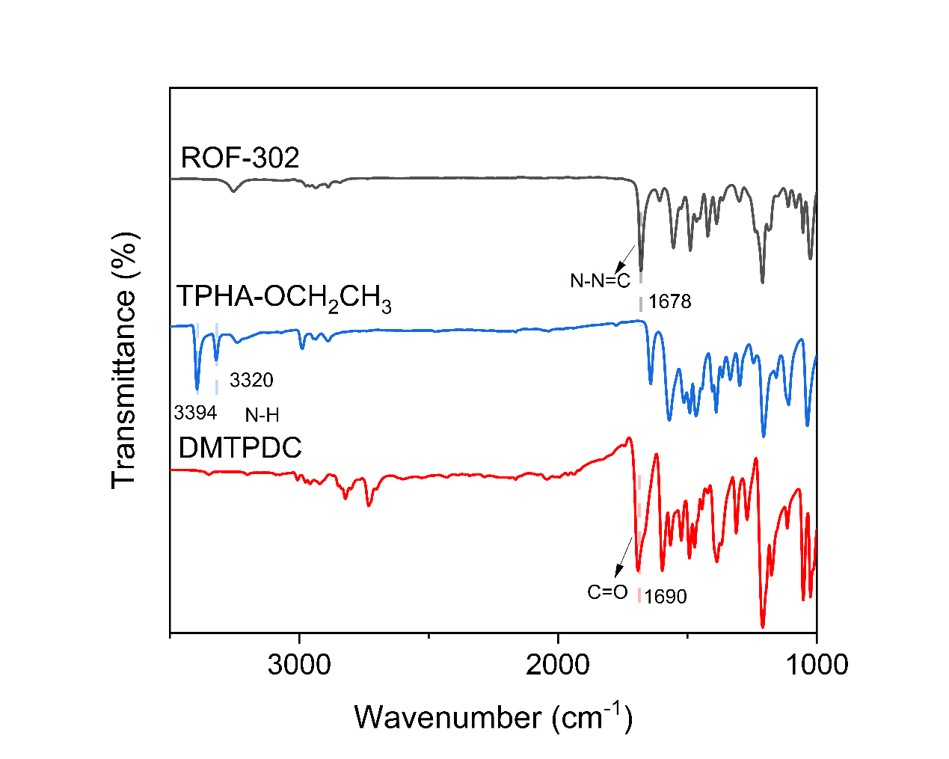
Supplementary Figure 88. The FT-IR spectrum of the starting materials, TPHA-OCH₂CH₃ and DMTPDC, and the products, ROF-302. The -C=N-NH- stretching vibration at 1678 cm⁻¹ indicated the formation of hydrazone linkages.

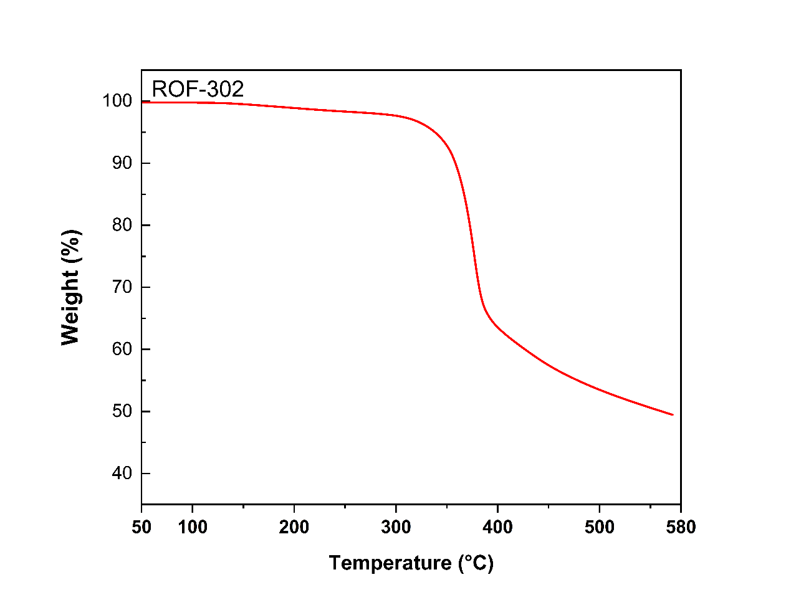
Supplementary Figure 89. The TGA profile of ROF-302.

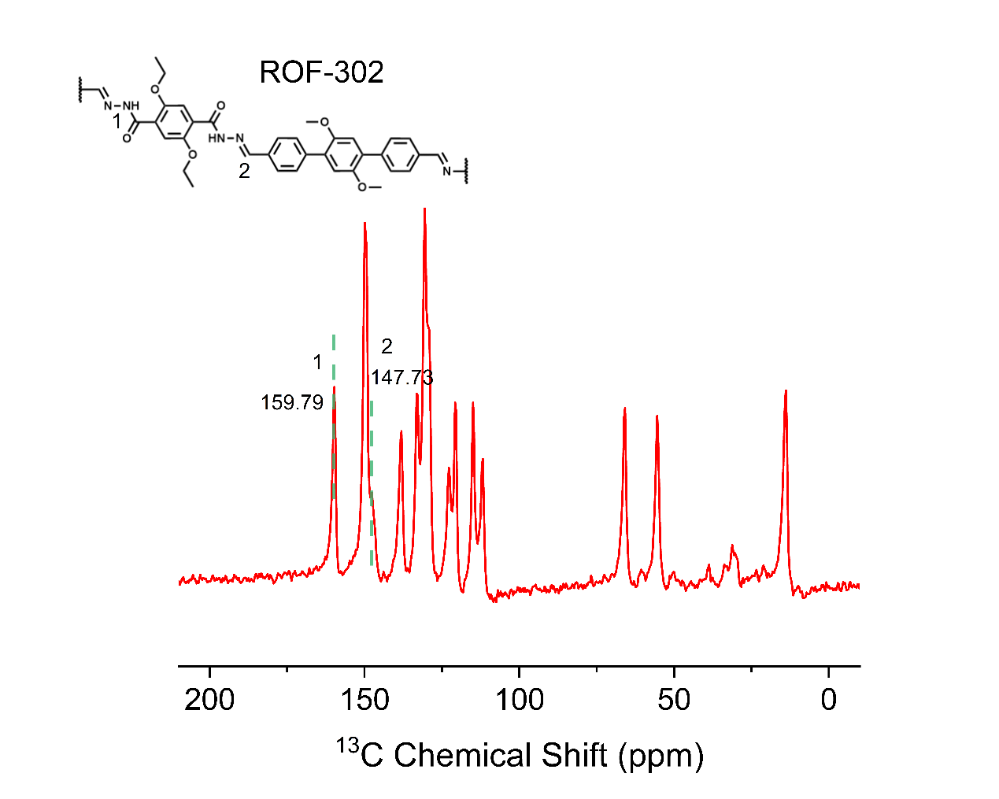
Supplementary Figure 90. ¹³C CP-MAS NMR of ROF-302.
The spectrum exhibited the corresponding hydrazone peak at 147.73 ppm and carbonyl peak at 159.79 ppm.

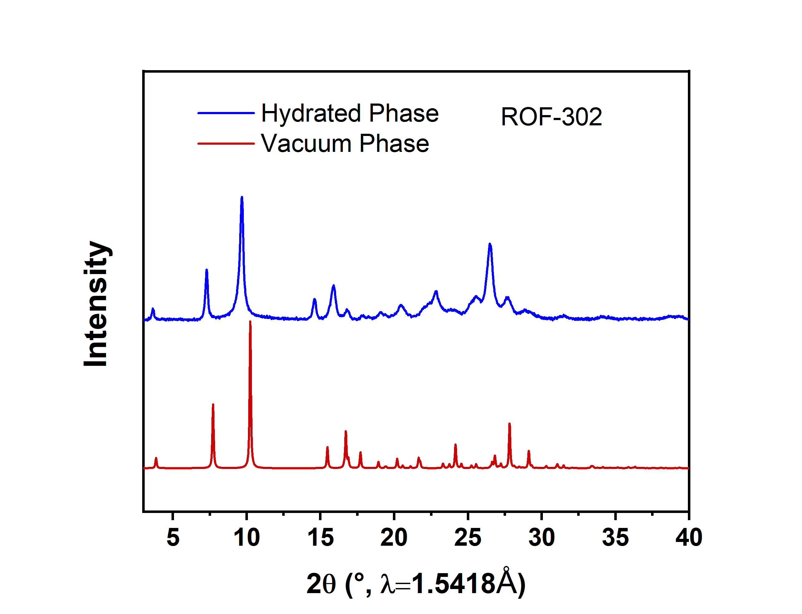
Supplementary Figure 91. PXRD patterns of ROF-302.

Supplementary Figure 92. Water vapor adsorption isotherm of ROF-302 at 298K.

References
1. Li, Y. H. et al. Molecular Probing in a Metal–Organic Framework for Selective Gas Adsorption and Separation. J. Am. Chem. Soc. 148, 18762-18768 (2026).
2. Ling, Y. et al. Atomic-level structural responsiveness to environmental conditions from 3D electron diffraction. Nat. Commun. 13, 6625 (2022).
3. Smeets, S. et al. Instamatic. Zenodo (2018).
4. Kabsch, W. XDS. Acta Crystallogr. D Biol. Crystallogr. 66, 125-132 (2010).
5. Burla, M. C. et al. Crystal structure determination and refinement via SIR2014. J. Applied Crystallogr. 48, 306-309 (2015).
6. Sheldrick, G. M. Crystal Structure Refinement with SHELXL. Acta Crystallogr., Sect. C: Cryst. Struct. Commun. 71, 3-8 (2015).
7. Dolomanov, O. V. et al. OLEX2: a complete structure solution, refinement and analysis program. J. Applied Crystallogr. 42, 339-341 (2009).
8. Sheldrick, G. M. SHELXT–Integrated Space-Group and Crystal-Structure Determination. Acta Crystallogr., Sect. A: Found. Crystallogr. 71, 3-8 (2015).
9. Palatinus, L., Brázda, P., Jelínek, M., Hrdá, J., Steciuk, G., Klementová, M. Specifics of the Data Processing of Precession Electron Diffraction Tomography Data and Their Implementation in The Program PETS2.0. Acta Crystallogr., Sect. B: Struct. Sci. 75, 512-522 (2019).
10. Kühne, T. D. et al. CP2K: An electronic structure and molecular dynamics software package - Quickstep: Efficient and accurate electronic structure calculations. J. Chem. Phys. 152, 194103 (2020).
11. VandeVondele, J., Hutter, J. Gaussian basis sets for accurate calculations on molecular systems in gas and condensed phases. J. Chem. Phys. 127, 114105 (2007).
12. Goedecker, S., Teter, M., Hutter, J. Separable dual-space Gaussian pseudopotentials. Phys. Rev. B. 54, 1703-1710 (1996).
13. Hartwigsen, C., Goedecker, S., Hutter, J. Relativistic separable dual-space Gaussian pseudopotentials from H to Rn. Phys. Rev. B. 58, 3641-3662 (1998).
14. Perdew, J. P., Burke, K., Ernzerhof, M. Generalized Gradient Approximation Made Simple. Phys Rev Lett. 77, 3865-3868 (1996).
15. Grimme, S., Ehrlich, S., Goerigk, L. Effect of the damping function in dispersion corrected density functional theory. J. Comput. Chem. 32, 1456-1465 (2011).
16. Lu, T., Chen, Q. Independent gradient model based on Hirshfeld partition: A new method for visual study of interactions in chemical systems. J. Am. Chem. Soc. 43, 539-555 (2022).
17. Lefebvre, C. et al. The Independent Gradient Model: A New Approach for Probing Strong and Weak Interactions in Molecules from Wave Function Calculations. Chem. Phys. Chem. 19, 724-735 (2018).
18. Lefebvre, C. et al. Accurately extracting the signature of intermolecular interactions present in the NCI plot of the reduced density gradient versus electron density. Phys. Chem. Chem. Phys. 19, 17928-17936 (2017).
19. Zhao, C. et al. Integrating machine learning interatomic potentials with batched optimization for crystal structure prediction. Digital Discovery, 5, 1913-1924 (2026).
20. Riniker, S., Landrum, G. A. Better informed distance geometry: using what we know to improve conformation generation. J. Chem. Inf. Model. 55, 2562–2574 (2015).
21. Landrum, G. RDKit: Open-source cheminformatics software. http://www.rdkit.org/ (2016).
22. Mayo, S. L., Olafson, B. D., Goddard, W. A. DREIDING: a generic force field for molecular simulations. J. Phys. Chem. 94, 8897–8909 (1990).
23. Kovács, D. P., Moore, J. H., Browning, N. J. et al. MACE-OFF: short-range transferable machine learning force fields for organic molecules. J. Am. Chem. Soc. 147, 17598–17611 (2025).
24. Larsen, A. H., Mortensen, J. J., Blomqvist, J. et al. The atomic simulation environment—a Python library for working with atoms. J. Phys.: Condens. Matter. 29, 273002 (2017).
25. Kresse, G. & Furthmüller, J. Vienna. Ab initio Simulation Package (VASP). Vienna University, Vienna (2001).
26. Blöchl, P. E. Projector augmented-wave method. Phys. Rev. B. 50, 17953 (1994).
27. Grimme, S., Antony, J., Ehrlich, S. & Krieg, H. A consistent and accurate ab initio parametrization of density functional dispersion correction (DFT-D) for the 94 elements H–Pu. J. Chem. Phys. 132, 154104 (2010).
28. Becke, A. D. & Johnson, E. R. A density-functional model of the dispersion interaction. J. Chem. Phys. 123, 154101 (2005).

